**Exercise 1:-**

1. **SELECT title FROM movies;**

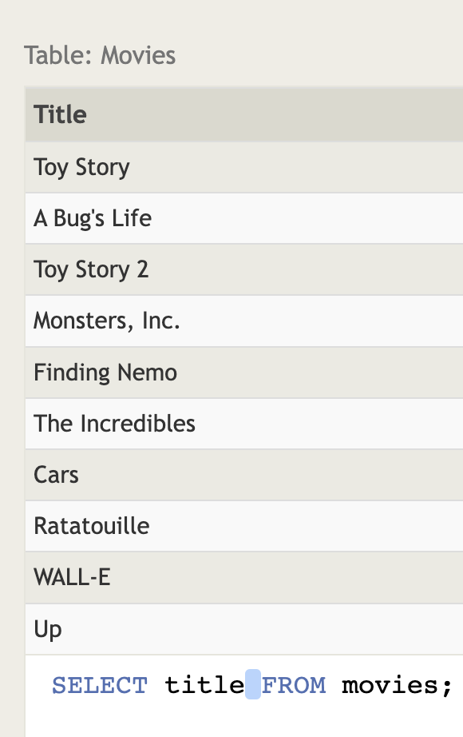

1. **SELECT director FROM movies;**

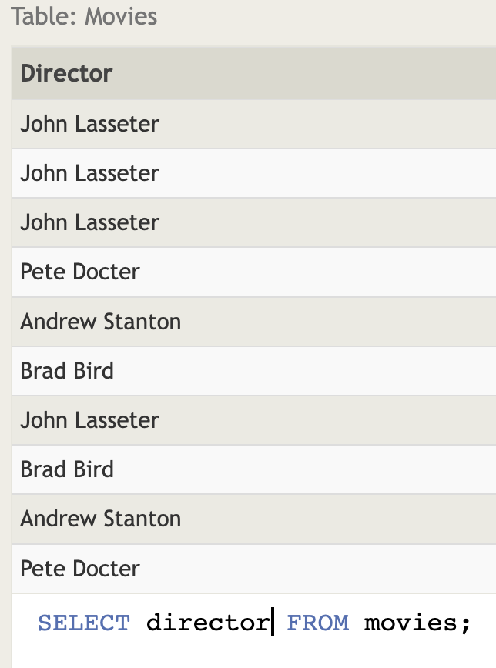

1. **SELECT title,director FROM movies;**

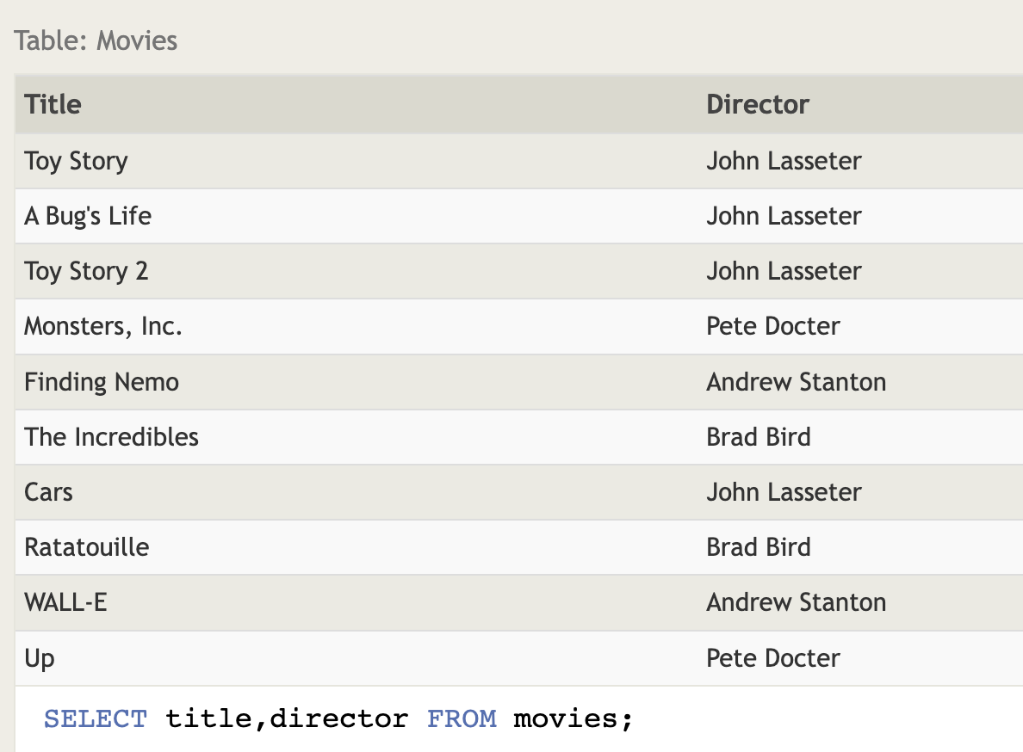

1. **SELECT title,year FROM movies;**

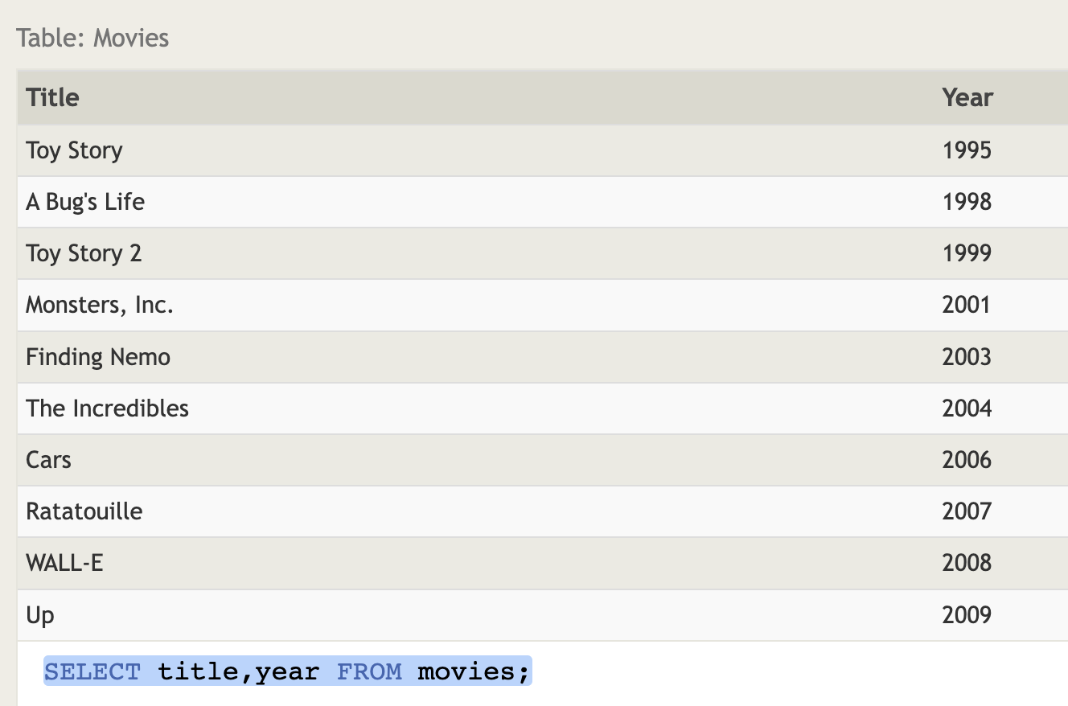

1. **SELECT * FROM movies;**

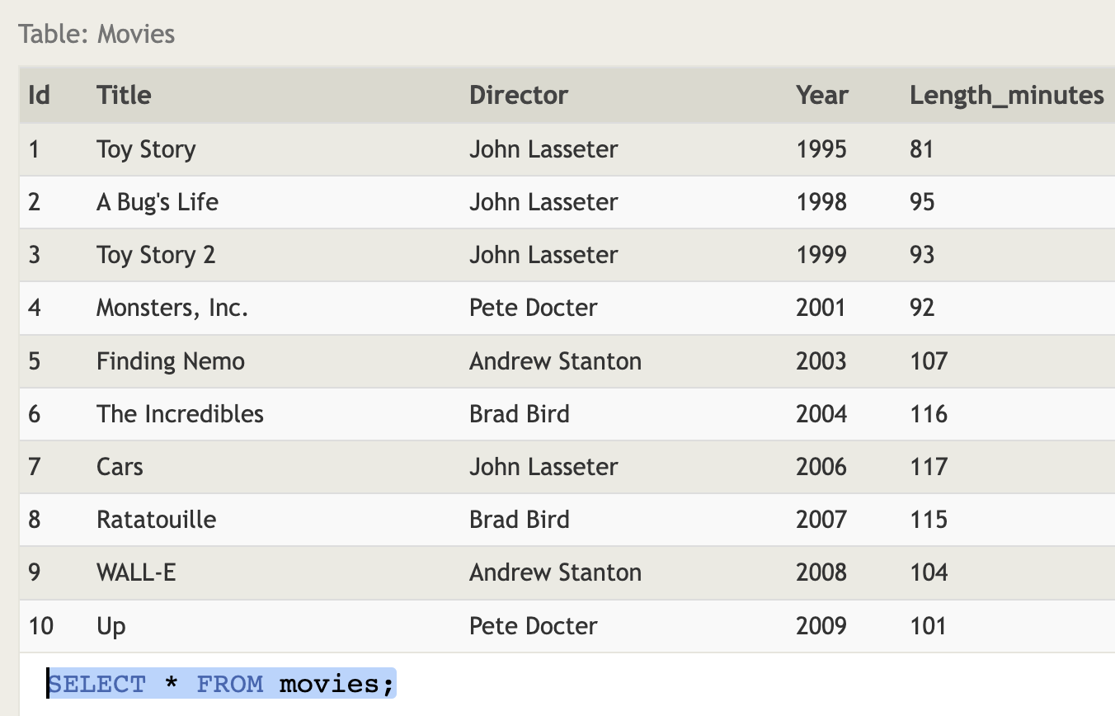

**Excersice 2:-**

1. **SELECT * FROM movies WHERE id="6"**

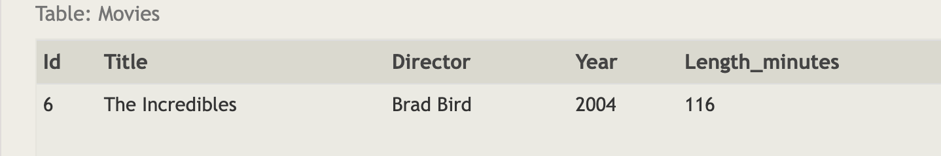

1. **SELECT * FROM movies WHERE year BETWEEN 2000 AND 2010**

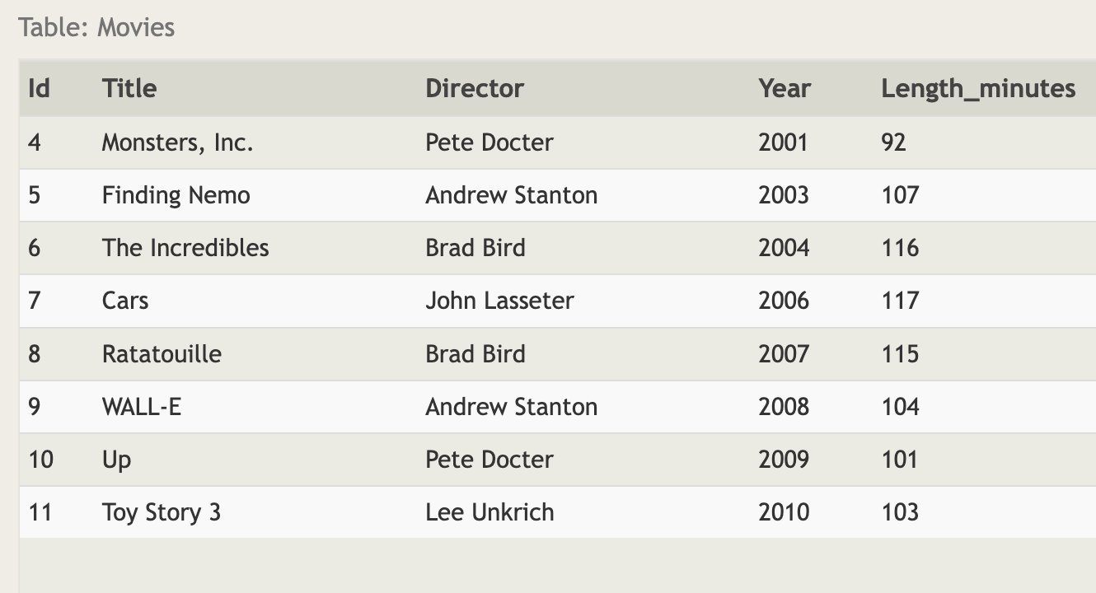

1. **SELECT * FROM movies WHERE year NOT BETWEEN 2000 AND 2010**

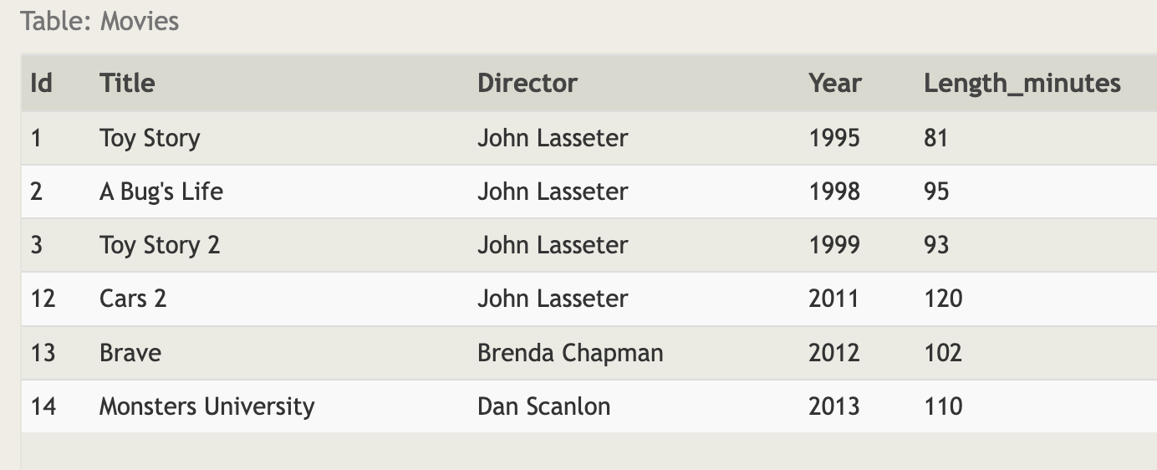

1. **SELECT title, year FROM movies WHERE year <= 2003;**

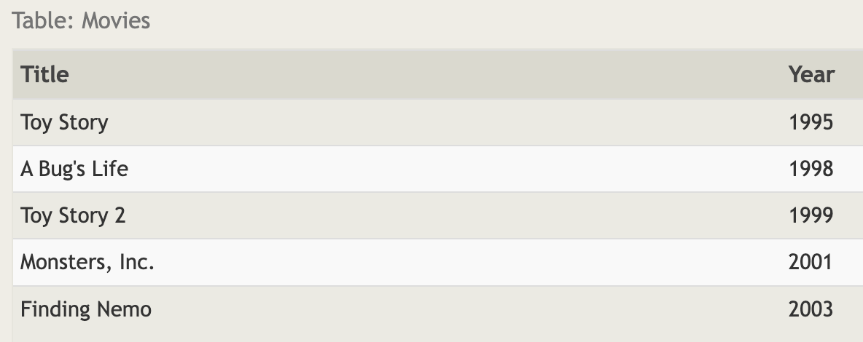

**Excersice 3:-**

1. **SELECT * FROM movies WHERE title LIKE "Toy Story%";**

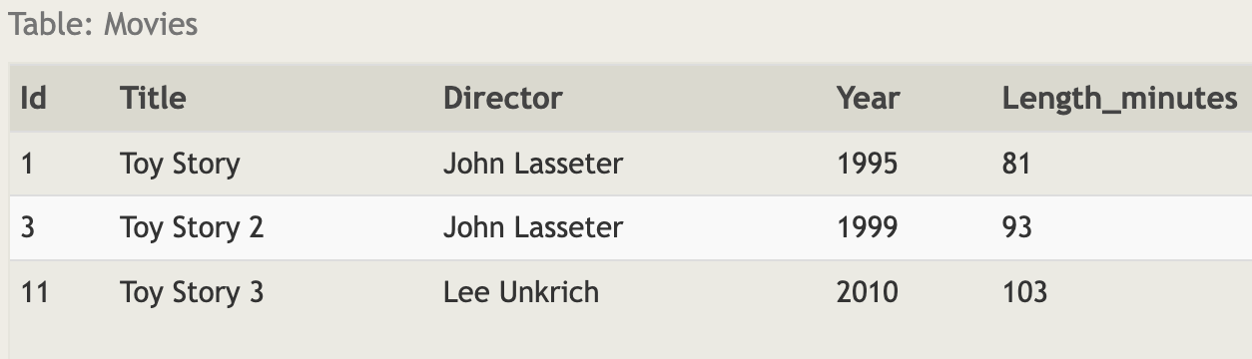

1. **SELECT Title FROM movies WHERE director LIKE "John Lasseter"**



1. **SELECT Title,Director FROM movies WHERE director NOT LIKE "John Lasseter"**

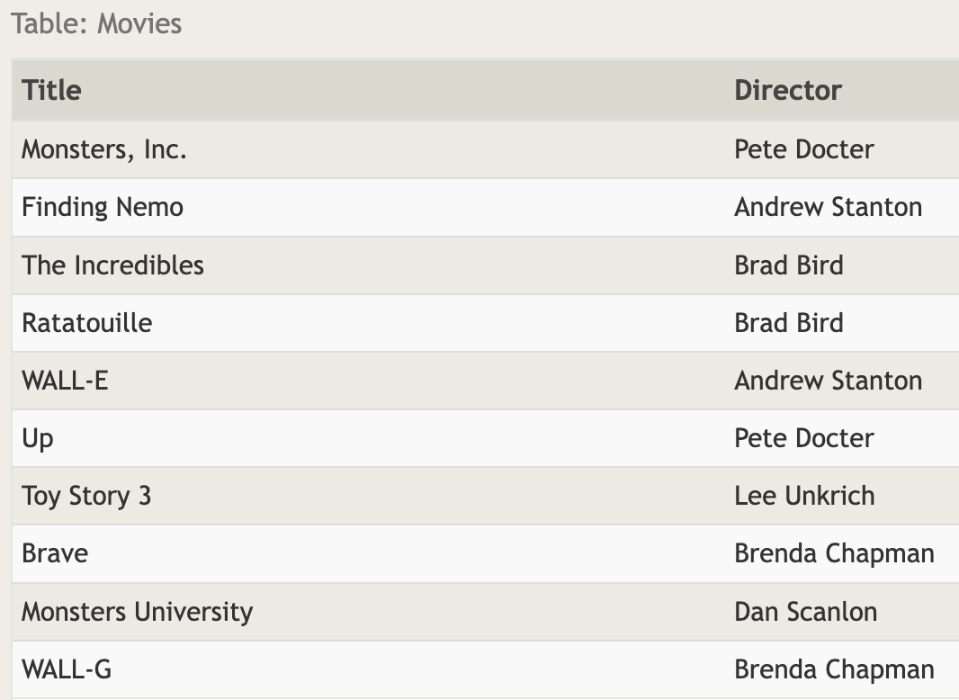

1. **SELECT * FROM movies where Title LIKE "Wall-%"**

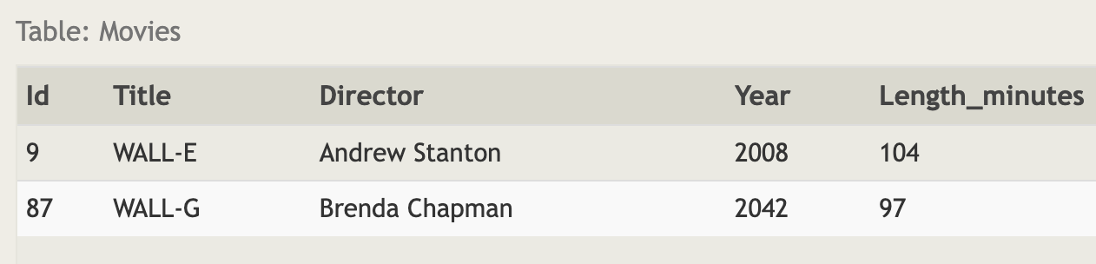

**EXCERSICE 4:-**

1. **SELECT DISTINCT director FROM movies ORDER BY director ASC;**

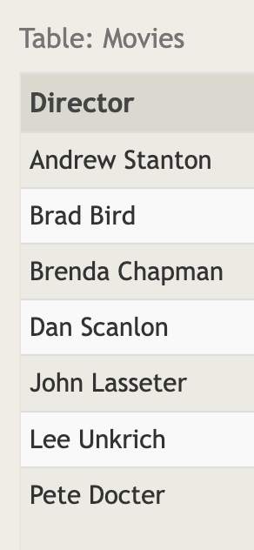

1. **SELECT title,year FROM movies ORDER BY Year DESC LIMIT 4**

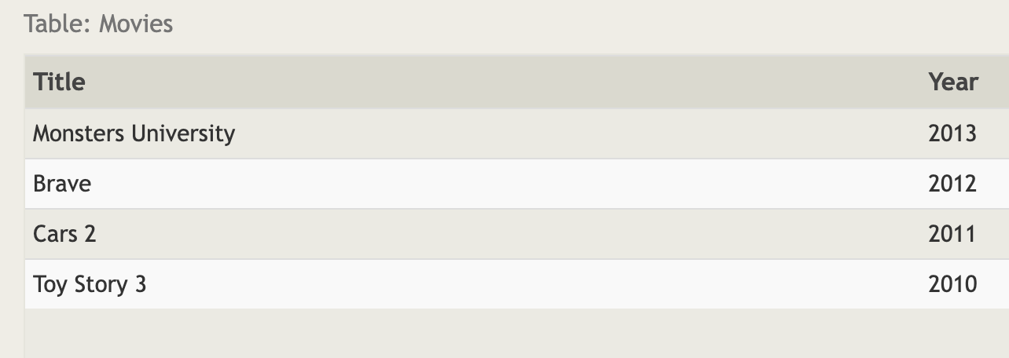

1. **SELECT title FROM movies ORDER BY title ASC LIMIT 5**



1. **SELECT title FROM movies ORDER BY title ASC LIMIT 5 OFFSET 5**

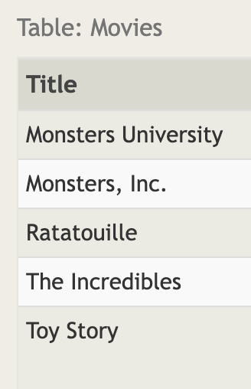

**Excersice 5:-**

1. **SELECT city,population FROM north_american_cities WHERE country LIKE "Canada"**

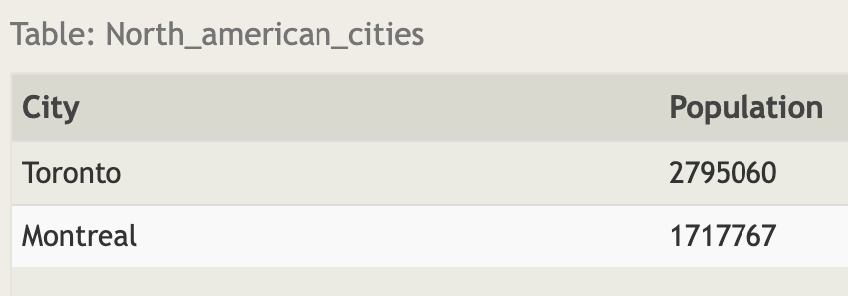

1. **SELECT city,latitude FROM North_american_cities WHERE country ="United States" ORDER BY latitude DESC**

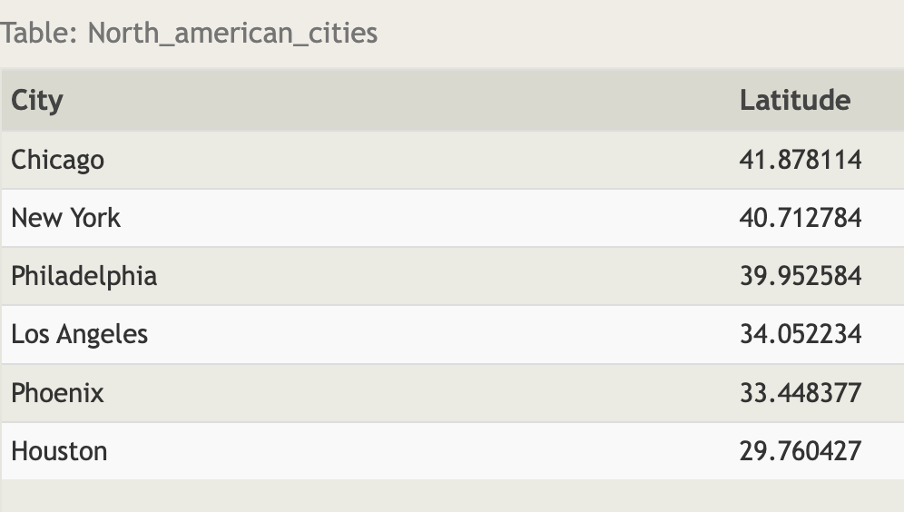

1. **SELECT city,longitude FROM North_american_cities WHERE longitude<-87.629798 ORDER BY longitude**

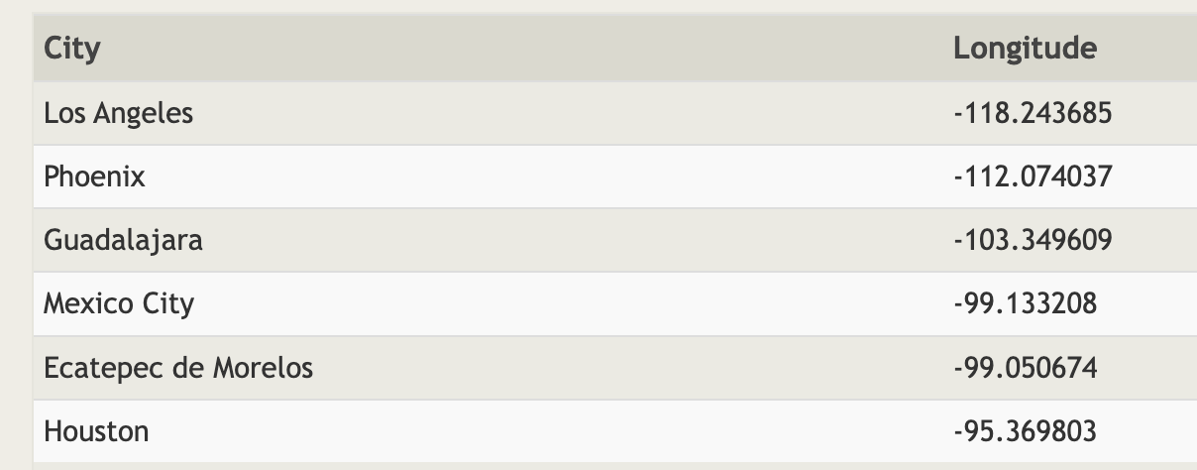

1. **SELECT city FROM North_american_cities WHERE country ="Mexico" ORDER BY population DESC LIMIT 2**

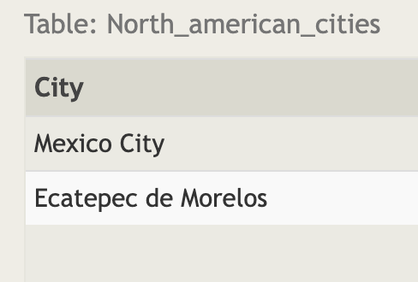

1. **SELECT city,population FROM North_american_cities WHERE country="United States" ORDER BY population DESC LIMIT 2 OFFSET 2**

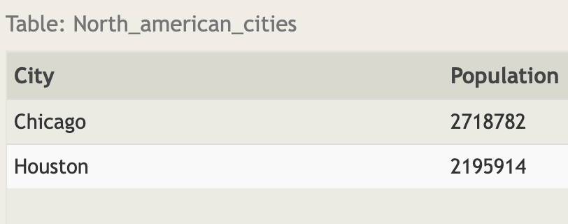

**EXCERSIE 6:-**

1. **SELECT Title,Domestic_Sales,International_sales FROM movies INNER JOIN Boxoffice on movies.Id=Boxoffice.Movie_id**

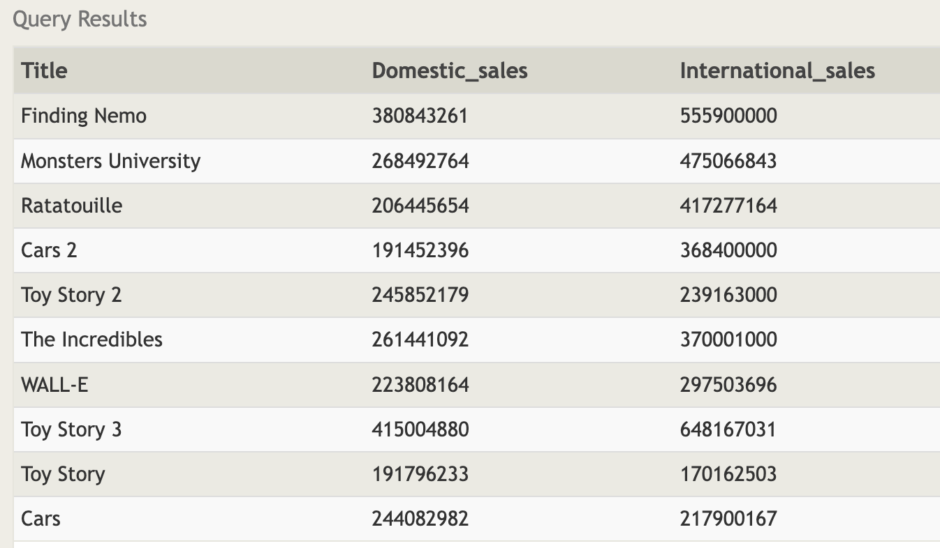

1. **SELECT title,domestic_sales,international_Sales FROM Movies INNER JOIN Boxoffice on Movies.Id=Boxoffice.movie_id WHERE International_sales > Domestic_Sales**

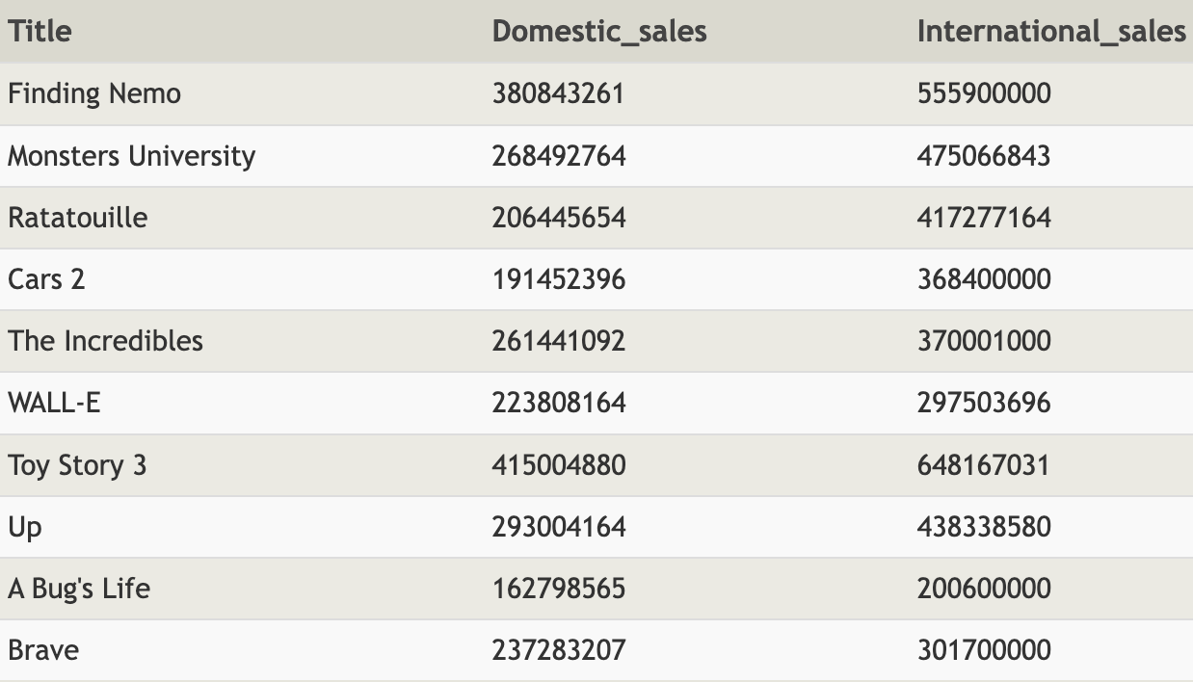

1. **SELECT Title,Rating FROM Movies INNER JOIN Boxoffice ON Movies.id=Boxoffice.Movie_id ORDER BY rating DESC**

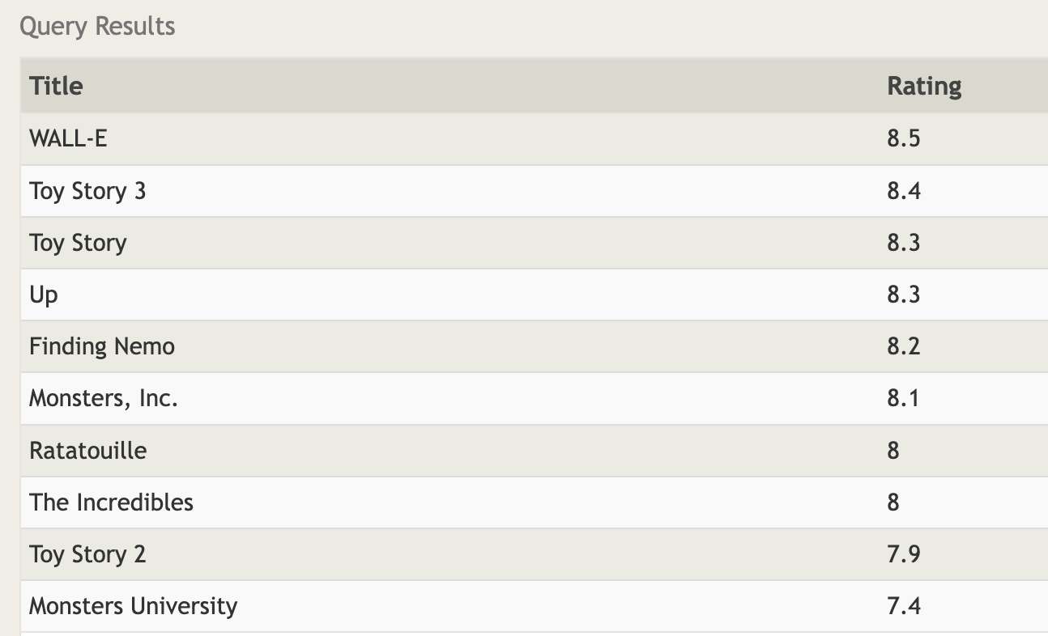

**EXERCISE 7:-**

1. **SELECT DISTINCT building FROM employees;**

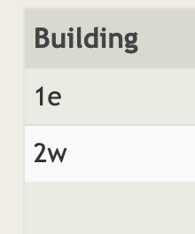

1. **SELECT * FROM BUILDINGS**

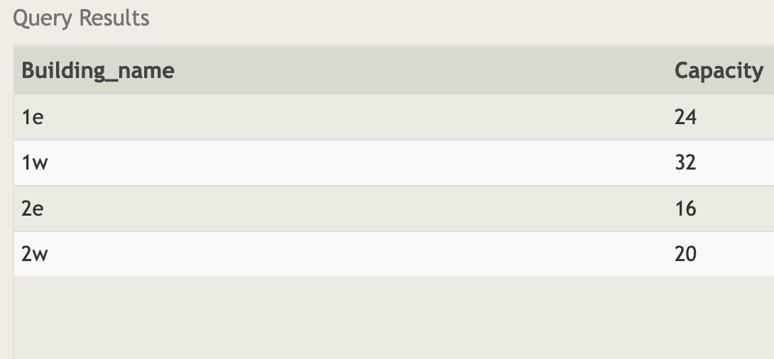

1. **SELECT DISTINCT BUILDING_NAME, ROLE FROM BUILDINGS LEFT JOIN EMPLOYEES ON BUILDING_NAME=BUILDING**

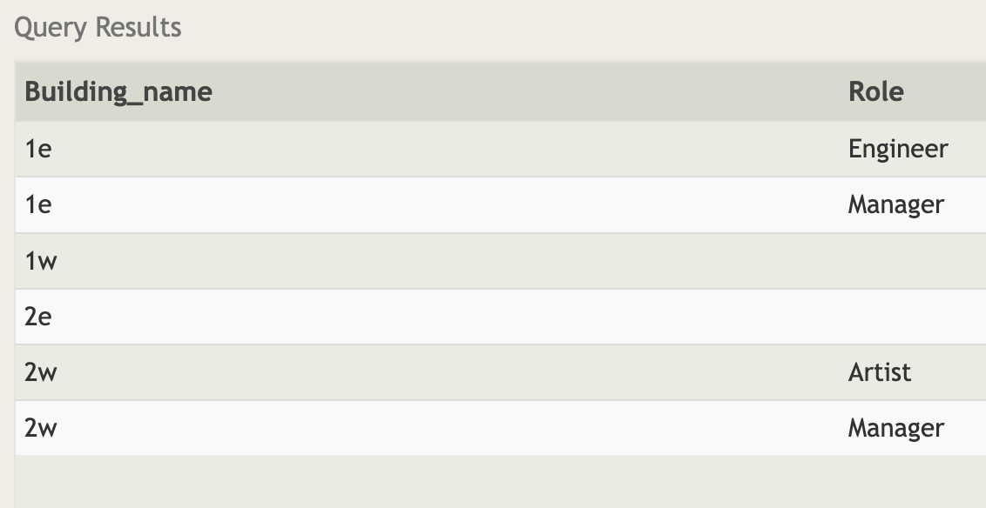

**EXERCISE 8**

1. **SELECT NAME,ROLE FROM employees WHERE Building is NULL**

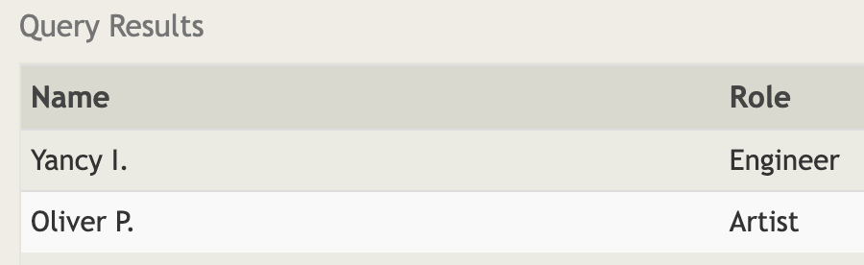

1. **SELECT Building_name FROM Buildings LEFT JOIN Employees on Building_name=Building where Building is NULL**

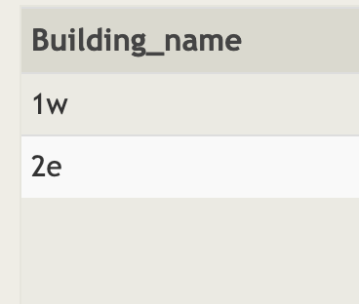

**Exercise 9:-**

1. **SELECT title,(Domestic_sales+International_sales)/1000000 AS Combined_Sales FROM movies INNER JOIN Boxoffice ON Id=Movie_ID**

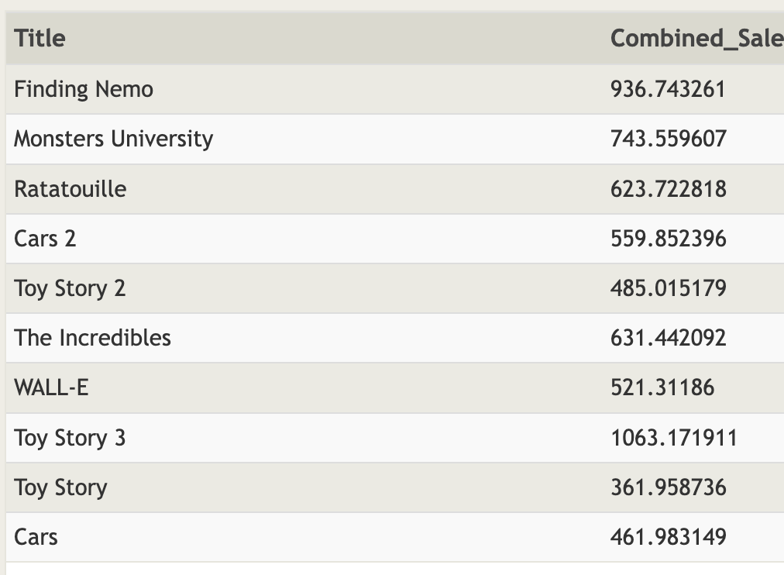

1. **SELECT Title, rating*10 AS Rating_in_Perc FROM movies INNER JOIN Boxoffice ON Id=Movie_ID**

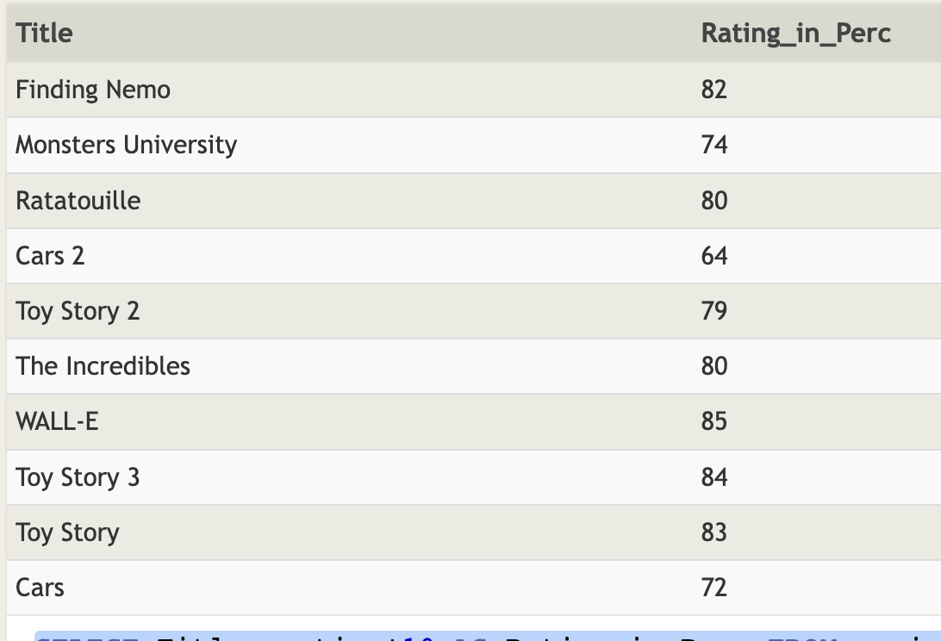

1. **SELECT Title, Year FROM movies INNER JOIN Boxoffice ON Id=Movie_ID WHERE (YEAR%2==0)**

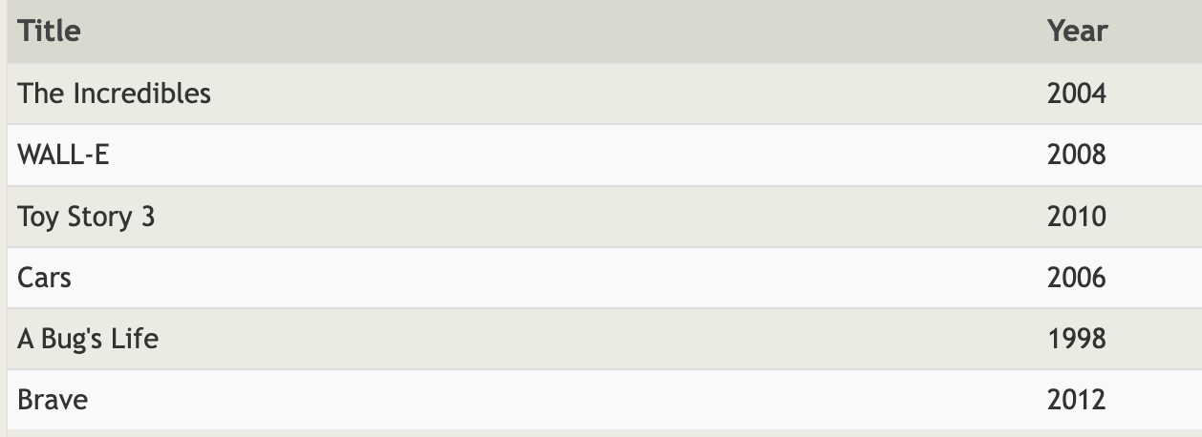

**Exercise 10:-**

1. **SELECT MAX(years_employed) as Longest_Time FROM Employees**

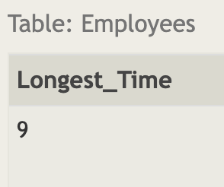

1. **SELECT Role,AVG(years_employed) as Average_years_worked FROM Employees Group BY Role**

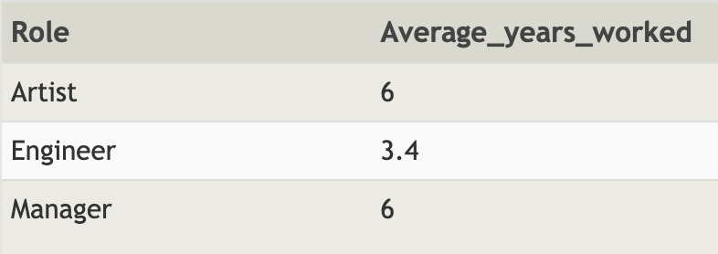

1. **SELECT Building, SUM(years_employed) FROM Employees GROUP BY Building**

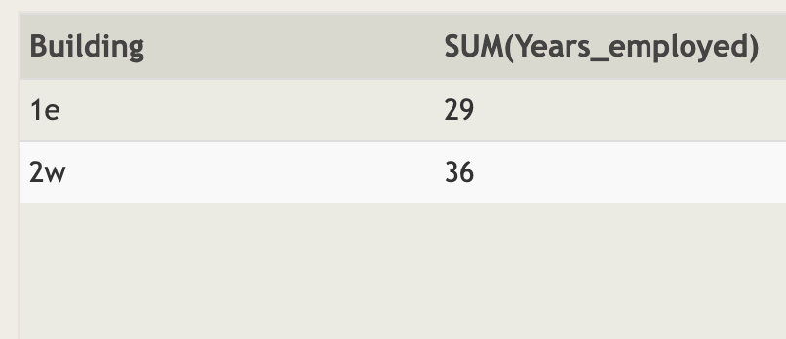

**Exercise 11**

1. **SELECT Count(Role) From Employees where Role="Artist"**

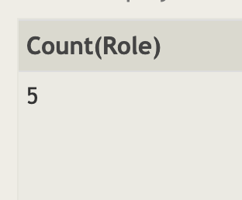

1. **SELECT Role,Count(Role) From Employees Group BY Role**

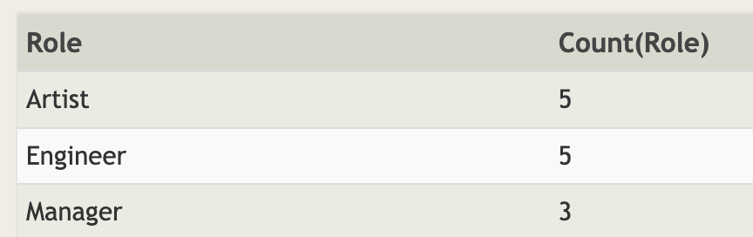

1. **SELECT Role,SUM(years_employed) FROM Employees GROUP BY ROLE Having Role="Engineer"**

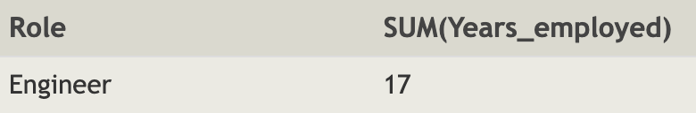

**Exercise 12**

1. **SELECT Director, Count(*) as No_of_Movies FROM Movies GROUP BY Director**

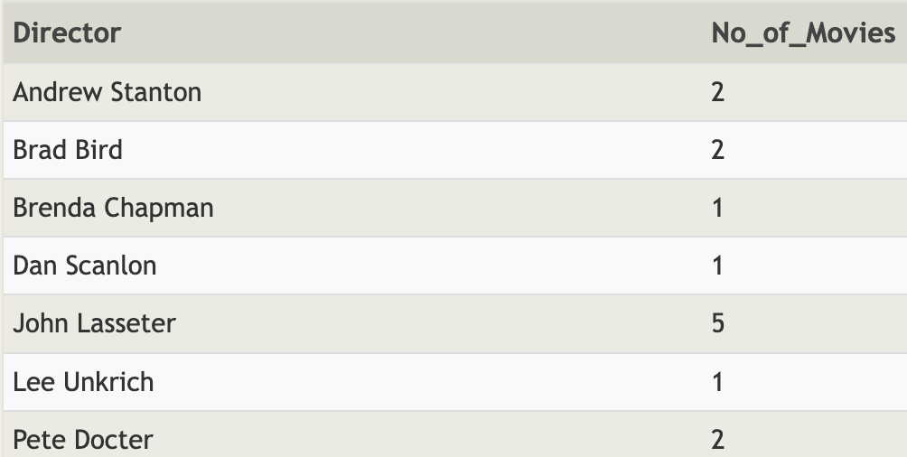

1. **SELECT Director,SUM(Domestic_Sales)+SUM(International_Sales) as Total_Sale FROM Movies INNER JOIN Boxoffice ON id=Movie_id Group BY Director**

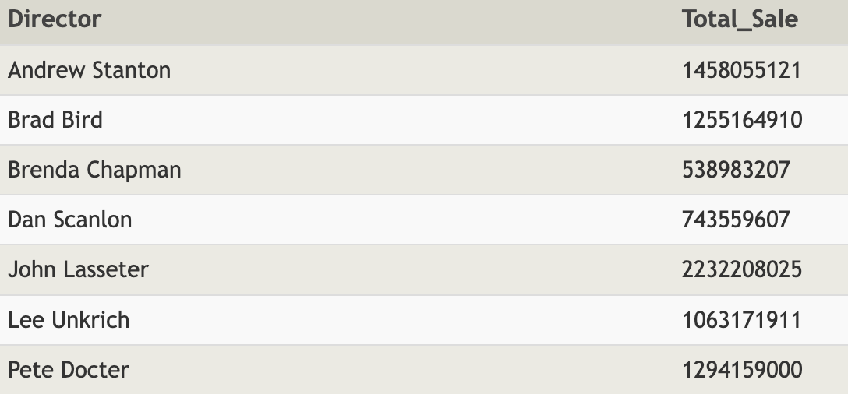

**Exercise 13**

1. **INSERT INTO Movies VALUES(4,"Toy Story 4","John Lasseter",2020,90);**

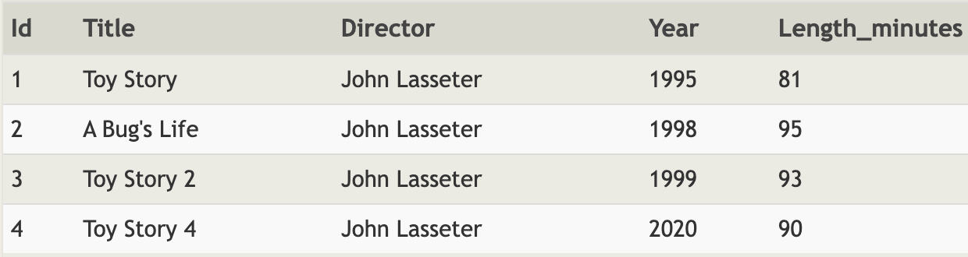

1. **INSERT INTO Boxoffice VALUES(4,8.7,340000000,270000000)**

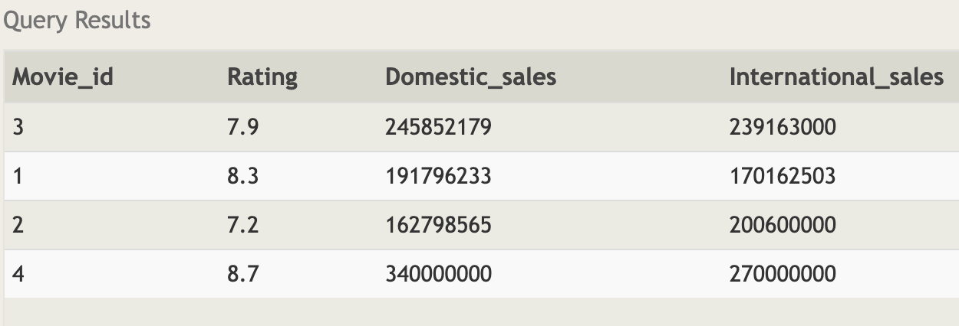

**EXERCISE 14:-**

1. **UPDATE Movies SET Director="John Lasseter" WHERE TITLE="A Bug's Life"**

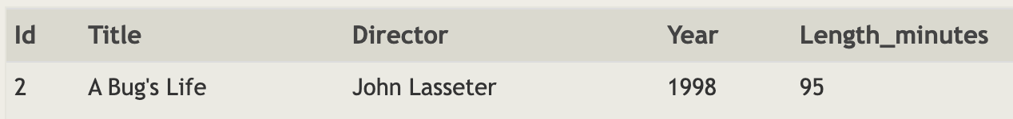

1. **UPDATE movies SET year = 1999 WHERE id = 3;**

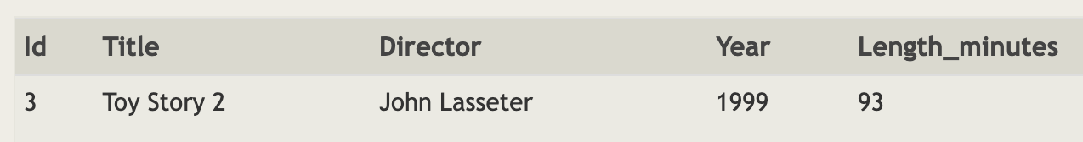

1. **UPDATE Movies SET Title="Toy Story 3", Director="Lee Unkrich" WHERE id=11**



**EXERCISE 15**

1. **DELETE FROM Movies WHERE Year<2005**

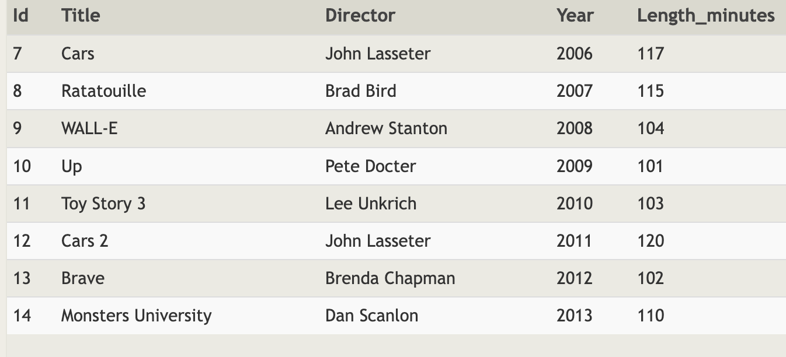

1. **DELETE FROM Movies WHERE Director="Andrew Stanton"**

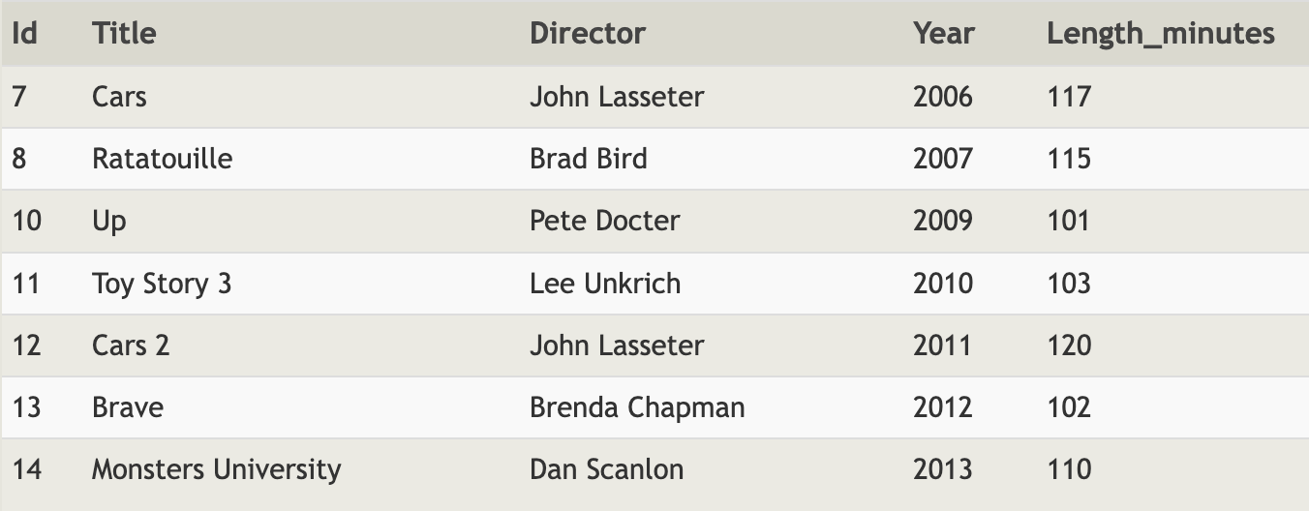

**Exercise 16:-**

1. **CREATE TABLE Database ( id INTEGER PRIMARY KEY, Name TEXT, Version FLOAT, Download_count Integer)**

**Exercise 17:-**

1. **ALTER TABLE movies ADD Aspect_ratio FLOAT**

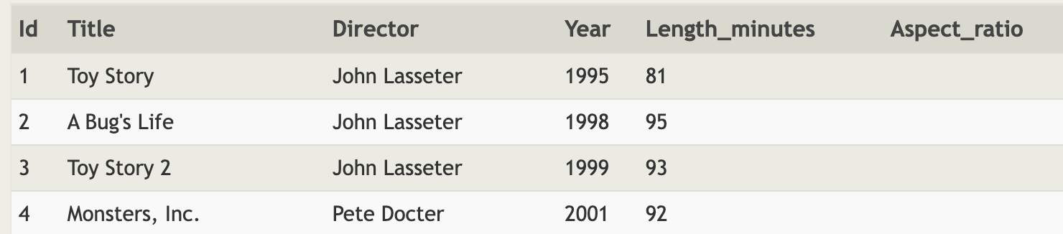

1. **ALTER TABLE movies ADD Language Text Default "English"**

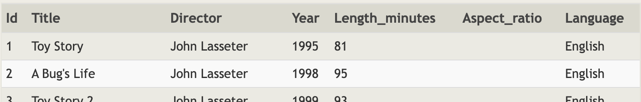

**Exercise 18**

1. **DROP TABLE Movies**

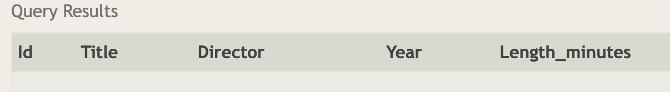

1. **DROP TABLE Boxoffice**

