A Project Report On

**“Online Cake Shop Management System”**

Submitted by-

Shivanshu gupta

Samik mehta

**CONTENTS**

|  |  |  |
| --- | --- | --- |
| **Sr.No** | **TITLE** | **Page no** |
| **1.** | **Content’s Abstract** | **3** |
| **2.** | **Introduction** | **4** |
| **3.** | **Overview** | **4** |
| **4.** | **Background and Motivation** | **4** |
| **5.** | **E-R Diagram** | **5** |
| **6.** | **Schema** | **6** |
| **7.** | **Conclusion** | **7** |

***ABSTRACT***

In this project we are created one application which is easy to access user friendly.For this application we used the backend as MYSQL to store the data which is used in the application and for the user interface we had used the PHP and HTML.5 kinds of people are able to use this application as manager and the customer as well. The customer is able to do the online ordering very easily from any place by reading the details of product and by seeing the product image.The manager is the only person who is able to add and remove the items and can also see the orders placed from the site.

***INTRODUCATION***

**Overview: -**

This report discusses the result of the work done in development of "Online Bakery Management System” on “PHP” Front-end Platform and “MySQL” as back-end Platform.

At the development of an application PHP provides a good connecting facility between all pages, also the back-end SQL is most important to save all the data related the application.

***Background and Motivation***

The definition of our problem lies in manual system and a fully automated system.

**Manual system:** The system is very time consuming and lazy. This system is more prone toErrors and sometimes the approaches to various problems are unstructured.

**Technical system:** With the advent of latest technology if we do not update our system then Our business results in losses gradually with time. The technical systems contains the tools of latestTrend i.e. computers printers, fax, Internet etc. The systems with this technology are very fast,Accurate, user-friendly and reliable.

***Objective***

**Need of Online Bakery**

1) **Convenience**

2**) Better prices**

3) **More variety**

4) **Price comparisons**

5) **No crowds**

***E-R Diagram***

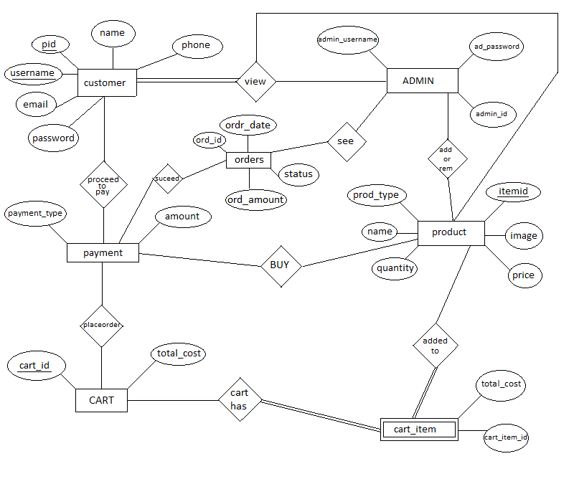

***E-R TO SCHEMA***

1.person(**pid**,username,password,name,ph one,address,email)

2.admin(**admin_id**,username,password)

3.product(**prod_id**,name,price,quantity,prod_type

,image)

4._order(**order_id**,pid,order_amount,ord_date ,status)

5. query(message,email ,date ,stall)

**Conclusion:**

THUS WE HAVE SUCCESSFULLY IMPLEMENTED ONLINE BAKERY DATABASE MANAGEMENT WHICH HELPS US IN CENTRALIZING THE DATA USED FOR MANAGING THE TASKS PERFORMED IN A ONLINE ORDERING.

WE HAVE SUCCEFULLY IMPLEMENTED VARIOUS FUNCTIONALITIES OF MYSQL AND PHP AND CREATED THE FULLY FUNCTIONAL DATABASE MANAGEMENT SYSTEM FOR ONLINE BAKERY SHOP.

**CONCEPTS USED:**

1.MYSQL-(DATABASE BACKEND)

2.HTML , BOOTSTROP & CSS -(FRONT END)

3.PHP –(CONNECTIVITY)

4.Apache (Server)