

Foundations of Programming

Lab Assignment No. : 02

PROBLEM STATEMENT:
Write a menu driven program in C to implement the basic arithmetic operations such as Addition, Subtraction, Multiplication, and Division.

OBJECTIVES:
• To understand the concept of menu driven programming in C.
• To apply conditional statements and switch–case control structures.
• To perform basic arithmetic operations using user-defined input.
• To enhance logical thinking and problem-solving skills.

THEORY:
if–else ladder statements syntax and sample program
switch–case or if–else ladder statement syntax and sample program
Basic arithmetic operations include Addition, Subtraction, Multiplication, and Division. Division by zero should be avoided.

–Menu Driven Programming
A menu driven program allows the user to choose an option from a list and perform operations based on that choice.
-Example menu:
- Addition
- Subtraction
- Multiplication
- Division

-switch-case Statement
The switch-case statement is used to select one block of code from multiple options based on a variable value.
Syntax:
switch(expression) {
case value1:
// code
break;
case value2:
// code
break;
default:
// default code
}
In this program:
It is used to perform different arithmetic operations depending on user choice.

-break Statement
The break statement is used to exit from the switch block.
Where to use:
Used after every case to prevent execution of the next case.
Arithmetic Operations
- Addition → a + b
- Subtraction → a - b
- Multiplication → a * b
- Division → a / b (denominator should not be zero)

–ALGORITHM:
- Start
- Display menu
- Input choice
- Input two numbers
- Use switch-case:
  - Case 1 → Addition
  - Case 2 → Subtraction
  - Case 3 → Multiplication
  - Case 4 → Division
- Check division by zero
- Display result
- Stop
—-------------------------------------------------------------------------------------------------------------------

–C programme –

#include <stdio.h>
int main() {
int choice;
float a, b;

printf("Menu:\n");
printf("1. Addition\n");
printf("2. Subtraction\n");
printf("3. Multiplication\n");
printf("4. Division\n");

printf("Enter your choice: ");
scanf("%d", &choice);

printf("Enter two numbers: ");
scanf("%f %f", &a, &b);

switch(choice) {

case 1:
printf("Addition = %.2f\n", a + b);
break;

case 2:
printf("Subtraction = %.2f\n", a - b);
break;

case 3:
printf("Multiplication = %.2f\n", a * b);
break;

case 4:
if (b != 0) {
printf("Division = %.2f\n", a / b);
} else {
printf("Error: Division by zero is not allowed\n");
}
break;

default:
printf("Invalid choice\n");
}

return 0;
}

—-------------------------------------------------------------------------------------------------------------------

–PLATFORM:
Linux
–INPUT:
1
10 5
–OUTPUT:
Displays the result of the selected arithmetic operation
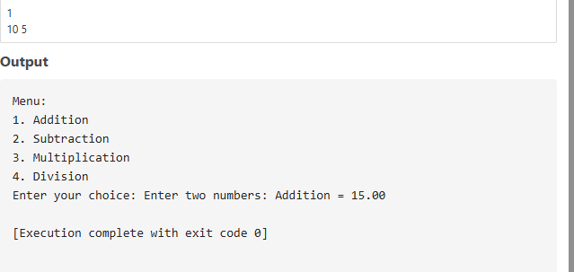

CONCLUSION:
Thus, the menu driven program in C successfully performs basic arithmetic operations using switch–case statements.

