8A
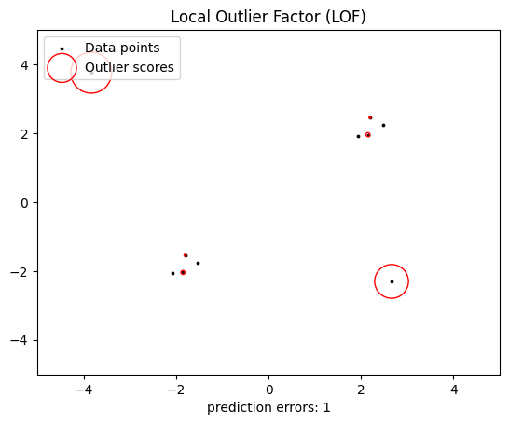

8B
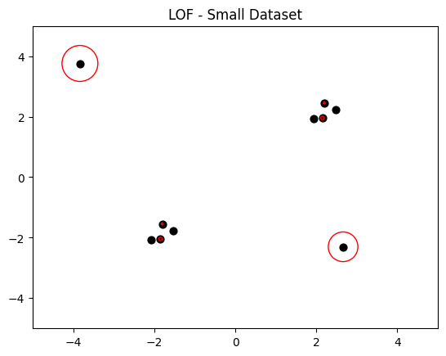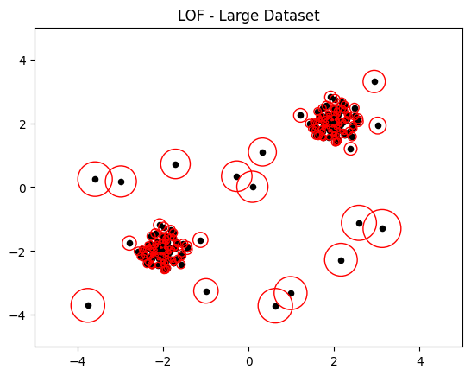

Change in code:
X_inliers = 0.3 * np.random.randn(100, 2)
X_inliers = np.r_[X_inliers + 2, X_inliers - 2]
X_outliers = np.random.uniform(low=-4, high=4, size=(20, 2))

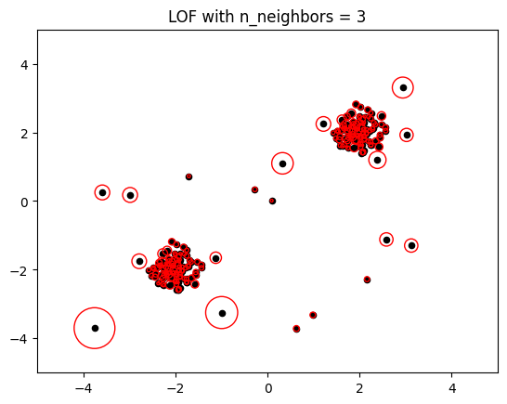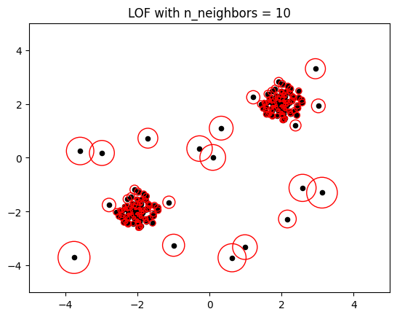

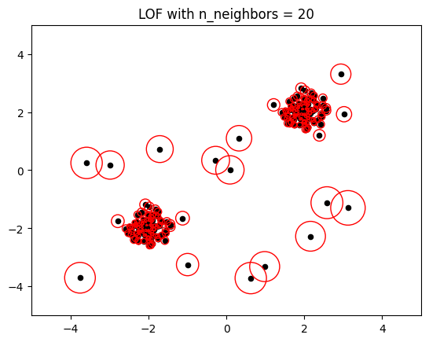

Change in code:
clf = LocalOutlierFactor(n_neighbors=3, contamination=0.1)
clf = LocalOutlierFactor(n_neighbors=10, contamination=0.1)
clf = LocalOutlierFactor(n_neighbors=20, contamination=0.1)
8C
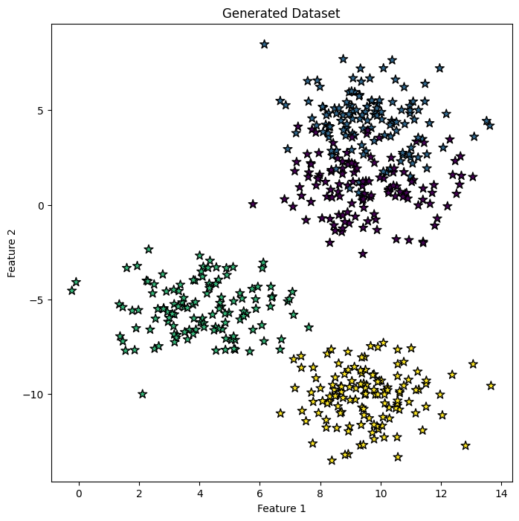
Accuracy with k=5: 93.60000000000001
Accuracy with k=1: 90.4
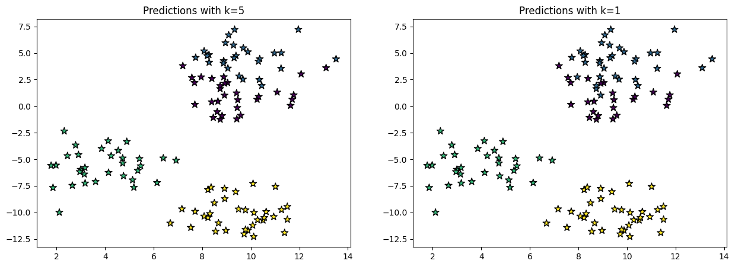

8D
Code:
import numpy as np
import matplotlib.pyplot as plt
from sklearn.datasets import make_blobs
from sklearn.neighbors import KNeighborsClassifier
from sklearn.model_selection import train_test_split
from sklearn.metrics import accuracy_score

# Generate dataset
X, y = make_blobs(n_samples=500, n_features=2, centers=4,
cluster_std=1.5, random_state=4)

# Plot original dataset
plt.figure(figsize=(8,8))
plt.scatter(X[:,0], X[:,1], c=y, marker='*', s=80, edgecolors='black')
plt.title("Generated Dataset")
plt.xlabel("Feature 1")
plt.ylabel("Feature 2")
plt.show()

# Split dataset
X_train, X_test, y_train, y_test = train_test_split(
X, y, test_size=0.25, random_state=0)

# Different k values
k_values = [1,3,5,9,11,13]

accuracies = []

print("KNN Accuracy Comparison\n")

for k in k_values:

model = KNeighborsClassifier(n_neighbors=k)
model.fit(X_train, y_train)

y_pred = model.predict(X_test)

acc = accuracy_score(y_test, y_pred) * 100
accuracies.append(acc)

print("Accuracy for k =", k, ":", acc)

# Plot accuracy vs k
plt.figure(figsize=(8,6))
plt.plot(k_values, accuracies, marker='o')

plt.title("Accuracy vs K value in KNN")
plt.xlabel("Number of Neighbors (k)")
plt.ylabel("Accuracy (%)")

plt.xticks(k_values)

plt.show()


KNN Accuracy Comparison
Accuracy for k = 1 : 90.4
Accuracy for k = 3 : 92.80000000000001
Accuracy for k = 5 : 93.60000000000001
Accuracy for k = 9 : 94.39999999999999
Accuracy for k = 11 : 94.39999999999999
Accuracy for k = 13 : 93.60000000000001
