# Project Scope (Predico)

* + The disease prediction system have 3 users such as doctor, patient and admin.
  + Each user of the system are authenticated by the system.
  + There is a role based access to the system.
  + The systemallows the patient to give symptoms and according to those symptoms the system will predict a disease.
  + The system suggests doctors for predicted diseases.
  + The system allows online consultation for patients.
  + The system helps the patients to consult the doctor at their convenience by sitting at home.

# TECHNOLOGY USED

**Front end: HTML, CSS , Bootstrap, Javascript, Jquery Back end: Django (**python based web framework**) Database: PostgreSQL**

# Tools: PgMyadmin, Orange

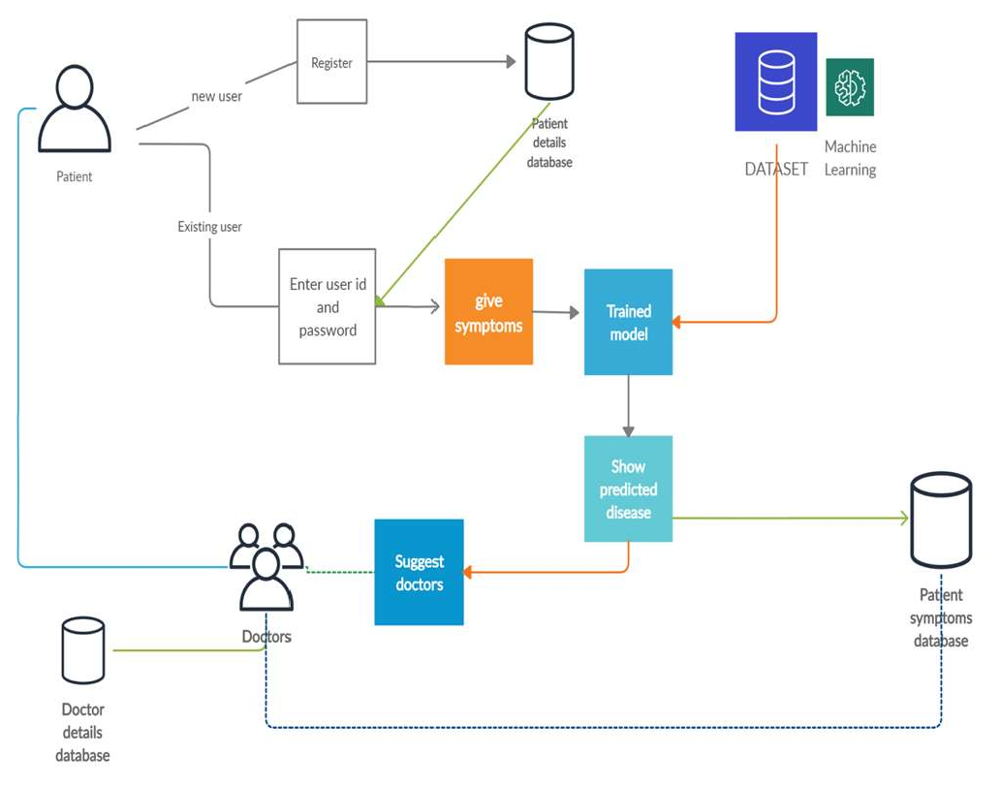

1. **Architecture of the System**

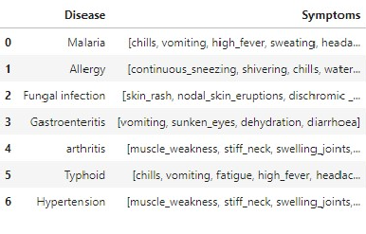

1. **Data collection**

Data collection has been done from the internet to identify the disease here the real symptoms of the disease are collected i.e. no dummy values are entered.

The symptoms of the disease are collected from kaggle.com and different health related websites. This csv file contain 5000 rows of record of the patients with their symptoms(132 types of different symptoms) and their corresponding disease(40 class of general disease) .

Some rows of disease with their corresponding symptoms in the dataset are -

1. **Webpages- Homepage-**

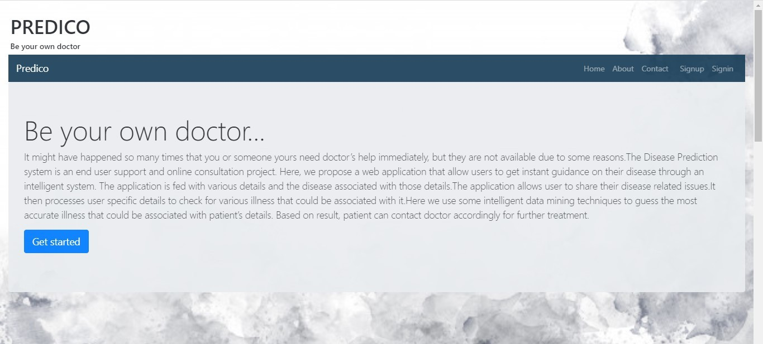

Login Modal-

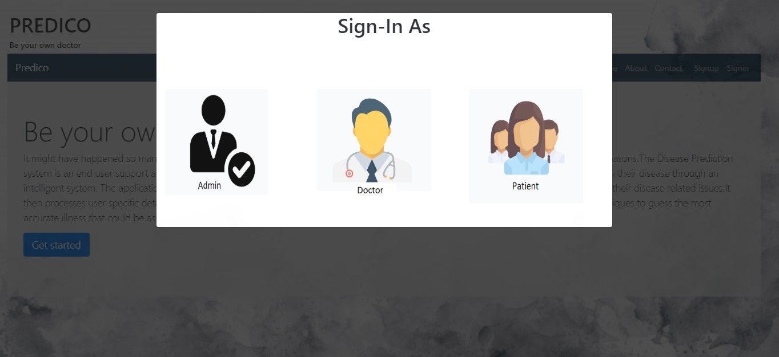

Login as Patient-

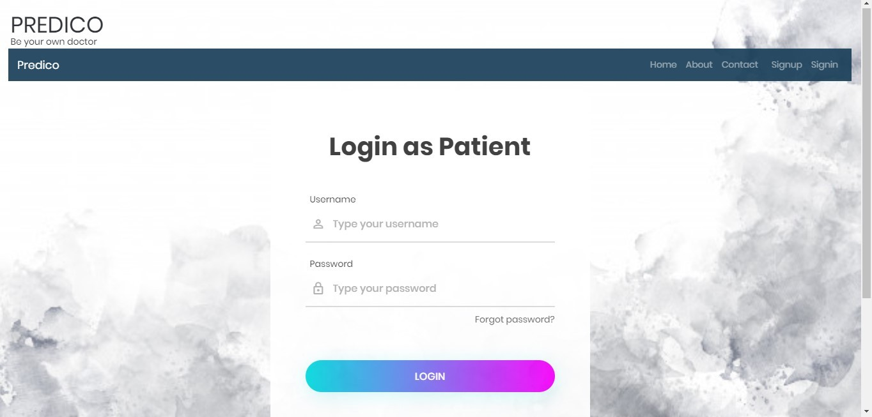

Patient UI-

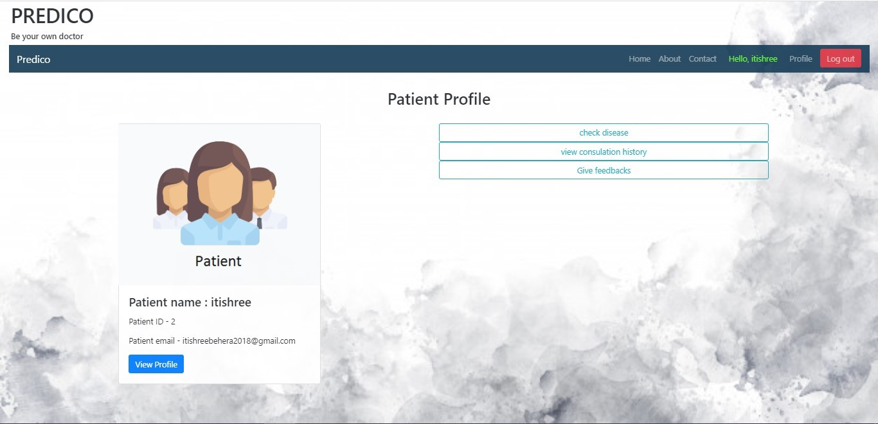

Feedback Form-

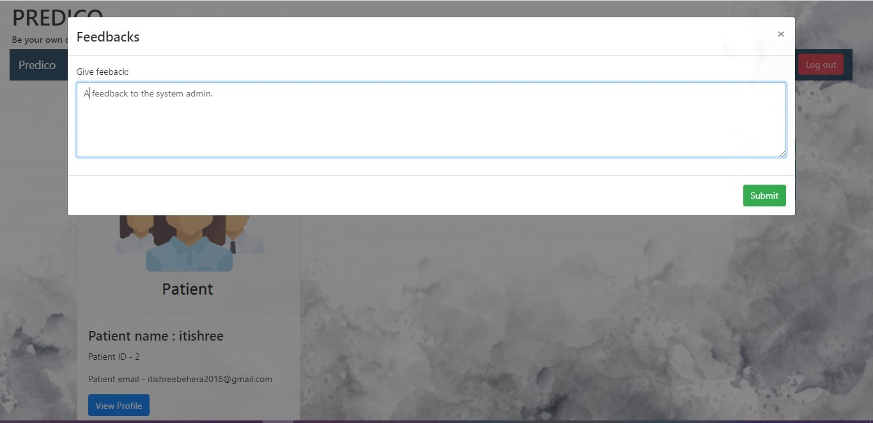

Check Disease- Entering symptoms

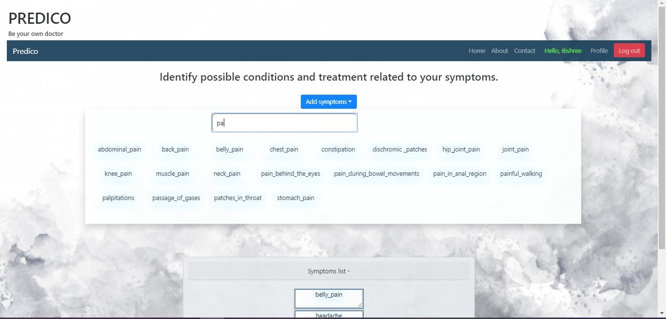

Predictions-

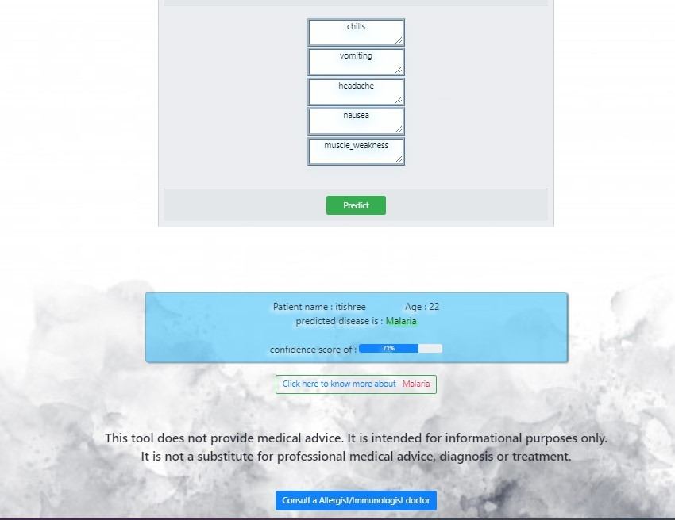

Consult a Doctor-

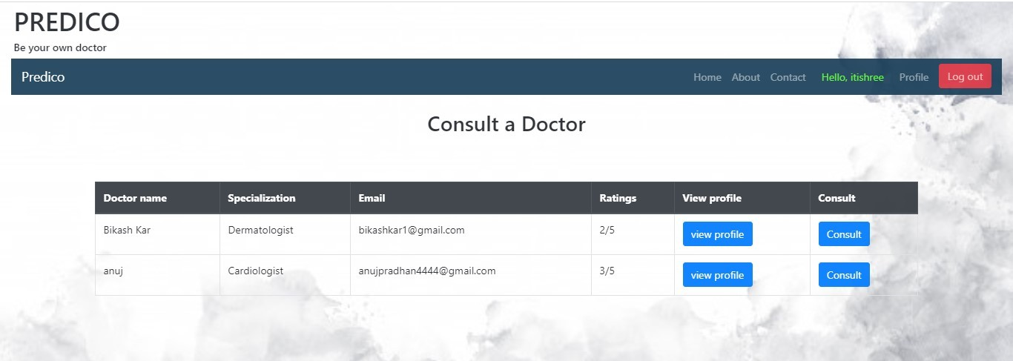

Consultation UI-

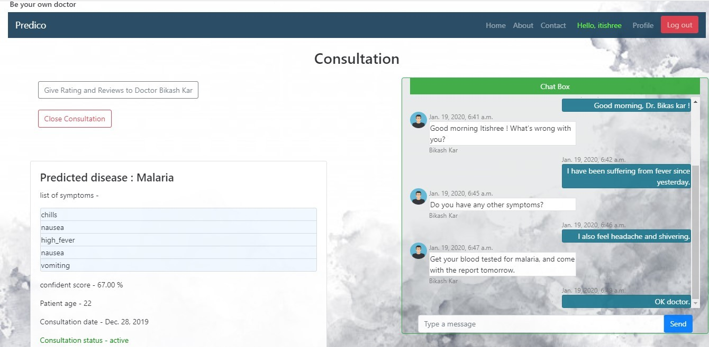

Consultation history- (Doctor)

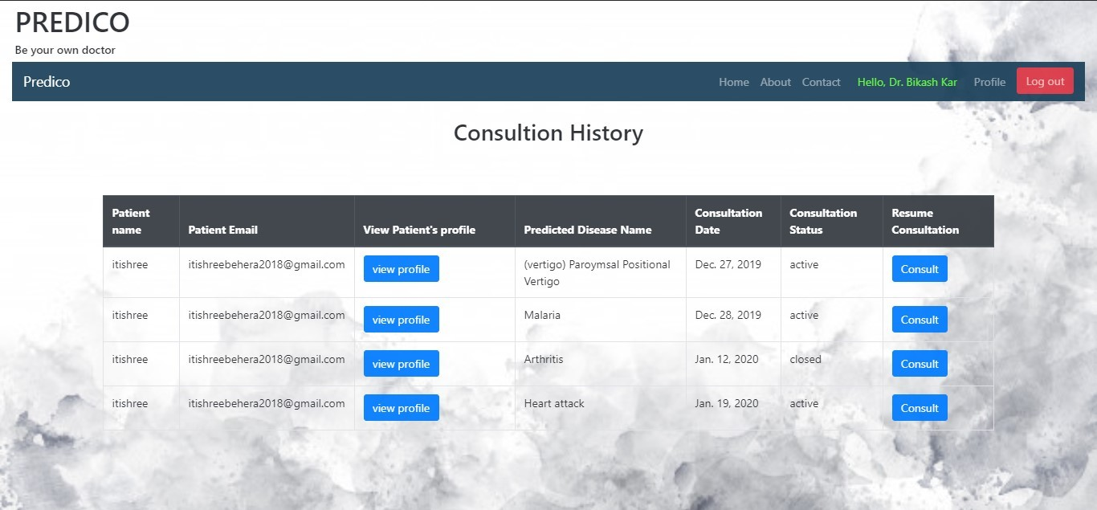

Admin Sign in-

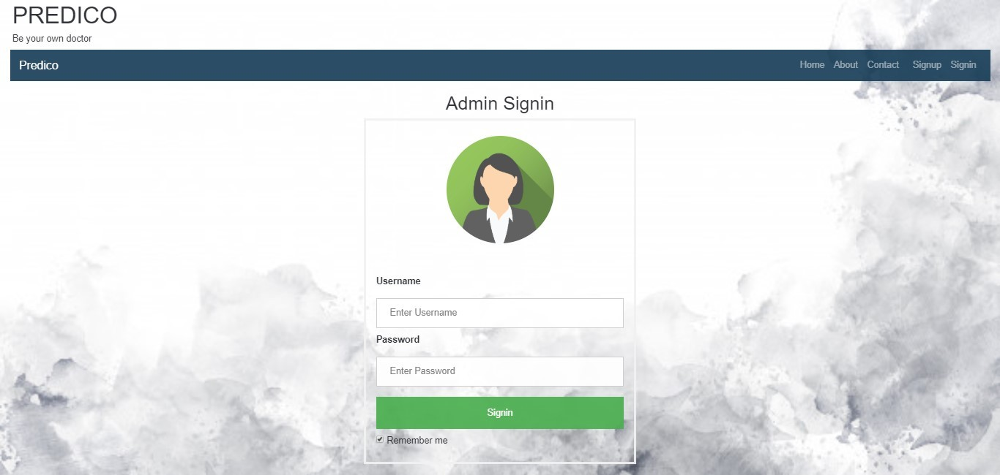

Admin Interface-

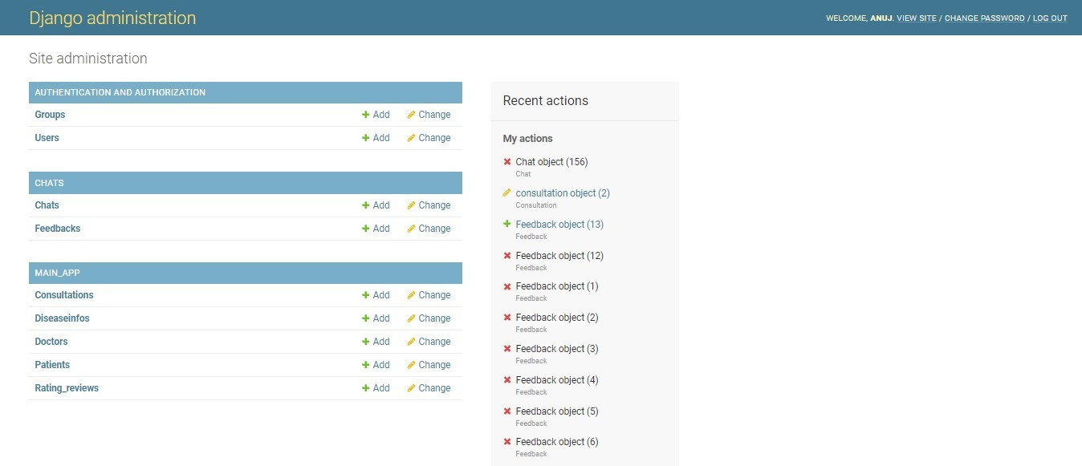

## Database predico- Users table-

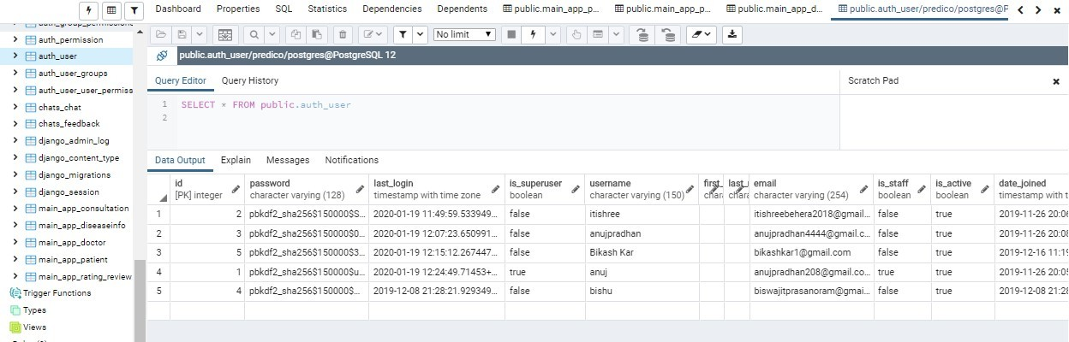

**Patient table-**

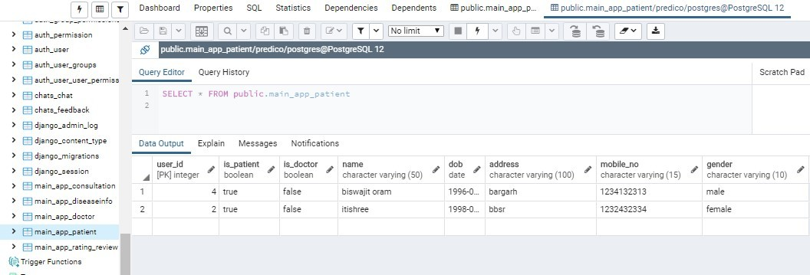

## Consultation table-

