Name : P. Hitesh Varma
Reg. No : 11601792
Section : K1615
Roll No. : A24
E-mail : hiteshvarmap@gmail.com
Github ID : HiteshVarma007

Question No. 1
The problem number - 2 is to build an algorithm which can used on a scheduler to process the given processes by round robin method. The processes arrival time and burst time are entered by the user. The algorithm should be able to handle processes so as assign the CPU to the process for a certain period of time not more than 6-time units in first case and 10-time units in second case. After executing for following time quantum scheduler searches for process which takes more time to execute.
In problem number – 3 is to build an algorithm which can be used on a scheduler to process the given processes by shortest job first method. The processes arrival time and burst time are entered by the user. The algorithm should be able to know the order of execution of processes. After executing it should give the average waiting time, turn around time and its averages.
Question No. 2
Algorithm for Problem – 2:
- Take input from the user about the arrival and burst time.
- Consider a structure which has attributes about the process and stores all those values.
- Initialize the status of all the process to zero.
- Compute the completion time for each process by using the total time variable.
- If any process takes more than 6 time units to execute, time slice that process and place it back in the queue for further execution
- If any process takes more than 10 time units to execute, time slice that process and place it back in the queue for further execution

- Maintain a queue to store all the processes which have executed.

- After executing for following time quantum scheduler search for process which has maximum burst time.

- Show the order as per maximum burst time left of process.
- Calculate the turnaround time and waiting time for each process.
- Now, calculate the average of times accordingly.

Algorithm for Problem – 3:
- Take input from the user about the arrival and burst time.
- Consider a structure which has attributes about the process and stores all those values.
- Initialize the status of all the process to zero.
- Compute the completion time for each process by using the total time variable.
- Order them as per shortest burst time.
- Maintain a queue to store all the processes which have executed.
- Calculate the turnaround time and waiting time for each process
- Now, calculate the average of times accordingly.

Question No. 3
Problem No. 2
Complexity: O (n log(n))
The complexity specified above is the worst-case scenario.
Where n is the size of input.

Problem No. 3
Complexity: O (n²)
The complexity specified above is the worst-case scenario.
Where n is the size of input.

Question No. 4
Problem No 2
After time Quantum 6 and 10
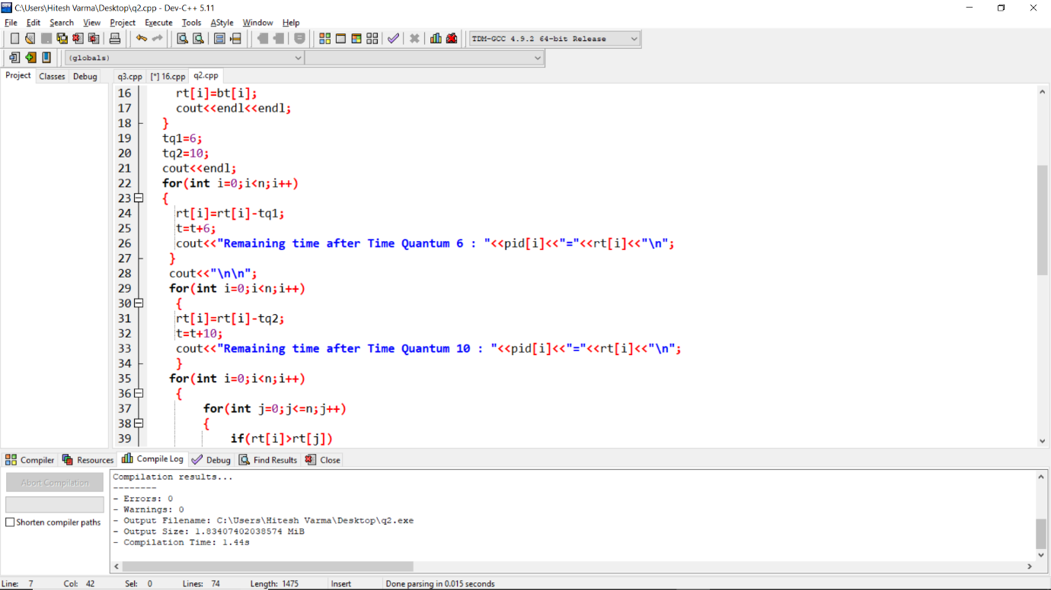
Order of execution
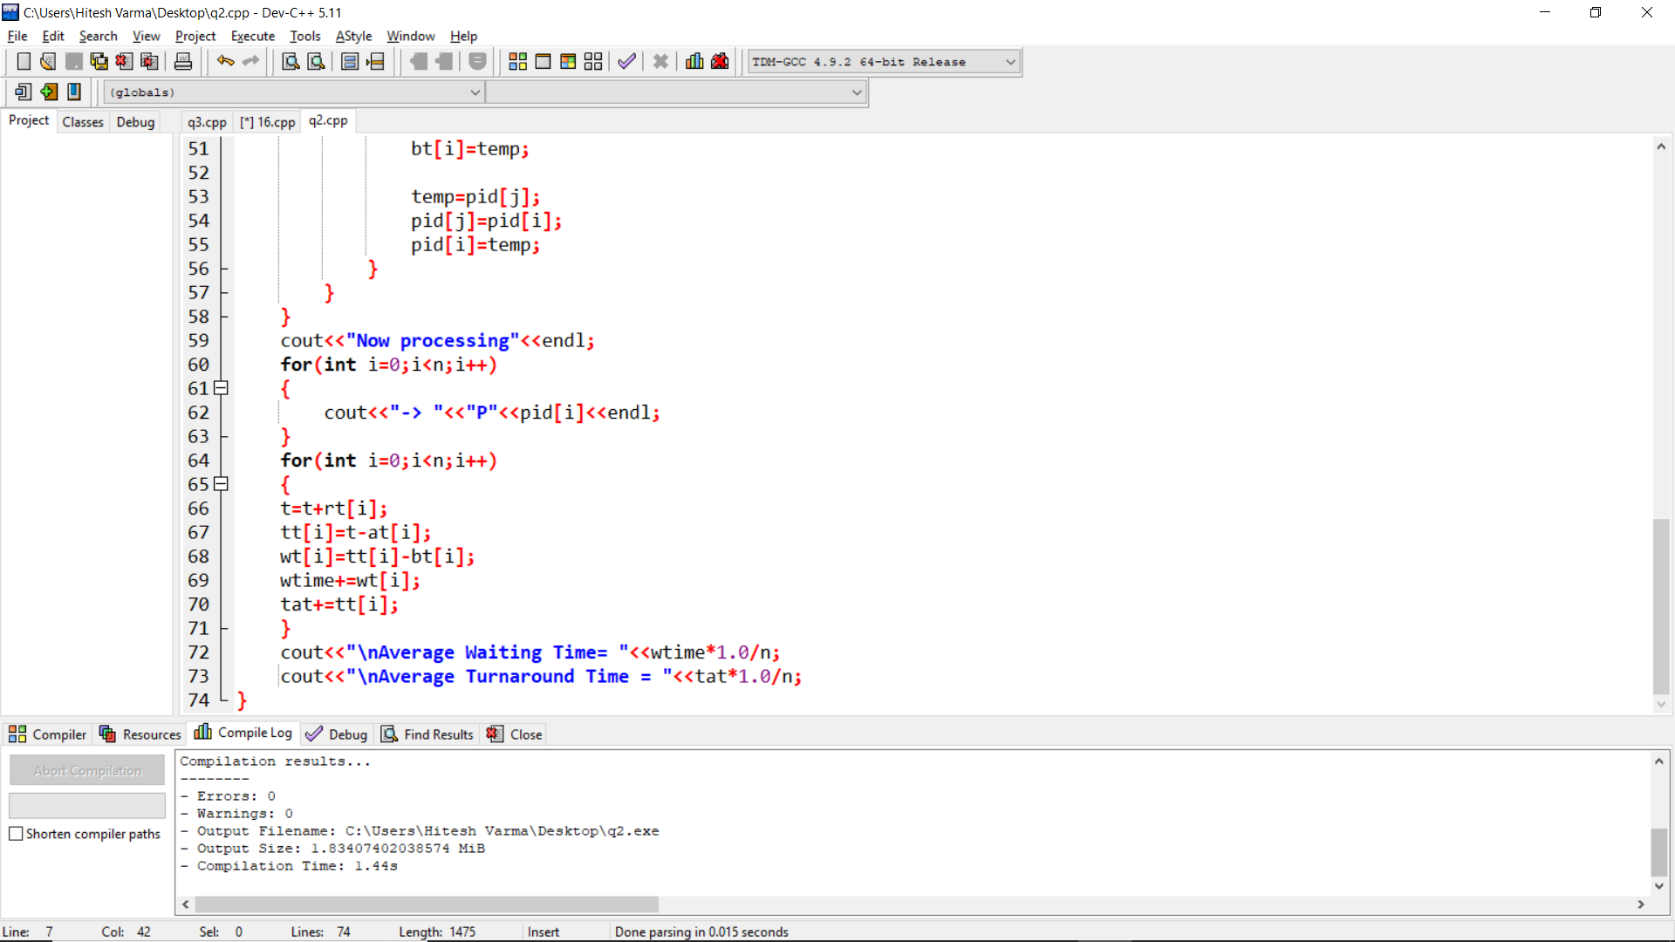
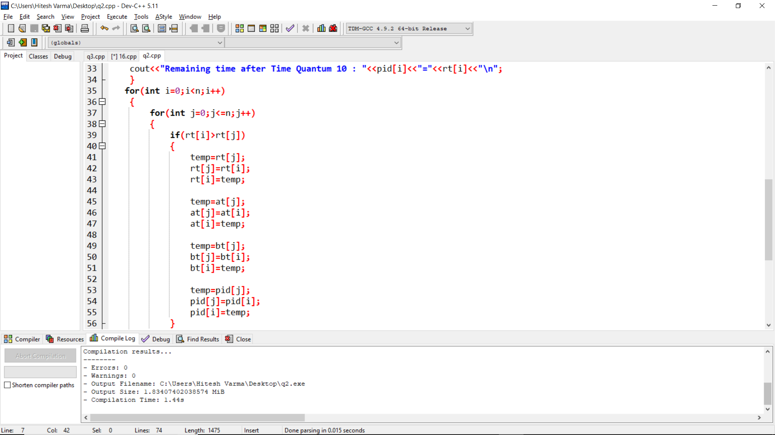

Problem no-3
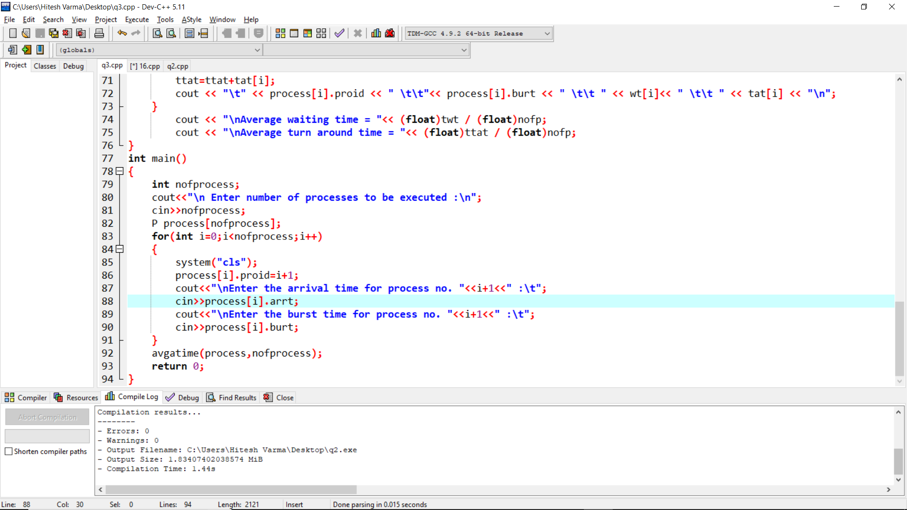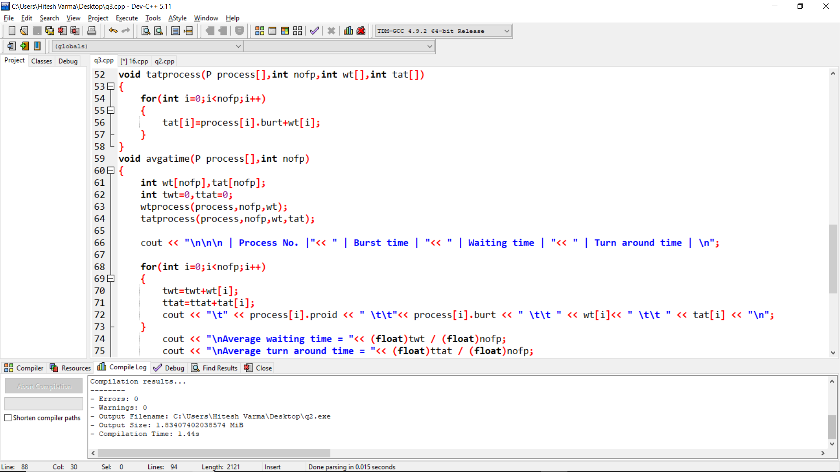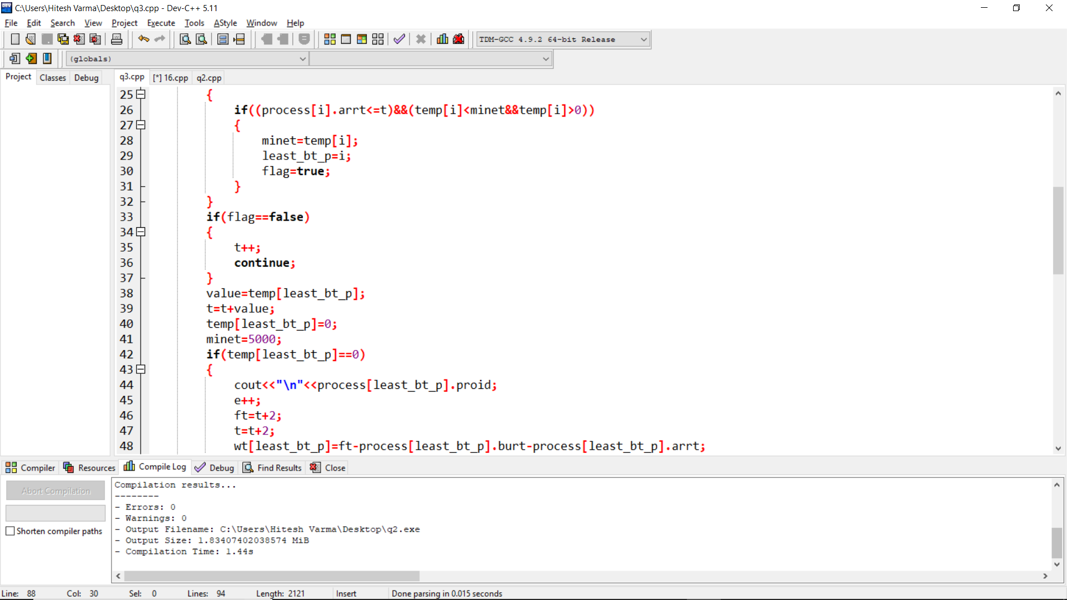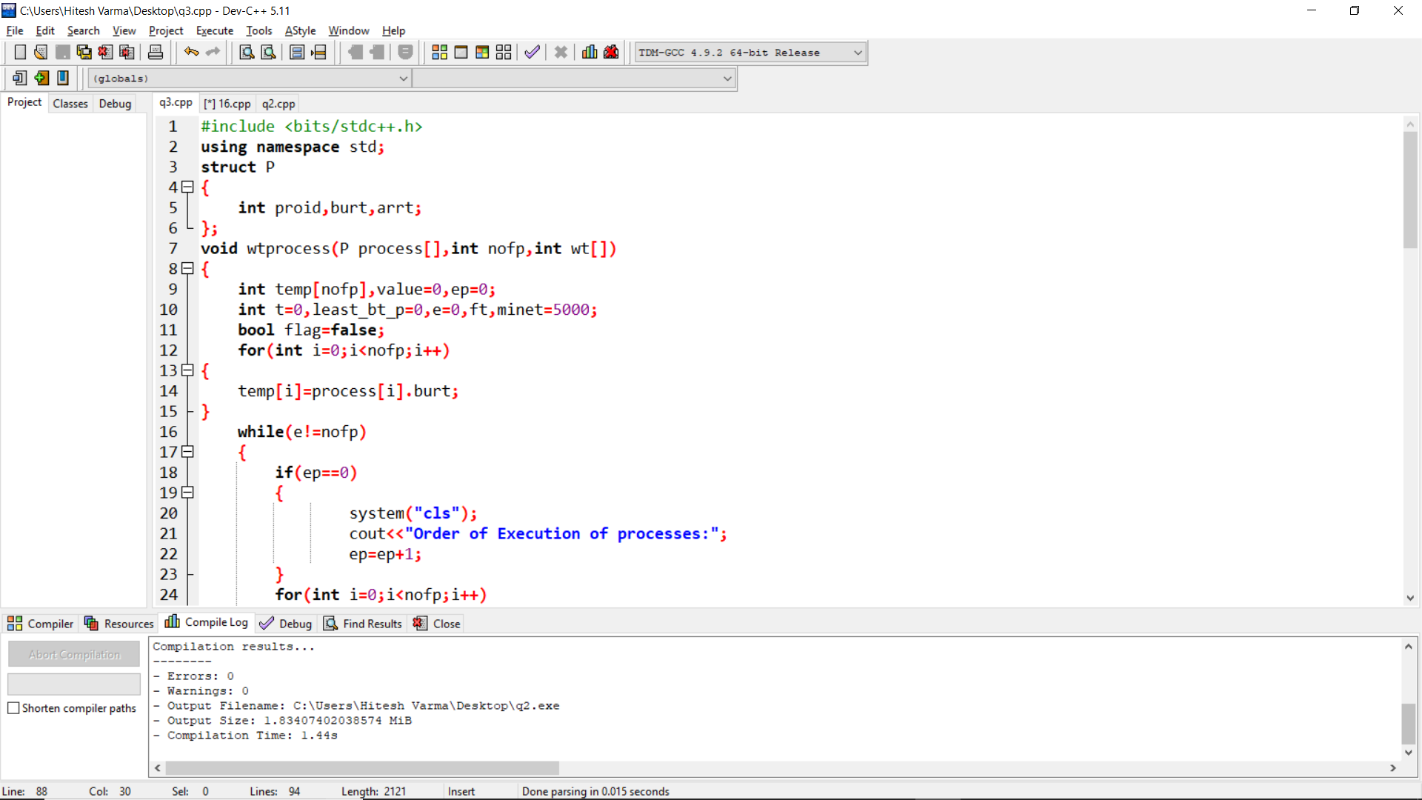
Question No. 5
The additional algorithm used in the both the problems is to sort the objects of the structures according to the arrival time and burst time.
It is used to implement the round robin and shortest job first algorithm

Question No. 6
The boundary conditions of the algorithm used in both the question is the number of input cases. Which in this case is given 30 input-size.

Question No. 7
Test – Cases
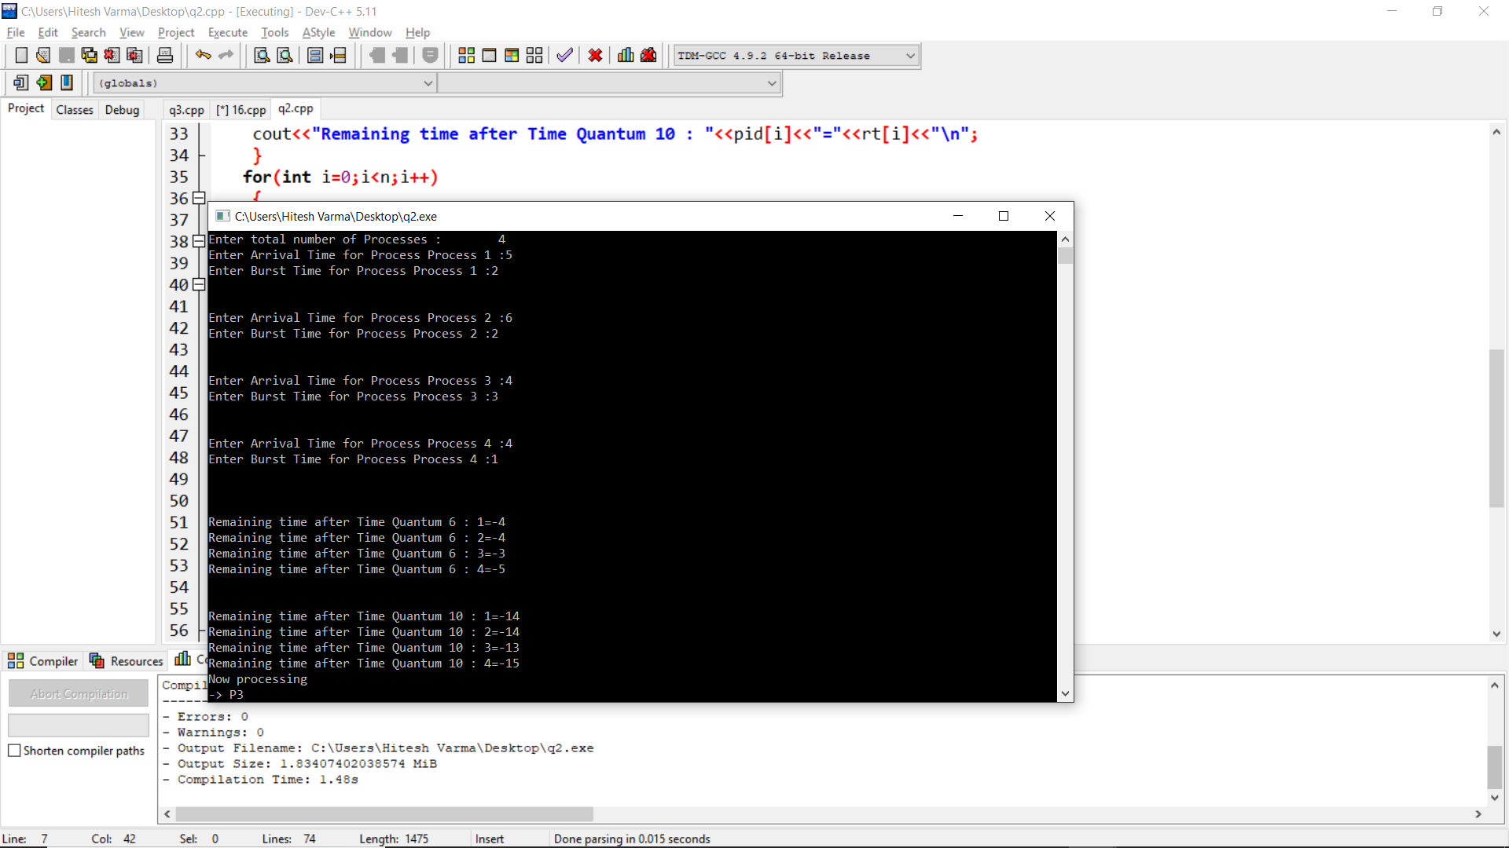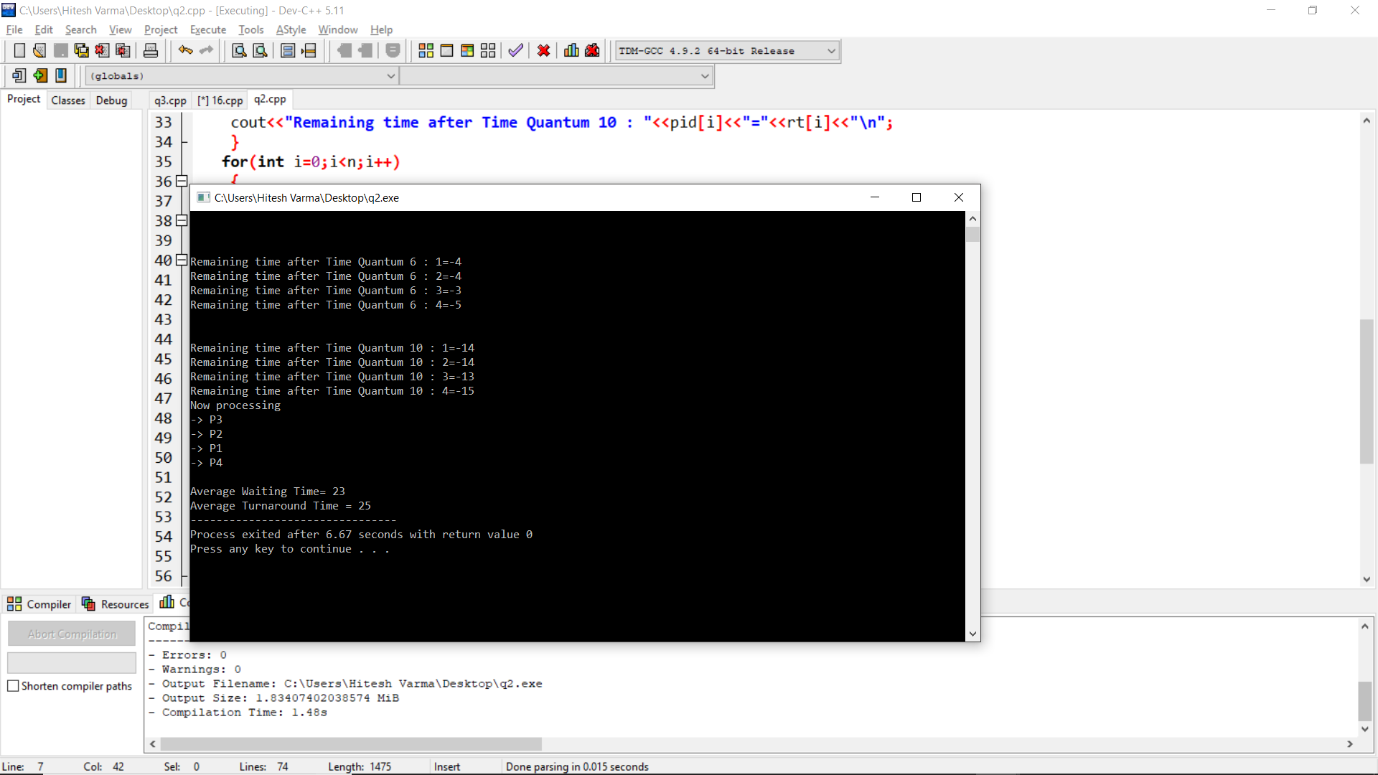

Question 3
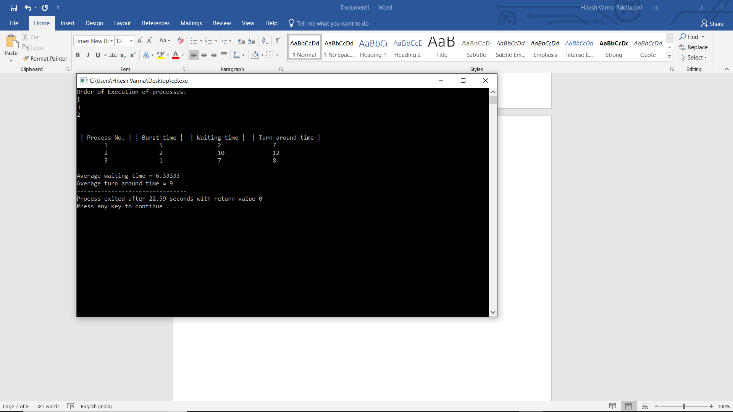
Question No. 8
No, I’ve uploaded the project but did not create 5 repositories of it previously.

