Machine Learning in Economics
Dacha Hitesh Kumar
Abstract
Economists use traditional and long complex methods to find the current economic status of a specific country. Machine learning helps in finding this data in a quite similar way but with less complexity and more accuracy. Here I will be developing a model that will be trained on the economic data of African countries and it will predict which countries will face the crises based on data.
Keywords: Economic Crisis, Machine Learning, Economic growth prediction, Bankruptcy, economic crisis prediction
Indexes
- Introduction
- ML in Economics
- Data Preprocessing and feature Engineering
- Model Building
- Conclusion
- Reference

- Introduction
In today’s world Machine Learning and Artificial Intelligence have become an integral part of our day-to-day lives, as some organizations have begun using AI and Machine Learning which supports them in developing new products. Machine Learning is algorithms that are trained in a way that it learns how people react in certain situations by itself.
Like all other industries, the economy, and finance industries use machine learning and artificial intelligence algorithm to get the solution or know some unknown events in advance which be handled in a planned manner.
Economists use complex formulas and big theorems to prove and find the economic situation of anything or a country. Using machine learning this process becomes faster and more efficient but the application needs to be defined carefully with appropriate data as the field itself is complex to understand. Economic crises, financial stability, and economic growth are some of the examples where machine learning can be used.
- ML in Economics
In my project, I am using a dataset that contains data related to the financial stability of African Countries. The dataset contains data about banking, debts, inflation, systematic crisis, and the financial state of different countries from the period 1860 to 2014. This dataset is a subset of Reinhart et. AL’s Global Financial Stability dataset on this dataset.
It’s a huge dataset containing data from different regions of Africa. I will use different techniques to visualize the data and analyze it to make that data more sensible for the training model on this data.
I will apply different classification models like decision trees, Random Forest, Gradient Boosting, Support Vector Machine, K Nearest Neighbor, and Gaussian Naive Bias to train the model and predict whether the given country will face a crisis or not. This will help to handle the situation that is going to arrive in the future in a better way by planning the economy and alerting citizens on certain issues in advance.
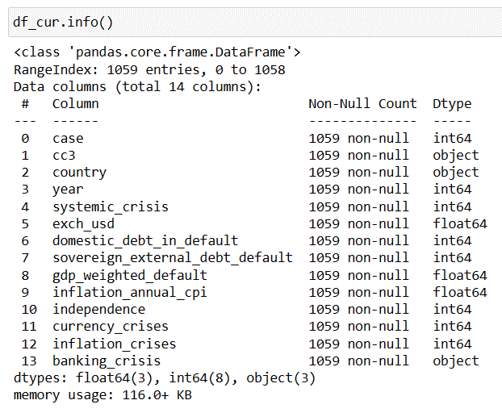
Figure 3
Now our target variable is in the text format and hence convert this text into a numeric format using a label encoder and then visualize the data again using the head function.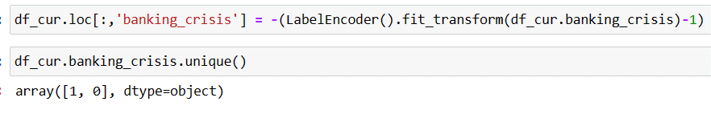Figure 4
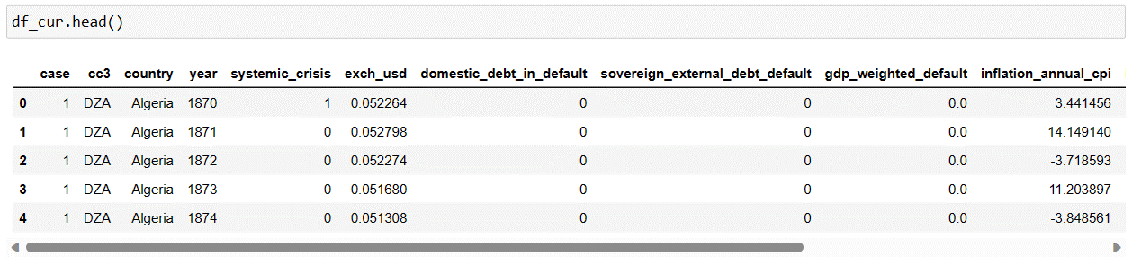Figure 5
Now I will check null values present in each feature using is null function.
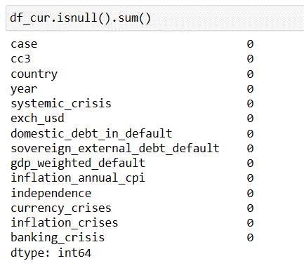
Figure 6

- Data Preprocessing and feature Engineering
Machine Learning will help us to find patterns out of the data which will be for prediction and to get this prediction correct, data needs to be construction in the correct format and the process of constructing this data is known as data preprocessing and feature engineering will help to scale and transform the data model training.
In my case study, I will use different preprocessing and visualization techniques to make raw data in a proper format.
Before starting preprocessing steps, I will import all the functions and libraries that will be required during preprocessing and visualization steps and in the modelling step.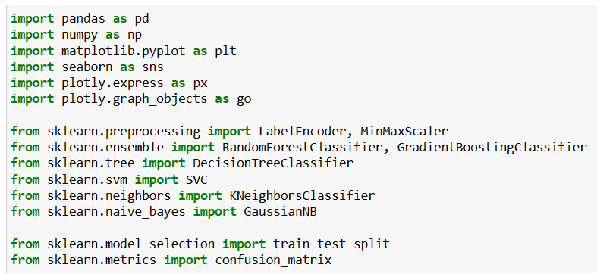
Figure 1
Now I will read the data from the CSV file into a data frame and display using the head function.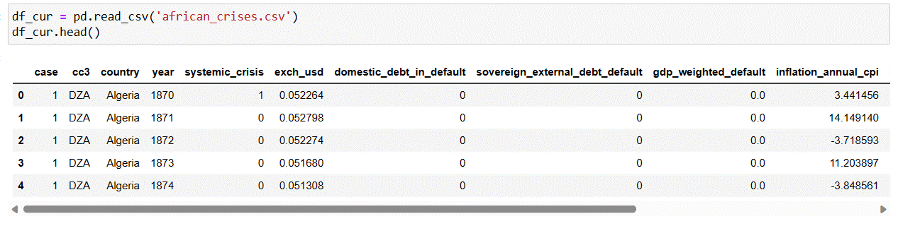
Figure 2
Now I will check what the data looks like in terms of datatype and how many records and features in total are there and what is the size of the total dataset.
Now I will try to see how the data distribution is done in terms of mean and standard deviation.
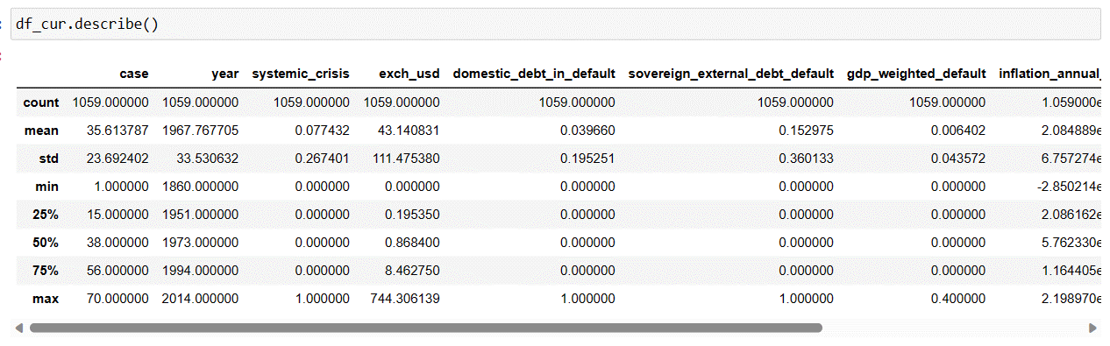Figure 7
Now let see how the data is distributed with respect to target label values and I can see value 0 data is quite high compare to value 1 as a target.
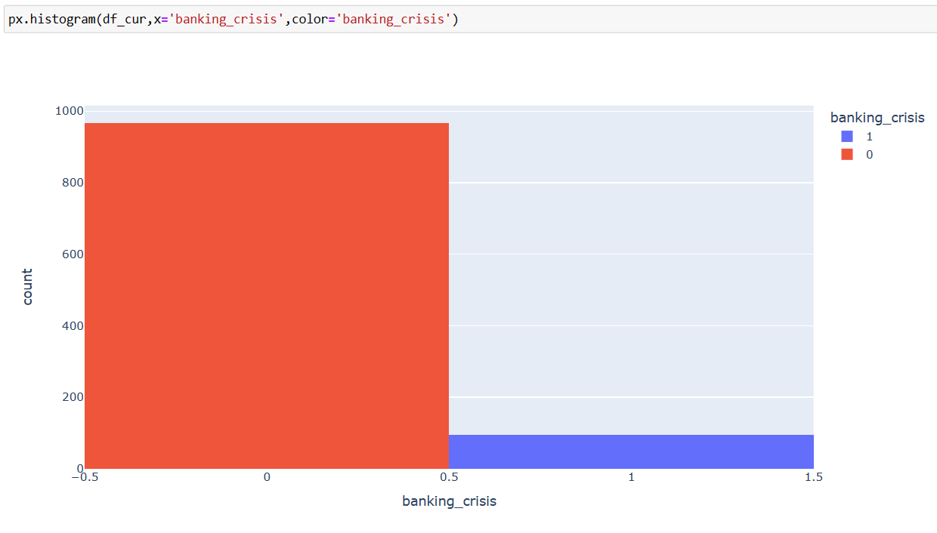
Figure 8
I will plot the line graph which shows the country wise annual inflation rate.
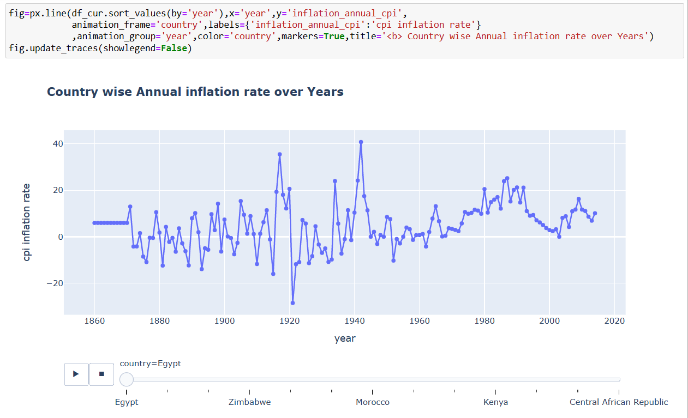
Figure 9
I will plot bar graph which shows the inflation rate for every country over the years.
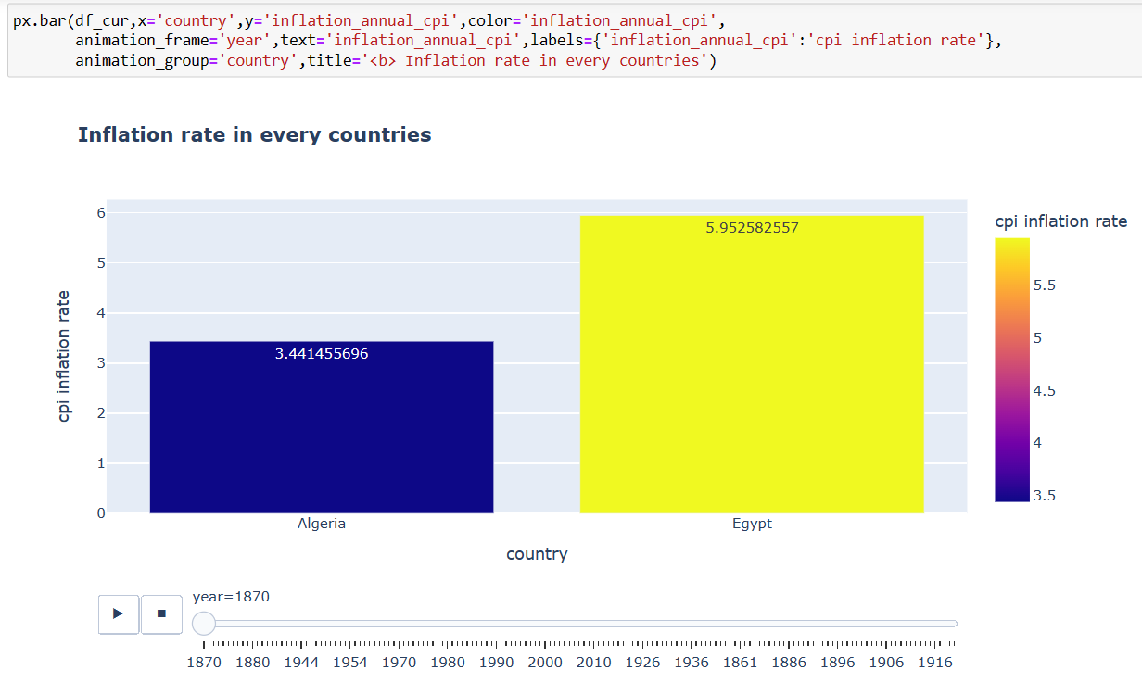
Figure 10
Now I will prepare a few more data frames that will be used for data visualization as well as data modeling.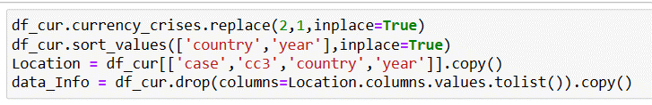
Figure 11
Now I will plot the data on the map which shows different crises over the year for specific countries.
First, I will plot systemic crisis on the map.
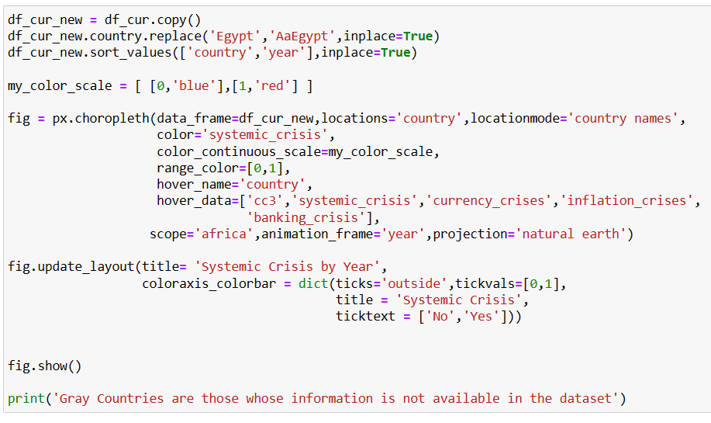
Figure 12
Figure 13 shows the map graph with a slider to move from one year to another and see which country was facing a systemic crisis in a particular year.

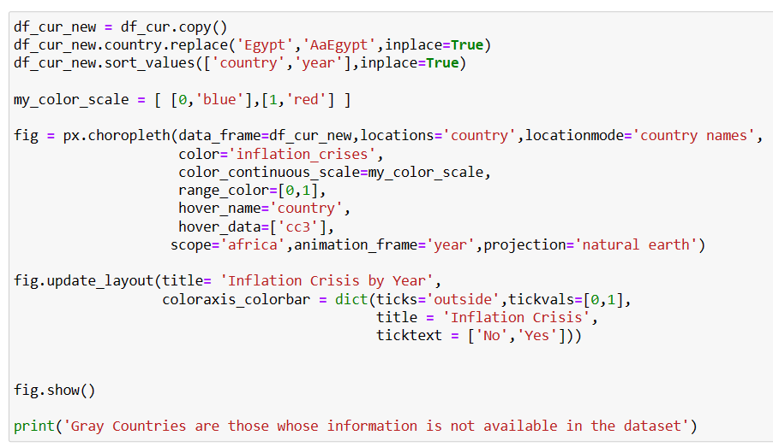
Figure 16
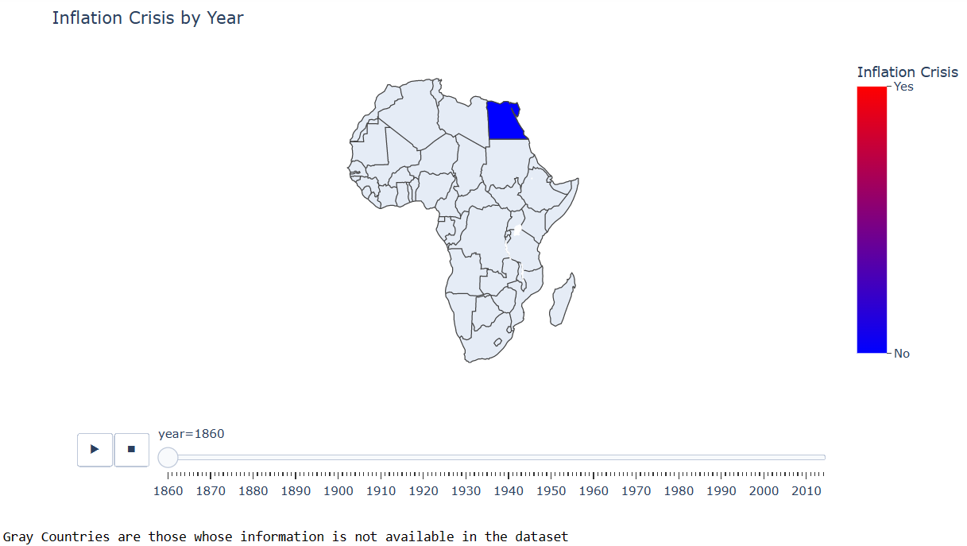
Figure 17
Banking Crisis is the next plot that is plotted for different countries over the year which can be visualized in Figure 19.
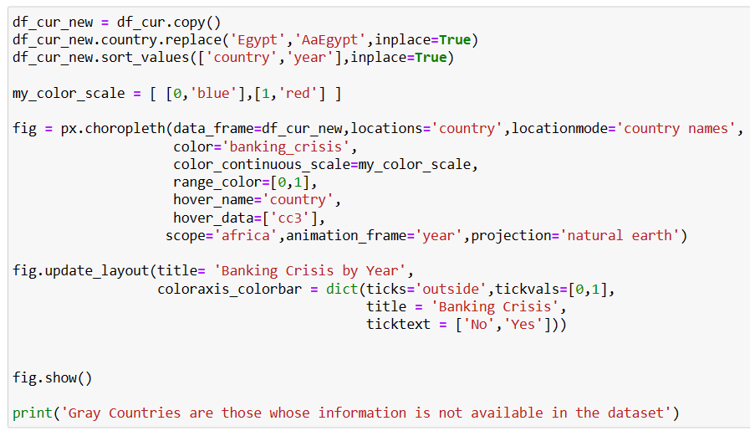
Figure 18
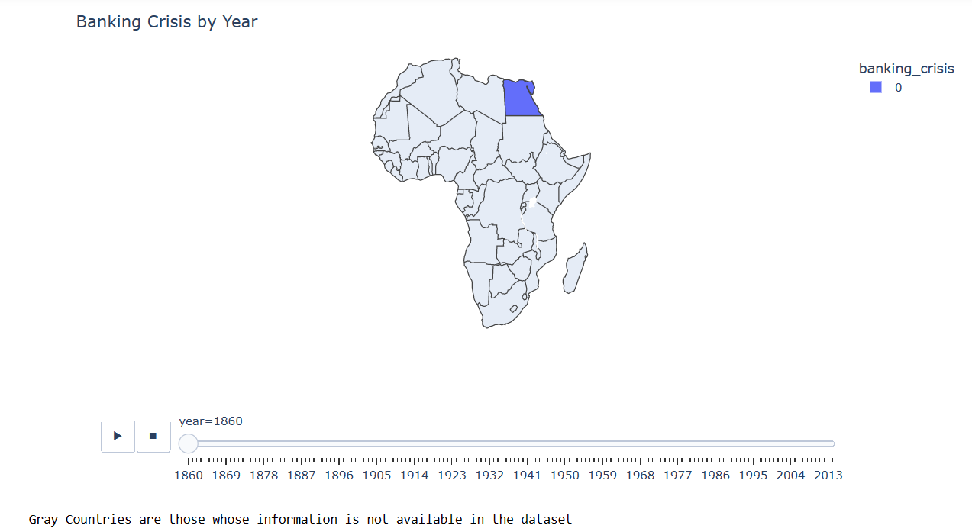
Figure 19

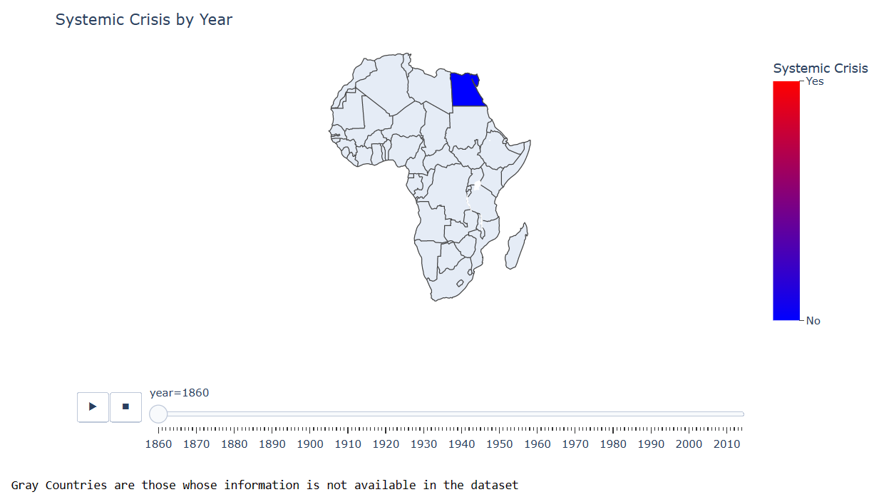
Figure 13
The next plot map is for the currency crisis. Figure 15 countries that faced currency crises corresponding can be seen using the slider.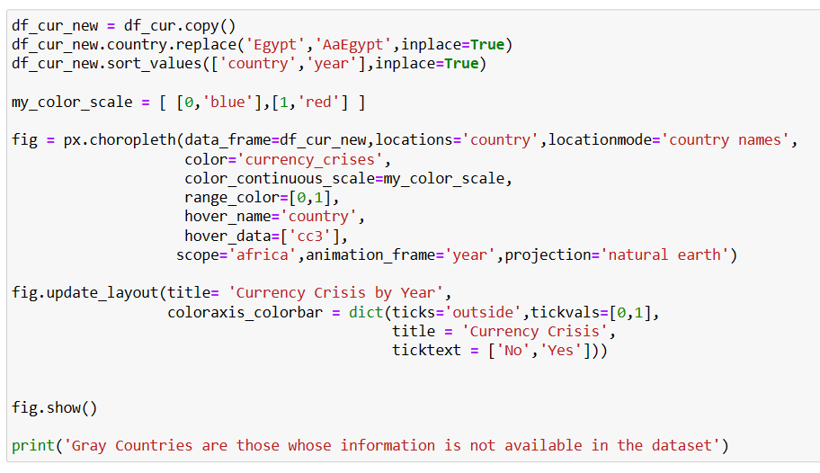
Figure 14
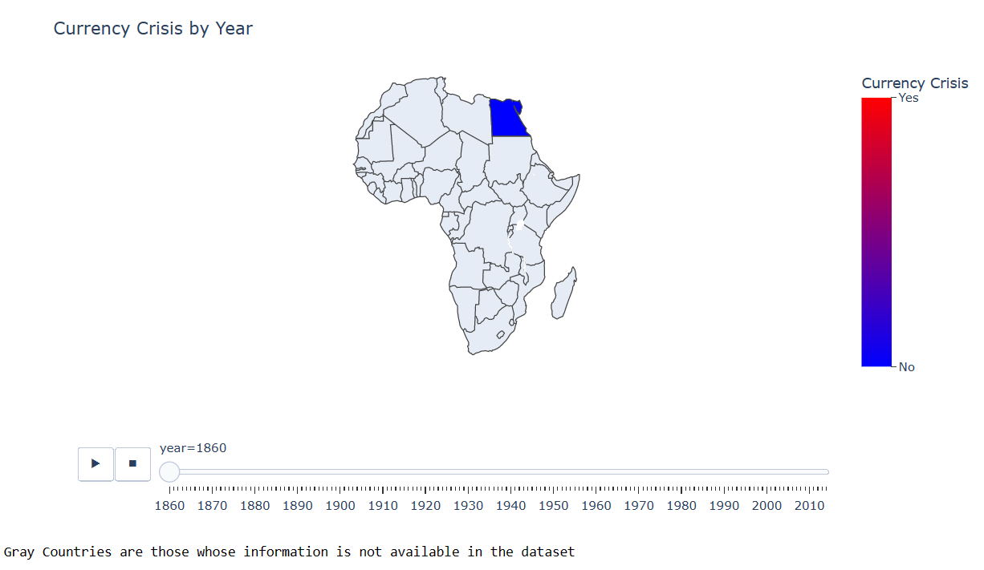
Figure 15
The next plot is for the inflation crisis over the year. Again, using the slider, a country that faced an inflation crisis can be visualized over the year.
The next plot demonstrates Exchange to US dollars by year for a different country.
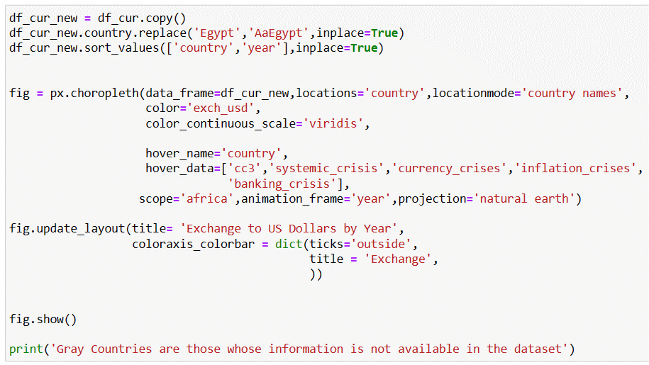
Figure 20
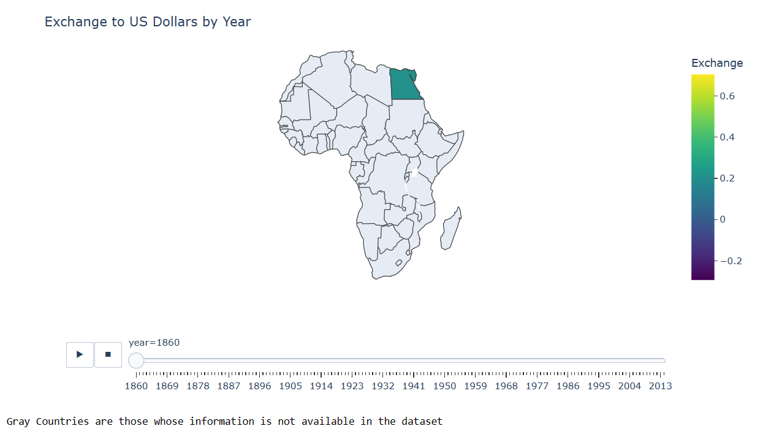
Figure 21
Annual inflation by year is the map plot that I have plotted as visualized in Figure 23
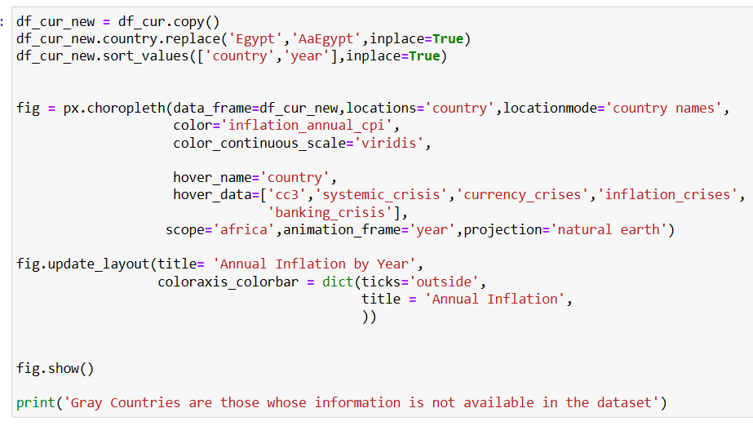
Figure 22
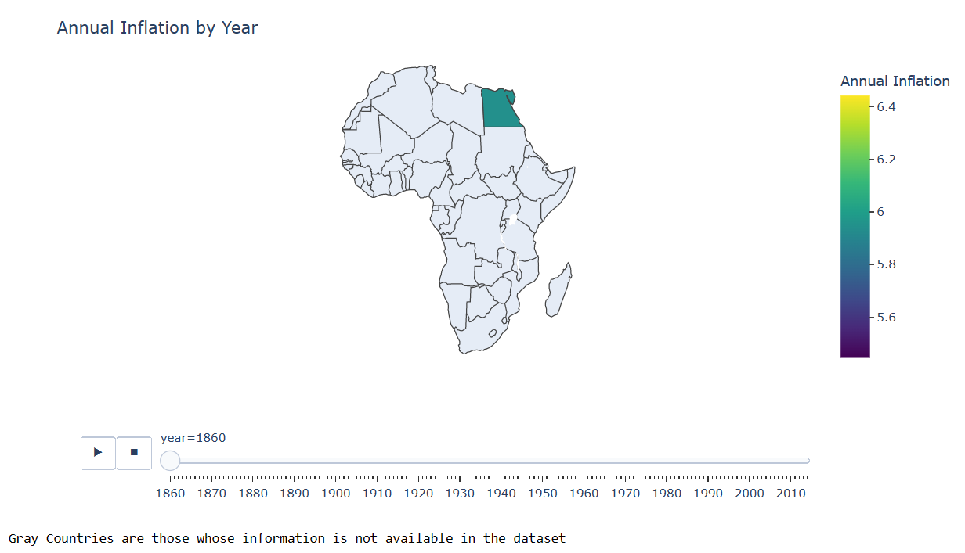
Figure 23
After visualizing the different data on the map let’s find the co-relation between different features and for that, I have plotted the heatmap for this data.
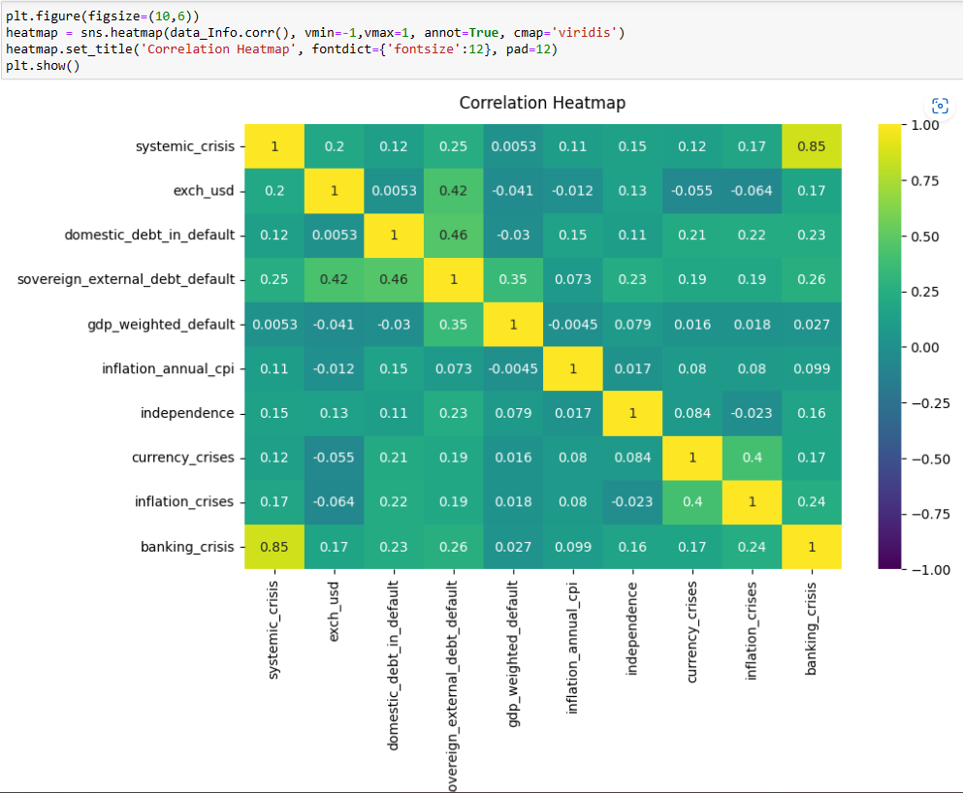
Figure 24
Figure 24 shows mostly all the features independent apart from the banking crisis and systemic crisis, these two features have high co-relation.
So now I have done enough analysis on the data and converted the data in the required format which can be used for model training and hence the next thing that I will do is the model training.

- Model Building
For training the model the data needs to be splitted and before that target variable and other features need to be separated.
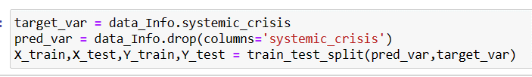
Figure 25

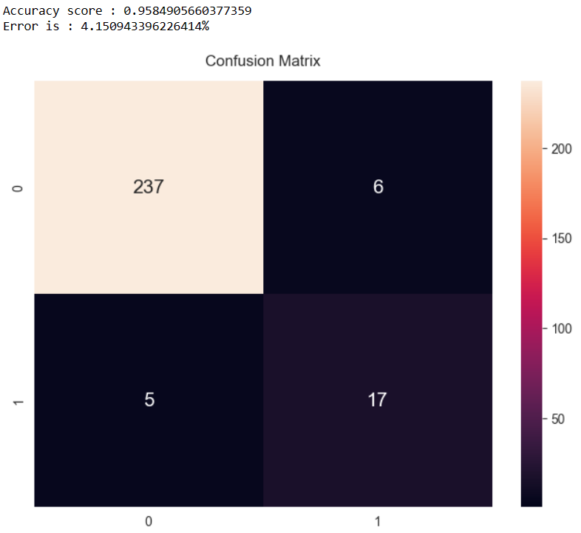
Figure 29
Gradient Boosting Classifier is the next model that I will train and test and after testing accuracy that I got is 95.84% and 4.15% of error which is the same as the previous decision tree model.
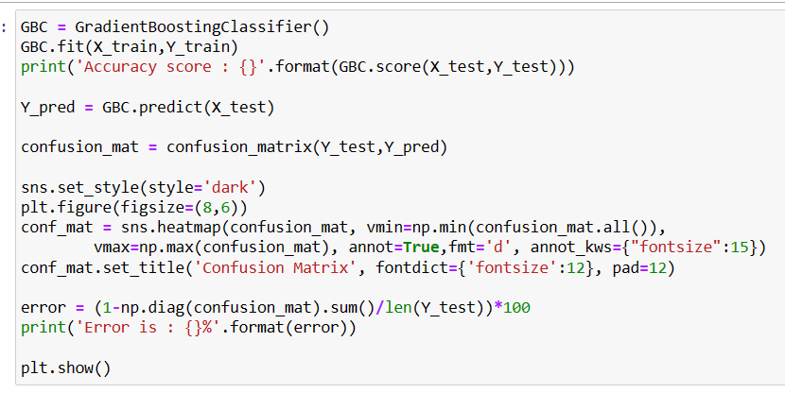
Figure 30
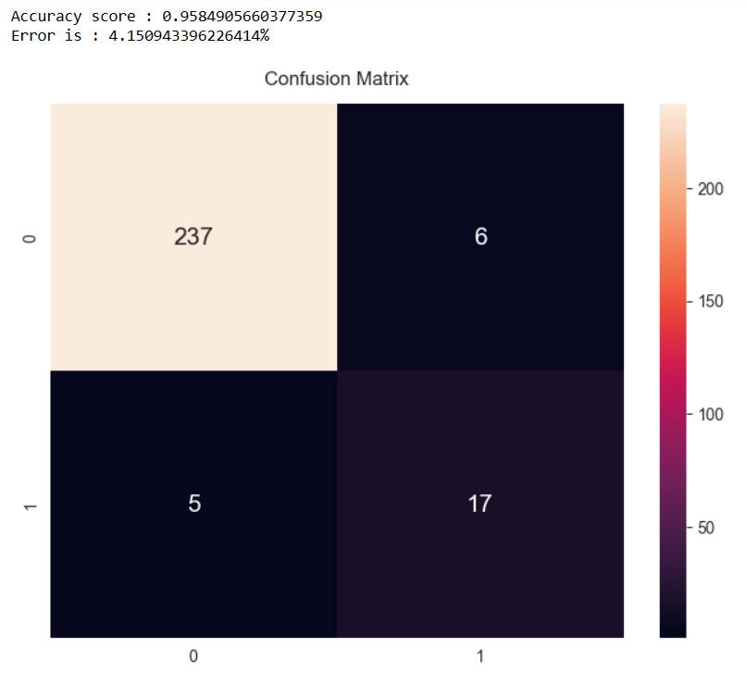
Figure 31

Now I start training for random forest classifier and test it with testing data to find the accuracy score and error which is 96% and 3.396% respectively. Also, to get the better understanding I printed the confusion matrix.
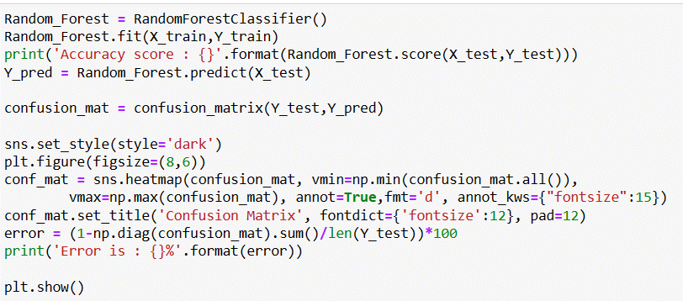
Figure 26
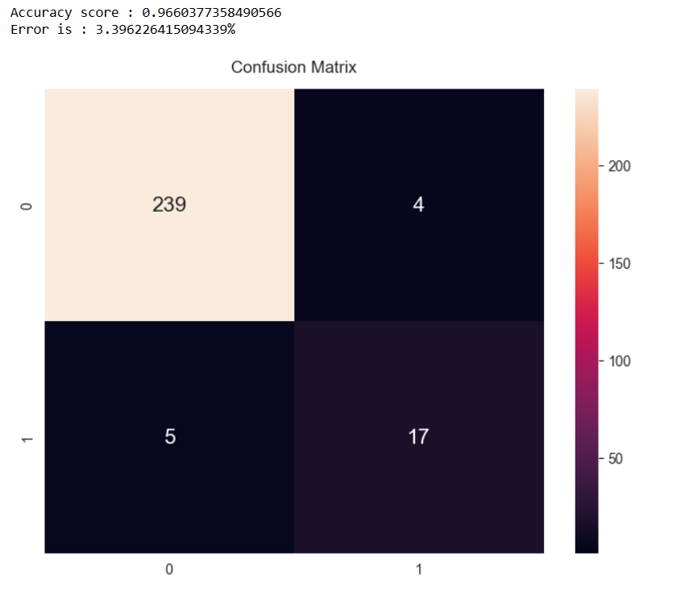
Figure 27
The next model that I will train is the decision tree classifier and after testing the trained model I got an accuracy of 95.84% with an error rate of 4.15%.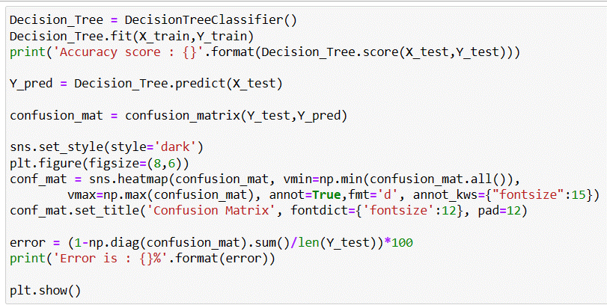
Figure 28

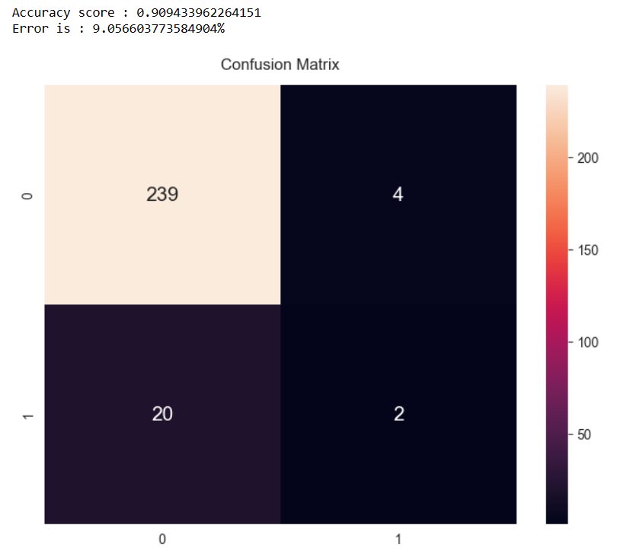
Figure 35
The last model that will train is the support vector machine and after testing on the test dataset accuracy that I got is 91.69% with an 8.30% error.
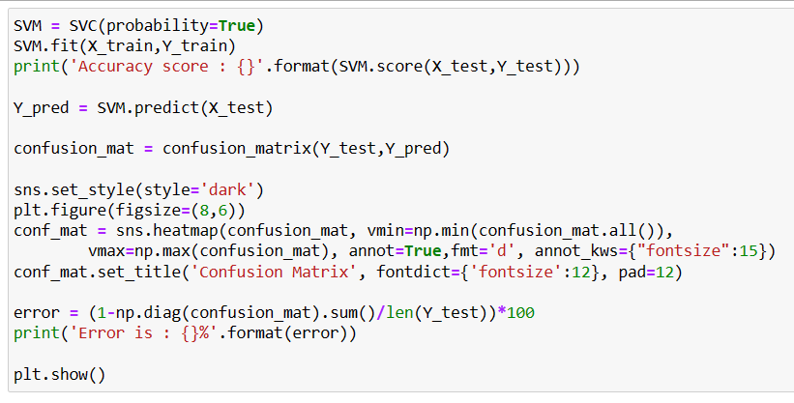
Figure 36
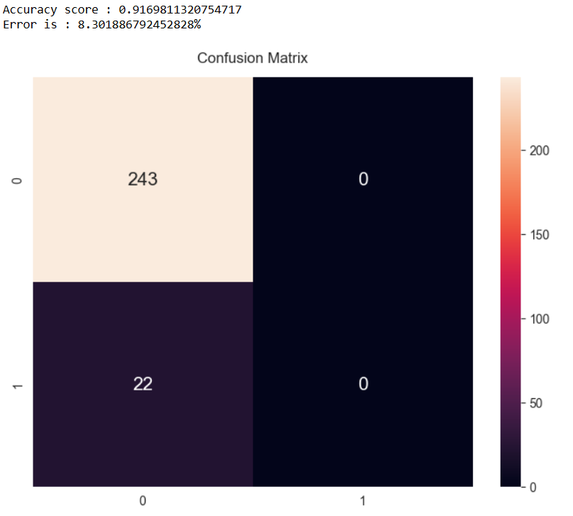
Figure 37
Now I will train the Gaussian Naïve Bias model on the training dataset and test to find the accuracy which is 92.45% and the error comes out to be 7.54%.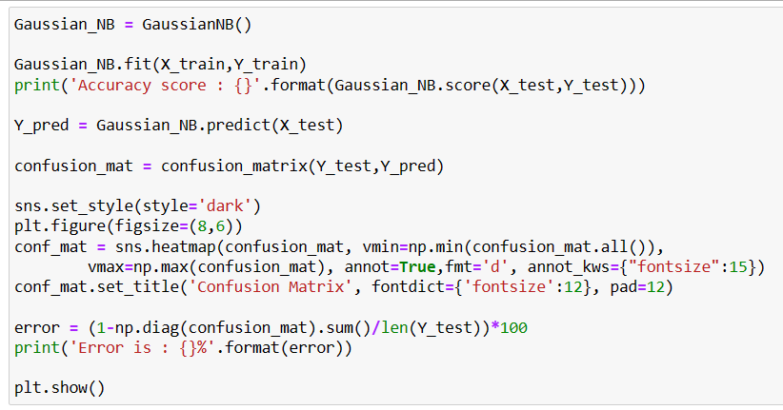
Figure 32
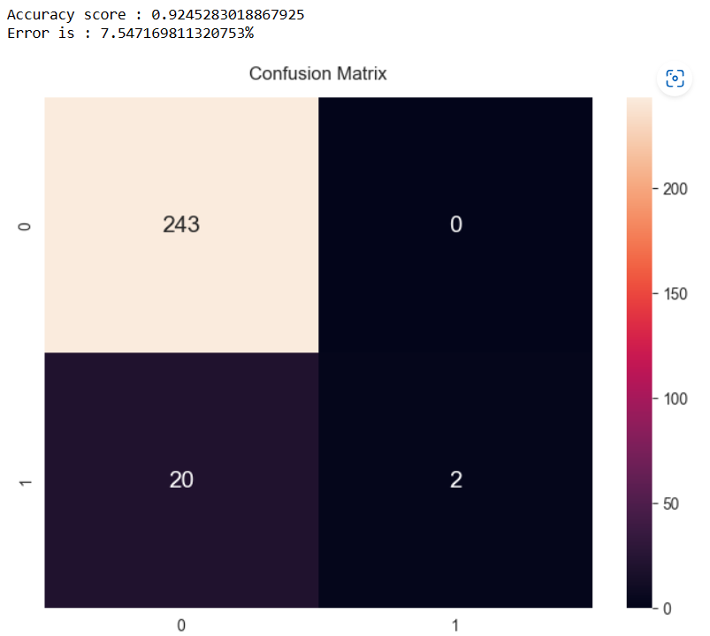
Figure 33
With k vale as 5, I will train the KNN model now and test to predict the output and find the accuracy and error. The accuracy percentage of the KNN model is 90.94% and 9.05% is the error rate.
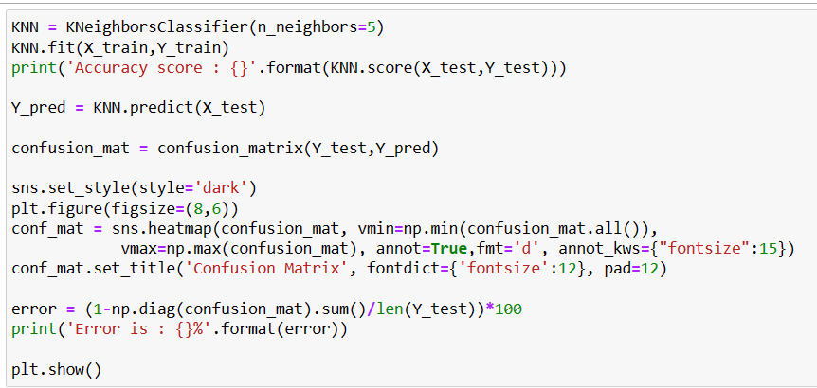
Figure 34

Hence the best model out of all is Random Forest Classifier and I will run the model again on the test data set and compare the predicted output with the actual output to see how well the model works.
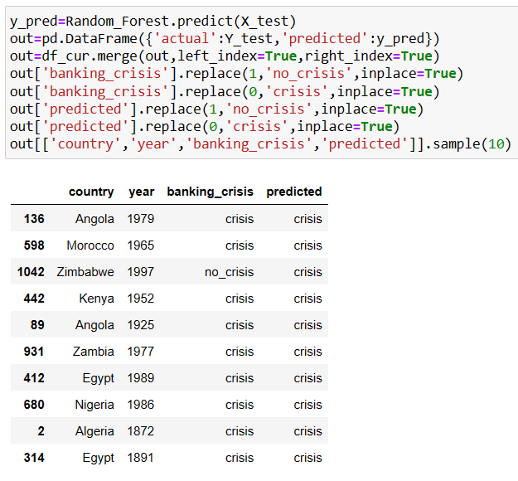
Figure 38

- Conclusion
Here in my project, I have trained 6 different models on the dataset that shows the financial status of the countries in Africa between 1870 to 2014. All the models that were trained have given the output accuracy of more than 90% but out of all the random forest classifiers is the model that is given the best accuracy of 96.60% and minimal error rate of 3.39% and hence this model can be used to predict the financial condition of any country.
- References

[1] Huang Junyu: Prediction of Financial Crisis Based on Machine Learning

[2] Aristeidis Samitas, Elias Kampouris, Dimitris Kenourgios: Machine learning as an early warning system to predict a financial crisis

[3] Wei-Yang Lin, Ya-Han Hu, Chih-Fong Tsai: Machine Learning in Financial Crisis Prediction: A Survey

[4] Blog by Sebastian Petric, CFA: Can Machine Learning help predict the Next Financial Crisis? https://blogs.cfainstitute.org/investor/2022/10/20/can-machine-learning-help-predict-the-next-financial-crisis/

[5] Data Visualization on map official documentation : https://plotly.com/python/choropleth-maps/

[6] Line plotting official documentation : https://plotly.com/python/plotly-express/#:~:text=The%20plotly.express%20module%20(usually,for%20creating%20most%20common%20figures.

[7] Anuganti Suresh : What is Confusion Matrix : https://medium.com/analytics-vidhya/what-is-a-confusion-matrix-d1c0f8feda5

[8] Official documentation for model training : https://scikit-learn.org/stable/

[9] Zach : How to perform Label Encoding in Python(With Example) : https://www.statology.org/label-encoding-in-python/

