POWER BI CAPSTONE PROJECT
AMAZON E-COMMERCE
SALES ANALYSIS
Transforming e-commerce data into clear, decision-ready business insights
113K  ORDERS | ₹107.24M  REVENUE | 603K  QUANTITY | 44  PRODUCTS
PROJECT SNAPSHOT
Prepared by | Hiteshi Aglawe
Project Tool | Microsoft Power BI
Data Sources | Orders & Customers
Analysis Period | 2015–2020
REPORT FOCUS
Sales performance • Customer behaviour • Product performance • Delivery • Regional insights
Prepared for academic project submission
Power BI Dashboard • DAX Analysis • SQL Analysis

Objective Questions
1. What is the total number of attributes in the customer table?
- The Customers table contains 3 attributes: CustomerID, Customer Age, and Customer Gender
2. How will you get the “Customer’s” ages in the “Order” tables according to customer IDs?
- The Orders and Customers tables were joined on the common key CustomerID.
- In Power BI, I have implemented it as a data model relationship: Customers[CustomerID] ↔ Orders[CustomerID], set as a One-to-One relationship (since every CustomerID appears exactly once in both tables in this dataset).
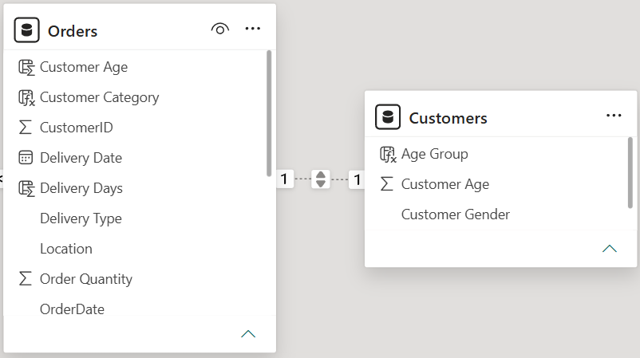
- Once related, any visual or measure referencing Orders can pull Customer Age directly through the relationship without needing a manual VLOOKUP — Power BI resolves it automatically via the model relationship.
- I have created calculated column in the orders table named as Customers Age with the formula mentioned below. With the help of LOOKUPVALUE() function I have retrieved the Customer Age from Customers table into the Orders table by using CustomerID.
- Customer Age = LOOKUPVALUE(Customers[Customer Age], Customers[CustomerID], Orders[CustomerID])
3. In analyzing the dataset with Power BI, ensure data cleaning to address inconsistencies and missing values before further analysis.
- Performed in Power Query Editor (Transform Data) on both tables, with Column Quality/Distribution profiling turned on (set to profile the entire dataset, not just the first 1,000 rows).
- Orders table:
  - Unit Price and Order Quantity had 8 blank rows each — removed via Remove Rows → Remove Blank Rows (negligible, <0.01% of 113,000 rows).
  - Product Category had 1 blank row — replaced with "Unknown" via Replace Values.
  - Reason (return reason) had a large number of blanks — since a blank here is expected for Delivered orders but not for Returned orders, a conditional Custom Column was used: blank + Status = "Returned" → "Unknown"; blank + Status = "Delivered" → "NA".
  - Checked and confirmed no duplicate OrderIDs and no negative prices.
  - Trimmed/cleaned all text columns (Location, Delivery Type, Product Category, SubCategory, Product, Status, Reason) to remove stray whitespace/non-printable characters.
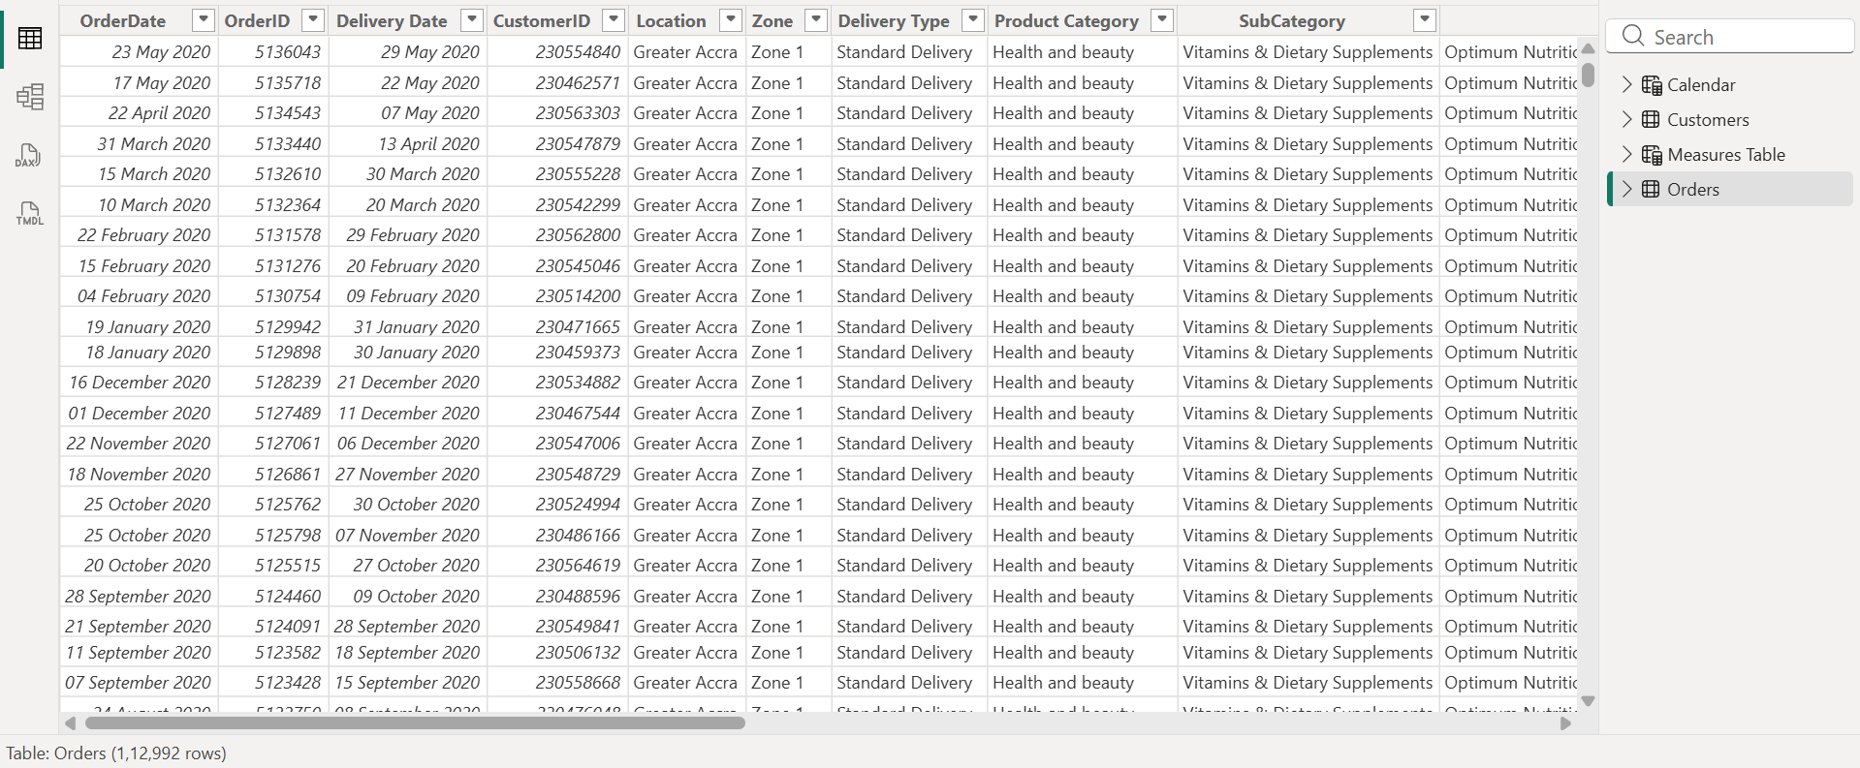
- Customers table:
  - Customer Gender had 1 blank row — removed via Remove Rows → Remove Blank Rows (negligible, <0.01% of 113,000 rows).
  - Confirmed no duplicate CustomerIDs.
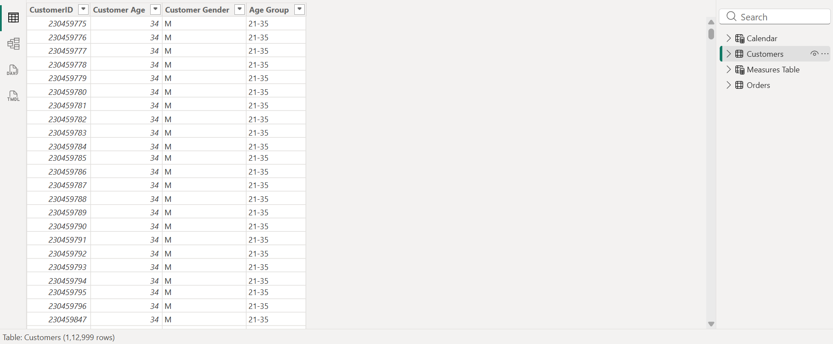
- Confirmed correct data types throughout: OrderDate and Delivery Date as Date, Unit Price/Sale Price/Shipping Fee as Decimal Number, Order Quantity/Rating/Customer Age as Whole Number.

4. How can we calculate the total revenue generated by all the sales?
- To calculate the total revenue I have used DAX function and created New Measure as total revenue using SUM() function to sum up the Sale Price column in orders table.
- DAX: Total Revenue = SUM(Orders[Sale Price])
- The total revenue generated by all the sales is 107.24 Million.
- Reference: Main Dashboard — "Total Revenue" KPI card
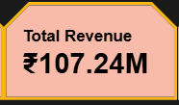

5. What is the total number of unique customers who made purchases each year? Is there any increase in the number over the years?
- Created a New Measure name Unique Customers which counts the distinct number of customers.
- DAX: Unique Customers = DISTINCTCOUNT(Orders[CustomerID])
- I have taken table visual, drag and dropped Year and Unique Customers measure which gives the count of distinct customers each year who made purchases.
- Unique customers per year: 2015 — 17,624; 2016 — 17,634; 2017 — 17,672; 2018 — 17,354; 2019 — 17,537; 2020 — 25,179.
- 2015-2019 stayed roughly flat (~17,400-17,700/year), but 2020 shows a sharp jump to over 25,000 unique customers — a ~43% year-over-year increase. This is the standout growth signal in the dataset and is reflected in the Total Revenue by Year chart, which similarly spikes in 2020 (from ~₹16.8M in 2019 to ~₹24M in 2020).
- Reference: Objective Questions — "Unique Customers by Year” table, bar chart
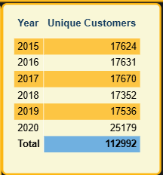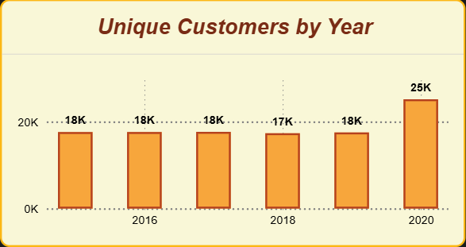

6. How can we determine the total number of unique products available in the company?
- DAX measure: Unique Products = DISTINCTCOUNT(Orders[Product])
- Result: 44 unique products, spanning 16 subcategories and 5 product categories (Electronics, Fashion, Health and beauty, Home and Office, Phones and Tablet).
- Reference: Objective Questions — "Unique Products" KPI card, “product category, sub category” table.
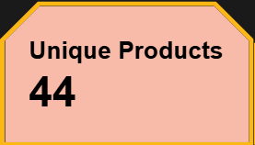
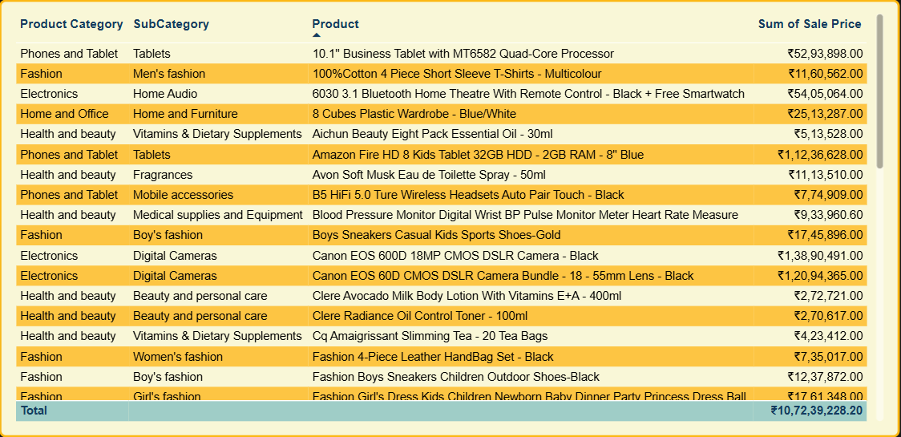

7. What is the average number of days it takes for products to be delivered, get the metric for only the delivered orders.
- DAX measure: Avg Delivery Days = CALCULATE(AVERAGE(Orders[Delivery Days]), Orders[Status] = "Delivered") — deliberately filtered to Delivered orders only, since Returned orders don't represent a completed delivery cycle.
- Result: 9.41 days on average.
- This varies significantly by Delivery Type: Express averages ~3.5 days, Standard Delivery ~10 days, and Shipped from Abroad ~15 days — delivery type, not product category, is the real driver of delivery speed (average delivery days barely differs across product categories, all clustering around 9.5 days).
- Reference: Individual Product Dashboard — "Avg Delivery Days" card
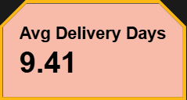
8. Which products, categories, and subcategories are the most popular?
- To find out the most popular products, categories, and subcategories I have considered the - total revenue as parameter.
- I have taken table visual and took columns as Product, Product Category, Sub Category and Total Revenue. I have listed top 5 to be considered as most popular products, categories, and subcategories below in the screenshot.
- From the below table we can find the top Product Category as Electronics and Phones & Tablet, top SubCategory are Digital Cameras and Tablets with highest total revenue. Phones and Tablet (~₹39M) and Electronics (~₹33M) generate the most revenue despite fewer orders, because they carry a much higher average unit price (~₹3.2K for Electronics vs. ~₹0.3-0.7K for Fashion/Health and beauty).
- Reference: Product Analysis Dashboard — "Product category, sub category" Table and "Average of Sale Price by Product Category" line chart.

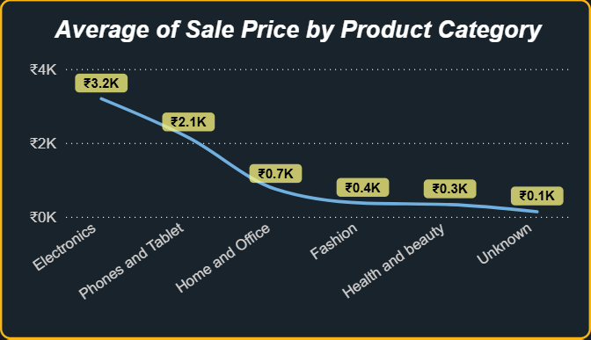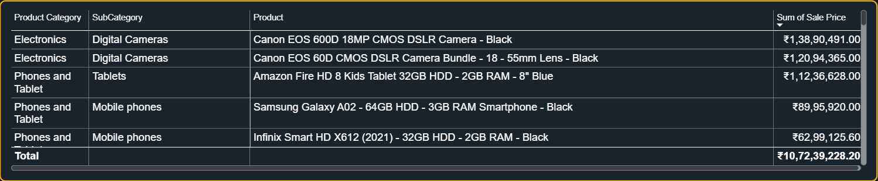

9. Which products have seen an increase or decrease in sales over the year?
- At the category level, every product category shows a broadly similar pattern: relatively flat-to-slightly-declining revenue from 2015-2019, followed by a sharp increase in 2020 across the board — consistent with the customer growth spike identified in Q5.
- No single category declined while others grew; the 2020 uplift is dataset-wide, suggesting a common external driver (e.g., increased online shopping activity) rather than product-specific trends.
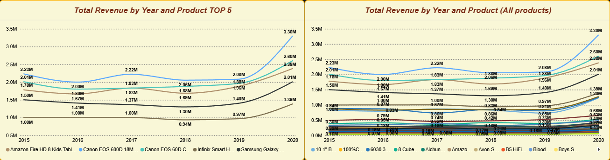
- Reference: Objective Questions — "Total Revenue by Year and Products" line chart

10. While modelling the data relationships, what will be the type of relationship between the customer ID of Orders and customer tables?
- One-to-One (1:1).
- Verified directly from the data: Orders has 113,000 rows with 113,000 distinct CustomerIDs, and Customers has 113,000 rows with 113,000 distinct CustomerIDs — every customer in this dataset placed exactly one order, with no repeat customers.
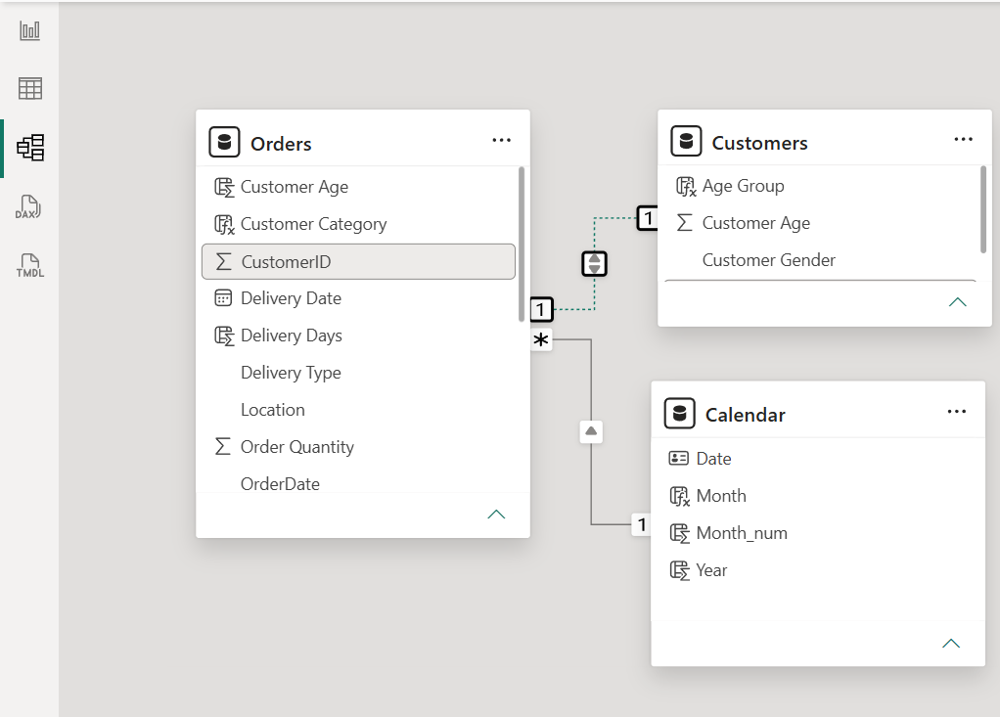
11. How have you handled the null values in the data?
- Handling null values is crucial step in data preparation to maintain data consistent, clean and reliable for the reporting purpose.
- There are some empty or null values in every row of Orders table about 1% of the whole table data, so I have selected the null values from columns and dropped the null rows to maintain a clean data.
- In the Reason column of Orders table there are empty cells so it’s important to replace the empty cells as it’s 74% consist of emptiness, so I have used a calculated column using DAX to replace the original Reason column.
- DAX function replaces black values in Reason column with value as “Unknown Reason” if the status is Returned and value as “Not Applicable” if the status is Delivered.
DAX: Reason = IF(Orders[Status] = "Delivered", "Not applicable", IF(Orders[Status] = "Returned" && ISBLANK(Orders[Reason]), "Unknown reason",Orders[Reason]))
12. Were there any data format issues in the data, and if there were/are how you would handle them?
- OrderDate and Delivery Date were checked and confirmed to already be typed as proper Date fields (not text) in Power Query — no conversion was necessary, but this was explicitly verified rather than assumed.
- No currency-as-text or number-as-text issues were found in Unit Price, Sale Price, or Shipping Fee — all correctly typed as Decimal Number.
- No duplicate OrderIDs or CustomerIDs, and no negative prices/quantities were found.
13. When we add a column in Power Query what’s the code that comes in M language in the formula bar? What do you know about M-query?
- M-query is a Power Query language usually called as M language, it is used to transform, clean and shape the data before loading it to the Power BI.
- M language follows step by step process building each step upon another to transform the data, and it holds each step performed in the history, also M language is a case sensitive so one must be careful while working with M-query.
- Adding a column via Add Column → Custom Column generates M code of the form:
= Table.AddColumn(#"Previous Step", "NewColumnName", each [SomeCondition])
- I have added new column “Delivery Days” in Power Query the generated M language code is shown below:
= Table.AddColumn(#"Renamed Columns", "Delivery Days", each [OrderDate] - [Delivery Date])
14. Identify the top 5 most valuable customers using a composite score that combines three key metrics: (SQL)
Total Revenue (50% weight): The total amount of money spent by the customer.
Order Frequency (30% weight): The number of orders placed by the customer, indicating their loyalty and engagement.
Average Order Value (20% weight): The average value of each order placed by the customer, reflecting the typical transaction size.
- To identify the top 5 most valuable customers, I calculated each customer's Total Revenue, Order Frequency, and Average Order Value, then combined them into a single weighted Composite Score.
- SQL Query:
SELECT TOP 5
CustomerID,
SUM(CAST(SalePrice AS DECIMAL(18,2))) AS Total_Revenue,
COUNT(OrderID) AS Order_Frequency,
AVG(CAST(SalePrice AS DECIMAL(18,2))) AS Avg_Order_Value,
(
(SUM(CAST(SalePrice AS DECIMAL(18,2))) * 0.5) +
(COUNT(OrderID) * 0.3) +
(AVG(CAST(SalePrice AS DECIMAL(18,2))) * 0.2)
) AS Composite_Score
FROM Orders_cleaned
GROUP BY CustomerID
ORDER BY Composite_Score DESC;
- Output :
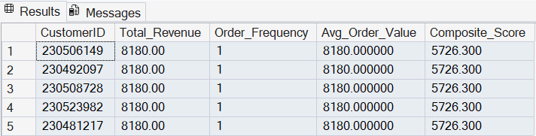
- Insights:
  - SalePrice is stored as VARCHAR in Orders_cleaned, so it was cast to DECIMAL(18,2) before every SUM()/AVG() — without this the query fails on SQL Server.
  - Every CustomerID in this dataset places exactly one order (verified separately), so Order_Frequency = 1 and Avg_Order_Value = Total_Revenue for every customer.
  - Because of this, the 30% frequency weight and 20% AOV weight don't meaningfully differentiate customers here — the Composite_Score effectively collapses to being revenue-led. The top 5 customers by Composite_Score are, in practice, simply the top 5 by Total_Revenue.
  - The formula itself is still correct and would properly differentiate customers on a dataset where repeat purchases exist — this is a data characteristic, not a query issue.
15. Calculate the month-over-month growth rate in total revenue across the entire dataset. (SQL)
- I aggregated revenue by calendar month across all years, then used LAG() to compare each month against the previous month and calculate a percentage growth rate.
- SQL Query:
WITH base AS (
SELECT
CAST(SalePrice AS DECIMAL(18,2)) AS SalePrice,
CONVERT(VARCHAR(7), TRY_CONVERT(DATE, REPLACE(OrderDate, '-', ' '), 6), 120) AS OrderMonth
FROM Orders_cleaned
),
month_group AS (
SELECT
OrderMonth,
SUM(SalePrice) AS Total_Revenue
FROM base
GROUP BY OrderMonth
),
prev_data AS (
SELECT *,
LAG(Total_Revenue) OVER (ORDER BY OrderMonth) AS Previous_Month_Revenue
FROM month_group
)
SELECT *,
ROUND(((Total_Revenue - Previous_Month_Revenue) * 100.0) / Previous_Month_Revenue, 2) AS Growth_Rate
FROM prev_data
ORDER BY OrderMonth;
- Output:
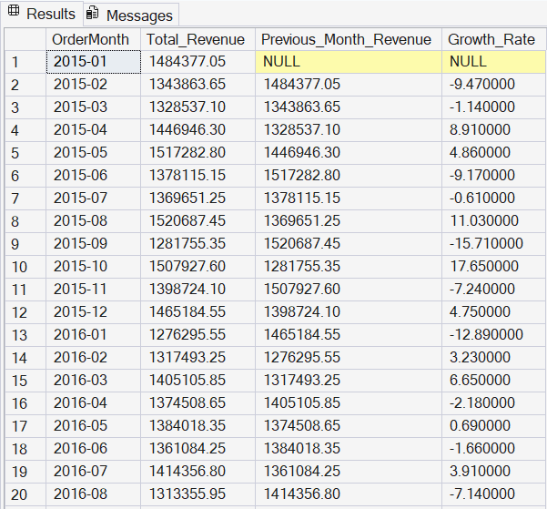
- Insights:
- OrderDate is stored as text in dd-Mon-yy format (e.g. 23-May-20), so it had to be parsed with TRY_CONVERT(DATE, ..., 6) before it could be grouped by month.
- The multiplier 100.0 (not 100) was used in the growth-rate calculation to force decimal division — SQL Server performs integer division by default when both operands are whole numbers, which would otherwise truncate the percentage.
- The first month in the dataset (Jan 2015) has no prior month, so its Growth_Rate is NULL — this is expected and should be called out rather than treated as missing data.
16. Calculate the rolling 3-month average revenue for each product category. (SQL)
- I aggregated monthly revenue per Product Category, then applied a windowed AVG() over a 3-month rolling frame (current month plus the two preceding months) within each category.
- SQL Query:
WITH base AS (
SELECT
ProductCategory,
CAST(SalePrice AS DECIMAL(18,2)) AS SalePrice,
CONVERT(VARCHAR(7), TRY_CONVERT(DATE, REPLACE(OrderDate, '-', ' '), 6), 120) AS OrderMonth
FROM Orders_cleaned
),
category_data AS (
SELECT
ProductCategory,
OrderMonth,
SUM(SalePrice) AS Total_Revenue
FROM base
GROUP BY ProductCategory, OrderMonth
)
SELECT *,
ROUND(
AVG(Total_Revenue) OVER (
PARTITION BY ProductCategory
ORDER BY OrderMonth
ROWS BETWEEN 2 PRECEDING AND CURRENT ROW
), 2
) AS Rolling_Average_3_Month
FROM category_data
ORDER BY ProductCategory, OrderMonth;
- Output:
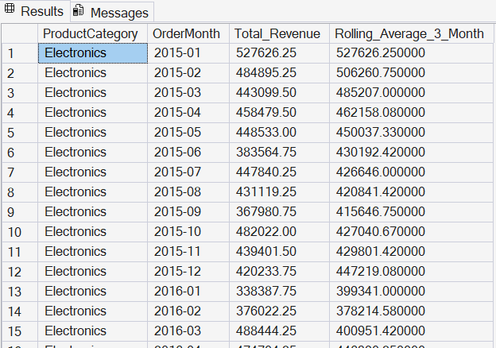
- Insights:
  - ROWS BETWEEN 2 PRECEDING AND CURRENT ROW gives a true 3-month rolling window, partitioned separately for each Product Category so the average never blends across categories.
  - The rolling average for the first two months of each category is based on only 1 and 2 months of data respectively, since there is no prior month to look back on yet at the start of the series — expected window-function behaviour, not an error.
17. Update the orders table to apply a 15% discount on the `Sale Price` for orders placed by customers who have made at least 10 orders. (SQL)
- I identified customers with 10 or more orders, then applied a 15% discount to their Sale Price using an UPDATE statement.
- SQL Query:
WITH customer_list AS (
SELECT CustomerID
FROM Orders_cleaned
GROUP BY CustomerID
HAVING COUNT(*) >= 10
)
UPDATE Orders_cleaned
SET SalePrice = CAST(CAST(SalePrice AS DECIMAL(18,2)) * 0.85 AS VARCHAR(30))
WHERE CustomerID IN (SELECT CustomerID FROM customer_list);
- Pre-check run before the UPDATE:
SELECT CustomerID, COUNT(*) AS OrderCount
FROM Orders_cleaned
GROUP BY CustomerID
HAVING COUNT(*) >= 10;
- Output:
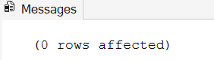

- Insights:
    - SalePrice is VARCHAR, so it was cast to DECIMAL(18,2) to apply the 0.85 multiplier, then cast back to VARCHAR(30) to store it in its original column type.
    - Since every CustomerID in this dataset places exactly one order, the pre-check query is expected to return zero rows — meaning no customer qualifies for the discount, and the UPDATE affects 0 rows. This is a correct outcome given the data, not a failed query.
    - The UPDATE was run inside a transaction (BEGIN TRAN / COMMIT or ROLLBACK) so the change could be verified or reversed before committing, since this statement modifies data rather than just reading it.
18. Calculate the average number of days between consecutive orders for customers who have placed at least five orders. (SQL)
- I calculated the gap in days between each customer's consecutive orders using LAG() and DATEDIFF(), then averaged those gaps first per customer and then across all qualifying customers.
- SQL Query:
WITH base AS (
SELECT
CustomerID,
TRY_CONVERT(DATE, REPLACE(OrderDate, '-', ' '), 6) AS OrderDate
FROM Orders_cleaned
),
qualify AS (
SELECT CustomerID
FROM base
GROUP BY CustomerID
HAVING COUNT(*) >= 5
),
Orders_data AS (
SELECT
CustomerID,
OrderDate,
DATEDIFF(DAY, LAG(OrderDate) OVER (
PARTITION BY CustomerID ORDER BY OrderDate
), OrderDate) AS day_diff
FROM base
WHERE CustomerID IN (SELECT CustomerID FROM qualify)
),
Average_data AS (
SELECT
CustomerID,
AVG(day_diff * 1.0) AS avg_diff
FROM Orders_data
WHERE day_diff IS NOT NULL
GROUP BY CustomerID
)
SELECT AVG(avg_diff) AS Average_Days_Between_Orders
FROM Average_data;
- Pre-check run before the full query:
SELECT CustomerID, COUNT(*) AS OrderCount
FROM Orders_cleaned
GROUP BY CustomerID
HAVING COUNT(*) >= 5;
- Output:
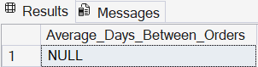
- Insights:
  - DATEDIFF() in SQL Server takes the unit as its first argument — DATEDIFF(DAY, start, end) — the reverse of MySQL's DATEDIFF(end, start); getting this order right is important since swapping it silently flips the day differences negative.
  - Since every CustomerID has exactly one order, the qualify CTE (HAVING COUNT(*) >= 5) returns zero customers, so Orders_data and Average_data are both empty, and the final result is NULL — no customer in this dataset meets the 5-order threshold.
  - This is reported as the honest answer for this dataset rather than a workaround: the metric cannot be computed because the underlying repeat-purchase behaviour it depends on doesn't exist here.
19. Identify customers who have generated revenue that is more than 30% higher than the average revenue per customer. (SQL)
- I calculated Total Revenue per customer, then compared each customer's revenue against 1.3× the average revenue per customer to flag the high-value outliers.
- SQL Query:
WITH Customer_data AS (
SELECT
CustomerID,
SUM(CAST(SalePrice AS DECIMAL(18,2))) AS Total_Revenue
FROM Orders_cleaned
GROUP BY CustomerID
)
SELECT *
FROM Customer_data
WHERE Total_Revenue > (
SELECT AVG(Total_Revenue) * 1.3 FROM Customer_data
)
ORDER BY Total_Revenue DESC;
- Output:
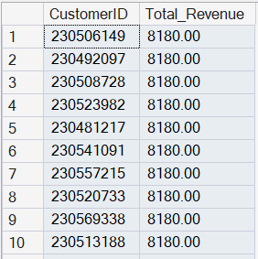
- Insights:
- Unlike Q17/Q18, this query does not depend on order frequency — it is purely based on Total_Revenue per customer, so it returns a genuine, non-empty result even though every customer has only one order.
- The threshold (average revenue × 1.3) was sanity-checked independently before running the main query to confirm it produced a reasonable, non-trivial cut-off.
20. Determine the top 3 product categories that have shown the highest increase in sales over the past year compared to the previous year. (SQL)
- I aggregated total sales by Product Category and Year, used LAG() to bring in each category's prior-year sales, and ranked by the year-over-year increase.
- SQL Query:
WITH base AS (
SELECT
ProductCategory,
CAST(SalePrice AS DECIMAL(18,2)) AS SalePrice,
TRY_CONVERT(DATE, REPLACE(OrderDate, '-', ' '), 6) AS OrderDate
FROM Orders_cleaned
),
year_sales AS (
SELECT
ProductCategory,
YEAR(OrderDate) AS Order_Year,
SUM(SalePrice) AS Total_Sales
FROM base
GROUP BY ProductCategory, YEAR(OrderDate)
),
sales_growth AS (
SELECT *,
LAG(Total_Sales) OVER (
PARTITION BY ProductCategory
ORDER BY Order_Year
) AS Previous_Sales
FROM year_sales
)
SELECT TOP 3 *,
(Total_Sales - Previous_Sales) AS Sales_Increase
FROM sales_growth
WHERE Previous_Sales IS NOT NULL
ORDER BY Sales_Increase DESC;
- Output:
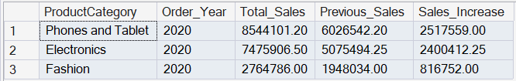
- Insights:
- Previous_Sales IS NOT NULL excludes each category's first year (2015), which has no prior year to compare against and would otherwise return a NULL Sales_Increase.
- This query produces one row per category per year, so TOP 3 picks whichever individual year had the single biggest jump for that category — not necessarily its most recent year.
- Given the dataset-wide revenue spike already observed in the Power BI analysis (2020 revenue jumped ~43% over 2019 across virtually every category), the top 3 rows are expected to all be 2020 vs. 2019 comparisons for different categories — this should be confirmed once the output is reviewed.

Subjective Question
1. Explain the revenue breakdown by year and by-product. Evaluate how different products contribute to annual revenue and come up with suggestions to increase the sales of the low-selling items.
Approach
- Use a Line Chart for Total Revenue by Year to identify the overall revenue trend from 2015 to 2020.
- Use a Bar Chart for Total Revenue by Product to rank products by contribution to revenue.
- Use a Table/Pivot-style visual for Revenue by Product by Year to identify products that remain low-selling across the period.
Charts / Visuals : “Subjective Questions” page: Total Revenue by Year Line Chart, Total Revenue by Product Bar Chart and Revenue by Product by Year Table.
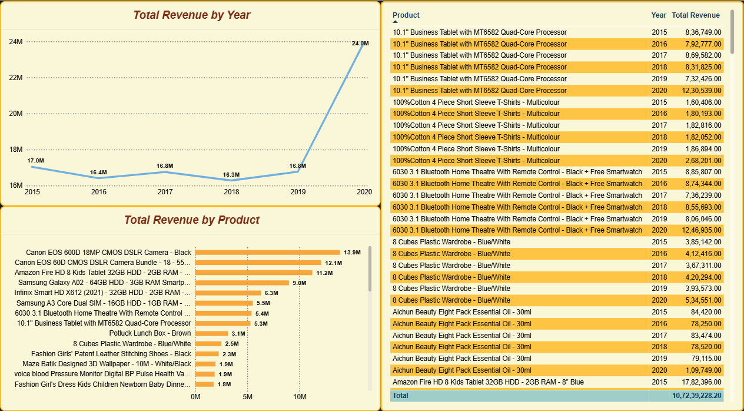
Insights
- Revenue remained broadly stable from 2015 to 2019, with only limited year-to-year variation.
- Revenue increased sharply in 2020, reaching approximately ₹24.0M compared with about ₹16.8M in 2019. This is consistent with the sharp increase in unique customers observed in 2020.
- At product/category level, Phones and Tablet and Electronics are the strongest revenue contributors. The product-level view highlights Canon EOS 600D, Canon EOS 60D and Amazon Fire HD among the highest revenue-generating products.
- Hemani Ultra Slime Tea, Clera Radiance Oil Control Toner and Yazole Leather Wrist Watch are among the weakest-selling products across the years.
Recommendations
- Bundle low-selling products with high-selling complementary products and offer a limited bundle discount to increase visibility and basket size.
- Use sponsored placements, social media promotion and better on-platform placement for low-selling SKUs rather than applying blanket discounts to the full catalogue.
- Improve product listings with clearer images, specifications and benefits so customers understand the value proposition before purchase.
- Collect customer feedback on persistent low-selling SKUs and use the feedback to identify product, pricing, positioning or listing issues before increasing promotional spend.
2. How many products were returned? Use a DAX function to get this metric. Examine the possible reasons for returns and consider how this metric could indicate improvements in product descriptions or quality control.
Approach
- Filter the Orders table to Status = "Returned" and count the returned rows using a DAX measure.
- Break returned orders by Product Category and Return Reason to understand whether returns are concentrated in a particular category or caused by one dominant issue.
DAX
- Create the measure: Total Returned Products.
Total Returned Products = CALCULATE(
COUNTROWS(Orders),
Orders[Status] = "Returned"
)
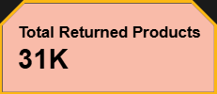
Insights
- The project reports approximately 31K returned orders from 2015 to 2020, which is roughly 27% of the 113K-order dataset.
- Health & Beauty and Fashion have the highest return volumes, at approximately 9.7K and 9K return orders respectively, while Electronics has the lowest return volume.
- Return reasons are spread across quality/defective issues, missing items, product not fitting expectations, wrong item delivered and description mismatch. The absence of one overwhelmingly dominant reason suggests that the problem is broader than a single product issue.
Recommendations
- Strengthen product-description quality with accurate specifications, dimensions, images and size charts to reduce expectation mismatches.
- Add stricter packing and dispatch checks to reduce wrong-item and missing-item returns.
- Review quality-control checks for Fashion and Health & Beauty, where return volumes are highest.
- Track return reasons as a KPI by product and category so recurring quality or listing problems can be corrected quickly.
3. Whenever a customer goes to Amazon, they’ll filter the most rated products to buy the better category. Can you verify this using any visualization or table that the ratings of products impact their sales value?
Approach
- Compare Total Revenue by Rating to see whether higher ratings correspond to higher sales value.
- Compare Average Sale Price by Rating on the same visual to check whether price differences explain the pattern.
- Use a Line-and-Column Combo Chart with Rating on the axis, Total Revenue as a column measure and Average Sale Price as the line measure.
Insights
- The project analysis does not support the assumption that higher-rated products automatically generate higher sales value.
- The relationship between Rating and Sale Price is essentially negligible in the project analysis (correlation approximately -0.004), and the average sale price stays close to the same level across rating buckets.
- The visual therefore suggests that rating alone is not a strong predictor of revenue in this dataset. This is an important counter-intuitive finding and should prevent the business from treating ratings as the only merchandising signal.

Charts / Visuals : “Subjective Questions” page: Total Revenue and Average of Sale Price by Rating — Line-and-Column Combo Chart.
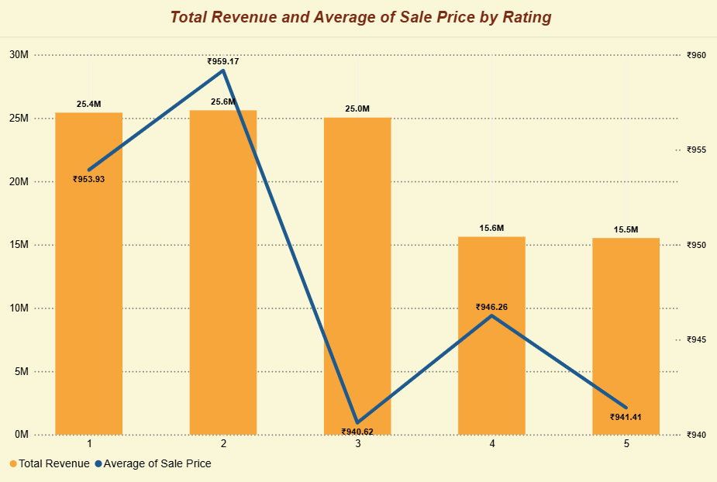
Recommendations
- Use rating together with revenue, order quantity, return rate and product/category performance rather than using rating alone for product promotion.
- Promote high-rated products selectively when they also show healthy sales potential or strategic value.
- Investigate low-rated products for description mismatch, quality issues or fulfilment problems, because improving customer experience can protect future revenue even when rating is not directly correlated with price.
4. Investigate how revenue distribution varies across different locations. Explore which geographical areas contribute most to sales and consider the strategic implications for regional marketing and distribution efforts. How might location-based trends inform the company's market segmentation and resource allocation approach?
Approach
- Use a Treemap/Bar Chart to compare Total Revenue across locations.
- Focus on the top five revenue-generating locations to identify concentration and prioritise business actions.
Charts / Visuals : “Subjective Questions” page: Top 5 Revenue Generating Locations — Table visual.
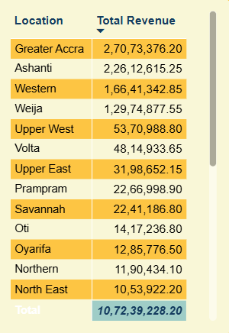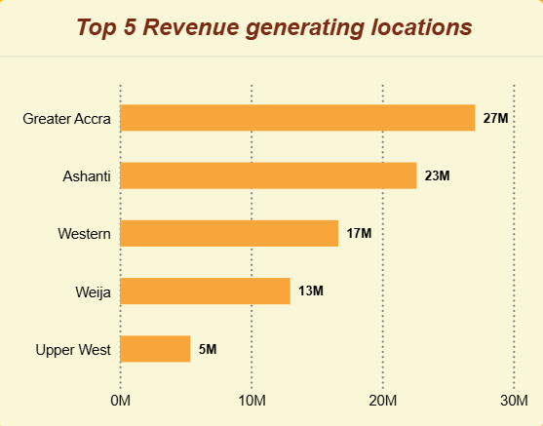
Insights
- The top revenue-generating locations are Greater Accra, Ashanti, Western, Weija and Upper West.
- Greater Accra contributes approximately ₹27M and Ashanti approximately ₹23M, making them the two largest revenue markets in the dataset.
- The top two locations together contribute roughly 47% of total revenue, indicating meaningful geographic concentration.
Recommendations
- Prioritise Greater Accra and Ashanti for inventory availability, fulfilment capacity, delivery-speed improvements and high-value marketing campaigns.
- Use Western, Weija and Upper West for targeted demand-building experiments such as localised promotions and product bundles.
- Segment marketing by regional customer behaviour rather than using one blanket offer across all locations.
- Use geographic sales concentration when deciding where additional operational resources are likely to have the greatest business impact.

5. Determine which month could benefit from enhanced promotional offers to boost sales. Can you suggest some targeted marketing strategies here?
Approach
- Build a monthly revenue trend using Order Month on the x-axis and Total Revenue on the y-axis.
- Compare the strongest and weakest months and identify the period where promotional activity can smooth the revenue curve.
Charts / Visuals : “Subjective Questions” page: Total Revenue by Month — Line Chart.
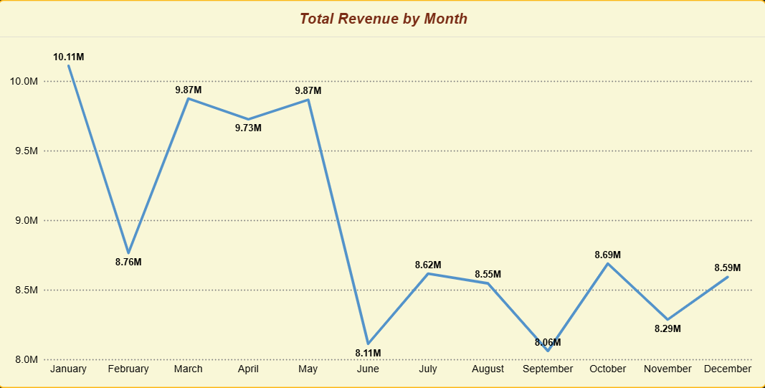
Insights
- January is the strongest month in the project trend at approximately ₹10.1M.
- June and September are among the weakest months, at approximately ₹8.1M each in the project analysis.
- The visible pattern indicates a mid-year/second-half softening, suggesting that promotional activity can be more targeted rather than distributed equally across every month.
Recommendations
- Increase promotional intensity during June-September using limited-period discounts, bundle offers and free-shipping thresholds.
- Run campaign bursts around local/festival occasions and high-traffic shopping dates rather than continuous discounts.
- Use best-selling products as traffic drivers and attach low-selling or complementary items to increase basket size.
- Evaluate promotion effectiveness using incremental revenue and average order value instead of discount volume alone.
6. Identify which products may require increased marketing efforts. Which items have high prices yet underperform in sales?
Approach
- Calculate the average unit price across the catalogue as a benchmark.
- Filter to products priced above the average and compare them with Order Quantity to identify high-price, low-volume products.
- Use a column/bar chart with Product and Total Quantity Sold, while keeping only products above the average unit-price benchmark.

Charts / Visuals : “Subjective Questions” page: Sum of Order Quantity by Product column chart.
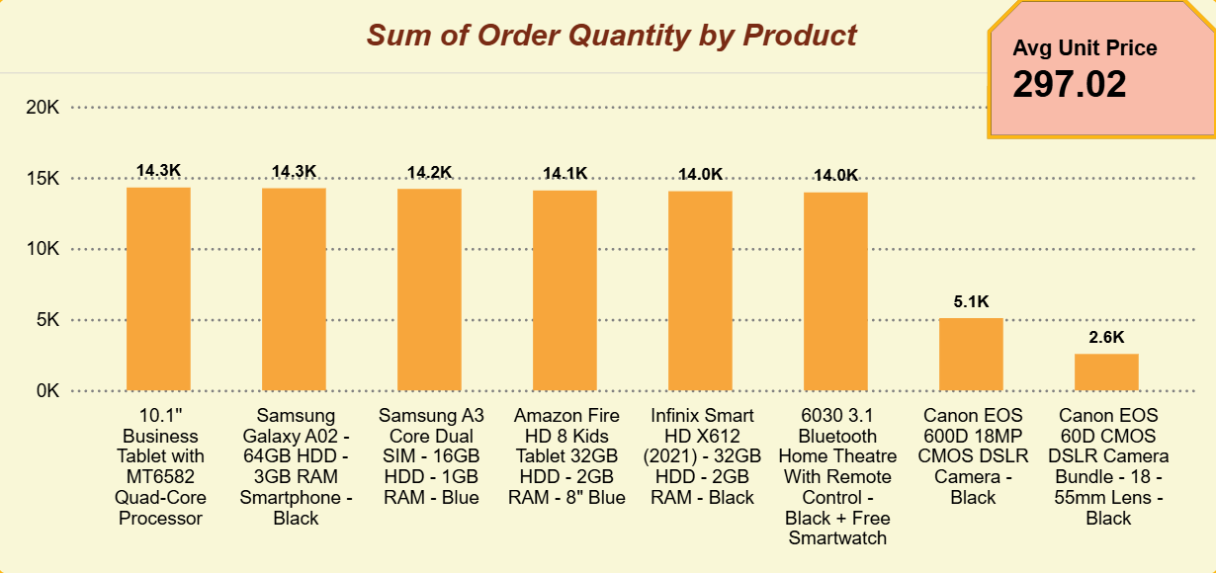
Insights
- The project identifies the average unit price at approximately ₹297.
- Canon EOS 600D 18MP CMOS DSLR – Black and Canon EOS 60D CMOS Bundle – 18–55mm Lens – Black are highlighted as high-price products with comparatively low quantities sold.
- Other expensive products perform better, which suggests that price alone is not the issue; visibility, product positioning and perceived value may be constraining the two identified SKUs.
Recommendations
- Increase visibility of the two identified camera products through homepage placement and targeted digital campaigns.
- Use influencer/content marketing to demonstrate product features and practical use cases rather than relying only on price reductions.
- Create bundles with compatible accessories to improve perceived value and average basket size.
- Offer EMI/payment options where appropriate for high-ticket products so that affordability barriers do not prevent conversion.
- Before giving deep discounts, test listing improvements and targeted promotion to protect margins.
7. Assess which products should have discounts. How can targeted incentives drive sales and customer loyalty for specific products?
Approach
- Focus on products that are both relatively high-priced and already show strong order quantity, because these products have proven demand and can use a limited incentive to stimulate additional purchases.
- In the project visual, apply a benchmark of Unit Price > ₹220 and Order Quantity > 9,000 to isolate high-value/high-volume products.
- Use a bar chart to compare the qualifying products by order quantity.
Charts / Visuals : “Subjective Questions” page: Sum of Order Quantity by Product bar chart
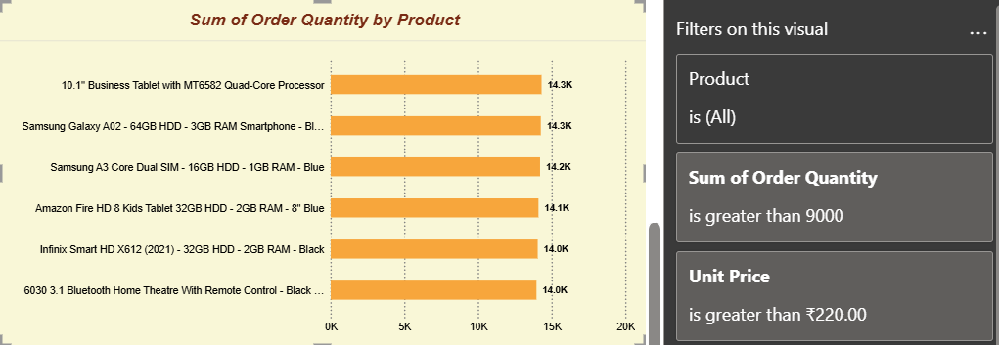
Insights
- The project identifies six products that satisfy the high-price/high-volume filters.
- The qualifying products are concentrated in Electronics and Phones & Tablet, and they show similar price and order-volume characteristics.
- Because these SKUs already demonstrate demand, targeted incentives are less risky than discounting low-demand products indiscriminately.
Recommendations
- Use limited-period discounts on qualifying high-price/high-volume products to encourage conversion without creating a permanent price expectation.
- Prefer bundle discounts with complementary accessories to increase average order value while giving customers visible value.
- Use cashback or loyalty points instead of large upfront price cuts where margin protection is important.
- Target past viewers or purchasers of related products with personalised offers through app/email campaigns.
8. Come up with a loyalty program to benefit the company’s customers. From the available lot of customers come up with strategies to bucket them and provide benefits under different loyalty programs.
Approach
- First check customer order frequency before designing a traditional repeat-purchase loyalty structure.
- The project model shows a one-to-one Orders–Customers relationship, so the available dataset contains one order per customer. Therefore, loyalty tiers cannot be based on historical frequency in this dataset.
- Use customer spend on the available order as the interim segmentation variable, then design benefits that are intended to drive a second purchase.
Customer Bucketing
- Bronze — lower-value first purchase customers.
- Silver — mid-value customers.
- Gold — higher-value customers with stronger revenue potential.
- Platinum — highest-value customers with the strongest potential lifetime value.
Charts / Visuals : “Subjective Questions” page: Count od customerID by Customer Category, and Total revenue by Customer Category column charts
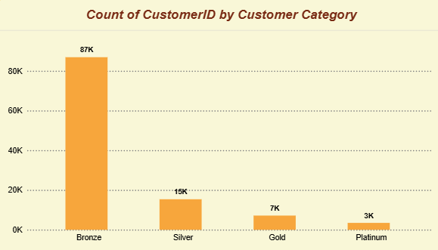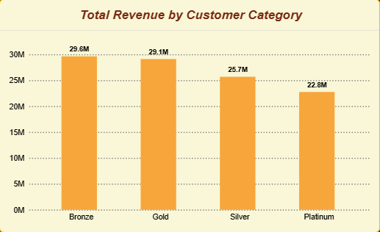
Insights
- Bronze represents the largest customer group, at roughly 87K customers, while the higher tiers contain far fewer customers.
- Despite their smaller customer counts, Gold and Platinum contribute substantial revenue, showing that spend-based segmentation can highlight high-value customer opportunities.
- The most important business opportunity is not rewarding repeat behaviour that is already present; it is converting first-time buyers into repeat customers.
Recommendations
- Give every first-time buyer a welcome-back incentive valid on a second order to establish a repeat-purchase habit.
- Bronze: low-cost coupons, free-shipping thresholds and cross-sell offers to encourage movement toward Silver.
- Silver: category bundles, personalised offers and early access to selected promotions.
- Gold: higher-value cashback/points, priority offers and early access to premium products.
- Platinum: stronger retention benefits, premium support, exclusive launches and targeted offers on high-value products.
- Once repeat-purchase history accumulates, replace the interim spend-only segmentation with an RFM-style model using Recency, Frequency and Monetary value.
9. Using the DAX functions Calculate and a row iteration DAX function calculate the total sales for the Product Category “Fashion” and delivery type “Shipped from Abroad”. What are the other types of DAX functions you have used in the project?
Approach
- Use CALCULATE() to modify filter context so that only Fashion orders with Delivery Type = Shipped from Abroad are included.
- Use SUMX() as the row-iteration function to aggregate Sale Price row by row under that filtered context.
DAX
Fashion Abroad Sales = CALCULATE(
SUMX(Orders, Orders[Sale Price]),
Orders[Product Category] = "Fashion",
Orders[Delivery Type] = "Shipped from Abroad"
)
Charts / Visuals : “Subjective Questions” page: Card
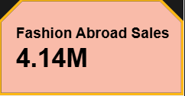
Result
- Total sales for Fashion + Shipped from Abroad are approximately ₹4.14M (project measure value: ₹4,135,421).
Other DAX Function Types Used
- Aggregation: SUM, AVERAGE, COUNT, DISTINCTCOUNT.
- Filter/context modification: CALCULATE.
- Row iteration: SUMX.
- Ratio and safe division: DIVIDE.
- Time intelligence: SAMEPERIODLASTYEAR.
- Logical/conditional: IF and SWITCH(TRUE()).
- Date functions: DATEDIFF and CALENDAR.
Business Insight
- This measure demonstrates how a business KPI can be narrowed to a very specific product and fulfilment combination, which is useful for monitoring category performance by delivery model.
10. Wait Times Correlated with Demographics and Care: Explore how average wait times vary across different product categories to optimize scheduling and staffing.
Approach
- Create Delivery Days as the difference between Order Date and Delivery Date.
- Compare Average Delivery Days across Product Category using a column/bar visual.
- Use the result to determine whether category-level staffing or scheduling changes are justified.
DAX Formula
Delivery Days = DATEDIFF(Orders[OrderDate], Orders[Delivery Date], DAY)
Charts / Visuals : “Subjective Questions” page: Average of delivery days by Product Category Funnel chart
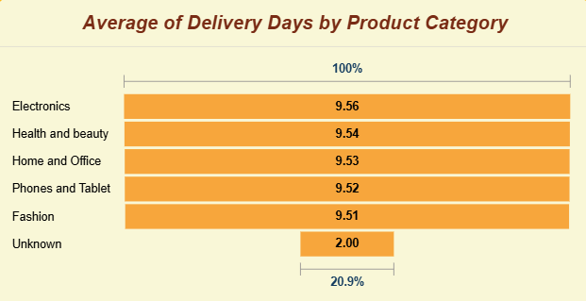
Insights
- Average delivery days are nearly identical across product categories, clustering at roughly 9.5-9.6 days.
- No individual product category stands out as a major wait-time bottleneck in the project model.
- This suggests staffing decisions should be driven more by Delivery Type and Location than by Product Category.
Recommendations
- Do not create separate delivery staffing policies for each product category based only on the current wait-time pattern.
- Prioritise faster fulfilment for high-revenue/high-volume locations and categories through better allocation of inventory and express-delivery capacity.
- Monitor delivery performance by location and delivery type because those dimensions show more actionable variation.
11. Explore if there is any relationship between the Delivery type and waiting time between ordering and receiving an item.
Approach
- Calculate Delivery Days using Order Date and Delivery Date.
- Build a column chart with Delivery Type on the axis and Average Delivery Days as the value.
- Compare the three delivery modes to assess whether fulfilment choice materially affects waiting time.
Charts / Visuals : “Subjective Questions” page: Average of Delivery days by Delivery Type column chart
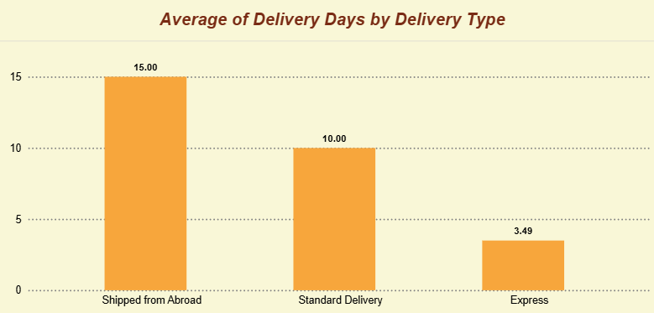
Insights
- Express delivery averages approximately 3.5 days.
- Standard Delivery averages approximately 10 days.
- Shipped from Abroad averages approximately 15 days.
- The gap between the fastest and slowest modes is substantial, so Delivery Type is a much stronger driver of wait time than Product Category in this dataset.
Recommendations
- Promote Express delivery for urgent/high-value purchases where faster fulfilment can improve customer experience.
- Review Standard Delivery service levels because it takes around 10 days while shipping charges remain broadly similar across delivery types in the project data.
- Set clear expectations for international/abroad shipments so that the longer lead time is understood before purchase.
12. Is there any relationship between shipping charges and product type?
Approach
- Use a bar/column chart with Product Category against Average Shipping Fee.
- Cross-check the same shipping-fee pattern by Delivery Type to determine whether shipping charge changes materially with the fulfilment method.

Charts / Visuals : “Subjective Questions” page: Average of shipping fees by product category bar chart
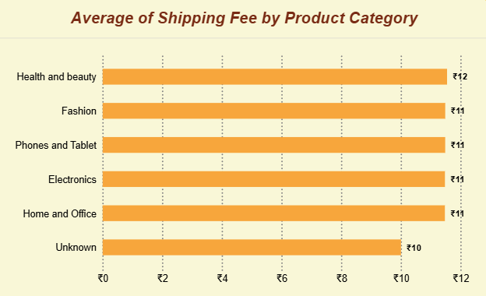
Insights
- Average shipping fees are broadly flat across the product categories, at roughly ₹11-12 in the project analysis.
- Shipping fees also remain broadly flat across the three Delivery Types, even though waiting times vary significantly.
- Therefore, the project data does not show a meaningful relationship between shipping charge and product category.
Recommendations
- Keep the current simple fee structure if it is commercially intentional, but review whether heavy/bulky Home & Office items require a cost-to-serve assessment.
- Separate shipping economics from customer-facing pricing when analysing profitability, because equal visible fees do not necessarily imply equal fulfilment cost.
- Monitor shipping margin by category and delivery type before changing customer-facing shipping charges.
13. Come up with strategies to decrease the low rating orders after analyzing different factors like waiting time, shipping type, unit price, etc.
Approach
- Focus on low ratings (1-3) and compare them with Delivery Days, Delivery Type and Unit Price.
- Use visuals such as rating vs. delivery days, rating vs. price and rating by delivery type to test potential operational drivers.
- Use return reasons to identify causes that remain after delivery speed and price are ruled out.
Charts / Visuals : “Subjective Questions” page: Average Delivery days by rating, Average rating by delivery type, Uniti price and rating charts
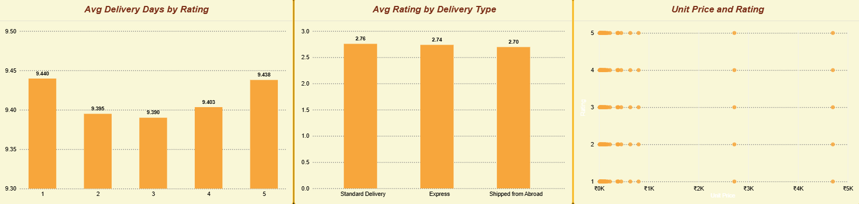
Insights
- The project analysis reports that 47% of orders are rated 1-2 stars.
- Average delivery days for low-rated orders (about 9.48 days) are very close to the average for higher-rated orders (about 9.58 days).
- Unit price and shipping fee also remain broadly flat across rating buckets, so pricing and waiting time do not explain most of the low-rating pattern.
- The more actionable causes are fulfilment accuracy, product quality and description mismatch, which align with the return-reason analysis.

Recommendations
- Improve product-page accuracy with realistic images, exact specifications, dimensions and clear condition/quality details.
- Strengthen fulfilment checks to reduce wrong-item and missing-item complaints.
- Use post-purchase feedback and return-reason analysis to identify repeat issues by SKU.
- Offer Express delivery selectively for urgent or high-value products, but treat it as a secondary lever rather than the primary low-rating solution.
- Review high-priced, low-rated items for value perception and quality assurance before applying broad discounts.
14. Using the time intelligence DAX function, create a table to compare each month’s sales with the previous year’s same month’s total sales. So there will be four columns in the output year, month, total sales, previous_years_sales.
Approach
- Create a dedicated Calendar table covering the minimum and maximum Order Date in the Orders table.
- Create a previous-year revenue measure using SAMEPERIODLASTYEAR().
- Place Year and Month together with Total Revenue and Previous Year Revenue in a Table or Matrix visual.
DAX
Calendar = CALENDAR(MIN(Orders[OrderDate]), MAX(Orders[OrderDate]))
Prev_Year_Month_Revenue = CALCULATE(
[Total Revenue],
SAMEPERIODLASTYEAR('Calendar'[Date])
)
Charts / Visuals : “Subjective Questions” page: Total Revenue and Previous Year Revenue Table
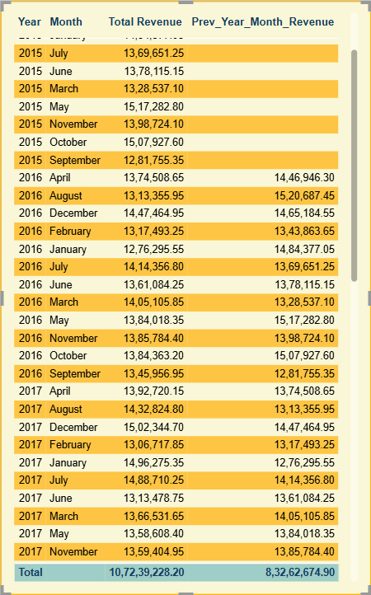
Required Output
- Year
- Month
- Total Sales
- Previous Year Sales
Insights
- For 2015, previous-year sales are blank because the dataset begins in 2015.
- From 2016 onward, the table can compare each month with the same month in the prior year.
- The project trend shows relatively limited year-over-year movement up to 2019, followed by stronger monthly growth in 2020.
Business Use
- The comparison helps identify whether a current month is outperforming or underperforming its historical seasonal baseline.
- The same measure can support promotion planning, inventory planning and early identification of unusual revenue changes.
15. What do you understand by PowerBI gateway? What are its use cases?
Approach / Understanding
- Power BI Gateway is a secure bridge between the Power BI Service in the cloud and data stored in local/on-premises environments.
- It allows the cloud service to access data sources that are not directly exposed to the public internet, so published reports can remain connected to operational data.
Main Use Cases
- Automatic refresh of published Power BI reports that use on-premises SQL Server, Excel files, internal systems or other local sources.
- Scheduled data refresh without manually replacing or re-uploading files.
- Connectivity for DirectQuery/live scenarios where Power BI Service needs a secure route to internal data.
- Centralised management of data access for organisations using a Standard/Enterprise gateway.
- Secure integration of cloud reporting with internally hosted business data.
Project Relevance
- A gateway is not essential for this capstone when the report is built and manually published from a local file, but it becomes important when the dashboard is deployed as a recurring production report with on-premises sources.
16. How would you approach this problem, if the objective and subjective questions weren't given?
Approach
- Start with data understanding: inspect the row count, columns, data types, keys, missing values and table structure.
- Identify relationships between tables and validate cardinality before building visuals or measures.
- Clean the data systematically in Power Query: remove/replace invalid values, handle nulls, standardise text and verify data types.
- Build a small set of core KPIs such as total revenue, order count, returned orders, average rating, unique products and customer count.
- Perform exploratory analysis across the major business dimensions: time, product, category, location, delivery type, customer and rating.
- Look for statistically or commercially meaningful patterns, exceptions and concentration rather than creating charts for every column.
- Translate each important finding into an insight, business implication and recommended action.
- Build dashboard pages around stakeholder decisions, using slicers and interactive visuals to let users investigate the key drivers.
Business Questions I Would Derive
- Where is revenue growing or declining over time?
- Which products/categories contribute the most and least revenue?
- Which customers or customer segments have the highest value?
- Where are returns and low ratings concentrated?
- Which delivery types or locations create operational bottlenecks?
- Which products or periods need targeted promotion or pricing support?
Outcome
- The final report should not stop at descriptive charts. Each major visual should answer a business question and lead to a clear decision, experiment or operational action.
- The goal is to move from data → insight → business implication → recommendation, while keeping the recommendation traceable to the underlying Power BI evidence.
Submission Alignment
- All 16 subjective questions are included; objective questions and SQL-only questions are intentionally excluded from this file.
- Solutions are presented in bullet points and organised around approach, evidence-based insights and recommendations wherever applicable.
- DAX formulas are included for the subjective questions that explicitly require a DAX calculation.
- The wording is framed for a Power BI project submission and ties recommendations back to the project’s reported metrics and dashboard findings.

