SOCIAL MEDIA ANALYSIS
SQL Project Documentation
Objective Questions & Subjective Questions

Database | ig_clone_ssms.sql
SQL Platform | Microsoft SQL Server / SSMS
Analysis Focus | User activity, engagement, relationships and marketing insights
SQL File Used | Social_Media_SQL_ssms.sql
Content Part A | Objective Questions (Q1–Q13)
Content Part B | Subjective Questions (Q1–Q10)
Submitted By | Hiteshi Aglawe

OBJECTIVE QUESTIONS
Q1) Are there any tables with duplicate or missing NULL values? If so, how would you handle them?

SQL Code
-- Q1) Tables with duplicate or missing null values?
-- ===============================================================
-- 1. Row counts per table (sanity check that load worked)
SELECT 'users' AS table_name, COUNT(*) AS row_count FROM users
UNION ALL SELECT 'photos', COUNT(*) FROM photos
UNION ALL SELECT 'comments', COUNT(*) FROM comments
UNION ALL SELECT 'likes', COUNT(*) FROM likes
UNION ALL SELECT 'follows', COUNT(*) FROM follows
UNION ALL SELECT 'tags', COUNT(*) FROM tags
UNION ALL SELECT 'photo_tags', COUNT(*) FROM photo_tags;
GO
-- 2. NULL checks (per table, key columns)
SELECT
SUM(CASE WHEN username IS NULL THEN 1 ELSE 0 END) AS null_username,
SUM(CASE WHEN created_at IS NULL THEN 1 ELSE 0 END) AS null_created_at
FROM users;
SELECT
SUM(CASE WHEN image_url IS NULL THEN 1 ELSE 0 END) AS null_image_url,
SUM(CASE WHEN user_id IS NULL THEN 1 ELSE 0 END) AS null_user_id
FROM photos;
SELECT
SUM(CASE WHEN comment_text IS NULL THEN 1 ELSE 0 END) AS null_comment_text,
SUM(CASE WHEN user_id IS NULL THEN 1 ELSE 0 END) AS null_user_id,
SUM(CASE WHEN photo_id IS NULL THEN 1 ELSE 0 END) AS null_photo_id
FROM comments;
GO
-- 3. Duplicate checks
-- Duplicate usernames (should be unique but no UNIQUE constraint was defined on username)
SELECT username, COUNT(*) AS cnt
FROM users
GROUP BY username
HAVING COUNT(*) > 1;
-- Duplicate likes (same user liking same photo more than once -- shouldn't be possible, PK enforces it,
-- but worth confirming zero rows returned)
SELECT user_id, photo_id, COUNT(*) AS cnt
FROM likes
GROUP BY user_id, photo_id
HAVING COUNT(*) > 1;
-- Duplicate follows (same follower->followee pair more than once)
SELECT follower_id, followee_id, COUNT(*) AS cnt
FROM follows
GROUP BY follower_id, followee_id
HAVING COUNT(*) > 1;
-- Self-follows (data quality issue: someone following themselves)
SELECT follower_id, followee_id
FROM follows
WHERE follower_id = followee_id;
GO
-- =========================================================
Output Image of SQL
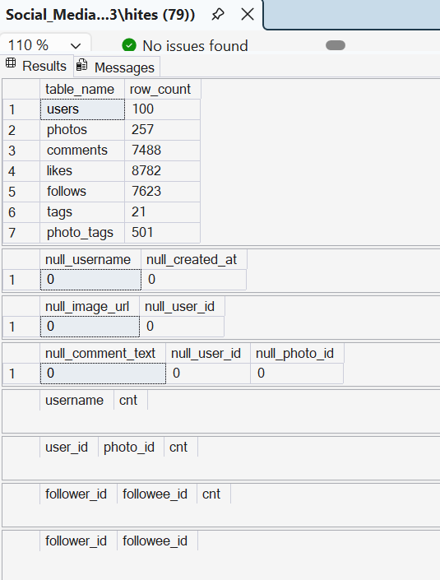

Brief Explanation
- The analysis checks whether the data was loaded correctly, whether important columns contain NULL values, and whether records that should be unique appear more than once.
- For columns that are mandatory, NULL values should normally be investigated and corrected at the source or handled according to the business meaning of the field. They should not be replaced blindly.
- Duplicate usernames should be reviewed because the current users table does not have a UNIQUE constraint on username.
- Duplicate likes and duplicate follow relationships are checked even though the composite primary keys on those tables are designed to prevent them.
- Self-follows are also checked as a basic data-quality issue because a user following themselves is normally not meaningful.

Q2. What is the distribution of user activity levels, such as number of posts, likes and comments, across the user base?

SQL Code
-- Q2: Distribution of user activity levels
-- (posts made, likes given, comments made -- per user)
-- =========================================================
SELECT
u.id AS user_id,
u.username,
COUNT(DISTINCT p.id) AS post_count,
COUNT(DISTINCT l.photo_id) AS likes_given,
COUNT(DISTINCT c.id) AS comment_count
FROM users u
LEFT JOIN photos p ON p.user_id = u.id
LEFT JOIN likes l ON l.user_id = u.id
LEFT JOIN comments c ON c.user_id = u.id
GROUP BY u.id, u.username
ORDER BY post_count DESC, likes_given DESC, comment_count DESC;
GO

Output Image of SQL
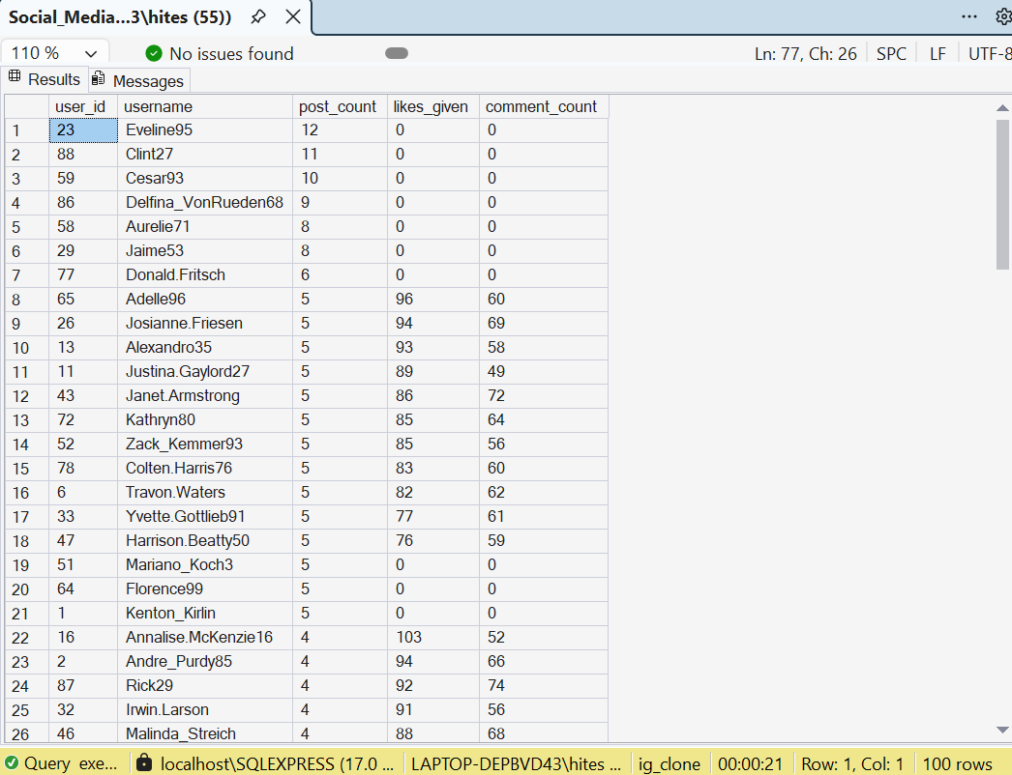

Visualization / Chart
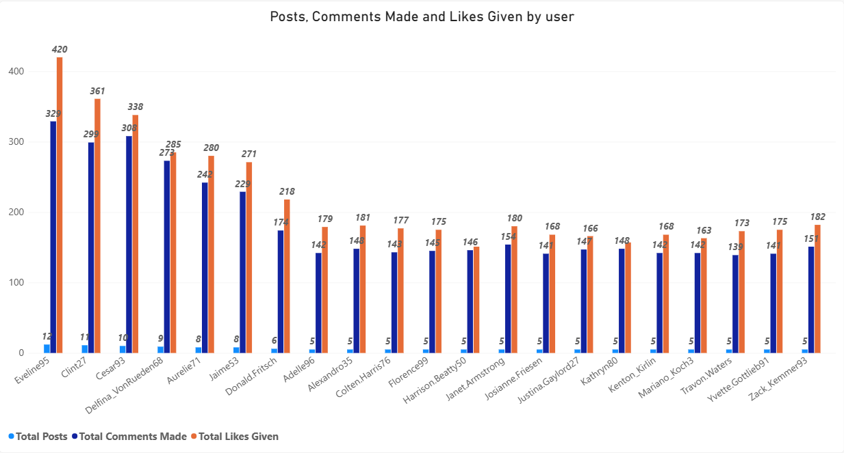

Brief Explanation
- The query measures three user activities separately: posts made, likes given and comments made.
- A LEFT JOIN is used so that users with little or no activity are not automatically removed from the result.
- The result can be used to identify highly active users, moderately active users and inactive or low-activity users.
- Users with high activity across several measures are stronger candidates for engagement-focused campaigns, while low-activity users can be targeted with re-engagement campaigns.

Q3) Calculate the average number of tags per post using the photo_tags and photos tables.

SQL Code
-- Q3: Average number of tags per post
-- (LEFT JOIN so posts with zero tags still count in the average)
-- =========================================================
SELECT
AVG(CAST(tag_count AS FLOAT)) AS avg_tags_per_post
FROM (
SELECT p.id AS photo_id, COUNT(pt.tag_id) AS tag_count
FROM photos p
LEFT JOIN photo_tags pt ON pt.photo_id = p.id
GROUP BY p.id
) AS per_photo_tags;
GO

Output Image of SQL
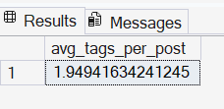

Visualization / Chart
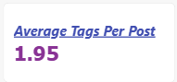

Brief Explanation
- The query first counts the number of tags attached to each photo.
- A LEFT JOIN is used so that photos with no tags are also included in the calculation.
- The average of the per-photo tag counts gives the average number of tags per post.
- This metric helps assess how extensively users are using hashtags/tags on their posts.

Q4) Identify the top users with the highest engagement rates (likes and comments) on their posts and rank them.

SQL Code
-- Q4: Identify and rank users based on the engagement
-- (likes + comments) received on their posts
-- Type of query/logic: CTE + aggregation + RANK() window function
-- Step 1: Calculate total likes and comments received per user
-- Step 2: Calculate total engagement = likes + comments
-- Step 3: Rank users based on total engagement in descending order
-- =========================================================
WITH user_engagement AS (
SELECT
u.id AS user_id,
u.username,
ISNULL(SUM(lk.like_count), 0) AS total_likes,
ISNULL(SUM(cm.comment_count), 0) AS total_comments,
ISNULL(SUM(lk.like_count), 0)
+ ISNULL(SUM(cm.comment_count), 0) AS total_engagement
FROM users u
LEFT JOIN photos p
ON p.user_id = u.id
LEFT JOIN (
SELECT
photo_id,
COUNT(*) AS like_count
FROM likes
GROUP BY photo_id
) lk
ON lk.photo_id = p.id
LEFT JOIN (
SELECT
photo_id,
COUNT(*) AS comment_count
FROM comments
GROUP BY photo_id
) cm
ON cm.photo_id = p.id
GROUP BY
u.id,
u.username
)
SELECT
user_id,
username,
total_likes,
total_comments,
total_engagement,
RANK() OVER (
ORDER BY total_engagement DESC
) AS engagement_rank
FROM user_engagement
ORDER BY engagement_rank, username;
GO

Output Image of SQL
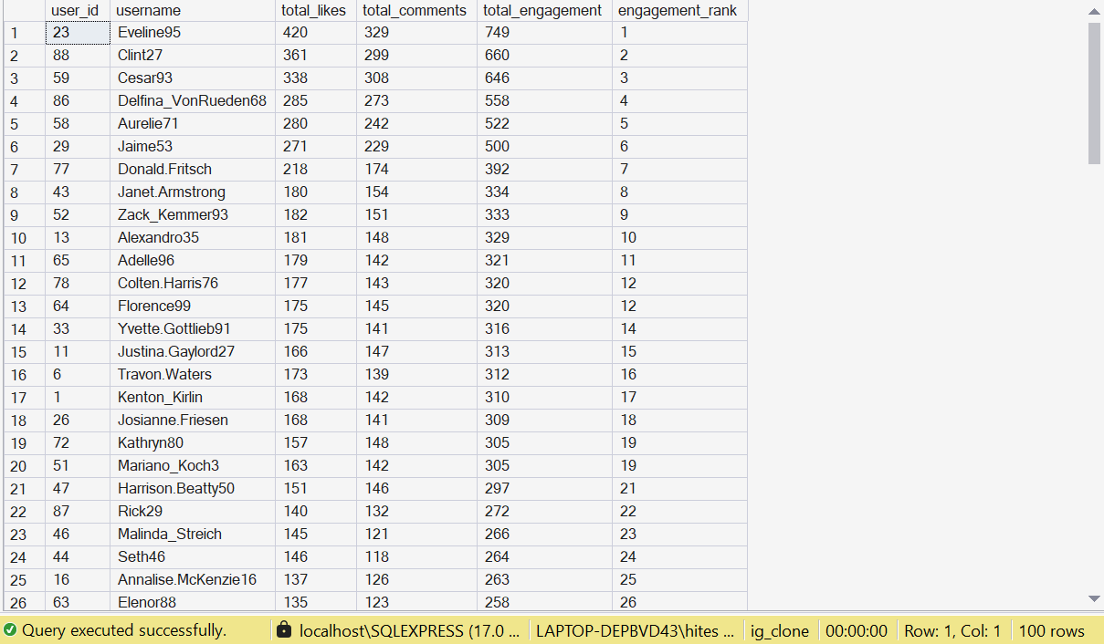

Visualization / Chart
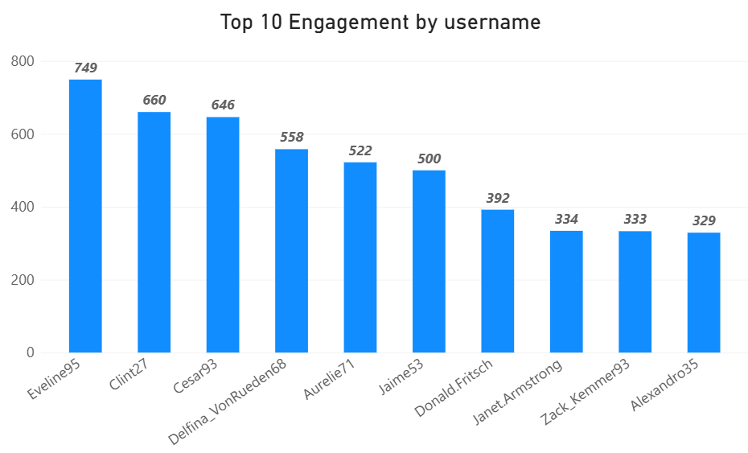

Brief Explanation
- The query calculates the total likes and comments received by each user's posts.
- Total engagement is defined for this project as likes plus comments received on the user's posts.
- The RANK() window function then ranks users from highest to lowest total engagement.
- This ranking highlights users whose content generates strong interaction and can help identify valuable creators or highly engaging users.
Analytical definition: For this project, engagement is defined as likes + comments received on a user's posts.
Q5) Which users have the highest number of followers and followings?

SQL Code
-- Q5: Users with the highest number of followers / followings
-- =========================================================
-- Top 10 by followers
SELECT TOP 10
followee_id AS user_id,
COUNT(follower_id) AS followers_count
FROM follows
GROUP BY followee_id
ORDER BY followers_count DESC;
-- Top 10 by followings
SELECT TOP 10
follower_id AS user_id,
COUNT(followee_id) AS followings_count
FROM follows
GROUP BY follower_id
ORDER BY followings_count DESC;
GO
Output Image of SQL
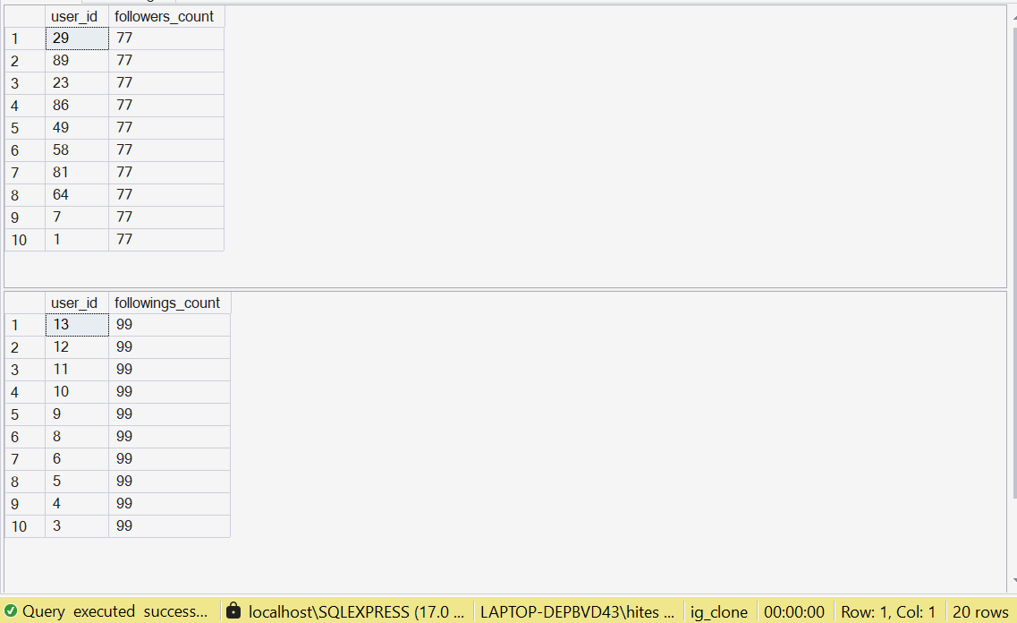

Visualization / Chart
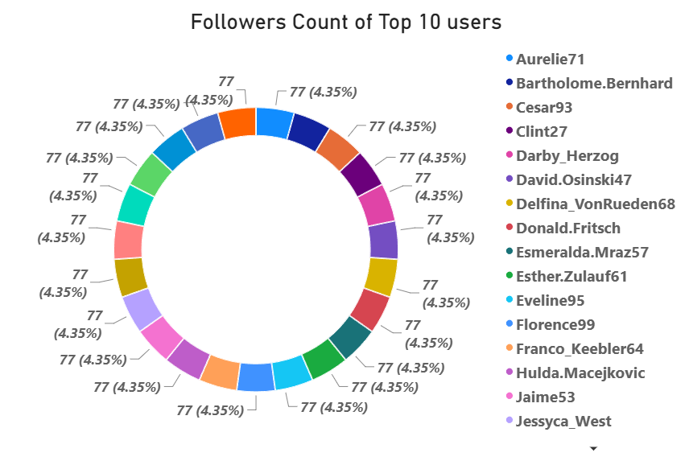

Brief Explanation
- The first query counts how many followers each user has by grouping the follows table by followee_id.
- The second query counts how many accounts each user follows by grouping the follows table by follower_id.
- The results identify users with strong audience reach and users who are highly connected within the platform.
- Users with high follower counts can be considered for influencer or creator campaigns, while high-following users may represent highly connected community members.

Q6) Calculate the average engagement rate (likes and comments) per post for each user.

SQL Code
-- Q6: Average engagement rate (likes+comments) per post, per user
-- =========================================================
SELECT
u.id AS user_id,
u.username,
ROUND(
SUM(ISNULL(lk.likes_count, 0) + ISNULL(cm.comments_count, 0)) * 1.0
/ COUNT(p.id)
, 2) AS avg_engagement_rate
FROM users u
JOIN photos p ON p.user_id = u.id
LEFT JOIN (SELECT photo_id, COUNT(*) AS likes_count FROM likes GROUP BY photo_id) lk
ON lk.photo_id = p.id
LEFT JOIN (SELECT photo_id, COUNT(*) AS comments_count FROM comments GROUP BY photo_id) cm
ON cm.photo_id = p.id
GROUP BY u.id, u.username
ORDER BY avg_engagement_rate DESC;
GO

Output Image of SQL
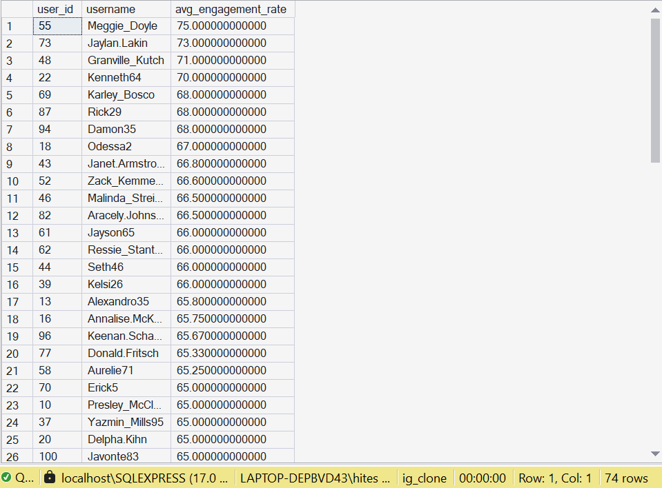

Visualization / Chart
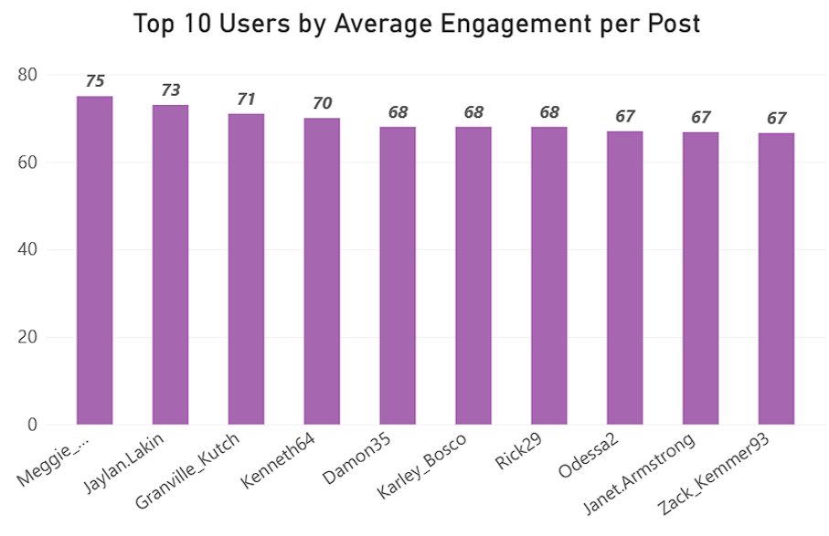

Brief Explanation
- The query counts likes and comments for each post separately and then links those results to the post owner.
- For each user, total likes and comments received across their posts are added together.
- The total engagement is divided by the user's number of posts to obtain average engagement per post.
- This is a project-specific engagement measure. It is useful for comparing how much interaction a typical post receives, rather than only looking at total engagement.
Analytical definition: Average engagement rate here means average likes + comments received per post; it is not a reach/impressions-based social media rate.

Q7) Get the list of users who have never liked any post.

SQL Code
-- Q7: Users who have never liked any post
-- Type of query/logic: LEFT JOIN + IS NULL (anti-join pattern)
-- Finds users with no matching row in likes at all
-- =========================================================
SELECT
u.id AS user_id,
u.username
FROM users u
LEFT JOIN likes l ON l.user_id = u.id
WHERE l.user_id IS NULL;
GO

Output Image of SQL
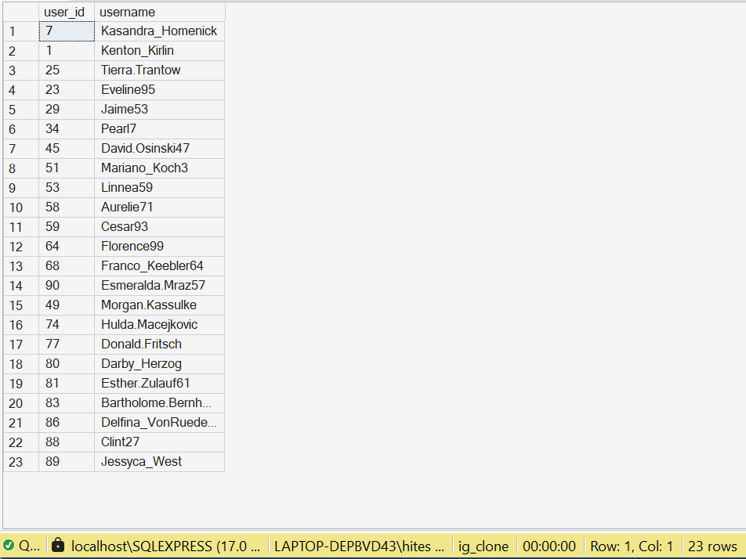

Visualization / Chart
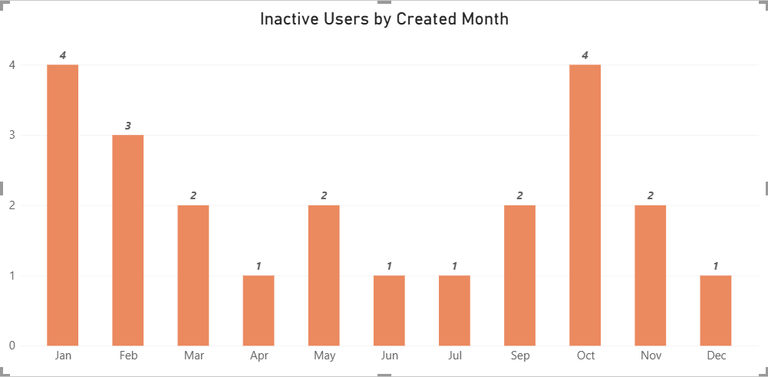

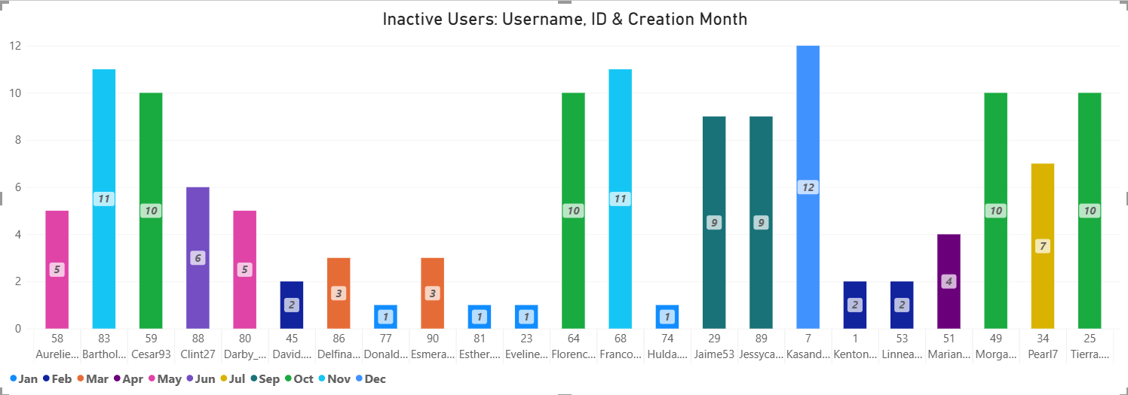

Brief Explanation
- The query starts with all users and uses a LEFT JOIN to the likes table.
- Users for whom no matching likes record exists are identified using IS NULL.
- These users can be treated as a low-engagement segment for further investigation.
- Before taking action, it would be useful to check whether these users are inactive overall or simply prefer other forms of interaction.

Q8) How can you leverage user-generated content (posts, hashtags and photo tags) to create more personalized and engaging ad campaigns?

SQL Code
Not applicable — this question is answered through business/analytical reasoning rather than a SQL query.

Brief Explanation
- Use frequently used hashtags and tags as signals of the topics or interests users interact with.
- Combine content interests with engagement behaviour to create audience segments instead of treating every user the same.
- Promote relevant products, themes or campaigns to users whose content behaviour indicates an interest in those areas.
- Use highly engaged creators and user-generated posts as inspiration for creator-led or community-focused campaigns.
- Keep targeting privacy-conscious and policy-compliant, and use aggregated or consented signals where appropriate.

Q9) Are there any correlations between user activity levels and specific content types such as photos, videos and reels? How can this information guide content creation and curation strategies?

SQL Code
Not applicable — this question is answered through business/analytical reasoning rather than a SQL query.

Brief Explanation
- The supplied database contains photo-related data but does not contain a field or table that distinguishes photos, videos and reels.
- Because the required content-type information is missing, a reliable comparison of engagement by content type cannot be calculated from this dataset.
- The correct analytical approach is to state this limitation rather than create an unsupported conclusion.
- If content-type data were available, engagement could be compared across content types to identify which formats perform better and guide content creation and curation.
Data limitation: No reliable content-type comparison can be performed because photos, videos and reels are not separately represented in the database.

Q10) Calculate the total number of likes, comments and photo tags for each user.

SQL Code
-- Q10: Total likes, comments, and photo tags received -- per user
-- (aggregated in subqueries first to avoid join fan-out inflating counts)
-- =========================================================
SELECT
u.id AS user_id,
u.username,
ISNULL(lk.total_likes, 0) AS total_likes,
ISNULL(cm.total_comments, 0) AS total_comments,
ISNULL(tg.total_tags, 0) AS total_tags
FROM users u
LEFT JOIN (
SELECT p.user_id, COUNT(l.user_id) AS total_likes
FROM photos p JOIN likes l ON l.photo_id = p.id
GROUP BY p.user_id
) lk ON lk.user_id = u.id
LEFT JOIN (
SELECT p.user_id, COUNT(c.id) AS total_comments
FROM photos p JOIN comments c ON c.photo_id = p.id
GROUP BY p.user_id
) cm ON cm.user_id = u.id
LEFT JOIN (
SELECT p.user_id, COUNT(pt.tag_id) AS total_tags
FROM photos p JOIN photo_tags pt ON pt.photo_id = p.id
GROUP BY p.user_id
) tg ON tg.user_id = u.id
ORDER BY total_likes DESC;
GO

Output Image of SQL
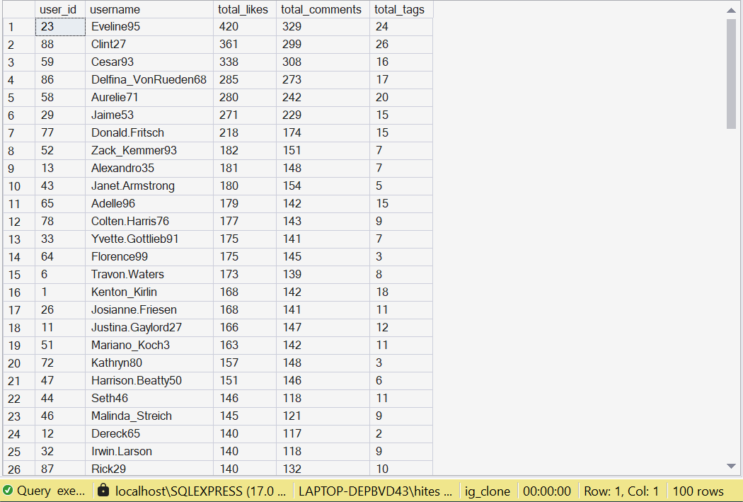

Visualization / Chart
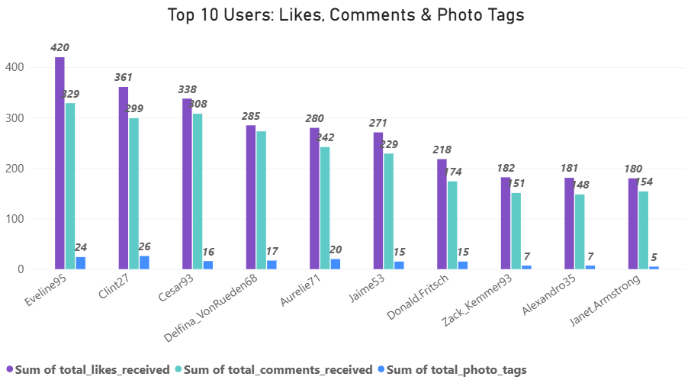

Brief Explanation
- The query calculates likes, comments and photo tags separately for each user's posts.
- The separate aggregations are then joined back to the users table.
- This approach avoids join fan-out, which can otherwise multiply rows and inflate counts when several one-to-many tables are joined together.
- The result provides a compact engagement profile for each user and can be used for segmentation and creator analysis.

Q11) Rank users based on their total engagement (likes, comments and shares) over a month.

SQL Code
-- Q11: Rank users based on their total engagement
-- (likes + comments) over a month
-- Type of query/logic: CTE + UNION ALL + GROUP BY + RANK()
-- Step 1: Combine likes and comments into one engagement dataset
-- Step 2: Extract the year and month of each interaction
-- Step 3: Aggregate total engagement per user per month
-- Step 4: Rank users within each month using RANK()
-- Note: The supplied schema has no shares data, so engagement
-- is calculated using likes + comments only.
-- =========================================================
WITH monthly_engagement AS (
SELECT
l.user_id,
YEAR(l.created_at) AS engagement_year,
MONTH(l.created_at) AS engagement_month,
COUNT(*) AS engagement_count
FROM likes l
GROUP BY
l.user_id,
YEAR(l.created_at),
MONTH(l.created_at)
UNION ALL
SELECT
c.user_id,
YEAR(c.created_at) AS engagement_year,
MONTH(c.created_at) AS engagement_month,
COUNT(*) AS engagement_count
FROM comments c
GROUP BY
c.user_id,
YEAR(c.created_at),
MONTH(c.created_at)
),
user_monthly_engagement AS (
SELECT
user_id,
engagement_year,
engagement_month,
SUM(engagement_count) AS total_engagement
FROM monthly_engagement
GROUP BY
user_id,
engagement_year,
engagement_month
)
SELECT
ume.user_id,
u.username,
ume.engagement_year,
ume.engagement_month,
ume.total_engagement,
RANK() OVER (
PARTITION BY
ume.engagement_year,
ume.engagement_month
ORDER BY
ume.total_engagement DESC
) AS monthly_engagement_rank
FROM user_monthly_engagement ume
JOIN users u
ON u.id = ume.user_id
ORDER BY
ume.engagement_year,
ume.engagement_month,
monthly_engagement_rank,
u.username;
GO

Output Image of SQL
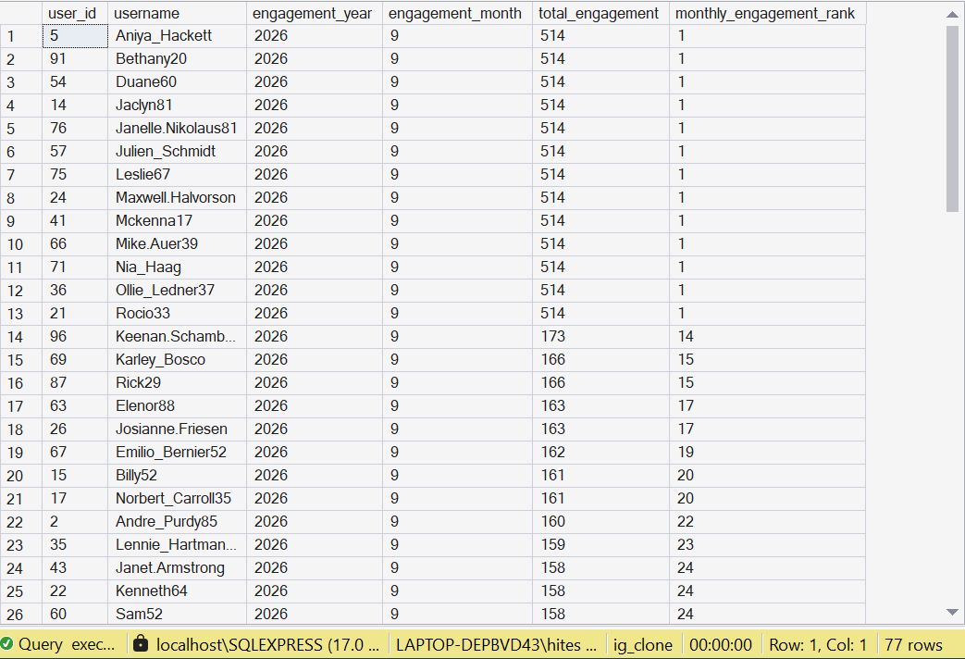

Visualization / Chart
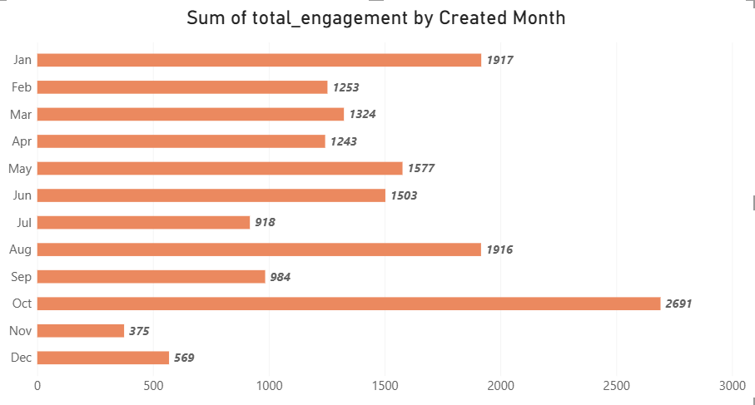

Brief Explanation
- The query combines likes and comments into one engagement dataset using UNION ALL.
- The interaction date is used to group engagement by user, year and month.
- RANK() with PARTITION BY ranks users separately within each month.
- The supplied schema does not contain share data, so the project calculation uses likes plus comments only.
- The available interaction timestamps should be interpreted carefully because the supplied table definitions use default timestamps for these interaction records.
Data limitation: The question mentions shares, but no shares field/table exists in the supplied schema. The available calculation therefore uses likes + comments.

Q12) Retrieve the hashtags that have been used in posts with the highest average number of likes. Use a CTE to calculate the average likes for each hashtag first.

SQL Code
-- Q12: Hashtags used in posts with the highest average likes
-- Type of query/logic: CTE (WITH clause) + multi-table JOIN + AVG/GROUP BY
-- Step 1 (CTE): compute avg likes per photo, per tag
-- Step 2: order tags by that average, take the top ones
-- =========================================================
WITH hashtag_avg_likes AS (
SELECT
t.id AS tag_id,
t.tag_name,
AVG(CAST(likes_per_photo.like_count AS FLOAT)) AS avg_likes
FROM tags t
JOIN photo_tags pt ON pt.tag_id = t.id
JOIN (
SELECT photo_id, COUNT(*) AS like_count
FROM likes
GROUP BY photo_id
) AS likes_per_photo ON likes_per_photo.photo_id = pt.photo_id
GROUP BY t.id, t.tag_name
)
SELECT TOP 10
tag_name,
ROUND(avg_likes, 2) AS avg_likes
FROM hashtag_avg_likes
ORDER BY avg_likes DESC;
GO

Output Image of SQL
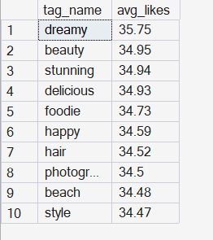

Visualization / Chart
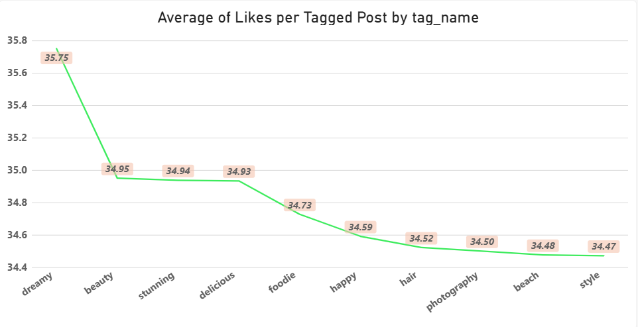

Brief Explanation
- The CTE calculates the average number of likes associated with each hashtag.
- The query connects tags, photo_tags and per-photo like counts to relate hashtags to post engagement.
- The hashtags are then sorted by average likes and the top 10 are returned.
- High-average-like hashtags can be useful signals for content themes that attract stronger engagement, subject to the data limitations of the sample.

Q13) Retrieve the users who have started following someone after being followed by that person.

SQL Code
-- Q13: Users who started following someone after that person
-- had already followed them first
-- Type of query/logic: Self-join on the same table (follows f1, f2)
-- via a correlated EXISTS subquery, matching the reverse pair
-- =========================================================
SELECT
f1.follower_id,
f1.followee_id,
f1.created_at AS f1_followed_on,
f2.created_at AS f2_followed_on
FROM follows f1
JOIN follows f2
ON f1.follower_id = f2.followee_id
AND f1.followee_id = f2.follower_id
WHERE f1.created_at > f2.created_at;
GO

Output Image of SQL
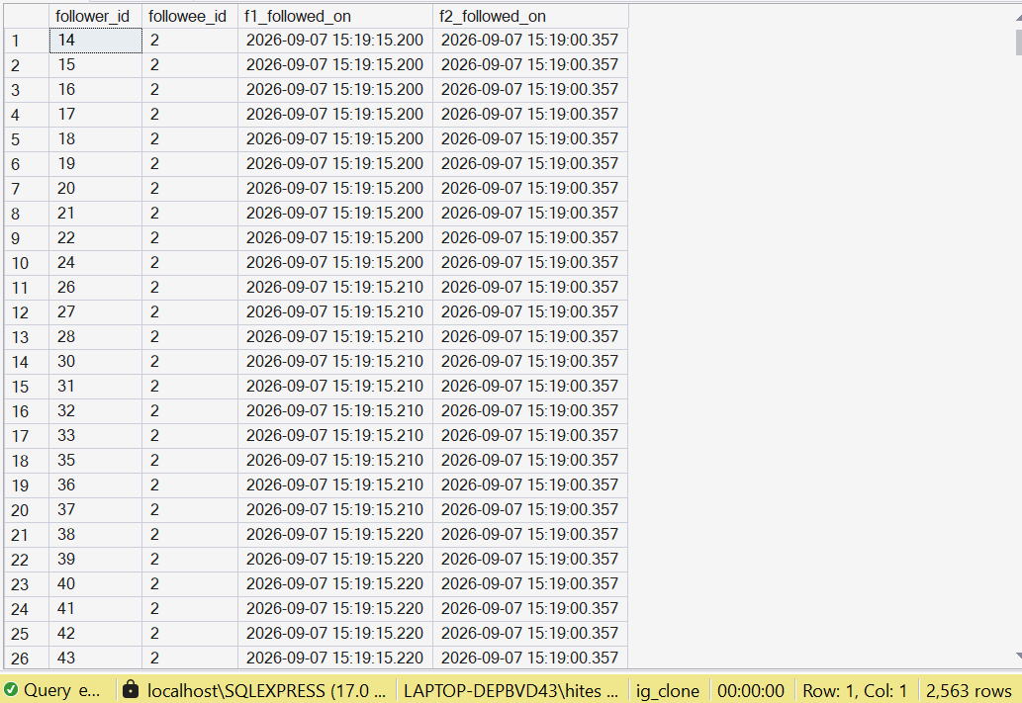

Brief Explanation
- The follows table is used twice with different aliases, f1 and f2.
- The query matches reverse follower-followee pairs to identify two-way relationships.
- The created_at values are compared so that the later follow can be identified.
- This is a self-join problem because the same table contains both sides of the relationship.
- Such reciprocal relationships can help identify closely connected users or community relationships.

SUBJECTIVE QUESTIONS
The subjective questions translate the SQL findings into business recommendations. The answers are written in simple English and use the available dataset while clearly stating where additional data would be required.
Q1) Based on user engagement and activity levels, which users would you consider the most loyal or valuable? How would you reward or incentivize these users?
Visualization / Chart (for reference)
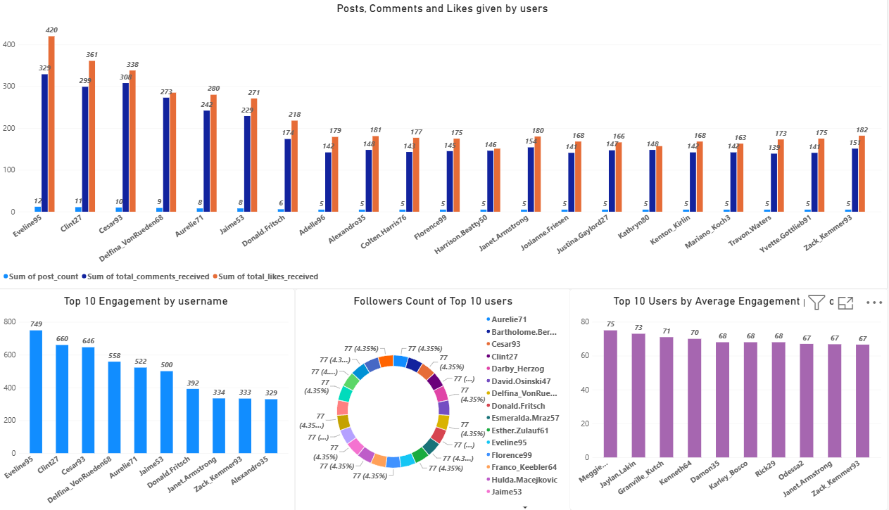

Approach
- Use Objective Q2 to understand overall activity, Objective Q4 to identify users whose posts receive strong engagement, Q5 to assess follower reach, and Q6 to compare average engagement per post.
- Do not judge value using one metric alone. A user with many followers but weak engagement may be less valuable for an engagement campaign than a smaller creator with highly engaged followers.

Insights
- The most valuable users should be those who show consistently strong participation and/or generate strong engagement on their content.
- Users with both strong engagement and meaningful follower reach are especially useful for creator and influencer opportunities.
- Highly active community members can also help maintain platform interaction and encourage other users to participate.

Recommendations
- Offer recognition such as creator badges, featured opportunities or early access to selected programs.
- Use exclusive challenges, rewards or community programs to encourage continued participation.
- For strong creators, consider structured creator partnerships rather than one-time promotions.
- Measure whether incentives increase activity and engagement before expanding the program.

Q2 For inactive users, what strategies would you recommend to re-engage them and encourage them to start posting or engaging again?

Approach
- Use Q2 and Q7 to identify users with very low activity or users who have never liked a post.
- Separate completely inactive users from users who browse but rarely interact, because the two groups may need different messages.

Visualization / Chart (for reference)
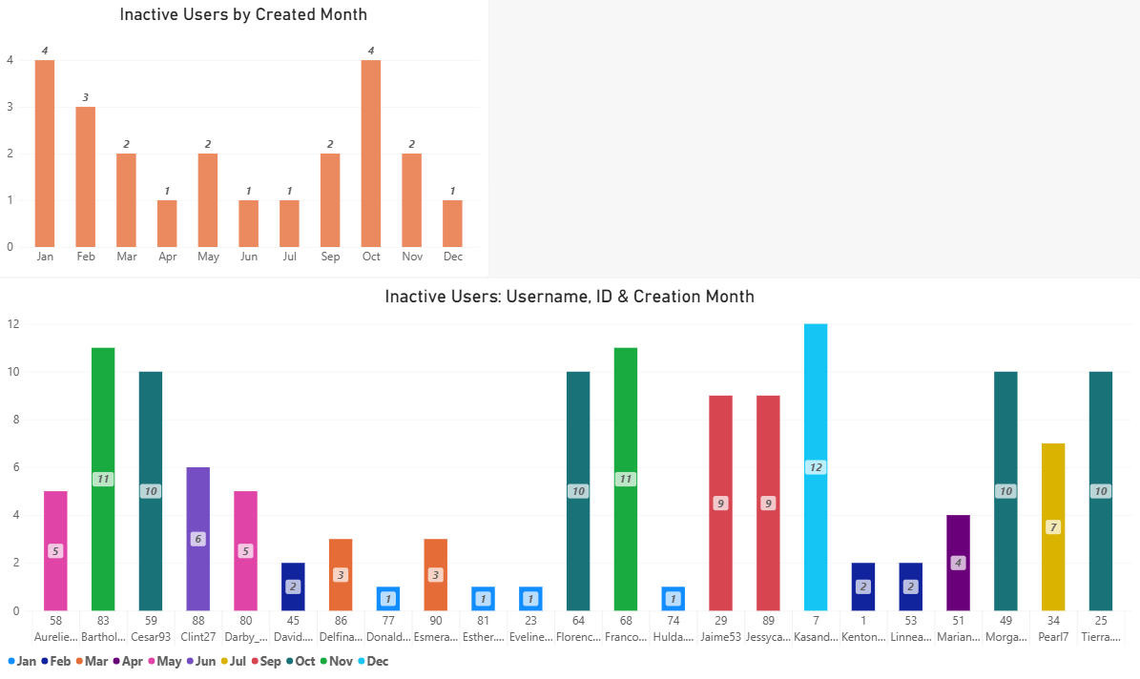

Insights
- A single re-engagement message is unlikely to work equally well for every inactive user.
- Users with some previous activity may be easier to reactivate than users who have never engaged.
- Low-friction actions such as liking, commenting or joining a simple challenge can be easier starting points than asking a user to create a post immediately.

Recommendations
- Send personalized reminders based on previous interests or activity.
- Use simple prompts such as polls, challenges, trending topics or easy posting ideas.
- Offer limited-time incentives for returning users, while avoiding excessive notifications.
- Track reactivation rate, repeat activity and retention after the campaign.
Q3) Which hashtags or content topics have the highest engagement rates? How can this information guide content strategy and ad campaigns?

Approach
- Use Q12 to identify hashtags associated with higher average likes.
- Combine hashtag performance with other engagement measures instead of relying only on hashtag frequency.
Visualization / Chart (for reference)

Insights
- Hashtags with higher average likes can indicate topics that attract stronger user interest in the sample.
- A popular hashtag is not automatically a good marketing target; the quality and consistency of engagement should also be considered.
- Hashtag performance can help guide which themes deserve more content experiments.

Recommendations
- Create more content around themes showing strong engagement, while continuing to test new topics.
- Use high-performing themes in relevant ad creatives and audience segments.
- Avoid overusing the same hashtags; combine established themes with new experiments.
- Monitor engagement after campaigns to confirm that the relationship continues.

Q4) Are there any patterns or trends in user engagement based on demographics (age, location, gender) or posting times? How can these insights inform targeted marketing campaigns?

Approach
- The ideal approach would combine engagement with age, location, gender and reliable posting timestamps.
- The supplied dataset does not contain age, gender or location fields, so demographic-level conclusions cannot be calculated from this project database.
- Posting-time analysis is also limited because the photo table uses a default timestamp and the supplied photo inserts do not provide a meaningful historical posting-time field.

Insights
- No reliable demographic pattern should be claimed from the current dataset.
- The absence of demographic fields is a data limitation, not evidence that demographic differences do not exist.
- A future analysis could compare engagement by demographic group and by hour/day once those fields are available.

Recommendations
- Add appropriate demographic and geographic attributes where legally and ethically permitted.
- Capture reliable content-posting timestamps for time-of-day analysis.
- Once available, test engagement across demographic segments and posting windows before making campaign decisions.
- Use statistically meaningful sample sizes and avoid targeting decisions based on very small groups.

Q5) Based on follower counts and engagement rates, which users would be ideal candidates for influencer marketing campaigns? How would you approach and collaborate with these influencers?

Approach
- Use Objective Q5 for follower reach and Objective Q4/Q6 for engagement strength.
- Prioritize users who combine strong follower reach with strong engagement instead of selecting influencers using follower count alone.
- Compare total engagement and average engagement per post to avoid favouring users simply because they post more often.

Visualization / Chart (for reference)
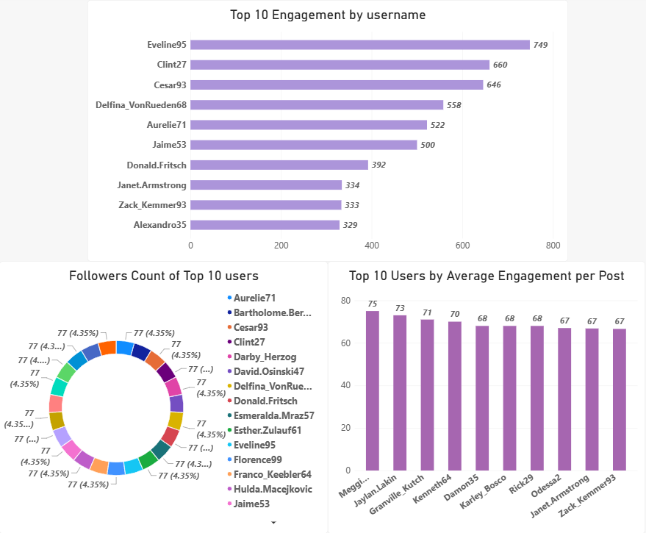

Insights
- High follower count provides reach, while high engagement indicates that an audience is actually interacting with the creator's content.
- A smaller but highly engaged creator can be valuable for focused campaigns.
- The strongest candidates should therefore balance reach, engagement and content relevance.

Recommendations
- Create a shortlist using follower count plus engagement metrics.
- Review content relevance and audience fit before contacting a creator.
- Use clear campaign objectives, deliverables and measurement criteria.
- Track engagement, clicks and conversions where campaign data is available.

Q6) Based on user behavior and engagement data, how would you segment the user base for targeted marketing campaigns or personalized recommendations?

Approach
- Combine post activity from Q2, engagement received from Q4/Q6, interaction totals from Q10, follower/following behaviour from Q5 and non-engagement from Q7.
- Create behavioural segments rather than treating every user as equally active.
Visualization / Chart (for reference)
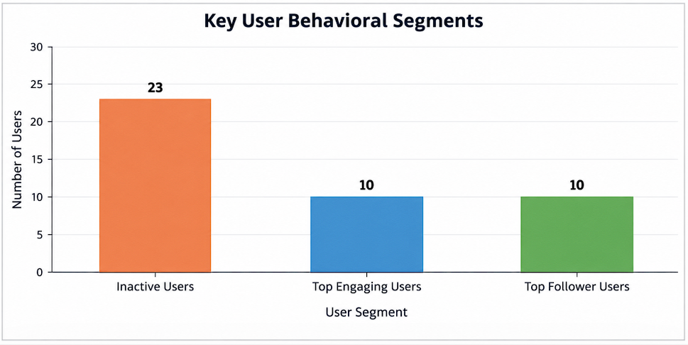

Insights
- A practical segmentation can separate highly active users, highly engaging creators, socially connected users, moderate users and inactive users.
- Users who generate engagement and users who mainly consume content may require different campaign objectives.
- Segmentation becomes more useful when multiple behaviour signals are considered together.

Recommendations
- High-engagement users: use loyalty, creator and advocacy programs.
- Highly connected users: test community and sharing campaigns.
- Moderately active users: use personalized content and engagement prompts.
- Inactive users: use reactivation campaigns with low-friction actions.
- Refresh segments periodically so users can move between groups as behaviour changes.

Q7) If data on ad campaigns (impressions, clicks, conversions) is available, how would you measure their effectiveness and optimize future campaigns?

Approach
- Connect campaign data to the audience, creative, placement and time period used for each campaign.
- Calculate funnel metrics from exposure to conversion and compare them across campaigns or segments.

Insights
- Impressions show reach, clicks show interest, and conversions show whether that interest resulted in the desired action.
- A campaign can have many clicks but still perform poorly if conversions are low.
- The most useful comparison is therefore based on the complete funnel, not one metric.

Recommendations
- Track CTR = clicks / impressions.
- Track conversion rate = conversions / clicks.
- Track cost per conversion and return on ad spend when cost and revenue data are available.
- Test different creatives, audiences and placements and shift budget toward combinations that deliver stronger business outcomes.

Q8) How can you use user activity data to identify potential brand ambassadors or advocates who could help promote Instagram's initiatives or events?

Approach
- Combine engagement received, activity level, follower reach and consistency of participation.
- Look for users who actively participate and have the ability to influence or engage other users.

Visualization / Chart (for reference)
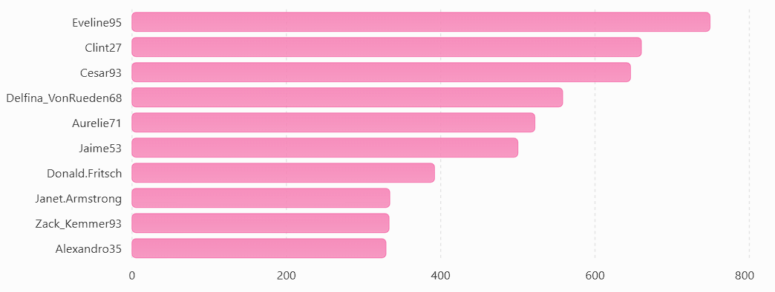

Insights
- A potential advocate does not need to have the largest follower count.
- Consistent participation and strong engagement can indicate that a user is trusted or active within a community.
- Users who combine reach with meaningful engagement are stronger ambassador candidates.

Recommendations
- Build an ambassador shortlist using multiple engagement and reach signals.
- Invite suitable users to early-access programs, events or creator communities.
- Give ambassadors clear messaging and creative freedom within campaign guidelines.
- Measure participation, engagement and downstream campaign results.

Q9) How would you approach this problem, if the objective and subjective questions weren't given?

Approach
- Start with the business goal: understand how users behave and how the platform can improve engagement, retention and acquisition.
- Understand the schema and data relationships before writing queries.
- Perform data-quality checks for missing values, duplicates, invalid relationships and unusual records.
- Explore the data using descriptive statistics and simple aggregations.
- Investigate user activity, engagement, content and network behaviour.
- Turn important patterns into business questions and test them with SQL.
- Create clear visualizations and translate findings into practical recommendations.
- Validate the analysis and clearly state data limitations before presenting conclusions.

Insights
- A strong analytics project should begin with the business problem rather than jumping directly into SQL.
- The analyst should move from data quality to exploration, then from patterns to business recommendations.
- The same process can be reused for many real-world analytics projects even when the specific questions are not provided.

Recommendations
- Use a structured workflow: Business problem → Data understanding → Data quality → Exploration → Analysis → Insights → Recommendations → Validation.
- Keep an analysis log so that assumptions and definitions are documented.
- Prioritize findings that can lead to a measurable business action.

Q10) Assuming there is a User_Interactions table tracking user engagements, how can you update the Engagement_Type column to change all instances of 'Like' to 'Heart' to align with Instagram's terminology?

SQL Code
UPDATE User_Interactions
SET Engagement_Type = 'Heart'
WHERE Engagement_Type = 'Like';

Approach
- Use an UPDATE statement because the task asks to modify existing records.
- Use a WHERE condition so only rows where Engagement_Type is exactly 'Like' are changed.

Insights
- The operation changes the stored value without changing the number of records.
- Filtering the UPDATE is important because an UPDATE without a WHERE clause can modify every row in the table.

Recommendations
- Run a SELECT first to confirm how many 'Like' records exist.
- Run the UPDATE inside a transaction when appropriate so the change can be reviewed before committing.
- After the update, run a validation query to confirm that no unintended values were changed.

