## **Project Report**

## **On**

## **Task Pulse**



**Guru Nanak Dev University Regional Campus**

**Jalandhar, Punjab**

**“BACHELOR OF TECHNOLOGY IN**

**COMPUTER SCIENCE ENGNEERING”**

**(2022-2026)**

Submitted To: Submitted By:

“Ms/Mrs/Mr Teacher’s Name Hiteshi Joshi

Designation Roll No. “17032249057”

**Department of Computer Science & Engneering**

**Guru Nanak Dev University Regional Campus Jalandhar**

**DECLARATION**

The project report entitled “Task Pulse “was submitted by me to Guru Nanak Dev University for the degree of Bachelor of Technology in Computer Science Engineering. This is the original piece of work and has not been submitted to any other university for the award of any degree. I also undertake that any quotation or a philosophy from the published or unpublished work of another person has been duly acknowledged in the work that I present in the project report.

Place: Guru Nanak Dev University

Hiteshi Joshi

**TRAINING CERTIFICATE**

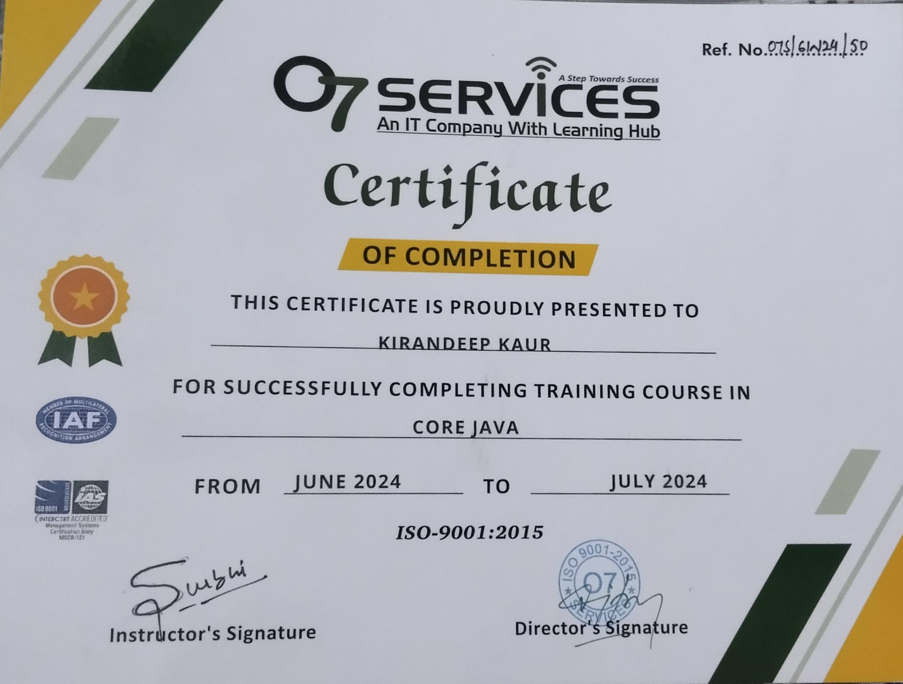

**COMPANY PROFILE**



O7 Services is an established company founded in 2015 and authorized by the government. They specialize in a variety of services including Web Development, Mobile Application Development, Custom Software Development, UI/UX Designing, Hosting services, Digital Marketing, Registration of Domain Names with various extensions, AMC & MMC Services, Bulk SMS and voice calls. O7 Services offers advanced IT solutions supporting the entire business cycle - from consulting to system development, deployment, quality assurance, and 24x7 support. With over 10 years of experience, the company aims to form long-lasting strategic partnerships with clients, offering affordable prices, timely delivery, and measurable business results. Their headquarters is located in Jalandhar with a branch office in Hoshiarpur. Some of the products developed by O7 Services include Vehicle Tracking System, Invoice Software, School Management System, Hospital Management System, Parents-Teacher Communication App, Fee Management system, Task Management System, Online Food Ordering App, Security App, Admission system, Inventory Software, and Car Servicing App. Additionally, O7 Services provides training programs including 6 Weeks/6 Months Industrial Training, Project-Based Training, Corporate Training, and Job-Oriented Courses Training, covering major IT trends such as Full Stack Development (MEAN/MERN), Flutter, Kotlin Android, Swift UI (iOS), Firebase, Python, Angular, React Js, Vue Nodejs, ASP.NET, NET Core, PHP, Laravel, CodeIgniter, Software Testing, cloud Computing, Blockchain, DevOps, Data Science, Artificial Intelligence, Machine Learning, UI/UX Designing, Digital Marketing, WordPress, Linux, CCNP, CCNA Security, Network Security, Cyber Security, MCSE, MCITP, Java, Spring, Hibernate, C/C++, Photoshop, Adobe Illustrator, Figma, CorelDraw and many more

+91- 8437365007, +91-181-5015007

E-Mail: [enquiry@o7services.com](mailto:enquiry@o7services.com) ,hr@o7services.com

[www.o7services.com](http://www.o7services.com)



# 

# 

# 

# 

# 

# 

# 

# 

# 

# 

# 

# 

# 

# 

# **ACKNOWLEDGEMENT**

It gives us great pleasure in bringing out the report titled **“Task Pulse”**. This project is not a solitary undertaking, it’s a work of many brains. We are pleased to take the opportunity of thanking all our teachers and friends for their help and assistance. We express our gratitude towards our project guide **Ms. Surbhi** for giving us the opportunity to take on our project work. We sincerely feel obliged to her for unreading efforts in guiding us for this project that will be great assistance to us in our future of the subject matter.

We thank her whole-heartedly for the expert guidance, encouragement, valuable suggestions and supervisions. Our sincere thanks also go to our parents, friends and our relatives for their ever-flowing love, care and timely guidance and encouragement.

Hiteshi Joshi

# **INDEX**

|  |  |  |
| --- | --- | --- |
| **Sr.** | **Title** | **Pg No.** |
| 1. | Student Declaration | 1 |
| 2. | Training Certificate | 2 |
| 3. | Company Profile | 3-4 |
| 4. | Acknowledgment | 5 |
| 5. | Chapter 1: Introduction of Project | 7 |
| 6. | Chapter 2: Problem Definition | 8-9 |
| 7. | Chapter 3: Technology Used | 10-11 |
| 8. | Chapter 4 System Design | 12-15 |
| 9. | Chapter 5 Hardware and Software Requirement | 16 |
| 10 | Chapter 6: Feasibility study | 17-19 |
| 11. | Chapter 7: Data Analysis | 20-22 |
| 12 | Chapter 8 ScreenShots | 23-32 |
| 13 | Chapter 9: Conclusion | 33 |
| 14. | Chapter 10: Future Scope | 34 |

**CHAPTER-1**

**Introduction of Project**

**1.1 INTRODUCTION:**

In the modern landscape of information management, Task pulse is the process of effectively and efficiently tracking, managing, and executing the life cycle of a task or many tasks within a project from inception to execution. The purpose of task Pulse is to improve the decision-making, communication, efficiency, and effectiveness of a task or project.

With a focus on optimising resource utilisation and improving user experience, our project aims to create a versatile platform that streamlines administrative tasks and facilitates seamless access to task materials. By leveraging innovative technologies, we seek to empower Admin to adapt to the evolving digital landscape while upholding their traditional role as bastions of learning and cultural enrichment.

**1.2. PROJECT DESCRIPTION**:

**Modules of Project**

There are various modules associated with the project. These modules are working in their specific area to lead and complete the project.

1. ADMIN

2. EMPLOYEE

**Admin modules:**

Admin can view all the information about the user and edit all details about the Employee.

1. Admin Login: Firstly, admin login with their account and manage the account of the registered employees and manage Task.
2. Logout: In this section admin can manage Logout. (Add, Update).

**Employee modules:** Project provides many facilities to the Employee.

1. Login
2. View project
3. Logout

**CHAPTER -2  
 PROBLEM DEFINITION**

Despite their enduring significance, many employees face challenges in effectively managing their resources and meeting the diverse needs of patrons in an increasingly digital world.

Task pulse, often lack the flexibility and efficiency required to keep pace with evolving technological advancements and changing user expectations. :

● Inefficient Resource Management: Manual cataloguing and tracking of Tasks materials can lead to inefficiencies in resource utilisation, hindering the ability to respond promptly to patron demands and preference

● Limited Accessibility: Outdated systems may lack user-friendly interfaces and robust search functionalities, making it difficult for patrons to navigate and access tasks materials effectively

● Data Security Concerns: With the increasing digitization of Task resources, there is a growing need to ensure the security and integrity of sensitive patron information and Admin data against potential cyber threats and breaches.

**2.1 EXISTING SYSTEM:**

The current state of Task pulse typically involves a combination of manual processes and legacy software solutions. While these systems have served employees for many years, they often struggle to keep pace with the demands of modern users and technological advancements. Key aspects of the existing system include.

Data Security Risks: With the increasing digitization of tasks resources and patron success. Existing systems may lack robust security measures to protect sensitive information, leaving employees vulnerable to potential cyber threats and privacy violations.

Limited Scalability : Many legacy Task Pulse lack scalability and flexibility to accommodate the growing needs of modern employees. They may struggle to integrate with new technologies, expand library collections, or adapt to changing user preferences and emerging trends in information management.

**2.2 PROPOSED SYSTEM:**

The proposed Task pulse aims to revolutionise the way Admin operate by leveraging cutting-edge technology to automate processes, enhance user experience, and improve overall efficiency. Key components of the proposed system include:

#### **1. Integrated Online Platform**

* **Centralized Hub:** The system will feature a comprehensive online platform accessible to both employees and admins. This platform will serve as a centralized hub for all activities related to task management, resource allocation, employee management, and administrative tasks.
* **User-Friendly Interface:** Designed for ease of use, the platform will offer an intuitive interface for quick navigation and task execution.

#### **2. User Roles and Permissions**

* **Admin Role:**
  + **Employee Management:** Create, edit, and delete employee profiles.
  + **Project and Task Assignment:** Assign projects and tasks to employees with deadlines and priority levels.
  + **Monitoring and Reporting:** Oversee project progress, task completion.
* **Employee Role:**
  + **Access and Updates:** Log in to the system to view assigned projects and tasks, update task status.

#### **3. Automated Task Assignment and Progress Tracking**

* **Dynamic Task Allocation:** Automatically assign tasks based on employee availability, skill sets, and current workload to optimize resource utilization.
* **Real-Time Tracking:** Monitor task progress in real-time, enabling timely interventions and adjustments

**CHAPTER 3**

**TECHNOLOGY USED**

**3.1 Java**

Java is a multi-platform, object-oriented, and network-centric language that can be used as a platform in itself. It is a fast, secure, reliable programming language for coding everything from mobile apps and enterprise software to big data applications and server-side technologies.

**3.1: Java**

**3.2 Xampp server**

XAMPP is one of the widely used cross-platform web servers, which helps developers to create and test their programs on a local webserver. It was developed by the Apache friends, and its native source code can be revised or modified by the audience. It consists of Apache HTTP server, Maria DB, and interpreters for different programming languages like PHP and Perl.

It is available in 11 languages and supported by different platforms such as the IA-32 package of windows and the x64 package of macOS and Linux.

**What is XAMPP?**

XAMPP is an abbreviation where X stands for Cross-Platform, A stands for Apache, M stands for MySQL and Ps stands for PHP and Perl. It is an open-source package of web solutions that includes Apache distribution of many servers and common-line executable along with modules such as Apache server, MariaDB, PHP, and Perl.

XAMPP helps a local host or server to test its website and clients via computer and laptop before releasing it to the main server. It is a platform that furnishes a suitable environment to and verify

working on projects based on Apache, Perl, MySQL database, and PHP through the system of the host itself. Among these technologies, Perl is a programming language used for web development,

PHP is a backend scripting language, and MariaDB Is the most vividly used database developed by MySQL.  


**3.2 diagram of: XAMPP**

**3.3 MYSQL**

A database is a separate application that stores a collection of data. Each database has one or more distinct APIs for creating, accessing, managing, searching and replicating the data it holds other kinds of data stores can also be used, such as files on the file system or large hash tables in memory but data fetching and writing would not be so fast and easy with those type of systems.

MySQL is an open-source relational database management system (RDBMS) that uses Structured Query Language (SQL) for database management. It's known for its high performance, scalability, and reliability, making it suitable for both small and large-scale applications. MySQL supports various operating systems, including Linux, Windows, and macOS, and offers features like robust transaction support, advanced security, and replication for high availability. It’s a key component of the LAMP stack (Linux, Apache, MySQL, PHP/Python/Perl) and is available in both a free community edition and a commercial enterprise edition with additional features and support.  
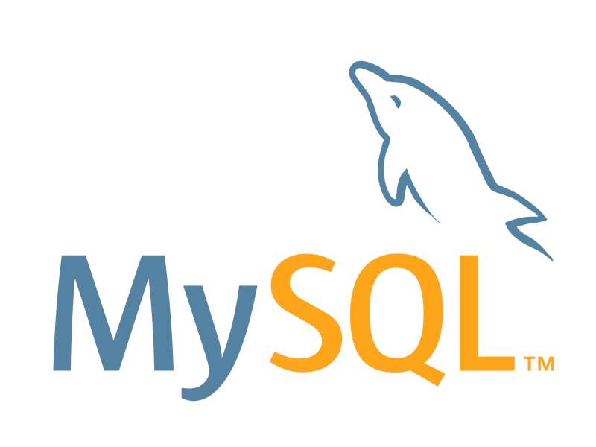

**CHAPTER - 4**

**System Design**

**4.1 Introduction of System Design**

System design in software development refers to the process of planning and creating the architecture and structure of a system. It involves making decisions about the overall system, including the technologies, frameworks and components that will be used. System design considers factors like scalability, performance, security and maintainability. It also involves designing the user interface, database structure and integration of different modules or services.

**4.2 Objectives of System Design**

1. Practicality: We need a system that should be targeting the set of audiences(users) corresponding to which they are designing.

2. Accuracy: Above system design should be designed in such a way it fills nearly all requirements around which it is designed be it functional or non-functional requirements.

3. Completeness: System design should meet all user requirements.

4. Efficient: The system design should be such that it should not overuse surpassing the cost of resources nor under use as it will by, now we know will result in low throughput (output) and less response time(latency).

5. Reliability: The system designed should be in proximity to a failure-free environment for a certain period of time.

6. Optimization: Time and space are just likely what we do for code chunks for individual components to work in a system.

**4.3 Initial Design**

1. Requirements In this I understand the requirements of what my client or stakeholder want in their system like colour, design, templates.

2 Technology used: I used Java Language to make frontend and backend and MySQL useas Database and for GUI i use Swing UI framework.

3. Security and Privacy Security & privacy are crucial aspects of a system. I provide the transaction security of my clients because they can freely purchase the clothes. Also, I hide the personal information of the client.

**4.4 Data Flow Diagram**

DFD is the visual representation that shows how data flows within a system or process. DFDs use different symbols to represent processes, inputs, outputs and data stores. They provide a clear and concise overview of how data moves through a system, making it easier to understand and analyze complex processes. DFDs are commonly used in software development and system analysis to model and document data flow within a system.

|  |  |
| --- | --- |
| Symbols | Description |
|  | Data Flow – Data flow are pipelines through the packets of information flow. |
|  | Process: A Process or task performed by the system. |
|  | Entity:. A source or destination data of a system. |
|  | Data Store: A place where data to be stored. |

**4.5 Context level DFD – 0 level**

The context level data flow diagram (DFD) describes the whole system. The (o) level DFD

describes the all user modules who operate the system. Below data flow diagram of gallery

shows the two users can operate the system Admin and employee.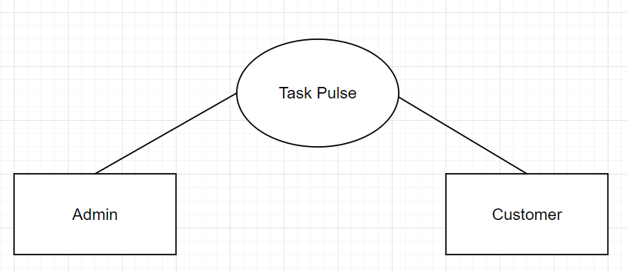

**4.6 Level 1 DFD**

Level 1 DFD expands on the context diagram by breaking down the main process into smaller, more detailed sub-processes. Each subprocess represents a major function or activity within the system. It also shows the flow of data between these subprocesses and external entities

DFD Level 1 for Admin Panel

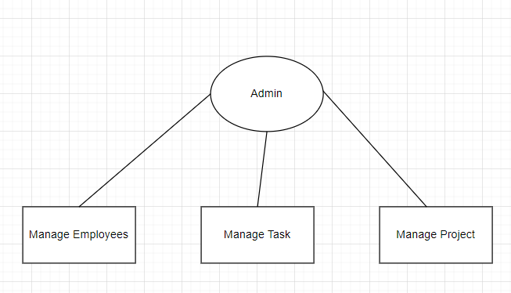

**Fig 4.6(DFD Level 1 Admin Panel)**

**DFD Level 1 for Employee Panel**

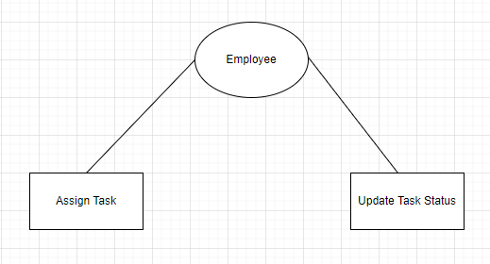

**Fig 4.7(DFD Level 1 Employee Panel)**

**CHAPTER 5**

**HARDWARE & SOFTWARE REQUIREMENTS**

For this project minimum hardware and software requirements are listed below:

**5.1 Hardware Requirements:**

1. RAM: 8 GB
2. Hard Disk: 50 GB
3. Processor: i3 or above version

**5.2 Software Requirements:**

1. End Tool: JAVA, MYSQL
2. Frontend Framework: Swing UI
3. Database: MYSQL
4. Browser: IE 7.0/Mozilla Firefox 6.0/Cross
5. Operating System: Windows Operating System / Linux

**CHAPTER-6**

**FEASIBILITY STUDY**

A feasibility study is an essential step in project planning, helping to determine the viability of a proposed project or business venture. It involves a comprehensive analysis of various aspects to access and potential success of the project. Evaluate resources and determine the return on investment.

A feasibility study for a task pulse project aims to evaluate the viability of the project from various perspectives, including technical, economic, legal, operational, and scheduling considerations.

Feasibility studies provide crucial information for decision-making, helping project managers discern the pros and cons of a project before significant investments are made.

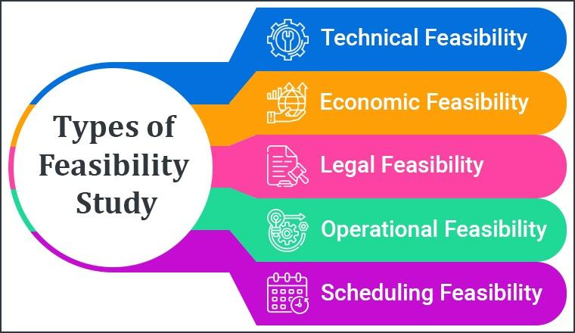

***Figure: Feasibility Diagram***

**6.1 TYPES OF FEASIBILITY STUDY**

**6.1.1. Technical Feasibility:**

* **Technology Requirements:** Identification of necessary technologies (e.g., web development frameworks, databases, cloud services).
* **System Architecture:** Proposed system architecture, including front-end and back-end components, APIs, and integrations.
* **Technical Skills:** Evaluation of the technical skills required for development and maintenance.
* **Infrastructure Needs:** Hardware, software, and network infrastructure requirements.
* **Scalability:** Potential for scaling the app to accommodate increasing users and data.

**6.1.2. Operational Feasibility:**

* **Business Model:** Outline of the business model (e.g., subscription-based, pay-per-use, freemium).
* **Operational Workflow:** Detailed workflow of how the app will operate, from user registration to parking space reservation and payment.
* **Resource Requirements:** Human resources, training, and support needed to operate the app.
* **Maintenance Plan:** Ongoing maintenance and support plans for the app.

**6.1.3. Economic Feasibility:**

* **Cost Analysis:** Estimation of costs involved in developing, launching, and maintaining the app (e.g., development costs, marketing expenses, operational costs).
* **Revenue Projections:** Expected revenue from different sources (e.g., user fees, advertisements, partnerships).
* **Return on Investment (ROI):** Calculation of the ROI based on cost and revenue projections.
* **Funding Requirements:** Identification of potential funding sources and financial requirements.

**6.1.4. Legal and Regulatory Feasibility:**

* **Regulatory Requirements:** Identification of relevant regulations and compliance requirements (e.g., data privacy laws, payment processing regulations).
* **Legal Considerations:** Legal aspects of operating a parking app, including liability issues, terms of service, and user agreements.
* **Intellectual Property:** Protection of intellectual property, such as trademarks and copyrights.

**6.1.5. Risk Analysis:**

* **Risk Identification:** Identification of potential risks (e.g., technical challenges, market competition, regulatory changes).
* **Risk Assessment:** Evaluation of the likelihood and impact of each risk.
* **Mitigation Strategies:** Strategies to mitigate identified risks.

**6.1.6. Scheduling Feasibility:**

* **Project Timeline:** Detailed project timeline with milestones, deliverables, and deadlines.
* **Resource Allocation:** Allocation of resources to different phases of the project.
* **Contingency Plans:** Plans to handle delays or unexpected issues.

**CHAPTER -7**

**SYSTEM ANALYSIS**

**7.1 DATA ANALYSIS**

Before developing this project, In the existing system all greetings are given manually. As we know, nowadays computers are used in every field. We can remove the manual work by using an automatic system. We see first that if it is feasible or not whether technically, economically, or operationally. We test whether it properly works or not. Its technical requirements are feasible or not. We analysed the system properly and then started designing it. After Designing, we implement this project to see

whether this project works properly or not. After implementing the project, we check whether there is any problem for the user while using this project. Prior to stating whether the system we have to develop is feasible or not we believe that we should emphasize on what is implied by the word “Analysis”. Analysis is the measure of how beneficial or practical the Development of the system will be to the organisation. It is a preliminary survey for the system &# 39s investigation. It aims to provide information to facilitate a later in-depth investigation.

Types

There are various measures of analysis helpful to decide whether a particular project is feasible or not.

These measures include –

⮚ Operational Analysis

⮚ Technical Analysis

⮚ Economical Analysis

Each of these types will be explained in detail throughout the project

Report Operational analysis A proposed system is beneficial only if it can be turned into an information system that will meet the operational requirements of an organisation. A system often

fails if it does not fit within existing operations and if users resist the change. Important issues a systems developer must look into are: Will the new system be used if implemented in an organisation?

Are there any major barriers to implementation or is the proposed system accepted without the wrong hands could jeopardise the entire IT organisation. Unlike in semi-computerized systems, the proposed system offers adequate control to protect against fraud and embezzlement and guarantees the accuracy and Security of data and information. This is handled by the system providing individuals with separate login names and passwords. The new system is user-friendlier, which enables the end-user to complete his/her work efficiently and accurately with interest. After taking the above fact into consideration we can state the operating of the proposed system is feasible.

**Economics Analysis**

In making recommendations a study of the economics of the proposed system should be made. Even though finding out the costs of the proposed project is difficult, assume and estimate the costs and benefits as follows. According to the computerised system we propose,

The costs can be broken down in two categories.

1. Costs associated with the development of the system.

2. Costs associated with operating the system.

**Technical Analysis**

Technical analysis assesses whether the technical resources required for the system are available or can be acquired. This includes evaluating hardware, software, and network requirements, as well as ensuring the technical expertise needed to develop and maintain the system is present. The feasibility of the system from a technical perspective involves:

* Assessing the current technology infrastructure.
* Determining the compatibility of new technology with existing systems.
* Evaluating the technical skills of the team responsible for development and maintenance.

The technical requirements of the proposed system are feasible, as the necessary infrastructure and skills are available.

**Operational Analysis**A proposed system is beneficial only if it can be turned into an information system that meets the operational requirements of an organization. A system often fails if it does not fit within existing operations and if users resist the change. Important issues a systems developer must consider include:

* Will the new system be used if implemented in the organization?
* Are there any major barriers to implementation, or is the proposed system accepted without resistance?

The proposed system provides adequate control to protect against fraud and embezzlement, ensuring the accuracy and security of data and information. This is achieved by providing individuals with separate login names and passwords. The new system is more user-friendly, enabling end-users to complete their work efficiently and accurately. Considering these factors, we can state that the operation of the proposed system is feasible.

**CHAPTER -8**

**SCREENSHOTS**

**8.1 Main Screen**

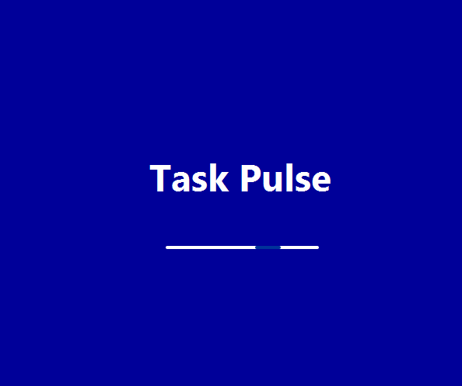

**8.1 diagram of: Main Screen**

**8.2 : Login Page**

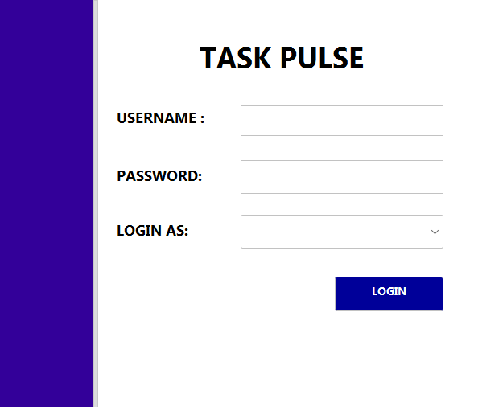

**8.2 diagram of: Login Page**

**8.3 Admin Login Page**

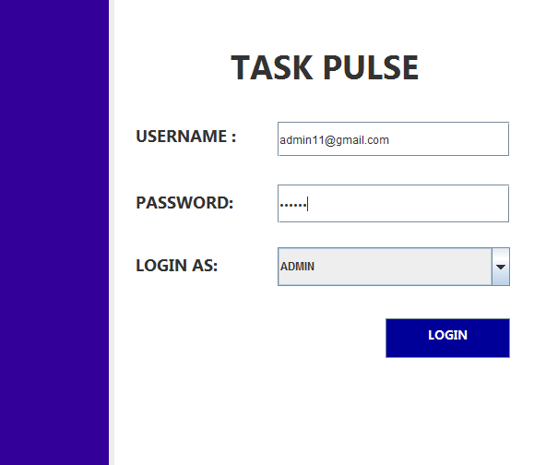

**8.3 diagram of: Admin Login Page**

**8.4 Admin Dashboard**

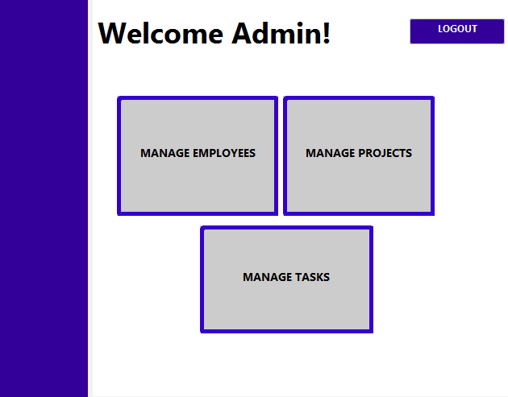

**8.4 diagram of:** **Admin Dashboard**

**8.5 Manage Employees**

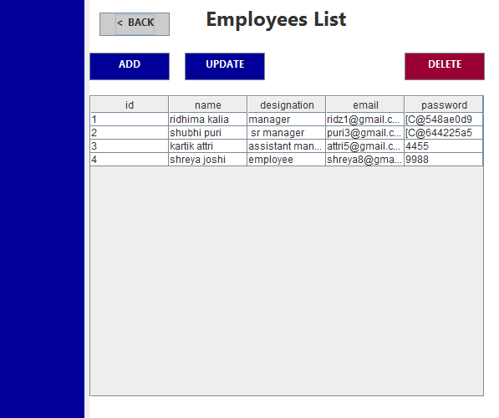

**8.5 diagram of: Manage Employees**

**8.6 Manage Projects**

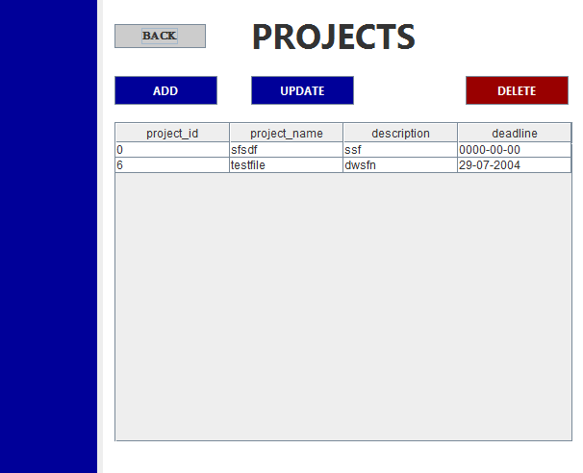

**8.6 diagram of: Manage Projects**

**8.7 Manage Tasks List**

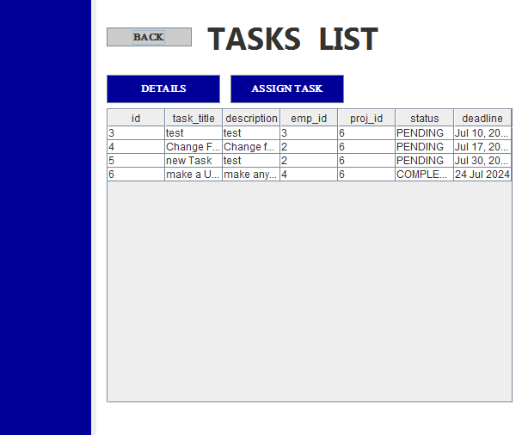

**8.7 diagram of : Manage Task List**

**8.8 Employee Login Page**

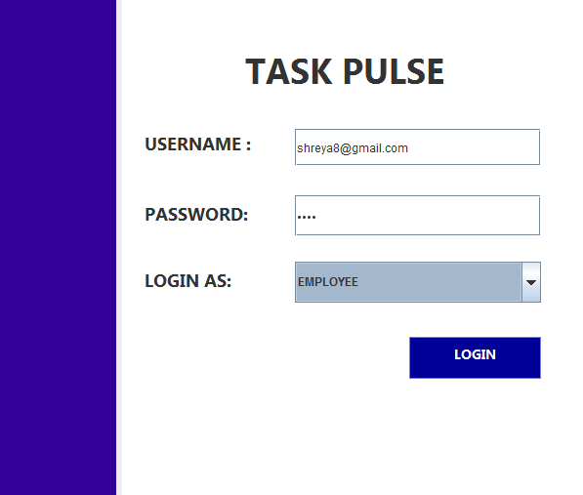

**8.8 diagram of: Employee Login Page**

**8.9 Employee Dashboard**

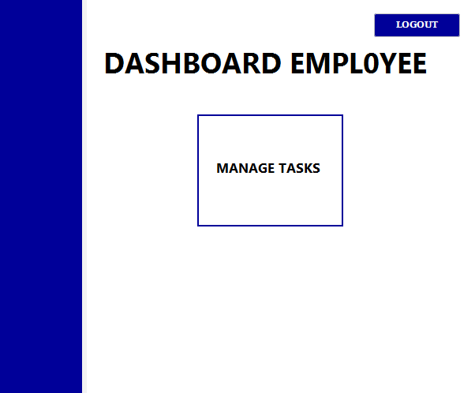

**8.9 diagram of: Employee Dashboard**

**8.10 Manage Tasks**

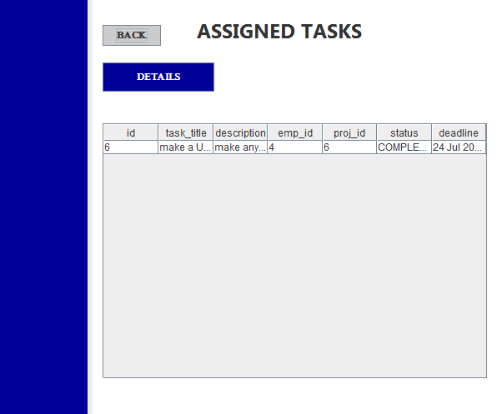

**8.10 diagram of: Manage Tasks**

**CHAPTER -9**

**CONCLUSION**

The project provides a robust foundation for effective employee and task management, with a user-friendly interface and essential features that streamline administrative processes. By allowing admins to manage employees and tasks efficiently and enabling employees to access their projects and tasks easily, the system improves organizational productivity and communication.

Looking ahead, the integration of AI and ML, enhanced analytics, mobile accessibility, and improved security measures could further elevate the system's functionality and user experience. These advancements will not only optimize task allocation and project management but also ensure that the platform remains relevant and effective in an increasingly digital and mobile-first work environment.

Overall, this project addresses current administrative and operational challenges while offering a scalable and adaptable solution for future needs. With continuous development and the integration of advanced technologies, it holds the potential to become an indispensable tool for organizations aiming to enhance their productivity and efficiency.

**CHAPTER -10**

**FUTURE SCOPE**

The project, designed to facilitate admin management of employees and tasks while enabling employees to view their projects and tasks, holds significant potential for future enhancements. One promising avenue is the integration of artificial intelligence (AI) and machine learning (ML) to optimize task allocation and project management. By analyzing employee performance data and project requirements, AI algorithms could automatically assign tasks to the most suitable employees, thereby maximizing efficiency and productivity.

Additionally, incorporating advanced analytics and reporting tools would provide deeper insights into project progress, employee performance, and potential bottlenecks. This data-driven approach can help in making informed decisions and improving overall workflow management.

The system could also be expanded to include mobile applications, ensuring that employees and admins can access the platform from anywhere, thereby enhancing flexibility and responsiveness. Furthermore, integrating third-party tools such as calendar apps, communication platforms, and project management software could create a more cohesive and interconnected work environment.

Another future enhancement could be the implementation of a more robust security framework, incorporating multi-factor authentication (MFA) and advanced encryption methods to protect sensitive data. This would be particularly crucial as the system scales and handles more significant amounts of data.