KINDRED: SMART CITY EMERGENCY RESPONSE AND MANAGEMENT SYSTEM
A PROJECT REPORT
Submitted by
HITESH SINGLA (25BCS11432)
in partial fulfillment for the award of the degree of
BACHELOR OF ENGINEERING
IN
COMPUTER SCIENCE AND ENGINEERING

Chandigarh University
November 2026

BONAFIDE CERTIFICATE
Certified that this project report “KINDRED: SMART CITY EMERGENCY RESPONSE AND MANAGEMENT SYSTEM” is the bonafide work of “HITESH SINGLA” who carried out the project work under my supervision.
SIGNATURE  Name: ______________________  HEAD OF THE DEPARTMENT  Computer Science and Engineering | SIGNATURE  Name: ______________________  SUPERVISOR  Designation: ________________  Computer Science and Engineering
Submitted for the project viva-voce examination held on ______________________
INTERNAL EXAMINER | EXTERNAL EXAMINER

TABLE OF CONTENTS

List of Figures 4
List of Tables 5
List of Standards 6
CHAPTER 1. INTRODUCTION 11
1.1. Identification of Client / Need / Relevant Contemporary issue 11
1.2. Identification of Problem 11
1.3. Identification of Tasks 12
1.4. Timeline 12
1.5. Organization of the Report 12
CHAPTER 2. LITERATURE REVIEW/BACKGROUND STUDY 14
2.1. Timeline of the reported problem 14
2.2. Existing solutions 14
2.3. Bibliometric analysis 15
2.4. Review Summary 15
2.5. Problem Definition 15
2.6. Goals/Objectives 16
CHAPTER 3. DESIGN FLOW/PROCESS 17
3.1. Evaluation & Selection of Specifications/Features 17
3.2. Design Constraints 17
3.3. Analysis of Features and finalization subject to constraints 19
3.4. Design Flow 19
3.5. Design selection 20
3.6. Implementation plan/methodology 21
CHAPTER 4. RESULTS ANALYSIS AND VALIDATION 24
4.1. Implementation of solution 24
CHAPTER 5. CONCLUSION AND FUTURE WORK 28
5.1. Conclusion 28
5.2. Future work 28
REFERENCES 29
APPENDIX 30
1. Plagiarism Report 30
2. Design Checklist 31
USER MANUAL 32

List of Figures

Figure 1.1 Gantt chart of the project timeline 12
Figure 3.1 Alternative designs for the solution 19
Figure 3.2 Kindred system workflow (browser demonstrations and C++ API-backed operations)
Figure 4.1 Conceptual shortest-path illustration; the implemented network appears in Figure 4.2
Figure 4.2 Graph module weighted-network view (screenshot) 26
Figure 4.3 Checkpoint filters and traversal result in the Graph module (screenshot) 27

List of Tables

Table 1.1 Project tasks and where they are reported 12
Table 2.1 Comparison of existing solutions 15
Table 3.1 Features ideally required in the solution 17
Table 3.2 Design constraints considered 18
Table 3.3 Finalisation of features 19
Table 3.4 Comparison of Design A and Design B 20
Table 3.5 Data-structure mapping to Smart City operations 21
Table 3.6 Typical complexity of the key operations 23
Table 4.1 Technologies used 24
Table 4.2 Educational graph calculation versus optional satellite layer 25
Table 4.3 Manual test cases 27

List of Standards

Standard | Publishing Agency | About the standard | Page no.
ECMA-262 (ECMAScript Language Specification) | Ecma International | Defines JavaScript syntax used by the browser-side modules and frontend; backend graph and queue operations are implemented in C++. | 24
HTML Living Standard | WHATWG | Defines the HTML5 markup used for the command-centre page and the six module pages. | 24
CSS specifications (Cascading Style Sheets) | W3C | Defines the styling, responsive layout and animation features used for the interface and map visualisation. | 24
RFC 9110: HTTP Semantics | IETF | Defines HTTP semantics used by the local C++ server for pages and JSON API responses. | 19
ISO/IEC 14882:2017 (C++17) | ISO/IEC | Specifies the C++17 language and library used by the local backend. | 24

ABSTRACT

Emergency response depends on a chain of data operations: an incident must be recorded, its urgency judged, an available vehicle located and a suitable response station chosen. No single way of organising data serves all of these operations efficiently, yet students of Advanced Data Structures and Algorithms (ADSA) usually meet data structures only as abstract definitions.
This project presents Kindred, a Smart City emergency-response demonstration for New Delhi that makes the choice of data structure visible. The command-centre dashboard presents 100 deterministic emergency records and a separate sample vehicle pool. Six interactive pages pair structures with tasks: an array for response-time readings, a linked list for vehicle-node operations, a stack for route-history demonstrations, a priority queue for emergency calls, a decision tree for triage rules, and a weighted graph for station routing. The frontend uses HTML5, CSS3 and JavaScript. A local C++17/Winsock server serves the pages and provides JSON APIs for dashboard data, emergency assignment, priority-queue operations and Dijkstra routing. Array, linked-list, stack and tree modules are browser-side demonstrations; the server keeps deterministic sample data in memory. The dashboard station map uses Leaflet and OpenStreetMap tiles.
The graph module uses coordinate-derived estimated edge weights, not live road distances or traffic, and the system is not connected to real emergency services. Table 4.3 is a manual test plan with expected outcomes; this report does not claim that those tests have been executed. Matching the dominant operation to a suitable structure gives clear complexity advantages, such as O(log n) heap insertion versus O(n) insertion into a sorted array.

GRAPHICAL ABSTRACT

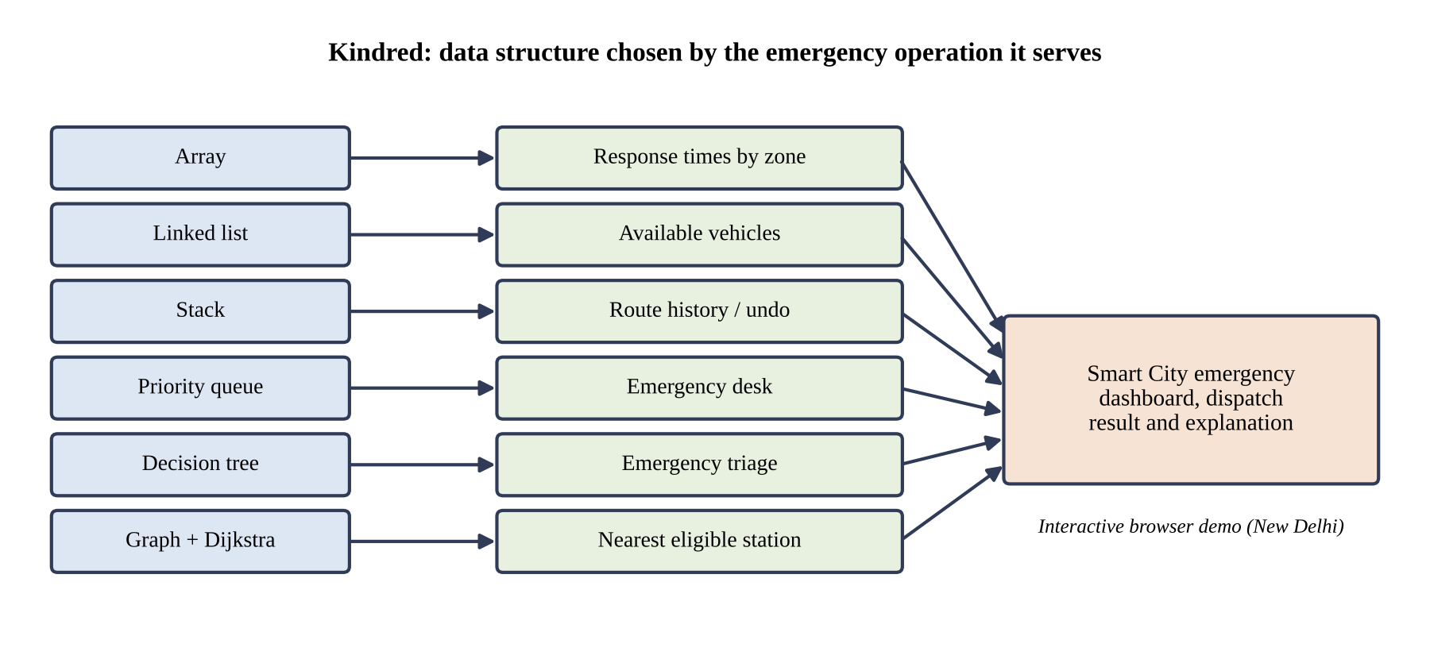
Graphical abstract: each data structure is matched to the emergency operation it serves.

ABBREVIATIONS

Abbreviation | Full form
ADSA | Advanced Data Structures and Algorithms
API | Application Programming Interface
BE-CSE | Bachelor of Engineering in Computer Science and Engineering
CAD | Computer-Aided Dispatch
CSS | Cascading Style Sheets
DSA | Data Structures and Algorithms
ERSS | Emergency Response Support System (India, emergency number 112)
FIFO | First In, First Out
GIS | Geographic Information System
HTML | HyperText Markup Language
HTTP | HyperText Transfer Protocol
JS | JavaScript
LIFO | Last In, First Out
UI | User Interface
UID | University Identification Number

SYMBOLS

Symbol | Meaning
n | Number of elements stored in a structure (readings, vehicles or calls)
V | Number of vertices in the graph (emergency locations and stations)
E | Number of edges in the graph (weighted connections)
h | Height of the decision tree (levels on the longest root-to-leaf path)
k | Position of a node counted from the head of a linked list
u, v | Vertices of the graph
w | Weight of an edge (estimated distance)
dist[u] | Tentative shortest distance from the source vertex to vertex u
∞ | Initial distance assigned to every vertex except the source
O( ) | Asymptotic upper bound on running time (big-O notation)

CHAPTER 1.
INTRODUCTION

1.1. Identification of Client / Need / Relevant Contemporary issue
Cities depend on timely information during emergencies. A request for an ambulance, a fire engine or a police unit sets off a chain of data operations: the incident must be recorded, its urgency judged, an available vehicle found and a suitable response station chosen. The speed and clarity of each step depend on how the underlying data is organised.
The need addressed here has two sides. First, emergency-management work in a large city such as New Delhi must keep changing records, process urgent calls in order of urgency, maintain a pool of available vehicles and select response stations, and each of these tasks places a different demand on the data. Second, the client for this project is the ADSA course itself: learners and instructors need a concrete, inspectable demonstration that links each data structure to a real operation, instead of definitions alone.
The issue is also a contemporary one. India’s Smart Cities Mission (launched in 2015) and the rollout of the unified emergency number 112 under the Emergency Response Support System (from 2019) have raised expectations that emergency response in cities will be fast and data-driven.

1.2. Identification of Problem
Emergency-management systems must store changing records, process urgent calls, maintain available vehicles, classify incidents and select suitable response stations. These tasks make different demands on data, and no single organisation of data performs all of them efficiently. Fast access by position, cheap change at the ends of a collection, history that can be reversed, service in order of urgency, rule-based classification and shortest-path selection are separate requirements.
At the same time, data structures are commonly learned as abstract definitions. The link between the operation that is required and the structure that suits it remains unclear, and learners have few realistic scenarios in which to observe that link. The broad problem is therefore the lack of a concrete, inspectable connection between emergency-response operations and the data structures and algorithms that support them.

1.3. Identification of Tasks
The work was divided into the tasks in Table 1.1. They define the structure of this report: each task corresponds to one chapter or section.
Table 1.1: Project tasks and where they are reported
No. | Task | Reported in
T1 | Identify the need and define the problem | Chapter 1
T2 | Study existing solutions and the reported background | Chapter 2
T3 | Evaluate features and identify design constraints | Sections 3.1 to 3.3
T4 | Prepare alternative designs and select the best one | Sections 3.4 and 3.5
T5 | Plan the methodology: workflow, structure mapping and algorithm | Section 3.6
T6 | Implement the dashboard and the six module pages | Section 4.1
T7 | Implement the Graph module with Dijkstra-style traversal | Section 4.1
T8 | Implement the C++17 backend for priority queue, emergency assignment and Dijkstra | Section 4.1
T9 | Test and validate the behaviour of the modules | Section 4.1
T10 | Draw conclusions and identify future work | Chapter 5

1.4. Timeline
Figure 1.1 shows the planned timeline of the project as a Gantt chart over eight weeks.
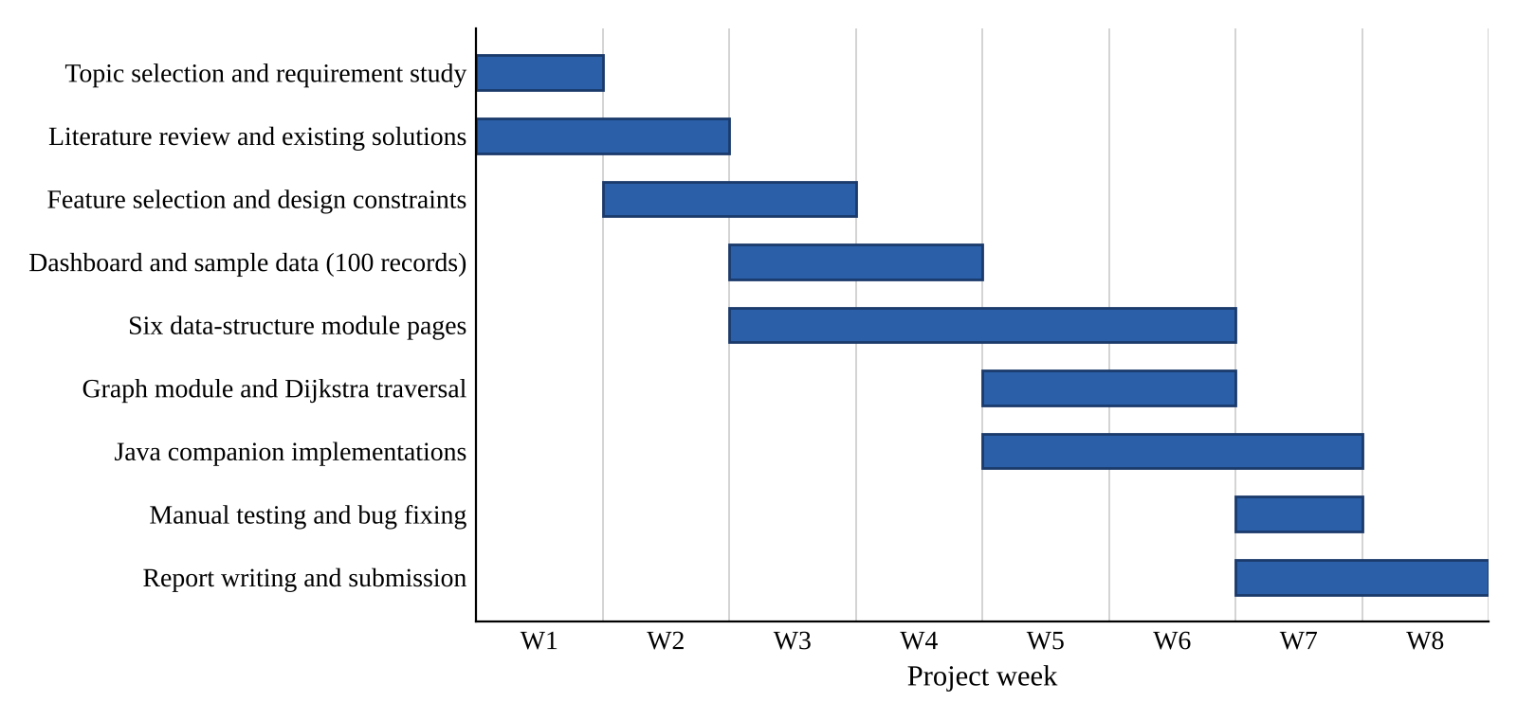
Figure 1.1: Gantt chart of the project timeline

1.5. Organization of the Report
The remainder of the report is organised as follows.
- Chapter 2 reviews the background: the timeline of the reported problem, existing solutions, their key features and drawbacks, and states the problem definition and the objectives.
- Chapter 3 describes the design flow: the evaluation of features, the design constraints, two alternative designs, the selection of the best one and the implementation methodology.
- Chapter 4 presents the implementation of the solution, the technologies used and the results of validation.
- Chapter 5 gives the conclusion, including deviations from the expected results, and the future work.
- The report ends with the references, the appendix (plagiarism report and design checklist) and a user manual for running the project.

CHAPTER 2.
LITERATURE REVIEW/BACKGROUND STUDY

2.1. Timeline of the reported problem
The need to organise emergency data efficiently has been recognised for a long time, and the algorithmic tools used in this project were developed alongside it. The milestones below are documented in the sources listed in the References.
- 1959: E. W. Dijkstra publishes the shortest-path algorithm for graphs with non-negative edge weights [3].
- 1964: J. W. J. Williams describes the binary heap, the structure that makes priority queues efficient [8].
- 1968: the first call is made to the single emergency number 911 in the United States, the beginning of centralised emergency call handling [9].
- From the 1970s: computer-aided dispatch (CAD) systems are adopted by emergency services to record calls and assign units.
- 2015: India launches the Smart Cities Mission, which promotes technology-based urban services [10].
- From 2019: India rolls out the Emergency Response Support System (ERSS) with the unified emergency number 112 [11].

2.2. Existing solutions
Three kinds of existing solutions are relevant to this project.
- Computer-aided dispatch systems. Operational systems used by emergency services to record incidents, track units and assign them. They are built for production use and are generally closed to students.
- Mapping and routing services. GIS-based services such as the Google Maps Platform and open-data routers calculate road routes and travel times, often with live traffic, through an API.
- Data-structure visualisation tools and textbooks. Tools such as VisuAlgo and the USFCA data-structure visualisations animate structures and algorithms in a general setting [12], and standard textbooks explain them formally [1], [2].

2.3. Bibliometric analysis
Table 2.1 compares the existing solutions on their key features, effectiveness and drawbacks. The analysis is qualitative; it does not compute citation counts.
Table 2.1: Comparison of existing solutions
Solution | Key features | Effectiveness | Drawbacks
Computer-aided dispatch systems | Call recording, unit tracking, assignment of units to incidents | Highly effective in real operations | Closed and complex; not designed to show data structures; unsuitable for classroom study
Mapping and routing services | Road routes, travel times, live traffic | Accurate for real roads | Needs an API key, billing and a network connection; hides the algorithm
Data-structure visualisers | General animations of structures and algorithms | Effective for learning mechanics | Not tied to a realistic scenario such as emergency response
Textbooks [1], [2] | Formal definitions, proofs, complexity analysis | Authoritative and complete | Abstract; no interactive or scenario-based demonstration

2.4. Review Summary
The review shows a gap. Operational dispatch systems solve the real problem but are closed and do not expose the data structures behind them. Routing services solve the distance problem but depend on external APIs and hide the algorithm. Visualisation tools and textbooks explain the structures but without a realistic emergency scenario. A project that connects each structure to an emergency-management task, runs locally and explains every step therefore fills a clear educational gap. This finding shapes the problem definition and objectives below.

2.5. Problem Definition
What is to be done: demonstrate how a data structure is selected according to the operation required, using a realistic Smart City emergency-response scenario for New Delhi.
How it is to be done: by building a browser frontend with one dashboard and six interactive module pages (Array, Linked List, Stack, Priority Queue, Decision Tree and Graph), plus a local C++17/Winsock server for dashboard data, emergency assignment, queue operations and Dijkstra routing. Pages redraw results and explain the operation.
What is not to be done: the project does not connect to real emergency services, send actual dispatch requests, provide live road distances or traffic, or implement production authentication or persistent storage. Its C++ server and sample data are local educational components only.

2.6. Goals/Objectives
The objectives are narrow, concrete and can be checked against the finished system:
- Demonstrate practical applications of arrays, linked lists, stacks, queues, trees and graphs through six working module pages.
- Connect every data structure to a realistic Smart City operation, as listed in Table 3.5.
- Provide interactive visual demonstrations in which each operation redraws the structure and states the result in text.
- Model emergency dispatch, resource management and response-station selection using 100 deterministic emergency records and a separate sample vehicle pool.
- Show how Dijkstra’s algorithm selects the nearest eligible response station, with the shortest route highlighted.
- Implement the C++17 backend for emergency processing, queue operations and Dijkstra routing.
- Keep the system understandable, locally runnable and suitable for classroom demonstration, validated by the manual tests in Table 4.3.

CHAPTER 3.
DESIGN FLOW/PROCESS

3.1. Evaluation & Selection of Specifications/Features
Table 3.1 lists the features that an ideal solution would offer, each justified by the literature review in Chapter 2.
Table 3.1: Features ideally required in the solution
No. | Feature | Justification from the review
F1 | Emergency dashboard with sample records | Gives a realistic context, as operational systems do
F2 | Six interactive module pages (one per structure) | Closes the gap left by abstract textbook treatment
F3 | Visual redraw after every operation | Strength of visualisation tools
F4 | Text explanation of every result | Makes the reasoning explicit for learners
F5 | Hospital and police checkpoint filters | Models eligibility of response stations
F6 | Dijkstra-based nearest-station selection | Core shortest-path problem in dispatch
F7 | Live road distance and traffic | Provided by routing services
F8 | Real dispatch to emergency services | Provided by operational CAD systems
F9 | User authentication and database | Needed by any production system
F10 | Real-time vehicle tracking | Provided by operational CAD systems
F11 | C++17 backend for API-backed operations | Shows compiled heap, emergency-assignment and graph algorithms
F12 | Satellite map layer | Improves the visual presentation of the Graph page

3.2. Design Constraints

3.2.1. Standards
The implementation uses the standards listed in the List of Standards: ECMAScript (ECMA-262), the HTML Living Standard, W3C CSS specifications, HTTP semantics (RFC 9110), and ISO/IEC 14882:2017 (C++17). The Windows server uses the Winsock2 API.

3.2.2. Other constraints
Table 3.2 summarises the regulatory, economic, environmental, safety, ethical and social considerations that limited the design.
Table 3.2: Design constraints considered
Constraint | How it affects the design
Regulations | The system must not connect to real emergency services or send real dispatch requests. The optional Google Maps layer is subject to Google’s API terms, billing and key restrictions.
Economic / Cost | The core uses free C++ and open-source Leaflet/OpenStreetMap, with no map API key. The separate optional Google satellite layer may incur billing.
Environmental | The local server and frontend run on one computer without cloud infrastructure; OpenStreetMap tiles are fetched over the internet when the dashboard map is viewed.
Health and Safety | The demonstration must not be mistaken for an operational dispatch tool; its limits are stated explicitly.
Manufacturability | The PowerShell launcher compiles and starts the C++17 server on Windows with MinGW-w64 g++; a modern browser is used for the frontend.
Professional / Ethical | Distances are described honestly as estimated educational weights; no live distance or traffic claim is made, and sources are cited.
Social and Political | Real New Delhi place names are used neutrally; deterministic sample data avoids any personal information.

3.3. Analysis of Features and finalization subject to constraints
Applying the constraints of Section 3.2 to the features of Table 3.1 gives the decisions in Table 3.3.
Table 3.3: Finalisation of features
No. | Decision | Reason
F1 | Retained | Needed for context; uses 100 deterministic records
F2 | Retained | Core of the project
F3 | Retained | Core of the project
F4 | Retained | Core of the project
F5 | Retained | Models station eligibility at low cost
F6 | Modified | Uses estimated educational weights calculated locally instead of live distances
F7 | Removed | Live road routing and traffic require external services and are outside scope
F8 | Removed | Regulatory and safety constraint
F9 | Removed | Persistent accounts and storage are outside scope; this local demo uses in-memory sample data
F10 | Removed | Requires real-time infrastructure; outside scope
F11 | Retained | The C++17 backend executes the implemented heap, emergency and graph operations
F12 | Modified | Made optional; the demonstration works without it

3.4. Design Flow
Two alternative designs were considered, shown in Figure 3.1.
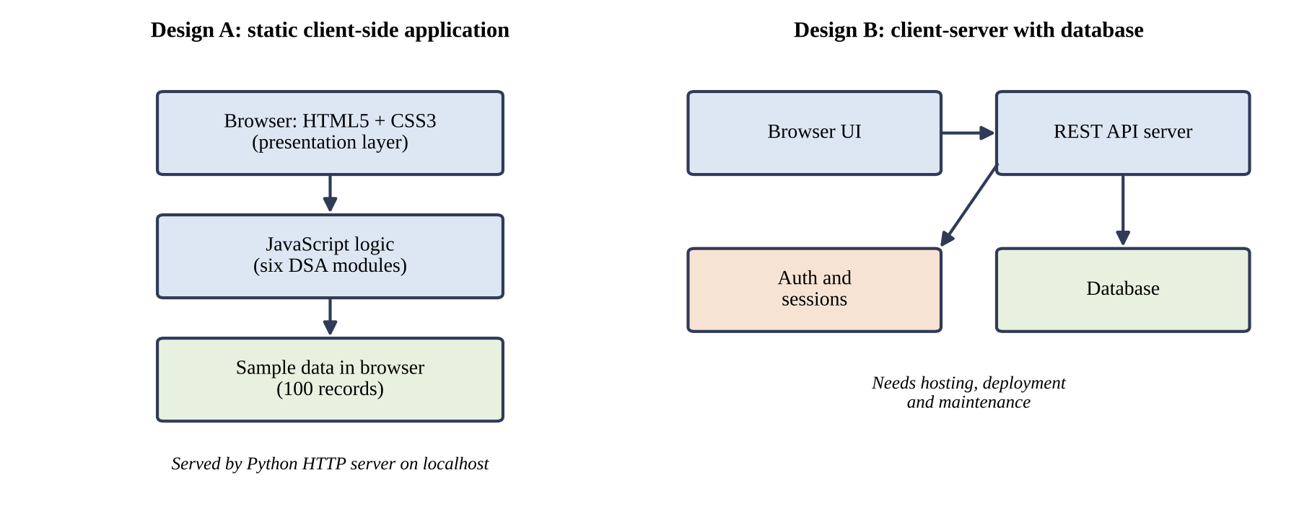
Figure 3.1: Alternative designs for the solution
Design A: browser-only application. HTML5 and CSS3 provide the presentation layer, JavaScript handles every operation, and sample data stays in the browser. A static-file host serves the pages; there is no JSON API or server-side algorithm. This alternative was not selected.
Design B: the selected local client-server application. HTML/CSS/JavaScript pages call a C++17/Winsock JSON API on localhost. The server handles dashboard data, emergency assignment, a binary min-heap priority queue and Dijkstra routing, using in-memory deterministic records. It has no database, user accounts or production dispatch integration.

3.5. Design selection
Table 3.4 compares the two designs on the criteria that matter for the objectives of Section 2.6.
Table 3.4: Comparison of Design A and Design B
Criterion | Design A (browser-only, not selected) | Design B (local C++17 client-server, selected)
Cost | Free static-file hosting | Free local tools; optional Google layer may incur billing
Setup | Serve static files; no API | Run PowerShell launcher with MinGW-w64 g++
Repeatable demonstration | Browser sample state | Deterministic in-memory C++ sample data; resets on restart
Development effort | Low; browser-only logic | Moderate; local HTTP/JSON API and C++ algorithms
Security exposure | No JSON API; intended for local classroom use | Unauthenticated localhost API; not for public/production deployment
Focus on data structures | Browser-side visualizations | Visualizations plus C++ heap and Dijkstra operations
Scalability | Limited to a single browser demo | Limited without persistence, authentication or multi-user controls

Selected design: Design B, the local C++17 client-server design. It preserves the educational visualizations while executing priority-queue, emergency-assignment and Dijkstra route operations in the C++ backend. It runs locally with deterministic in-memory data. Persistent storage, authentication and production-scale deployment remain future work.

3.6. Implementation plan/methodology

3.6.1. Workflow
The user opens the local site and the dashboard requests sample records from the C++ API. The user then chooses a module and operation. Array, linked-list, stack and decision-tree demonstrations update in the browser; dashboard data, emergency assignment, priority-queue operations and graph routing use JSON APIs served by C++. In Graph, the user selects an emergency location and hospital/police filters. Dijkstra traverses the prebuilt weighted network, returns the nearest eligible station and a modeled route, and the page displays the result. This is not a real dispatch. The dashboard map is a separate Leaflet/OpenStreetMap view, with live browser location opt-in.
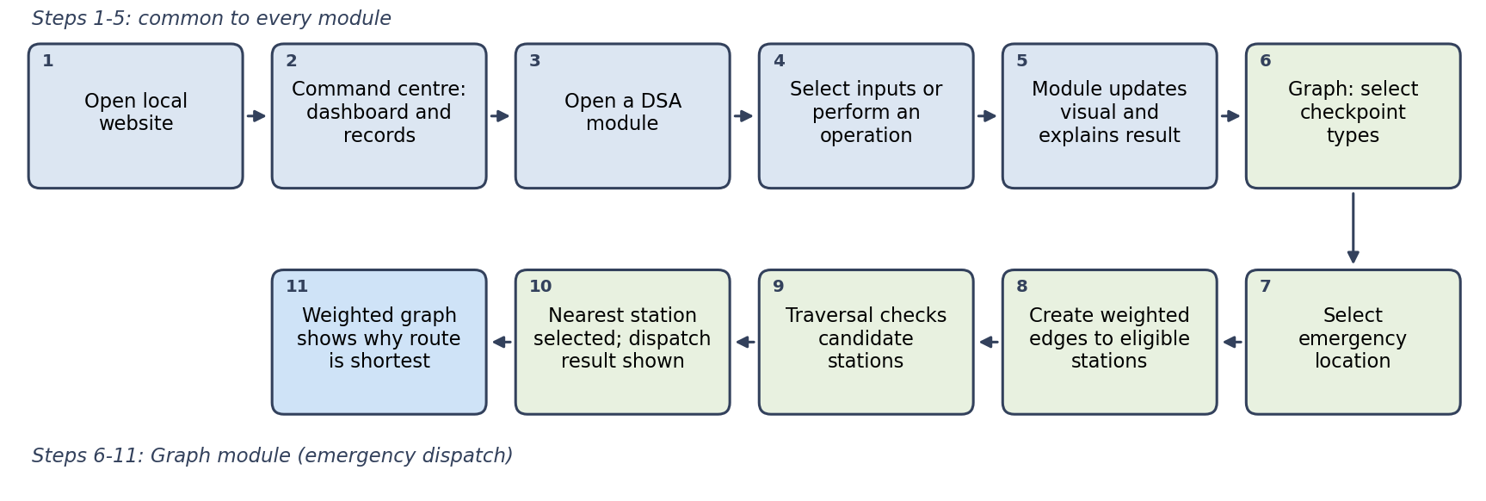
Figure 3.2: Kindred system workflow (browser demonstrations and C++ API-backed operations)

3.6.2. Data-structure selection
Each structure in Kindred is chosen because its strongest operation matches the demands of the task it supports. Table 3.5 summarises the mapping.
Table 3.5: Data-structure mapping to Smart City operations
Structure | Project use | Important operation
Array | Ambulance response-time readings indexed by Delhi zone | Search, sort, reverse, direct index access
Linked list | Available emergency vehicles | Insert, remove, reverse, pointer traversal
Stack | Route-history and undo system | Push, pop, peek, clear; LIFO
Priority queue | Emergency desk | Enqueue by priority and process the most urgent call first
Decision tree | Emergency triage | Traverse type and severity branches to select team and priority
Graph | Emergency-response network | Weighted vertices and edges; Dijkstra traversal

Array: response-time readings by zone. Each position corresponds to a Delhi zone, so the reading for any zone is reached by direct index access in O(1). The module demonstrates searching (a linear scan, O(n)), sorting the readings to rank zones from fastest to slowest (O(n log n) with a comparison sort) and reversing the order. Arrays suit this data because lookup by zone is the common operation; their weakness, shifting elements on insertion or deletion, is the reason they are not used for the vehicle pool.
Linked list: available-vehicle demonstration. The browser-side module models vehicles as nodes linked by next pointers. Inserting or removing at a known end rewires pointers in O(1), while reaching the k-th node takes O(k). This is an instructional visualization, not the C++ backend?s operational vehicle store.
Stack: route history and undo. A stack follows last-in, first-out (LIFO) order, which matches an undo system: the most recent route is the first to be reversed. The module provides push (record a route), pop (undo the latest), peek (inspect the latest without removing it) and clear. Each runs in O(1), because only the top is touched.
Priority queue: emergency desk. The C++ backend uses a custom binary min-heap to process the highest-priority call first; equal-priority calls retain FIFO arrival order. Insertion and removal cost O(log n), whereas insertion into a sorted array costs O(n). A plain FIFO queue without priority could let a less urgent call delay a critical one.
Decision tree: emergency triage. The browser-side tree branches on incident type and severity; its leaf names the suggested response team and priority. A classification visits one node per level, so its cost is O(h). The tree makes the demonstration rules visible; it is not medical or operational triage advice.
Graph: emergency-response network. The C++ backend models 21 vertices (11 locations/junctions and 10 stations) and 22 undirected connections. Coordinate-derived edge weights are approximate educational distances. Dijkstra finds a minimum-weight route through junctions to an eligible station; it does not calculate live road directions.

3.6.3. Dijkstra’s algorithm
Dijkstra’s algorithm finds the minimum-weight path from a source vertex to the other vertices of a graph whose edge weights are non-negative, which holds for distance estimates. Using a priority queue keyed on tentative distance, it proceeds as follows:
- Set the distance of the source to 0 and of every other vertex to ∞; insert the source into the priority queue.
- Repeatedly remove the vertex u with the smallest tentative distance and mark it final.
- For each edge (u, v) of weight w, if dist[u] + w < dist[v], update dist[v] and insert or update v in the queue.
- Stop when the queue is empty or, as in Kindred, as soon as the nearest eligible station is finalised.
Each vertex is finalised once and each edge is examined once, giving O((V + E) log V) with a binary-heap priority queue.

3.6.4. Complexity summary
Table 3.6 lists the typical complexity of the key operations.
Table 3.6: Typical complexity of the key operations
Operation | Typical complexity
Array direct access | O(1)
Array search | O(n)
Array sorting | O(n log n)
Linked-list insertion/removal at a known end | O(1)
Stack push/pop/peek | O(1)
Priority-queue insertion/removal | O(log n)
Tree traversal | O(h), where h is the tree height
Dijkstra with a priority queue | O((V + E) log V), commonly written O(E log V)
Symbols are defined in the list of Symbols; the priority-queue figures assume a binary heap.

CHAPTER 4.
RESULTS ANALYSIS AND VALIDATION

4.1. Implementation of solution

4.1.1. Tools and technologies
Kindred combines a browser frontend with a local C++17 backend; it uses no persistent database. Table 4.1 lists the technologies used.
Table 4.1: Technologies used
Technology | Role in the project
HTML5 | Page structure for the dashboard and the six module pages
CSS3 | Layout, responsive styling, map visualisation and animations
JavaScript | Frontend interactions, browser-side Array/Linked List/Stack/Tree demonstrations, map controls, API calls and visual updates
C++17 and Winsock2 | Local HTTP server and JSON APIs for dashboard data, emergency assignment, heap queue and Dijkstra
MinGW-w64 g++ and Windows PowerShell | Compile and launch the C++17 backend with start-localhost.ps1
Leaflet + OpenStreetMap | OpenStreetMap tiles, station markers and attribution on the dashboard map; no API key
Google Maps JavaScript API (optional) | Separate satellite imagery layer on the Graph page; not used for routing or distance calculation and may require billing

The HTML, CSS and JavaScript pages are served by the C++17/Winsock process, which also handles local JSON API requests. Run the project from Windows PowerShell using start-localhost.ps1; the script compiles backend\main.cpp with MinGW-w64 g++ before starting the server at localhost:8000. The map uses Leaflet and OpenStreetMap tiles, so internet access is required for map imagery and visible attribution [13], [14].
Each module accepts an input or operation, redraws its visual representation and explains the result. Browser-side demonstrations update in JavaScript; queue, emergency assignment and graph routing call the C++ API. Deterministic in-memory sample data makes the server-backed demonstrations repeatable; it resets when the server restarts.

4.1.2. The emergency-response network
The Graph page represents an emergency-response network for New Delhi:
- Emergency locations: Chandni Chowk, India Gate, Saket, Dwarka Sector 10, Rohini Sector 18 and Hauz Khas.
- Hospital checkpoints: AIIMS Trauma Centre, Safdarjung Hospital, Lok Nayak Hospital, Deen Dayal Upadhyay Hospital and GTB Hospital.
- Police checkpoints: Central Police Station, Saket Police Station, Dwarka Sector 10 Police, Rohini Sector 18 Police and Hauz Khas Police Station.
The user can filter the network to show police stations, hospitals or both. Only the stations that pass the filter are eligible for the selected emergency.

4.1.3. Local calculation versus satellite imagery
Two separate things appear on the Graph page and must not be confused (Table 4.2).
Table 4.2: Educational graph calculation versus optional satellite layer
Aspect | Educational local graph calculation | Optional Google satellite imagery
Purpose | Weighted-graph and Dijkstra demonstration for ADSA | Visual map layer for presentation only
Source of values | Estimated weighted distances calculated locally | None; imagery is not used for any calculation
Needed for the demo | Yes; the core Graph demonstration depends on it | No; the demo works without it
API configuration | None | Google Maps JavaScript API key (billing and key restrictions apply)
Live driving distance or traffic | Not provided | Not provided

The Graph page does not use the Directions API or Routes API. The distances shown on the edges are estimated educational weights, and the project does not claim live Google driving distances or live traffic routing.

4.1.4. Application of Dijkstra’s algorithm in Kindred
When the user selects a location and starts traversal, the C++ API runs Dijkstra over its fixed 21-vertex, 22-edge undirected graph. Edge weights are coordinate-derived estimates (approximately 111 km per latitude degree and 103 km per longitude degree at Delhi), not measured road distances. The algorithm may traverse junctions before reaching a station accepted by the selected hospital/police filters. It returns a modeled route, not an actual dispatch or driving direction. In the captured example, Chandni Chowk to Central Police Station passes through Central Delhi Junction and is reported as about 2.5 km of estimated graph distance.
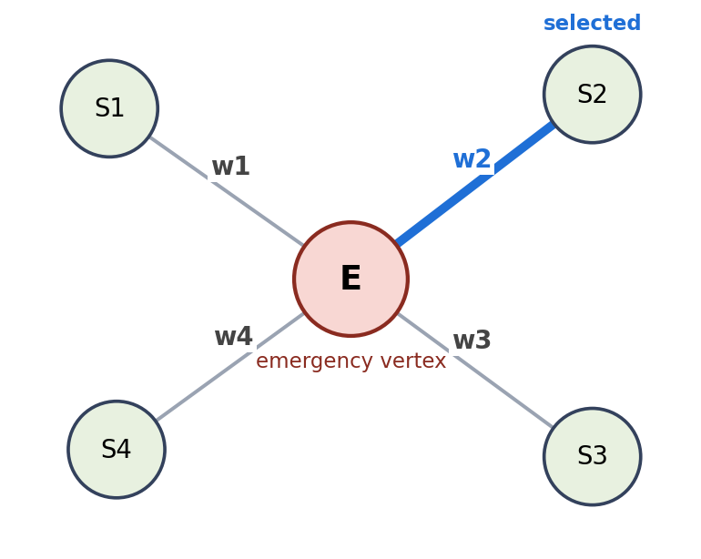
Figure 4.1: Conceptual shortest-path illustration; the implemented connected network is shown in Figure 4.2.
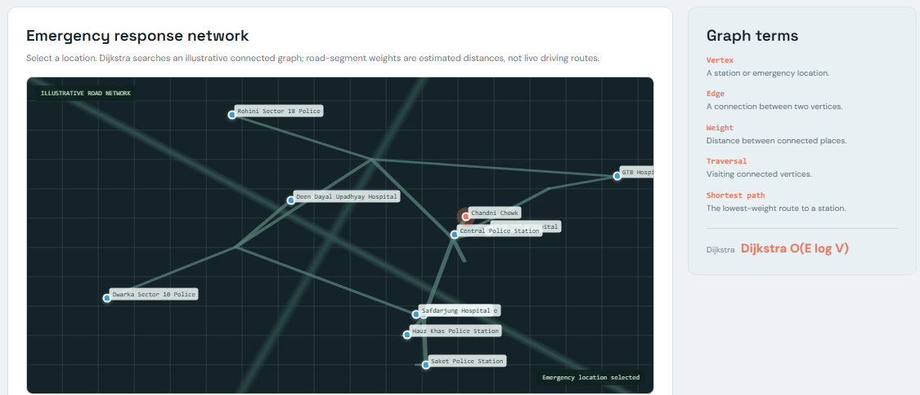
Figure 4.2: Connected weighted network in the Graph module, with modeled junctions and response stations.

4.1.5. Testing and validation
Table 4.3 is a manual test plan with expected behaviour, not evidence that the cases have been executed. Record actual pass/fail results before submission. No automated unit-test coverage is claimed.
Table 4.3: Manual test cases
No. | Test | Expected behaviour
1 | Open every DSA page through localhost | Each page loads and renders its structure
2 | Perform each Array operation | Search, sort, reverse and index access highlight the affected result
3 | Push, peek, pop and clear Stack entries | Top entry changes (or empties) according to LIFO order
4 | Add and remove linked-list vehicle nodes | Nodes appear and disappear with pointers redrawn
5 | Enqueue calls with different priorities, then process them | Most urgent call is processed first
6 | Run multiple Tree emergency classifications | Type and severity branches lead to the matching team and priority
7 | Toggle Hospital and Police station filters | Only the selected checkpoint types are shown and eligible
8 | Run Graph traversal for multiple emergency locations | Stations are checked and the nearest eligible one is selected
9 | Check the weighted graph after traversal | Shortest weighted edge is highlighted in blue
10 | Run the Graph demo without Google satellite configuration | Graph demonstration still works with local weights
11 | Confirm JavaScript syntax and page loading | Pages load without script errors

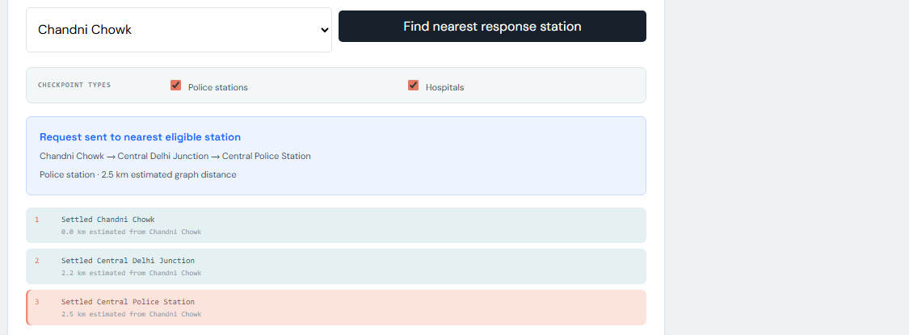
Figure 4.3: Hospital and police filters with the modeled Dijkstra result for Chandni Chowk.

CHAPTER 5.
CONCLUSION AND FUTURE WORK

5.1. Conclusion
Kindred demonstrates how the choice of data structure affects the speed, organisation and clarity of emergency-response operations. Arrays give direct access to zone data, linked lists manage a changing vehicle pool, stacks support undo, priority queues put the most urgent call first, decision trees make triage explicit, and a weighted graph with Dijkstra’s algorithm selects the nearest eligible station. The project is an educational ADSA system that connects theoretical concepts to a realistic Smart City scenario.
Delivered outcome. The project provides six interactive modules, 100 deterministic emergency records, a sample vehicle pool, a local C++17/Winsock API for queue/emergency/graph operations, and a Dijkstra-based modeled route. The implementation and its limitations are described in Chapter 4.
Deviations from the expected results and their reasons. The deviations are deliberate and follow from the constraints of Chapter 3:
- Graph distances are estimated educational weights, not live road distances, because live routing needs paid APIs and a protected server.
- The satellite layer is optional, because it depends on Google API configuration, billing and key restrictions.
- The system is not connected to real emergency services and sends no actual dispatch requests, for regulatory and safety reasons.
- The local C++ backend has no production authentication, persistent database or multi-user support; its sample data is held in memory.
- Validation is by manual tests only; no automated unit-test coverage is claimed.

5.2. Future work
The way ahead is to move from a demonstration towards a production tool. Suggested extensions are:
- Add persistent storage and production authentication to the existing local C++ API; design and validate a secure deployment before supporting real users.
- Add authenticated dispatcher accounts.
- Use live traffic and routing services through a protected server.
- Add real-time vehicle tracking.
- Add incident history and analytics.
- Add accessibility improvements and multilingual support.
- Add automated unit and integration tests.

REFERENCES

[1] T. H. Cormen, C. E. Leiserson, R. L. Rivest and C. Stein, Introduction to Algorithms, 4th ed. MIT Press, 2022.
[2] R. Sedgewick and K. Wayne, Algorithms, 4th ed. Addison-Wesley, 2011.
[3] E. W. Dijkstra, “A note on two problems in connexion with graphs,” Numerische Mathematik, vol. 1, pp. 269–271, 1959.
[4] MDN Web Docs, HTML, CSS and JavaScript documentation. developer.mozilla.org
[5] ISO/IEC, Programming languages - C++. ISO/IEC 14882:2017 (C++17).
[6] Microsoft Learn, Windows Sockets 2 (Winsock) documentation. learn.microsoft.com/windows/win32/winsock/
[7] Google, Maps JavaScript API documentation. developers.google.com/maps
[8] J. W. J. Williams, “Algorithm 232: Heapsort,” Communications of the ACM, vol. 7, no. 6, pp. 347–348, 1964.
[9] National 911 Program, U.S. Department of Transportation, history of 911. 911.gov
[10] Ministry of Housing and Urban Affairs, Government of India, Smart Cities Mission. smartcities.gov.in
[11] Ministry of Home Affairs, Government of India, Emergency Response Support System (ERSS) 112 documentation.
[12] VisuAlgo (National University of Singapore) and USFCA Data Structure Visualizations, online algorithm visualisation tools. visualgo.net
[13] Leaflet, Leaflet 1.9 reference documentation. leafletjs.com/reference.html
[14] OpenStreetMap contributors, Copyright and attribution. openstreetmap.org/copyright

2. Design Checklist

Item | Addressed | Where
Need and problem identified without hinting at the solution | Yes | Sections 1.1, 1.2
Tasks and timeline defined | Yes | Sections 1.3, 1.4
Existing solutions reviewed and compared | Yes | Sections 2.2, 2.3
Problem defined with what is and is not to be done | Yes | Section 2.5
Measurable objectives stated | Yes | Section 2.6
Features evaluated against constraints | Yes | Sections 3.1 to 3.3
Standards listed | Yes | List of Standards, Section 3.2.1
At least two alternative designs | Yes | Section 3.4
Design selected with comparison and reason | Yes | Section 3.5
Methodology, flow and algorithm described | Yes | Section 3.6
Implementation and validation reported | Yes | Chapter 4
Deviations, conclusion and future work stated | Yes | Chapter 5
Ethical and safety limits stated honestly | Yes | Sections 3.2, 5.1
Sources cited | Yes | References

USER MANUAL

This manual explains how to run Kindred on a single computer and how to use each page.

Requirements
- A Windows computer with MinGW-w64 g++ on PATH and a modern web browser.
- The Kindred project folder.
- Internet access for Leaflet/OpenStreetMap tiles on the dashboard map. The separate optional Google satellite layer on the Graph page may require an API key and billing configuration.

Steps to run the project
- Copy or extract the Kindred project folder to a location on your computer.
- Open Windows PowerShell and change to the project folder with cd.
- Run .\start-localhost.ps1. The script compiles backend\main.cpp with g++ in C++17 mode, links Winsock2 and starts the server on port 8000. If g++ is missing, install MinGW-w64 and add it to PATH.
- Open a browser and go to http://localhost:8000. The dashboard loads its sample records from the C++ API. Internet access is needed for OpenStreetMap tiles; the rest of the local demonstration can run without a map API key.
On the dashboard map, select a station marker to preview a straight-line segment. Use my live location is optional and requests browser permission; if the reported location is outside Delhi, the station layer remains readable. Map tiles require internet access.
- From the dashboard, open a module page: Array, Linked List, Stack, Priority Queue, Decision Tree or Graph.
- On a module page, choose an input or operation (for example search, push, enqueue or classify). The structure is redrawn and the result is explained in text.
- In the Graph module, select the checkpoint types (Hospital, Police or both) and an emergency location, then start the traversal. The nearest eligible station is selected and the shortest route is shown in blue.
- The dashboard station map uses OpenStreetMap and does not need a key. The Graph page?s separate optional Google satellite layer can be configured with a Google Maps JavaScript API key; without it, Dijkstra still works on local estimated weights.
- To stop the server, return to the terminal and press Ctrl + C.
- The C++ server source is in backend\main.cpp. The PowerShell launcher compiles and runs it; no additional language runtime is required.

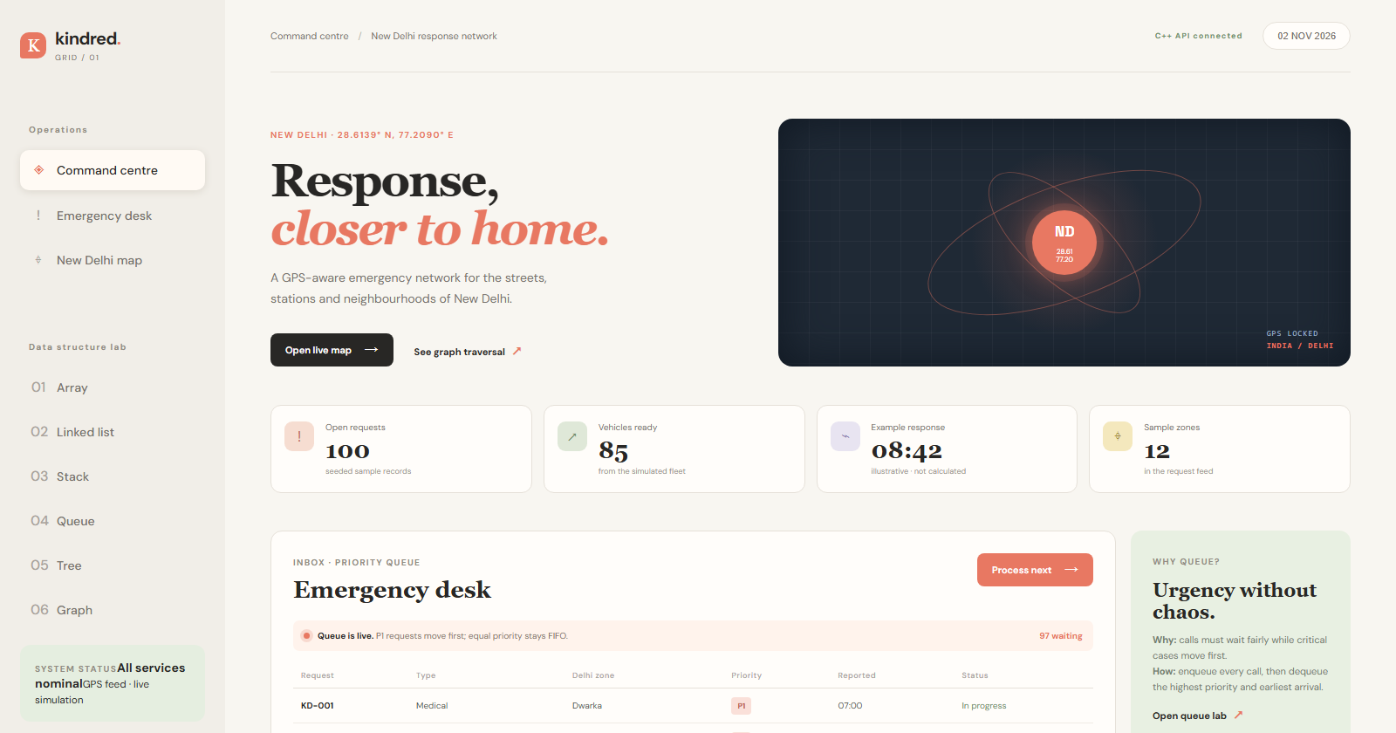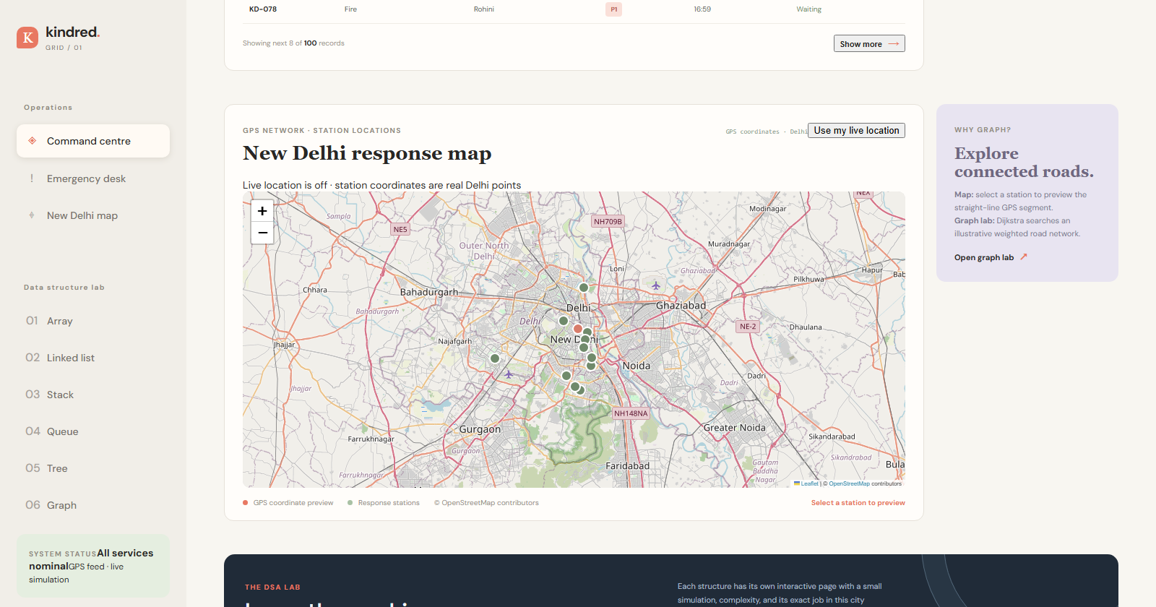
Screenshot: Command-centre dashboard (left) and OpenStreetMap station map with attribution (right).

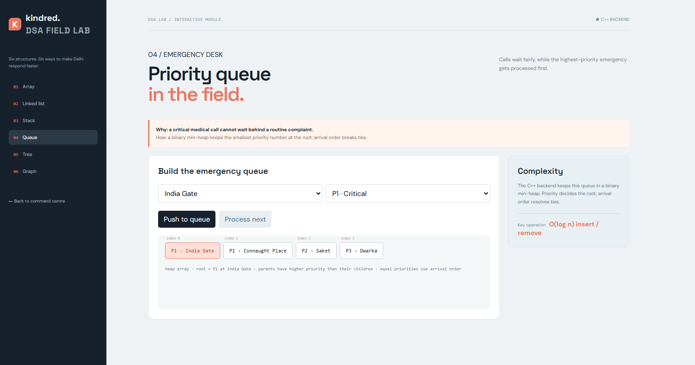
Screenshot: Priority Queue module after an operation.

