KINDRED: SMART CITY EMERGENCY RESPONSE AND MANAGEMENT SYSTEM
A PROJECT REPORT
Submitted by
HITESH SINGLA (25BCS11432)
in partial fulfillment for the award of the degree of
BACHELOR OF ENGINEERING
IN
COMPUTER SCIENCE AND ENGINEERING

Chandigarh University
November 2026

BONAFIDE CERTIFICATE
Certified that this project report “KINDRED: SMART CITY EMERGENCY RESPONSE AND MANAGEMENT SYSTEM” is the bonafide work of “HITESH SINGLA” who carried out the project work under my supervision.
SIGNATURE  Name: ______________________  HEAD OF THE DEPARTMENT  Computer Science and Engineering | SIGNATURE  Name: ______________________  SUPERVISOR  Designation: ________________  Computer Science and Engineering
Submitted for the project viva-voce examination held on ______________________
INTERNAL EXAMINER | EXTERNAL EXAMINER

TABLE OF CONTENTS

List of Figures 4
List of Tables 5
List of Standards 6
CHAPTER 1. INTRODUCTION 11
1.1. Identification of Client / Need / Relevant Contemporary issue 11
1.2. Identification of Problem 11
1.3. Identification of Tasks 12
1.4. Timeline 12
1.5. Organization of the Report 12
CHAPTER 2. LITERATURE REVIEW/BACKGROUND STUDY 14
2.1. Timeline of the reported problem 14
2.2. Existing solutions 14
2.3. Bibliometric analysis 15
2.4. Review Summary 15
2.5. Problem Definition 15
2.6. Goals/Objectives 16
CHAPTER 3. DESIGN FLOW/PROCESS 17
3.1. Evaluation & Selection of Specifications/Features 17
3.2. Design Constraints 17
3.3. Analysis of Features and finalization subject to constraints 19
3.4. Design Flow 19
3.5. Design selection 20
3.6. Implementation plan/methodology 21
CHAPTER 4. RESULTS ANALYSIS AND VALIDATION 24
4.1. Implementation of solution 24
CHAPTER 5. CONCLUSION AND FUTURE WORK 28
5.1. Conclusion 28
5.2. Future work 28
REFERENCES 29
APPENDIX 30
1. Plagiarism Report 30
2. Design Checklist 31
USER MANUAL 32

List of Figures

Figure 1.1 Gantt chart of the project timeline 12
Figure 3.1 Alternative designs for the solution 19
Figure 3.2 Kindred system workflow (common module flow and Graph dispatch flow) 21
Figure 4.1 Schematic of the weighted graph 26
Figure 4.2 Graph module weighted-network view (screenshot) 26
Figure 4.3 Checkpoint filters and traversal result in the Graph module (screenshot) 27

List of Tables

Table 1.1 Project tasks and where they are reported 12
Table 2.1 Comparison of existing solutions 15
Table 3.1 Features ideally required in the solution 17
Table 3.2 Design constraints considered 18
Table 3.3 Finalisation of features 19
Table 3.4 Comparison of Design A and Design B 20
Table 3.5 Data-structure mapping to Smart City operations 21
Table 3.6 Typical complexity of the key operations 23
Table 4.1 Technologies used 24
Table 4.2 Educational graph calculation versus optional satellite layer 25
Table 4.3 Manual test cases 27

List of Standards

Standard | Publishing Agency | About the standard | Page no.
ECMA-262 (ECMAScript Language Specification) | Ecma International | Defines the JavaScript language used for all module logic, record handling and the local Graph traversal. | 24
HTML Living Standard | WHATWG | Defines the HTML5 markup used for the command-centre page and the six module pages. | 24
CSS specifications (Cascading Style Sheets) | W3C | Defines the styling, responsive layout and animation features used for the interface and map visualisation. | 24
RFC 9110: HTTP Semantics | IETF | Defines the HTTP behaviour followed when the Python HTTP server delivers the static pages on localhost. | 19
The Java Language Specification, Java SE | Oracle | Defines the Java language used for the companion implementations of the core data structures. | 24

ABSTRACT

Emergency response depends on a chain of data operations: an incident must be recorded, its urgency judged, an available vehicle located and a suitable response station chosen. No single way of organising data serves all of these operations efficiently, yet students of Advanced Data Structures and Algorithms (ADSA) usually meet data structures only as abstract definitions.
This project presents Kindred, a browser-based Smart City emergency-response demonstration for New Delhi that makes the choice of data structure visible. A command-centre dashboard holds 100 deterministic emergency and vehicle records, and six interactive module pages pair one data structure with one emergency task: an array for response-time readings by zone, a linked list for available vehicles, a stack for route history and undo, a priority queue for the emergency desk, a decision tree for triage, and a weighted graph with Dijkstra’s algorithm for selecting the nearest eligible hospital or police station. Every operation redraws the structure and explains the result in text. The system is built with HTML5, CSS3 and JavaScript, is served locally by a Python HTTP server, and is accompanied by Java implementations of the core structures.
The graph module uses estimated, locally calculated edge weights; it does not use live road distances or traffic, and the system is not connected to real emergency services. Validation consists of eleven manual browser tests. The work shows how matching the dominant operation of a task to a data structure gives clear complexity advantages, for example O(log n) priority-queue insertion against O(n) insertion into a sorted array.

GRAPHICAL ABSTRACT

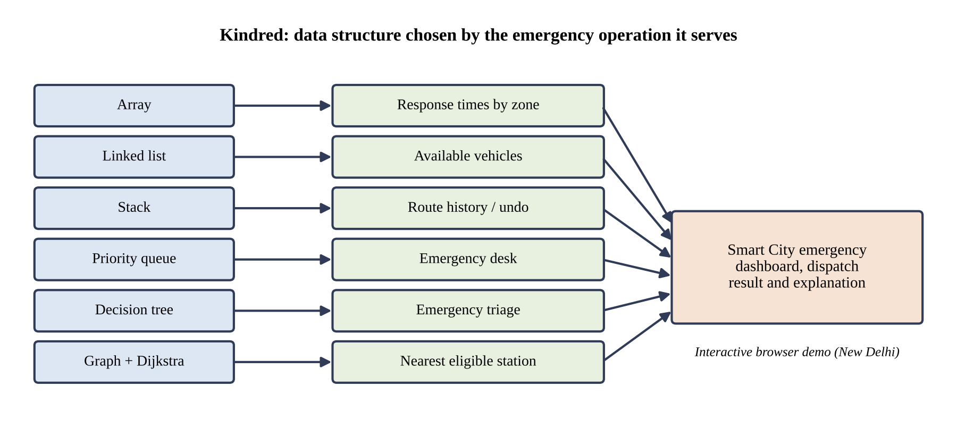
Graphical abstract: each data structure is matched to the emergency operation it serves.

ABBREVIATIONS

Abbreviation | Full form
ADSA | Advanced Data Structures and Algorithms
API | Application Programming Interface
BE-CSE | Bachelor of Engineering in Computer Science and Engineering
CAD | Computer-Aided Dispatch
CSS | Cascading Style Sheets
DSA | Data Structures and Algorithms
ERSS | Emergency Response Support System (India, emergency number 112)
FIFO | First In, First Out
GIS | Geographic Information System
HTML | HyperText Markup Language
HTTP | HyperText Transfer Protocol
JS | JavaScript
LIFO | Last In, First Out
UI | User Interface
UID | University Identification Number

SYMBOLS

Symbol | Meaning
n | Number of elements stored in a structure (readings, vehicles or calls)
V | Number of vertices in the graph (emergency locations and stations)
E | Number of edges in the graph (weighted connections)
h | Height of the decision tree (levels on the longest root-to-leaf path)
k | Position of a node counted from the head of a linked list
u, v | Vertices of the graph
w | Weight of an edge (estimated distance)
dist[u] | Tentative shortest distance from the source vertex to vertex u
∞ | Initial distance assigned to every vertex except the source
O( ) | Asymptotic upper bound on running time (big-O notation)

CHAPTER 1.
INTRODUCTION

1.1. Identification of Client / Need / Relevant Contemporary issue
Cities depend on timely information during emergencies. A request for an ambulance, a fire engine or a police unit sets off a chain of data operations: the incident must be recorded, its urgency judged, an available vehicle found and a suitable response station chosen. The speed and clarity of each step depend on how the underlying data is organised.
The need addressed here has two sides. First, emergency-management work in a large city such as New Delhi must keep changing records, process urgent calls in order of urgency, maintain a pool of available vehicles and select response stations, and each of these tasks places a different demand on the data. Second, the client for this project is the ADSA course itself: learners and instructors need a concrete, inspectable demonstration that links each data structure to a real operation, instead of definitions alone.
The issue is also a contemporary one. India’s Smart Cities Mission (launched in 2015) and the rollout of the unified emergency number 112 under the Emergency Response Support System (from 2019) have raised expectations that emergency response in cities will be fast and data-driven.

1.2. Identification of Problem
Emergency-management systems must store changing records, process urgent calls, maintain available vehicles, classify incidents and select suitable response stations. These tasks make different demands on data, and no single organisation of data performs all of them efficiently. Fast access by position, cheap change at the ends of a collection, history that can be reversed, service in order of urgency, rule-based classification and shortest-path selection are separate requirements.
At the same time, data structures are commonly learned as abstract definitions. The link between the operation that is required and the structure that suits it remains unclear, and learners have few realistic scenarios in which to observe that link. The broad problem is therefore the lack of a concrete, inspectable connection between emergency-response operations and the data structures and algorithms that support them.

1.3. Identification of Tasks
The work was divided into the tasks in Table 1.1. They define the structure of this report: each task corresponds to one chapter or section.
Table 1.1: Project tasks and where they are reported
No. | Task | Reported in
T1 | Identify the need and define the problem | Chapter 1
T2 | Study existing solutions and the reported background | Chapter 2
T3 | Evaluate features and identify design constraints | Sections 3.1 to 3.3
T4 | Prepare alternative designs and select the best one | Sections 3.4 and 3.5
T5 | Plan the methodology: workflow, structure mapping and algorithm | Section 3.6
T6 | Implement the dashboard and the six module pages | Section 4.1
T7 | Implement the Graph module with Dijkstra-style traversal | Section 4.1
T8 | Provide Java companion implementations of the core structures | Section 4.1
T9 | Test and validate the behaviour of the modules | Section 4.1
T10 | Draw conclusions and identify future work | Chapter 5

1.4. Timeline
Figure 1.1 shows the planned timeline of the project as a Gantt chart over eight weeks.
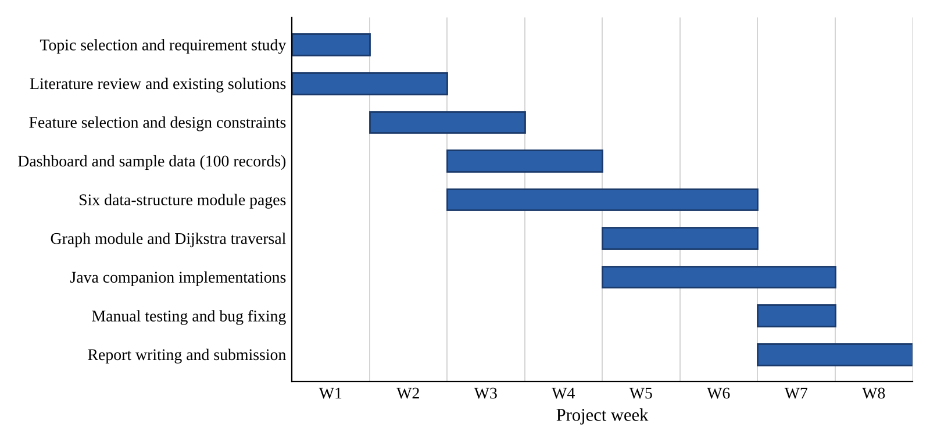
Figure 1.1: Gantt chart of the project timeline

1.5. Organization of the Report
The remainder of the report is organised as follows.
- Chapter 2 reviews the background: the timeline of the reported problem, existing solutions, their key features and drawbacks, and states the problem definition and the objectives.
- Chapter 3 describes the design flow: the evaluation of features, the design constraints, two alternative designs, the selection of the best one and the implementation methodology.
- Chapter 4 presents the implementation of the solution, the technologies used and the results of validation.
- Chapter 5 gives the conclusion, including deviations from the expected results, and the future work.
- The report ends with the references, the appendix (plagiarism report and design checklist) and a user manual for running the project.

CHAPTER 2.
LITERATURE REVIEW/BACKGROUND STUDY

2.1. Timeline of the reported problem
The need to organise emergency data efficiently has been recognised for a long time, and the algorithmic tools used in this project were developed alongside it. The milestones below are documented in the sources listed in the References.
- 1959: E. W. Dijkstra publishes the shortest-path algorithm for graphs with non-negative edge weights [3].
- 1964: J. W. J. Williams describes the binary heap, the structure that makes priority queues efficient [8].
- 1968: the first call is made to the single emergency number 911 in the United States, the beginning of centralised emergency call handling [9].
- From the 1970s: computer-aided dispatch (CAD) systems are adopted by emergency services to record calls and assign units.
- 2015: India launches the Smart Cities Mission, which promotes technology-based urban services [10].
- From 2019: India rolls out the Emergency Response Support System (ERSS) with the unified emergency number 112 [11].

2.2. Existing solutions
Three kinds of existing solutions are relevant to this project.
- Computer-aided dispatch systems. Operational systems used by emergency services to record incidents, track units and assign them. They are built for production use and are generally closed to students.
- Mapping and routing services. GIS-based services such as the Google Maps Platform and open-data routers calculate road routes and travel times, often with live traffic, through an API.
- Data-structure visualisation tools and textbooks. Tools such as VisuAlgo and the USFCA data-structure visualisations animate structures and algorithms in a general setting [12], and standard textbooks explain them formally [1], [2].

2.3. Bibliometric analysis
Table 2.1 compares the existing solutions on their key features, effectiveness and drawbacks. The analysis is qualitative; it does not compute citation counts.
Table 2.1: Comparison of existing solutions
Solution | Key features | Effectiveness | Drawbacks
Computer-aided dispatch systems | Call recording, unit tracking, assignment of units to incidents | Highly effective in real operations | Closed and complex; not designed to show data structures; unsuitable for classroom study
Mapping and routing services | Road routes, travel times, live traffic | Accurate for real roads | Needs an API key, billing and a network connection; hides the algorithm
Data-structure visualisers | General animations of structures and algorithms | Effective for learning mechanics | Not tied to a realistic scenario such as emergency response
Textbooks [1], [2] | Formal definitions, proofs, complexity analysis | Authoritative and complete | Abstract; no interactive or scenario-based demonstration

2.4. Review Summary
The review shows a gap. Operational dispatch systems solve the real problem but are closed and do not expose the data structures behind them. Routing services solve the distance problem but depend on external APIs and hide the algorithm. Visualisation tools and textbooks explain the structures but without a realistic emergency scenario. A project that connects each structure to an emergency-management task, runs locally and explains every step therefore fills a clear educational gap. This finding shapes the problem definition and objectives below.

2.5. Problem Definition
What is to be done: demonstrate how a data structure is selected according to the operation required, using a realistic Smart City emergency-response scenario for New Delhi.
How it is to be done: by building a browser-based demonstration with one dashboard and six interactive module pages (Array, Linked List, Stack, Priority Queue, Decision Tree and Graph), supported by Java companion implementations, in which every operation redraws the structure and explains the result.
What is not to be done: the project does not connect to real emergency services, does not send actual dispatch requests, does not use live road distances or traffic, and does not provide a production backend, authentication or database.

2.6. Goals/Objectives
The objectives are narrow, concrete and can be checked against the finished system:
- Demonstrate practical applications of arrays, linked lists, stacks, queues, trees and graphs through six working module pages.
- Connect every data structure to a realistic Smart City operation, as listed in Table 3.5.
- Provide interactive visual demonstrations in which each operation redraws the structure and states the result in text.
- Model emergency dispatch, resource management and response-station selection using 100 deterministic emergency and vehicle records.
- Show how Dijkstra’s algorithm selects the nearest eligible response station, with the shortest route highlighted.
- Provide a Java implementation of the core data structures.
- Keep the system understandable, locally runnable and suitable for classroom demonstration, validated by the manual tests in Table 4.3.

CHAPTER 3.
DESIGN FLOW/PROCESS

3.1. Evaluation & Selection of Specifications/Features
Table 3.1 lists the features that an ideal solution would offer, each justified by the literature review in Chapter 2.
Table 3.1: Features ideally required in the solution
No. | Feature | Justification from the review
F1 | Emergency dashboard with sample records | Gives a realistic context, as operational systems do
F2 | Six interactive module pages (one per structure) | Closes the gap left by abstract textbook treatment
F3 | Visual redraw after every operation | Strength of visualisation tools
F4 | Text explanation of every result | Makes the reasoning explicit for learners
F5 | Hospital and police checkpoint filters | Models eligibility of response stations
F6 | Dijkstra-based nearest-station selection | Core shortest-path problem in dispatch
F7 | Live road distance and traffic | Provided by routing services
F8 | Real dispatch to emergency services | Provided by operational CAD systems
F9 | User authentication and database | Needed by any production system
F10 | Real-time vehicle tracking | Provided by operational CAD systems
F11 | Java companion implementations | Allows comparison with a conventional implementation
F12 | Satellite map layer | Improves the visual presentation of the Graph page

3.2. Design Constraints

3.2.1. Standards
The implementation follows the open standards listed in the List of Standards: ECMAScript (ECMA-262) for JavaScript, the HTML Living Standard, the W3C CSS specifications, HTTP semantics (RFC 9110) for local serving, and the Java Language Specification for the companion code.

3.2.2. Other constraints
Table 3.2 summarises the regulatory, economic, environmental, safety, ethical and social considerations that limited the design.
Table 3.2: Design constraints considered
Constraint | How it affects the design
Regulations | The system must not connect to real emergency services or send real dispatch requests. The optional Google Maps layer is subject to Google’s API terms, billing and key restrictions.
Economic / Cost | The project must run at no cost using free, open technologies. The Google Maps layer is optional because it may incur billing.
Environmental | A static application on one machine needs no server infrastructure and therefore has a very small energy footprint.
Health and Safety | The demonstration must not be mistaken for an operational dispatch tool; its limits are stated explicitly.
Manufacturability | All pages are static files, so the system can be copied and run on any machine with Python and a browser.
Professional / Ethical | Distances are described honestly as estimated educational weights; no live distance or traffic claim is made, and sources are cited.
Social and Political | Real New Delhi place names are used neutrally; deterministic sample data avoids any personal information.

3.3. Analysis of Features and finalization subject to constraints
Applying the constraints of Section 3.2 to the features of Table 3.1 gives the decisions in Table 3.3.
Table 3.3: Finalisation of features
No. | Decision | Reason
F1 | Retained | Needed for context; uses 100 deterministic records
F2 | Retained | Core of the project
F3 | Retained | Core of the project
F4 | Retained | Core of the project
F5 | Retained | Models station eligibility at low cost
F6 | Modified | Uses estimated educational weights calculated locally instead of live distances
F7 | Removed | Requires paid routing APIs and a protected server; outside scope
F8 | Removed | Regulatory and safety constraint
F9 | Removed | Requires a backend; not needed for a classroom demonstration
F10 | Removed | Requires real-time infrastructure; outside scope
F11 | Retained | Supports study alongside the browser behaviour
F12 | Modified | Made optional; the demonstration works without it

3.4. Design Flow
Two alternative designs were considered, shown in Figure 3.1.
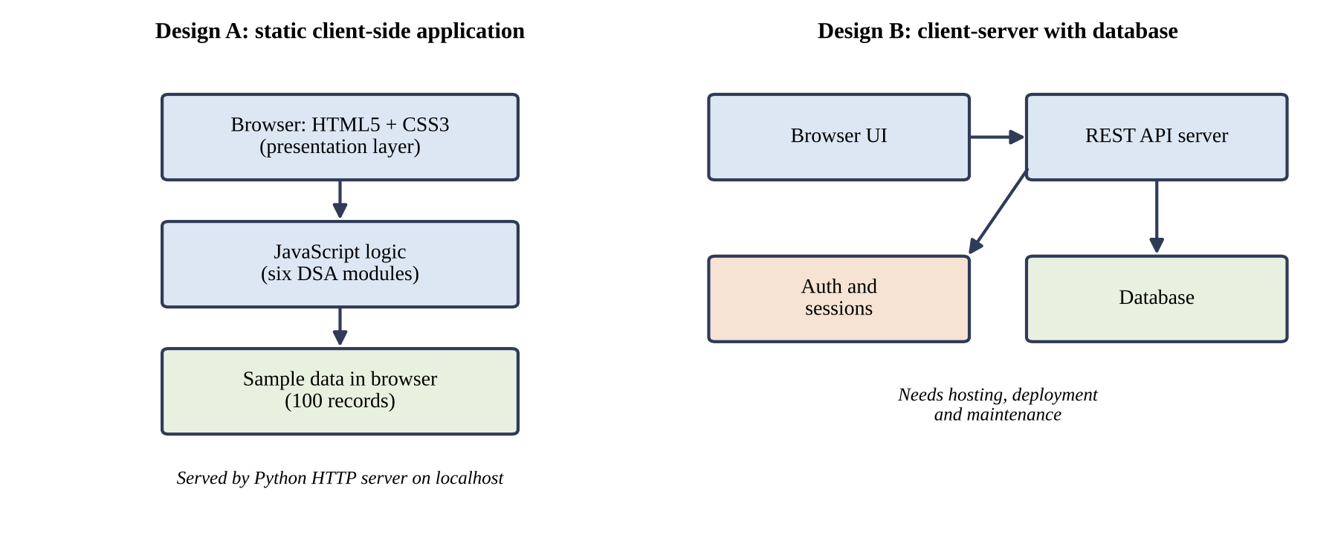
Figure 3.1: Alternative designs for the solution
Design A: static client-side application. HTML5 and CSS3 provide the presentation layer, JavaScript provides the logic for all six modules, and deterministic sample data is held in the browser. A Python HTTP server delivers the static files on localhost. No server-side logic or database is needed.
Design B: client-server application with a database. A browser interface calls a REST API server that stores records in a database and handles user authentication and sessions. This design resembles a production system and could support real data.

3.5. Design selection
Table 3.4 compares the two designs on the criteria that matter for the objectives of Section 2.6.
Table 3.4: Comparison of Design A and Design B
Criterion | Design A (static client-side) | Design B (client-server)
Cost | None | Hosting and database may cost money
Setup | One command to start a local server | Server, database and configuration required
Repeatable demonstration | Yes; deterministic data gives identical results | Depends on stored data and server state
Development effort | Low | High (API, database, authentication)
Security exposure | None; no network services beyond localhost | Needs authentication and protection of API keys
Focus on data structures | High; logic is visible in the browser | Diluted by infrastructure work
Scalability | Limited to the demonstration | Higher

Selected design: Design A. The project objective is educational: to show how data structures are chosen. Design A meets this objective at no cost, runs on one machine, gives repeatable results and keeps attention on the structures. Design B’s main advantage, scalability, is outside the scope defined in Section 2.5; it is retained as future work (Section 5.2).

3.6. Implementation plan/methodology

3.6.1. Workflow
The user opens the local website, and the command centre displays the Smart City dashboard with its emergency records. The user then opens a DSA module, selects inputs or performs an operation, and the module updates its visual structure and explains the result (steps 1 to 5 in Figure 3.2). In the Graph module the user additionally selects the checkpoint types (hospitals, police stations or both) and an emergency location. The system creates weighted connections to the eligible stations, the traversal checks the candidates, the nearest station is selected and the dispatch result is displayed. Finally, the weighted graph visualisation shows why the selected route is the shortest (steps 6 to 11).
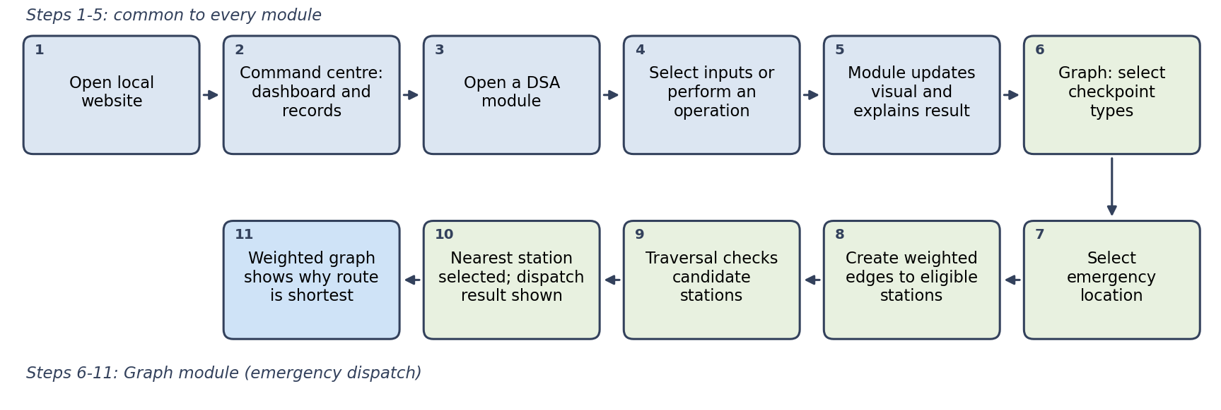
Figure 3.2: Kindred system workflow (common module flow and Graph dispatch flow)

3.6.2. Data-structure selection
Each structure in Kindred is chosen because its strongest operation matches the demands of the task it supports. Table 3.5 summarises the mapping.
Table 3.5: Data-structure mapping to Smart City operations
Structure | Project use | Important operation
Array | Ambulance response-time readings indexed by Delhi zone | Search, sort, reverse, direct index access
Linked list | Available emergency vehicles | Insert, remove, reverse, pointer traversal
Stack | Route-history and undo system | Push, pop, peek, clear; LIFO
Priority queue | Emergency desk | Enqueue by priority and process the most urgent call first
Decision tree | Emergency triage | Traverse type and severity branches to select team and priority
Graph | Emergency-response network | Weighted vertices and edges; Dijkstra traversal

Array: response-time readings by zone. Each position corresponds to a Delhi zone, so the reading for any zone is reached by direct index access in O(1). The module demonstrates searching (a linear scan, O(n)), sorting the readings to rank zones from fastest to slowest (O(n log n) with a comparison sort) and reversing the order. Arrays suit this data because lookup by zone is the common operation; their weakness, shifting elements on insertion or deletion, is the reason they are not used for the vehicle pool.
Linked list: available emergency vehicles. Vehicles constantly leave and rejoin the available pool. Each vehicle is a node holding its data and a pointer to the next node, so inserting or removing at a known end only rewires pointers in O(1), with no shifting of other records. Reaching the k-th vehicle means walking from the head in O(k), so the structure is chosen where frequent change matters more than random access.
Stack: route history and undo. A stack follows last-in, first-out (LIFO) order, which matches an undo system: the most recent route is the first to be reversed. The module provides push (record a route), pop (undo the latest), peek (inspect the latest without removing it) and clear. Each runs in O(1), because only the top is touched.
Priority queue: emergency desk. An emergency desk must serve the most urgent call first, not the oldest. Each call is enqueued with a priority and processing always removes the most urgent entry. With a heap, insertion and removal cost O(log n), whereas keeping a sorted array would cost O(n) per insertion. A plain first-in, first-out queue would allow a minor call to delay a critical one.
Decision tree: emergency triage. The tree branches first on the type of emergency and then on its severity, and the leaf reached names the response team and the priority. A classification visits one node per level, so its cost is O(h), independent of how many emergency types exist at other branches. The tree also makes the triage rules explicit and easy to modify.
Graph: emergency-response network. Emergency locations and response stations are vertices, and estimated distances are weighted edges. The question “which eligible station is nearest?” is a shortest-path problem, which a weighted graph models naturally.

3.6.3. Dijkstra’s algorithm
Dijkstra’s algorithm finds the minimum-weight path from a source vertex to the other vertices of a graph whose edge weights are non-negative, which holds for distance estimates. Using a priority queue keyed on tentative distance, it proceeds as follows:
- Set the distance of the source to 0 and of every other vertex to ∞; insert the source into the priority queue.
- Repeatedly remove the vertex u with the smallest tentative distance and mark it final.
- For each edge (u, v) of weight w, if dist[u] + w < dist[v], update dist[v] and insert or update v in the queue.
- Stop when the queue is empty or, as in Kindred, as soon as the nearest eligible station is finalised.
Each vertex is finalised once and each edge is examined once, giving O((V + E) log V) with a binary-heap priority queue.

3.6.4. Complexity summary
Table 3.6 lists the typical complexity of the key operations.
Table 3.6: Typical complexity of the key operations
Operation | Typical complexity
Array direct access | O(1)
Array search | O(n)
Array sorting | O(n log n)
Linked-list insertion/removal at a known end | O(1)
Stack push/pop/peek | O(1)
Priority-queue insertion/removal | O(log n)
Tree traversal | O(h), where h is the tree height
Dijkstra with a priority queue | O((V + E) log V), commonly written O(E log V)
Symbols are defined in the list of Symbols; the priority-queue figures assume a binary heap.

CHAPTER 4.
RESULTS ANALYSIS AND VALIDATION

4.1. Implementation of solution

4.1.1. Tools and technologies
Kindred is primarily a frontend demonstration and does not require a backend database. Table 4.1 lists the technologies used.
Table 4.1: Technologies used
Technology | Role in the project
HTML5 | Page structure for the dashboard and the six module pages
CSS3 | Layout, responsive styling, map visualisation and animations
JavaScript | Interaction, emergency and vehicle records, visual updates, filtering and local graph traversal
Java | Companion ADSA implementations of the core data structures
Python HTTP server | Local hosting of the static pages on localhost
Google Maps JavaScript API (optional) | Satellite imagery as a visual map layer on the Graph page

All pages are static files, so the complete system runs on a single machine once the Python HTTP server has been started in the project folder and the pages are opened through localhost. Serving through HTTP rather than opening files directly keeps the pages’ scripts and resources loading consistently.
Every module follows the same interaction pattern: the user supplies input or chooses an operation, the JavaScript updates the underlying structure, the visual representation is redrawn, and a short textual explanation states the outcome. The sample data is deterministic, so a demonstration can be repeated with identical results. The Java files provide conventional implementations of the same core structures for study and comparison.

4.1.2. The emergency-response network
The Graph page represents an emergency-response network for New Delhi:
- Emergency locations: Chandni Chowk, India Gate, Saket, Dwarka Sector 10, Rohini Sector 18 and Hauz Khas.
- Hospital checkpoints: AIIMS Trauma Centre, Safdarjung Hospital, Lok Nayak Hospital, Deen Dayal Upadhyay Hospital and GTB Hospital.
- Police checkpoints: Central Police Station, Saket Police Station, Dwarka Sector 10 Police, Rohini Sector 18 Police and Hauz Khas Police Station.
The user can filter the network to show police stations, hospitals or both. Only the stations that pass the filter are eligible for the selected emergency.

4.1.3. Local calculation versus satellite imagery
Two separate things appear on the Graph page and must not be confused (Table 4.2).
Table 4.2: Educational graph calculation versus optional satellite layer
Aspect | Educational local graph calculation | Optional Google satellite imagery
Purpose | Weighted-graph and Dijkstra demonstration for ADSA | Visual map layer for presentation only
Source of values | Estimated weighted distances calculated locally | None; imagery is not used for any calculation
Needed for the demo | Yes; the core Graph demonstration depends on it | No; the demo works without it
API configuration | None | Google Maps JavaScript API key (billing and key restrictions apply)
Live driving distance or traffic | Not provided | Not provided

The Graph page does not use the Directions API or Routes API. The distances shown on the edges are estimated educational weights, and the project does not claim live Google driving distances or live traffic routing.

4.1.4. Application of Dijkstra’s algorithm in Kindred
When the user selects an emergency location and starts the traversal, the system calculates estimated weighted distances locally and ranks the eligible response stations. A Dijkstra-style traversal then checks the stations in turn and sends the request to the nearest eligible one; the dispatch result is displayed on the page. The weighted graph in the lower part of the page shows one emergency vertex connected to several station vertices, with each edge labelled by its estimated distance. Candidate routes are drawn first, and the shortest route is revealed in blue after the traversal finishes. Because the emergency vertex is joined directly to each candidate station in this view, the selected route is the minimum-weight edge, which lets the user verify the result at a glance.
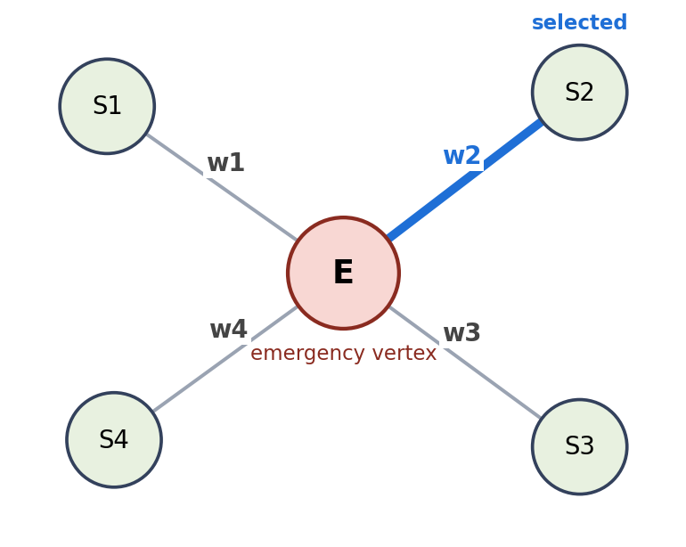
Figure 4.1: Schematic of the weighted graph (E: emergency vertex, S1 to S4: stations, w1 to w4: edge weights; the shortest edge is highlighted in blue)
[Insert screenshot: Graph page weighted network with the shortest route in blue]
Figure 4.2: Graph module weighted-network view (screenshot)

4.1.5. Testing and validation
Validation was designed as a set of practical manual tests carried out in the browser through localhost. The project does not claim automated unit-test coverage. Table 4.3 lists the tests and the behaviour each is expected to show.
Table 4.3: Manual test cases
No. | Test | Expected behaviour
1 | Open every DSA page through localhost | Each page loads and renders its structure
2 | Perform each Array operation | Search, sort, reverse and index access highlight the affected result
3 | Push, peek, pop and clear Stack entries | Top entry changes (or empties) according to LIFO order
4 | Add and remove linked-list vehicle nodes | Nodes appear and disappear with pointers redrawn
5 | Enqueue calls with different priorities, then process them | Most urgent call is processed first
6 | Run multiple Tree emergency classifications | Type and severity branches lead to the matching team and priority
7 | Toggle Hospital and Police station filters | Only the selected checkpoint types are shown and eligible
8 | Run Graph traversal for multiple emergency locations | Stations are checked and the nearest eligible one is selected
9 | Check the weighted graph after traversal | Shortest weighted edge is highlighted in blue
10 | Run the Graph demo without Google satellite configuration | Graph demonstration still works with local weights
11 | Confirm JavaScript syntax and page loading | Pages load without script errors

[Insert screenshot: checkpoint filters (Hospital / Police) and the traversal result showing the selected station]
Figure 4.3: Checkpoint filters and traversal result in the Graph module (screenshot)

CHAPTER 5.
CONCLUSION AND FUTURE WORK

5.1. Conclusion
Kindred demonstrates how the choice of data structure affects the speed, organisation and clarity of emergency-response operations. Arrays give direct access to zone data, linked lists manage a changing vehicle pool, stacks support undo, priority queues put the most urgent call first, decision trees make triage explicit, and a weighted graph with Dijkstra’s algorithm selects the nearest eligible station. The project is an educational ADSA system that connects theoretical concepts to a realistic Smart City scenario.
Expected results. The expected outcome was a locally runnable system with six interactive modules, a dashboard of 100 deterministic records, a Dijkstra-based station selection and Java companion code. These have been delivered as described in Chapter 4.
Deviations from the expected results and their reasons. The deviations are deliberate and follow from the constraints of Chapter 3:
- Graph distances are estimated educational weights, not live road distances, because live routing needs paid APIs and a protected server.
- The satellite layer is optional, because it depends on Google API configuration, billing and key restrictions.
- The system is not connected to real emergency services and sends no actual dispatch requests, for regulatory and safety reasons.
- There is no production authentication, database or multi-user backend, because the project is a frontend demonstration.
- Validation is by manual tests only; no automated unit-test coverage is claimed.

5.2. Future work
The way ahead is to move from a demonstration towards a production tool. Suggested extensions are:
- Add a backend and database (Design B of Section 3.4).
- Add authenticated dispatcher accounts.
- Use live traffic and routing services through a protected server.
- Add real-time vehicle tracking.
- Add incident history and analytics.
- Add accessibility improvements and multilingual support.
- Add automated unit and integration tests.

REFERENCES

[1] T. H. Cormen, C. E. Leiserson, R. L. Rivest and C. Stein, Introduction to Algorithms, 4th ed. MIT Press, 2022.
[2] R. Sedgewick and K. Wayne, Algorithms, 4th ed. Addison-Wesley, 2011.
[3] E. W. Dijkstra, “A note on two problems in connexion with graphs,” Numerische Mathematik, vol. 1, pp. 269–271, 1959.
[4] MDN Web Docs, HTML, CSS and JavaScript documentation. developer.mozilla.org
[5] Oracle, Java Platform, Standard Edition documentation. docs.oracle.com/javase
[6] Python Software Foundation, Python documentation: http.server. docs.python.org
[7] Google, Maps JavaScript API documentation. developers.google.com/maps
[8] J. W. J. Williams, “Algorithm 232: Heapsort,” Communications of the ACM, vol. 7, no. 6, pp. 347–348, 1964.
[9] National 911 Program, U.S. Department of Transportation, history of 911. 911.gov
[10] Ministry of Housing and Urban Affairs, Government of India, Smart Cities Mission. smartcities.gov.in
[11] Ministry of Home Affairs, Government of India, Emergency Response Support System (ERSS) 112 documentation.
[12] VisuAlgo (National University of Singapore) and USFCA Data Structure Visualizations, online algorithm visualisation tools. visualgo.net

APPENDIX

1. Plagiarism Report
[Attach the plagiarism (similarity) report for this project report here]

2. Design Checklist

Item | Addressed | Where
Need and problem identified without hinting at the solution | Yes | Sections 1.1, 1.2
Tasks and timeline defined | Yes | Sections 1.3, 1.4
Existing solutions reviewed and compared | Yes | Sections 2.2, 2.3
Problem defined with what is and is not to be done | Yes | Section 2.5
Measurable objectives stated | Yes | Section 2.6
Features evaluated against constraints | Yes | Sections 3.1 to 3.3
Standards listed | Yes | List of Standards, Section 3.2.1
At least two alternative designs | Yes | Section 3.4
Design selected with comparison and reason | Yes | Section 3.5
Methodology, flow and algorithm described | Yes | Section 3.6
Implementation and validation reported | Yes | Chapter 4
Deviations, conclusion and future work stated | Yes | Chapter 5
Ethical and safety limits stated honestly | Yes | Sections 3.2, 5.1
Sources cited | Yes | References

USER MANUAL

This manual explains how to run Kindred on a single computer and how to use each page.

Requirements
- A computer with Python 3 installed and a modern web browser.
- The Kindred project folder.
- Optional: a Java Development Kit (JDK) to run the Java companion files, and a Google Maps JavaScript API key for the satellite layer.

Steps to run the project
- Copy or extract the Kindred project folder to a location on your computer.
- Open a terminal (Command Prompt, PowerShell or Terminal) and move into the project folder with cd.
- Start the local server with python -m http.server 8000 (use python3 on some systems, or another free port number if 8000 is busy).
- Open a browser and go to http://localhost:8000. The command-centre dashboard opens with the emergency records.
- From the dashboard, open a module page: Array, Linked List, Stack, Priority Queue, Decision Tree or Graph.
- On a module page, choose an input or operation (for example search, push, enqueue or classify). The structure is redrawn and the result is explained in text.
- In the Graph module, select the checkpoint types (Hospital, Police or both) and an emergency location, then start the traversal. The nearest eligible station is selected and the shortest route is shown in blue.
- Optional: to see the satellite layer, add your Google Maps JavaScript API key in the Graph page configuration. Without a key, the Graph module still works with its local weights.
- To stop the server, return to the terminal and press Ctrl + C.
- Optional: to study the Java companion code, open the Java folder, compile the files with javac and run the main class with java.

[Insert screenshot: command-centre dashboard at localhost]
Screenshot: the command-centre dashboard (Step 4)

[Insert screenshot: a module page after an operation]
Screenshot: a module page showing the redrawn structure and explanation (Step 6)

