**SYNOPSIS OF THE PROJECT**

Account Retention Modelling using Machine Learning

1. **Introduction**

Retaining old customers along with making new ones is an important aspect in any industry and many efforts are made by the companies to do so. When a customer leaves a particular company and shifts to from one service provider to its competitor in the market, it is called Customer Churn. Although there are many reasons for customer churn, some of the major reasons are service dissatisfaction, lower interest rates, and better alternatives. A customer retention model is a way of predicting whether a customer will stay with your business. It helps you identify which customers are most or least likely to buy your product or use your service again. By running customer retention models, companies can focus on marketing efforts on the people who are most likely to respond and send personalized offers to different segments based on predicted behaviour.

So we use retention modelling to predict the impact of marketing activities on retention and churn.

1. **Objective**

To Create a model to have knowledge of the customers that are planning to leave the bank based on the predictions made by our Machine Learning Model and try to retain them by offering better deals.

1. **Name of the Organization**

The project is a part of BCIIT second semester Minor Project. Banarsidas Chandiwala Institute of Information Technology (BCIIT) was established in 1999 to run Master of Computer Application (MCA) programme. The Institute is affiliated with Guru Gobind Singh Indraprastha University.

1. **Future Scope**

After trying to understand who can leave and what caused customers to leave the bank, we could do analysis on what facilities or factors led to the retention of other customers, what the customer expects from the company.

1. **Data Required & Data Collection Method**

Data Collection is done through kaggle, it is in a csv format containing various rows and columns. It has following attributes:

|  |  |
| --- | --- |
| • RowNumber  • CustomerId  • Surname  • CreditScore  • Geography  • Gender  • Age | • TenureBalance  • NumOfProducts  • HasCrCard  • IsActiveMember  • EstimatedSalary  • Exited |

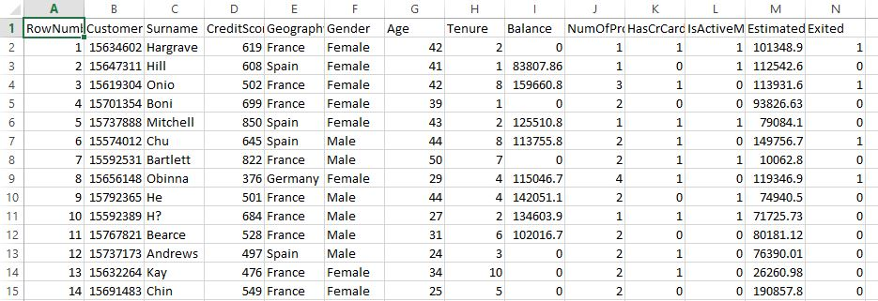

1. **Methodology**

The methodology used for Analysis, Design & Development is as follows:

We would be taking sample dataset from platforms like kaggle, uci, etc. Using them we will build models to predict the outputs as mentioned above using Machine Learning, which consists of using python language and its libraries.

The machine learning coding will be done in Google Colaboratory. It is a data analysis and machine learning tool that allows to combine executable Python code and rich text along with charts, images, HTML and more into a single document stored in Google Drive. It connects to powerful Google Cloud Platform runtimes and enables you to easily share your work and collaborate with others.

Data Analysis will be done using Google Data Studio, it is a web-based data visualization tool that helps users build customized dashboards and easy-to-understand reports.

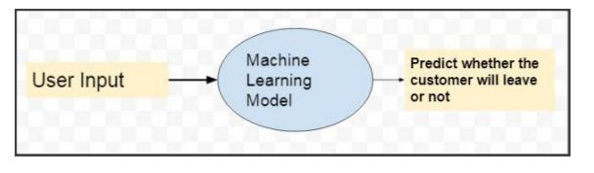

1. **Hardware Requirements**

|  |  |
| --- | --- |
| Type of Hardware | Hardware requirements |
| Hardware | Intel core ® 2.70 GHZ processor .64-bit system |
| Installed Memory(RAM) | 4 GB or higher |

1. **Software Requirements**

|  |  |
| --- | --- |
| Types of Software | Software Requirements |
| Operating System | Windows 7 or higher |
| Web browser | Google Chrome or FireFox |
| Code Editor | Google Colaboratory |
| Data Analysis | Google Data Studio |