**Flutter Class Assignment-2**

Hitesh Walia, MCA

00311104422

**TASK-3: Simple Image Fetch**

// We also need to add our image folder which is "img_src" in our case in the assests section

// in pubspec.yaml file to fetch images from "img_src" folder.

import 'package:flutter/material.dart';

void main() {

runApp( MyApp());

}

class MyApp extends StatelessWidget {

const MyApp({super.key});

// This widget is the root of your application.

@override

Widget build(BuildContext context) {

return MaterialApp(

title: 'Flutter Demo',

home: Scaffold( appBar: AppBar(title: Text("Image Demo"),),

body: Center(

child: Column(

mainAxisAlignment: MainAxisAlignment.center,

children: <Widget>[

Image.asset("img_src/1.jpg", width: 300, height: 300),

Image.asset("img_src/2.jpg", width: 300, height: 300),

],

),

),

),

);

}

}

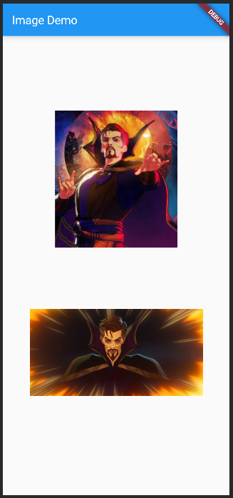

**TASK-4: Working with TextFields and Elevated Buttons by making a simple addition operation**

import 'package:flutter/material.dart';  
  
void main() {  
 runApp(MyApp());  
}  
  
class MyApp extends StatelessWidget {  
 @override  
 Widget build(BuildContext context) {  
 return MaterialApp(  
 debugShowCheckedModeBanner: false,  
 home: MiniCalc(),  
 );  
 }  
}  
  
class MiniCalc extends StatefulWidget {  
 @override  
 _MiniCalcState createState() => _MiniCalcState();  
}  
  
class _MiniCalcState extends State<MiniCalc> {  
 int firstNum = 0;  
 int secNum = 0;  
 int resNum = 0;  
 final fnController = TextEditingController();  
 final snController = TextEditingController();  
 final resController = TextEditingController();  
  
 void _calcAdd() {  
 setState(() {  
 firstNum = int.*parse*(fnController.text);  
 secNum = int.*parse*(snController.text);  
 resNum = firstNum + secNum;  
 resController.text = resNum.toString();  
 });  
 }  
  
 @override  
 Widget build(BuildContext context) {  
 return Scaffold(  
 backgroundColor: Colors.*white*,  
 appBar: AppBar(title: const Text("MiniCalc")),  
 body: Column(  
 children: <Widget>[  
 Padding(  
 padding: const EdgeInsets.all(15.0),  
 child: TextField(  
 controller: fnController,  
 decoration: const InputDecoration(  
 border: OutlineInputBorder(),  
 labelText: 'First Number',  
 hintText: "Enter an integer value",  
 ),  
 keyboardType: TextInputType.*number*,  
 ),  
 ),  
 Padding(  
 padding: const EdgeInsets.all(15),  
 child: TextField(  
 controller: snController,  
 decoration: const InputDecoration(  
 border: OutlineInputBorder(),  
 labelText: 'Second Number',  
 hintText: "Enter an integer value",  
 ),  
 keyboardType: TextInputType.*number*,  
 ),  
 ),  
 ElevatedButton(  
 onPressed: _calcAdd,  
 child: const Text(  
 'Add Numbers',  
 style: TextStyle(color: Colors.*white*, fontSize: 15),  
 ),  
 ),  
 Padding(  
 padding: const EdgeInsets.symmetric(horizontal: 15),  
 child: TextField(  
 controller: resController,  
 decoration: const InputDecoration(  
 border: OutlineInputBorder(),  
 labelText: 'Result',  
 hintText: "Displaying Result of Operation",  
 ),  
 enabled: false,  
 ),  
 ),  
 ],  
 ),  
 );  
 }  
}

