**Flutter Class Assignment-2**

Hitesh Walia, MCA

00311104422

**TASK-3: Simple Image Fetch**

// We also need to add our image folder which is "img_src" in our case in the assests section

// in pubspec.yaml file to fetch images from "img_src" folder.

import 'package:flutter/material.dart';

void main() {

runApp( MyApp());

}

class MyApp extends StatelessWidget {

const MyApp({super.key});

// This widget is the root of your application.

@override

Widget build(BuildContext context) {

return MaterialApp(

title: 'Flutter Demo',

home: Scaffold( appBar: AppBar(title: Text("Image Demo"),),

body: Center(

child: Column(

mainAxisAlignment: MainAxisAlignment.center,

children: <Widget>[

Image.asset("img_src/1.jpg", width: 300, height: 300),

Image.asset("img_src/2.jpg", width: 300, height: 300),

],

),

),

),

);

}

}

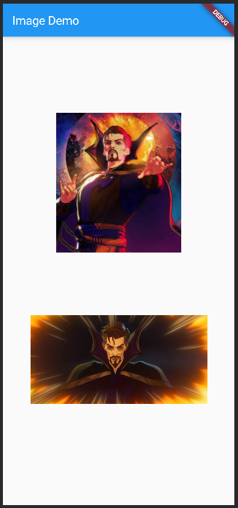

**TASK-4: Working with TextFields and Elevated Buttons by making a simple addition operation**