**Flutter Assignment-5**

*Hitesh Walia, MCA*

*00311104422*

1. Class Assignment Task-1

* **Method1:**

import 'package:flutter/material.dart';  
  
void main() {  
 runApp(MyApp());  
}  
  
class MyApp extends StatelessWidget{  
//This widget is the rest of your application.  
 @override  
 Widget build(BuildContext context) {  
 return MaterialApp(  
 title: 'Flutter Demo',  
 home: Scaffold(  
 appBar: AppBar(  
 title: Text("NRR Application"),  
 ),  
 body: Center(  
 child: Column(  
 mainAxisAlignment: MainAxisAlignment.center,  
 children: <Widget>[  
 Text ('My Name is : Hitesh Walia', style: TextStyle(fontSize: 18), ),  
 Text('My Roll No is 003',style: TextStyle(fontSize: 18)),  
 Text( 'My Semester is :3rd Sem', style: TextStyle(fontSize: 18)),  
 Text('My Subject is Computer Science Engineering', style: TextStyle(fontSize: 18)),  
 ],  
),  
),  
),  
);  
}  
}

* **Method 2:**
* import 'package:flutter/material.dart';  
  void main()=>runApp(MaterialApp(  
   title: "Flutter Demo",  
   home: Scaffold(  
   appBar: AppBar(  
   title: Text("NRR Application"),  
   ),  
   body: Center(  
   child: Column(  
   mainAxisAlignment: MainAxisAlignment.center,  
   children: <Widget>[  
   Text ('My Name is : Hitesh Walia', style: TextStyle(fontSize: 18), ),  
   Text('My Roll No is 003',style: TextStyle(fontSize: 18)),  
   Text( 'My Semester is :3rd Sem', style: TextStyle(fontSize: 18)),  
   Text('My Subject is Computer Science Engineering', style: TextStyle(fontSize: 18)),  
   ],  
   ),  
   ),  
   ),  
  )  
  );

**Output:**

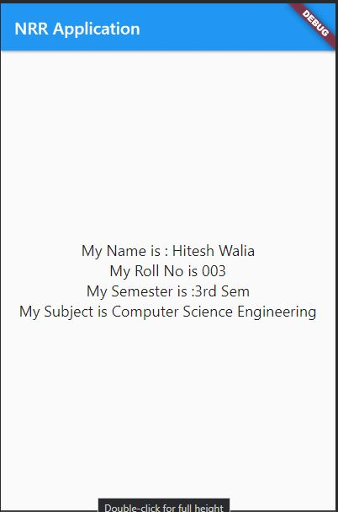

1. Class Assignment Task-2

import 'package:flutter/material.dart';  
import 'dart:ui';  
  
void main() => runApp(MyApp());  
  
class MyApp extends StatelessWidget {  
// This widget is the root of your application.  
 @override  
 Widget build(BuildContext context) {  
 return MaterialApp(  
 title: 'Flutter Demo',  
 home: Scaffold(  
 appBar: AppBar(  
 title: Text("Sample Application A5"),  
 ),  
  
 body: Center(  
 child: Column(  
 mainAxisAlignment: MainAxisAlignment.center,  
 children: <Widget>[  
 Text(  
 'My Name is : Hitesh Walia',  
 style: TextStyle(  
 fontWeight: FontWeight.*bold*,  
 color: Color.fromRGBO(225, 10, 170, 1),  
 fontSize: 30,  
 fontFamily: "Times New Roman",  
 ), // TextStyle  
 ), // Text  
  
 Padding(  
 padding: EdgeInsets.fromLTRB(5, 20, 5, 20),  
 child: Text("My Roll No is 003", style: TextStyle(fontSize: 40,  
 foreground: Paint()  
 ..style = PaintingStyle.stroke  
 ..strokeWidth = 3  
 ..color = Colors.*blue*[700]!), // TextSty  
 ),  
 ), // Padding  
  
 Text(  
 "My Semester is 3rd Sem", style: TextStyle(  
 fontSize: 20,  
 color: Colors.*purple*,  
 fontWeight: FontWeight.*w700*,  
 fontStyle: FontStyle.italic,  
 letterSpacing: 4,  
 wordSpacing: 20,  
 backgroundColor: Colors.*yellow*,  
  
 shadows: [  
 Shadow(color: Colors.*blueAccent*,  
 offset: Offset(2, 1),  
 blurRadius: 10)  
 ]),  
 ),  
  
 Padding(padding: EdgeInsets.fromLTRB(17, 10, 17, 10),  
 child: Container(  
 padding: EdgeInsets.fromLTRB(10, 10, 10, 10),  
 color: Colors.*tealAccent*, width: 300.0,  
 child: Text(  
 "My Subject is Computer Science Engg.",  
 textAlign: TextAlign.center,  
 style: TextStyle(  
 fontSize: 25,  
 height: 2,  
 color: Colors.*redAccent*,  
 backgroundColor: Colors.*black12*,  
 letterSpacing: 7,  
 decoration: TextDecoration.*underline*,  
 decorationStyle: TextDecorationStyle.double,  
 decorationColor: Colors.*brown*,  
 decorationThickness: 1.5,  
 fontStyle: FontStyle.italic,  
 ),  
 ),  
 ),  
 ),  
 ],  
 ),  
 ),  
 ),  
 );  
 }  
}

**Output:**

