# Mini Project I

**Business Requirements:**

**Considering the following questions:**

* **Think about what kind of information may be interesting to your audience? What kind of question may they use your report to find answers to?**
* **What are essential measures that matter to the management team? e.g., Sales Revenue? Sales Quantity? Cost? Profit margin? Are they available in the data file, or do you need to create a calculated field?**
* **What dimensions should be used? e.g., Date? Location? Customer? Product? Manufacturer?**

**Schema Used:**

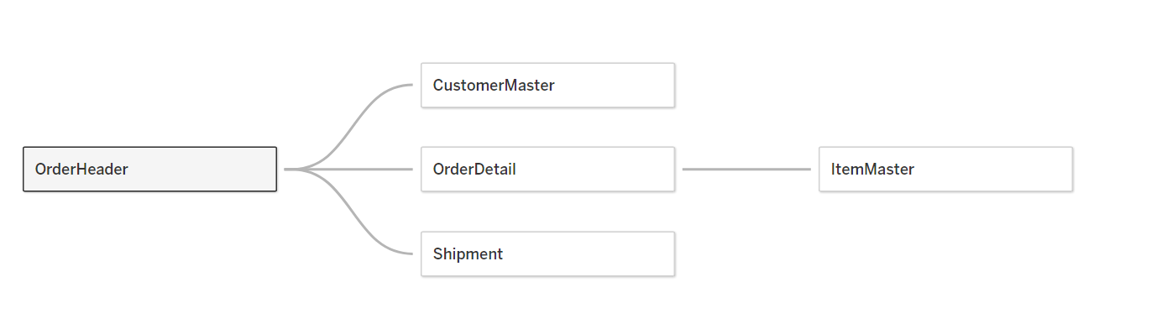

**1)** **Average Discount per State:**

In the above pictorial representation, we can see the average discount offered in the different states of the United States of America. The average discount ranges from 0.0% to 0.28%. The state with the highest average discount is Illinois with 0.2837% and the second highest state which is providing more discount is Texas with 0.268%. In some of the northwest states of the USA like Idaho, Montana, Washington, and Nevada all their discounts range between 0.560% to 0.0670%. The states like Michigan, Wisconsin, Kansas, etc. have no discount at all.

From a business point of view, the companies can focus more on the central region by giving more discounts to increase sales in their respective states.

By viewing the above graph, the audience can figure out that there are more discounts available in the western and eastern when compared to the central region.

**2)** **Calculated Profit < 5000 for Subcategories:**

This picture depicts the Profit which is attained at most of $5000 for the different subcategories. Here we can see the highest profit attained in the subcategory **Tables** with aprofit of around $4600. The **Storage** subcategory stands second with a profit margin of $4171. The subcategories **Copiers** and **Accessories** are slightly in a similar range with a profit of around $4000. The **Appliances, Furnishings,** and **Binders** all these subcategories range their profit nearly to $2200. Her, we can also observe that the subcategory **Fasteners** are in negative terms so it’s currently in loss.

To get the profit, we need to create a calculated field. The calculated field which I used is:

The profit graph can be useful for the business purpose to view in which subcategory they’ve attained more profits and where they need to focus to gain more profits. By using the **bar** graph the audience can feel much more comfortable understanding the data and can remember the values even after a particular period.

**3) Actual Sales per DATE:**

***fig: Actual sales year wise***

Here we can observe the actual sales received per year. We can observe that at the beginning the actual sales remained constant ranging from 475,000 to 525,000 and suddenly it got crept up to 725,183 in the year 2021.

We can also observe the actual sales that happened quarterly

***fig: Actual sales quarterly wise***

**Calculated Field:**

To get the actual sales I have used this calculated field

From a business point of view, the company can know their sales attained on a particular date and they can also know whether they reached the target or not. From the audience’s point of view, the above graphs are easily understandable as they are gradually increasing throughout the period it would be easy to remember the trend as they wouldn’t face many difficulties.

# Bonus

**Schema Used:**

**Sales Target V/s Actual Sales:**

The above-plotted graph is between Sales target and Actual Sales. Here we can observe is the sales target was 2,299,781 whereas the actual sales attained is 2,229,260. The difference is 70,521. Here, simply by looking at the scatter plot, we can estimate the actual value and it would be easily understandable for the audience.