# Mini Project II

**Business Requirements:**

* **Describe the comparison between the sales target and actual sales;**
* **What are the potential causes for the gap between target and reality;**
* **Explain what attempts you have made to reduce your audience's cognitive load and help them focus on the essential information?**

**Schema Used:**

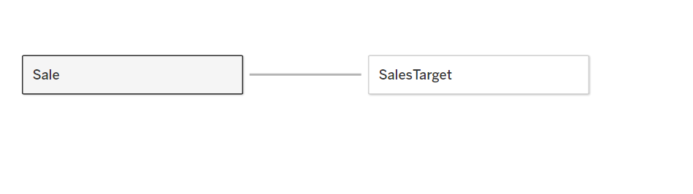

**1) Most Popular/Least Popular products by Sales Revenue:**

Here the most popular product by sales revenue is the 3D Systems Cube Printer, 2nd generation with revenue of more than 11k and the next most popular product is Staples with revenue of 7k. The least popular products are “While you were” Message Book, #10 Gummed Flap White Envelopes, "1/4 Fold Party Design Invitations & White Envelopes with respective revenue of 25,45 and 50.

**Calculated field:**

I have used the above-calculated field to get the revenue.

By looking at the above graph the audience can understand the most popular and least popular products by their respective revenue. The bar graph is easily understandable, and it doesn’t take much load to understand the visualization.

**2)Most Profitable/Least Profitable products:**

The above graph depicts the most and least profitable products. Here, Canon imageCLASS 2200 is the most profitable product with a profit of 23,878. Whereas the products Apple iPhone 5, Lexmark, and Hewlett Packard LaserJet have profits in the range of 9500 to 9900. Here, the least profitable product is OIC Thumb Stacks, OIC Binder Clips, Stockwell Gold Paper Clips, and Eureka disposable bags with an overall profit of 1.

I have used the below-calculated field to get the profit.

**Calculated field:**

I have used the bar graph to capture the audience’s views as it is understandable, and it’ll reduces the cognitive load of the audience.

**3) “Good” or “Bad” by Sales Revenue/quantity/profit:**

The above graph shows the good and bad states of Order Quantity, Revenue, and profit. The color Orange states that the parameter is in a good state whereas the color blue states that the parameter is in a bad state.

**Calculated field:**

I have used three calculated fields to get the 3-line graphs.

***Fig: Calculation Field of Order Quantity***

***Fig: Calculation Field of Profit***

***Fig: Calculation Field of Revenue***

Here, I have calculated the average of all the three parameters such as order quantity, profit, and revenue, and added their reference lines to the graph so that audience can understand the graph easily and reduce their cognitive load. I assumed the values above the average value as a “good” state and the values below the average value as a “bad” state. If we look at the line graph, we can observe the color variations in the graph with the colors orange and blue by this the audience can easily understand the good and bad stages of all the parameters.

**4) Order Shipped “On-time”:**

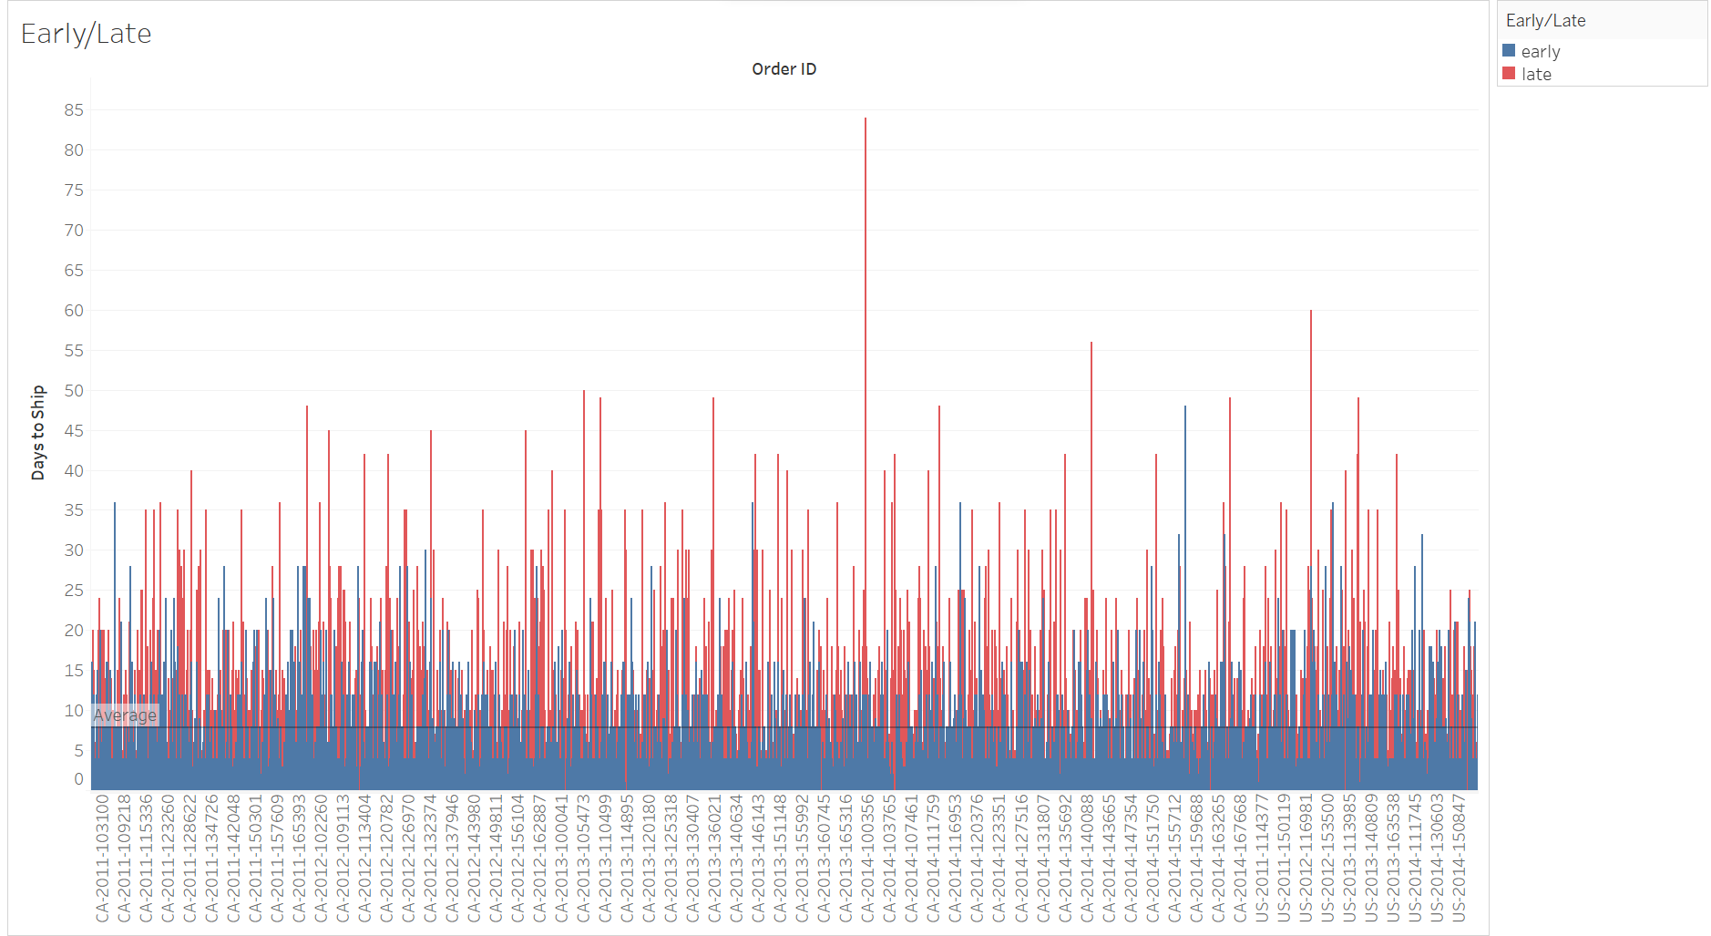

**On-Time:** Generally, delivery in time defines as the product being delivered between the 3 to 5 days of ordering the product. So, I have taken an average of 3 to 5 business days and got the value of 4 days as the on-time delivery date for the order to be delivered.

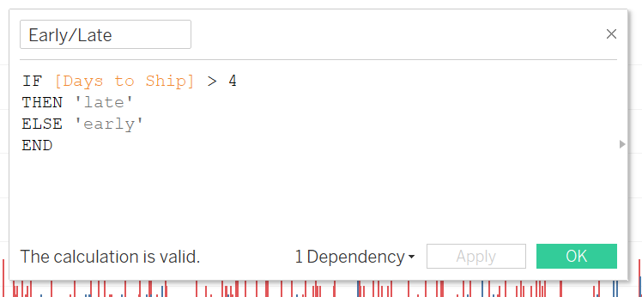

**Calculated field:**

I have used this calculated field to calculate the days to ship the product.

In the above bar graph, the audience can observe that the blue color states the product is delivered early or on time whereas the red color states that the product is delivered late. This reduces the cognitive load of the audience as there is the use of only two colors.

# Bonus II

**2) Switching between monthly sales quantity, revenue, and profit of the selected year:**

**Fig: Year-wise parameters of profit, sales, and Revenue.**

I have made use of the line graph which reduces the audience’s cognitive load and makes them easily understand the visualization. And also there is a drop-down window in which we can select a particular year to toggle the months and years to know the respective values of the parameters.