An Internship Report
Of
Cisco Networking Academy Internship
Submitted
To
School of Computer Science and Engineering
IILM University, Greater Noida, U.P.
In partial fulfilment of the requirement of degree of
B.Tech (Computer Science and Engineering)

By
Roll Number of Student: 2410031458
Name of Student: YADAV HITESH SHRAVAN
Section: 3CSE8
Batch: 2024-2028

Candidate's Declaration
I, YADAV HITESH SHRAVAN, do hereby declare that the internship report titled “Cisco Networking Academy Internship” has been completed by me to fulfil the requirement for the award of the degree of Bachelor of Technology in Computer Science and Engineering. All the references have been quoted and I have not taken as such any material from any other source. I affirm that this report is my own and has not been submitted to any other institute for any degree/diploma requirement, and further I shall be solely responsible for any kind of copyright violation in this regard.
Signature:-
Student Name: YADAV HITESH SHRAVAN
Roll No.: 2410031458

Acknowledgement
I am using this opportunity to express my gratitude to everyone who supported me throughout the internship. I am thankful for their aspiring guidance, invaluably constructive criticism, and friendly advice during this work.
I would like to thank the Cisco Networking Academy program and IILM University for providing me the opportunity and the structured platform to learn and gain hands-on exposure in the domain of computer networking. I am sincerely grateful to Mr Abhinav Raghav, Instructor, IILM University, for his guidance throughout the completion of these modules. I am also thankful to my institute, IILM University, Greater Noida, and the faculty of the School of Computer Science and Engineering for their continuous support and encouragement.
I express my gratitude to my parents for their blessings.
Signature:-
Student Name: YADAV HITESH SHRAVAN
Roll No.: 2410031458

Table of Contents
1. Candidate's Declaration i
2. Acknowledgement ii
3. Internship Certificates of Completion -
4. Project Description
4.1 Introduction 1
4.2 Organization Profile 2
4.3 Problem Statement 3
4.4 Project Objectives 3
4.5 Scope of the Project 4
4.6 Technologies and Tools Used 4
4.7 System Architecture / Applied Project 5
4.8 Methodology 6
4.9 Expected Outcomes 7
4.10 Certificates and Communication Proof 8
5. Bibliography/References 9

3. Internship Certificates of Completion
The following three certificates, issued by IILM University through the Cisco Networking Academy program, confirm successful completion of the internship modules referenced in this report.
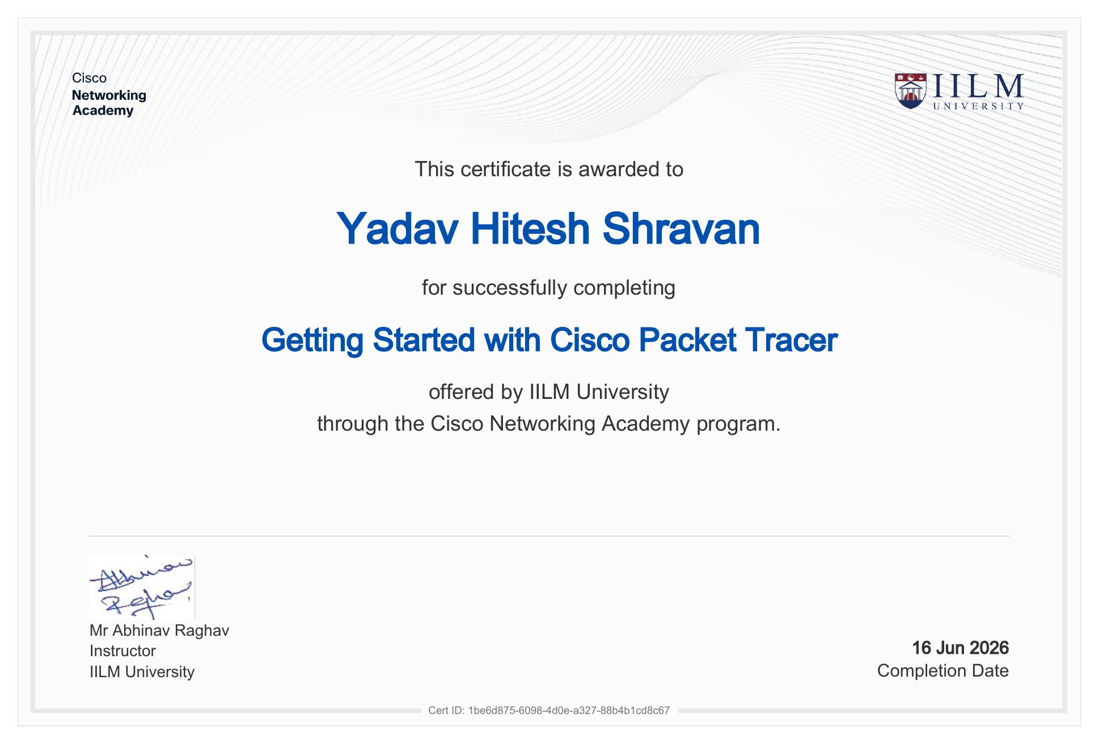
Certificate: Getting Started with Cisco Packet Tracer — Completion Date: 16 Jun 2026 — Cert ID: 1be6d875-6098-4d0e-a327-88b4b1cd8c67

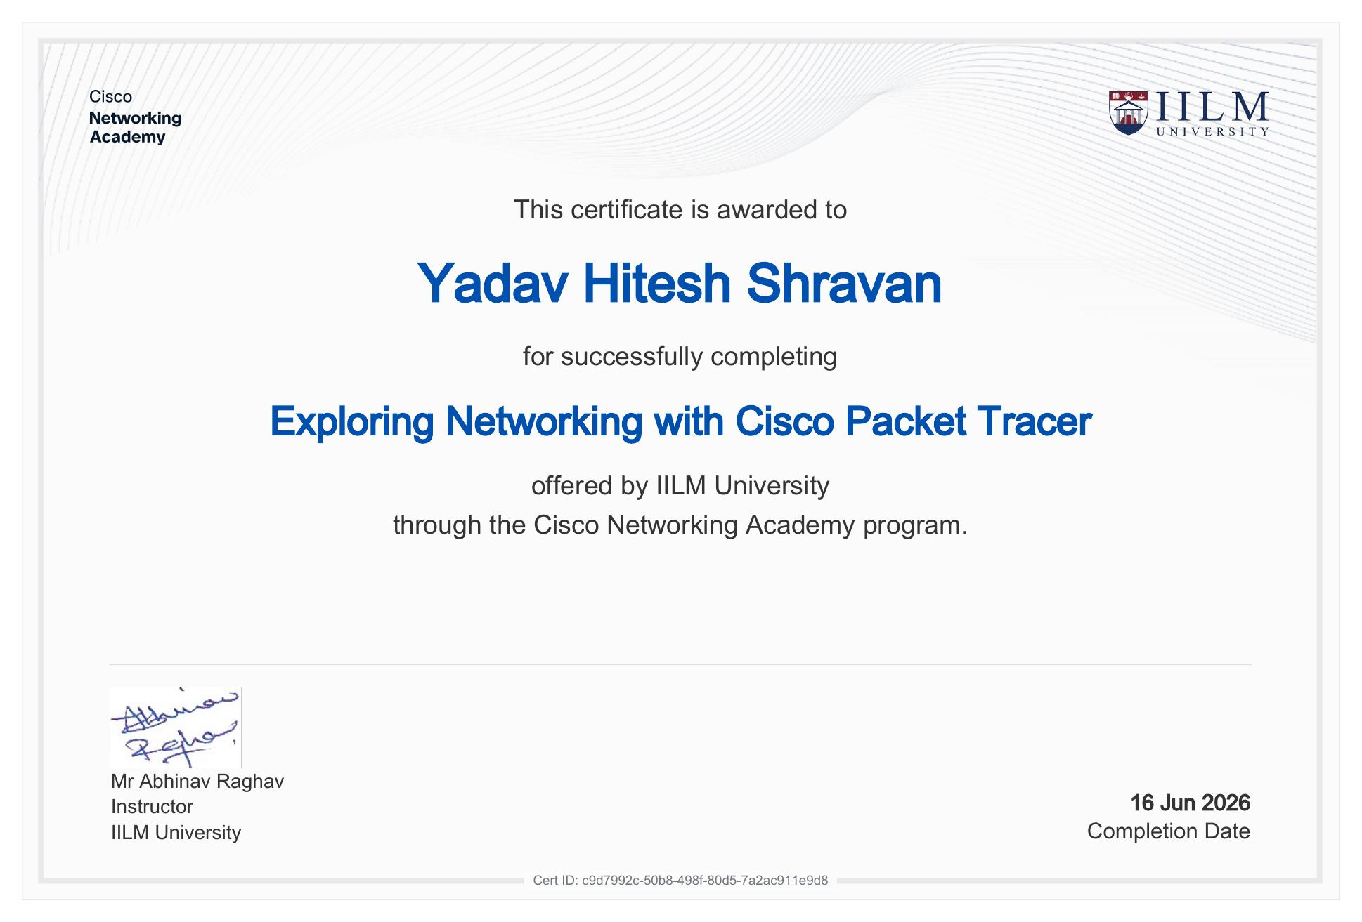
Certificate: Exploring Networking with Cisco Packet Tracer — Completion Date: 16 Jun 2026 — Cert ID: c9d7992c-50b8-498f-80d5-7a2ac911e9d8

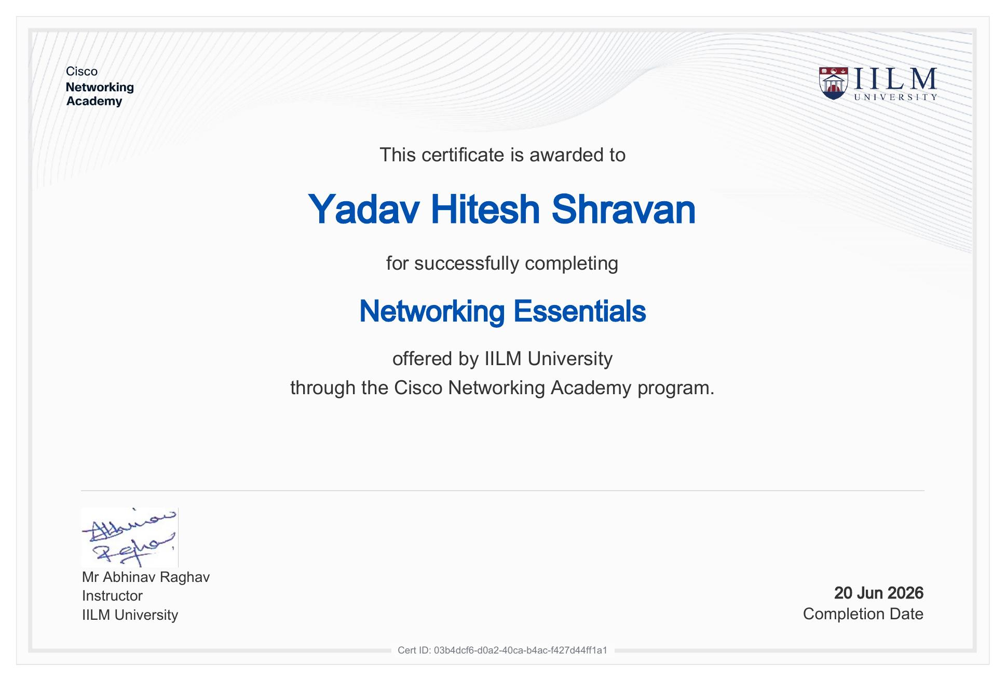
Certificate: Networking Essentials — Completion Date: 20 Jun 2026 — Cert ID: 03b4dcf6-d0a2-40ca-b4ac-f427d44ff1a1

4. Project Description

4.1 Introduction
This report presents a detailed account of the internship undertaken under the Cisco Networking Academy program, delivered through IILM University, Greater Noida, in the domain of computer networking. The internship was completed between 16 June 2026 and 20 June 2026, under the guidance of Mr Abhinav Raghav, Instructor, IILM University, as part of the requirement of the Bachelor of Technology (Computer Science and Engineering) programme.
The internship consisted of three modules — Getting Started with Cisco Packet Tracer, Exploring Networking with Cisco Packet Tracer, and Networking Essentials — aimed at building a practical foundation in network simulation, topology design, and core networking concepts. Following the completion of these modules, the concepts learned were applied to a hands-on branch-office network design and fault-diagnosis project, described in Section 4.7.

4.2 Organization Profile
The Cisco Networking Academy is Cisco's global IT skills and career-building program, offering structured courses in networking fundamentals, network simulation using Cisco Packet Tracer, and career-oriented technical training. At IILM University, Greater Noida, the program is delivered by the School of Computer Science and Engineering under Instructor Mr Abhinav Raghav, giving engineering students structured, hands-on exposure to enterprise networking concepts and tools alongside their regular coursework.

4.3 Problem Statement
Many engineering students learn networking concepts such as IP addressing, VLANs, routing, and switching only at a theoretical level, with limited hands-on practice in designing, configuring, and troubleshooting an actual network. The internship addressed this gap by providing structured, simulation-based training in Cisco Packet Tracer and core networking essentials, followed by an applied project to design and validate a working branch-office network.

4.4 Project Objectives
- To get started with Cisco Packet Tracer and understand its interface, device palette, and basic simulation workflow.
- To explore networking concepts practically by building and connecting devices within Packet Tracer.
- To learn core Networking Essentials — IP addressing, subnetting, switching, routing, and related fundamentals.
- To apply these concepts to a practical branch-office network design covering VLANs, inter-VLAN routing, DHCP, DNS, routing, ACLs, NAT, and wireless connectivity.
- To practice fault-finding and troubleshooting on a simulated network.

4.5 Scope of the Project
The scope of the internship covers the three completed Cisco Networking Academy modules and their practical application to a branch-office network design exercise. The work was carried out entirely within the Cisco Packet Tracer simulation environment as part of a structured academic program, and did not involve configuration of live production network hardware.

4.6 Technologies and Tools Used
Technology / Tool | Purpose
Cisco Packet Tracer | Network simulation, topology design, and device configuration
Cisco Networking Academy platform | Structured course delivery and assessment for all three modules
Python | Used in the applied fault-diagnosis assurance tool built alongside the network design
CSV-based case data | Used to record and validate documented network fault scenarios

4.7 System Architecture / Applied Project
As an applied extension of the Networking Essentials module, a branch-office network (“SmartBranch 360”) was designed to put the internship concepts into practice. It consists of four progressive Packet Tracer topology stages — a basic LAN, a VLAN and inter-VLAN routing stage, a DHCP/DNS stage, and a combined final topology with static routing, ACLs, NAT, and wireless connectivity. VLAN 10 and VLAN 20 were configured with router-on-a-stick inter-VLAN routing, DHCP and DNS services were configured for automatic addressing and name resolution, and ACLs and NAT were used to filter and translate traffic. A companion Python tool was also built to match typed-in network symptoms against a documented set of 30 fault cases and suggest likely causes and fixes, reinforcing the troubleshooting skills introduced in the internship.

4.8 Methodology
Module | Description | Completion Date
Getting Started with Cisco Packet Tracer | Introduction to the Packet Tracer interface, device palette, and basic simulation workflow | 16 Jun 2026
Exploring Networking with Cisco Packet Tracer | Building and connecting devices to explore practical networking behaviour within simulations | 16 Jun 2026
Networking Essentials | Core networking fundamentals — addressing, subnetting, switching, and routing | 20 Jun 2026
Applied Project (SmartBranch 360) | Practical branch-office network design, fault injection, and a Python-based diagnosis tool built to apply the concepts learned | Following module completion

4.9 Expected Outcomes
- Working familiarity with the Cisco Packet Tracer environment and simulation workflow.
- Practical understanding of core networking essentials — addressing, subnetting, switching, and routing.
- Ability to design a segmented network using VLANs, inter-VLAN routing, DHCP, DNS, ACLs, and NAT.
- Hands-on experience diagnosing and fixing simulated network faults.
- Three Cisco Networking Academy certificates of completion, issued by IILM University.

4.10 Certificates and Communication Proof
The three certificates of completion issued by IILM University through the Cisco Networking Academy program — for Getting Started with Cisco Packet Tracer, Exploring Networking with Cisco Packet Tracer, and Networking Essentials — are attached in Section 3 of this report as proof of successful completion.

5. Bibliography/References
1. IILM University / Cisco Networking Academy, “Getting Started with Cisco Packet Tracer”, Certificate of Completion, Cert ID: 1be6d875-6098-4d0e-a327-88b4b1cd8c67, 2026.
2. IILM University / Cisco Networking Academy, “Exploring Networking with Cisco Packet Tracer”, Certificate of Completion, Cert ID: c9d7992c-50b8-498f-80d5-7a2ac911e9d8, 2026.
3. IILM University / Cisco Networking Academy, “Networking Essentials”, Certificate of Completion, Cert ID: 03b4dcf6-d0a2-40ca-b4ac-f427d44ff1a1, 2026.
4. Cisco Networking Academy, https://www.netacad.com/
5. Cisco Packet Tracer Documentation, https://www.netacad.com/courses/packet-tracer
6. Python Software Foundation, https://www.python.org/

