**ANALYSIS-2**

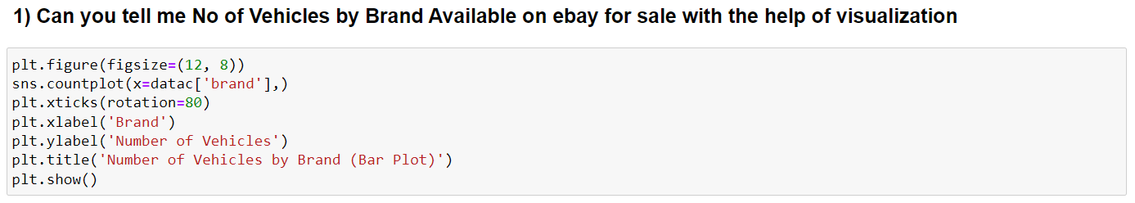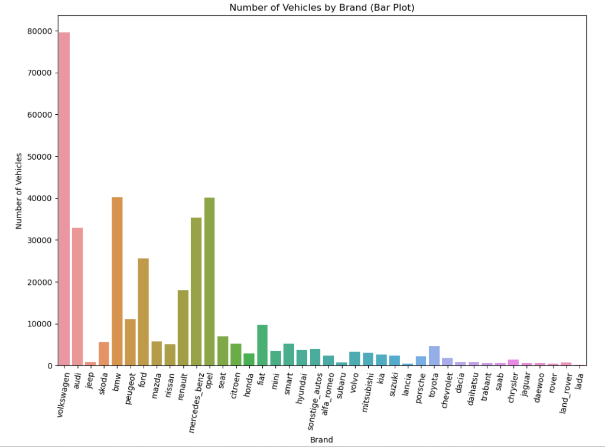

The generated bar plot offers a clear visualization of the distribution of vehicles among different brands. This information can be valuable for various purposes, including market analysis, inventory management, and understanding the popularity of specific brands in the dataset

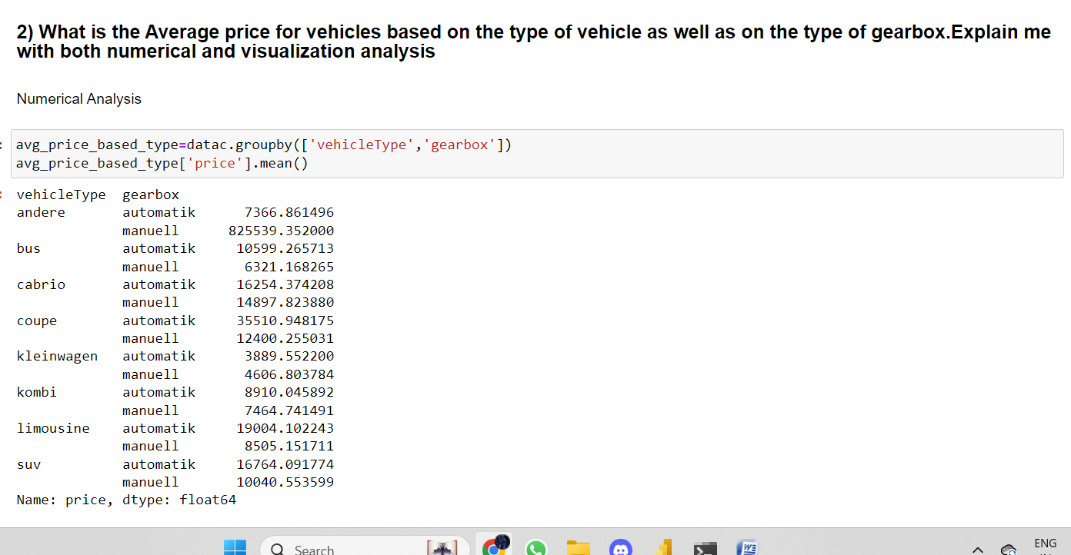

The analysis conducted in the code allows for a more detailed understanding of how vehicle prices are influenced by two categorical variables: 'vehicleType' and 'gearbox.' The resulting Series can be valuable for various purposes, including market analysis, pricing strategies, or making informed decisions related to vehicle types and gearbox types.

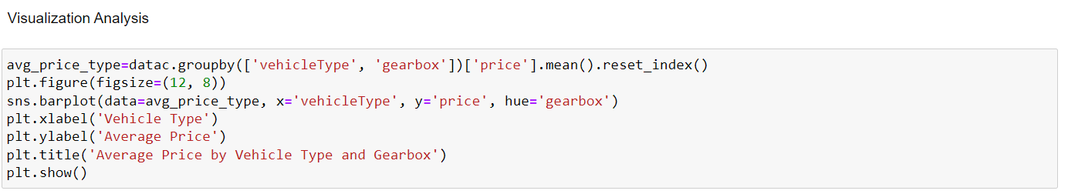

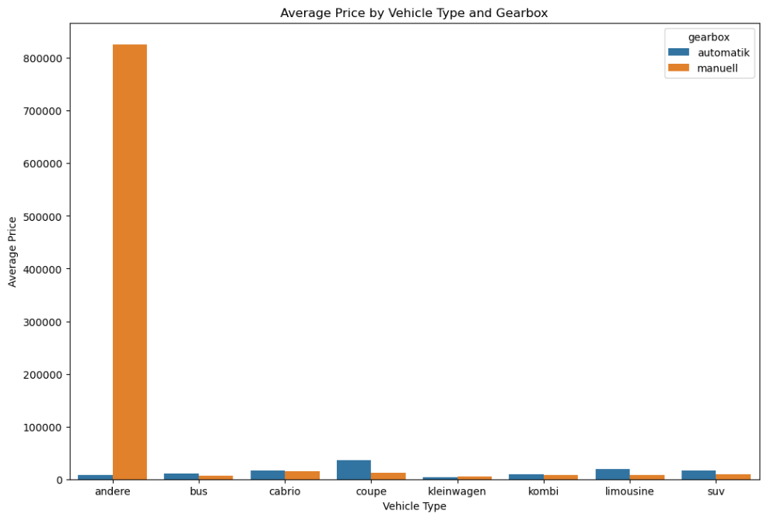

The output of the provided code is a bar plot that visually represents the average prices of vehicles based on their 'vehicle Type' and 'gearbox' types. Each bar corresponds to a specific 'vehicle Type,' and the bars are grouped by 'gearbox' type, enabling a comparison of average prices within each vehicle type.

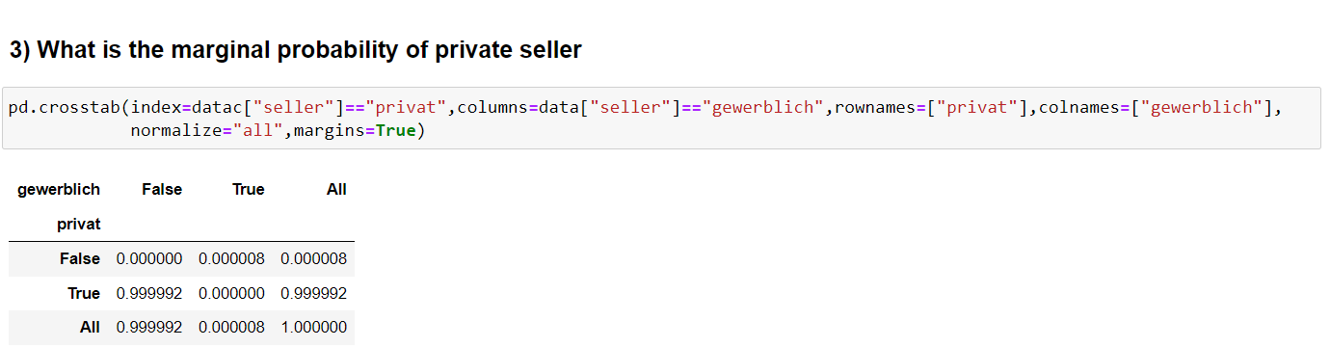

Here the marginal probability for private seller is 0.999992

Here the marginal probability for not a private seller is 0.000008

Here the marginal probability for gewerblitch seller is 0.000008

Here the marginal probability for not a gewerblitch seller is 0.999992