Agentic AI Food Donation Management System using Service-Oriented Architecture with ChatGPT, GitHub Copilot, Lucidchart AI, Jira AI and Postman Agent Mode
Dr.Neelima Gogineni  Assistant Professor  Department of Computer Science and Engineering,  Koneru Lakshmaiah Education Foundation, Bowrampet,  Hyderabad-500043, Telangana, India.  dr.neelima@klh.edu.in | Anahitha  Department of Computer Science and Engineering,  Koneru Lakshmaiah Education Foundation, Bowrampet,  Hyderabad-500043, Telangana, India.  2420030708@klh.edu.in
Hitheshini Kola  Department of Computer Science and Engineering,  Koneru Lakshmaiah Education Foundation, Bowrampet,  Hyderabad-500043, Telangana, India.  2420030233@klh.edu.in | Mihika Chowdary  Department of Computer Science and Engineering,  Koneru Lakshmaiah Education Foundation, Bowrampet,  Hyderabad-500043, Telangana, India.  2420040041@klh.edu.in

Abstract—Every day, large quantities of edible food are discarded by restaurants, events and households while nearby NGOs and shelters struggle to feed people in need. The gap is rarely a lack of food; it is a lack of timely coordination between donors, recipients and transport volunteers. This paper presents an Agentic AI Food Donation Management System built on a Service-Oriented Architecture (SOA). Independent REST services handle donors, recipients, donations, pickups and notifications, while a layer of cooperating AI agents – matching, safety validation, logistics and notification – uses large-language-model reasoning and tool calling to orchestrate these services without manual dispatch. The system was also engineered with an AI-assisted toolchain: ChatGPT for requirement analysis and agent prompt design, GitHub Copilot for code generation, Lucidchart AI for architecture and UML diagrams, Jira AI for backlog and sprint planning, and Postman Agent Mode for API test generation. We describe the architecture, a weighted donor–NGO matching model, the agent workflow and the role of each tool in the development lifecycle, and we outline an evaluation plan covering API correctness, matching latency, donation fulfilment and development effort.
Index Terms—Agentic AI, Food Donation, Service-Oriented Architecture, Large Language Models, Multi-Agent Systems, REST API, GitHub Copilot, Postman
I. INTRODUCTION
Food waste and hunger exist side by side. The UNEP Food Waste Index Report estimated that about 931 million tonnes of food, roughly 17% of the food available to consumers, was wasted in 2019, most of it in households, food services and retail [1]. Meanwhile, charities and shelters often depend on irregular, phone-based arrangements to receive surplus food. A donor with a tray of leftover meals has a short window of safety; if no recipient can be found and a vehicle arranged within that window, the food is thrown away. The problem is therefore one of real-time coordination under time, distance and safety constraints.
Traditional donation platforms are passive directories: the donor browses a list of NGOs and calls one. They do not reason about which NGO is closest, has capacity, needs this type of food, and can collect before expiry. Recent progress in large language models (LLMs) has made it practical to build agents that perceive a situation, reason about it, and act by calling external tools and APIs [2]–[4]. When such agents sit on top of well-defined services, they can automate the matching and dispatch decisions that humans currently make by hand.
A. Service-Oriented Architecture
Service-Oriented Architecture (SOA) structures an application as a set of loosely coupled, independently deployable services that communicate through standard interfaces [5]. For a donation platform this is a natural fit: donor management, recipient management, pickup scheduling and notification can evolve and scale separately, and each exposes a REST/JSON contract [6] that both web clients and AI agents can call. SOA also gives agents a clean “tool” boundary: every business capability an agent may use is an explicit, documented API.
B. AI-Assisted Software Engineering
The project itself was developed with AI assistance at every stage. ChatGPT supported requirement elicitation and prompt design; GitHub Copilot accelerated coding, which controlled studies have associated with faster task completion [7]; Lucidchart AI produced architecture and UML diagrams from text descriptions; Jira AI generated user stories and sprint plans; and Postman Agent Mode generated and executed API test suites. A second goal of this paper is to document how these tools fit together in a single, reproducible workflow.
The main contributions are: (i) an SOA-based design for food donation with clearly separated services; (ii) an agentic layer of four cooperating agents with a weighted matching model; (iii) a lifecycle mapping of five AI tools to engineering activities; and (iv) an evaluation methodology for the system.
II. LITERATURE SURVEY
This section briefly reviews prior work on food-waste reduction, LLM-based agents and AI-assisted development that informs the proposed system.
The UNEP Food Waste Index Report 2021 provides a global estimate of food waste at retail, food-service and household level and highlights that most waste arises at the consumption stage, motivating interventions close to donors [1]. Earlier FAO work reported that roughly one third of food produced for human consumption is lost or wasted along the supply chain [8].
Vaswani et al. introduced the Transformer architecture, which underlies modern LLMs [9]. Brown et al. showed that a large pre-trained language model can perform many tasks from natural-language instructions and a few examples without task-specific training [10], enabling prompt-driven applications such as requirement analysis and message generation.
Yao et al. proposed ReAct, in which an LLM interleaves reasoning traces with actions, allowing it to query external sources and update its plan as observations arrive [2]. Schick et al. presented Toolformer, a model that learns when and how to call external APIs [3]. Wang et al. survey LLM-based autonomous agents and describe the common profile, memory, planning and action modules [4]. These works motivate the design of our agents, which reason about a donation and act through service APIs.
Wooldridge and Jennings define an intelligent agent as a system that is autonomous, reactive, pro-active and socially able [11]; the cooperating matching, logistics, safety and notification agents in this paper follow that view of multi-agent collaboration.
On the engineering side, Chen et al. evaluated Codex, the model behind early code assistants, on functional-correctness benchmarks [12], and Peng et al. reported in a controlled experiment that developers using GitHub Copilot completed an HTTP-server task significantly faster than a control group [7]. Erl describes SOA design principles such as loose coupling, abstraction and reusability [5], and Fielding’s REST style underpins the service interfaces used here [6].
To our knowledge, few published systems combine an SOA backbone, LLM-based agents for donor–recipient matching and a documented multi-tool AI-assisted development workflow; this paper aims to fill that gap.
III. METHODOLOGY
This section details the system architecture, the agent layer, the matching model and the AI-assisted development workflow.
A. System Architecture
The system follows a layered SOA, shown in Fig. 1. Donor, NGO and volunteer client applications reach the back end through an API gateway that handles routing, token-based authentication and rate limiting. Behind the gateway, five stateless REST services own distinct business capabilities:
- Donor Service: registration, profile and donation history of restaurants, events and individuals.
- Recipient Service: NGO profiles, location, storage capacity, food preferences and operating hours.
- Donation Service: creation and lifecycle of a donation (type, quantity, packaging, expiry time, pickup address, status).
- Pickup Service: volunteer availability, route assignment and delivery status.
- Notification Service: e-mail/SMS/push alerts to donors, NGOs and volunteers.
Services communicate over HTTP/JSON, publish OpenAPI descriptions and persist data in a relational database. External map and messaging APIs are accessed only through the services, never directly by clients.
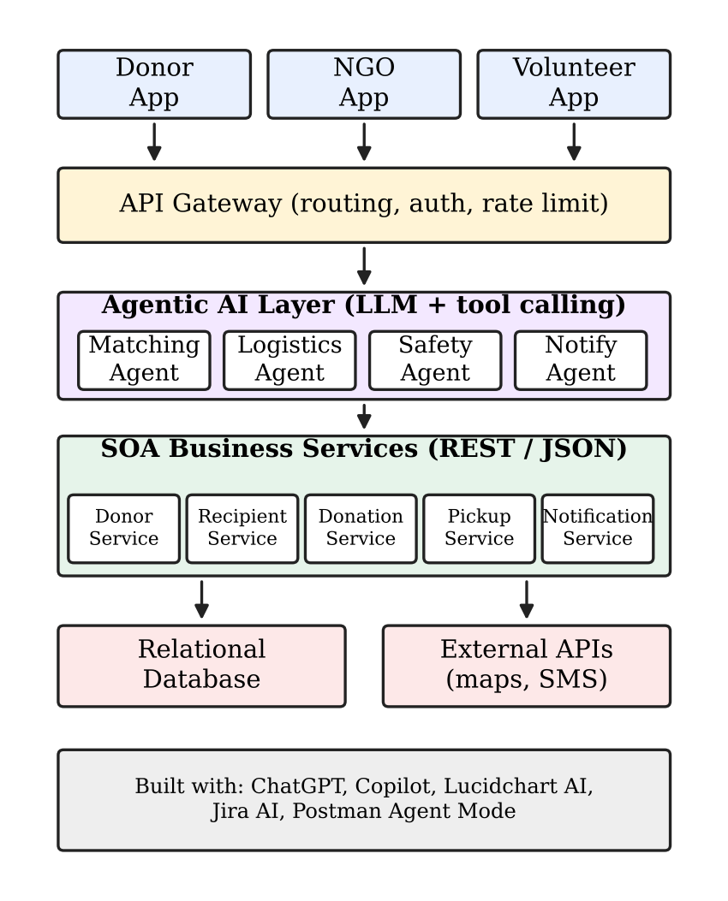
Fig. 1. SOA-based architecture with the agentic AI layer
B. Agentic AI Layer
The agentic layer sits between the gateway and the services. Each agent is an LLM instance with a role-specific system prompt and a restricted set of tools, where every tool is a call to one SOA endpoint. Agents follow a reason–act–observe loop [2]:
- Safety Agent: validates food category, preparation time and expiry; rejects or flags unsafe items and computes a “collect-by” deadline.
- Matching Agent: retrieves candidate NGOs from the Recipient Service and ranks them with the model in Section III-C.
- Logistics Agent: selects an available volunteer, proposes a pickup slot before the deadline and calls the Pickup Service.
- Notification Agent: composes clear, personalised messages and triggers the Notification Service at every state change.
Because agents act only through service APIs, every action is authenticated, validated and logged by ordinary SOA mechanisms. Final state transitions (e.g., confirming a pickup) are written by the services, not by free-form LLM output, which limits the effect of a faulty model response.
C. Donor–NGO Matching Model
For a donation d and candidate NGO r, the Matching Agent computes a score
S(d,r) = w₁·P + w₂·C + w₃·U + w₄·N (1)
where P is proximity (a normalised inverse of travel distance), C is capacity fit (whether the quantity fits the NGO’s storage), U is urgency (how comfortably pickup can occur before the collect-by deadline) and N is need (a match between food category and the NGO’s stated requirements and recent receipts). Each term lies in [0,1] and the weights satisfy w₁+w₂+w₃+w₄ = 1. The agent sends the highest-ranked NGO a request; on decline or timeout it moves to the next candidate, as shown in Fig. 2. The weights are configuration values and can be tuned from fulfilment data.
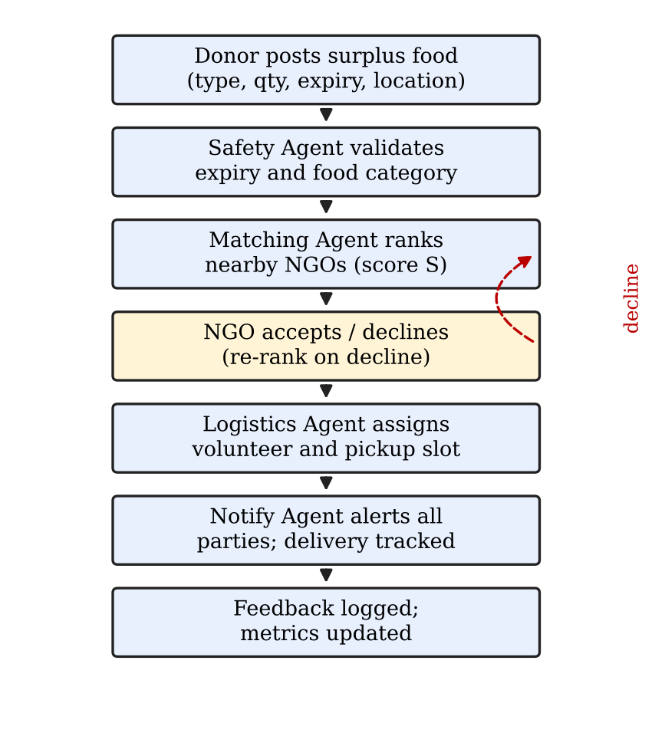
Fig. 2. End-to-end donation workflow executed by the agents
D. AI-Assisted Development Workflow
Table I summarises how the five AI tools were used. The output of each tool feeds the next: ChatGPT-refined requirements become Jira AI stories; stories drive Lucidchart AI diagrams; diagrams guide Copilot-assisted implementation; and Postman Agent Mode verifies the implemented APIs against their OpenAPI contracts.
TABLE I
AI TOOLS AND THEIR ROLE IN THE LIFECYCLE
Tool | Lifecycle stage | Contribution in this project
ChatGPT | Analysis, design | Requirement elicitation, user stories, agent system prompts, sample data and message templates
Jira AI | Planning | Epic/story breakdown, acceptance criteria, sprint backlog and issue summaries
Lucidchart AI | Design | Architecture, sequence, ER and use-case diagrams generated from text and then refined
GitHub Copilot | Implementation | Controller/service boilerplate, DTOs, validation, unit tests and refactoring suggestions
Postman Agent Mode | Testing | Collections generated from OpenAPI, test scripts, regression runs and failure analysis

All AI-generated artefacts were reviewed by the team before acceptance; generated code was compiled, tested and code-reviewed like any other contribution.
E. Testing Environment
Tests were performed on the following setup:
- CPU / RAM: [processor, e.g., Intel Core i5, 8 GB]
- OS: [e.g., Windows 11]
- Back end: [Spring Boot / Node.js], database: [MySQL / PostgreSQL]
IV. RESULTS & ANALYSIS
This section reports the evaluation of the system. Values in highlighted brackets are to be replaced with the measurements obtained from the implemented system; the metrics and their interpretation are defined below.
A. API Functional Testing
Postman Agent Mode generated test collections for each service from its OpenAPI description, covering positive, negative and boundary cases.
A high pass rate indicates that the service contracts are implemented as specified; failures are categorised by cause (validation, authorisation, data) to guide fixes.
B. Agent Performance
The agents were evaluated on simulated donation requests. We measure matching time (from donation creation to NGO request), end-to-end time to confirmed pickup, and fulfilment rate (donations collected before expiry divided by donations posted).
The expected benefit is a shorter time to pickup and a higher fulfilment rate, because matching and dispatch run immediately rather than waiting for a coordinator. The top-1 acceptance rate shows how well Eq. (1) reflects real NGO preferences; a low value suggests re-tuning the weights.
C. Development Effort with AI Tools
To assess the AI toolchain we compare the effort for comparable tasks with and without assistance using hours logged in Jira.
Time saved must be weighed against review effort: AI output can contain errors, so quality was checked through unit tests, Postman regression runs and peer review.
D. Discussion and Limitations
The SOA boundary made the agents safe and testable, since each tool call maps to a documented endpoint that can be mocked and replayed in Postman. Limitations include dependence on LLM response latency and availability, possible non-deterministic agent decisions, evaluation on simulated rather than field data, and reliance on accurate donor-supplied food information, which cannot replace on-site food-safety inspection.
V. CONCLUSION
This paper presented an Agentic AI Food Donation Management System based on Service-Oriented Architecture. Independent REST services provide stable business capabilities, while matching, safety, logistics and notification agents coordinate them to connect surplus food with NGOs before it expires. The paper also documented how ChatGPT, Jira AI, Lucidchart AI, GitHub Copilot and Postman Agent Mode were combined into a coherent AI-assisted development workflow. The design shows that an SOA backbone provides the control, auditability and testability that LLM agents need in a safety-sensitive domain.
This work can be extended in the following ways:
- Using demand forecasting to predict surplus at regular donors and pre-schedule pickups.
- Adding computer vision to verify food condition from donor photographs.
- Using route optimisation to batch several pickups for one volunteer.
- Building a native mobile application with real-time tracking, and deploying a pilot with partner NGOs to evaluate the system on field data.
REFERENCES
[1] UNEP, “UNEP Food Waste Index Report 2021,” United Nations Environment Programme, Nairobi, 2021.
[2] S. Yao, J. Zhao, D. Yu, N. Du, I. Shafran, K. Narasimhan, and Y. Cao, “ReAct: Synergizing Reasoning and Acting in Language Models,” in Proc. Int. Conf. Learning Representations (ICLR), 2023, arXiv:2210.03629.
[3] T. Schick et al., “Toolformer: Language Models Can Teach Themselves to Use Tools,” arXiv:2302.04761, 2023.
[4] L. Wang et al., “A Survey on Large Language Model based Autonomous Agents,” arXiv:2308.11432, 2023.
[5] T. Erl, Service-Oriented Architecture: Concepts, Technology, and Design. Upper Saddle River, NJ, USA: Prentice Hall, 2005.
[6] R. T. Fielding, “Architectural Styles and the Design of Network-based Software Architectures,” Ph.D. dissertation, Univ. California, Irvine, CA, USA, 2000.
[7] S. Peng, E. Kalliamvakou, P. Cihon, and M. Demirer, “The Impact of AI on Developer Productivity: Evidence from GitHub Copilot,” arXiv:2302.06590, 2023.
[8] J. Gustavsson, C. Cederberg, U. Sonesson, R. van Otterdijk, and A. Meybeck, Global Food Losses and Food Waste. Rome, Italy: FAO, 2011.
[9] A. Vaswani et al., “Attention Is All You Need,” in Adv. Neural Information Processing Systems (NeurIPS), 2017, arXiv:1706.03762.
[10] T. Brown et al., “Language Models are Few-Shot Learners,” in Adv. Neural Information Processing Systems (NeurIPS), 2020, arXiv:2005.14165.
[11] M. Wooldridge and N. R. Jennings, “Intelligent agents: theory and practice,” Knowledge Engineering Review, vol. 10, no. 2, pp. 115–152, 1995.
[12] M. Chen et al., “Evaluating Large Language Models Trained on Code,” arXiv:2107.03374, 2021.

