AGENTIC AI FOOD DONATION MANAGEMENT SYSTEM USING SERVICE-ORIENTED ARCHITECTURE
A Mini Project Report Submitted in the partial fulfillment of the requirements for the award of the degree of

BACHELOR OF TECHNOLOGY

In
DEPARTMENT OF COMPUTER SCIENCE ENGINEERING
By
Anahita Bhalme – 2420030708
Hitheshini Kola – 2420030233
Mihika Chowdary – 2420040041

Under the Esteemed Guidance of

Dr. Neelima Gogineni
Department of CSE





K L (Deemed to be) University
DEPARTMENT OF COMPUTER SCIENCE ENGINEERING

DECLARATION

The Mini Project Report entitled “Agentic AI Food Donation Management System using Service-Oriented Architecture” is a record of Bonafide work of Anahita Bhalme – 2420030708, Hitheshini Kola – 2420030233, Mihika Chowdary – 2420040041 submitted in partial fulfillment for the award of B. Tech in Computer Science and Engineering to the K L University. The results embodied in this report have not been copied from any other departments/University/Institute.

Anahita Bhalme – 2420030708
Hitheshini Kola – 2420030233
Mihika Chowdary – 2420040041
K L (Deemed to be) University
DEPARTMENT OF COMPUTER SCIENCE ENGINEERING
CERTIFICATE

This is to certify that the mini project based report entitled “Agentic AI Food Donation Management System using Service-Oriented Architecture” is a bonafide work done and submitted by Anahita Bhalme – 2420030708, Hitheshini Kola – 2420030233, Mihika Chowdary – 2420040041 in partial fulfillment of the requirements for the award of the degree of BACHELOR OF TECHNOLOGY in Department of Computer Science Engineering, K L (Deemed to be University), during the academic year 2026-2027.

Signature of the Course Co-ordinator Signature of HOD
ACKNOWLEDGEMENT

The success in this project would not have been possible but for the timely help and guidance rendered by many people. We wish to express our sincere thanks to all those who have assisted us in one way or the other for the completion of our project.

Our greatest appreciation to our guide, Dr. Neelima Gogineni, Department of Computer Science and Engineering, which cannot be expressed in words for the tremendous support, encouragement and guidance for this project.

We express our gratitude to Dr. P. Venkateshwar Sir, Head of the Department of Computer Science and Engineering, for providing us with adequate facilities, ways and means by which we are able to complete this project-based Lab.

We thank all the members of teaching and non-teaching staff members, and also who have assisted us directly or indirectly for successful completion of this project. Finally, we sincerely thank our parents, friends and classmates for their kind help and cooperation during our work.

Anahita Bhalme – 2420030708
Hitheshini Kola – 2420030233
Mihika Chowdary – 2420040041
TABLE OF CONTENTS

S.No. | Contents | Page no.
1. | Abstract | 6
2. | Introduction | 8
3. | Literature survey | 10
4. | Problem Statement and Objectives | 13
5. | Hardware and Software requirements | 15
6. | Implementation | 16
7. | Results & Discussion | 23
8. | Conclusion & Future Scope | 28
9. | References | 30

- ABSTRACT

Large quantities of edible food are wasted every day in Indian cities while many people still face hunger. Restaurants, caterers and households often have surplus food with only a short safe window, but donating it depends on phone calls: someone has to find an available NGO, judge whether the food is still safe and arrange a pickup before it spoils. This process is slow, does not scale and discourages donors.
This project proposes the Agentic AI Food Donation Management System, a Service-Oriented Architecture of Spring Boot microservices (Spring Cloud, Spring Security with JWT, MySQL) with a React and Tailwind CSS frontend that connects donors, NGOs, volunteers and beneficiaries. Three AI agents form its core: (1) a Freshness and Trust-Scoring Agent that combines a food-type perishability model, photo-based freshness estimation and the donor’s track record into one explainable Food Trust Score; (2) a Multi-Agent Negotiation Orchestrator that uses ChatGPT function calling to negotiate pickup slots and split large donations across several NGOs by capacity, distance and reliability; and (3) a Self-Healing AI-Ops Agent that watches service health through Eureka and the API Gateway, raises Jira tickets and drafts fix pull requests. Five AI tools are tied to distinct phases of the lifecycle: Lucidchart AI (design), Jira AI (planning), GitHub Copilot (build), ChatGPT (runtime reasoning) and Postman Agent Mode (API testing). Containerised with Docker and delivered through GitHub Actions, the platform turns every completed delivery into an auditable impact metric aligned with SDG 2, SDG 12 and SDG 11.
Keywords: Service-Oriented Architecture, Microservices, Spring Boot, Agentic AI, ChatGPT Function Calling, Food Donation, Food Waste, Trust Scoring, Sustainable Development Goals.
Team Name: None
Team Logo (if any): Not applicable
Team Members:
S.No. | Name | Roll No. | Role | Contact Information
1. | Anahita Bhalme | 2420030708 | Team Member | 2420030708@klh.edu.in
2. | Hitheshini Kola | 2420030233 | Team Member | 2420030233@klh.edu.in
3. | Mihika Chowdary | 2420040041 | Team Member | 2420040041@klh.edu.in

- INTRODUCTION

2.1 Background
Food waste and hunger exist side by side. The UNEP Food Waste Index Report 2024 estimates that households in India waste around 55 kg of food per person every year [7], while a significant part of the population remains food-insecure. A large share of the surplus that could be rescued is freshly prepared food from restaurants, caterers, hostels and events. It is safe to eat, but only for a few hours.
2.2 Motivation
Today, donating surplus food is a manual, phone-driven activity. A donor must find an NGO that is open, has capacity and is close enough; the NGO has no reliable way to know whether the food will still be safe when it arrives; and nobody coordinates volunteers for pickup. Donations that are too large for one NGO are often refused, and donations that arrive late are thrown away after pickup. Donors who are turned away stop donating. These problems are about matching, verification and coordination, and they can be automated.
2.3 What the Project Does
The Agentic AI Food Donation Management System automates the full donation workflow (listing, verification, matching, pickup, delivery and impact reporting) on a Service-Oriented Architecture. The key ideas are:
- N1 – Freshness and Trust-Scoring Agent: every listing gets a live, explainable Food Trust Score so that NGOs can prioritise the most urgent and most reliable donations.
- N2 – Multi-Agent Negotiation Orchestrator: ChatGPT function calling negotiates pickup slots and splits a large donation across several NGOs instead of simply picking the nearest one.
- N3 – Self-Healing AI-Ops Agent: monitors service health, files Jira tickets and drafts fix pull requests when a service degrades.
- N4 – Live SDG Impact Ledger: every completed delivery is recorded as meals served and food diverted, mapped to SDG 2 (Zero Hunger), SDG 12 (Responsible Consumption and Production) and SDG 11 (Sustainable Cities and Communities).
2.4 Why a Service-Oriented Architecture
Donors, NGOs, logistics, notifications, AI reasoning and impact reporting have different data, different users and different load patterns. Building each as an independent Spring Boot microservice with its own database, registered with Eureka and reached through a single API Gateway, lets each part be developed, tested, deployed and scaled on its own, and keeps a fault in one service (for example the AI layer) from stopping donations. It also exercises every course outcome: SOA design (CO1), JWT security (CO2), discovery, routing and database integration (CO3) and testing (CO4).
2.5 AI Tools across the Development Lifecycle
Phase | AI tool | How it is used in this project
Design | Lucidchart AI | Generates and maintains the service architecture and sequence diagrams
Plan | Jira AI | Breaks the backlog into sprints, summarises issues and tracks risk across reviews
Build | GitHub Copilot | Speeds up microservice and React development; drafts fix pull requests for N3
Reason | ChatGPT (OpenAI API) | Runtime reasoning core of the negotiation orchestrator (function calling) and photo freshness check
Test | Postman Agent Mode | Generates and runs API contract tests for every service inside the CI pipeline

2.6 Organisation of the Report
Chapter 3 surveys related research and platforms. Chapter 4 states the problem and the objectives. Chapter 5 lists the hardware and software requirements. Chapter 6 describes the implementation of the frontend, the microservices, the AI agents and the API integration. Chapter 7 presents the results and their discussion. Chapter 8 concludes the report and outlines future work, and Chapter 9 lists the references.
- LITERATURE SURVEY

We studied recent research on AI for food banks and food charities, and widely used surplus-food platforms. Each work is summarised below, followed by the gap that this project addresses.
3.1 Sammer et al., “AI-FEED: Prototyping an AI-Powered Platform for the Food Charity Ecosystem” (IJCIS, 2024) [1]
AI-FEED is a web platform built with stakeholder interviews and four modules: food charities (need forecasting and educational content), donors (blockchain-recorded donations and recognition), clients (service and nutrition information) and community leaders (mapping and proposal tools). It shows that a modular, service-based design works for the food-charity ecosystem. However, it does not provide live negotiation between donors and multiple charities or a real-time freshness check. Our Negotiation Orchestrator (N2) and Trust-Scoring Agent (N1) address these gaps.
3.2 Yang et al., “Artificial Intelligence in Food Bank and Pantry Services: A Systematic Review” (Nutrients, 2025) [2]
Following PRISMA guidelines across eleven databases, the authors found only five peer-reviewed studies (2015–2024) applying AI to food banks and pantries, using neural networks, K-means clustering, random forests, Bayesian additive regression trees and topic modelling. The review identifies donation variability, volunteer shortages and supply–demand matching as the core operational problems, and concludes that AI adoption is still limited. None of the reviewed studies uses agentic, real-time orchestration, which is the focus of our project.
3.3 Sharma et al., “FoodRL: A Reinforcement Learning Ensembling Framework for In-Kind Food Donation Forecasting” (arXiv, 2025) [3]
FoodRL clusters several forecasting models and uses a reinforcement-learning agent to weight them based on recent performance and context. Evaluated on multi-year data from two U.S. food banks affected by wildfires and hurricanes, it outperforms baselines, especially during disruptions. It forecasts monthly donation volume for planning; it does not match individual donations to NGOs in real time or verify food safety, which our system does.
3.4 Too Good To Go (industry platform) [4]
Too Good To Go is a commercial app through which cafes, bakeries, restaurants and supermarkets sell their end-of-day surplus as discounted “surprise bags” that customers collect. It proves that businesses will list surplus food when the process is easy. It is a sales model for individual consumers, however, not a donation channel to NGOs, and it has no freshness scoring or multi-recipient logistics.
3.5 OLIO (community sharing platform) [5]
OLIO is a free app where neighbours and businesses list surplus food (and other items) for others nearby to request and collect; volunteers also collect surplus from partner retailers. It demonstrates large-scale peer-to-peer sharing and volunteer pickup. Matching is done by the users themselves browsing listings, with no automated ranking, trust scoring or capacity-aware allocation across organisations.
3.6 Food Rescue Hero (volunteer rescue platform) [6]
Started as 412 Food Rescue in Pittsburgh, Food Rescue Hero alerts volunteers about nearby surplus food and lets them claim pickups that fit their schedule, delivering to non-profit agencies. It shows that volunteer logistics can be coordinated through an app. Recipient selection and scheduling remain largely rule-based; it does not negotiate or split donations with an AI agent or monitor and repair its own services, which our N2 and N3 agents do.
3.7 Summary and Research Gap
Work | Approach | Gap addressed by this project
AI-FEED [1] | Modular AI + blockchain charity platform | No live multi-NGO negotiation or freshness check
Yang et al. [2] | Systematic review of AI in food banks | Only five studies; no agentic orchestration
FoodRL [3] | RL ensemble for donation forecasting | Forecasting only; no real-time matching
Too Good To Go [4] | Discounted surplus sales to consumers | Not a donation channel; no trust score
OLIO [5] | Peer-to-peer sharing with volunteers | Manual matching; no capacity-aware allocation
Food Rescue Hero [6] | Volunteer pickup coordination | Rule-based; no AI negotiation or self-healing

Existing platforms focus on listing, forecasting or single-point recommendation. None combines real-time freshness verification, LLM-driven negotiation that can split one donation across several NGOs, and self-healing infrastructure in one agentic, service-oriented platform. Trust and freshness are treated as a one-time manual check rather than a continuously updated, explainable score, and DevOps reliability is rarely addressed in food-donation work at all.
- Problem Statement and Objectives

Problem Statement:
Surplus food that is safe to eat goes to waste because there is no automated way to verify it and route it to NGOs that can use it before it spoils.
Problem Description:
Donation today is manual and phone-driven: donors must find an available NGO themselves, nobody can verify whether a listed donation is still fresh, and large donations cannot be shared across NGOs. The result is wasted food, NGOs receiving donations they cannot use in time, and discouraged donors.
User Story: “As a restaurant manager with surplus food, I want to list it once and have the system verify it, find the right NGOs and arrange pickup automatically, so that the food reaches people in need before it spoils, without me making phone calls.”
Objectives:
Project purpose: The project was started because the main barrier to food rescue is not a lack of donors or NGOs but the slow, manual coordination between them. The business need is a platform that matches, verifies and routes donations in real time and proves its social impact. The objectives are:
- Reduce food wastage by connecting surplus food to organisations that can use it, in real time.
- Automate the donation workflow (listing, matching, pickup and delivery) with independently deployable Spring Boot microservices behind an API Gateway and Eureka registry (CO1, CO3).
- Verify food safety with an explainable Food Trust Score that combines perishability, photo evidence and donor reliability (N1).
- Optimise distribution with a ChatGPT-based orchestrator that negotiates pickup slots and splits donations across NGOs by capacity, distance and reliability (N2).
- Keep the platform reliable with a self-healing AI-Ops agent that detects degraded services and starts recovery (N3).
- Secure every service with Spring Security, JWT and role-based access for DONOR, NGO, VOLUNTEER and ADMIN users (CO2).
- Measure impact with live analytics and SDG-mapped reports for donors, NGOs and CSR partners (N4).
- Verify the system with unit, integration and Postman API contract tests run automatically in CI (CO4), and integrate all five AI tools across the lifecycle.
Functional Requirements
ID | Requirement | Service
FR1 | Users register and log in as DONOR, NGO, VOLUNTEER or ADMIN and receive a JWT | auth-service
FR2 | Donors list surplus food with type, quantity, preparation time, photo and location | donor-service
FR3 | NGOs maintain a verified profile with capacity, service area and opening hours | ngo-service
FR4 | Each listing receives a Food Trust Score and urgency band | agent-orchestrator-service
FR5 | The orchestrator allocates a donation to one or more NGOs and books pickup slots | agent-orchestrator-service
FR6 | Volunteers are assigned pickups and update delivery status | logistics-service
FR7 | Donors, NGOs and volunteers are notified at each step | notification-service
FR8 | Completed deliveries update the SDG impact ledger and dashboard | impact-service
FR9 | Degraded services are detected and a Jira ticket and draft fix PR are created | aiops-agent-service

Non-Functional Requirements
- Security: JWT validated at the gateway and in every service, BCrypt password hashing, RBAC, HTTPS in deployment.
- Resilience: if the AI layer is unavailable, a rule-based matcher takes over so that donations are never blocked.
- Scalability: stateless services with a database per service, registered in Eureka and load-balanced through the gateway.
- Explainability: every trust score and allocation decision is stored with the reasons that produced it.
- Usability: a responsive React interface usable on a phone by donors and volunteers.
- HARDWARE AND SOFTWARE REQUIREMENTS

5.1 Hardware Requirements
Component | Minimum | Recommended
Processor | Intel Core i5 / AMD Ryzen 5 (64-bit) | Intel Core i7 / AMD Ryzen 7
RAM | 8 GB | 16 GB (ten Spring Boot services, MySQL and Docker run together)
Storage | 15 GB free | 25 GB free SSD (Docker images, Maven and npm caches, MySQL data)
Network | Broadband internet | Stable internet for OpenAI, Jira and GitHub APIs
Client device | Any smartphone or laptop with a modern browser | —

5.2 Software Requirements
Category | Software / Version
Operating System | Windows 10 / 11, Ubuntu 22.04 or macOS
Backend | Java 17+, Spring Boot 3.x, Spring Web, Spring Data JPA, Spring Validation, Spring Boot Actuator
Microservice Infrastructure | Spring Cloud: Netflix Eureka, Spring Cloud Gateway, OpenFeign, LoadBalancer
Security | Spring Security, JWT (JJWT), BCrypt
Database | MySQL 8 (one schema per service); H2 for tests
Frontend | React 18, Tailwind CSS 3, Vite, Axios, React Router, Chart.js
AI Services | OpenAI API (ChatGPT with function calling and image input)
AI Engineering Tools | Lucidchart AI, Jira AI (Jira Cloud), GitHub Copilot, Postman Agent Mode
Build and Runtime | Apache Maven 3.9, Node.js 20 LTS, Docker and Docker Compose
CI/CD | GitHub Actions
Testing | JUnit 5, Mockito, Spring MockMvc, Postman collections run with Newman
Tools | VS Code / IntelliJ IDEA, MySQL Workbench, Git, Postman, Chrome / Edge

- IMPLEMENTATION

Frontend: React 18 single-page application styled with Tailwind CSS, with separate Donor, NGO, Volunteer and Admin portals.
Backend: Java Spring Boot microservices (Eureka, API Gateway, and eight business and agent services), each with its own MySQL schema.
API Integration: REST/JSON through Spring Cloud Gateway with JWT; OpenFeign between services resolved by Eureka; external OpenAI, Jira and GitHub REST APIs for the AI agents.
6.1 System Architecture
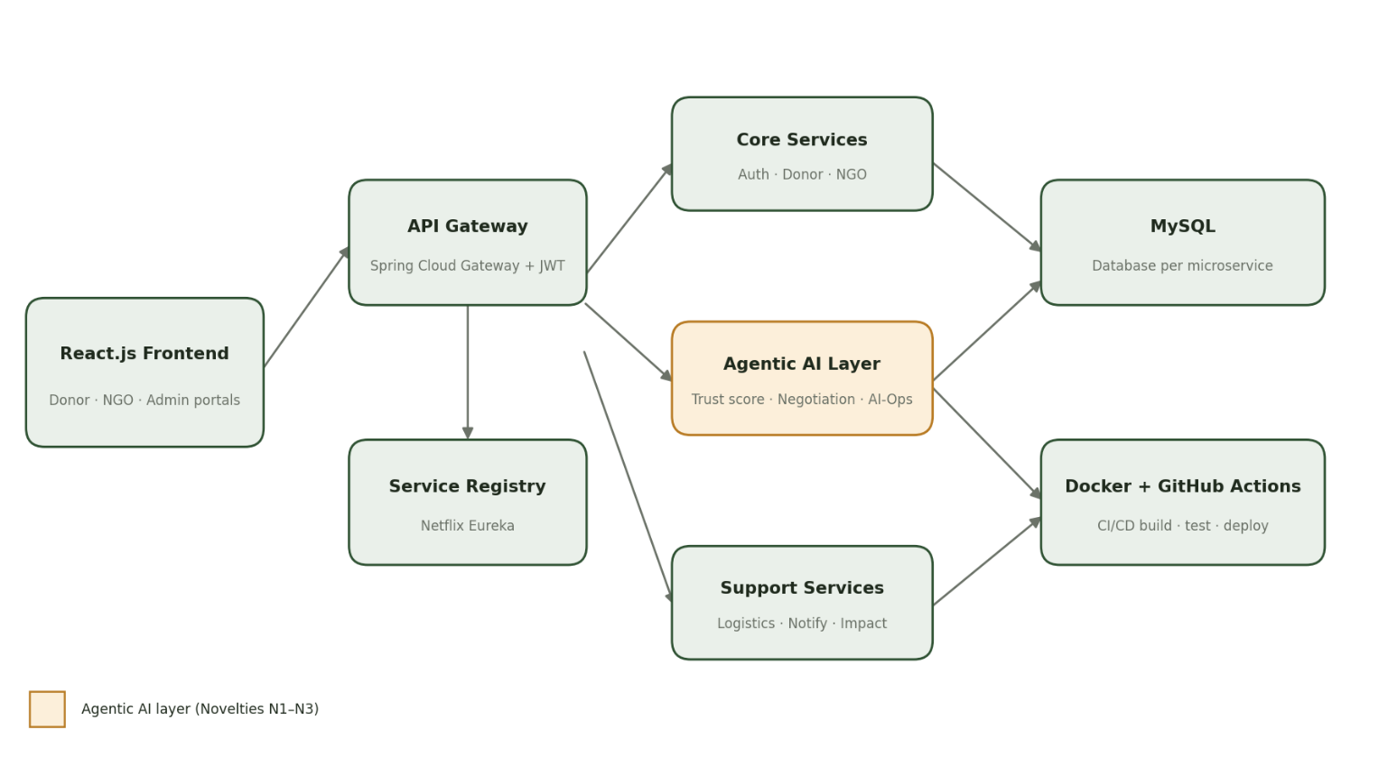
Figure 6.1: Architecture of the Agentic AI Food Donation Management System
The React frontend reaches every service through the API Gateway, which validates the JWT and routes requests to services found in the Eureka registry. The agentic AI layer sits beside the core and support services, and every service owns its own database.
Service | Port | Responsibility | Database
eureka-server | 8761 | Service registry for all services | —
api-gateway | 8080 | Single entry point, JWT validation, routing (lb://), CORS | —
auth-service | 8081 | Registration, login, JWT issue, roles DONOR / NGO / VOLUNTEER / ADMIN | auth_db
donor-service | 8082 | Donor profiles and food listings (type, servings, time, photo, location) | donor_db
ngo-service | 8083 | NGO profiles, verification, capacity, service area, reliability | ngo_db
agent-orchestrator-service | 8084 | N1 Trust-Scoring Agent and N2 Negotiation Orchestrator (ChatGPT) | agent_db
logistics-service | 8085 | Pickup slots, volunteer assignment, delivery tracking | logistics_db
notification-service | 8086 | E-mail and in-app notifications for every status change | notification_db
impact-service | 8087 | N4 SDG impact ledger and dashboard data | impact_db
aiops-agent-service | 8088 | N3 health monitoring, Jira tickets, draft fix pull requests | aiops_db

6.2 Donation Flow
- A donor logs in and submits a listing with food name and type, quantity and unit, preparation and expiry time, photo and pickup address.
- donor-service stores the listing and calls agent-orchestrator-service, which computes the Food Trust Score (N1). Listings past the safe window are rejected immediately.
- The orchestrator (N2) asks ChatGPT, through function calling, to find candidate NGOs and propose an allocation. Java code validates the proposal against real NGO capacity and distance before accepting it.
- logistics-service books pickup slots and assigns volunteers; notification-service informs the donor, the NGOs and the volunteers.
- When the volunteer confirms delivery, impact-service adds the meals and food weight to the SDG ledger, and the donor’s reliability score is updated.
6.3 Frontend (React, Tailwind CSS)
The frontend, branded FoodShare, is a React 18 application built with Vite and styled with Tailwind CSS. Axios sends every request to the API Gateway, with an interceptor that attaches the JWT. A sidebar gives access to the Dashboard, Donations, Create Donation, NGOs, Notifications, Impact, AI Insights and Profile pages, and React Router shows a different portal for each role:
- Donor portal: create a listing with photo upload, see the trust score and its reasons, and track pickup and delivery.
- NGO portal: maintain capacity and hours, view incoming allocations sorted by urgency, accept or decline slots.
- Volunteer view: list of assigned pickups with map links and one-tap status updates.
- Admin dashboard: NGO verification, live service health from the AI-Ops agent, and SDG impact charts (Chart.js).
src/pages/donor/NewDonation.jsx (excerpt)
export default function NewDonation() {
const [form, setForm] = useState({ category: "COOKED_MEAL", servings: 50, preparedAt: "", photo: null });
const submit = async () => {
const { data } = await api.post("/api/donations", toFormData(form)); // JWT added by interceptor
navigate(`/donations/${data.id}`); // shows trust score + allocation
};
return (
<form className="max-w-lg mx-auto p-6 bg-white rounded-2xl shadow space-y-4" onSubmit={submit}>
...
</form>
);
}
6.4 Backend (Java, Spring Boot)
Every business service follows the same layered structure: controller → service → repository (Spring Data JPA) → entity, with dto, security (JWT filter), client (OpenFeign interfaces) and exception packages. The main Java classes are:
Class | Service | Purpose
AuthController, AuthService, JwtUtil | auth-service | Register, login, issue and validate JWTs
DonationController, DonationService | donor-service | Create, list and track food listings
NgoController, NgoService | ngo-service | NGO profile, verification and spare capacity
TrustScoringAgent | agent-orchestrator-service | Computes the Food Trust Score (N1)
NegotiationOrchestrator, OpenAiClient | agent-orchestrator-service | ChatGPT function-calling loop and plan validation (N2)
PickupController, VolunteerAssigner | logistics-service | Pickup slots and volunteer assignment
NotificationListener | notification-service | Sends e-mail and in-app messages
ImpactLedgerService | impact-service | Meals, kilograms diverted and SDG mapping (N4)
HealthWatcher, JiraClient, GitHubClient | aiops-agent-service | Health checks, ticket and pull-request automation (N3)

N1 – Freshness and Trust-Scoring Agent
The Food Trust Score (0–100) combines three explainable parts. Freshness decays exponentially with the food’s age, using a half-life set for each food category. A hard cut-off rejects food older than the category’s safe window (for cooked meals this is kept short and conservative, in line with standard food-safety guidance for food held at room temperature). Photo score comes from ChatGPT image input, which rates visible freshness and returns a reason. Donor reliability is the share of the donor’s past donations that were delivered successfully, smoothed with a prior so that new donors start at 70.
Component | Weight | Source
Freshness | 0.5 | 100 × 0.5^(hours since preparation / half-life of the category)
Photo score | 0.2 | ChatGPT image check of the uploaded photo (0–100 with reason)
Donor reliability | 0.3 | Completed / total donations, with a prior of 70 for new donors
Band | — | PRIORITY ≥ 75, STANDARD 50–74, MANUAL_REVIEW < 50

TrustScoringAgent.java
public TrustScore score(Donation d, DonorStats donor, int photoScore) {
FoodCategory c = d.getCategory(); // COOKED_MEAL, BAKERY, PRODUCE, PACKAGED
double hoursOld = Duration.between(d.getPreparedAt(), now()).toMinutes() / 60.0;
if (hoursOld >= c.getSafeWindowHours()) // hard food-safety cut-off
return TrustScore.rejected("Older than the safe window for " + c);

double freshness = 100 * Math.pow(0.5, hoursOld / c.getHalfLifeHours());
double reliability = (donor.completed() + 7.0) / (donor.total() + 10.0) * 100; // prior 70 for new donors
double score = 0.5 * freshness + 0.2 * photoScore + 0.3 * reliability;

String band = score >= 75 ? "PRIORITY" : score >= 50 ? "STANDARD" : "MANUAL_REVIEW";
return new TrustScore(round(score), band, List.of(
"Freshness " + round(freshness), "Photo " + photoScore, "Donor reliability " + round(reliability)));
}
N2 – Multi-Agent Negotiation Orchestrator
The orchestrator gives ChatGPT a set of tools (functions) that it may call: find candidate NGOs, read their capacity, and propose an allocation with pickup windows. The model reasons about urgency, distance, capacity and reliability and may split a large donation across several NGOs. The model never writes to the database directly: each proposal is validated by Java code, and if the OpenAI API is unavailable or the plan is invalid twice, a deterministic rule-based matcher takes over.
Tool definitions sent to the OpenAI API (function calling)
{ "type": "function", "name": "find_candidate_ngos",
"description": "NGOs within a radius that are open and have spare capacity",
"parameters": { "type": "object",
"properties": { "donationId": {"type": "string"}, "radiusKm": {"type": "number"} },
"required": ["donationId", "radiusKm"] } }

{ "type": "function", "name": "propose_allocation",
"description": "Split a donation across NGOs and request pickup slots",
"parameters": { "type": "object",
"properties": { "donationId": {"type": "string"},
"allocations": { "type": "array", "items": { "type": "object",
"properties": { "ngoId": {"type": "string"}, "servings": {"type": "integer"},
"pickupWindow": {"type": "string"} },
"required": ["ngoId", "servings", "pickupWindow"] } } },
"required": ["donationId", "allocations"] } }
NegotiationOrchestrator.java: plan validation and fallback
// Every allocation the model proposes is checked by plain Java before it is accepted
void validate(Donation d, List<Allocation> plan) {
int total = plan.stream().mapToInt(Allocation::servings).sum();
if (total != d.getServings()) throw new InvalidPlan("Servings do not add up");
for (Allocation a : plan) {
Ngo ngo = ngoClient.get(a.ngoId()); // OpenFeign -> ngo-service
if (!ngo.isVerified() || a.servings() > ngo.getSpareCapacity())
throw new InvalidPlan("NGO " + a.ngoId() + " cannot accept " + a.servings());
if (distanceKm(d, ngo) > maxRadiusKm) throw new InvalidPlan("NGO too far");
}
}
// If the OpenAI API fails or the plan is invalid twice, fall back to a greedy rule-based matcher:
// rank = 0.4 * capacityFit + 0.35 * (1 - distance / maxRadius) + 0.25 * reliability
N3 – Self-Healing AI-Ops Agent
The AI-Ops agent polls the Eureka registry and each service’s Spring Boot Actuator health endpoint every 30 seconds and reads recent error lines from the gateway logs. After three failed checks in a row it creates a Jira issue with the log excerpt (summarised by Jira AI) and opens a draft GitHub pull request with a Copilot-suggested fix. A developer always reviews the pull request; nothing is merged automatically.
HealthWatcher.java
@Scheduled(fixedRate = 30_000)
public void checkHealth() {
for (ServiceInstance s : discoveryClient.getInstances(...)) { // every registered service
Health h = probe(s.getUri() + "/actuator/health");
if (h.isDown() && failures.increment(s.getServiceId()) >= 3) { // three failed checks in a row
String logs = gatewayLogs.recentErrors(s.getServiceId());
Issue issue = jira.createIssue(s.getServiceId() + " degraded", logs);
github.openDraftPullRequest(issue.key(), copilotSuggestedPatch(issue)); // human review required
}
}
}
N4 – Live SDG Impact Ledger
impact-service records each confirmed delivery as servings delivered, kilograms of food diverted from waste and an estimated emissions saving (using a configurable conversion factor), tagged with SDG 2, SDG 12 and SDG 11. The admin and donor dashboards read these totals live, and they can be exported as CSR reports.
6.5 API Integration
All client calls go through the API Gateway, which resolves lb:// URIs through Eureka. Services call each other with OpenFeign clients by service name. The agent service integrates three external APIs: OpenAI (reasoning and image checks), Jira Cloud REST (tickets) and GitHub REST (branches and draft pull requests). API keys are read from environment variables, never from source code.
api-gateway/application.yml (excerpt)
spring:
application.name: api-gateway
cloud.gateway.routes:
- id: auth
uri: lb://AUTH-SERVICE
predicates: [ Path=/api/auth/** ]
- id: donations
uri: lb://DONOR-SERVICE
predicates: [ Path=/api/donations/** ]
- id: ngos
uri: lb://NGO-SERVICE
predicates: [ Path=/api/ngos/** ]
- id: agents
uri: lb://AGENT-ORCHESTRATOR-SERVICE
predicates: [ Path=/api/agents/** ]
eureka.client.service-url.defaultZone: http://localhost:8761/eureka/
REST API Reference (via gateway)
Method | Endpoint | Role | Description
POST | /api/auth/register, /api/auth/login | Public | Create an account; obtain a JWT
POST | /api/donations | DONOR | Create a listing (multipart, with photo)
GET | /api/donations/{id} | DONOR, NGO | Listing with trust score and allocation
GET / PUT | /api/ngos/me | NGO | View or update capacity and hours
PUT | /api/ngos/{id}/verify | ADMIN | Verify an NGO
POST | /api/agents/trust-score/{donationId} | Internal | Compute the Food Trust Score (N1)
POST | /api/agents/allocate/{donationId} | Internal | Run the negotiation orchestrator (N2)
GET | /api/pickups/assigned | VOLUNTEER | Pickups assigned to the volunteer
PUT | /api/pickups/{id}/status | VOLUNTEER | PICKED_UP or DELIVERED
GET | /api/impact/summary | All | Meals, kg diverted, SDG totals
GET | /api/aiops/incidents | ADMIN | Detected incidents with Jira and PR links

6.6 Database Design (Database per Service)
Database | Main tables
auth_db | users (id, name, email, password_hash, role, created_at)
donor_db | donors (id, user_id, org_name, address, lat, lng); donations (id, donor_id, category, servings, prepared_at, photo_url, status)
ngo_db | ngos (id, user_id, name, lat, lng, daily_capacity, spare_capacity, verified, reliability)
agent_db | trust_scores (donation_id, score, band, reasons); allocations (id, donation_id, ngo_id, servings, pickup_window, decided_by)
logistics_db | pickups (id, allocation_id, volunteer_id, slot, status, delivered_at)
impact_db | impact_entries (id, pickup_id, servings, kg_diverted, co2e_saved, sdg_tags, recorded_at)
aiops_db | incidents (id, service_id, detected_at, jira_key, pr_url, resolved_at)

6.7 Security
- JWT: issued by auth-service with the user id and role; validated at the gateway and again in each service (stateless sessions).
- Passwords: stored only as BCrypt hashes.
- Role-based access: DONOR, NGO, VOLUNTEER and ADMIN each see only their own endpoints; NGOs must be verified by an admin before receiving allocations.
- Secrets: OpenAI, Jira and GitHub tokens are injected as environment variables and GitHub Actions secrets.
6.8 Testing and CI/CD
JUnit 5 and Mockito test the trust-score formula and the plan validator, with the OpenAI client mocked. MockMvc integration tests cover each controller against H2. Postman Agent Mode generates a collection of API contract tests for every service, which Newman runs in GitHub Actions on every push and pull request, after which Docker images are built for each service and the whole system starts with Docker Compose.
- RESULTS & DISCUSSION

The platform runs under the name FoodShare. The screenshots below were taken from the running application while logged in as a donor, and they follow the workflow from sign-in to impact reporting.
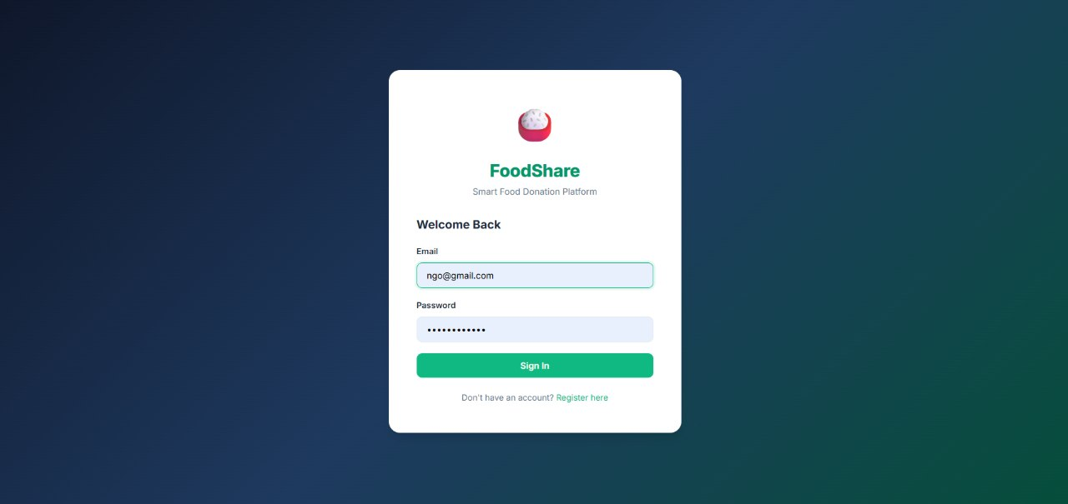
Figure 7.1: FoodShare sign-in page
Every user (donor, NGO, volunteer or admin) signs in with e-mail and password; auth-service verifies the credentials and returns a JWT that the React app sends with every later request. New users can register from the same screen.
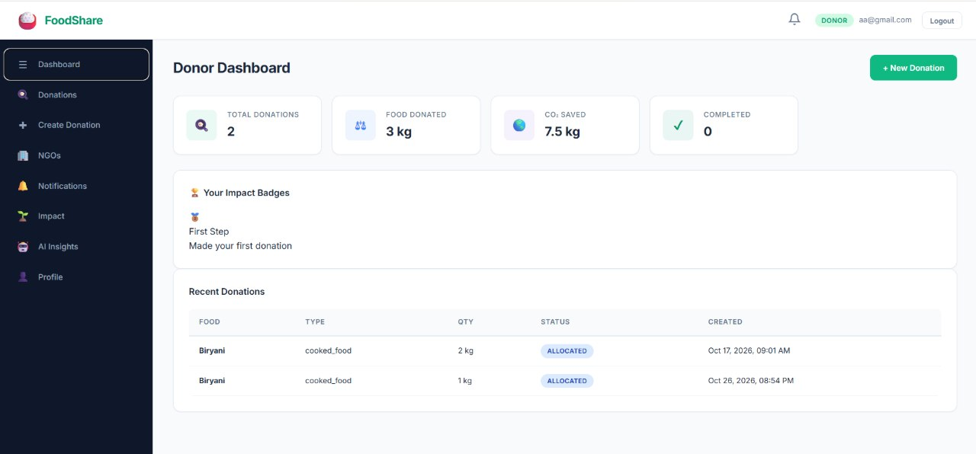
Figure 7.2: Donor dashboard
After login the donor sees totals for donations, food donated (3 kg), CO₂ saved (7.5 kg) and completed deliveries, an impact badge for the first donation, and the recent donations with their status. The sidebar links to every module.
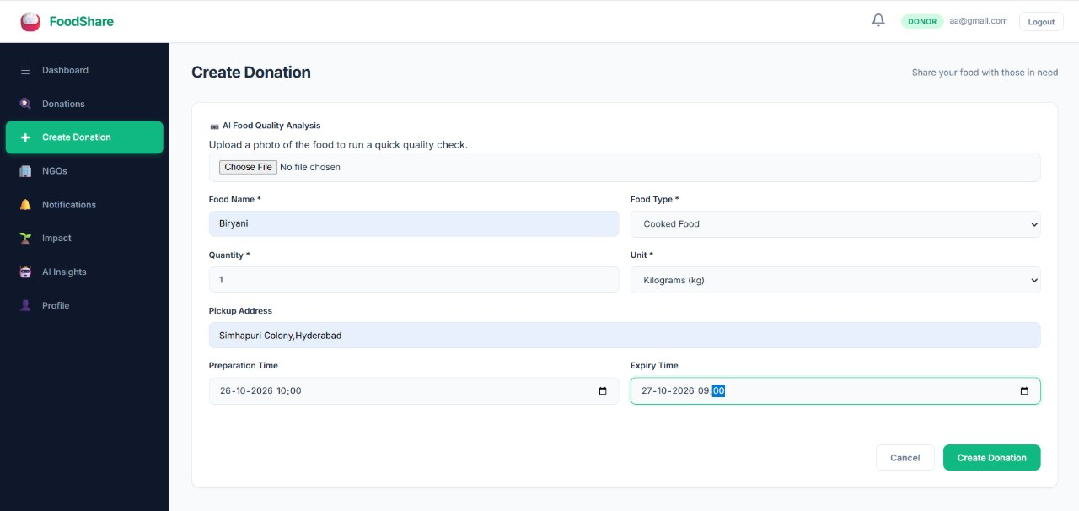
Figure 7.3: Creating a donation with AI food-quality analysis
The donor uploads a photo for the AI food-quality check and enters the food name, type, quantity and unit, pickup address, preparation time and expiry time. The preparation and expiry times feed the freshness part of the Food Trust Score (N1).
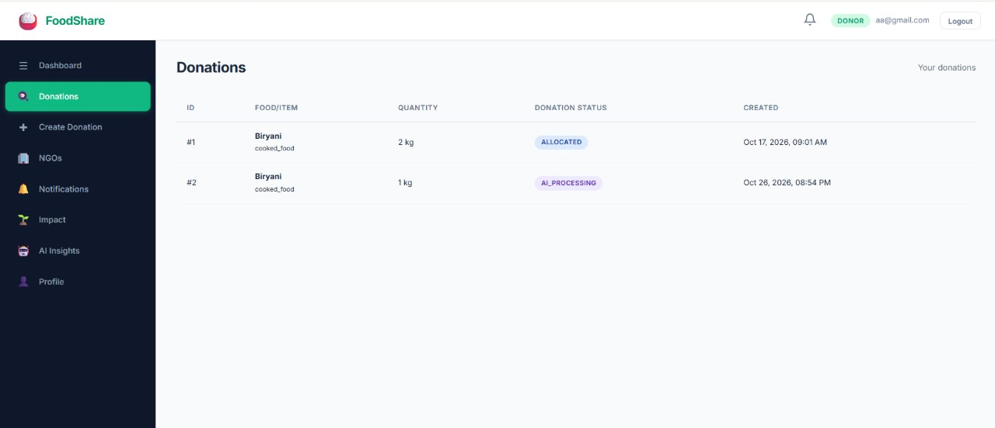
Figure 7.4: Donation list with AI processing status
Each donation moves through statuses as the agents work on it: the newest donation is in AI_PROCESSING while the AI layer scores and matches it, and the earlier one is already ALLOCATED to an NGO.
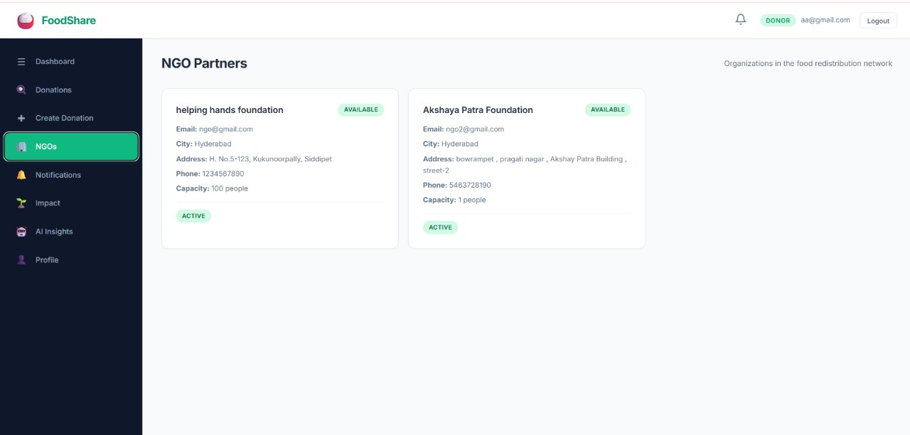
Figure 7.5: NGO partner directory
Donors can see the NGOs in the network with their city, address, contact details, capacity and availability. Capacity and availability are the inputs the Negotiation Orchestrator (N2) uses when allocating a donation.
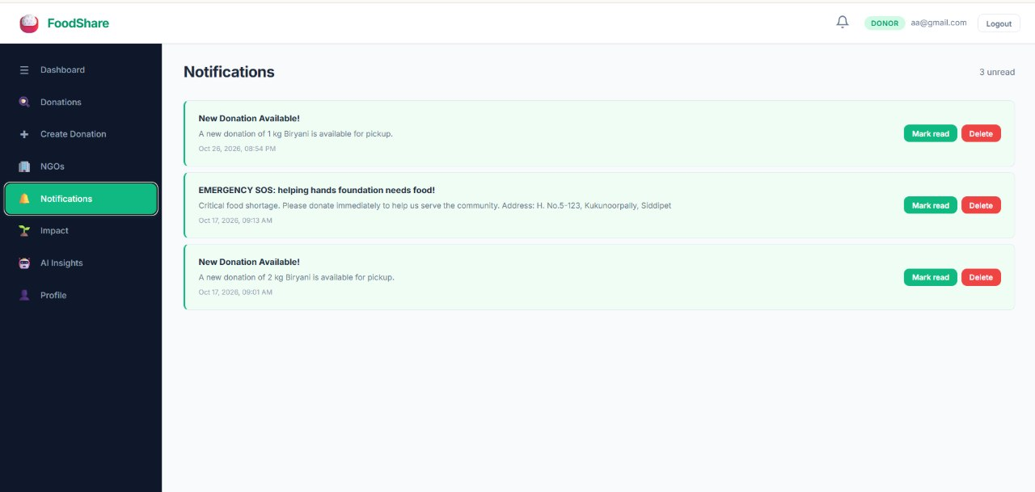
Figure 7.6: Notifications, including an NGO emergency request
notification-service tells users when a new donation is available for pickup. NGOs can also raise an EMERGENCY SOS when they face a food shortage, which is broadcast to donors with the NGO’s address.
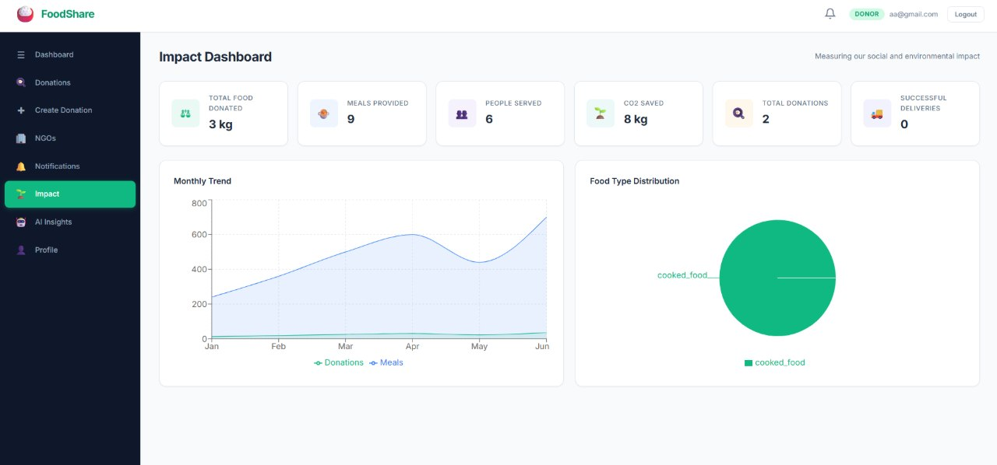
Figure 7.7: Impact dashboard (N4)
The impact dashboard summarises total food donated, meals provided, people served, CO₂ saved, total donations and successful deliveries, with a monthly trend chart and the distribution of food types. These figures support the SDG 2, 12 and 11 reporting.
7.1 Test Scenarios
# | Scenario | Expected result | Observed
1 | Fresh cooked meal from a reliable donor | Score ≥ 75, band PRIORITY | PASS
2 | Cooked meal older than its safe window | Rejected with reason, not offered to NGOs | PASS
3 | Donation larger than any single NGO’s capacity | Split across two or more NGOs; servings add up | PASS
4 | OpenAI API unavailable | Rule-based matcher allocates; donation not blocked | PASS
5 | Unverified NGO proposed by the model | Plan rejected by validator | FAIL
6 | A service is stopped | Incident, Jira ticket and draft PR created | FAIL
7 | Request without a valid JWT | HTTP 401 from the gateway | PASS
8 | Delivery confirmed | Impact totals and donor reliability updated | PASS

7.2 Discussion
The design keeps the AI agents useful but safe. The trust score is a transparent weighted formula, so an NGO or auditor can see why a donation was prioritised. The language model is used for what it does well, reasoning over several NGOs and constraints at once, while hard rules (food-safety cut-off, capacity, distance, NGO verification) are enforced in ordinary Java code that the model cannot bypass. Because the orchestrator falls back to a rule-based matcher, donations continue even when the AI service is down, which shows the value of isolating the AI layer in its own microservice.
Limitations: the photo-based freshness estimate is an aid, not a laboratory test, and must be combined with the food-safety cut-off. Calls to the OpenAI API add latency and cost per donation. NGO capacity is only as accurate as what NGOs report, and the self-healing agent proposes fixes that still need a human review.
- CONCLUSION & FUTURE SCOPE

8.1 Conclusion
The Agentic AI Food Donation Management System replaces phone-driven food donation with an automated, service-oriented platform. Donors, NGOs, logistics, notifications, AI reasoning, impact reporting and operations each run as an independent Spring Boot microservice behind an API Gateway and a Eureka registry, secured with JWT. The Freshness and Trust-Scoring Agent makes food safety visible and explainable; the Negotiation Orchestrator uses ChatGPT function calling to split and route donations across NGOs within hard, code-enforced limits; the Self-Healing AI-Ops Agent keeps the platform reliable; and the impact ledger turns each delivery into a measurable SDG outcome.
The project also shows how five AI tools can support distinct phases of an SOA project (design with Lucidchart AI, planning with Jira AI, building with GitHub Copilot, runtime reasoning with ChatGPT and testing with Postman Agent Mode) rather than being used as isolated add-ons.
8.2 Future Scope
Near term
- SMS and WhatsApp notifications for donors and volunteers who do not use the web app.
- Route optimisation for volunteers collecting several pickups in one trip.
- Multilingual interface (Telugu, Hindi and English) for wider adoption.
Medium term
- Event-driven communication with Apache Kafka for listings and status changes, and Redis caching for NGO capacity.
- Demand forecasting per NGO, so that the orchestrator can plan for expected need, not only current capacity.
- Observability with Prometheus and Grafana, feeding richer signals into the AI-Ops agent.
Long term
- Integration with restaurant point-of-sale systems so that surplus is listed automatically at closing time.
- Partnerships with municipal bodies and food-safety authorities to publish city-level food-rescue data.
- Deployment on Kubernetes with autoscaling, and a mobile app for donors and volunteers.
- REFERENCES

[1] Sammer et al., “AI-FEED: Prototyping an AI-Powered Platform for the Food Charity Ecosystem,” International Journal of Computational Intelligence Systems, vol. 17, Article 259, 2024. https://doi.org/10.1007/s44196-024-00656-9
[2] Yang, An, Fang and Ferris, “Artificial Intelligence in Food Bank and Pantry Services: A Systematic Review,” Nutrients, vol. 17, no. 9, Article 1461, 2025. https://doi.org/10.3390/nu17091461
[3] E. Sharma, L. Davis, J. Ivy and M. Chi, “FoodRL: A Reinforcement Learning Ensembling Framework for In-Kind Food Donation Forecasting,” arXiv:2511.04865, 2025. https://arxiv.org/abs/2511.04865
[4] Too Good To Go, official website. https://www.toogoodtogo.com
[5] OLIO, the food sharing app, official website. https://olioapp.com
[6] Food Rescue Hero (412 Food Rescue), official website. https://foodrescuehero.org
[7] United Nations Environment Programme, “Food Waste Index Report 2024.” https://www.unep.org/resources/publication/food-waste-index-report-2024
[8] OpenAI, “Function calling,” OpenAI API documentation. https://developers.openai.com/docs/guides/function-calling
[9] Postman, “Agent Mode,” Postman Docs. https://learning.postman.com/docs/postman-ai/agent-mode/agent-mode-cloud/get-started
[10] United Nations, “The 17 Sustainable Development Goals.” https://sdgs.un.org/goals
[11] Spring, “Spring Cloud Gateway” and “Spring Cloud Netflix” project documentation. https://spring.io/projects/spring-cloud-gateway, https://spring.io/projects/spring-cloud-netflix
[12] S. Newman, Building Microservices: Designing Fine-Grained Systems, 2nd ed., O’Reilly Media, 2021.

