UDP Bandwidth Tester
User Guide · Networking Concepts · API Reference · Source Guide
Qt / C++ tool for UDP throughput, loss, jitter and data-integrity testing with framed packets (FE FA … 33)
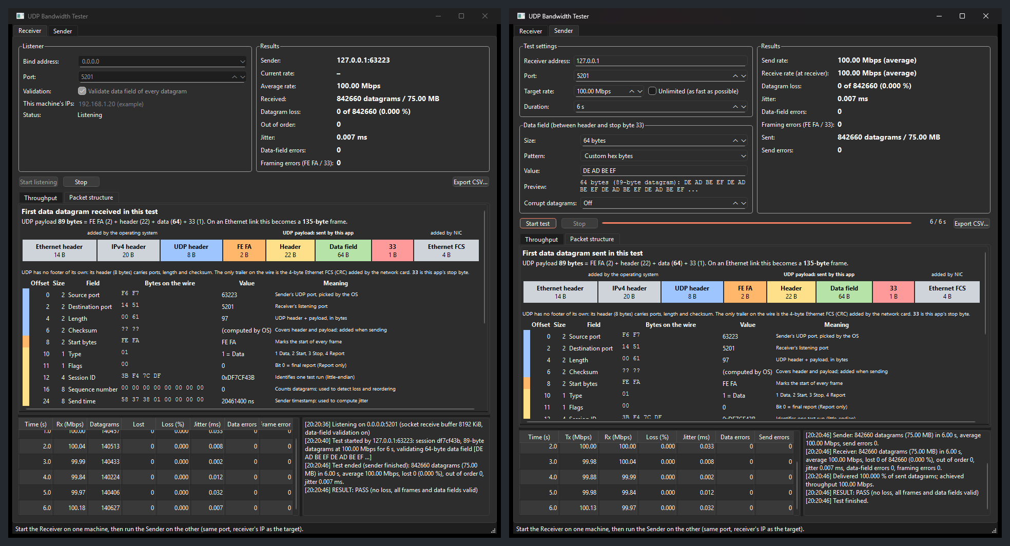
Sender and receiver showing the packet structure of a 10-byte data field test
Version 1.2 · October 2026
github.com/Hitheshkaranth/UDP_TEST_BENCH_V1
Contents
Part 1: User Guide 6
✨ Features 6
⚡ Quick start 6
🖱️ How to use the GUI, step by step 6
Step 1: Start the receiver 6
Step 2: Configure the sender 7
Step 3: Run the test 9
Step 4: Read the results 9
Step 5: Inspect the packets 10
Step 6: Verify error detection (optional) 11
⌨️ How to use the command line 11
⚙️ How it works 12
Architecture 12
Datagram format 13
One test, end to end 14
📊 What the numbers mean 14
🛠️ Building from source 15
Prerequisites (Windows) 16
Step 1: Get the source 16
Step 2: Install Qt 16
Step 3: Build 16
Step 4: Run and check the build 17
Building on Linux 17
What gets built 17
Build troubleshooting 17
🩺 Troubleshooting 18
📚 Project layout and documentation 18
Part 2: Networking Concepts 19
1. The OSI model 19
2. Encapsulation: from your data to bits on the wire 21
3. The network layer: IP, MTU and fragmentation 22
MTU 22
Fragmentation 22
4. How UDP works 23
4.1 The UDP header (8 bytes) 23
4.2 Properties of UDP 23
4.3 UDP compared with TCP 24
4.4 Sockets and ports 25
5. What can happen to a UDP datagram 25
6. Bandwidth, throughput and goodput 27
Units 27
The overhead formula 27
Effect of the datagram size on a 1 Gbps link 27
7. How this tool measures bandwidth 28
7.1 What is counted 28
7.2 Measuring over time 28
7.3 Controlling the offered rate: the token bucket 29
7.4 Accuracy notes 30
8. How loss, reordering and jitter are measured 31
8.1 Loss 31
8.2 Reordering 31
8.3 Jitter (RFC 3550) 31
9. Finding the real capacity of a link 31
10. Quick reference 33
Part 3: API Reference 34
How the pieces fit together 35
Public engine API 36
UdpSender 36
SenderConfig 37
UdpReceiver 38
Statistics 41
TxStats 41
RxStats 41
Wire protocol 42
Protocol constants 42
Protocol structs 42
Protocol functions 42
Data field 46
PayloadPattern and PayloadConfig 46
Payload functions 46
Packet description 49
Frame types 49
Frame functions 49
Helpers 50
Network helpers 50
Formatting 50
Internals 51
SenderWorker (internal) 51
ReceiverWorker (internal) 52
Front ends 55
GUI functions 55
CLI functions 56
Part 4: Source Guide 57
1. Architecture 57
Core files 57
2. Wire protocol 58
2.1 Frame layout 58
2.2 Message types 58
2.3 Session sequence 59
3. Transmission (sender) 59
3.1 Entry point: UdpSender 59
3.2 SenderWorker::run() step by step 60
3.3 Rate control: token bucket 60
3.4 Send errors 60
3.5 Error injection (corruptEvery) 61
4. Reception (receiver) 61
4.1 Entry point: UdpReceiver 61
4.2 Socket setup: ReceiverWorker::startListening() 61
4.3 Receive loop: onReadyRead() 61
4.4 Sessions 61
4.5 Per-datagram processing: handleData() 62
4.6 Framing errors: handleBadFrame() 62
4.7 Reports to the sender 62
5. Monitoring packets and bandwidth 62
5.1 What "bandwidth" means here 62
5.2 Sender statistics (TxStats) 63
5.3 Receiver statistics (RxStats) 63
5.4 Where the numbers appear 63
5.5 Packet structure view 64
6. Threading model 64
7. Using and extending the core 65
7.1 Using the engine from other code 65
7.2 Common changes 65
8. Performance limits and tuning 65

Part 1: User Guide
What the tool does, how to install it, and how to use the GUI and the command line, step by step.

✨ Features
🚀 Bandwidth | Paced sending at any rate from 10 kbps to 100 Gbps (token bucket), or unlimited. Live per-second throughput on both ends
📉 Loss and order | Per-datagram sequence numbers give exact loss, including at the very end of a test, and out-of-order counts
⏱️ Jitter | RFC 3550 interarrival jitter; the two machines don't need synchronised clocks
🧱 Framing | Every datagram is FE FA · header · data · 33. Bad frames are counted and logged
🔍 Data validation | Choose the data field (size 1 to 65466 bytes; incrementing, fixed, random, hex or text pattern). The receiver checks every byte of every datagram
💥 Error injection | Corrupt 1 in N datagrams on purpose to prove the validation works
🧬 Packet structure view | Ethernet / IPv4 / UDP / frame layers, every field decoded, colour-coded hex dump, bytes on the wire
✅ Verdict | PASS/FAIL per test; CSV export; scriptable CLI with exit codes
🧩 Clean architecture | UDP engine (src/core) fully independent of the GUI; GUI and CLI are thin front ends

⚡ Quick start
- Download UdpBandwidthTester_win64.zip from the Releases page and unzip it on both PCs. No installation is needed; Qt and the Visual C++ runtime are included.
- On the receiving PC, run allow_firewall_port_5201.bat once as Administrator. This lets the test traffic in.
- Receiving PC: open UdpBandwidthTester.exe → Receiver tab → Start listening.
- Sending PC: open UdpBandwidthTester.exe → Sender tab → enter the receiver's IP → Start test.
💡 To try it on one PC, run two copies of the app and use 127.0.0.1 as the receiver address.
🛠️ Prefer to build it yourself? See Building from source: one command once Visual Studio and Qt are installed.

🖱️ How to use the GUI, step by step

Step 1: Start the receiver
On the PC that will receive, open the Receiver tab and click Start listening. Keep the bind address 0.0.0.0 (all network interfaces) and port 5201. The tab lists this PC's IP addresses; give one of them to the sender.
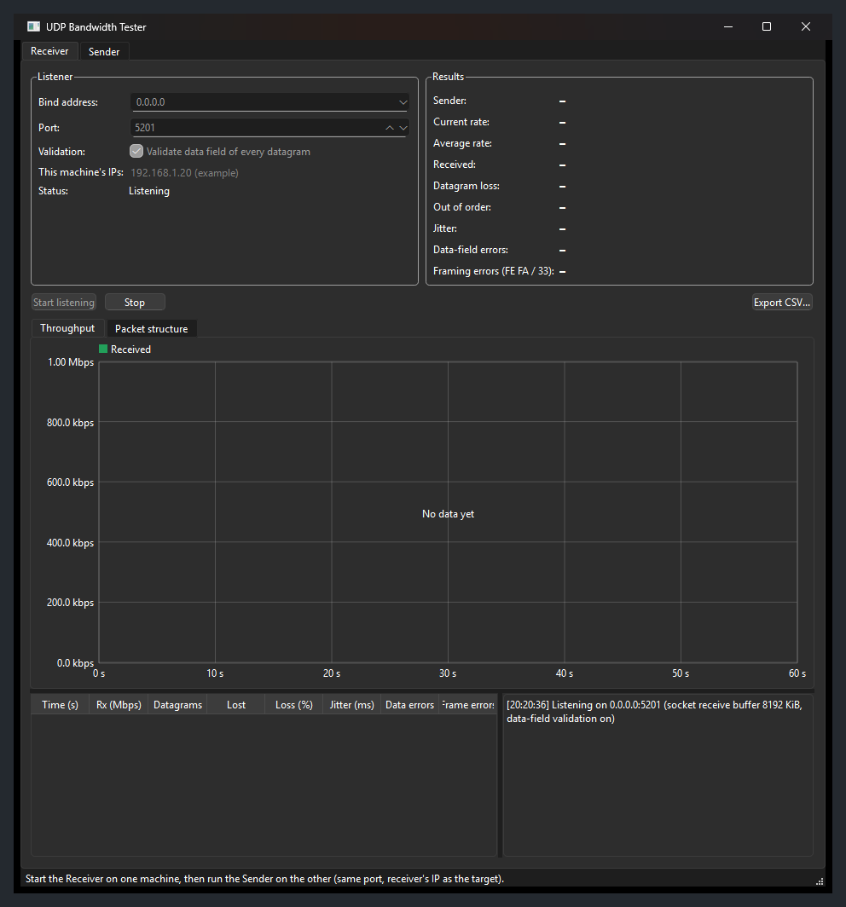
Receiver listening

Step 2: Configure the sender
On the sending PC, open the Sender tab:
Setting | What to enter
Receiver address | The receiver's IP (or host name)
Port | Same as the receiver (default 5201)
Target rate | Rate to send at, in Mbps, or tick Unlimited
Duration | Test length in seconds
Data field: Size | Data bytes per datagram (1 to 65466). Each datagram adds 25 bytes (FE FA + header + 33)
Data field: Pattern / Value | What the data bytes contain (see the table below)
Corrupt datagrams | Off, or 1 in N to deliberately damage every Nth datagram

The Preview line and the Packet structure tab update as you type, showing exactly what will be sent:
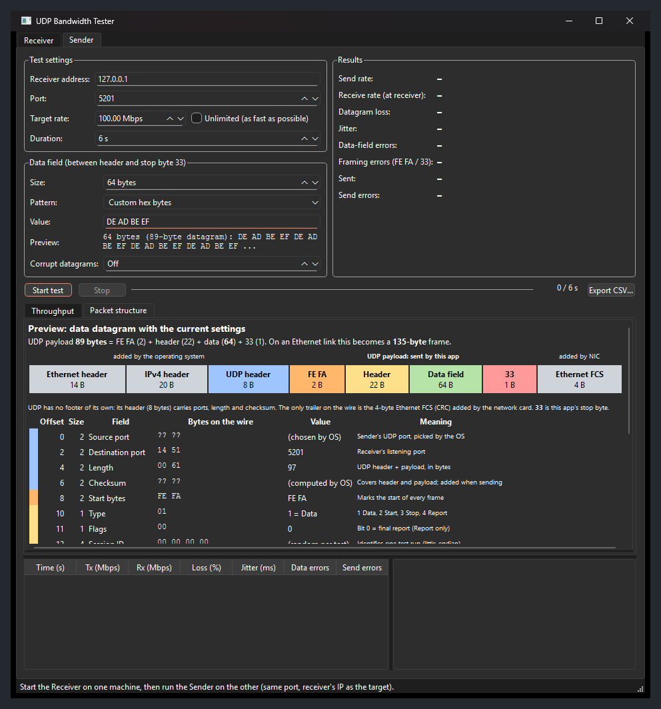
Sender settings with packet preview
Pattern | Value | Data field example
Incrementing bytes | first byte in hex (optional) | 00 01 02 03 …
Fixed byte | one byte in hex | A5 A5 A5 …
Pseudo-random | seed (optional) | xorshift32 sequence
Custom hex bytes | DE AD BE EF, 0xDE,0xAD, DEADBEEF | repeated to fill the field
Text | HELLO | UTF-8, repeated to fill the field

Invalid input is caught immediately. The reason is shown in red, and Start test stays disabled until you fix it:
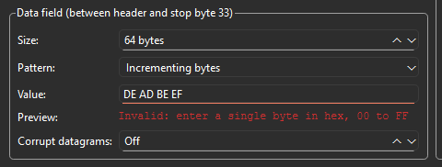
Input validation

Step 3: Run the test
Click Start test. Both windows plot throughput every second. The sender also shows what the receiver actually got, because the receiver reports back once per second.
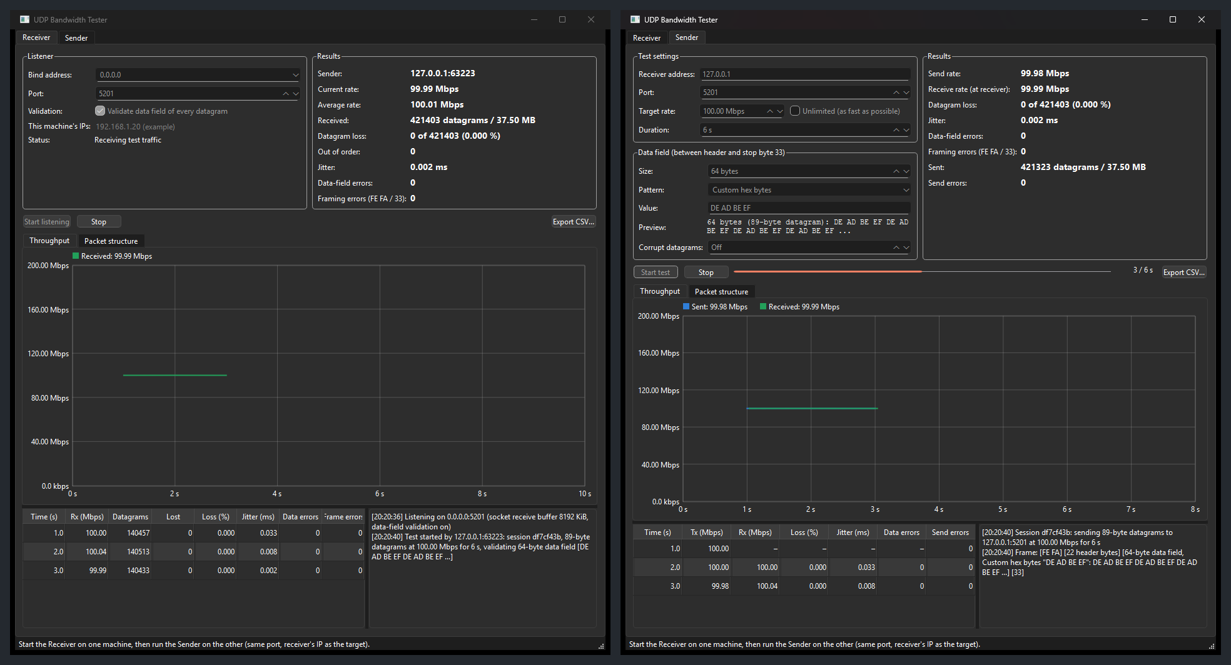
Test running

Step 4: Read the results
When the test ends, both logs print a summary and a verdict. PASS means no loss, no framing errors and no data-field errors. Export CSV… saves the per-second table.
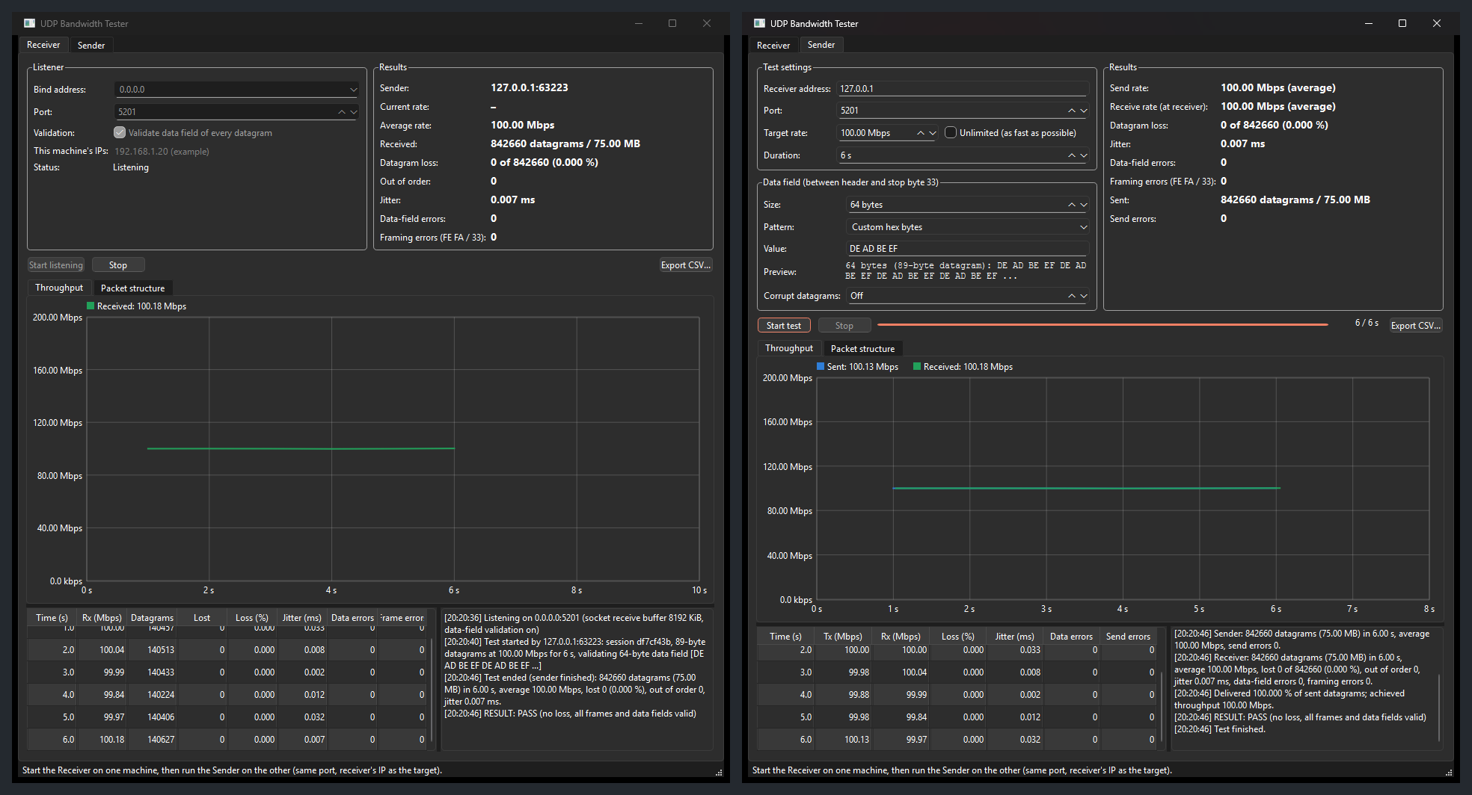
Results

Step 5: Inspect the packets
Open the Packet structure tab to see the first datagram of the test, as sent (left: the receiver's copy; right: the sender's):
- 🟦 UDP header (8 B), 🟧 FE FA, 🟨 header (22 B), 🟩 data field, 🟥 33, plus the Ethernet/IPv4 layers and FCS added by the OS and network card;
- every field decoded: ports, length, session, sequence number, timestamp;
- a colour-coded hex dump, and how many bytes one datagram occupies on the link.
Packet structure

Step 6: Verify error detection (optional)
Set Corrupt datagrams to 1 in 1000 and run again. The receiver logs each damaged datagram (datagram number, offset, expected and actual byte), and the test ends with FAIL. Here 561 datagrams were corrupted, and 561 data-field errors were detected:
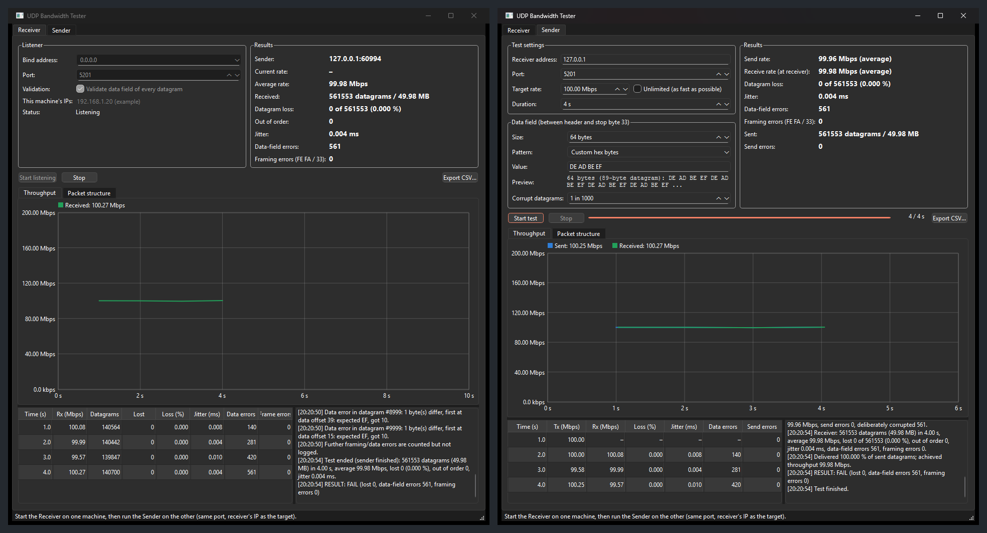
Error detection

⌨️ How to use the command line
udpbw-cli.exe uses the same engine and protocol as the GUI, so they can test each other.
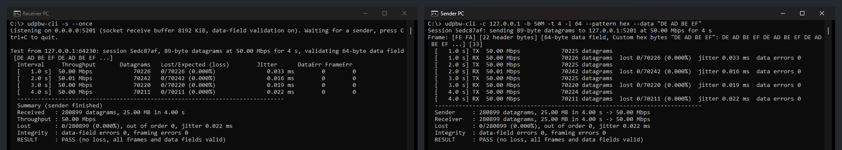
CLI receiver and sender
:: Receiving PC
udpbw-cli -s :: listen on port 5201 until Ctrl+C
udpbw-cli -s --once --csv rx.csv :: one test, then exit; save per-second CSV

:: Sending PC
udpbw-cli -c 192.168.1.20 -b 500M -t 10 :: 500 Mbps for 10 s
udpbw-cli -c 192.168.1.20 -b max -l 8947 :: unlimited rate, jumbo-frame datagrams
udpbw-cli -c 192.168.1.20 -b 2M -l 10 --show-frame :: 10 data bytes; print packet layout
udpbw-cli -c 192.168.1.20 --pattern hex --data "DE AD BE EF" :: custom data field
udpbw-cli -c 192.168.1.20 --pattern fixed --data A5 --corrupt 1000 :: test the validation
Option | Mode | Meaning
-s, --server | receiver | Run as receiver
-c, --client <host> | sender | Run as sender towards host
-p, --port <n> | both | UDP port (default 5201)
-B, --bind <addr> | receiver | Local address to listen on (default 0.0.0.0)
--once | receiver | Exit after the first test
--no-validate | receiver | Skip data-field checks (framing is always checked)
-b, --bandwidth <rate> | sender | 500k, 100M, 1.5G; a bare number means Mbps; 0/max = unlimited (default 100M)
-t, --time <s> | sender | Duration (default 10)
-l, --length <bytes> | sender | Data-field size, 1 to 65466 (default 1447)
--pattern <name> | sender | inc, fixed, random, hex, text (default inc)
--data <value> | sender | Pattern value: byte, seed, hex bytes or text
--corrupt <N> | sender | Corrupt one data-field byte in every Nth datagram
--show-frame | both | Print the structure and hex dump of the first data datagram
--csv <file> | both | Write per-second results to a CSV file

Exit codes: 0 PASS · 1 error (bad input, socket) · 2 no final report from the receiver · 3 FAIL (loss, framing or data-field errors).

⚙️ How it works
📘 New to UDP or the OSI model? Read Networking Concepts first.

Architecture
The UDP engine lives in src/core and has no GUI dependency. The GUI and the CLI are thin front ends that only call UdpSender / UdpReceiver and react to their signals.
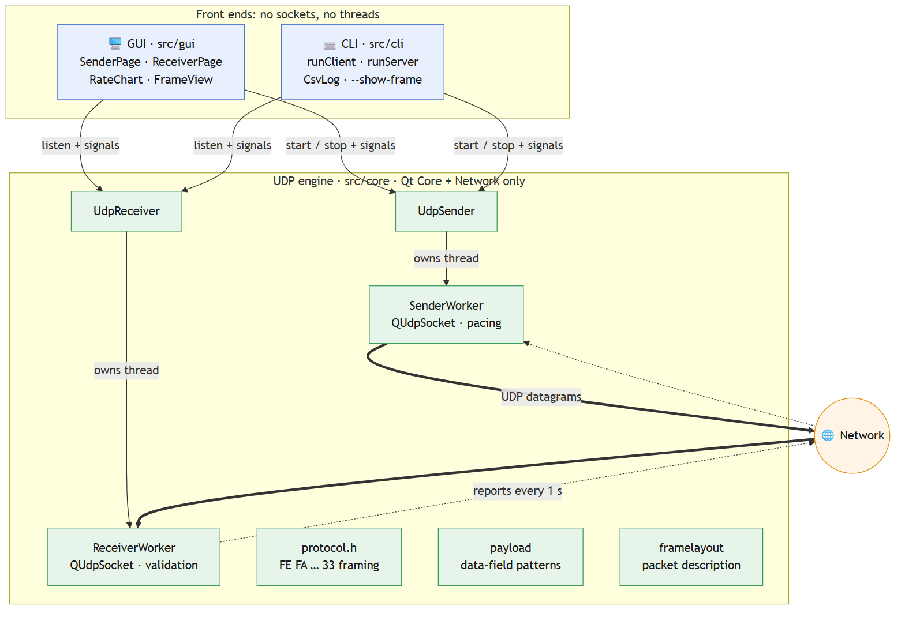
Architecture: the UDP engine (src/core) is independent of the GUI and CLI

Datagram format
Every datagram, in both directions, is framed with FE FA at the start and 33 at the end:
Datagram format: FE FA start bytes, header, data field, 33 stop byte
On the wire, the OS adds a UDP header (8 B), an IPv4 header (20 B) and an Ethernet header (14 B), and the network card adds the Ethernet FCS (4 B). UDP has no footer; 33 is this app's own stop byte.

One test, end to end
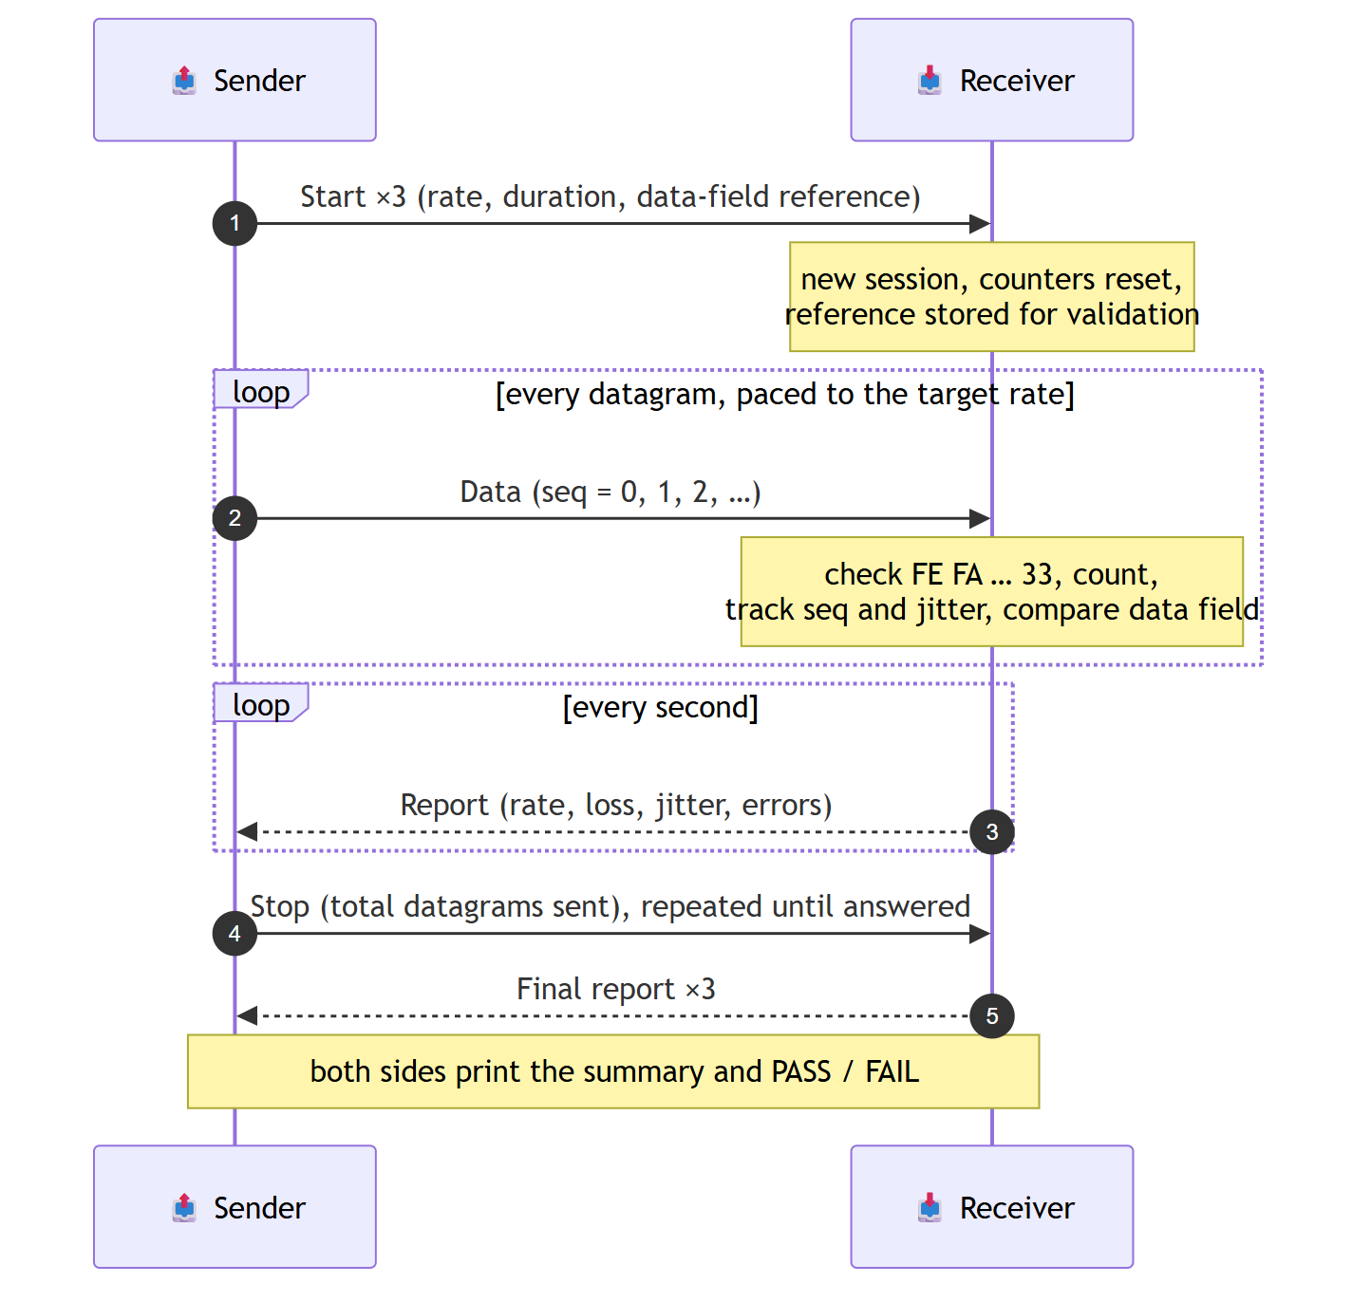
One test, end to end

📊 What the numbers mean
Metric | Definition
Throughput | UDP payload bits per second (FE FA … 33). IP/UDP/Ethernet headers aren't counted
Loss | expected − received, where expected = highest sequence number + 1, or the total announced in Stop
Out of order | Datagrams that arrived after one with a higher sequence number
Jitter | RFC 3550: running average of the variation in transit time
Framing errors | Datagrams not starting with FE FA or not ending with 33
Data-field errors | Datagrams whose data field differs from the reference sent in Start
Efficiency | Data bytes ÷ bytes on the link (see the Packet structure tab). Small datagrams are mostly headers

🛠️ Building from source
You can build the GUI and the CLI from source in about 15 minutes, most of it downloads. The steps below were tested on Windows 11 with Visual Studio 2022 Build Tools, CMake 4 and Qt 6.8.3.
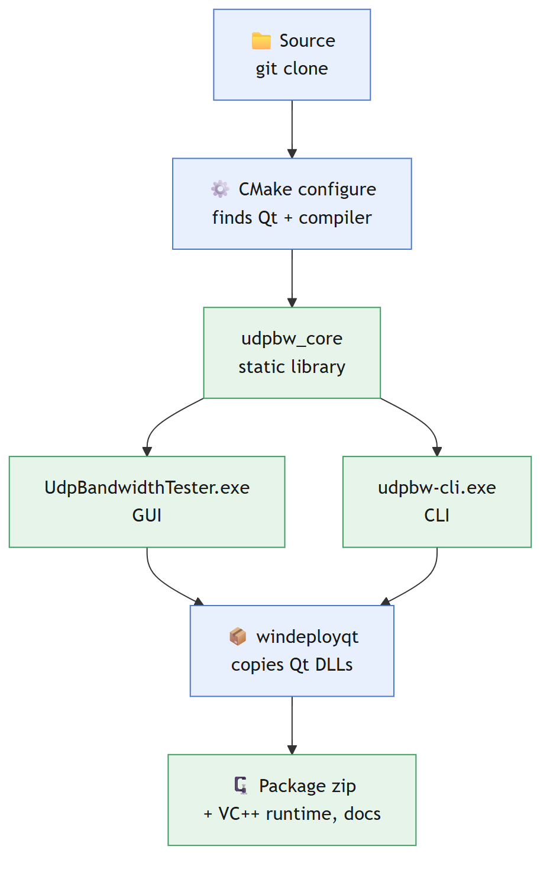
Build pipeline: CMake builds the core library, the GUI and the CLI; windeployqt and packaging follow

Prerequisites (Windows)
Tool | Version | How to get it
Visual Studio 2022 (Community, Professional, or just the free Build Tools) | 17.x | visualstudio.microsoft.com. In the installer, select the Desktop development with C++ workload
CMake | 3.16 or newer | Included with Visual Studio's C++ workload, or from cmake.org (tick Add CMake to PATH)
Qt | 6.x (or 5.15) for MSVC 2022 64-bit, modules Qt Base (Core, Network, Widgets) | Step 2 below
Git | any | git-scm.com

Step 1: Get the source
git clone https://github.com/Hitheshkaranth/UDP_TEST_BENCH_V1.git
cd UDP_TEST_BENCH_V1

Step 2: Install Qt
Option A: Qt Online Installer (needs a free Qt account). Download it from qt.io/download-qt-installer. In the component list choose Qt 6.8.x → MSVC 2022 64-bit; nothing else is needed. The default location is C:\Qt\6.8.x\msvc2022_64.
Option B: aqtinstall (no account; this is how this project was built):
pip install aqtinstall
aqt install-qt windows desktop 6.8.3 win64_msvc2022_64 -O C:\Qt
⚠️ Keep the -O folder short (like C:\Qt). Long paths hit the Windows 260-character limit and aqt fails with "Specified path is bad".

Step 3: Build
Option A: one command (recommended). The script finds Visual Studio, configures, builds in Release mode and copies the Qt DLLs next to the exes:
powershell -ExecutionPolicy Bypass -File scripts\build_windows.ps1 -QtDir C:\Qt\6.8.3\msvc2022_64
Add -Package to also create the ready-to-run zip in dist\UdpBandwidthTester_win64.zip, which includes the Qt DLLs, the Visual C++ runtime, the docs and the firewall script.
Option B: by hand. Open "x64 Native Tools Command Prompt for VS 2022" from the Start menu, so the compiler is on PATH, then:
cmake -S . -B build -G "NMake Makefiles" -DCMAKE_BUILD_TYPE=Release -DCMAKE_PREFIX_PATH=C:/Qt/6.8.3/msvc2022_64
cmake --build build
C:\Qt\6.8.3\msvc2022_64\bin\windeployqt.exe --release build\UdpBandwidthTester.exe build\udpbw-cli.exe
-G Ninja also works if Ninja is installed, and builds faster.
Option C: Qt Creator. Open CMakeLists.txt (or UdpBandwidthTester.pro / udpbw-cli.pro for qmake), select the Desktop Qt 6.8.x MSVC2022 64bit kit, set the build type to Release, and press Ctrl+B.

Step 4: Run and check the build
:: GUI
build\UdpBandwidthTester.exe

:: CLI self-test on one PC: receiver in one window ...
build\udpbw-cli.exe -s --once
:: ... sender in a second window. Expect "RESULT : PASS"
build\udpbw-cli.exe -c 127.0.0.1 -b 50M -t 3
To run the exes on another PC, copy the whole build folder (exe + Qt DLLs + plugin folders), or use the -Package zip.

Building on Linux
sudo apt install build-essential cmake qt6-base-dev # Debian / Ubuntu 22.04+
cmake -S . -B build -DCMAKE_BUILD_TYPE=Release
cmake --build build -j
./build/udpbw-cli -s --once & ./build/udpbw-cli -c 127.0.0.1 -t 3
The core and the CLI use only portable Qt APIs. The Linux build has not yet been tested in this project.

What gets built
Target | Type | Contents | Qt modules
udpbw_core | static library | src/core: the UDP engine | Core, Network
UdpBandwidthTester | Windows GUI app | src/gui + udpbw_core | + Widgets
udpbw-cli | console app | src/cli + udpbw_core | Core, Network

The compiler runs with all warnings on (/W4 on MSVC, -Wall -Wextra on GCC/Clang); the code builds without warnings.

Build troubleshooting
Message | Fix
Could not find a package configuration file provided by "Qt6" | Pass the Qt kit folder: -DCMAKE_PREFIX_PATH=C:/Qt/6.8.3/msvc2022_64 (or -QtDir for the script)
No CMAKE_CXX_COMPILER could be found / 'cl' is not recognized | Use the x64 Native Tools Command Prompt, or the build script, which sets up the compiler itself
Qt6Core.dll was not found when starting the exe | Run windeployqt (Step 3), or add C:\Qt\6.8.3\msvc2022_64\bin to PATH
VCRUNTIME140.dll was not found on another PC | Use the -Package zip (it includes the runtime), or install the VC++ 2015–2022 Redistributable
aqt: "Specified path is bad" | Install Qt to a short path such as C:\Qt
windeployqt warns "Cannot find dxcompiler.dll" / "VCINSTALLDIR is not set" | Harmless: the app doesn't need DirectX shader compilers, and the script copies the VC++ runtime itself
Changed CMakeLists.txt and the build fails strangely | Delete the build folder and configure again

🩺 Troubleshooting
Symptom | Cause / fix
"No final report from the receiver" | The receiver isn't listening, or a firewall blocks UDP. Run allow_firewall_port_5201.bat on the receiver; check the IP and port
Loss appears at high rates | The link or the receiving PC is saturated. Lower the rate, or use bigger datagrams
Rate far below target with small datagrams | Each PC can send only so many packets per second (~150–250k). Use a larger data field
Framing errors | Something else is sending to the port, or a device on the path alters datagrams
Data-field errors without error injection | Corruption on the path; the log shows which byte changed and how

📚 Project layout and documentation
src/core/ UDP engine: framing, sending, receiving, validation, statistics (no GUI)
src/gui/ Qt Widgets front end
src/cli/ Command-line front end
docs/ Documentation and screenshots
scripts/ build_windows.ps1 (build + package), allow_firewall_port_5201.bat
Document | Contents
UDP_Bandwidth_Tester_Documentation.docx | All documentation in one Word file: user guide, networking concepts, API reference, source guide
docs/NETWORKING_CONCEPTS.md | How UDP works, the OSI model, encapsulation, MTU, and how bandwidth, loss and jitter are measured, with worked examples
docs/API_REFERENCE.md | Every class and function: parameters, return values, what it does, how to use it, with flow charts
docs/SOURCE_GUIDE.md | How transmission, reception and monitoring work internally: algorithms, formulas, threading

Using the engine in your own code takes a few lines:
UdpSender sender;
QObject::connect(&sender, &UdpSender::remoteStats, [](const RxStats &s) {
qDebug() << s.intervalMbps() << "Mbps, lost" << s.totalLost;
});
SenderConfig cfg;
cfg.target = resolveHost("192.168.1.20");
Payload::build({PayloadPattern::FixedByte, "A5"}, 10, cfg.payload); // 10 data bytes of A5
cfg.packetSize = Proto::packetSizeFor(10);
sender.start(cfg);

Part 2: Networking Concepts
How UDP works, the OSI model, encapsulation, MTU and fragmentation, and how bandwidth, loss and jitter are measured, with worked examples.
This chapter explains the networking theory behind the UDP Bandwidth Tester: how data travels through the layers of the OSI model, how UDP works, what can happen to UDP datagrams on the way, and exactly how bandwidth, loss and jitter are measured. All examples use the real numbers produced by this tool.

1. The OSI model
The Open Systems Interconnection (OSI) model splits network communication into seven layers. Each layer offers a service to the layer above and uses the service of the layer below. When sending, data passes down the layers and each layer adds its own header (encapsulation). When receiving, it passes up and each layer removes its header (decapsulation). Each layer only "talks" to the same layer on the other machine.
# | Layer | Unit of data (PDU) | What it does | Typical examples | In this tool
7 | Application | Data / message | Services for the user's program | HTTP, DNS, SNMP, UDP Bandwidth Tester | Test logic: send, receive, measure, report
6 | Presentation | Data | Data format, encoding, encryption | TLS, JSON, byte order | Little-endian header fields; FE FA / 33 framing; data-field patterns
5 | Session | Data | Opens, manages and closes dialogues | RPC, session IDs | Session ID; Start → Data → Stop → final Report handshake
4 | Transport | Segment (TCP) / datagram (UDP) | End-to-end delivery between programs, identified by ports | UDP, TCP | UDP, port 5201 by default
3 | Network | Packet | Addressing and routing between networks, identified by IP addresses | IPv4, IPv6, ICMP | IPv4 (or IPv6)
2 | Data link | Frame | Delivery on one local link, identified by MAC addresses; error detection | Ethernet, Wi-Fi | Ethernet frame with CRC-32 FCS
1 | Physical | Bits | Signals on the medium | Copper, fibre, radio | Line rate (100 Mbps, 1 Gbps, …), preamble, inter-frame gap

The internet in practice uses the simpler TCP/IP model, which merges OSI layers 5–7 into one application layer and layers 1–2 into one link layer:
TCP/IP model | OSI layers | Here
Application | 7, 6, 5 | UDP Bandwidth Tester (src/core)
Transport | 4 | UDP (operating system)
Internet | 3 | IPv4 (operating system)
Link | 2, 1 | Ethernet driver, network card, cable

Only the top layer is code in this project. Everything from UDP downwards is provided by the operating system and the network hardware. The app reaches it through a socket (Qt's QUdpSocket).
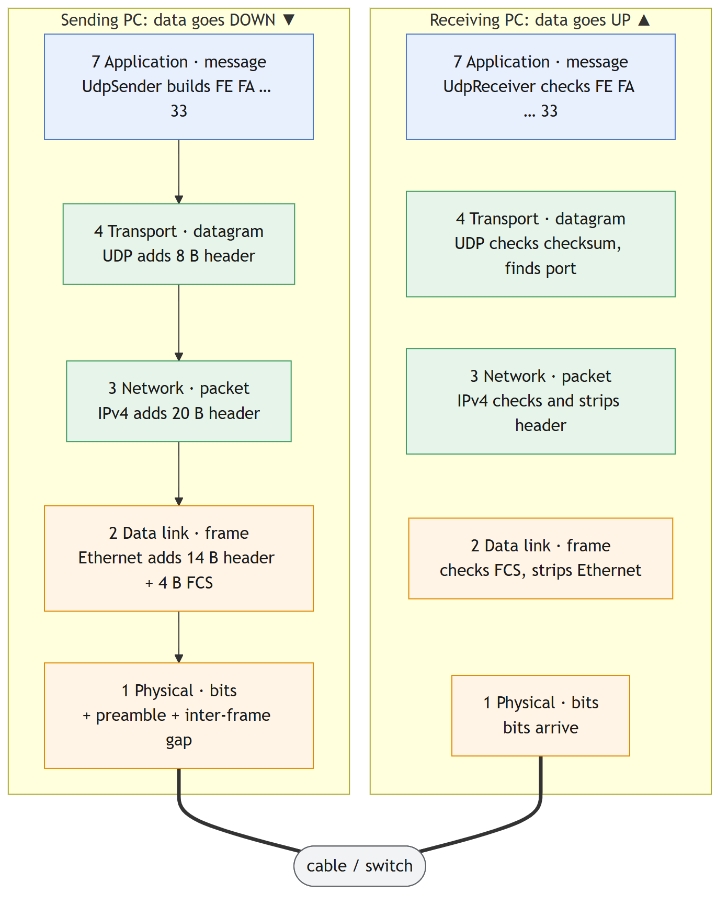
The OSI layers on both PCs: each layer adds its header when sending and removes it when receiving
Each layer only "talks" to the same layer on the other PC: the app's Start/Data/Stop/Report messages, UDP datagrams, IP packets and Ethernet frames are each read and removed by the matching layer on the receiving side.

2. Encapsulation: from your data to bits on the wire
Here is a single test datagram with a 10-byte data field (A5 × 10), followed down through the layers:
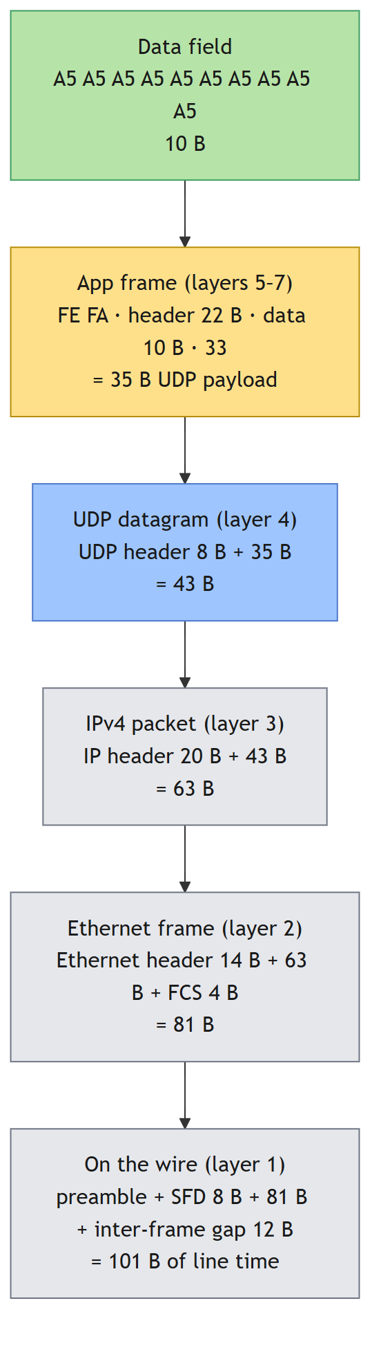
Encapsulation of one datagram with a 10-byte data field
Layer | Adds | Running size | Added by
Your data | — | 10 B | you (data field)
App frame | FE FA (2) + header (22) + 33 (1) | 35 B | UDP Bandwidth Tester
UDP | 8-byte header | 43 B | operating system
IPv4 | 20-byte header | 63 B | operating system
Ethernet | 14-byte header + 4-byte FCS | 81 B | OS driver + network card
Physical | 8-byte preamble/SFD + 12-byte inter-frame gap | 101 B | network card

Only 10 of those 101 bytes are your data, an efficiency of 9.9 %. With the default 1447-byte data field, the same calculation gives 1447 of 1538 bytes, or 94.1 %. Section 6 shows why this matters for bandwidth.
The receiver does the reverse: the network card checks the FCS and drops the frame if it is corrupt; IP checks its header; UDP checks its checksum and delivers the payload to the socket bound to the destination port; and the app checks FE FA … 33 and the data field.

3. The network layer: IP, MTU and fragmentation
IPv4 carries each UDP datagram in a packet with a 20-byte header. The fields that matter for testing:
Field | Meaning
Source / destination address | Which machines (e.g. 192.168.1.10 → 192.168.1.20)
Protocol | 17 = UDP
Total length | Header + payload, max 65535
TTL | Hop limit, decreased by each router
Identification, flags, fragment offset | Used when a packet must be fragmented
Header checksum | Protects the IP header only

MTU
Every link has a Maximum Transmission Unit (MTU): the largest IP packet it can carry in one frame. Standard Ethernet has an MTU of 1500 bytes; "jumbo frame" networks use 9000 bytes.
largest UDP payload without fragmentation = MTU − 20 (IPv4) − 8 (UDP)
= 1500 − 28 = 1472 bytes
largest data field in this tool = 1472 − 25 (FE FA … 33) = 1447 bytes (default)
with jumbo frames (MTU 9000) = 8972-byte payload, 8947-byte data field

Fragmentation
If a datagram is larger than the MTU allows, IP splits it into fragments, each with its own IP header, and the receiver's IP layer reassembles them. UDP and the app never see the fragments, but they matter for testing:
- If any fragment is lost, the whole datagram is lost. A 9000-byte datagram on a 1500-MTU link becomes 7 fragments, so its loss probability is roughly 7× that of a single frame.
- Reassembly costs memory and CPU on the receiver, and some firewalls drop fragments.
So for bandwidth tests, keep datagrams within the MTU, which is the default here.

4. How UDP works
The User Datagram Protocol (RFC 768) is the simplest transport protocol. It adds port numbers and a checksum to IP, and nothing else.

4.1 The UDP header (8 bytes)
0 15 16 31 (bits)
+----------------------+----------------------+
| Source port | Destination port |
+----------------------+----------------------+
| Length | Checksum |
+----------------------+----------------------+
| payload (data) ... |
Field | Size | Meaning | Example (10-byte data test)
Source port | 16 bit | Sender's port; the OS picks a free one ("ephemeral port") | C7 95 = 51093
Destination port | 16 bit | Port the receiver listens on | 14 51 = 5201
Length | 16 bit | UDP header + payload, in bytes (8 to 65535) | 00 2B = 43
Checksum | 16 bit | Ones'-complement sum over a pseudo-header (source and destination IP, protocol 17, length), the UDP header and the payload | computed by the OS

All fields are big-endian (network byte order). The Packet structure view and udpbw-cli --show-frame show these bytes for every test.

4.2 Properties of UDP
Property | UDP | Consequence for testing
Connectionless | No handshake; the first datagram is data | Nothing to set up; the app adds its own Start/Stop
Unreliable | No acknowledgements, no retransmission | Lost datagrams stay lost, so loss can be measured
Unordered | No sequence numbers | The app adds a sequence number to detect loss and reordering
No flow or congestion control | Sends as fast as the program asks | You choose the rate, so you can probe the link's real capacity
Message-oriented | One send = one datagram = one receive; boundaries are kept | Each datagram is one test unit (FE FA … 33)
Checksum | Detects corruption; bad datagrams are silently dropped | Corruption on the wire shows up as loss, not as bad data
Small header | 8 bytes (TCP: 20–60) | Low overhead; predictable sizes
Max payload | 65507 bytes over IPv4 (65535 − 20 − 8) | Upper limit of the datagram size

4.3 UDP compared with TCP
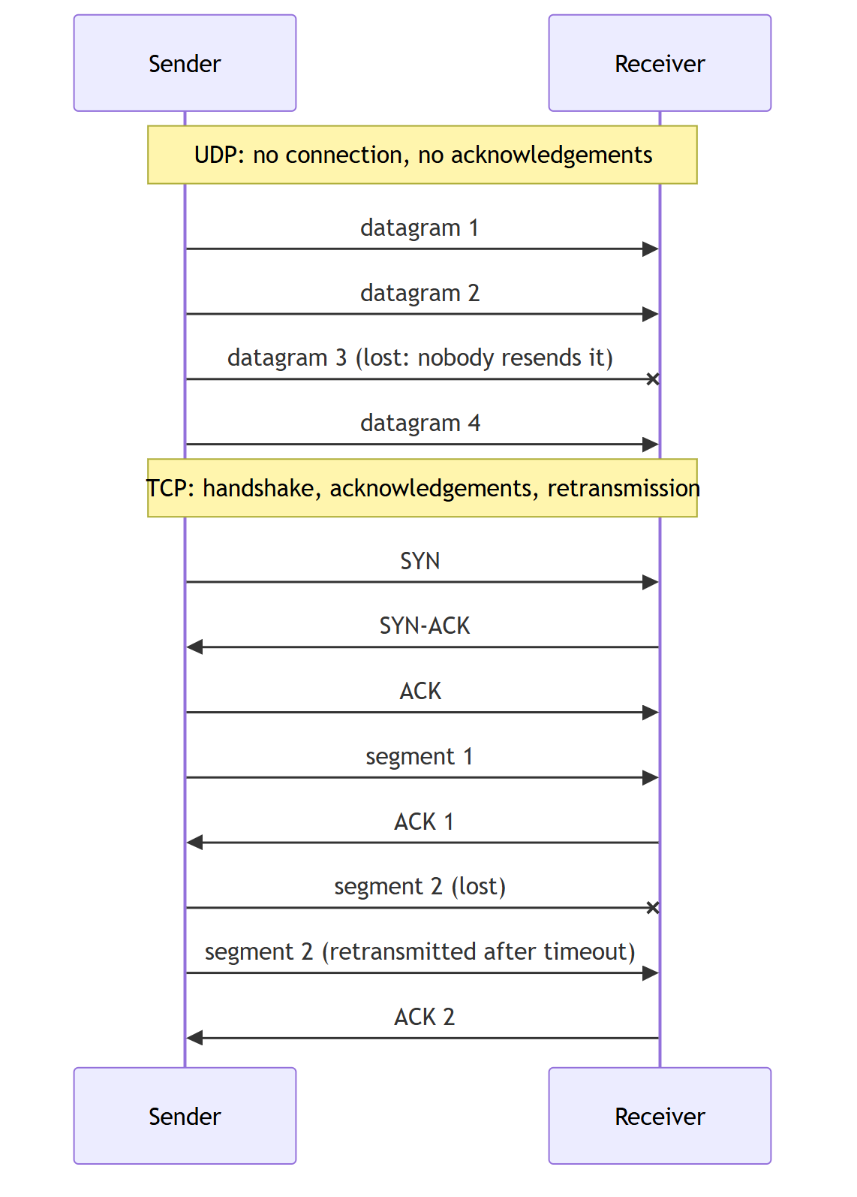
UDP compared with TCP
 | UDP | TCP
Connection | none | 3-way handshake
Reliability | none | acknowledgements and retransmission
Ordering | none | guaranteed
Rate | as fast as the program sends | adapts (flow and congestion control)
Latency | lowest | higher (handshake, retransmissions, head-of-line blocking)
Typical uses | real-time data, telemetry, sensor and avionics data links, video and voice, DNS, NTP, gaming | web, file transfer, email
Testing a link with it | shows raw capacity, loss and jitter | shows what one TCP flow achieves; hides loss behind retransmissions

That's why bandwidth testers such as this tool (and iperf -u) use UDP: you control the rate exactly, and the network's loss and jitter are measured directly instead of being hidden by TCP.

4.4 Sockets and ports
A program uses UDP through a socket:
- bind the socket to a local address and port. The receiver binds 0.0.0.0:5201, which means all interfaces, port 5201. The sender binds port 0, so the OS picks a free ephemeral port.
- send a datagram to a destination address and port (sendto, Qt writeDatagram).
- receive a datagram along with the sender's address and port (recvfrom, Qt readDatagram). The receiver uses that address and port to send its Report datagrams back.
Each socket has a send buffer and a receive buffer in the OS. This tool asks for 4 MiB and 8 MiB respectively. If the receiving program can't read fast enough, the receive buffer fills up and the OS drops new datagrams. That is one of the most common causes of UDP loss.

5. What can happen to a UDP datagram
UDP gives no guarantees, so between writeDatagram() and readDatagram() a datagram can be:
Event | Where it happens | How the tool detects it
Lost | Full send buffer or NIC queue; congested switch port; corrupted frame (FCS or checksum fails → silently dropped); full receive buffer | Gap in sequence numbers → loss
Reordered | Multiple paths, link aggregation, Wi-Fi retries | Sequence number lower than one already seen → out of order
Delayed unevenly | Queues in switches, routers, OS scheduling | Variation of transit time → jitter
Duplicated | Rare (some link-layer retries, misconfigured networks) | Counted as received and as out of order (its sequence number was already seen); doesn't increase loss
Corrupted but delivered | Very rare: errors not caught by CRC/checksum, faulty middleboxes, application bugs | Data field ≠ reference → data-field error
Not one of ours | Other traffic to the port, truncated datagrams | Missing FE FA / 33 → framing error

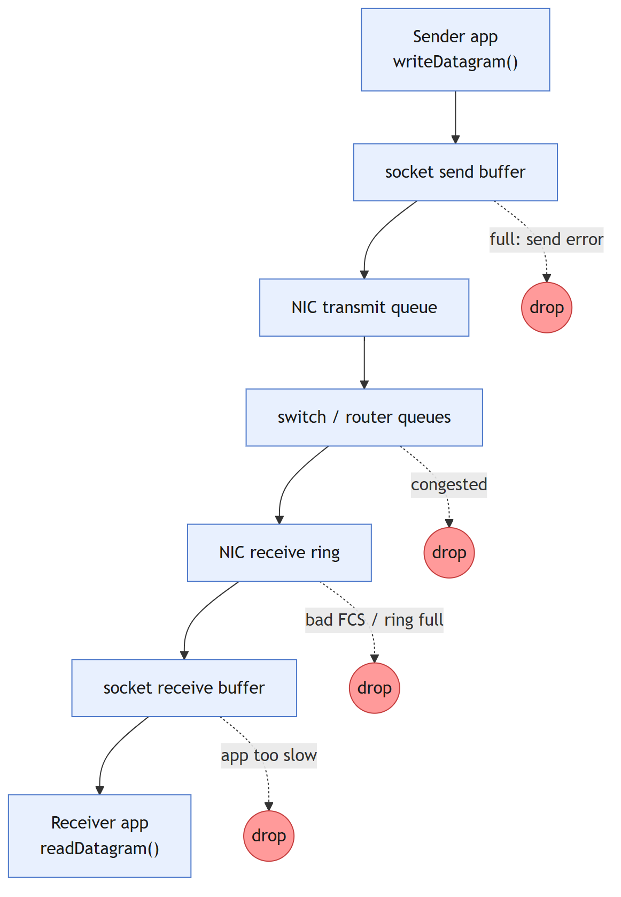
Where a UDP datagram can be dropped on its way
Why does the tool validate the data field if UDP has a checksum? Corruption on the wire is almost always caught by the Ethernet CRC or the UDP checksum, and the datagram is dropped, so it shows up as loss. The data-field check catches what those can't: devices that rewrite payloads, bugs in the sending or receiving software, and memory or DMA errors. It also lets you prove the whole chain works by injecting errors on purpose (Corrupt datagrams: 1 in N).

6. Bandwidth, throughput and goodput
These terms are often mixed up:
Term | Meaning | Example on 1 Gbps Ethernet, 1472-byte datagrams
Bandwidth / line rate | Raw capacity of the link at the physical layer | 1000 Mbps
Throughput | Rate actually achieved at a given layer | 957.1 Mbps of UDP payload
Goodput | Useful application data delivered per second (excludes all headers and lost data) | 940.8 Mbps of data field
Packet rate (pps) | Datagrams per second | 81,274 pps
Utilisation | Throughput ÷ capacity | 95.7 % at the UDP payload level

Units
- Network rates are in bits per second, with decimal prefixes: 1 Mbps = 1,000,000 bit/s, 1 Gbps = 10⁹ bit/s.
- Sizes are in bytes (8 bits). Example: 100 MB in 8 s is 100,000,000 × 8 / 8 s = 100 Mbps.
- This tool reports throughput in bits per second and sizes in decimal MB, so rates and sizes always match.

The overhead formula
For a data field of d bytes, each datagram uses:
UDP payload p = d + 25 (FE FA + header + 33)
IP packet = p + 8 + 20 (UDP + IPv4 headers)
Ethernet frame = max(64, p + 8 + 20 + 18) (header 14 + FCS 4; 64 B minimum frame)
line time w = frame + 20 (preamble/SFD 8 + inter-frame gap 12)

max packets/s = line rate / (w × 8)
max UDP payload rate = packets/s × p × 8 (what this tool reports)
max data rate = packets/s × d × 8 (goodput)
efficiency = d / w

Effect of the datagram size on a 1 Gbps link
Data field d | UDP payload | Ethernet frame | Line time w | Efficiency | Max packets/s | Max UDP payload rate | Max data rate
1 B | 26 B | 72 B | 92 B | 1.1 % | 1,358,696 | 282.6 Mbps | 10.9 Mbps
10 B | 35 B | 81 B | 101 B | 9.9 % | 1,237,624 | 346.5 Mbps | 99.0 Mbps
64 B | 89 B | 135 B | 155 B | 41.3 % | 806,452 | 574.2 Mbps | 412.9 Mbps
100 B | 125 B | 171 B | 191 B | 52.4 % | 654,450 | 654.5 Mbps | 523.6 Mbps
512 B | 537 B | 583 B | 603 B | 84.9 % | 207,297 | 890.5 Mbps | 849.1 Mbps
1447 B (default) | 1472 B | 1518 B | 1538 B | 94.1 % | 81,274 | 957.1 Mbps | 940.8 Mbps
8947 B (jumbo) | 8972 B | 9018 B | 9038 B | 99.0 % | 13,830 | 992.7 Mbps | 989.9 Mbps

Two lessons from this table:
- Small datagrams waste the link. At 10 data bytes, 90 % of the line time is headers and gaps.
- Small datagrams need huge packet rates. Filling 1 Gbps with 35-byte datagrams takes 1.24 million packets per second. A typical PC sends and receives only about 150,000 to 250,000 UDP datagrams per second through the normal socket API. So with small datagrams, the PC is the bottleneck, not the link. In this project's own test, 10 data bytes reached about 45 Mbps (≈160,000 pps) on a fast loopback.
Link | 1472-B datagrams per second | Max UDP payload | Max data (1447 B)
100 Mbps Ethernet | 8,127 | 95.7 Mbps | 94.1 Mbps
1 Gbps Ethernet | 81,274 | 957.1 Mbps | 940.8 Mbps
10 Gbps Ethernet | 812,744 | 9,570.9 Mbps | 9,408.3 Mbps

So a "100 % clean" result on 1 Gbps Ethernet is about 957 Mbps in this tool, not 1000, because the rest of the line rate goes to the UDP, IP and Ethernet layers.

7. How this tool measures bandwidth

7.1 What is counted
The tool counts UDP payload bytes: the whole FE FA … 33 frame, the bytes the program hands to the socket and gets back from it. It can't see the bytes the OS and network card add, so those are calculated, not measured (section 6 and the Packet structure view).

7.2 Measuring over time
Both sides use a monotonic clock with nanosecond resolution (QElapsedTimer). It is never adjusted by NTP or daylight saving, so time differences are always correct.
rate over an interval = bytes counted in the interval × 8 / interval length (s)
average rate = total bytes × 8 / time from first to last datagram (s)
- The sender counts the bytes writeDatagram() accepted: the offered load.
- The receiver counts the bytes readDatagram() returned: the achieved throughput. This is the real bandwidth figure; anything the network or the receiving PC couldn't carry is missing from it.
- Every second, the receiver sends its numbers back in a Report datagram, so the sender shows both sides together.
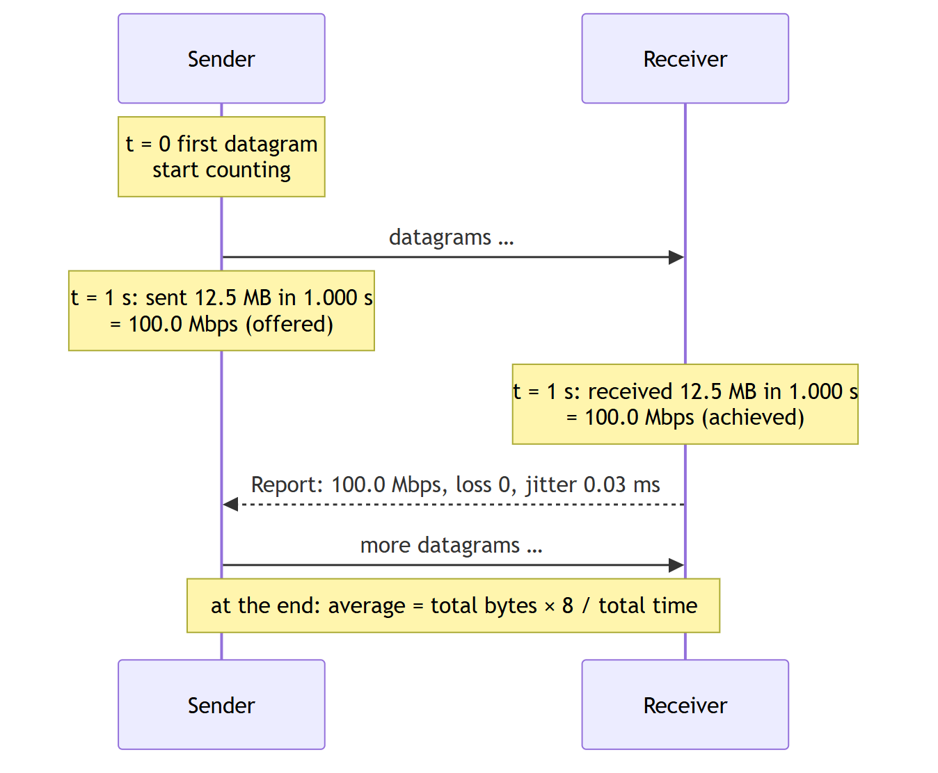
How bandwidth is measured every second on both sides

7.3 Controlling the offered rate: the token bucket
To send at exactly R Mbps, the sender uses a token bucket:
- Credit ("tokens", in bytes) accumulates continuously at R × 10⁶ / 8 bytes per second.
- A datagram may be sent when the bucket holds at least one datagram's worth; sending spends that much credit.
- The bucket is capped at about 20 ms of credit, so after a pause the sender catches up with a short burst, never a long one.
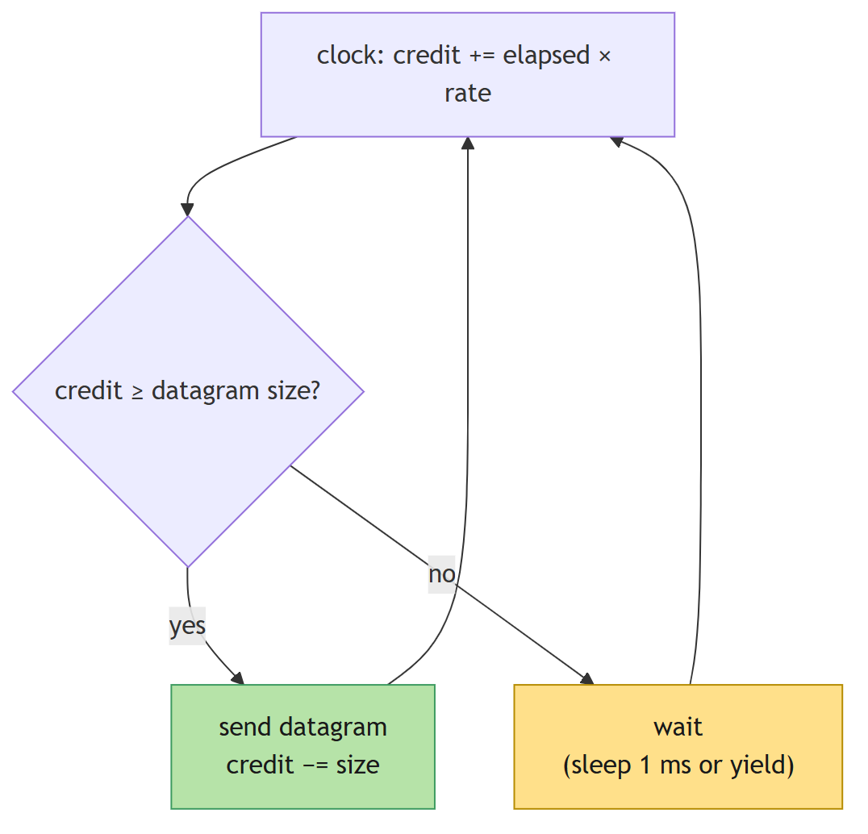
Token bucket: how the sender holds the target rate
This gives smooth, accurate rates: 200 Mbps requested gives 200.00 Mbps measured in this project's tests. Unlimited mode skips the bucket and sends back to back, which measures the most the sending PC can generate.

7.4 Accuracy notes
- Interval edges: datagrams sent at the end of one second may be counted at the start of the next on the receiver, so single intervals can read slightly above or below the target (for example 99.6 then 100.4 Mbps). The average is exact.
- Buffering: socket buffers can absorb a short burst, so a receiver interval can briefly exceed the link rate. Over a whole test, buffers don't change the average.
- Loopback (127.0.0.1) never touches a network card. It measures the PCs' and the OS's speed, not a link.

8. How loss, reordering and jitter are measured

8.1 Loss
Every data datagram carries a sequence number 0, 1, 2, …. The receiver tracks the highest one seen, and the final Stop message says how many were sent in total:
expected = max(highest sequence number + 1, total announced in Stop)
lost = expected − received
loss % = lost / expected × 100
Example: the sender sends datagrams 0–999. The receiver gets 990 of them, the highest being 999, and Stop says 1000 were sent. So expected = 1000, lost = 10, loss = 1.0 %. Without the total from Stop, datagrams lost at the very end (after the last one received) would go unnoticed.

8.2 Reordering
If a datagram arrives with a sequence number lower than one already received, it's counted as out of order. A late datagram also fills the gap it left, which is why one interval's loss can be negative: datagrams counted as lost in one second arrive in the next.

8.3 Jitter (RFC 3550)
Jitter is how much the one-way delay varies from datagram to datagram. It's what makes real-time data, voice and video stutter even when nothing is lost. The tool uses the standard RFC 3550 (RTP) formula:
transit(i) = arrival time(i) − send time(i) (receiver clock − sender clock)
D(i) = | transit(i) − transit(i−1) |
J(i) = J(i−1) + ( D(i) − J(i−1) ) / 16
The two PCs' clocks are not synchronised, so transit includes an unknown offset. But D is a difference of two transits, and the offset cancels out. That's why jitter can be measured without synchronised clocks, while the one-way delay itself can't.
Example (transit times in ms; the constant clock offset doesn't matter):
Datagram | Transit | D | J
1 | 10.00 | — | 0
2 | 10.20 | 0.20 | 0.0125
3 | 9.90 | 0.30 | 0.0305
4 | 10.05 | 0.15 | 0.0379

The ÷16 makes J a smoothed running average that reacts gradually, so one late datagram doesn't dominate.

9. Finding the real capacity of a link
The most useful UDP test is a step test: raise the rate until the network can't keep up.
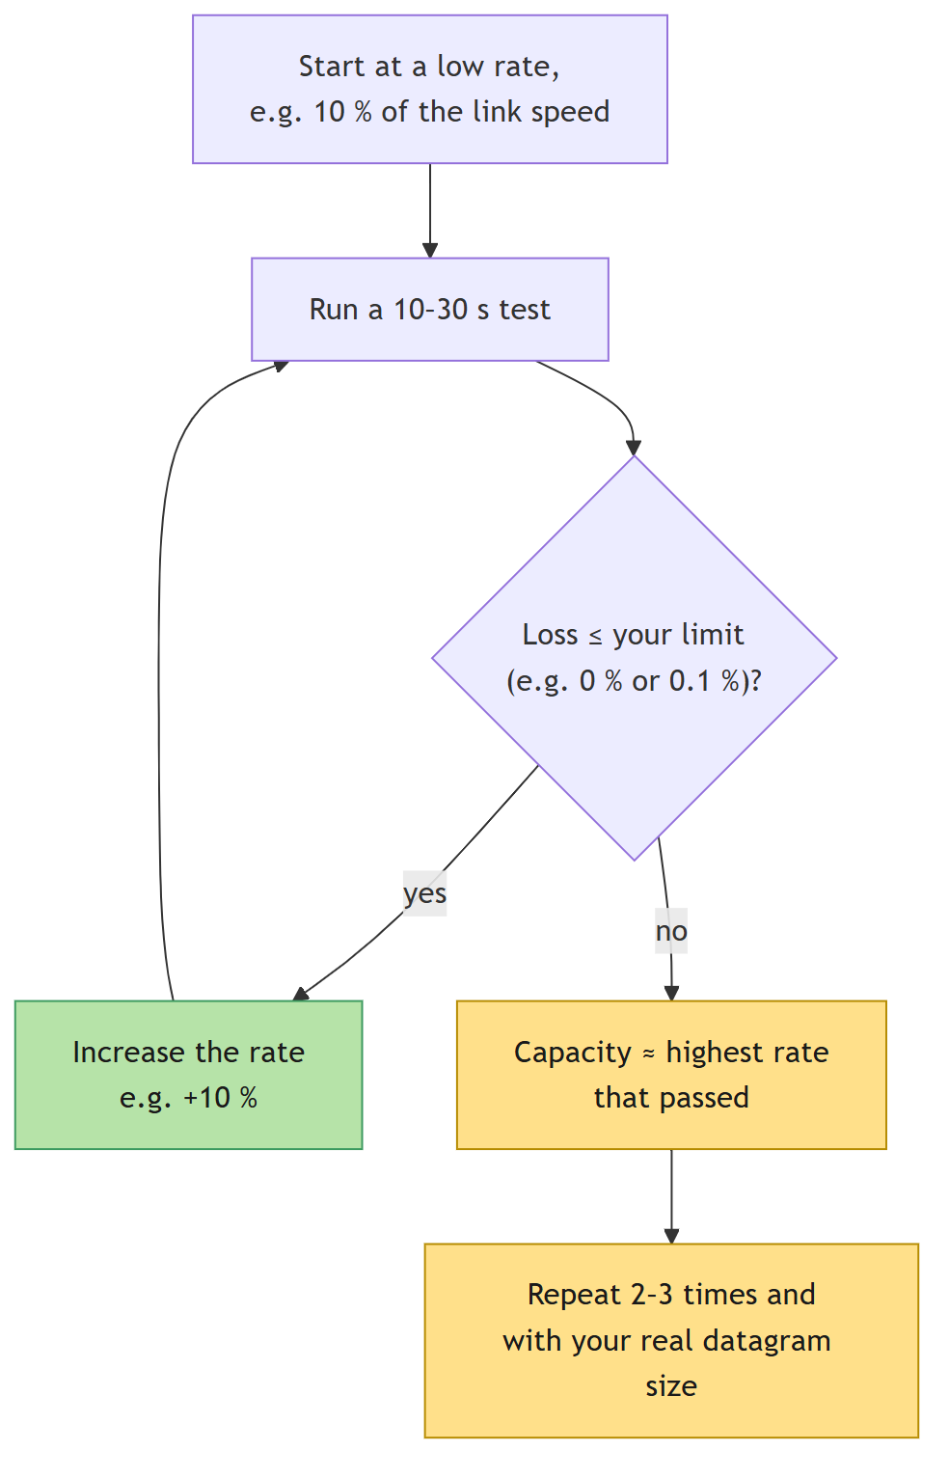
Step test: finding the real capacity of a link
Tips:
- Use the datagram size of your real traffic. Capacity in Mbps depends heavily on datagram size (section 6).
- Watch both ends. If the sender reaches the target but the receiver doesn't, the difference is being lost in the network or the receiving PC. If the sender itself can't reach the target, the sending PC is the limit.
- Check CPU load during small-datagram tests; a busy receiver drops datagrams from its receive buffer.
- Run longer tests (minutes) to catch periodic problems such as other traffic or power-saving modes.
- Test both directions: swap the roles of the two PCs.

10. Quick reference
Question | Answer
Header sizes | UDP 8 B · IPv4 20 B (IPv6 40 B) · Ethernet 14 B + FCS 4 B · preamble + gap 20 B · this app 25 B
Largest datagram without fragmentation | 1472 B UDP payload on a 1500-B MTU (1447-B data field in this tool)
Largest UDP payload | 65,507 B over IPv4
Clean result on 1 Gbps Ethernet | ≈ 957 Mbps UDP payload with 1472-B datagrams
What corrupts the data field? | Rarely the wire (CRC/checksum drop those → loss); mostly devices or software. Use data-field validation
Why is my rate low with small datagrams? | Packets-per-second limit of the PCs, not the link
Why can interval loss be negative? | Late (reordered) datagrams fill gaps counted in the previous interval
Do the clocks need to be synchronised? | No: jitter uses differences of transit times

Part 3: API Reference
Every class, function and signal: parameters, return values, what it does and how to use it.
Every class, function and signal in the UDP Bandwidth Tester, with its parameters, return value, what it does and how to use it.
Where to start: to send or receive UDP from your own code, you only need UdpSender and UdpReceiver, plus Payload::build to make a data field. Everything else is either a helper or internal.

How the pieces fit together
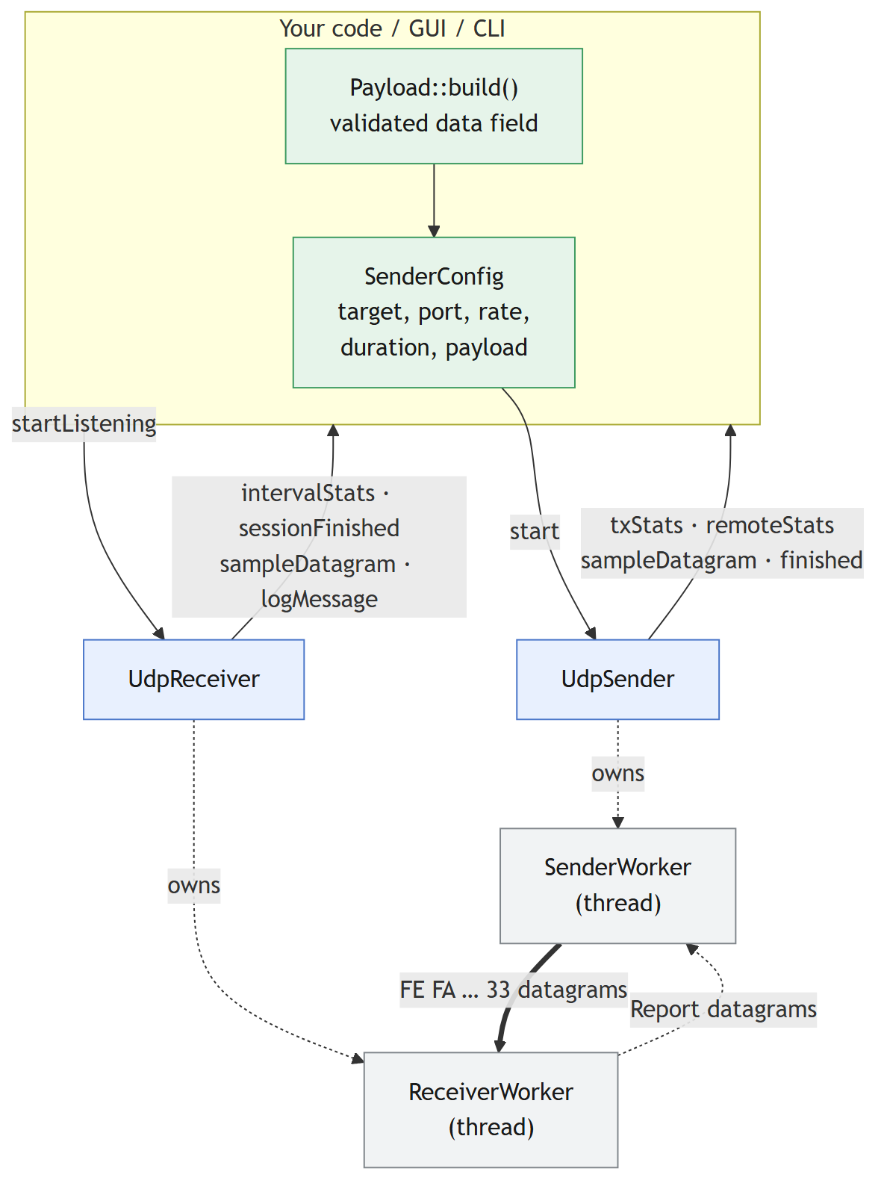
How the pieces fit together
All signals are delivered in the thread that owns the UdpSender / UdpReceiver object (usually the GUI or main() thread), so your slots never run concurrently with each other.

Public engine API

UdpSender
#include "udpsender.h" · inherits QObject
Runs one sender test at a time in a background thread. You give it a SenderConfig and it announces the session, sends paced datagrams, collects the receiver's reports, and emits statistics as signals.

Lifecycle
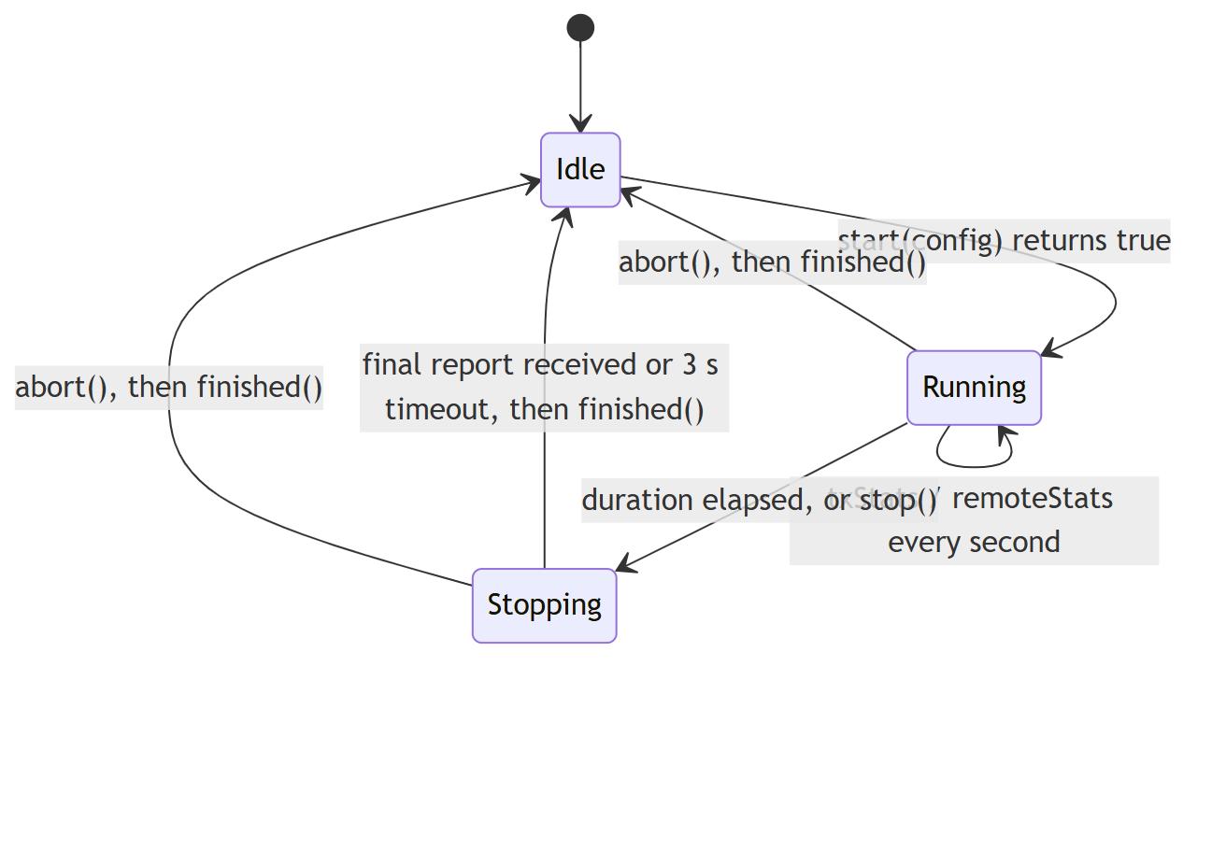
UdpSender lifecycle

UdpSender(QObject *parent = nullptr)
Creates an idle sender.
Parameter | Type | Description
parent | QObject* | Optional Qt parent; the sender is deleted with it

~UdpSender()
Aborts a running test (without waiting for the receiver's report) and waits for the worker thread to end. Safe to destroy at any time.

bool isRunning() const
Returns true while a test is in progress, from start() until finished().

bool start(const SenderConfig &config)
Starts a test in a new background thread and returns immediately.
Parameter | Type | Description
config | SenderConfig | Target, rate, duration and data field. config.payload must be exactly Proto::payloadSize(config.packetSize) bytes

Returns false if a test is already running (nothing changes); otherwise true. Problems found while running (bad config, socket errors) are reported through logMessage and end with finished().

void stop()
Ends the data phase early. The sender still sends Stop and waits up to 3 s for the receiver's final report, so remoteStats(final) normally still arrives. Does nothing when idle.

void abort()
Ends the test as soon as possible, without waiting for the final report. Does nothing when idle.

Signals
Signal | Parameters | When
logMessage(const QString &text) | text: human-readable line | Session start, frame description, send errors, missing final report
txStats(const TxStats &stats) | TxStats | Every second, then once with stats.final == true when the data phase ends
remoteStats(const RxStats &stats) | RxStats | Every receiver report (≈1/s), last one with stats.final == true
sampleDatagram(const QByteArray &datagram, quint16 localPort) | datagram: the first data datagram exactly as sent (FE FA … 33); localPort: sender's UDP source port | Once, right after the first datagram is sent
finished() | — | The test is over and the thread has ended; start() may be called again

Example
UdpSender sender;
QObject::connect(&sender, &UdpSender::txStats, [](const TxStats &s) {
if (!s.final) qDebug() << "sent" << s.intervalMbps() << "Mbps";
});
QObject::connect(&sender, &UdpSender::remoteStats, [](const RxStats &s) {
if (s.final) qDebug() << "receiver got" << s.totalPackets << "lost" << s.totalLost;
});
QObject::connect(&sender, &UdpSender::finished, qApp, &QCoreApplication::quit);

SenderConfig cfg;
cfg.target = resolveHost("192.168.1.20");
cfg.rateMbps = 200;
cfg.durationSec = 5;
Payload::build({PayloadPattern::Incrementing, ""}, 1447, cfg.payload);
cfg.packetSize = Proto::packetSizeFor(1447);
sender.start(cfg);

SenderConfig
#include "senderworker.h" (included by udpsender.h), plain struct.
Field | Type | Default | Description
target | QHostAddress | — | Receiver address (IPv4 or IPv6). Use resolveHost() for names
port | quint16 | 5201 | Receiver UDP port
packetSize | int | 1472 | Whole datagram size in bytes, FE FA and 33 included. Use Proto::packetSizeFor(dataSize)
rateMbps | double | 100.0 | Target rate in Mbit/s (UDP payload); ignored when unlimited
unlimited | bool | false | true = send as fast as possible
durationSec | int | 10 | Length of the data phase in seconds
payload | QByteArray | — | The data field: exactly packetSize − 25 bytes. Build it with Payload::build()
payloadDescription | QString | — | Free text for the log, e.g. Fixed byte "A5"
corruptEvery | int | 0 | Error injection: corrupt one data-field byte in every Nth datagram (0 = off)

UdpReceiver
#include "udpreceiver.h" · inherits QObject
Listens for test traffic in a background thread for its whole lifetime. It handles any number of consecutive tests (sessions), validates every datagram, and reports statistics both to you (signals) and back to the sender (Report datagrams).

Lifecycle
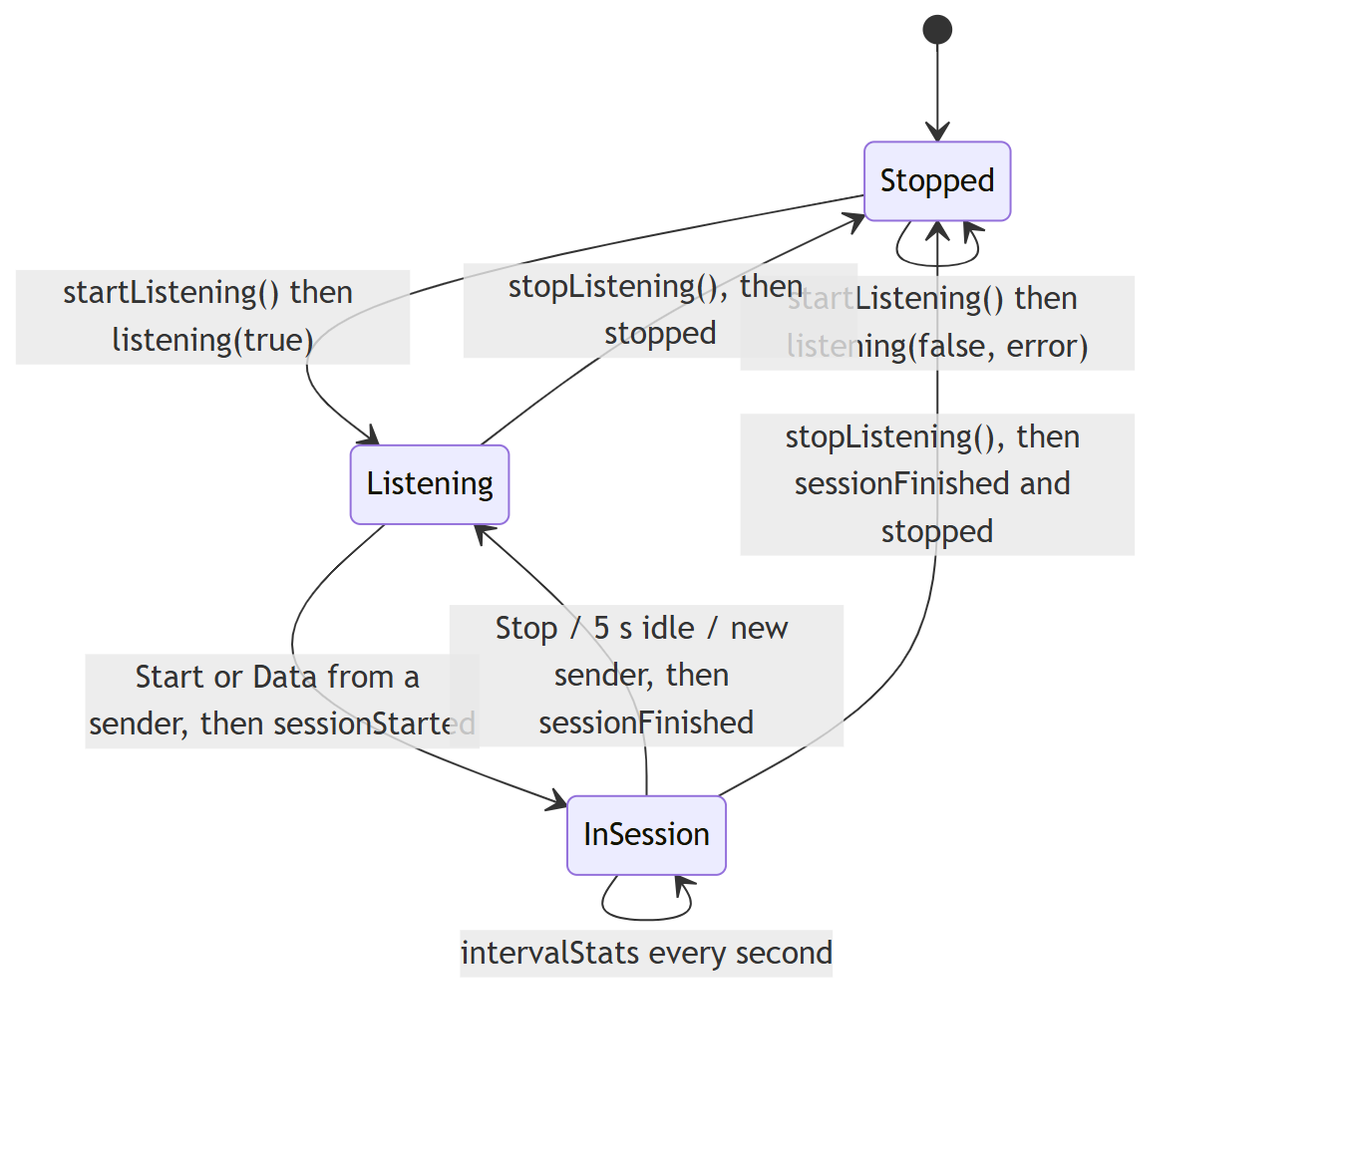
UdpReceiver lifecycle

UdpReceiver(QObject *parent = nullptr)
Creates the receiver and starts its worker thread. No socket is opened yet.
Parameter | Type | Description
parent | QObject* | Optional Qt parent

~UdpReceiver()
Calls shutdown().

void startListening(const QString &bindAddress, quint16 port, bool validatePayload)
Opens the UDP socket (asynchronously); the result arrives through listening(ok, message). Calling it again re-opens the socket with the new settings.
Parameter | Type | Description
bindAddress | QString | Local address, e.g. "0.0.0.0" (all IPv4 interfaces) or one interface's IP
port | quint16 | UDP port to listen on
validatePayload | bool | true = compare every datagram's data field with the reference from the sender's Start datagram. Framing (FE FA … 33) is always checked

void stopListening()
Closes the socket asynchronously. A running test is finished first (final report sent, sessionFinished emitted), then stopped() is emitted.

void shutdown()
Synchronous version for application exit: closes the socket and ends the worker thread before returning. Signals produced while closing are still queued for your thread; call QCoreApplication::processEvents() afterwards if you need them. Safe to call more than once.

Signals
Signal | Parameters | When
listening(bool ok, const QString &message) | ok: socket opened; message: details or the error | After startListening()
stopped() | — | After the socket is closed
sessionStarted(const QString &peer, const QString &details) | peer: sender ip:port; details: session ID, datagram size, rate, duration, validation status | A sender starts a test
intervalStats(const RxStats &stats) | RxStats with interval fields filled | Every second during a session
sessionFinished(const RxStats &stats, const QString &reason) | stats: totals (final == true); reason: "sender finished", "timed out…", "listener stopped", "superseded by a new session" | A test ends
logMessage(const QString &text) | text | Each framing/data-field error (first 10 per session)
sampleDatagram(const QByteArray &datagram, quint16 srcPort, quint16 dstPort) | first data datagram of the session; sender's port; local port | Once per session

Example
UdpReceiver receiver;
QObject::connect(&receiver, &UdpReceiver::intervalStats, [](const RxStats &s) {
qDebug() << s.intervalMbps() << "Mbps," << s.intervalLossPct() << "% loss";
});
QObject::connect(&receiver, &UdpReceiver::sessionFinished, [](const RxStats &s, const QString &why) {
qDebug() << "test ended:" << why << "data errors:" << s.payloadErrors;
});
receiver.startListening("0.0.0.0", 5201, true);

Statistics

TxStats
Sender statistics for one interval, or for the whole data phase when final == true.
Field / method | Type | Description
final | bool | true for the end-of-test summary
elapsedSec | double | Seconds since the first data datagram
intervalSec | double | Length of this interval (≈1 s; 0 in the summary)
intervalPackets, intervalBytes | quint64 | Sent in this interval
totalPackets, totalBytes | quint64 | Sent since the start
sendErrors | quint64 | Failed writeDatagram calls
corruptedPackets | quint64 | Datagrams deliberately corrupted (error injection)
intervalMbps() const | double | intervalBytes × 8 / intervalSec / 10⁶
avgMbps() const | double | totalBytes × 8 / elapsedSec / 10⁶

RxStats
Receiver statistics. The same struct is used locally (intervalStats, sessionFinished) and is sent to the sender in Report datagrams (remoteStats).
Field / method | Type | Description
session | quint32 | Session ID of the test
final | bool | true for the end-of-test summary
elapsedSec | double | Since the first data datagram (to the last datagram in the summary)
totalPackets, totalBytes | quint64 | Valid data datagrams received
totalLost | quint64 | max(0, expected − received)
outOfOrder | quint64 | Datagrams that arrived after a higher sequence number
framingErrors | quint64 | Datagrams without FE FA … 33
payloadErrors | quint64 | Datagrams whose data field didn't match the reference
jitterMs | double | RFC 3550 interarrival jitter, in ms
intervalSec, intervalPackets, intervalBytes |  | This interval
intervalLost | qint64 | Lost in this interval; can be negative when late datagrams fill earlier gaps
intervalMbps() const | double | Receive rate in this interval
avgMbps() const | double | Average receive rate
totalLossPct() const | double | totalLost / (totalPackets + totalLost) × 100
intervalLossPct() const | double | Same for the interval (negative loss counted as 0)

Wire protocol
#include "protocol.h" · namespace Proto

Protocol constants
Constant | Value | Meaning
kStartByte0, kStartByte1 | 0xFE, 0xFA | Start bytes of every datagram
kStopByte | 0x33 | Last byte of every datagram
kHeaderSize | 24 | FE FA + type + flags + session + seq + sendNs
kTrailerSize | 1 | The stop byte
kFramingOverhead | 25 | Bytes around the data field
kStartBodySize | 16 | Size of StartBody
kReportSize | 121 | Size of a Report datagram
kStopSize | 25 | Size of a Stop datagram
kMinPacketSize, kMaxPacketSize | 26, 65491 | Datagram size limits
kMinDataSize, kMaxDataSize | 1, 65466 | Data-field size limits
kDefaultDataSize | 1447 | Gives a 1472-byte datagram (fits a 1500-byte MTU)
kDefaultPort | 5201 | Default UDP port
Type | Data=1, Start=2, Stop=3, Report=4 | Datagram types
Flags | FinalReport=0x01 | Report flag

Protocol structs
All are #pragma pack(1) with little-endian fields (quint32_le, …), so they can be copied straight to and from the wire.
Struct | Size | Fields
Header | 24 | start[2], type, flags, session, seq, sendNs
StartBody | 16 | packetSize, rateBps (0 = unlimited), durationMs
ReportBody | 96 | totalPackets, totalBytes, totalLost, outOfOrder, framingErrors, payloadErrors, jitterNs, elapsedNs, intervalPackets, intervalBytes, intervalLost, intervalNs

Protocol functions

constexpr int payloadSize(int packetSize)
Returns the number of data-field bytes in a datagram of packetSize bytes (packetSize − 25).

constexpr int packetSizeFor(int dataSize)
Returns the datagram size needed for a dataSize-byte data field (dataSize + 25).
cfg.packetSize = Proto::packetSizeFor(10); // 35

void writeHeader(char *buf, Type type, quint32 session, quint64 seq, qint64 sendNs, quint8 flags = 0)
Writes the 24-byte header, start bytes included, to the start of buf.
Parameter | Description
buf | Destination, at least 24 bytes
type | Data, Start, Stop or Report
session | Session ID
seq | Sequence number (Data) or total sent (Stop)
sendNs | Sender timestamp in ns
flags | FinalReport for the last report, else 0

void writeTrailer(char *buf, qint64 len)
Writes the stop byte 33 at buf[len − 1].

QByteArray buildDatagram(Type type, quint32 session, quint64 seq, qint64 sendNs, const QByteArray &body, quint8 flags = 0)
Builds a complete datagram: header + body + 33. Every datagram the app sends is built by this function.
Parameter | Description
type, session, seq, sendNs, flags | As for writeHeader
body | Data field (Data), StartBody + data-field reference (Start), ReportBody (Report), or empty (Stop)

Returns the framed datagram (body.size() + 25 bytes).
QByteArray d = Proto::buildDatagram(Proto::Data, session, 0, 0, QByteArray(10, '\xA5'));
// FE FA 01 00 <session> <seq> <time> A5 A5 A5 A5 A5 A5 A5 A5 A5 A5 33

bool hasValidFraming(const char *buf, qint64 len)
Returns true if the datagram is at least 25 bytes, starts with FE FA and ends with 33.

bool readHeader(const char *buf, qint64 len, Header &h)
Checks the framing and, if it's valid, copies the header into h.
Parameter | Description
buf, len | Received datagram
h | Output header

Returns false (with h untouched) on bad framing.
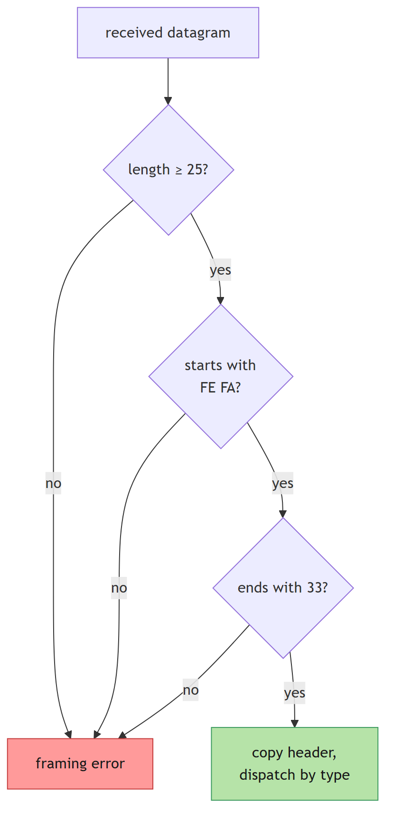
readHeader(): framing check of every received datagram

QByteArray encodeReport(const RxStats &s)
Builds a Report datagram (121 bytes) from receiver statistics; sets FinalReport when s.final.

bool decodeReport(const char *buf, qint64 len, RxStats &s)
Parses a Report datagram into s. Returns false if it is not a valid, framed Report.

Data field
#include "payload.h" · namespace Payload

PayloadPattern and PayloadConfig
PayloadPattern | value meaning | Example result
Incrementing | first byte in hex, optional (default 00) | 00 01 02 …
FixedByte | one byte in hex (required) | A5 A5 A5 …
PseudoRandom | seed 1–4294967295, optional (default 1) | xorshift32 bytes
CustomHex | hex bytes, repeated to fill | DE AD BE EF DE AD …
Text | text (UTF-8), repeated to fill; spaces are kept | HELLOHELLO…

struct PayloadConfig { PayloadPattern pattern; QString value; }. The array kAllPayloadPatterns[] lists every pattern, for menus.

Payload functions

Payload::build
bool build(const PayloadConfig &cfg, int length, QByteArray &out, QString *error = nullptr)
Validates the user's input and produces exactly length data-field bytes.
Parameter | Description
cfg | Pattern and value as typed by the user
length | Data-field size in bytes (1 to 65466)
out | Output: the data field
error | Optional output: a user-readable reason when the input is invalid

Returns true on success.
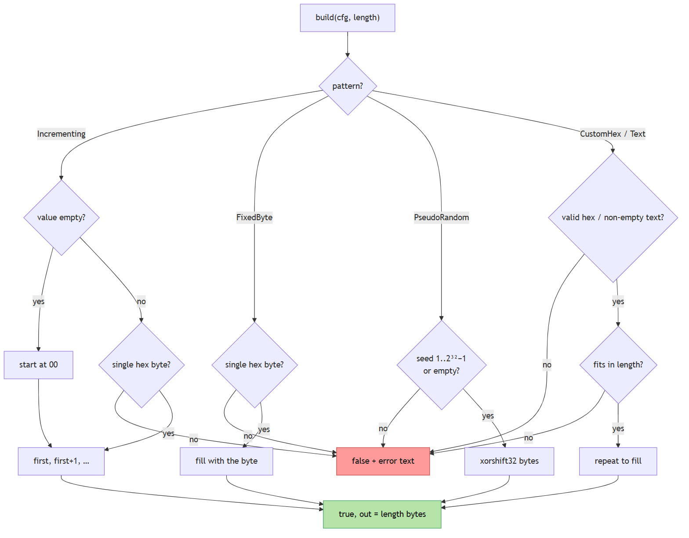
Payload::build(): data-field input validation
QByteArray data; QString why;
if (!Payload::build({PayloadPattern::CustomHex, "DE AD BE EF"}, 10, data, &why))
qWarning() << "invalid:" << why;
// data = DE AD BE EF DE AD BE EF DE AD

bool parseHexBytes(const QString &text, QByteArray &out, QString *error = nullptr)
Parses hex bytes. Accepted separators are spaces, , ; : and -; each token may have a 0x prefix; long tokens are read two digits at a time (DEADBEEF); a 1-digit token is one byte (B → 0B).
Parameter | Description
text | Input text
out | Output bytes
error | Optional output: reason on failure

Returns false for non-hex characters, odd-length long tokens, or empty input.

QString hexPreview(const QByteArray &data, int maxBytes = 24)
Returns the first maxBytes bytes as "DE AD BE EF ..." (with ... if truncated).

QString patternName(PayloadPattern pattern)
Returns the display name, e.g. "Fixed byte".

QString patternKeyword(PayloadPattern pattern)
Returns the CLI keyword: inc, fixed, random, hex or text.

bool patternFromKeyword(const QString &keyword, PayloadPattern &pattern)
Converts a CLI keyword (case-insensitive) to a pattern. Returns false if unknown.

QString valueHint(PayloadPattern pattern)
Returns help text for the value field, e.g. "byte value in hex, e.g. A5".

Packet description
#include "framelayout.h" · namespace Frame. Used by the GUI's Packet structure view and the CLI's --show-frame.

Frame types
Type | Description
enum class Part | UdpHeader, StartBytes, Header, Data, StopByte
struct Field | part, name, offset (from the start of the UDP header), size, hex (bytes on the wire), value (decoded), meaning
struct WireSize | dataField, udpPayload, udpDatagram, ipPacket, ethernetFrame, onWire, dataEfficiency (%)
Constants | kUdpHeaderSize 8, kIpv4HeaderSize 20, kEthernetHeaderSize 14, kEthernetFcsSize 4, kPreambleAndGap 20

Frame functions

QVector<Field> describe(const QByteArray &payload, int srcPort, int dstPort, bool preview)
Lists every field of the UDP header followed by the app frame.
Parameter | Description
payload | One UDP payload (FE FA … 33)
srcPort, dstPort | UDP ports, or -1 if unknown (shown as ?? ??)
preview | true = values are examples (session "random per test", seq "0, 1, 2, …")

Returns 12 fields for a valid frame (4 UDP + 8 app), or only the 4 UDP header fields if payload is too short.

WireSize wireSize(int payloadSize)
Returns the per-layer sizes for one datagram on Ethernet/IPv4, including the 64-byte minimum frame and preamble/gap.
Frame::WireSize w = Frame::wireSize(35); // 10-byte data field
// w.ethernetFrame == 81, w.onWire == 101, w.dataEfficiency ≈ 9.9

QString toText(const QByteArray &payload, int srcPort, int dstPort, bool preview)
Returns a printable report (field table, annotated hex dump, wire sizes), as printed by udpbw-cli --show-frame.

Part partAt(int offset, int payloadSize)
Returns which part the byte at offset (counted from the start of the UDP header) belongs to; used to colour the hex dump.

QByteArray udpHeader(int srcPort, int dstPort, int payloadSize)
Returns the 8-byte UDP header (big-endian). Unknown ports and the checksum are zero; the OS fills in the real checksum when sending.

QString partName(Part part)
Returns a display name, e.g. "Stop byte 33".

Helpers

Network helpers
#include "netutil.h"

QHostAddress resolveHost(const QString &host)
Turns an IP address or host name into an address, preferring IPv4. Blocks during a DNS lookup.
Parameter | Description
host | "192.168.1.20", "::1" or "testpc.local"

Returns a null QHostAddress if the name can't be resolved.

QStringList localIPv4Addresses(bool includeLoopback)
Returns this machine's IPv4 addresses as text (127.0.0.1 included only if includeLoopback).

Formatting
#include "format.h"
Function | Parameters | Returns
QString formatRate(double mbps) | rate in Mbit/s | "850.0 kbps", "99.98 Mbps" or "1.250 Gbps"
QString formatBytes(quint64 bytes) | byte count | "512 B", "1.5 kB", "25.00 MB" or "1.250 GB" (decimal units)

Internals
These classes are owned by UdpSender / UdpReceiver; you don't use them directly.

SenderWorker (internal)
senderworker.h/.cpp. Lives in the sender thread.
Function | Parameters | What it does
SenderWorker(cfg, control) | cfg: SenderConfig; control: shared atomic flag (SenderRun/SenderStop/SenderAbort) | Stores the config; picks a random non-zero session ID
void run() | — | The whole test (flow chart below). Blocks until done, then emits finished()
void sendStart(QUdpSocket &sock, qint64 nowNs) | socket; timestamp | Sends Start = StartBody (size, rate, duration) + data-field reference
void sendStop(QUdpSocket &sock, quint64 totalSent, qint64 nowNs) | socket; datagrams sent; timestamp | Sends Stop with seq = totalSent
void pollReports(QUdpSocket &sock) | socket | Reads pending Report datagrams for this session; emits remoteStats (each final report only once)
int control() const | — | Current value of the shared stop flag

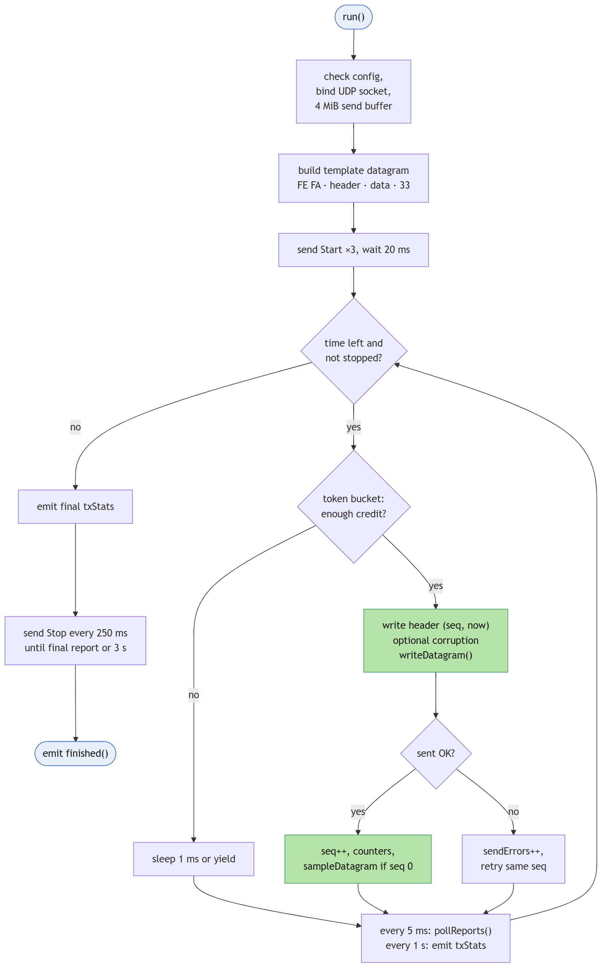
SenderWorker::run(): the send loop

ReceiverWorker (internal)
receiverworker.h/.cpp. Lives in the receiver thread.
Function | Parameters | What it does
ReceiverWorker(parent) | Qt parent | Allocates a 64 KiB receive buffer; starts the clock
startListening(bindAddress, port, validatePayload) | as in UdpReceiver | Binds the socket, 8 MiB receive buffer, 250 ms timer; emits listening
stopListening() | — | Finishes a running session, closes the socket, emits stopped
closeSocket() | — | Stops the timer and deletes the socket
onReadyRead() | — | Drains up to 20,000 datagrams per call and dispatches them (flow chart below)
onTick() | — | Every 250 ms: closes a session idle for 5 s, emits interval stats while traffic is stalled
handleBadFrame(buf, len) | datagram | Counts a framing error and logs its first/last bytes
handleStart(h, buf, len, from, fromPort, now) | header, datagram, sender address/port, time | Begins a new session; stores the data-field reference from the Start body
handleData(h, buf, len, from, fromPort, now) | same | Counts, tracks seq (loss / out-of-order), updates jitter, validates the data field
handleStop(h) | header | Records the announced total and finishes the session, or repeats the final report
validatePayload(seq, buf, len) | sequence number, datagram | Compares length and data field with the reference; counts and logs mismatches
beginSession(session, from, fromPort, now) | session ID, sender, time | Resets all counters
finishSession(reason) | text | Emits the last interval, sends the final report ×3, emits sessionFinished
emitInterval(now) | time | Emits intervalStats and sends it to the sender as a Report
snapshot(now) const | time | Builds an RxStats with the cumulative counters
expectedPackets() const | — | max(maxSeq + 1, announcedTotal)
sendReport(stats, copies) | stats, number of copies | Sends Report datagram(s) to the session's sender

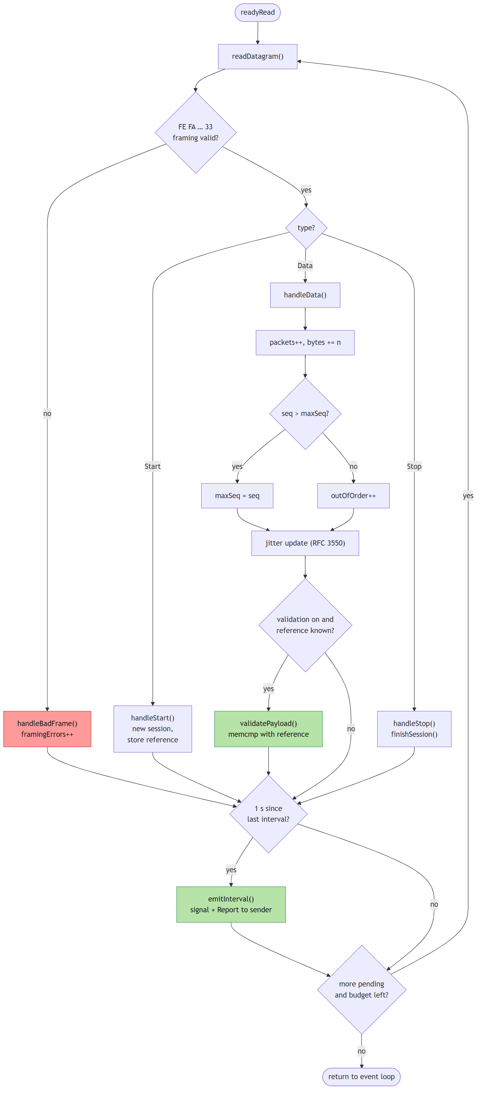
ReceiverWorker::onReadyRead(): the receive loop

Front ends
The front ends contain no networking code; they only call the API above.

GUI functions

SenderPage (Sender tab, gui/senderpage.*)
Function | Parameters | What it does
SenderPage(parent) | Qt parent | Builds the tab and connects a UdpSender
createSettingsBox() | — | Address, port, rate, duration inputs
createDataFieldBox() | — | Size, pattern, value, preview, corruption inputs
createResultsBox() | — | Live value labels
onPatternChanged() | — | Updates the value hint; rebuilds the preview
updatePayloadPreview() | — | Validates the data field with Payload::build; shows the hex preview or a red error; enables Start; refreshes the packet preview
updateStartEnabled() | — | Start is enabled only when idle and the input is valid
start() | — | Resolves the address, fills SenderConfig, calls UdpSender::start
stop() | — | UdpSender::stop()
onTxStats(s) | TxStats | Updates the rate labels, chart, table; logs the summary
onRemoteStats(s) | RxStats | Receiver's view: loss, jitter, errors; final summary and PASS/FAIL
onSampleDatagram(datagram, localPort) | first datagram, source port | Shows it in the Packet structure tab
onFinished() | — | Back to idle
setRunning(running) | bool | Enables or disables the inputs
resetResults() | — | Clears the chart, table and labels
log(text) | QString | Appends a time-stamped log line

ReceiverPage (Receiver tab, gui/receiverpage.*)
Function | Parameters | What it does
ReceiverPage(parent) / ~ReceiverPage() | Qt parent | Builds the tab, owns a UdpReceiver; shuts it down on exit
createListenerBox(), createResultsBox() | — | Settings and value labels
startListening(), stopListening() | — | Forward to UdpReceiver
onListening(ok, message) | result | Logs it; shows a message box on failure
onStopped() | — | Back to the stopped state
onSessionStarted(peer, details) | sender, details | Clears the previous results
onInterval(s) | RxStats | Labels, chart, table row
onSessionFinished(s, reason) | totals, reason | Summary and PASS/FAIL
onSampleDatagram(datagram, srcPort, dstPort) | first datagram | Shows it in the Packet structure tab
showTotals(s) | RxStats | Updates the cumulative labels
setListening(listening) | bool | Enables or disables the controls
log(text) | QString | Appends a time-stamped log line

Widgets and helpers
Function | Parameters | What it does
FrameView::showDatagram(title, payload, srcPort, dstPort, preview) | as Frame::describe + a title | Renders the layer diagram, field table, hex dump and wire sizes
FrameView::showMessage(text) | QString | Shows a placeholder message
RateChart::addSeries(name, color) | label, colour | Adds a line; returns its index
RateChart::append(series, xSec, mbps) | index, time, rate | Adds a point and repaints
RateChart::clear() / setWindowSeconds(seconds) | — / visible span | Clears points / sets the time window (≥ 5 s)
makeValueLabel(parent) | Qt parent | Bold, selectable result label
makeStatsTable(headers, parent) | column titles | Read-only results table
appendTableRow(table, cells) | table, values | Adds a row; auto-scrolls when at the bottom
exportTableCsv(parent, table, defaultName) | dialog parent, table, file name | Save dialog, then writes CSV; returns true on success
main(argc, argv) | — | Creates the window with both tabs

CLI functions
cli/main.cpp
Function | Parameters | What it does
main(argc, argv) | command line | Parses and validates every option; runs runServer or runClient; returns the exit code
runServer(app, bindAddress, port, once, validate, showFrame, csvPath) | receiver options | Runs a UdpReceiver; prints per-second lines, summary and verdict; --once exits after one test
runClient(app, cfg, showFrame, csvPath) | SenderConfig + options | Runs a UdpSender; prints TX/RX lines and summary; returns 0/2/3
parseRate(text, mbps, unlimited) | "100M", "1.5G", "500k", "max" | Converts to Mbps; returns false if invalid
passed(s) / printVerdict(s) | RxStats | PASS = no loss and no framing/data errors
lossText(lost, expected, pct) | counts | Formats "lost/expected (pct%)"
watchInterrupts(context, onInterrupt) | callback | Polls Ctrl+C every 100 ms; first press = stop, second = abort
out(line) / err(line) | text | Thread-safe print to stdout/stderr
CsvLog::open(path) / row(…) | file / one row | Per-second CSV output

Part 4: Source Guide
How transmission, reception and the monitoring of packets and bandwidth work internally.
This guide explains how the UDP Bandwidth Tester works internally: how datagrams are built and sent, how they are received and checked, and how packets and bandwidth are measured and shown. For using the tools, see the README; for every function's parameters, see the API Reference.

1. Architecture
The code is split into three layers. Only core touches the network.
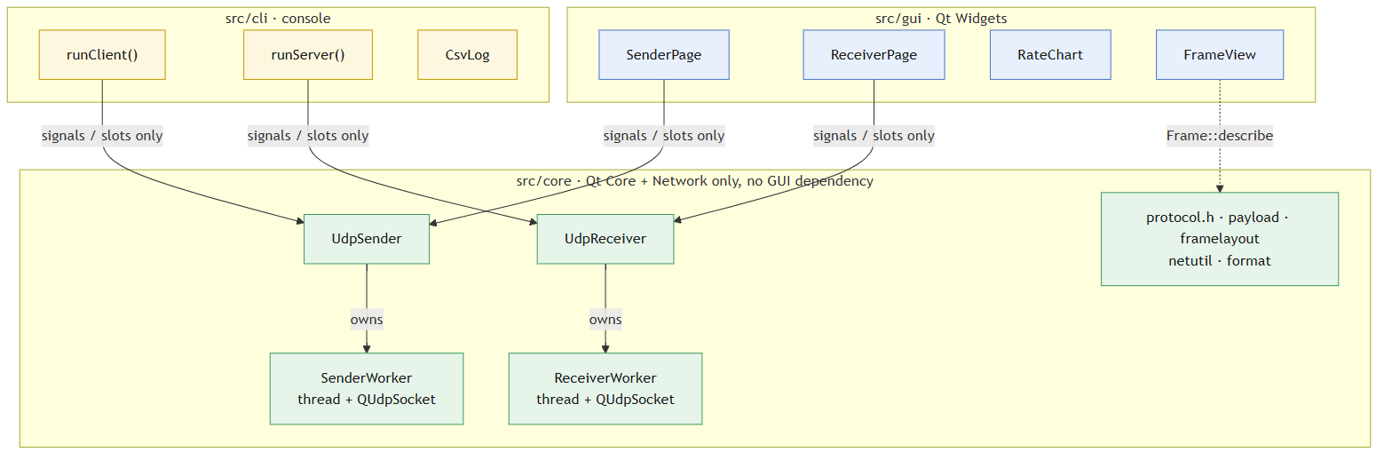
Layers and dependencies
Layer | Folder | Depends on | Responsibility
Core | src/core | Qt Core, Qt Network | Framing, sending, receiving, validation, statistics, packet description
GUI | src/gui | core, Qt Widgets | Settings forms, charts, tables, packet structure view
CLI | src/cli | core | Command-line options, console output, CSV, exit codes

The CMake target udpbw_core links only Qt::Core and Qt::Network, so any widget include in src/core fails to build. That keeps the engine independent of the GUI. Both front ends use only the public core API: UdpSender, UdpReceiver, protocol.h, payload.h, framelayout.h, netutil.h and format.h.

Core files
File | Contents
protocol.h | Frame layout, header/body structs, buildDatagram(), readHeader(), report encode/decode, TxStats / RxStats
senderworker.h/.cpp | SenderWorker: the sending loop (pacing, error injection, stop handshake)
receiverworker.h/.cpp | ReceiverWorker: receive loop, session tracking, loss/jitter/validation, reports
udpsender.h/.cpp | UdpSender: public API; owns the sender thread and forwards signals
udpreceiver.h/.cpp | UdpReceiver: public API; owns the receiver thread and forwards signals
payload.h/.cpp | Data-field patterns (Payload::build), hex parsing, input validation
framelayout.h/.cpp | Field-by-field description of a datagram (Frame::describe, Frame::toText)
netutil.h/.cpp | resolveHost(), localIPv4Addresses()
format.h/.cpp | formatRate(), formatBytes()

2. Wire protocol

2.1 Frame layout
Every datagram the app sends, in either direction, is one UDP payload with this layout. All multi-byte fields are little-endian.
offset 0 1 2 3 4..7 8..15 16..23 24 .. n-2 n-1
┌────┬────┬──────┬──────┬──────────┬─────────┬──────────┬─────────────┬────┐
│ FE │ FA │ type │ flags│ session │ seq │ sendNs │ body / data │ 33 │
└────┴────┴──────┴──────┴──────────┴─────────┴──────────┴─────────────┴────┘
start bytes \______________ Header: 24 bytes ______/ stop byte
Field | Size | Meaning
Start bytes | 2 | Always FE FA (Proto::kStartByte0/1)
type | 1 | 1 Data, 2 Start, 3 Stop, 4 Report (Proto::Type)
flags | 1 | Bit 0 = final report (Proto::FinalReport); otherwise 0
session | 4 | Random, non-zero ID chosen by the sender for each test
seq | 8 | Data: datagram sequence number (0, 1, 2, ...). Stop: total datagrams sent
sendNs | 8 | Sender's monotonic clock in nanoseconds when the datagram was sent
body / data | n-25 | Depends on type (see below)
Stop byte | 1 | Always 33 (Proto::kStopByte)

The framing overhead is Proto::kFramingOverhead = 25 bytes, so datagram size = data-field size + 25 (Proto::packetSizeFor()). The data field can be 1 to 65466 bytes (kMinDataSize … kMaxDataSize). The upper limit leaves room for the Start datagram, which is 16 bytes larger and must fit the 65507-byte IPv4 UDP maximum.
Every datagram is built by Proto::buildDatagram(type, session, seq, sendNs, body). Every received datagram is checked by Proto::hasValidFraming(): length ≥ 25, first bytes FE FA, last byte 33. Datagrams that fail this check are never parsed further.

2.2 Message types
Type | Direction | Body | Purpose
Start (2) | sender → receiver | StartBody (16 B) + reference copy of the data field | Opens a session; tells the receiver the datagram size, rate, duration and the exact data field to expect
Data (1) | sender → receiver | the data field | The measured traffic
Stop (3) | sender → receiver | none | Ends the session; seq = total data datagrams sent
Report (4) | receiver → sender | ReportBody (96 B) | Per-second statistics, plus a final report

StartBody: packetSize (u32), rateBps (u64, 0 = unlimited), durationMs (u32).
ReportBody: totals (packets, bytes, lost, out-of-order, framing errors, data-field errors), jitter, elapsed time, and the current interval (packets, bytes, lost, length). It is encoded and decoded by Proto::encodeReport() and Proto::decodeReport().

2.3 Session sequence
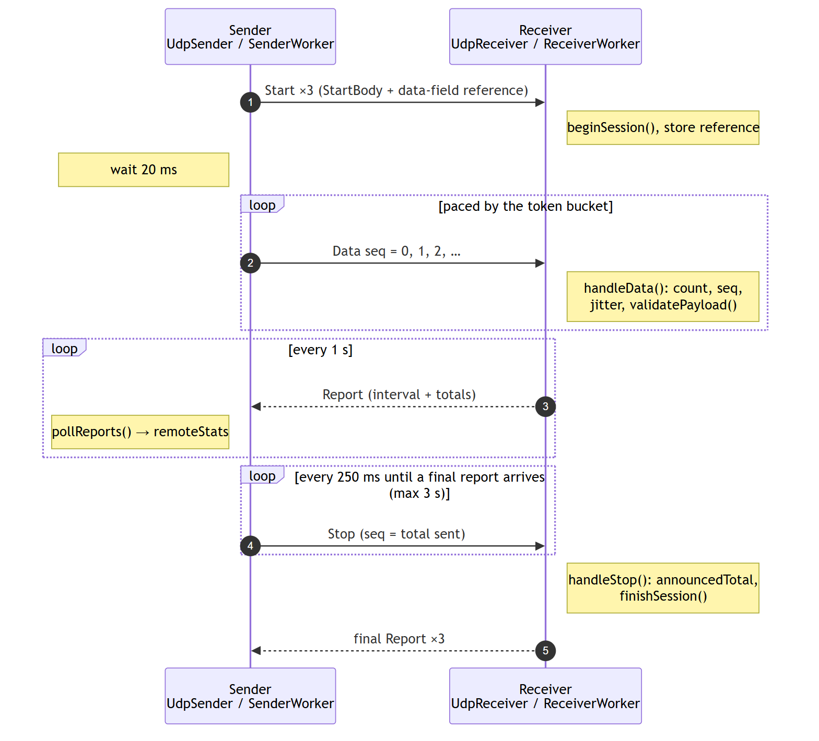
Session sequence between sender and receiver
The Start and final Report are sent several times because UDP can drop them. The receiver ignores duplicate Starts and answers repeated Stops by resending its last final report.

3. Transmission (sender)

3.1 Entry point: UdpSender
UdpSender::start(const SenderConfig &) creates a SenderWorker, moves it to a new QThread, connects the worker's signals to its own, and starts the thread. The thread's started() signal runs SenderWorker::run(). stop() and abort() set a shared atomic flag (SenderControl) that the loop checks on every iteration. When the worker emits finished(), UdpSender joins the thread and emits its own finished().
SenderConfig fields: target, port, packetSize (whole datagram), rateMbps, unlimited, durationSec, payload (the data field, exactly packetSize - 25 bytes), payloadDescription, and corruptEvery.

3.2 SenderWorker::run() step by step
📈 Flow chart: API Reference: SenderWorker
- Check the config. The data field must match the datagram size. Otherwise it emits an error and finishes.
- Open the socket. It binds a QUdpSocket to an ephemeral local port (AnyIPv4 or AnyIPv6 to match the target) and asks for a 4 MiB send buffer.
- Build the template. packet = buildDatagram(Data, session, 0, 0, payload). Only the header changes per datagram, so the data field and stop byte are written once.
- Announce. It sends Start three times, then sleeps 20 ms so the receiver can reset.
- Send loop, until the duration ends or a stop is requested. Each iteration:
  - computes whether a datagram may be sent (see 3.3);
  - overwrites the header in the template with writeHeader(data, Data, session, seq, now);
  - applies error injection if configured (see 3.5);
  - calls writeDatagram(data, packetSize, target, port);
  - on success, increments seq and the counters; for seq == 0, emits sampleDatagram(bytes, localPort) with the exact bytes sent;
  - every 5 ms, reads any Report datagrams (pollReports()), which emit remoteStats;
  - every 1 s, emits txStats for the interval (see 5.2).
- Final statistics. It emits a trailing partial interval (if ≥ 200 ms), then txStats with final = true covering the whole data phase.
- Stop handshake. It sends Stop(seq = total sent) every 250 ms and polls for the final report, for up to 3 s. If none arrives, it logs a firewall/address hint.
- Emits finished().

3.3 Rate control: token bucket
For a target rate R (Mbit/s) the sender earns credit at
bytesPerNs = R × 10^6 / 8 / 10^9
tokens = min(burstBytes, tokens + (now − last) × bytesPerNs)
burstBytes = max(4 × packetSize, bytesPerNs × 20 ms)
A datagram is sent when tokens ≥ packetSize, and that many tokens are spent. The cap of about 20 ms of credit means that if the thread gets descheduled, the sender catches up with a short burst but never a huge one. Between datagrams the loop waits like this:
- more than 2 ms until the next datagram: QThread::usleep(1000);
- otherwise: QThread::yieldCurrentThread(). This busy-waits, which gives precise pacing at the cost of one CPU core.
On Windows, main() calls timeBeginPeriod(1) so that 1 ms sleeps are really about 1 ms. In unlimited mode the bucket is skipped and datagrams are sent back to back.
The rate counts UDP payload bytes, so FE FA, the header, the data field and 33 all count, but IP and Ethernet headers do not (see 5.1).

3.4 Send errors
If writeDatagram() doesn't return the full size:
- QAbstractSocket::TemporaryError (socket buffer full): it's counted in sendErrors and retried with the same seq.
- Any other error: also counted, and the test aborts after 1000 such errors in a row.
- Each new error text is logged once.

3.5 Error injection (corruptEvery)
When corruptEvery = N > 0, every datagram with seq % N == N − 1 has one data-field byte inverted. The byte's position is seq % dataSize, so it moves around the field. The byte is restored right after sending, so the template stays clean. The count goes into TxStats::corruptedPackets. The receiver should report exactly that many data-field errors, which verifies its validation end to end.

4. Reception (receiver)

4.1 Entry point: UdpReceiver
UdpReceiver creates one ReceiverWorker in its own thread for its whole lifetime.
- startListening(addr, port, validate) and stopListening() are forwarded to the worker's thread with QMetaObject::invokeMethod(..., Qt::QueuedConnection).
- shutdown() stops listening synchronously (BlockingQueuedConnection), so a running test still sends its final report, and then ends the thread. The destructor calls it.

4.2 Socket setup: ReceiverWorker::startListening()
It binds QUdpSocket to bindAddress:port, requests an 8 MiB receive buffer to absorb bursts (and logs the size actually granted), connects readyRead to onReadyRead(), and starts a 250 ms housekeeping timer (onTick()).

4.3 Receive loop: onReadyRead()
📈 Flow chart: API Reference: ReceiverWorker
while budget > 0 and datagrams are pending:
n = readDatagram(buf, 65536, &from, &fromPort)
now = monotonic clock (ns)
if !readHeader(buf, n) → handleBadFrame() (framing error)
switch type: Data → handleData(); Start → handleStart(); Stop → handleStop()
if a session is active and 1 s has passed → emitInterval(now)
if budget exhausted and more is pending → re-invoke onReadyRead() through the event loop
The budget (20,000 datagrams per call) keeps the timer and other events running even under heavy load.

4.4 Sessions
Situation | Action
Start with a new session ID | Finish any active session, then beginSession() (reset all counters) and store the data-field reference from the Start body
Start with the current or previous session ID | Ignored (duplicate)
Data with a new session ID (Start was lost) | Begin the session implicitly; data-field validation isn't possible without a reference
Data from the previous session | Ignored (stragglers)
Data after the session finished | Ignored (late)
Stop for the active session | Record announcedTotal = seq, then finishSession()
Stop after the session finished | Resend the final report (the sender missed it)
No datagrams for 5 s | finishSession("timed out") (from onTick())

4.5 Per-datagram processing: handleData()
For each valid Data datagram:
- Counters: packets++, bytes += n, plus the same for the current interval.
- Sequence tracking: if seq > maxSeq, then maxSeq = seq; otherwise outOfOrder++.
- Jitter (RFC 3550, section 6.4.1):
transit = arrivalNs − sendNs (includes the unknown clock offset) D = |transit − previousTransit| (the offset cancels out) J = J + (D − J) / 16
Because only differences of transit times are used, the two machines don't need synchronised clocks.
- Data-field validation (if enabled and a reference exists): validatePayload() first checks the length. Then it compares the data field with the reference using memcmp, which is the fast path. On a mismatch it counts payloadErrors and logs the datagram number, how many bytes differ, the first differing offset, and the expected and actual bytes. Up to 10 errors are logged per session; the rest are only counted.
- For the first datagram of a session it emits sampleDatagram(bytes, srcPort, dstPort) for the packet structure view.

4.6 Framing errors: handleBadFrame()
During an active session, any datagram without FE FA … 33, or shorter than 25 bytes, increments framingErrors. The log shows its length, first two bytes and last byte. Stray traffic between tests is ignored.

4.7 Reports to the sender
emitInterval() emits intervalStats locally and sends the same statistics to the sender as a Report datagram (sendReport(stats, 1)). finishSession() sends the final report three times. Reports go to the address and port the session's datagrams came from, so they come back through the sender's own socket. The sender's firewall therefore treats them as replies and lets them through.

5. Monitoring packets and bandwidth

5.1 What "bandwidth" means here
All rates count UDP payload bytes, which is the whole FE FA … 33 frame:
Mbps = bytes × 8 / seconds / 10^6
The OS and network card add more on the link. Frame::wireSize() computes this per datagram:
Layer | Bytes
Data field (your data) | N
+ FE FA + header + 33 | N + 25 = UDP payload
+ UDP header | + 8
+ IPv4 header | + 20
+ Ethernet header + FCS | + 18 (minimum frame 64 B)
+ preamble + inter-frame gap | + 20 = time on the link

Data efficiency = N / (bytes on the link). For N = 1447 it is about 94 %; for N = 10 it is about 10 %. Small datagrams use most of the link for headers.

5.2 Sender statistics (TxStats)
Emitted once per second and once at the end (final = true):
Field | Meaning
intervalPackets, intervalBytes, intervalSec | Sent in this interval. intervalMbps() = bytes × 8 / s / 10⁶
totalPackets, totalBytes, elapsedSec | Since the first data datagram. avgMbps()
sendErrors | writeDatagram failures (see 3.4)
corruptedPackets | Datagrams deliberately corrupted (see 3.5)

5.3 Receiver statistics (RxStats)
Built by ReceiverWorker::snapshot() and emitInterval(), and sent to the sender in each Report:
Field | Formula / meaning
totalPackets, totalBytes | Valid data datagrams received
expected | max(maxSeq + 1, announcedTotal). announcedTotal comes from Stop, so datagrams lost at the very end are counted too
totalLost | max(0, expected − totalPackets)
totalLossPct() | lost / (received + lost) × 100
intervalLost | (expected now − expected at interval start) − intervalPackets. It can be negative when late datagrams fill gaps counted earlier; displays clamp it to 0
outOfOrder | Datagrams that arrived after a higher sequence number
jitterMs | RFC 3550 interarrival jitter (see 4.5)
framingErrors | Datagrams without FE FA … 33
payloadErrors | Datagrams whose data field didn't match the reference
elapsedSec | From the first data datagram to now (to the last datagram for the final report)
avgMbps() | totalBytes × 8 / elapsedSec / 10⁶

Verdict: PASS when totalLost == 0 && payloadErrors == 0 && framingErrors == 0; otherwise FAIL. The CLI exits with code 3 on FAIL.

5.4 Where the numbers appear
Place | Shows | Code
GUI Results boxes | Current and average rate, loss, jitter, data/framing errors, counts | SenderPage::onTxStats/onRemoteStats, ReceiverPage::showTotals
GUI Throughput tab | Per-second rate chart (sender: sent and received) | RateChart, fed by txStats / intervalStats / remoteStats
GUI table + Export CSV | One row per second | appendTableRow, exportTableCsv (gui/common.cpp)
GUI log | Session start/end, every logged error, PASS/FAIL | log() slots
GUI Packet structure tab | Layers, field table, hex dump, bytes on the wire | FrameView + Frame::describe
CLI | TX / RX lines per second, summary, verdict | runClient, runServer (cli/main.cpp)
CLI --csv | side,time_s,mbps,datagrams,lost,loss_pct,jitter_ms,data_errors,framing_errors | CsvLog
CLI --show-frame | Text version of the packet structure view | Frame::toText

On the sender, the receiver's numbers arrive through Report datagrams, about 1 s behind the sender's own numbers. So the sender's table shows the most recent receiver report next to each sender interval.

5.5 Packet structure view
Frame::describe(payload, srcPort, dstPort, preview) returns a list of Frame::Field entries: the four UDP header fields (big-endian; the checksum is shown as ?? ?? because the OS computes it), then FE FA, type, flags, session, seq, sendNs, the data field and 33. Offsets count from the first byte of the UDP header. Frame::partAt(offset) gives each byte's part for colouring. FrameView renders this as HTML; Frame::toText renders it as text for the CLI.

6. Threading model
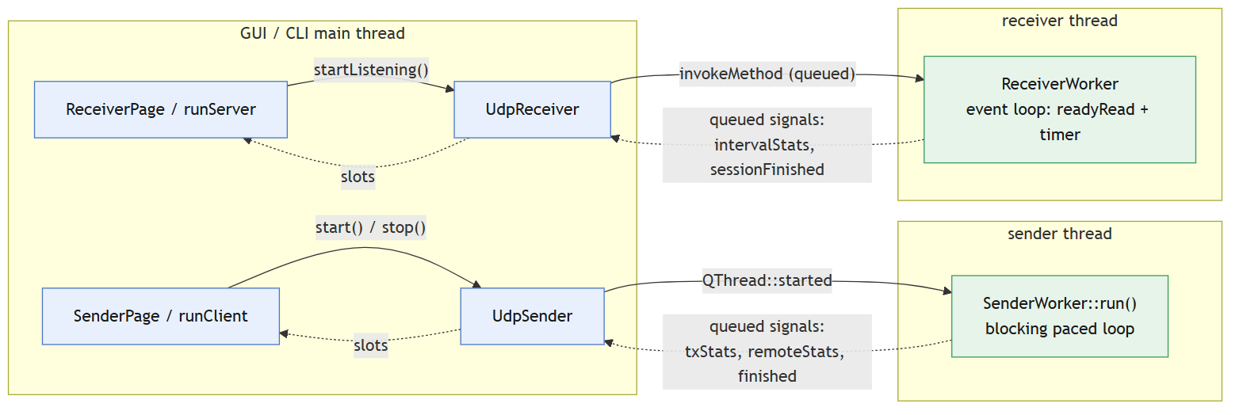
Threading model
- Sockets live only in worker threads. The sender's socket is created inside run(); the receiver's inside startListening(). Each is used only by the thread that created it.
- The sender loop doesn't use an event loop. It polls the socket directly (hasPendingDatagrams / readDatagram) and checks an atomic flag to stop. This keeps pacing precise.
- The receiver is event driven (readyRead plus a 250 ms timer), with a read budget per wake-up.
- Signal forwarding: worker signals connect to UdpSender/UdpReceiver signals across threads, so Qt queues them. Slots therefore always run in the front end's thread, and the GUI never needs locks.
- Ordering: queued signals from one worker arrive in order. A test's final statistics always arrive before finished().

7. Using and extending the core

7.1 Using the engine from other code
#include "udpsender.h"
#include "payload.h"
#include "netutil.h"

UdpSender sender;
QObject::connect(&sender, &UdpSender::remoteStats, [](const RxStats &s) {
qDebug() << s.intervalMbps() << "Mbps, lost" << s.totalLost;
});
QObject::connect(&sender, &UdpSender::finished, qApp, &QCoreApplication::quit);

SenderConfig cfg;
cfg.target = resolveHost("192.168.1.20");
cfg.port = 5201;
cfg.rateMbps = 50;
cfg.durationSec = 10;
PayloadConfig data{PayloadPattern::CustomHex, "DE AD BE EF"};
QString error;
if (!Payload::build(data, 100, cfg.payload, &error)) // 100 data bytes
qFatal("%s", qPrintable(error));
cfg.packetSize = Proto::packetSizeFor(100);
sender.start(cfg);
A receiver works the same way with UdpReceiver::startListening() and its signals. Your own program needs only udpbw_core, Qt Core and Qt Network.

7.2 Common changes
Change | Where
Different start/stop bytes | Proto::kStartByte0, kStartByte1, kStopByte in protocol.h. Rebuild both ends
New data-field pattern | Add to PayloadPattern and kAllPayloadPatterns, then handle it in Payload::build, patternName, patternKeyword and valueHint (payload.cpp). The GUI and CLI pick it up automatically
New statistic | Compute it in ReceiverWorker, add it to RxStats and ReportBody (update the size static_assert), encode/decode it in protocol.h, then display it in the front ends
Different report interval | kNsPerSec comparisons in ReceiverWorker::onReadyRead/onTick and SenderWorker::run
Idle timeout | kIdleTimeoutNs in receiverworker.cpp
Socket buffer sizes | kSendBufferBytes (sender), kRecvBufferBytes (receiver)

Any change to the wire format makes the build incompatible with older builds. Update both machines.

8. Performance limits and tuning
- Packets per second, not bits, limit small datagrams. On a typical PC the sender manages roughly 150,000 to 250,000 datagrams per second. With a 10-byte data field (35-byte datagram) that is only about 45 Mbps, even on a fast link. Use larger data fields to measure link bandwidth.
- MTU. A 1447-byte data field gives a 1472-byte datagram, which fills a 1500-byte MTU without IP fragmentation. With jumbo frames (MTU 9000), use 8947. Larger datagrams are fragmented by IP: losing one fragment loses the whole datagram.
- Receiver drops. If loss appears on a fast link while the receiver's CPU is busy, the receiving host is likely the bottleneck. The receive buffer is 8 MiB; the log shows what the OS actually granted.
- CPU. The sender busy-waits for precise pacing (one core at 100 % during a test).
- Firewall. The receiver needs inbound UDP on the test port. Reports return through the sender's socket as replies.

