ARINC 615A-4 · HOST DATA LOADER

CLI Engineering Trace
A function-by-function walkthrough of the command-line data loader: every function on the path from main() to a byte on the wire, and back up through the handler callbacks that print to the console.
SUBJECT | arinc_615a — ARINC 615A Tool Suite, CLI targets only
COVERS | arinc_615a_operation · arinc_615a_download_request_file
SECTIONS | 23, including customisation, build and run procedures
METHOD | Static source reading; no build or live target was exercised

Line numbers refer to the working copy this document was generated from. Verify against your checkout before relying on them.

Contents
The table below is a Word field. Open the document, select it and press F9 (or Ctrl+A then F9) to populate page numbers.

01 — SCOPE

What this document covers
A function-by-function trace of the command-line data loader in this repository: every function on the path from main() to a byte on the wire, and back up through the handler callbacks that print to the console.
This working copy has been reduced to a CLI-only variant: app/CMakeLists.txt wires in a single application and the Qt libraries have been removed from lib/. The table below reflects that state — see §20 for what the variant excludes and how to re-enable a target.
TARGET | ROLE | COVERED
arinc_615a_operation | Built. Host data loader — nine sub-commands, all protocol operations | §4–§17
arinc_615a_download_request_file | On disk, not wired into the build. Offline generator for the .LNR request file | §18
arinc_615a_test_tha | On disk, not wired into the build. Simulated target hardware | Referenced only
arinc_615a_unit_test | On disk, not wired into the build. Boost.Test suite | Out of scope
arinc_615a_data_loader_gui | Removed from this working copy along with the Qt libraries | Out of scope

How to read it
Sections 4 through 7 are a linear walkthrough of process startup and command dispatch — read them in order. Sections 8 through 13 are one per protocol operation and are independent of each other; §9 is shared machinery that §10–§13 all build on, so read §9 before any of them. Sections 14 through 17 are the layers underneath, and can be consulted as reference.
Every function block carries its source location as file:line. Line numbers refer to the tree as it stands in this working copy. Collapsed blocks expand on click.
The target side is not the subject here. Everything below describes the host data loader — the machine that initiates. Where the target's behaviour matters to the host's state machine, it is described as an observed stimulus, not as an implementation.
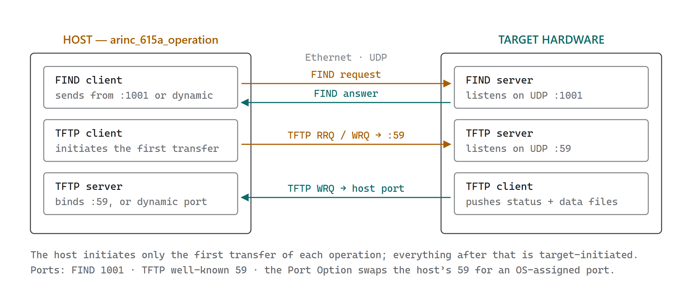
Two processes, four sockets. The host owns the FIND client and a TFTP client/server pair; the target mirrors it. Which side listens is fixed by the standard, which is why the host’s own TFTP server has to be running before the first request goes out.

02 — ARCHITECTURE

Six layers, one direction
Control flows downward through six layers on the way out and returns through registered handler callbacks on the way in. No layer calls back into the layer above it directly; the upward path is always a std::function or an abstract handler interface bound during setup. That inversion is what lets the same host protocol library serve both the CLI and the Qt GUI.
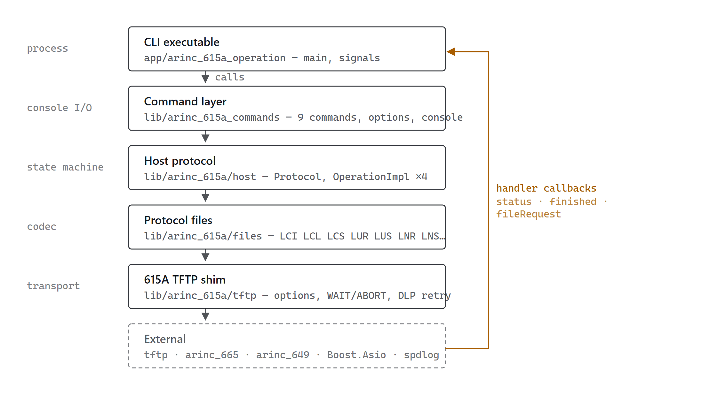
Calls descend the stack; results climb it only through handlers bound at setup time. The command layer implements the host layer's handler interfaces, which is why a command object is its own callback sink.

The dependency that shapes everything
Five of this project's dependencies are pulled at configure time by FetchContent from git.thomas-vogt.de — helper, arinc_649, arinc_665, tftp, and commands. (qt_icon_resources was dropped when this tree was reduced to the CLI variant.) Two of them carry weight in the CLI path and are worth naming:
• commands supplies Commands::CommandRegistry and Commands::Utils_commandLineHandler — the entire sub-command dispatch mechanism. It is not in this repository.
• tftp supplies the generic TFTP client and server. The Arinc615a::Tftp namespace in this repository is a thin decorator over it, not a reimplementation.
arinc_665 matters for upload only: it resolves load headers and media sets. arinc_649 supplies CheckValue and the check-value generators used for the checksum TFTP option.

03 — CONCURRENCY

Two threads and a latch
The process runs exactly two threads of interest. The main thread parses the command line and then blocks; a single std::jthread runs the Boost.Asio io_context and executes every protocol handler. All protocol state lives on the I/O thread and is never touched concurrently, because the main thread does nothing but wait once the operation starts.
The handshake between them is a std::latch{1} named done, a member of each command object. The command's finished() callback — invoked on the I/O thread — counts it down; the main thread's done.wait() returns.
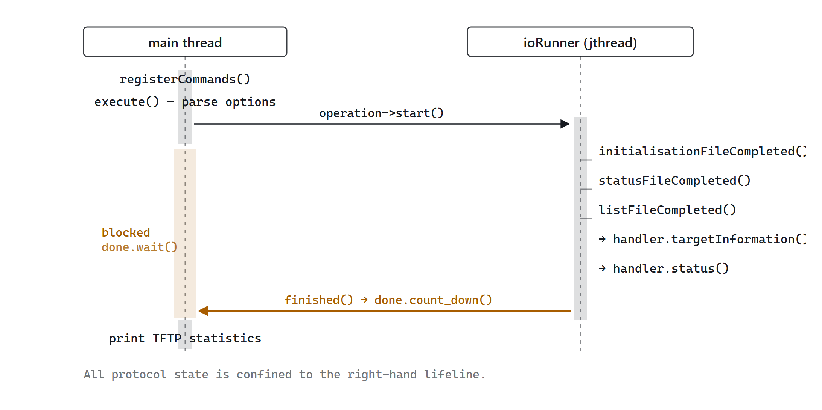
Once start() hands off, the main thread contributes nothing until the latch releases. Every box on the right runs on the single I/O thread, serialised by the io_context.
CONSEQUENCE
Because done is a std::latch initialised to 1, a second call to the command's finished() decrements it below zero, which is undefined behaviour. Nothing in OperationImpl::finished() guards against being called twice. §19 documents two concrete paths that reach it twice.

Signal handling
SIGINT and SIGTERM are handled asynchronously on the same io_context via boost::asio::signal_set. The handler is re-armed after each delivery, and uses a function-local static bool abortIndicator to escalate: the first signal raises abortSignal (graceful protocol abort), any subsequent signal raises terminateSignal (immediate teardown). Both are boost::signals2::signal<void()>, and each command connects its own operation's abort/terminate to them with a scoped_connection so the wiring dies with the command invocation.

04 — ENTRY POINT

main(), line by line
The entry point is 74 lines with three nested exception frames. Its job is narrow: set log levels, build a registry, start an I/O thread, hand the argument vector to the dispatcher, then unwind cleanly.
int main( int argc, char *argv[] )
arinc_615a_operation.cpp:76
Wrapped in a function-try-block whose handler prints "Very bad exception" — this catches throws from the initialisation of function-local statics and from the inner handlers themselves.
01 Log levels. Nine separate setLogLevel() calls, one per library — spdlog, Arinc615aCommands, Arinc615a, Tftp, Arinc665Commands, Arinc665, Arinc649, Commands, Helper. Each library owns a private spdlog level; setting one does not set the others. All start at warn.
02 Banner. Prints "ARINC 615A Operation - {version}" from Arinc615a::Version::VersionInformation, a generated header.
03 Registry.Commands::CommandRegistry::instance() returns a shared pointer to the command table.
04 I/O primitives. Constructs io_context, a signal_set bound to SIGINT and SIGTERM, and the two AbortTerminateSignal objects.
05 Command registration.Arinc615aCommands::registerCommands(...) then Arinc665Commands::registerCommands(registry). The second call adds the ARINC 665 media-set management commands that appear in the same CLI.
06 Arm signals.signals.async_wait(...) with a bind_front onto signalHandler, capturing the signal set by reference so the handler can re-arm itself.
07 Start I/O. A std::jthread running ioContext.run(). Note there is no work_guard — run() stays alive only because the signal_set has a pending async operation.
08 Dispatch.Commands::Utils_commandLineHandler( registry )( argc, argv ) — blocking, returns the process exit code.
09 Teardown.signals.cancel(), ioContext.stop(), ioRunner.join(), then return result.
The inner try has three handlers: boost::exception and std::exception both print via boost::diagnostic_information(), and a catch-all prints "Unknown exception occurred". All three return EXIT_FAILURE.
static void signalHandler( signal_set&, abortSignal, terminateSignal, error_code, int )
arinc_615a_operation.cpp:151
Returns immediately if the error code is operation_aborted — that is the normal teardown path from signals.cancel(). Otherwise it logs which signal arrived, re-arms itself with another async_wait, and then escalates.
Escalation uses a function-local static bool abortIndicator{ false }. First signal: prints "Abort request from user", calls abortSignal(), sets the flag. Every subsequent signal: prints "Terminate request from user", calls terminateSignal().
DESIGN INTENT
Abort is protocol-level: the host stops initiating and sends an ARINC 615A ABORT error message the next time the target opens a status transfer, letting the target close out cleanly with a final status file. Terminate is immediate: it fabricates a final status locally and releases the latch. One Ctrl-C is polite; two is not.

05 — REGISTRATION

How a name becomes a handler
Registration is a two-level fan-out. Arinc615aCommands::registerCommands() delegates to two namespace-level functions, each of which constructs command objects and binds two member functions per command into the registry.
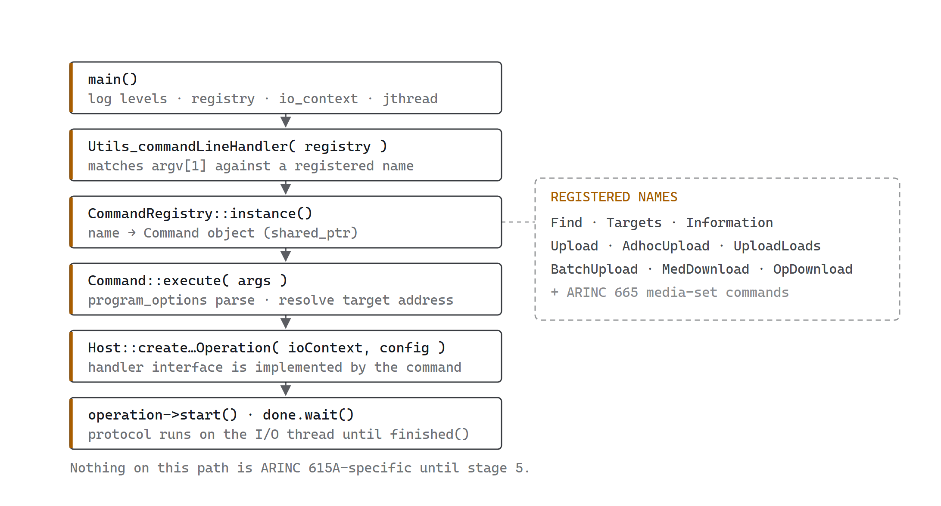
The dispatch path. Stages 1–4 are generic Commands machinery shared with the ARINC 665 sub-commands; the protocol only appears at stage 5, where the command hands itself to the operation factory as the handler.
void Arinc615aCommands::registerCommands( registry, ioContext, abortSignal, terminateSignal )
Arinc615aCommands.cpp:23
Two calls, nothing else: Targets::registerCommands(...) for the discovery commands and Operations::registerCommands(...) for the protocol operations. All four arguments are forwarded unchanged.
void Targets::registerCommands( … )
targets/Targets.cpp:22
Constructs FindQueryCommand and ListTargetsCommand as shared_ptrs, then registers each with registry->command( name, description, executeFn, helpFn ). The two function objects are std::bind_front( &T::execute, ptr ) and std::bind_front( &T::help, ptr ) — the shared_ptr is copied into the binder, so the command object outlives this function and lives as long as the registry.
Registered names: Find, Targets.
void Operations::registerCommands( … )
operations/Operations.cpp:27
The same pattern, seven times over. Registered names in order: Information, Upload, AdhocUpload, UploadLoads, BatchUpload, MedDownload, OpDownload.
Every command object is constructed eagerly, at startup, whether or not it will be used. Each constructor builds a full boost::program_options::options_description. That is why running any sub-command pays the cost of building all nine option tables.
shared_ptr<option_description> Arinc615aCommands::targetAddress( address*, bool defaultIsBroadcast )
Arinc615aCommands.cpp:34
Factory for the shared --target-address,-a option. Builds a value_semantic bound to the caller's address variable, marks it required(), and — when defaultIsBroadcast is true — defaults it to address_v4::broadcast(). Only FindQueryCommand passes true.
The other commands do not use this factory; they declare target-address inline and without required(), because the address may instead be resolved from a targets-list JSON file. See §7.

The dispatcher itself
Commands::Utils_commandLineHandler() lives in the external commands dependency and is not part of this repository. What it does is inferable from the registry API and the documentation: it reads a command-selection argument, looks the name up in the registry, and invokes the bound execute with the remaining arguments as a Commands::Parameters (a string vector). --help routes to the bound help instead.
DOCUMENTATION CONFLICT
The repository disagrees with itself on the selection flag. app/arinc_615a_operation/arinc_615a_operation.adoc documents -c|--command=<Name>; every manpage under doc/arinc_615a_manpage/ documents --operation=<Name>. Only one can be right, and the deciding code is in the fetched commands library. Confirm against --help on your built binary before scripting around either form — §21 shows how.

06 — CATALOGUE

The nine commands
Seven perform protocol operations against a target; two are local utilities. The Initiates column names the protocol file the host reads first, which is what actually selects the operation on the target side.
NAME | CLASS | INITIATES | PURPOSE
Find | FindQueryCommand | UDP 1001 | Broadcast discovery of targets on the network
Targets | ListTargetsCommand | — | Reads a saved targets JSON and prints it; no network
Information | InformationOperationCommand | .LCI | Reads the Load Configuration List — part numbers, serials
Upload | UploadOperationCommand | .LUI | Uploads loads from a registered ARINC 665 media set manager
AdhocUpload | AdhocUploadOperationCommand | .LUI | Uploads from raw media source directories, no manager needed
UploadLoads | UploadLoadsOperationCommand | .LUI | Uploads loads addressed by load-header file path
BatchUpload | BatchUploadOperationCommand | .LUI | Drives an ARINC 665 batch file across multiple targets
MedDownload | MediaDefinedDownloadOperationCommand | .LND | Download where the host names the files it wants
OpDownload | OperatorDefinedDownloadOperationCommand | .LNO | Download where the target advertises a list first

The Arinc665Commands::registerCommands() call in main() adds more names to the same binary — Create, ImportMediaSet, ImportMediaSetXml, ListBatches, ListLoads, ListMediaSets, RemoveMediaSet — which manage the media set store that Upload and BatchUpload read from. They belong to the arinc_665 dependency and are outside this document.

07 — SKELETON

The shape every command shares
All seven protocol commands are built to one template. Learning it once means §10 through §13 only have to describe what differs.

Constructor — build the option table
Each constructor stores references to ioContext, abortSignal, terminateSignal, then assembles optionsDescriptionV in a fixed order:
01 --log-level,-l with a notifier lambda that calls setLogLevel on every library at once. This is the only way to raise verbosity across all layers from the command line.
02 optionsDescriptionV.add( configurationV.options() ) — splices in the whole Arinc615aConfiguration option group, which itself splices in the TFTP and TFTP-option groups. §19 lists the fields these expose.
03 Target addressing: --target-address,-a, --targets-list,-l, --target-id,-i (required).
04 --dlp-timeout, defaulting to DefaultArinc615aDlpTimeout = 13 s, with a notifier that converts the integer to std::chrono::seconds.
05 --port-option, a bool_switch enabling the ARINC 615A-3 Port Option.
06 Command-specific options — media set paths, load headers, download directories.
CONFIRMED DEFECT — AFFECTS ALL NINE COMMANDS
The short flag -l is declared twice in every command: once for log-level,l and once for targets-list,l. Eighteen sites across nine files, e.g. InformationOperationCommand.cpp:58 and :80. Boost.Program_options cannot disambiguate; -l is unusable and the long forms must be spelled out. Fix by renaming the second to a free letter — targets-list,T is unclaimed. See §22.

execute() — seven steps
01 Parse.command_line_parser( parameters ).options( optionsDescriptionV ).run() into a variables_map, then notify() to fire the notifiers and enforce required().
02 Resolve the address. If --targets-list was given, read the JSON with read_json, convert it with TargetInformation::targetsAddressInformation(), index it by Target ID via TargetsAddressInformationMap_fromTargetsAddressInformation(), and look up targetIdV. A hit overwrites targetAddressV. A miss leaves whatever --target-address supplied.
03 Guard. If targetAddressV.is_unspecified(), throw program_options::error{ "Target IP address invalid, not provided, or not in target list." }.
04 Build the operation.Protocol::instance( ioContextV ), then the matching factory method with a designated-initialiser configuration struct carrying dataLoaderConfiguration, handler = *this, targetAddress, targetId, dlpTimeout, portOption.
05 Wire signals. Two boost::signals2::scoped_connection objects bind abort and terminate with AbortReason::Operator pre-bound. They disconnect when execute() returns.
06 Run and block.operationV->start(), then done.wait().
07 Report. Print Tftp::Packets::PacketStatistic::globalReceive() and globalTransmit().
The catch chain re-throws program_options::error so the dispatcher can print usage, and swallows everything else after printing to stderr. Note the consequence: a failed operation still returns success unless the parse failed — the process exit code does not reflect protocol outcome. If you are scripting these commands, parse the printed final status code instead.

The handler interface
Each command privately inherits the matching handler interface — InformationOperationHandler, UploadOperationHandler, and so on — and passes *this as the handler. The overrides are the console output layer. All of them run on the I/O thread.
OVERRIDE | WHEN IT FIRES | PRESENT ON
initialisationDeferred(s) | Target answered the init read with a WAIT error | all operations
initialisationResponse(r) | Init file decoded; carries accept / deny / unsupported | all operations
status(s) | Each status file the target writes to the host | all operations
finished(code, desc) | Terminal — counts down the latch | all operations
targetInformation(t, ok) | Load Configuration List decoded | Information
fileRequest(…) | Target asks for a data file | Upload, both downloads
downloadingList(files) | Target advertised its downloadable files | OpDownload

08 — FIND

Discovery: one broadcast, N answers
FIND is the only operation that does not use TFTP. It is a single UDP broadcast on port 1001 followed by a fixed listening window, default three seconds. Every target that answers is printed and optionally appended to a JSON file that the other commands can then use to resolve Target IDs to addresses.

Packet format
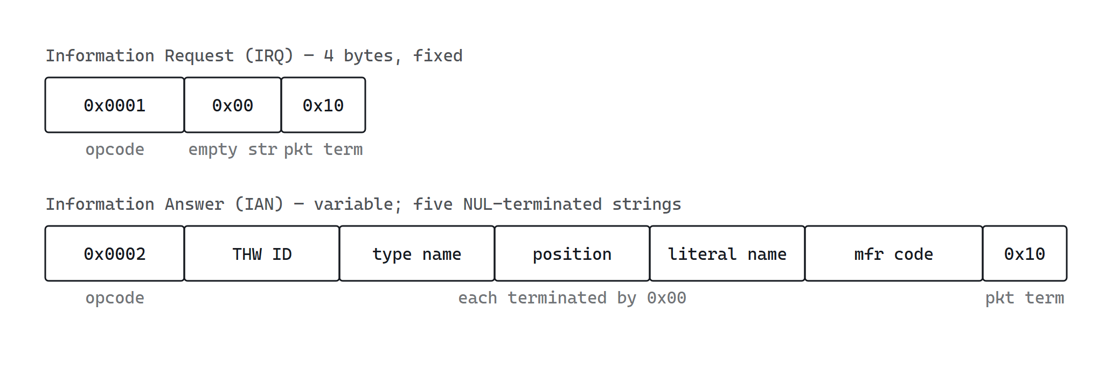
Both packet forms carry a 16-bit opcode, one or more NUL-terminated strings, and a single 0x10 packet terminator. Constants live at find/packets/Packet.hpp:72–78; the parameter order is fixed by the ParameterList enum at find/packets/Packets.hpp:58.

Call sequence
void FindQueryCommand::execute( const Commands::Parameters& )
targets/FindQueryCommand.cpp:84
Diverges from the §7 skeleton because there is no Target ID and no host TFTP server.
01 Parse options into a variables_map and notify().
02 Find::Clients::Client::instance( ioContextV ) then client->query() — a ClientImpl that exists only to hand back a QueryImpl.
03 Connect both abort and terminate signals to the same slot, Query::abort. FIND has no graceful mode — the distinction collapses.
04 Configure by fluent chain: responseHandler, completionHandler, localAddress, remoteAddress, port, dynamicLocalPort, timeout.
05 query->start(), then done.wait().
06 If --targets-list was given and at least one target answered, serialise targetsV with write_json.
void QueryImpl::start()
find/clients/implementation/QueryImpl.cpp:83
Opens the UDP socket, sets SO_BROADCAST, and binds to localAddressV. The local port is 0 when --dynamic-port is set, otherwise the same 1001 as the destination — binding the well-known port locally is what lets a target reply to a fixed source port.
Then, in order: send( remote, Packet{ Opcode::InformationRequest, 1U } ) — a packet with exactly one empty parameter, which encodes to the four fixed bytes above; receive() to arm the first async read; timerV.expires_after( timeoutV ) and async_wait onto timerHandler.
A boost::system::system_error from any socket call invokes the completion handler and rethrows as FindClientException — so a bind failure still releases the latch rather than hanging the CLI.
void QueryImpl::receiveHandler( const error_code&, size_t bytesTransferred )
find/clients/implementation/QueryImpl.cpp:203
Returns silently on operation_aborted. Logs and continues on any other error. On success, forwards the received span to PacketHandler::packet(), then unconditionally re-arms receive(). The listening window is bounded by the timer alone, never by packet count — which is what allows N targets to answer one broadcast.
void PacketHandler::packet( const udp::endpoint&, ConstRawDataSpan )
find/packets/PacketHandler.cpp:23
The dispatch point. Calls Packet::packetType() to peek the opcode without full decoding, then switches: InformationRequest → informationRequestPacket(), InformationAnswer → informationAnswerPacket(), anything else → invalidPacket(). Each branch constructs a full Packet inside a try; an InvalidFindPacket throw is caught, counted as invalid in the statistics, and rerouted to invalidPacket().
Every branch updates PacketStatistic::globalReceive() — the counters the CLI does not print for FIND, though it does for TFTP.
Packet::Packet( Helper::ConstRawDataSpan rawPacket )
find/packets/Packet.cpp:67
The decoding constructor. Four validation gates, each throwing InvalidFindPacket with a distinct message:
• Size must exceed 2 bytes — "Packet to small".
• Last byte must equal PacketTerminator (0x10) — "Packet is not terminated by packet terminator". The terminator is then trimmed off.
• Opcode must be 1 or 2 — "Invalid opcode".
• The remaining bytes are split on '\0'; a segment with no terminator throws "String Terminator missing". At least one parameter must result — "Packet must contain at least one (empty) parameter".
void QueryImpl::informationAnswerPacket( const udp::endpoint& remote, const Packet& answer )
find/clients/implementation/QueryImpl.cpp:233
Rejects any answer whose parameter count is not exactly ParameterList::Last (5), logging "invalid number of parameters" and returning — a five-field contract with no tolerance for extension. Otherwise builds a TargetInformation by indexing the parameters in enum order and invokes responseHandlerV.
void FindQueryCommand::response( const address&, const TargetInformation& )
targets/FindQueryCommand.cpp:150
Prints the six fields — THW ID, type name, position, literal name, manufacturer code, and the derived Target ID — then appends the pair to targetsV. There is no de-duplication: a target that answers twice appears twice in the printout and twice in the saved JSON.
void QueryImpl::timerHandler( const error_code& )
find/clients/implementation/QueryImpl.cpp:168
The normal exit. Returns on operation_aborted. Otherwise cancels and closes the socket, then calls completionHandlerV() → FindQueryCommand::finishedFind() → done.count_down().
LATENT DOUBLE-RELEASE
timerHandler() and abort() both call completionHandlerV() unconditionally, and neither sets a guard flag. The common orderings are safe because each cancels the other's pending operation, but a Ctrl-C that lands after the timer has already fired reaches abort() on a latch that is already at zero — count_down() below zero is undefined behaviour. A bool completedV checked in both is the minimal fix.

Target ID construction
TargetInformation::targetId() at find/TargetInformation.cpp:150 returns TargetId{ thwId, thwPosition } — the ID used for every protocol filename in every other operation. Its validation rules, from TargetId.cpp and TargetId.hpp:39–48, are worth knowing because they constrain what your hardware may report:
FIELD | LENGTH | CHARACTER SET | SOURCE
THW ID | 4 … 15 | alphanumeric only, C locale | TargetId.hpp:39,42
Position | 0 … 8 | alphanumeric only, C locale | TargetId.hpp:45,48
Separator | 1 | first _ in the string splits the two | TargetId.cpp splitTargetId

So ABCDEF_123 is a valid Target ID and yields protocol filenames like ABCDEF_123.LCI. A THW ID with a hyphen, a space, or fewer than four characters fails isCompliant() and every protocol filename built from it will be rejected by the host's own checkRequest(). §19 covers what to do when your hardware does not follow this.

09 — OPERATION BASE

OperationImpl: the shared state machine
Every TFTP-based operation derives from Arinc615a::Host::OperationImpl. It owns the TFTP client, the TFTP server, the DLP timeout timer, the abort state, and the protocol file logger — and it implements the initialisation handshake that all four operations begin with. The derived classes supply only start(), tftpRequest(), and their own file handling.
The asymmetry to hold onto: the host is a TFTP client when it reads the initialisation file and writes request files, and a TFTP server for everything the target pushes back — status files, list files, and data files. Both run simultaneously.
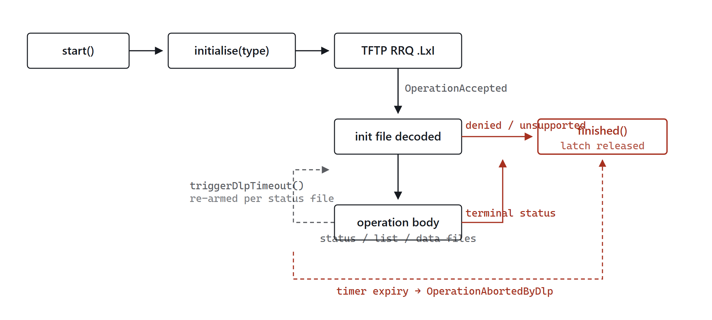
Initialisation is a gate: the operation body is only entered on OperationAccepted. Once inside, the DLP watchdog is re-armed by every status file, and its expiry is the only unconditional exit.
OperationImpl::OperationImpl( ioContext, configuration, handler, targetAddress, targetId, dlpTimeout, portOption )
host/implementation/OperationImpl.cpp:50
Stores all six parameters as const members, constructs a TFTP client and server from the shared io_context, and constructs the timer. The one active step is configuring the server:
( *tftpServerV )
.serverAddress( { configurationV.localInterfaceAddress,
portOptionV ? 0U : configurationV.tftpConfiguration.tftpServerPort } )
.requestHandler( std::bind_front( &OperationImpl::receivedTftpRequest, this ) );
Port 0 when the Port Option is enabled — the OS picks an ephemeral port, whose actual value is read back later via tftpServerV->localEndpoint().port() and advertised to the target inside the TFTP option set. That is the whole mechanism of the ARINC 615A-3 Port Option.
void OperationImpl::initialise( Files::ProtocolFileType fileType )
host/implementation/OperationImpl.cpp:249
Starts the operation proper. In order: tftpServerV->start() so the host is listening before it asks for anything; allocate a MemoryFile as the sink; create a TFTP read operation; configure it by fluent chain; call request(); bump ProtocolFileStatistic::globalReceive().
The configuration chain is where the whole Arinc615aConfiguration reaches the wire — tftpTimeout, tftpRetries, dally, optionsConfiguration, dlpRetries, the three handlers, the filename from protocolFilename( fileType ), the port option, and the remote endpoint built from targetAddress() and tftpServerPort.
Catches Arinc615aException and only logs it. Note what that means: an exception here leaves the operation with no pending work and no finished() call, so the CLI blocks on the latch until the DLP timer fires.
void OperationImpl::initialisationFileCompleted( fileType, MemoryFilePtr, TransferStatus )
host/implementation/OperationImpl.cpp:376
The gate in the diagram above. Resets initialisationOperationV, then:
01 Any status other than Successful → finished( OperationAbortedByDlp, "Initialisation File could not be received" ).
02 Log the raw bytes through the protocol file logger, then decode as Files::InitializationFile.
03 Invoke handlerV.initialisationResponse( initFile.response() ) — this is what prints the initialisation code to the console.
04 Switch on the acceptance code:
• OperationAccepted → store protocolVersionV from the file, then triggerDlpTimeout(). Every protocol file the host writes afterwards uses this version.
• OperationDenied / OperationNotSupported → finished() with that code and the target's description.
• anything else → finished( OperationAbortedByDlp, "unknown status code" ).
A decode failure is caught and mapped to finished( OperationAbortedByDlp, "Initialisation File could not be received" ).
bool OperationImpl::initialisationFileOptionsNegotiation( const Arinc615aOptions& )
host/implementation/OperationImpl.cpp:342
Strict validation of what the target echoed back. Returns false — which aborts the transfer — in four cases: a checksum option arrived when none was requested; a port option arrived when --port-option was off; the echoed port differs from the host's actual listening port; or the host requested the port option and the target did not echo it at all.
That last case logs "Port option not accepted - Operation must be restarted with default port", which is the actionable message: rerun without --port-option against targets that predate ARINC 615A-3.
void OperationImpl::triggerDlpTimeout( seconds exceptionTime = 0s )
host/implementation/OperationImpl.cpp:149
One line of policy: timerV.expires_after( std::max( exceptionTime, dlpTimeoutV ) ), then re-arm timerHandler. The target's advertised exception timer can only ever extend the window, never shorten it below the configured --dlp-timeout. Calling expires_after on a pending timer cancels it, which is what makes each status file reset the watchdog.
void OperationImpl::timerHandler( const error_code& )
host/implementation/OperationImpl.cpp:312
Returns on operation_aborted (the re-arm path). A genuine timer error yields finished( OperationAbortedByDlp, "Internal timer error" ). Expiry yields finished( OperationAbortedByDlp, "DLP Timeout" ).
Carries a //! @todo cancel active transfers. In-flight TFTP transfers are not cancelled on DLP timeout; the server is stopped by finished(), but individual operations unwind on their own schedule.
bool OperationImpl::isAborted( const udp::endpoint& remote )
host/implementation/OperationImpl.cpp:186
Called at the top of every status-file request handler — the designated moment to inject an abort. Returns false immediately if abortReasonV == NoAbort. Otherwise it maps the reason to a status code (Operator → OperationAbortedByOperator, Protocol → OperationAbortedByDlp), sends it via tftpServerV->abortOperation( remote, statusCode ), resets abortReasonV to NoAbort, re-arms the DLP timeout, and returns true.
The reset is deliberate: the abort is delivered exactly once, and the host then waits for the target to close the operation with its own final status file. That is why a single Ctrl-C does not end the process immediately.
bool OperationImpl::checkRequest( string_view filename, const udp::endpoint& remote )
host/implementation/OperationImpl.cpp:228
The host's only authorisation check. If the filename parses as a protocol filename and its embedded Target ID differs from this operation's, the request is refused with TFTP error FileNotFound and the message "Wrong target ID for protocol file". Non-protocol filenames — data files during upload and download — pass through unchecked.
void OperationImpl::finished( StatusCode status, string_view description = {} )
host/implementation/OperationImpl.cpp:159
Three statements: handlerV.finished( status, description ), timerV.cancel(), tftpServerV->stop(). No idempotence guard, no state check. Every re-entry counts the command's latch down again. §22 lists the two confirmed paths that reach it twice.
void OperationImpl::doAbort( AbortReason ) · void doTerminate( AbortReason )
host/implementation/OperationImpl.cpp:77, 96
doAbort is idempotent — it returns early if abortReasonV != NoAbort. It records the reason and, if the initialisation read is still in flight, calls gracefulAbort() on it. It does not call finished(); delivery is deferred to the next isAborted() check.
doTerminate has no such guard. It aborts the initialisation transfer if present, maps the reason to a status code, and calls finished() directly. Two SIGINTs in quick succession therefore reach finished() twice.
string OperationImpl::protocolFilename( ProtocolFileType ) const
host/implementation/OperationImpl.cpp:171
static_cast<std::string>( Files::ProtocolFilename{ targetIdV, fileType } ) — the single place protocol filenames are built. See §14 for the extension table.

10 — INFORMATION

Information: the reference operation
The simplest complete operation, and the one to understand first — the other three are variations on its structure. The host reads .LCI, the target pushes back .LCL (the Load Configuration List) and zero or more .LCS status files, and the host prints the target's part numbers.
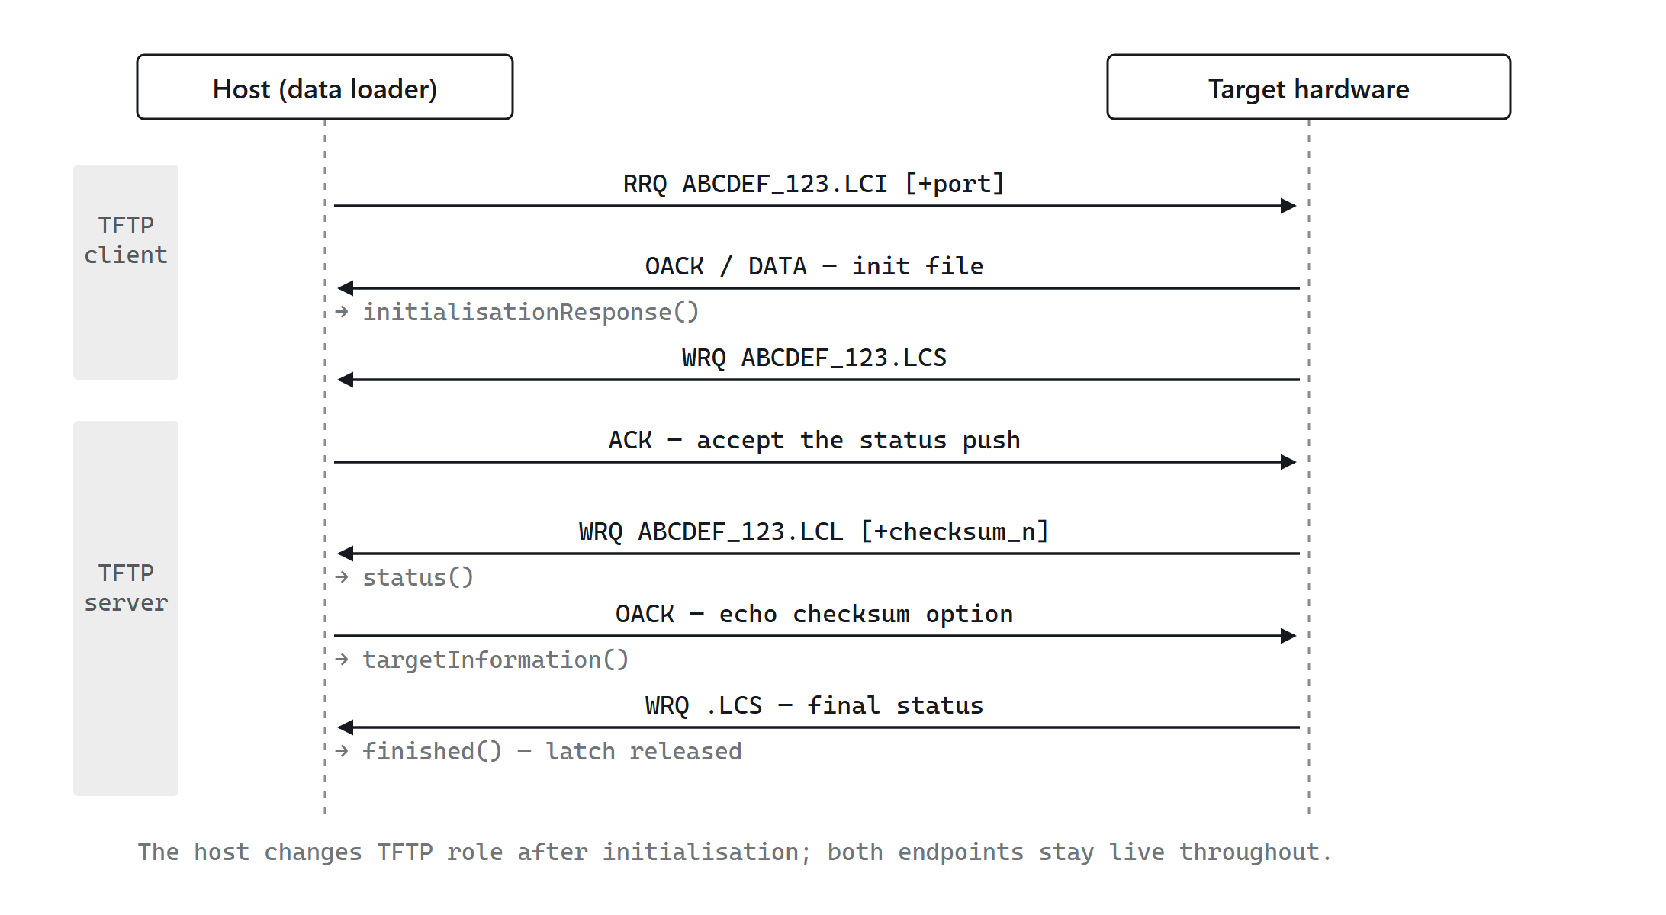
The host initiates exactly one transfer — the .LCI read. Everything after that is the target pushing files to the host TFTP server, which is why the server is started before the read is issued.
ORDERING IS NOT GUARANTEED
A conforming target may send the .LCL with no status file at all, or bracket it with status files. The implementation handles both through the waitForFinalStatusV flag described below — do not assume the sequence above is the only legal one.
void InformationOperationImpl::start()
host/implementation/InformationOperationImpl.cpp:70
Two statements: clear waitForFinalStatusV, then initialise( ProtocolFileType::LoadConfigurationInitialization ). The file type is the only thing that distinguishes this operation from the other three at startup.
void InformationOperationImpl::tftpRequest( remote, requestType, filename, tftpOptions, arinc615aOptions )
host/implementation/InformationOperationImpl.cpp:87
The inbound router. Parses the filename into a ProtocolFilename, runs checkRequest() and returns on failure, rejects non-write requests, then switches on file type: LoadConfigurationList → listFileRequest(); LoadConfigurationStatus → statusFileRequest(); anything else → TFTP FileNotFound with "Wrong filename". Each accepted branch bumps ProtocolFileStatistic::globalReceive().
CONFIRMED DEFECT — MISSING RETURN
At InformationOperationImpl.cpp:103–107 the non-Write branch sends IllegalTftpOperation but has no return. Control falls into the file-type switch and a second TFTP operation is created for a request already refused. Compare UploadOperationImpl.cpp:180, where the same check is a switch with proper breaks. Add return; after the errorOperation() call.
void InformationOperationImpl::listFileRequest( remote, tftpOptions, arinc615aOptions )
host/implementation/InformationOperationImpl.cpp:260
Accepts the target's push of the Load Configuration List. If a previous list transfer is still open, it is closed with gracefulAbort( NotDefined, "New list file received" ) — last write wins.
The checksum option is accepted here and nowhere else in this operation: the value is captured, echoed back in negotiatedArinc615aOptions, and bound into the completion handler for verification. Part-number and port options are logged as unexpected and dropped.
A thrown Arinc615aException triggers abort( AbortReason::Protocol ).
void InformationOperationImpl::listFileCompleted( MemoryFilePtr, CheckValue, TransferStatus )
host/implementation/InformationOperationImpl.cpp:319
Where the payload finally becomes console output.
01 On non-success: finished( OperationAbortedByDlp, "Invalid Protocol file" ) if no status file has been seen, otherwise abort( Protocol ) and let the target close out.
02 Integrity check. Build an Arinc649::CheckValueGenerator for the negotiated type, run it over the received bytes, compare to the advertised value. A mismatch sets integrityInformation = false and logs a warning — it does not abort.
03 Log the raw file, decode as Files::LoadConfigurationListFile.
04 Warn if the file's protocol version differs from the one latched at initialisation. Warning only.
05 handlerV.targetInformation( listFile.targetsHardware(), integrityInformation ) — the command prints Information Integrity: Valid|Invalid and then each target hardware block.
06 If no status file was ever received, finished( OperationCompleted ). Otherwise triggerDlpTimeout() and wait for the target's final status.
WORTH KNOWING
A checksum mismatch surfaces only as the word Invalid on one console line and a warning in the log. The exit code is unaffected and the part numbers are printed regardless. If integrity matters in your workflow, key on that line explicitly.
void InformationOperationImpl::statusFileRequest( remote, tftpOptions, arinc615aOptions )
host/implementation/InformationOperationImpl.cpp:135
Calls isAborted( remote ) first and returns if it fired — this is the abort injection point. Otherwise logs any unexpected ARINC 615A options, creates a TFTP server write operation, and pushes it onto statusFileOperationsV, a std::forward_list that allows concurrent status transfers.
void InformationOperationImpl::statusFileCompleted( MemoryFilePtr, WriteOperationPtr, TransferStatus )
host/implementation/InformationOperationImpl.cpp:180
Removes the operation from the list; if it was not found, calls finished() and returns — this is the correct form of the pattern that is broken in the upload and download variants (§22).
Decodes as Files::InformationOperationStatusFile, warns on version mismatch, invokes handlerV.status(), then dispatches on the status code:
STATUS CODE | ACTION
OperationAccepted | set waitForFinalStatusV, re-arm DLP timeout
OperationInProgress  …AdditionalInfo | set waitForFinalStatusV, re-arm with the file's exception timer
OperationCompleted | finished() — terminal
OperationNotAccepted  OperationNotSupported  …AbortedByTargetHw  …AbortedByDlp  …AbortedByOperator | finished() with that code — terminal
anything else | warn, finished( OperationAbortedByDlp )

The exception timer is honoured only for the two in-progress codes. That is the mechanism by which a target performing a long internal operation keeps the host from timing out.

Console output path
Four overrides in InformationOperationCommand produce everything the user sees, all on the I/O thread:
• initialisationDeferred — :209 — prints the WAIT duration.
• initialisationResponse — :214 — prints the initialisation code and description.
• status — :237 — prints counter, code, description, exception timer, estimated time.
• targetInformation — :255 — prints the integrity verdict, then targetHardware.toString() per entry.
• finished — :225 — prints the final code and description, then done.count_down().

11 — UPLOAD

Upload: host as file server
Upload inverts the data direction. After initialisation the host writes a .LUR request file naming the loads it intends to send, and then serves the target's read requests for the actual load files out of an ARINC 665 media set. The host is a TFTP server for both the status pushes and the data pulls.
The critical detail is when the load list is sent: not at start(), but from inside the status() handler, on the first status file carrying OperationAccepted.
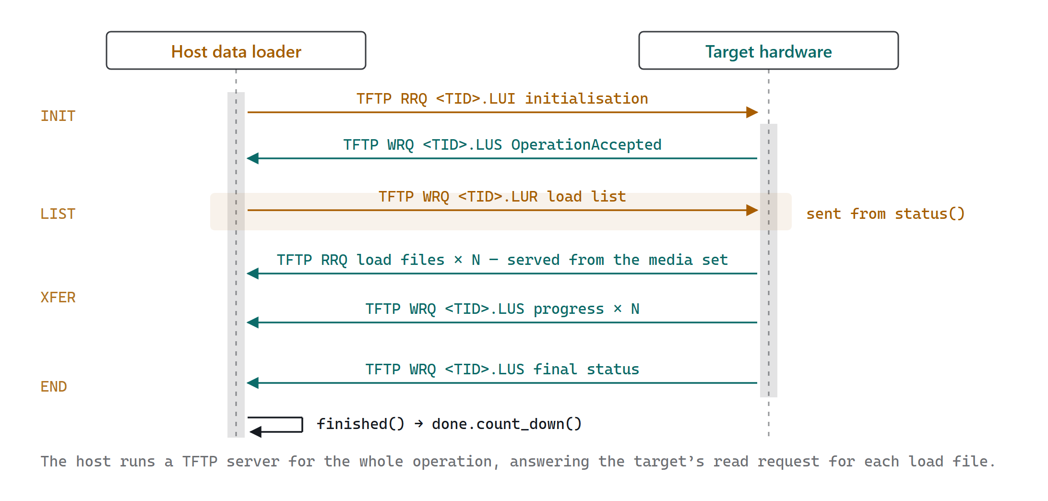
Upload. The one host-initiated transfer is the .LUI read; the .LUR load list follows only after the target has accepted, and every load file afterwards is pulled by the target from the host’s TFTP server.
void UploadOperationCommand::execute( … )
operations/UploadOperationCommand.cpp:158
Follows the §7 skeleton with three extra steps between address resolution and operation construction:
01 Arinc665::Utils::MediaSetManager::load( mediaSetManagerDirectoryV, checkMediaSetManagerIntegrityV, loadProgress ) — opens the media set store, optionally verifying every file. The progress callback prints "Loading: n/N pn medium:total".
02 mediaSetManagerV->mediaSet( mediaSetPartNumberV ); a miss throws program_options::error{ "Media Set '…' does not exist" }. The returned pair yields the media set and its check values, stored in checkValuesV.
03 For each --load-header: mediaSet->first->recursiveLoads( loadHeader ). Zero matches and multiple matches both throw. Survivors are appended to loadsV.
All three failures are program_options::error, so they are re-thrown to the dispatcher and reported as usage errors before any network traffic occurs.
void UploadOperationCommand::status( const Information::UploadStatus& )
operations/UploadOperationCommand.cpp:334
Prints the aggregate status — counter, code, description, list ratio, exception timer, estimated time — then one block per load with its header filename, part number, ratio, and per-load status. Flushes explicitly, because progress output matters here.
Then the trigger:
if ( status.code() == StatusCode::OperationAccepted && !loadListTransmittedV )
{
// build UploadLoads from loadsV
operationV->loadList( std::move( loadsList ) );
loadListTransmittedV = true;
}
Each entry is an Information::UploadLoad holding only headerFilename and partNumber — taken from the ARINC 665 load object, not from anything the user typed. This is the field pair the target matches against; see §19 if your loads are named differently.
void UploadOperationImpl::loadList( Information::UploadLoads loads )
host/implementation/UploadOperationImpl.cpp:88
Guarded by loadListSentV — a second call logs "Load list can be only transmitted once" and returns.
Builds a Files::UploadOperationRequestFile at the latched protocol version, encodes it into a MemoryFile, logs it via the protocol file logger, and issues a TFTP write to <TargetId>.LUR on the target's TFTP port. Completion routes to loadListCompleted(); a failed transfer calls abort( AbortReason::Protocol ).
void UploadOperationImpl::tftpRequest( … )
host/implementation/UploadOperationImpl.cpp:180
Splits on request type rather than filename, which is the structural difference from the Information operation.
• Read — the target pulling a load file. Forwarded straight to handlerV.fileRequest() with the part number and check value extracted from the ARINC 615A options. The host layer creates no TFTP operation itself; the command does.
• Write — only UploadStatus (.LUS) is accepted; everything else is refused with FileNotFound and "Wrong filename".
void UploadOperationCommand::fileRequest( remote, filename, tftpOptions, loadPartNumber, checkValue )
operations/UploadOperationCommand.cpp:391
Resolves and serves one load file.
01 Arinc665::Media::Loads_file( loadsV, checkValuesV, filename, loadPartNumber, checkValue ) — matches on all three of filename, part number, and check value. A miss sends TFTP FileNotFound and returns.
02 mediaSetManagerV->filePath( file ) maps the logical file to a path on disk; a non-regular file also sends FileNotFound.
03 Opens a Tftp::Files::StreamFile in Transmit mode with the known file size — this is what populates the TFTP transfer-size option.
04 operationV->fileTransfer( … ) builds the server read operation with the part number and checksum echoed back as negotiated options, then start().
Concurrent transfers are held in fileOperationsV, a forward_list. Completion removes the entry; a failed transfer logs "File transfer failed - Ignore it from the host side" and does nothing else — the target is expected to report the failure in its own status file, and the per-load status codes in status() are where it surfaces.
Tftp::Servers::ReadOperationPtr UploadOperationImpl::fileTransfer( dataHandler, remote, tftpOptions, partNumber, checkValue )
host/implementation/UploadOperationImpl.cpp:128
Builds but does not start the operation — the caller starts it, so it can attach its own completion handler first. Populates Arinc615aOptions with the part number when non-empty and the check value when its type is not NotUsed. The port option is explicitly never used for data transfers.
void UploadOperationImpl::statusFileCompleted( … )
host/implementation/UploadOperationImpl.cpp:321
Structurally identical to the Information variant, decoding Files::UploadOperationStatusFile and dispatching on the same status-code table — except that OperationAccepted here only re-arms the timer; the waitForFinalStatus concept does not exist in this operation.
CONFIRMED DEFECT — MISSING RETURN
At UploadOperationImpl.cpp:326–330, the "operation completed which was not initiated" branch calls finished() and then falls through into the rest of the function, which may call finished() again. InformationOperationImpl.cpp:189 has the return; this one does not, and neither does DownloadOperationImpl.cpp:162. Two finished() calls means two count_down() on a latch of 1.

The three upload variants
AdhocUpload, UploadLoads, and BatchUpload reuse UploadOperationImpl unchanged. They differ only in how loadsV is populated during execute():
COMMAND | LOAD SOURCE | KEY OPTIONS
Upload | Registered media set manager, load looked up by header name inside a named media set | --media-set-manager-dir  --media-set-pn  --load-header
AdhocUpload | Raw media source directories imported on the fly, no persistent store | --source-directory  --check-file-integrity  --load-header
UploadLoads | Load header addressed directly by filesystem path | --load-header (path)  --check-file-integrity
BatchUpload | ARINC 665 batch file; drives multiple targets, resolving each through the targets list | --batch-file  --targets-list (required)  --media-set-pn

BatchUpload is the only command with no --target-id and no --target-address: targets come from the batch file, and --targets-list is required() because it is the only way to resolve them. It drives operations through Host::BatchUploadOperationProxy.

12 — MEDIA DOWNLOAD

Media Defined Download: host names the files
The host initialises with .LND, writes a .LNR request file listing the filenames it wants plus optional user-defined data, and then receives those files as TFTP writes from the target. DownloadOperationImpl holds the machinery shared with the operator-defined variant; MediaDefinedDownloadOperationImpl adds the request file.
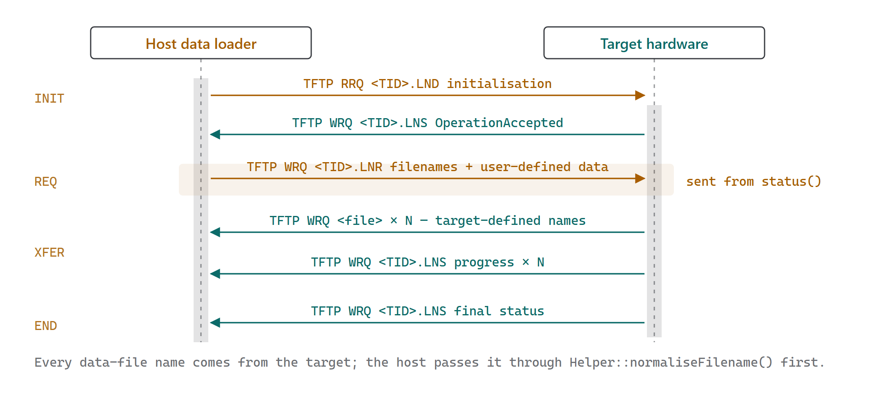
Media Defined Download. Structurally the upload with the data direction reversed: the .LNR request replaces the .LUR load list, and the target writes the files instead of reading them.
void MediaDefinedDownloadOperationImpl::request( DownloadFiles files, RawData userDefinedData )
host/implementation/MediaDefinedDownloadOperationImpl.cpp:106
Guarded by requestSentV. Builds a Files::DownloadOperationRequestFile at the latched protocol version, logs it, and TFTP-writes it to <TargetId>.LNR. Called from the command's status() handler on the first OperationAccepted, exactly mirroring the upload load-list trigger.
The option negotiation handler rejects any ARINC 615A option echoed by the target on this transfer — the request file carries no part number, checksum, or port.
void MediaDefinedDownloadOperationImpl::tftpRequest( … )
host/implementation/MediaDefinedDownloadOperationImpl.cpp:150
Read requests are always wrong here and are refused with IllegalTftpOperation. Write requests split on file type: DownloadStatus (.LNS) goes to statusFileRequest(); everything else is treated as a data file and forwarded to handlerV.fileRequest() with the part number and check value from the options.
That default branch is the important one — downloaded filenames are arbitrary and target-defined, so the router cannot whitelist them.
void MediaDefinedDownloadOperationCommand::fileRequest( remote, filename, tftpOptions, partNumber, checkValue )
operations/MediaDefinedDownloadOperationCommand.cpp:358
Builds the destination path as downloadDataPathV / Helper::normaliseFilename( filename ). The normalisation call is the path-traversal guard — the target supplies this filename, and it is not otherwise validated.
Registers the transfer with downloadInformationV.fileStart(), opens a StreamFile in Receive mode, creates the server write operation via operationV->fileTransfer(), binds a completion handler carrying the filename, path, and expected transfer size, and starts it.
void MediaDefinedDownloadOperationCommand::fileCompleted( filename, filePath, expectedFileSize, operation, status )
operations/MediaDefinedDownloadOperationCommand.cpp:396
On failure, records DownloadInformation::TransferError and returns — the download continues for other files. On success, compares the on-disk size against the TFTP transfer-size option and warns only if they differ, then records TransferOk with the actual size.
A size mismatch does not fail the operation, delete the file, or change the exit code.

Where downloaded files land
Controlled by three options. --download-base-directory sets the root. By default a per-operation sub-directory is created beneath it; --no-download-directory,-n disables that and writes directly into the base. --no-check-validity,-c disables the post-transfer validity check. If --file is given no values, the operation is cancelled after the list transfer rather than downloading anything.

13 — OPERATOR DOWNLOAD

Operator Defined Download: target advertises first
The negotiation runs one step longer. The host initialises with .LNO; the target pushes a .LNL list file advertising what it can provide; the host replies with a .LNA answer file selecting from that list; the selected files then transfer. Everything else matches §12.
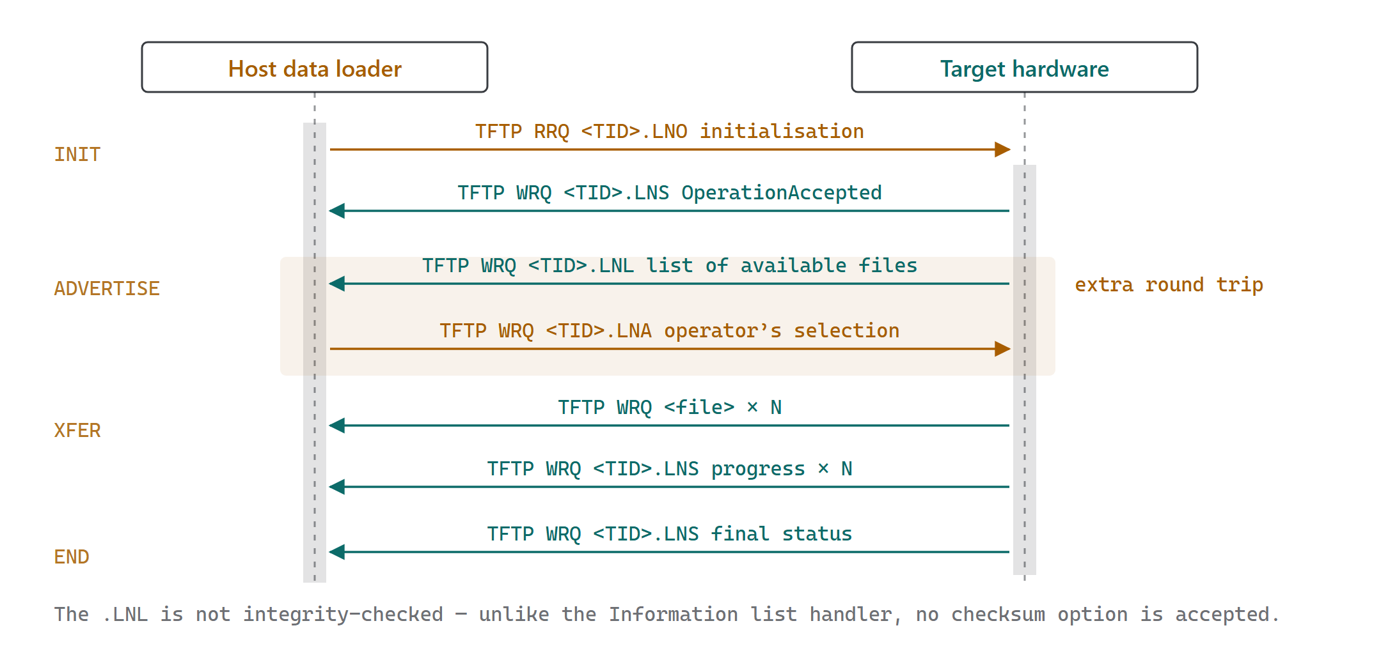
Operator Defined Download. The shaded band is the whole difference from §12 — one extra round trip in which the target advertises with .LNL and the host answers with .LNA.
void OperatorDefinedDownloadOperationImpl::listFileRequest( … ) · listFileCompleted( … )
host/implementation/OperatorDefinedDownloadOperationImpl.cpp:224, 271
listFileRequest closes any in-flight list transfer with gracefulAbort, logs unexpected ARINC 615A options, and accepts the write into a MemoryFile. Unlike the Information operation's list handler, no checksum option is accepted — the .LNL is not integrity-checked.
listFileCompleted decodes a Files::DownloadOperationListFile, warns on version mismatch, and calls handlerV.downloadingList( listFile.files() ). A transfer failure or decode failure both call abort( AbortReason::Protocol ).
void OperatorDefinedDownloadOperationImpl::answer( Information::DownloadFiles files )
host/implementation/OperatorDefinedDownloadOperationImpl.cpp:112
Guarded by answerSentV. Builds a Files::DownloadOperationAnswerFile and TFTP-writes it to <TargetId>.LNA. The command calls this from its downloadingList handler: with --download-all it echoes the whole advertised list, otherwise it intersects the advertisement with the --file values.
Like the media-defined request, the answer transfer rejects any echoed ARINC 615A option.
void OperatorDefinedDownloadOperationImpl::tftpRequest( … )
host/implementation/OperatorDefinedDownloadOperationImpl.cpp:154
Same shape as §12 with one extra case: OperatorDefinedDownloadList routes to listFileRequest(). DownloadStatus routes to the shared status handler; every other filename is a data file.
WriteOperationPtr DownloadOperationImpl::doFileTransfer( … ) · void statusFileCompleted( … )
host/implementation/DownloadOperationImpl.cpp:57, 157
Shared by both download variants. doFileTransfer builds a server write operation with part number and check value echoed as negotiated options. statusFileCompleted decodes Files::DownloadOperationStatusFile and runs the same status-code dispatch table as §10 — including the same missing return at :162 flagged in §22.

14 — PROTOCOL FILES

Protocol file codec
Every ARINC 615A protocol file shares a six-byte header and is built from three primitive encodings: big-endian integers, length-prefixed NUL-terminated strings, and three-character ASCII ratios. All of it lives under lib/arinc_615a/files/.
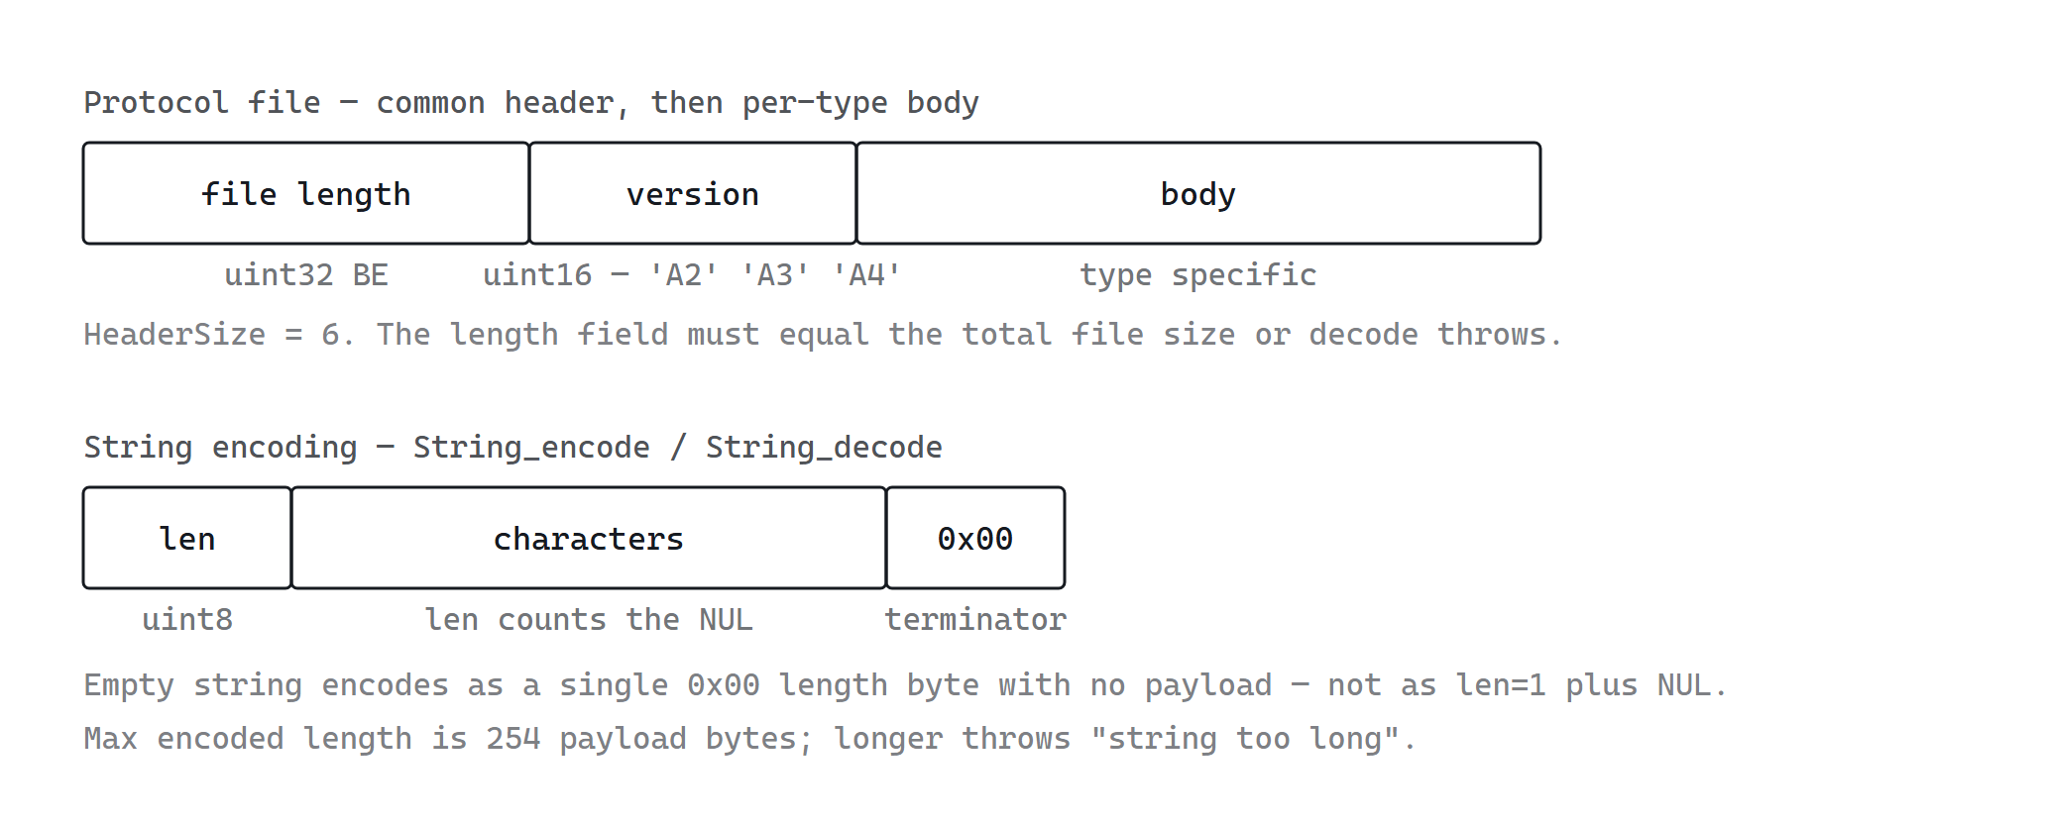
The length field is redundant with the transfer size but is validated strictly, which makes truncated protocol files fail fast rather than decode into garbage.
void ProtocolFile::insertHeader( RawDataSpan ) const · ConstRawDataSpan decodeHeader( ConstRawDataSpan )
files/ProtocolFile.cpp:43, 52
insertHeader is called last by every encode() — the body is built first, then the now-known total length and the version are written into the reserved leading six bytes.
decodeHeader enforces three things and throws Arinc615aException on each: the buffer is at least HeaderSize; the embedded length equals the actual buffer size ("internal length field and data size differs"); the version is one of Arinc615a2 (0x4133) or Arinc615a34 (0x4134). Arinc615a1 (0x4132) is deliberately rejected — supplement 1 protocol files are not supported.
RawData String_encode( string_view, uint8_t fixedLength = 0 ) · tuple<span,string_view> String_decode( ConstRawDataSpan )
files/String.cpp:64, 24
String_encode computes rawStringSize as zero for an empty string, otherwise size() + 1 for the terminator. Throws if that reaches 255 or exceeds fixedLength when one is given. Writes the length byte, then the characters, then forces the final byte to NUL.
String_decode reads the length byte, validates the remaining buffer is long enough ("string length inconsistent"), and for non-zero lengths requires an embedded NUL ("string not NULL terminated"). The returned string is truncated at that NUL — a declared length longer than the actual text is legal, which is exactly the ARINC 615A-2 change noted in the project README.
tuple<span,Ratio> Ratio_decode( ConstRawDataSpan ) · RawData Ratio_encode( const Ratio& )
files/Ratio.cpp
Ratios are three ASCII digits, space-padded via std::format( "{:3}", value ). Decode parses with std::stoul and rejects values above 100. A parse failure becomes Arinc615aException. These carry upload and download completion percentages in status files.

Filename mapping
ProtocolFilename splits on the first ., validates the stem as a Target ID, and maps the extension through a Boost.MultiIndex table at files/ProtocolFilename.cpp:148. Both directions are supported, which is why isProtocolFilename() can reject unknown extensions cheaply.
EXT | PROTOCOLFILETYPE | OPERATION | DIRECTION
LCI | LoadConfigurationInitialization | Information | host reads
LCL | LoadConfigurationList | Information | target writes
LCS | LoadConfigurationStatus | Information | target writes
LUI | UploadInitialization | Upload | host reads
LUR | UploadRequest | Upload | host writes
LUS | UploadStatus | Upload | target writes
LND | MediaDefinedDownloadInitialization | Med download | host reads
LNR | MediaDefinedDownloadRequest | Med download | host writes
LNO | OperatorDefinedDownloadInitialization | Op download | host reads
LNL | OperatorDefinedDownloadList | Op download | target writes
LNA | OperatorDefinedDownloadAnswer | Op download | host writes
LNS | DownloadStatus | both downloads | target writes

File bodies
CLASS | BODY LAYOUT AFTER THE 6-BYTE HEADER
InitializationFile | uint16 acceptance code, then description string
LoadConfigurationListFile | uint16 THW count; per THW: literal name, serial number, uint16 P/N count; per P/N: part number, amendment, part designation
InformationOperationStatusFile | uint16 counter, uint16 status code, uint16 exception timer, int16 estimated time, description string
DownloadOperationRequestFile | uint16 file count, N filename strings, uint8 UDD length, UDD bytes
UploadOperationRequestFile | uint16 load count; per load: header filename, part number
UploadOperationStatusFile | counter, status, ratio, exception timer, estimated time, description, then per-load status blocks

Every decode() ends with a check that no bytes remain ("More data then expected"), so a target sending vendor extensions past the defined fields will have its file rejected outright. §19 covers this if you need to tolerate it.
void ProtocolFileLogger::logProtocolFile( prefix, filename, file )
files/ProtocolFileLogger.cpp
Enabled by --log-protocol-files. Writes every protocol file, in both directions, as a raw binary dump named {ISO-8601 timestamp}_{operation}_{RX|TX}_{protocol filename} into loggingDirectoryV. The directory defaults to the process working directory — the CLI never calls loggingDirectory(), so files land wherever the binary was run.
This is the single most useful diagnostic in the tool. When a target rejects a file or the host rejects a decode, the exact bytes are on disk.
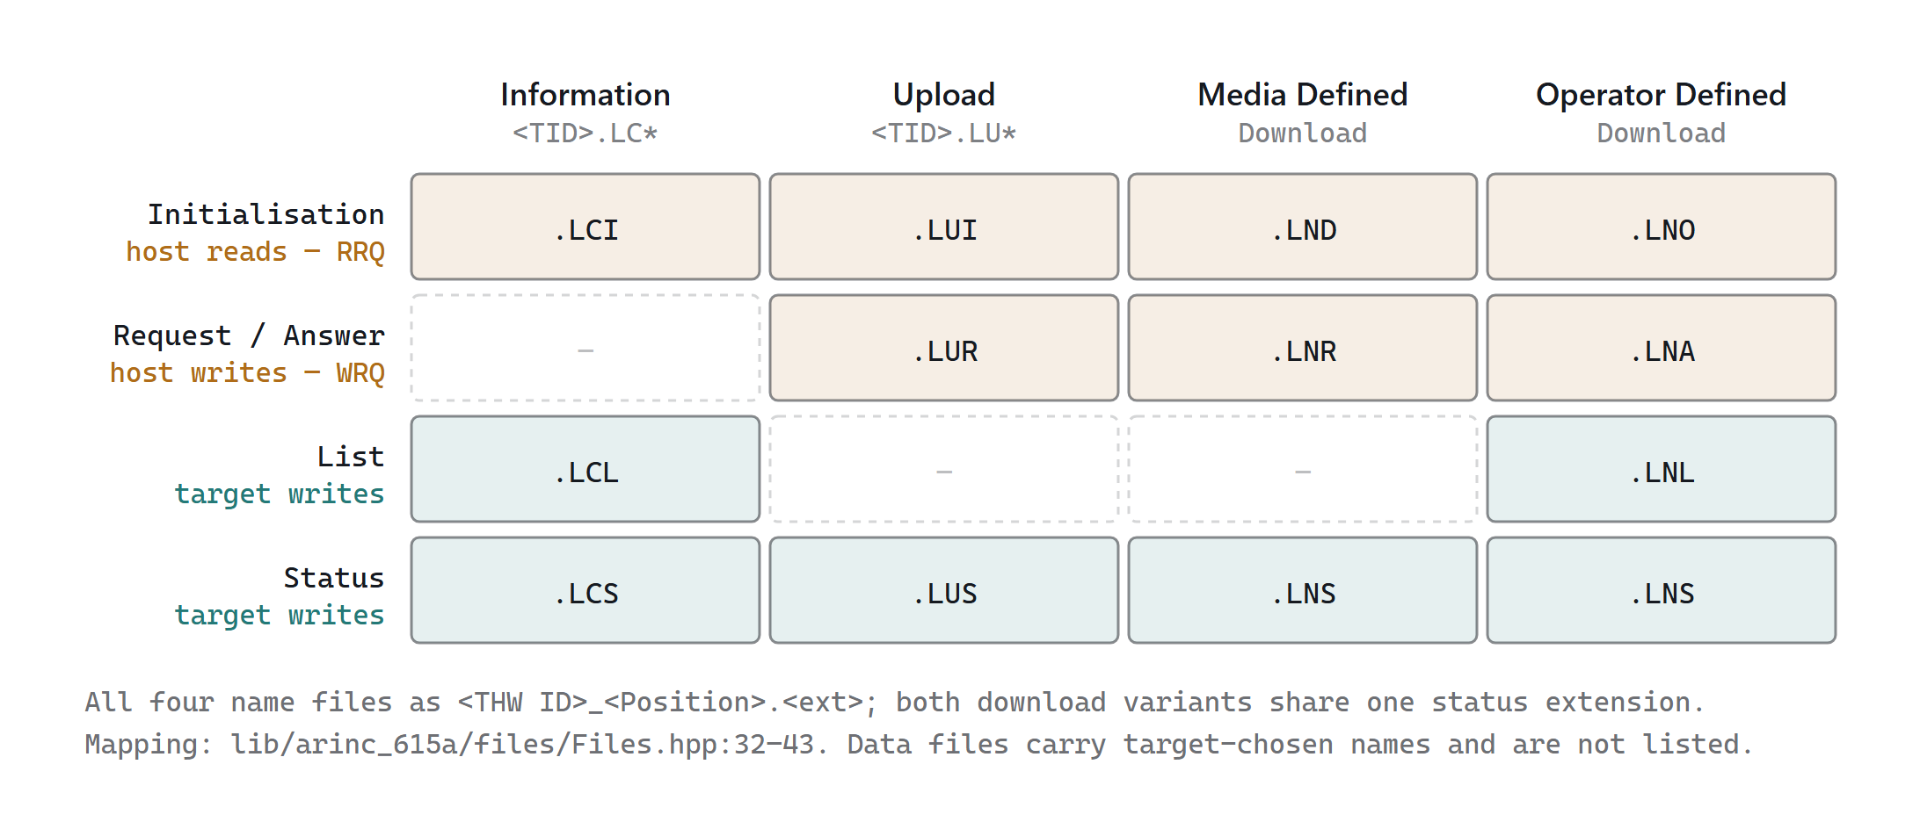
Which protocol file belongs to which operation, and who writes it. Reading a row across shows the four operations are the same state machine over different extensions; reading a column down gives the complete file inventory for one operation.

15 — TFTP LAYER

What ARINC 615A adds to TFTP
lib/arinc_615a/tftp/ is a decorator over the generic tftp dependency. It adds three things and nothing else: extra option names, two overloaded uses of the TFTP error packet, and a retry layer above the TFTP retry layer.

Option names on the wire
Arinc615aOptions_name() at tftp/Arinc615aOptions.cpp is the entire mapping. These strings go into the TFTP option-negotiation fields verbatim:
WIRE NAME | MEANING | CHECK VALUE TYPE
port | ARINC 615A-3 Port Option — host's dynamic TFTP server port | —
part number | Load part number for a data transfer (note the space) | —
checksum_1 | CRC8 | Crc8
checksum_2 | CRC16 | Crc16
checksum_3 | CRC32 | Crc32
checksum_4 | MD5 | Md5
checksum_5 | SHA1 | Sha1
checksum_6 | SHA256 | Sha256
checksum_7 | SHA512 | Sha512
checksum_8 | CRC64 | Crc64

Arinc615aOptions_checksum() extracts whichever checksum option is present, and returns { false, {} } — a negotiation failure — if more than one checksum option appears, or if the value fails to parse into a valid Arinc649::CheckValue. Exactly zero or one is legal.

Error packets carry protocol semantics
ARINC 615A overloads the TFTP error packet, with error code NotDefined and a structured message, to carry two protocol events. ErrorMessage_type() classifies them:
MESSAGE | MEANING | HOST REACTION
WAIT:<seconds> | Target is busy; retry after the stated delay | Arm a timer, call operationDeferredHandler, retry without consuming a retry
ABORT:<4 hex digits> | Target is terminating with this ARINC 615A status code | Map to OperationAbortedByDlp or …ByOperator and complete

ErrorMessage_abort() parses the four hex digits with std::from_chars base 16 and validates the result against the known status codes, returning StatusCode::Invalid for anything unrecognised. ErrorMessage_wait() parses base 10 into a uint16_t and returns std::nullopt on failure. Both are noexcept; malformed messages degrade to "not an ARINC 615A message" rather than throwing.

The DLP retry layer
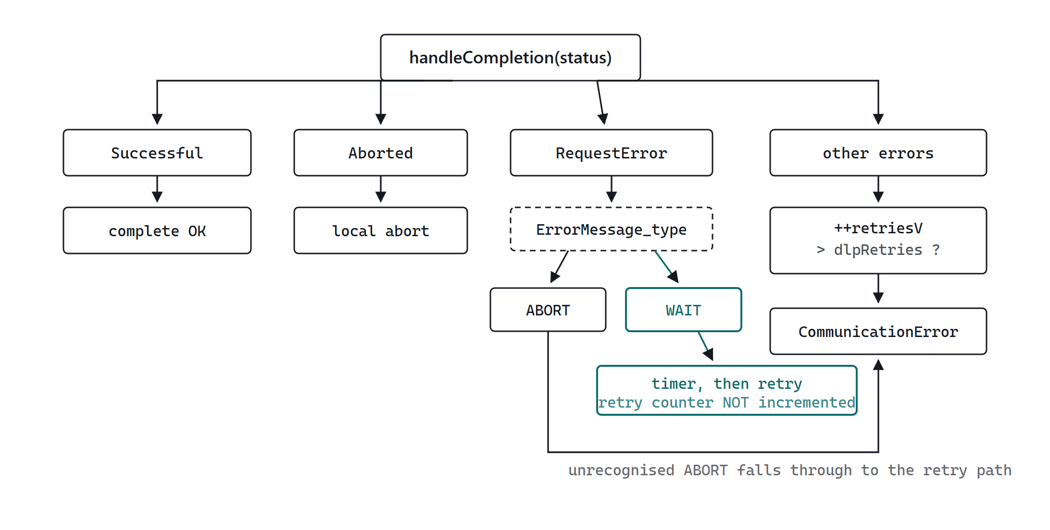
The teal path is what makes WAIT different from every other failure: it re-issues the request after the target's stated delay without spending a retry, so a busy target cannot exhaust the counter.
void Tftp::Clients::OperationImpl::handleCompletion( ::Tftp::TransferStatus status )
tftp/clients/implementation/OperationImpl.cpp:155
The function the diagram describes. Success clears the operation and error information and reports TransferStatus::Successful. Aborted reports a local abort. RequestError is classified as ABORT, WAIT, or neither.
ABORT handling is conditional on handleAbortV, and only two status codes are honoured — OperationAbortedByDlp and OperationAbortedByOperator. Any other abort code logs "Invalid ABORT status code" and falls through to the retry path, which is why the diagram has that long return edge.
Everything that reaches the bottom increments retriesV and re-issues via tftpOperation() until retriesV > dlpRetriesV, at which point it reports CommunicationError.
bool Tftp::Clients::OperationImpl::handleOptionNegotiation( ::Tftp::Packets::Options& serverOptions )
tftp/clients/implementation/OperationImpl.cpp:115
Destructively extracts the ARINC 615A options from the server's option map — port, part number, checksum — leaving only generic TFTP options behind. Anything left over that the generic TFTP layer does not recognise will abort the transfer, which is how unknown options are rejected without an explicit check here.
The assembled Arinc615aOptions is then handed to the operation-specific optionNegotiationHandlerV — the strict validators in §9 and §11.
::Tftp::Clients::OperationPtr ReadOperationImpl::tftpOperation()
tftp/clients/implementation/ReadOperationImpl.cpp
Called once per attempt — including every retry — so each retry rebuilds the underlying TFTP operation from scratch. Assembles additionalOptions from the port, part number, and checksum if set, then configures the real TFTP read with TransferMode::OCTET, the two ARINC 615A handlers, the data sink, and a local endpoint bound to port 0.

16 — TIMEOUT & ABORT

Three timers, two abort modes
Timeouts nest. Understanding which layer fired is most of diagnosing a stalled load.
TIMER | DEFAULT | SCOPE | OPTION
TFTP packet timeout | 2 s | One TFTP packet; retried tftpRetries times | --tftp-timeout
DLP retry | 1 | Whole TFTP transfer, re-issued from scratch | --dlp-retries
DLP timeout | 13 s | Watchdog on the whole operation; re-armed by each status file | --dlp-timeout
FIND receive window | 3 s | FIND only; fixed listening period | --timeout

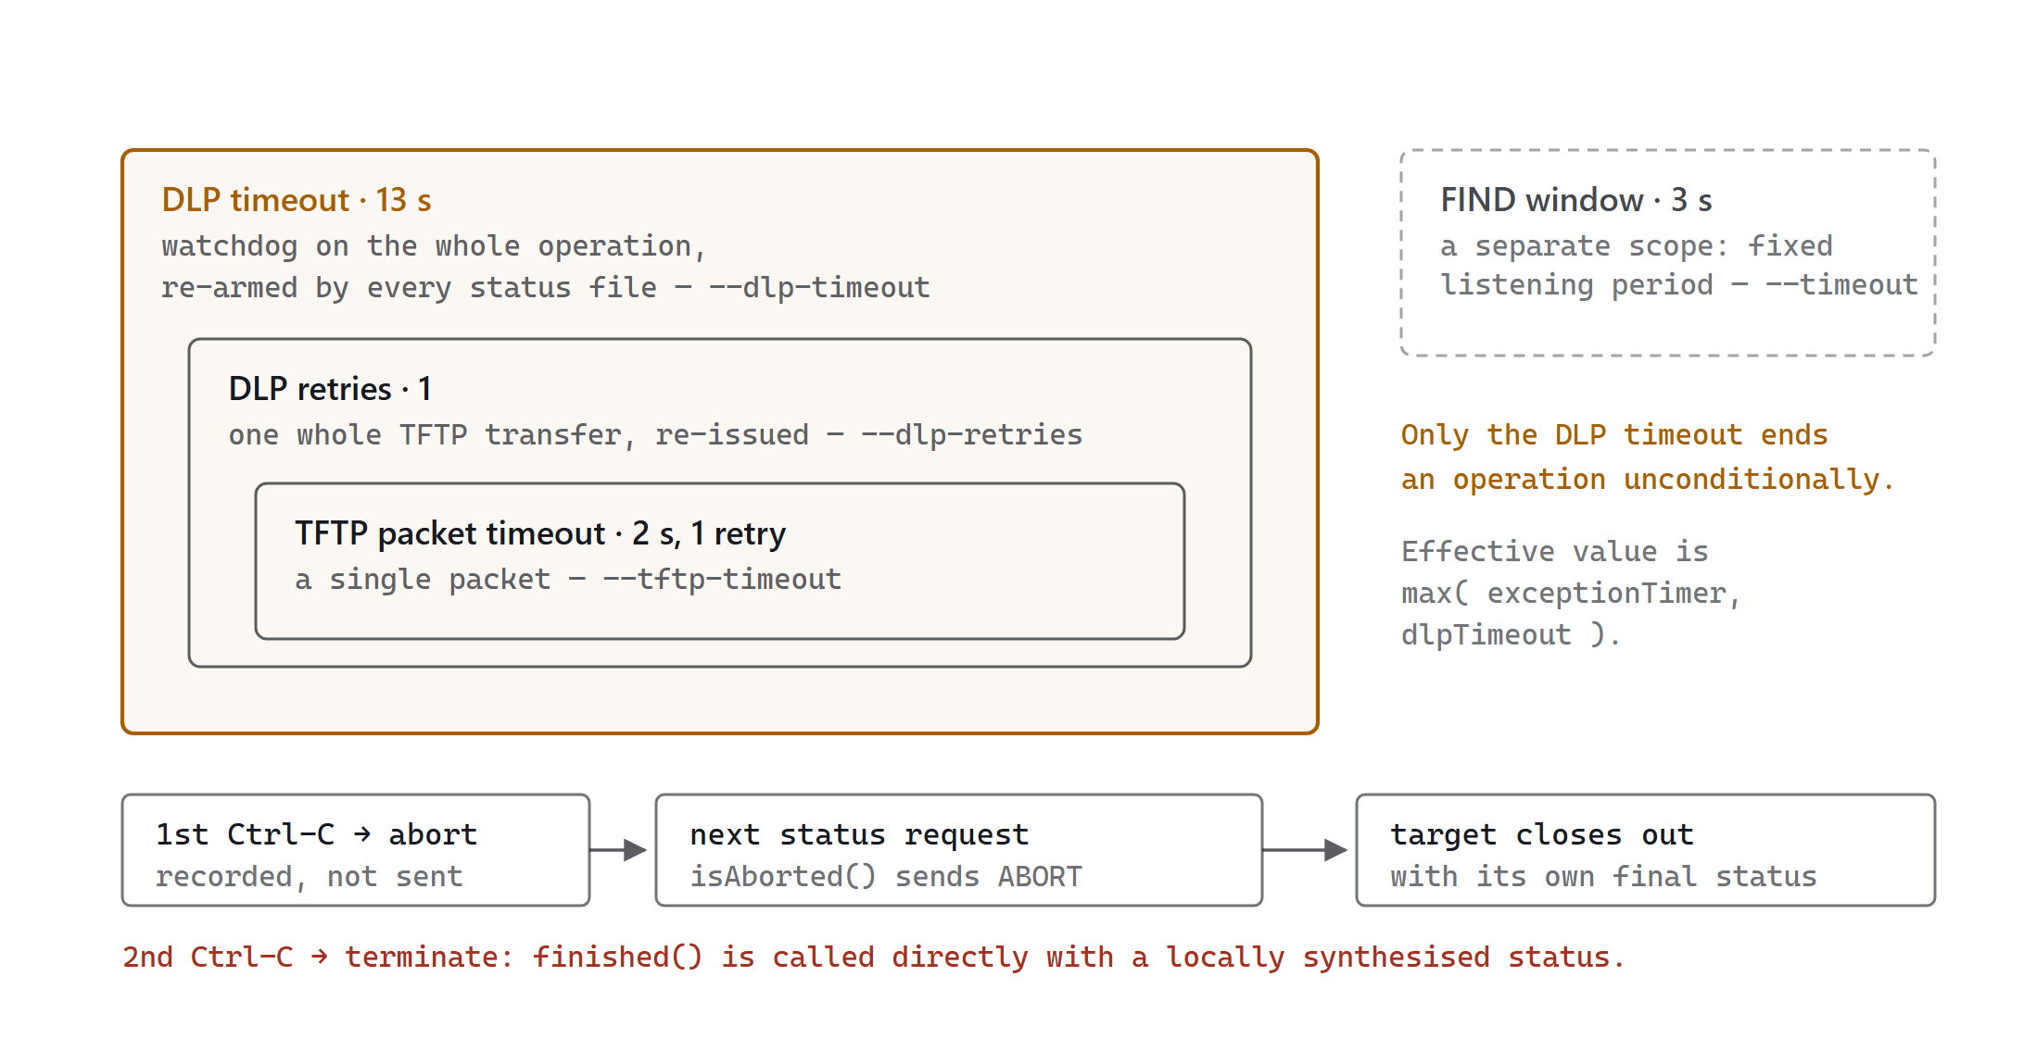
Timer scopes nest strictly: a TFTP packet timeout can fire many times inside one DLP retry, and DLP retries can be exhausted well inside the DLP watchdog. The bottom row is the graceful abort path — note that it only makes progress when the target asks to write a status file.
The DLP timeout is the only one that ends an operation unconditionally. Its effective value is max( exceptionTimer, dlpTimeout ), so a target that advertises a long exception timer extends the window but can never shrink it below the configured value. Defaults are declared in Arinc615a.hpp as DefaultArinc615aTftpTimeout, DefaultArinc615aTftpRetries, DefaultArinc615aDlpTimeout, and DefaultArinc615aDlpRetries.
DOCUMENTATION MISMATCH
The manpage states --dlp-retries defaults to 2; the source constant DefaultArinc615aDlpRetries is 1. The source is authoritative.

Abort versus terminate
• Abort (first Ctrl-C, or AbortReason::Protocol raised internally) records the reason and waits. Delivery happens at the next status-file request via isAborted(), which sends an ARINC 615A ABORT error and lets the target close the operation with its own final status. Idempotent.
• Terminate (second Ctrl-C) calls finished() directly with a locally synthesised status. Not idempotent — see §22.
If the target has gone silent, abort never delivers, and the operation ends on the DLP timeout instead. Pressing Ctrl-C twice is the intended escape.

17 — STATUS CODES

Status code reference
Declared in Arinc615a.hpp. These values appear in status files, in initialisation responses, and inside ABORT: error messages.
VALUE | ENUMERATOR | MEANING | TERMINAL
0x0001 | OperationAccepted | Accepted, not yet started | no
0x0002 | OperationInProgress | Running; exception timer valid | no
0x0003 | OperationCompleted | Completed without error | yes
0x0004 | OperationInProgressAdditionalInfo | Running, with description text (615A-3+) | no
0x1000 | OperationNotAccepted | Denied — initialisation response only | yes
0x1002 | OperationNotSupported | Not supported — initialisation response only | yes
0x1003 | OperationAbortedByTargetHw | Target aborted | yes
0x1004 | OperationAbortedByDlp | Data loader aborted | yes
0x1005 | OperationAbortedByOperator | Operator aborted | yes
0x1007 | LoadPartNumberOrDownloadFileFailed | Per-file or per-load failure inside a status file | per item
0xFFFE | OperationDeferred | Internal only — signals a WAIT response, never on the wire | no
0xFFFF | Invalid | Sentinel for parse failure | —

statusCode( uint16_t ) at StatusCode.cpp validates on decode and throws Arinc615aException for any value not in this table — including OperationDeferred, which is why that code can never legally arrive from a target. status( OperationClass, StatusCode, description, … ) renders the human-readable sentences used in log output.

18 — DRF GENERATOR

arinc_615a_download_request_file
A single-file utility that writes a .LNR download request file to disk without touching the network. Useful for preparing request files that a different tool or a media-based workflow will deliver, and for producing known-good inputs when testing a target.
Its main() at arinc_615a_download_request_file.cpp parses five options, builds a Files::DownloadOperationRequestFile, appends each --download-file via requestFile.file(), attaches --user-defined-data as raw bytes, and writes the encoded result with a binary std::fstream.
OPTION | REQUIRED | NOTES
-f, --filename | yes | Output path for the generated file
--download-file | yes | Multitoken — repeat or list to add several filenames
--user-defined-data | no | Copied verbatim as bytes; max 255
--arinc615a-version | no | A3 = 615A-2 (default), A4 = 615A-3/4
-l, --log-level | no | Defaults to warn

NOT BUILT IN THIS VARIANT
app/CMakeLists.txt no longer contains add_subdirectory( arinc_615a_download_request_file ), so this tool is not produced by the build described in §20. The sources are still present under app/arinc_615a_download_request_file/; add that line back to app/CMakeLists.txt and reconfigure to build it. The same applies to arinc_615a_test_tha and arinc_615a_unit_test.
QUIRK
--help returns EXIT_FAILURE, not success. Scripts that treat a zero exit from --help as a capability probe will misread this binary.

19 — CUSTOMISATION

Where to change things for your application
Most adaptation is a command-line option and needs no rebuild. The rest is a small number of specific constants and tables. This section is ordered by how invasive the change is.

Tier 1 — runtime options, no rebuild
Every field below is a member of Arinc615aConfiguration or a per-command variable, and every one is settable on the command line. The Field column names the C++ member, so you can trace it into the code from here.
WHAT YOU ARE CHANGING | OPTION | FIELD | DEFAULT
Which target you talk to | --target-address | targetAddressV | —
Which target ID names the protocol files | --target-id | targetIdV | — (required)
Which NIC the host TFTP server binds to | --local-tftp-address | localInterfaceAddress | 0.0.0.0
Target TFTP port | --server-port | tftpConfiguration.tftpServerPort | 59
Per-packet TFTP timeout | --tftp-timeout | tftpConfiguration.tftpTimeout | 2 s
TFTP dally on last ACK | --dally | tftpConfiguration.dally | —
Whole-transfer retries | --dlp-retries | dlpRetries | 1
Operation watchdog | --dlp-timeout | dlpTimeoutV | 13 s
TFTP block size negotiation | --block-size-option | tftpOptionsConfiguration | 1486 if bare
TFTP timeout option negotiation | --timeout-option | tftpOptionsConfiguration | 2 s if bare
Transfer-size option handling | --handle-transfer-size-option | tftpOptionsConfiguration | true
Dynamic host port (615A-3) | --port-option | portOptionV | off
Dump every protocol file | --log-protocol-files | protocolFileLogging | off
Log verbosity, all libraries | --log-level | — | warn

THERE IS NO CONFIG FILE
Arinc615aConfiguration::fromProperties() and toProperties() exist and read JSON keys local_tftp_address, dlp_retries, tftp, tftp_options, protocol_file_logging — but the CLI never calls them. They serve the GUI and the test target application. If you want a config file for the CLI, that is the hook to wire up: parse the JSON in execute() before notify() and let command-line options override it.

Tier 2 — your data, not the code
Three inputs are files you author, not code you edit:
• Targets list JSON — produced by Find --targets-list, consumed by every other command. Structure comes from TargetInformation::toProperties(): an array of target objects each with address, thwId, thwTypeName, thwPosition, literalName, manufacturerCode. You can hand-write this file for targets that do not answer FIND — only address, thwId, and thwPosition actually matter, since the lookup key is TargetId{ thwId, thwPosition }.
• ARINC 665 media set — the load headers and part numbers uploaded by Upload. Managed by the arinc_665 commands in the same binary.
• Download request file — generate with the §18 tool, or let MedDownload --file build it in memory.

Tier 3 — source changes, rebuild required
Each row names the exact file and symbol. These are the points where the implementation encodes an assumption that your hardware might not share.
IF YOU NEED TO… | EDIT | WHAT TO CHANGE
Accept Target IDs your hardware reports that are shorter, longer, or contain non-alphanumerics | TargetId.hpp:39–48 | ThwIdSizeMin 4, ThwIdSizeMax 15, PositionSizeMin 0, PositionSizeMax 8. For non-alphanumerics you must also relax isCompliant() in TargetId.cpp, which currently requires isalnum in the C locale.
Change the Target ID separator from _ | TargetId.cpp | splitTargetId() hard-codes find('_'). Also update the formatter that rebuilds the string.
Use vendor-specific protocol file extensions | ProtocolFilename.cpp:148 | The extensionTypeInfoIndex() static table maps twelve extensions to ProtocolFileType. Both directions come from this one table — change it and filename generation and parsing stay consistent.
Change the default protocol version written into files you generate | Arinc615a.hpp | Arinc615aVersion: Arinc615a2=0x4133, Arinc615a34=0x4134. Note the host normally latches the version from the target's initialisation file, so this only affects the offline generator (§18) and its --arinc615a-version default.
Accept ARINC 615A-1 (A2, 0x4132) protocol files | ProtocolFile.cpp:77–86 | decodeHeader() whitelists only Arinc615a2 and Arinc615a34. Add the case — but supplement 1 has different field semantics, so verify each decoder too.
Tolerate targets that append vendor data past the defined fields | every files/*.cpp decode() | Each decode() ends with a check that no bytes remain and throws "More data then expected". Relax to a warning per file type you need to accept.
Change the FIND port or the answer field set | find/Find.hpp:47  find/packets/Packets.hpp:58 | DefaultPort = 1001 and DefaultReceiveTimeout = 3 s. The five answer fields and their order come from the ParameterList enum; QueryImpl.cpp:235 rejects any answer whose count is not exactly ParameterList::Last.
Change the default timing constants baked into --help | Arinc615a.hpp | DefaultArinc615aTftpPort 59, DefaultArinc615aTftpTimeout 2 s, DefaultArinc615aTftpRetries 1, DefaultArinc615aDlpTimeout 13 s, DefaultArinc615aDlpRetries 1.
Change or extend the checksum option names | tftp/Arinc615aOptions.cpp | Both Arinc615aOptions_name() overloads. The KnownOptions enum in Arinc615a.hpp must gain a matching entry, and Arinc615aOptions_checksum() must include the new type in its scan list.
Send protocol file dumps somewhere other than the working directory | host/implementation/*Impl.cpp constructors | Each constructor calls protocolFileLogger().loggingEnabled(…).operation(…) but never .loggingDirectory(…). Add that call — and expose it as an option alongside --log-protocol-files.
Fix the unusable -l short flag | 9 command .cpp files | Rename "targets-list,l" to a free letter in all nine. See §22.

Adding a command of your own
The pattern is mechanical. Four steps:
01 Write MyCommand in lib/arinc_615a_commands/operations/, privately inheriting the handler interface for the operation class you need. Follow the §7 skeleton exactly.
02 Add both files to the target_sources() list in lib/arinc_615a_commands/CMakeLists.txt.
03 In Operations::registerCommands() (operations/Operations.cpp:27), construct it and call registry->command( "MyName", "description", bind_front(&MyCommand::execute, ptr), bind_front(&MyCommand::help, ptr) ).
04 Add a manpage .adoc under doc/arinc_615a_manpage/ and register it in that directory's CMakeLists.txt if you want it installed.
If your command needs protocol behaviour that none of the four operations provide, the extension point is a new OperationImpl subclass plus a factory method on Host::Protocol and ProtocolImpl — the pattern in host/implementation/ProtocolImpl.cpp.

20 — BUILDING

Building the CLI, command by command
This tree has been reduced to a CLI-only variant. One executable is built: arinc_615a_operation. Everything below is a single command, what it does, and how to tell it worked before you run the next one.
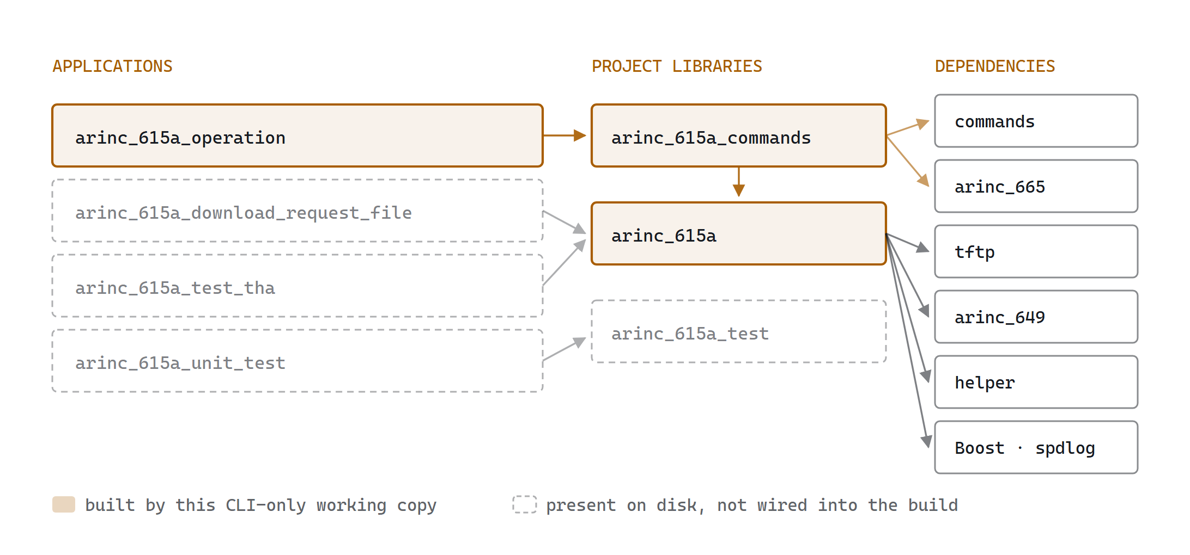
Link structure of the tree, with this working copy’s reduction marked. arinc_615a_operation also links commands and arinc_665_commands directly; those edges are omitted here to keep the library chain readable.
WHAT THE VARIANT EXCLUDES
lib/CMakeLists.txt now adds only arinc_615a and arinc_615a_commands; app/CMakeLists.txt adds only arinc_615a_operation. The Qt library directories are gone, and qt_icon_resources has been dropped from the FetchContent set — five dependencies remain: helper, arinc_649, arinc_665, tftp, commands. The vcpkg.json manifest no longer declares a with-qt feature.
The sources for arinc_615a_download_request_file, arinc_615a_test_tha, and arinc_615a_unit_test are still on disk under app/ but are no longer referenced by any add_subdirectory(), so they will not build. §18 explains how to re-enable the request-file generator if you want it.

Step 0 — check the toolchain, one command at a time
Run these four before configuring. Each failure has a distinct fix, and a bad result here produces a confusing error much later.
01 CMake version. Must report 4.3 or higher — every CMakeLists.txt in this tree declares cmake_minimum_required( VERSION 4.3 ).
cmake --version
If this reports 3.x you cannot proceed. The CMake bundled inside Visual Studio 2022 is 3.31 and is not sufficient; install CMake separately and make sure it precedes the VS copy on PATH.
02 Ninja. Every preset in this repository sets "generator": "Ninja", so Ninja must be on PATH. There is no Makefile or Visual Studio solution preset.
ninja --version
03 Compiler. The targets request cxx_std_23, so you need GCC 14+, Clang 18+, or MSVC 19.4x.
g++ --version # or: clang++ --version, or: cl
04 Dependency host reachability. Configure will clone five repositories from git.thomas-vogt.de. Confirm you can reach it before waiting on a configure that will fail.
git ls-remote --heads https://git.thomas-vogt.de/thomas-vogt/helper.git
A commit hash and refs/heads/main means you are fine. A timeout or auth prompt means you need the offline path at the end of this section.

Track A — Linux with GCC
01 Install the system dependencies. Boost, libxml++, and spdlog are found by find_package, not fetched.
sudo apt install -y build-essential g++-14 ninja-build git pkg-config \
libboost-all-dev libxml++2.6-dev libspdlog-dev
On Fedora or RHEL substitute dnf install gcc-c++ ninja-build boost-devel libxml++-devel spdlog-devel.
02 Change into the source root. Presets are resolved relative to the directory holding CMakePresets.json, so every later command assumes you are here.
cd arinc_615a-main
03 List the presets to confirm CMake parses them and to see the exact names available to you.
cmake --list-presets
You should see sixteen configure presets: four each of gcc-, clang-, msvc-, and mingw-cross-. The msvc- entries are conditioned on a Windows host and will be hidden on Linux.
04 Configure. This is the long step: it clones the five dependencies, runs every find_package, and writes the Ninja build files.
cmake --preset gcc-shared-release
Creates cmake-build-gcc-shared-release/. Success ends with -- Generating done and -- Build files have been written to: …. Anything else, stop and read §"When a step fails" below rather than re-running.
05 Build. The build preset name matches the configure preset name.
cmake --build --preset gcc-shared-release
Add -j$(nproc) if Ninja is not already saturating your cores. To build the single executable and skip everything not needed to link it, target it by name instead:
cmake --build cmake-build-gcc-shared-release --target arinc_615a_operation
06 Confirm the binary exists and is the architecture you expect.
ls -l cmake-build-gcc-shared-release/app/arinc_615a_operation/arinc_615a_operation
file cmake-build-gcc-shared-release/app/arinc_615a_operation/arinc_615a_operation
07 Run it once with no arguments. This prints the banner and the usage text — and settles the --command versus --operation question from §5 for your build.
./cmake-build-gcc-shared-release/app/arinc_615a_operation/arinc_615a_operation
Expect ARINC 615A Operation - <version> followed by the list of registered command names.
08 Install into the preset's install tree. This also gathers the shared libraries declared through RUNTIME_DEPENDENCY_SET arinc_615a-runtime-deps.
cmake --install cmake-build-gcc-shared-release
Lands in cmake-install-gcc-shared-release/. Pass --prefix /usr/local to install elsewhere, and --component runtime to take only the binaries and their libraries without the documentation.
WANT ONE FILE YOU CAN COPY TO ANOTHER MACHINE?
Use the static preset instead. cmake --preset gcc-static-release then cmake --build --preset gcc-static-release leaves BUILD_SHARED_LIBS off, so the project's own libraries are archived into the executable and there is no cmake-install dance to get the .so files alongside it. System libraries such as Boost are still linked dynamically unless your distribution ships static variants.

Track B — Windows with MSVC and vcpkg
The msvc- presets set toolchainFile to $env{VCPKG_ROOT}/scripts/buildsystems/vcpkg.cmake, so VCPKG_ROOT must be set before you configure — that is the single most common first-run failure on Windows.
01 Clone vcpkg somewhere permanent. Do this once per machine, not once per project.
git clone https://github.com/microsoft/vcpkg.git C:\vcpkg
02 Bootstrap it. Builds vcpkg.exe from the cloned sources.
C:\vcpkg\bootstrap-vcpkg.bat
03 Set VCPKG_ROOT permanently so the preset can expand it.
setx VCPKG_ROOT C:\vcpkg
setx affects new shells only. Close and reopen your terminal, then confirm with echo %VCPKG_ROOT% before continuing.
04 Open a Developer Command Prompt for VS 2022, or import the MSVC environment into your current shell. Without this, CMake will not find cl.exe.
"C:\Program Files (x86)\Microsoft Visual Studio\2022\BuildTools\VC\Auxiliary\Build\vcvars64.bat"
05 Confirm the compiler is now visible.
where cl
cl
cl with no arguments prints its version banner. Anything else means step 4 did not take effect in this shell.
06 Change into the source root.
cd arinc_615a-main
07 Configure. vcpkg reads vcpkg.json automatically in manifest mode and builds Boost, libxml++, pkgconf, and spdlog into the build tree. Expect this to take a long time on a cold vcpkg cache — tens of minutes is normal, and almost all of it is Boost.
cmake --preset msvc-shared-release
08 Build.
cmake --build --preset msvc-shared-release
09 Confirm and run.
dir cmake-build-msvc-shared-release\app\arinc_615a_operation\arinc_615a_operation.exe
cmake-build-msvc-shared-release\app\arinc_615a_operation\arinc_615a_operation.exe
10 Install, which is what collects the dependent DLLs next to the executable.
cmake --install cmake-build-msvc-shared-release
Note the presets set VCPKG_APPLOCAL_DEPS=OFF, so vcpkg does not copy DLLs beside the binary at build time. If you skip the install step and run straight from the build tree, expect missing-DLL errors — use the install tree, or build a msvc-static-release variant instead.

Track C — cross-compiling for Windows from Linux
01 Install the MinGW-w64 toolchain.
sudo apt install -y mingw-w64
02 Configure with the cross preset, which points CMake at mingw64-cross-toolchain.cmake in the repository root.
cmake --preset mingw-cross-shared-release
03 Build. The CLI target explicitly links wsock32 and ws2_32, which MinGW requires and MSVC links implicitly — so this works where a naive cross build would fail at link time.
cmake --build --preset mingw-cross-shared-release

Choosing a variant
Each compiler family offers the same four. The only cache difference is CMAKE_BUILD_TYPE and BUILD_SHARED_LIBS.
PRESET SUFFIX | BUILD TYPE | BUILD_SHARED_LIBS | USE IT WHEN
-static-release | Release | off | Shipping a portable binary; simplest to deploy
-shared-release | Release | on | Normal development; faster relink
-static-debug | Debug | off | Stepping through with a debugger
-shared-debug | Debug | on | Iterating on library code with symbols

Append -with-doc to any build preset name to additionally generate the Doxygen and AsciiDoc output — cmake --build --preset gcc-shared-release-with-doc. That requires Doxygen and Asciidoctor and is unrelated to producing the binary.

When a step fails
SYMPTOM | FAILING STEP | FIX
CMake 4.3 or higher is required | configure | Your cmake is too old. Check cmake --version; the VS-bundled 3.31 does not qualify.
Could not find toolchain file … vcpkg.cmake | configure (MSVC) | VCPKG_ROOT is unset in this shell. setx only affects new shells — reopen the terminal.
No CMAKE_CXX_COMPILER could be found | configure (MSVC) | You are not in a Developer Command Prompt. Run vcvars64.bat.
CMake Error … generator Ninja not found | configure | Install Ninja and put it on PATH. Every preset requires it.
Hang or failure inside FetchContent | configure | git.thomas-vogt.de is unreachable. Use the offline path below.
Could NOT find Boost / spdlog / LibXML++ | configure | System packages missing (Linux) or vcpkg manifest install failed (Windows). Read the vcpkg log path printed in the error.
Build stops on a warning | build | All presets set CMAKE_COMPILE_WARNING_AS_ERROR=True. A newer compiler may warn where the authors' did not. Reconfigure with -DCMAKE_COMPILE_WARNING_AS_ERROR=OFF to triage.
.dll not found | running (Windows) | VCPKG_APPLOCAL_DEPS is off. Run cmake --install and use the install tree, or build a static preset.
Configure succeeds but nothing builds | build | Confirm app/CMakeLists.txt still contains add_subdirectory( arinc_615a_operation ). In this variant it is the only application wired in.

Building without network access
The root CMakeLists.txt has an escape hatch built into each dependency declaration. For every dependency it checks if( IS_DIRECTORY ${CMAKE_SOURCE_DIR}/<name> ) and, when that directory exists, sets FETCHCONTENT_SOURCE_DIR_<NAME> to it instead of cloning.
So on a machine with network access, clone the five repositories into the source root using exactly these directory names:
cd arinc_615a-main
git clone https://git.thomas-vogt.de/thomas-vogt/helper.git helper
git clone https://git.thomas-vogt.de/thomas-vogt/arinc-649.git arinc-649
git clone https://git.thomas-vogt.de/thomas-vogt/arinc_665.git arinc_665
git clone https://git.thomas-vogt.de/thomas-vogt/tftp.git tftp
git clone https://git.thomas-vogt.de/thomas-vogt/commands.git commands
Note arinc-649 uses a hyphen while arinc_665 uses an underscore — the directory names must match the IS_DIRECTORY checks exactly or the redirect silently does not happen and CMake clones anyway. Transfer the whole tree to the offline machine and configure normally.
NOT YET VERIFIED END TO END
These commands are derived from the presets and manifests in this tree, not from a completed build — no compiler toolchain was installed on the machine this document was written on. Treat your first configure and build as verification steps.

21 — RUNNING

Using the binaries
ESTABLISH THE SELECTION FLAG FIRST
Because the repository documents both --command= and --operation= (§5), run the bare binary once and read its own usage output before anything else. Every example below is written with --operation=, matching the manpages; substitute --command= if that is what your build reports.
# from the build tree produced in §20
cd cmake-build-gcc-shared-release/app/arinc_615a_operation

./arinc_615a_operation
./arinc_615a_operation --operation=Information --help

A typical session
Discover, then interrogate, then load — each step feeding the next through the targets list.
# 1. Discover every target on the subnet, saving what answers
./arinc_615a_operation --operation=Find \
--target-address=192.168.1.255 \
--timeout=5 \
--targets-list=targets.json

# 2. Re-read that list later without touching the network
./arinc_615a_operation --operation=Targets --targets-list=targets.json

# 3. Ask one target what software it is carrying
./arinc_615a_operation --operation=Information \
--targets-list=targets.json \
--target-id=ABCDEF_123

# 4. Upload two loads from a media set
./arinc_615a_operation --operation=Upload \
--targets-list=targets.json \
--target-id=ABCDEF_123 \
--media-set-manager-dir=/srv/media-sets \
--media-set-pn=MS-00042 \
--load-header=LOAD1.LUH \
--load-header=LOAD2.LUH

# 5. Pull files off the target
./arinc_615a_operation --operation=MedDownload \
--targets-list=targets.json \
--target-id=ABCDEF_123 \
--file=FLIGHTLOG.DAT \
--download-base-directory=./downloads

Addressing a target directly
# --target-address instead of a targets list; --target-id is always required
./arinc_615a_operation --operation=Information \
--target-address=192.168.1.50 \
--target-id=ABCDEF_123
When both are supplied, a Target ID found in the list overrides --target-address (§7, step 2). Supplying neither a resolvable list entry nor an address is the one hard error before any traffic.

Diagnosing a failing load
# Full verbosity plus a binary dump of every protocol file exchanged
./arinc_615a_operation --operation=Information \
--target-address=192.168.1.50 \
--target-id=ABCDEF_123 \
--log-level=trace \
--log-protocol-files

# Dumps land in the working directory as:
# 2026-08-26T14-22-05+0000_Information_TX_ABCDEF_123.LCI
# 2026-08-26T14-22-05+0000_Information_RX_ABCDEF_123.LCL
Other levers worth knowing when a target misbehaves:
• --dlp-timeout=60 — for targets that take a long time between status files. Remember the effective window is max(exception timer, this).
• --port-option — only for ARINC 615A-3 and later targets. If the target does not echo the option, the transfer aborts with "Port option not accepted"; rerun without it.
• --block-size-option=512 — narrow the TFTP block size when an intermediate network drops larger datagrams.
• --local-tftp-address=192.168.1.10 — pin the host TFTP server to one NIC on a multi-homed machine. Without it the server binds 0.0.0.0 and the target may answer to an address you did not intend.
• --server-port — only if your target listens somewhere other than the standard port 59. Binding port 59 on the host side needs privilege on Linux.

Generating a download request file offline
./arinc_615a_download_request_file \
--filename=ABCDEF_123.LNR \
--download-file FLIGHTLOG.DAT MAINTLOG.DAT \
--user-defined-data="bench run 7" \
--arinc615a-version=A4
EXIT CODES DO NOT REPORT PROTOCOL OUTCOME
A denied, aborted, or timed-out operation still exits 0 — only command-line parse failures produce a non-zero status (§7). To gate a script on success, match the printed Final Status Code line against OperationCompleted rather than testing $?.

Stopping an operation
One Ctrl-C requests a protocol abort: the host waits for the target's next status transfer, sends an ABORT error, and lets the target close out with a final status file. That can take up to the DLP timeout. A second Ctrl-C terminates immediately with a locally synthesised status. See §16.

22 — FINDINGS

Defects found while tracing
Five issues, each confirmed by reading the source rather than inferred. Ordered by consequence.
# | FINDING | LOCATION | EFFECT
1 | Missing return after finished() in the "operation completed which was not initiated" branch. Present correctly in the Information variant, absent in the other two. | UploadOperationImpl.cpp:326  DownloadOperationImpl.cpp:162  (cf. InformationOperationImpl.cpp:189) | Control falls through and can reach finished() a second time. Because finished() has no guard, the command's std::latch{1} is counted down twice — undefined behaviour.
2 | OperationImpl::finished() is not idempotent. No state flag, no early return. | host/implementation/OperationImpl.cpp:159 | The amplifier for #1 and for a rapid double Ctrl-C via doTerminate(), which unlike doAbort() has no guard. A one-line if (finishedV) return; closes all of these.
3 | Duplicate -l short option — log-level,l and targets-list,l declared in the same options description. | 18 sites across 9 command files, e.g. InformationOperationCommand.cpp:58 and :80 | -l is ambiguous and unusable; only the long forms work. Systemic — every command is affected.
4 | Missing return after refusing a non-write TFTP request. The error is sent, then control falls into the file-type switch. | InformationOperationImpl.cpp:103–107 | A read request against the host during an Information operation is refused and processed, creating a TFTP operation for a transfer already rejected.
5 | Unguarded completion handler in the FIND query. timerHandler() and abort() both invoke it unconditionally. | find/clients/implementation/QueryImpl.cpp:118, 168 | A Ctrl-C arriving after the FIND timer has already fired counts the latch down a second time. Narrow race, same UB as #1.

Documentation defects
• Command selection flag contradicts itself — arinc_615a_operation.adoc says -c|--command, every manpage says --operation. One is wrong and users cannot tell which without running the binary.
• --dlp-retries default — manpage says 2, DefaultArinc615aDlpRetries is 1.

Observations, not defects
• timerHandler() carries //! @todo cancel active transfers — in-flight TFTP transfers are not cancelled when the DLP watchdog fires.
• Exceptions caught inside initialise() are logged but produce no finished() call, so the CLI blocks until the DLP timeout rather than failing fast.
• A list-file checksum mismatch is reported as one word on the console and never affects the exit code.
• ProtocolFileLogger::loggingDirectory() is never called by the CLI, so dumps land in the working directory.
• FIND responses are not de-duplicated; a target answering twice appears twice in targets.json.

23 — REFERENCES

Sources

Standards
• ARINC Report 615A-4 — Software Data Loader Using Ethernet Interfaces, 2023-07-24. §6.4 defines the protocol filenames in §14.
• ARINC Report 615A-3, 2007-06-30 — introduces the Port Option and Checksum Option handled in §15.
• ARINC Report 615A-2, 2002-05-10 — renames SNIP to FIND (§8) and permits a declared string length longer than the text (§14).
• ARINC Report 665-5 — Loadable Software Standards; the media set format behind §11.
• ARINC Report 649 — check values and part numbering.

Primary source paths in this repository
PATH | CONTENTS
app/arinc_615a_operation/ | CLI entry point, signal handling (§4)
lib/arinc_615a_commands/ | Nine command classes, option tables, console output (§5–§13)
lib/arinc_615a/host/ | Operation state machines (§9–§13)
lib/arinc_615a/find/ | FIND client, packets (§8)
lib/arinc_615a/files/ | Protocol file codecs (§14)
lib/arinc_615a/tftp/ | ARINC 615A TFTP specialisation (§15)
lib/arinc_615a/information/ | Status, part number, and target hardware value types
doc/arinc_615a_manpage/ | Per-command manpages — authoritative on options, not on the selection flag

Method and limits
This document was produced by static reading of the working copy. Line numbers reflect that tree. Nothing here was validated against a running target: no build was performed, no traffic was captured, and the behaviour of the three fetched dependencies — commands, tftp, and arinc_665 — is described from their call sites in this repository, not from their own source. Where that mattered, notably the command selection flag in §5 and §21, it is called out rather than guessed.

