ARINC 615A Tool Suite — CLI
Installation, Operation and Test Procedure

Item | Value
Document title | ARINC 615A CLI — Installation, Operation and Test Procedure
Applies to | arinc_615a_operation (CLI), all 16 commands
Repository | arinc-615a-tool-suite
Platforms | Windows x64 (MSVC 2022); Linux x64/arm64 (GCC 13+)
Document status | Issue 1
Licence | MPL-2.0 — upstream project by Thomas Vogt

Verification note
Every expected result in Section 9 marked VERIFIED was produced by executing the stated command on a Windows x64 machine and copying the actual output. Results marked NOT EXECUTED are specified from the tool's own option definitions but were not run, because they require either ARINC 615A target hardware on the network or a Linux environment. No expected output in this document is invented.

1 Purpose and scope
This document is a step-by-step procedure for installing, operating and testing the ARINC 615A command-line data loader. It is written to be followed literally: every step is a command to type, with the output you should see.
In scope:
- Installing all prerequisites and dependencies on Windows and Linux.
- Building the application from source.
- Running each of the 16 commands.
- A test procedure with pass/fail criteria.
- Diagnosing the failures that are known to occur.
Out of scope:
- The target-side implementation (the avionics box). This tool is the host.
- Airworthiness, certification or approval of any data-loading activity.
- The ARINC standards themselves, which are published by SAE ITC.

1.1 Acronyms
Term | Meaning
DLP | Data Loader Protocol
FIND | Find Identification of Network Devices — the discovery protocol
IRQ / IAN | FIND Information Request / Information Answer
LRU | Line Replaceable Unit — an avionics box
MSM | Media Set Manager — the local ARINC 665 software store
THA | Target Hardware Application — the software on the target that speaks 615A
TFTP | Trivial File Transfer Protocol (RFC 1350), the transport
P/N | Part Number

2 System overview
ARINC 615A is a file-driven protocol layered on TFTP. The host (this tool) and the target exchange files with fixed three-letter extensions; the state machine is driven by which file arrives next. FIND is the exception — a plain UDP request/answer pair used to discover targets before a transfer.
Extension | File | Direction
LCI | Load Configuration Initialisation | host to target
LCL | Load Configuration List (part numbers, THW IDs) | target to host
LCS | Load Configuration Status | target to host
LUI / LUR / LUS | Upload Initialisation / Request / Status | both
LNR / LNA / LNS | Download Request / Answer / Status | both

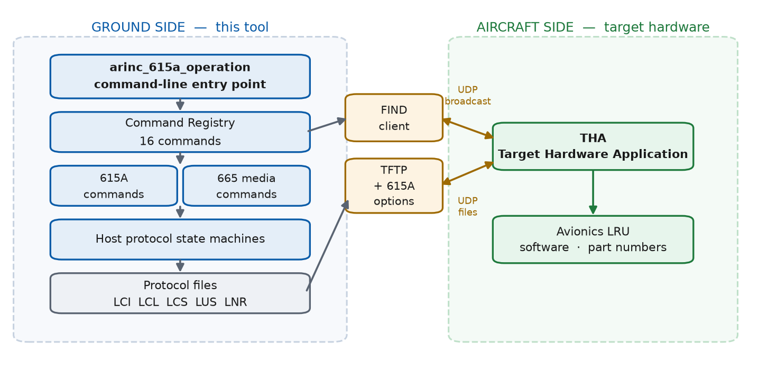
Figure 1 — System context: the tool is the host; the data path is files over TFTP
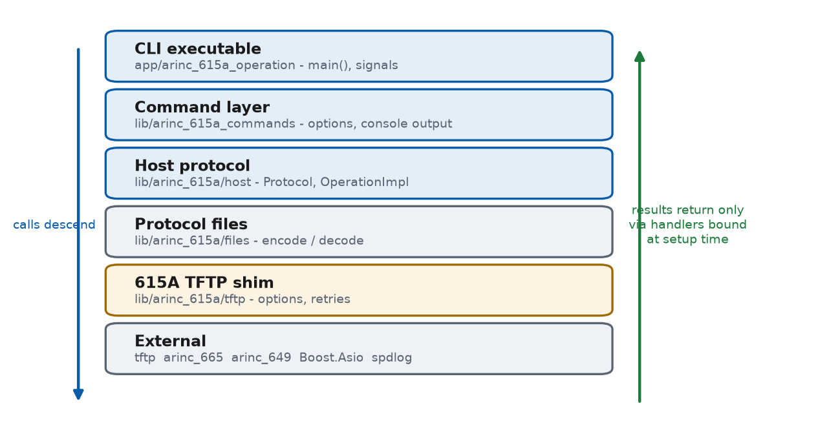
Figure 2 — Six layers, one direction. Calls descend; results return through handlers
Two behaviours matter operationally. The exception timer (--dlp-timeout, default 13 s) fails an operation if the target stops sending status files, rather than hanging. And the first Ctrl-C is a graceful protocol abort, not a kill — it tells the target to stop so it is not left mid-load in an undefined state. A second Ctrl-C terminates hard.

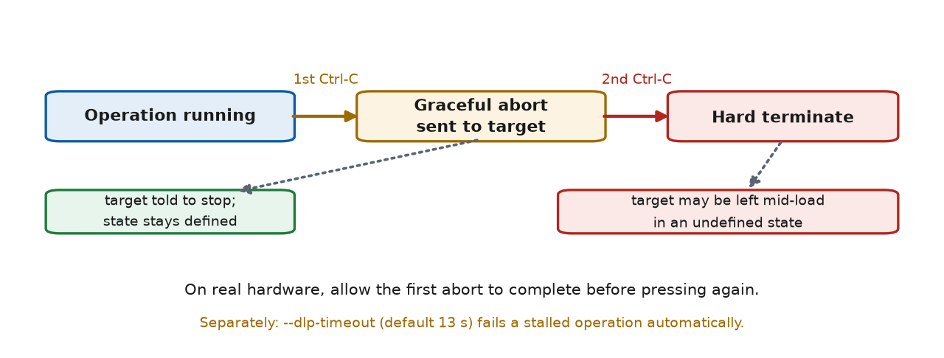
Figure 3 — Abort model: the first Ctrl-C is a protocol abort, the second is a hard stop

2.1 Where ARINC 615A sits in the protocol stack
ARINC 615A is an application-layer protocol. It defines no transport of its own: it rides on TFTP over UDP over IPv4 over Ethernet. Everything below the session layer is provided by the operating system and the network, which is why interfacing the loader to another system is mostly a networking exercise rather than a software one.
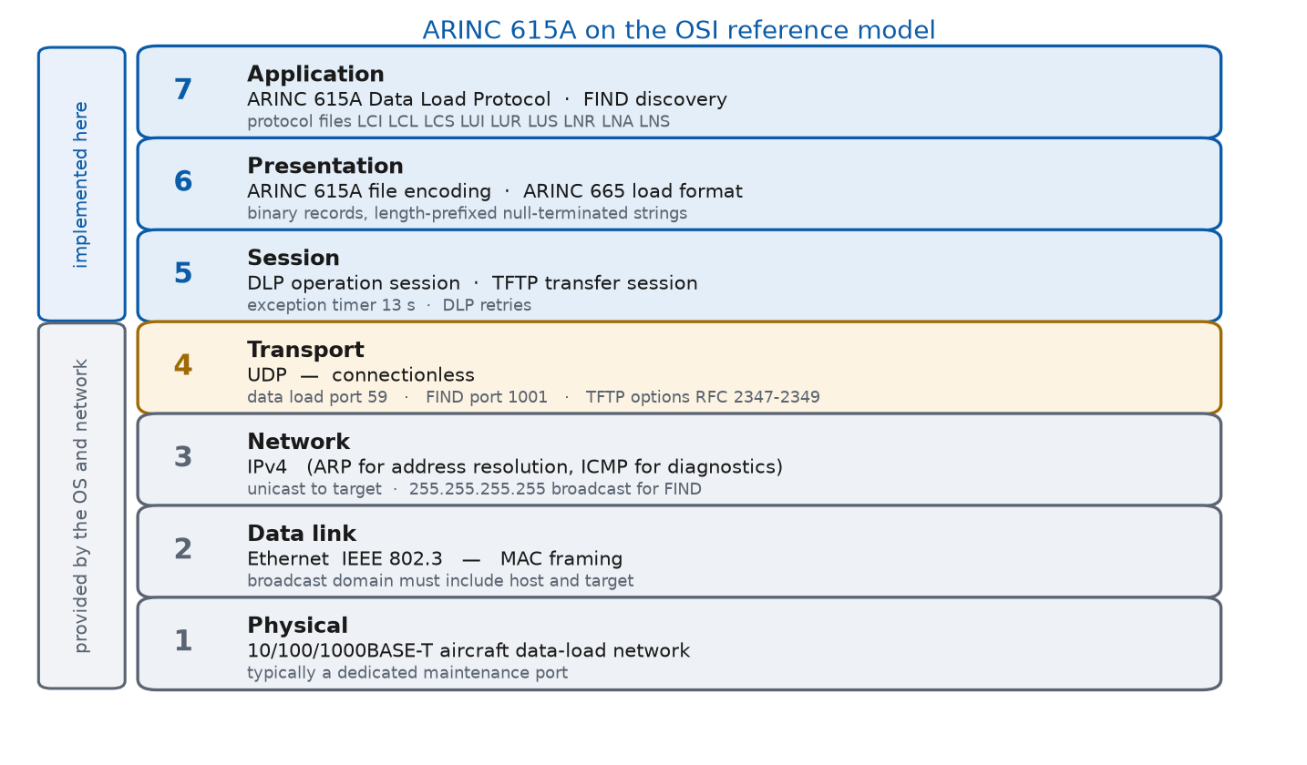
Figure 4 — ARINC 615A mapped onto the OSI reference model, with the ports this build uses

2.2 Protocols in use while an operation runs
A packet capture taken during a load shows more than ARINC 615A. The table lists everything on the wire and whether this software drives it.
Protocol | Layer | Role during an operation | Driven by
ARINC 615A DLP | Application | Protocol files LCI, LCL, LCS, LUI, LUR, LUS, LNR, LNA, LNS | This tool
FIND | Application | Discovery: IRQ opcode 1, IAN opcode 2 | This tool
ARINC 665 | Presentation | Load and media set format carried in the transfer | This tool
TFTP (RFC 1350) | Session | Moves every protocol file and every load file | tftp library
TFTP options (RFC 2347-2349) | Session | Block size, timeout and transfer size negotiation | This tool
UDP | Transport | Connectionless datagrams; no delivery guarantee | Operating system
IPv4 | Network | Addressing and routing | Operating system
ARP | Network | Resolves target IP to a MAC address before any UDP flows | Operating system
ICMP | Network | Diagnostics only; not part of the protocol | Operating system
Ethernet 802.3 | Data link | Framing; carries the FIND broadcast | NIC and switch

2.3 Ports and timers used by this build
Purpose | Default | Source constant | Override
Data load (TFTP) | UDP 59 | DefaultArinc615aTftpPort | --server-port
FIND discovery | UDP 1001 | Find::DefaultPort | --find-port
TFTP packet timeout | 2 s | DefaultArinc615aTftpTimeout | --tftp-timeout
TFTP retries | 1 | DefaultArinc615aTftpRetries | --dlp-retries
DLP exception timer | 13 s | DefaultArinc615aDlpTimeout | --dlp-timeout
DLP retries | 1 | DefaultArinc615aDlpRetries | --dlp-retries

The data-load port is UDP 59, not the TFTP well-known port 69. ARINC 615A-1 states the port explicitly and this build takes its default from that constant. If a firewall between host and target permits only port 69, the load will not start.
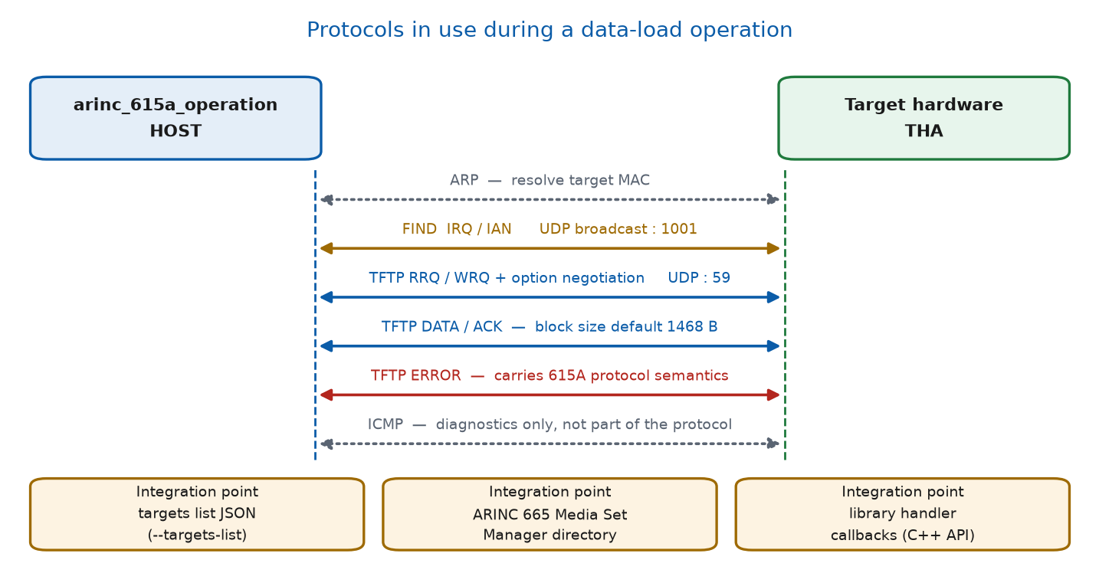
Figure 5 — What is exchanged during an operation, and the three integration points

2.4 Interfacing the loader to other systems
The loader can be driven as a process or as a library; both are supported.
- As a process: invoke the CLI and read its exit code. --targets-list produces machine-readable discovery output a wrapper can parse and feed back in.
- As a library: link lib/arinc_615a and implement the ...OperationHandler interfaces to receive progress, status and completion callbacks. The CLI is itself only a thin consumer of that API, so everything it does is available to your own application.
- Software to be loaded is supplied as ARINC 665 media sets managed through the Media Set Manager directory; ARINC 649 supplies the shared check-value functions.
Network conditions that must hold:
- Host and target must share a broadcast domain for FIND to discover anything. Routers block broadcast; across a router, address the target directly with --target-address.
- UDP 59 and UDP 1001 must not be filtered between host and target.
- On a multi-homed host set --local-tftp-address and --local-find-address explicitly, or the sockets may bind to the wrong interface.
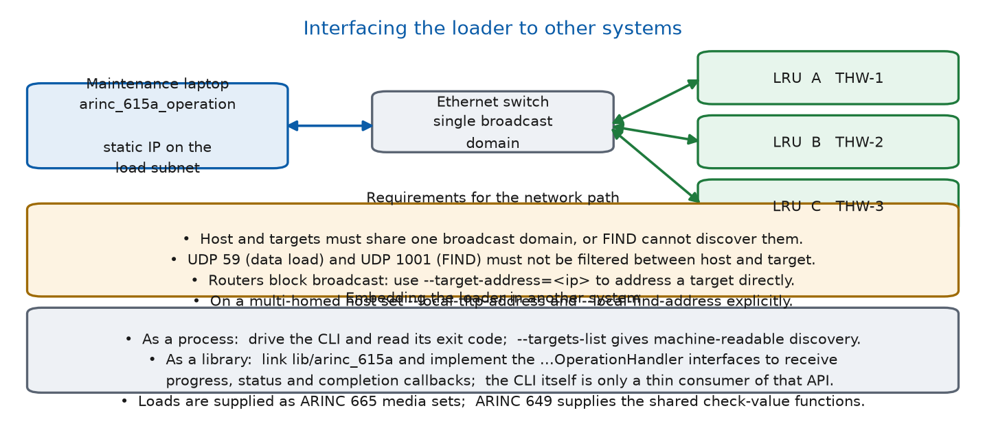
Figure 6 — Interfacing the loader to an aircraft or bench network

3 Prerequisites
Requirement | Windows | Linux
Operating system | Windows 10/11 x64 | x86_64 or aarch64
Compiler | Visual Studio 2022 C++ build tools | GCC 13 or newer (C++23)
Build system | CMake 4.3+ and Ninja | CMake 4.3+ and Ninja
Source control | Git | Git
Libraries from | vcpkg (approx. 84 packages) | distro packages
Privileges | normal user | sudo, for package installation
Disk space | approx. 10 GB (vcpkg build trees) | approx. 2 GB
Network | required — see 3.1 | required — see 3.1

3.1 Network access required at build time
The CMake configure step clones five sibling projects with FetchContent. There is no vendored copy and no offline fallback: without access to git.thomas-vogt.de, configure cannot complete.
Host | Needed for
git.thomas-vogt.de | helper, arinc_649, arinc_665, tftp, commands
github.com | vcpkg clone (Windows); CMake binary (Linux, if distro CMake is too old)
Package mirrors | distro packages (Linux) or vcpkg source downloads (Windows)

3.2 Time expectations
The first Windows build is slow and this is normal, not a fault. vcpkg builds roughly 84 packages; libiconv alone runs its autotools configure twice and was measured at 2.3 hours on the reference machine. Subsequent builds are served from the vcpkg binary cache and take seconds to a few minutes. Linux is minutes, because it uses distro packages and never builds libiconv from source.

4 Installation — Windows

Step 4.1 Install the C++ toolset
Run in an elevated PowerShell or Command Prompt:
winget install --id Microsoft.VisualStudio.2022.BuildTools -e --override "--quiet --add Microsoft.VisualStudio.Workload.VCTools --includeRecommended"

Expected: winget reports successful installation. Skip if Visual Studio 2022 with the C++ workload is already present.

Step 4.2 Install CMake and Git
winget install --id Kitware.CMake -e
winget install --id Git.Git -e

CMake must be 4.3 or newer. The CMake bundled inside Visual Studio is 3.31 and is NOT sufficient; the setup script detects this and searches for a qualifying installation.

Step 4.3 Obtain the source
git clone <repository-url> arinc-615a-tool-suite
cd arinc-615a-tool-suite

Step 4.4 Install, build and run — one command
This is the entire installation. It installs dependencies, builds, and runs the tool:
build.bat

To build and immediately run a specific command, pass its arguments through:
build.bat -c Find
build.bat debug -c Find
build.bat --no-run

Expected output, abbreviated:
==============================================================
ARINC 615A Tool Suite
install dependencies -> build (release) -> run
==============================================================
[1/3] Checking toolchain...
OK: Visual Studio C:\Program Files (x86)\Microsoft Visual Studio\2022\BuildTools
OK: CMake C:\Program Files\CMake\bin\cmake.exe
OK: Ninja
[2/3] Setting up vcpkg at C:\vcpkg...
OK: vcpkg ready
[3/3] Installing dependencies from vcpkg.json...
[1/2] Configuring...
[2/2] Building all targets...
==============================================================
BUILD OK
==============================================================

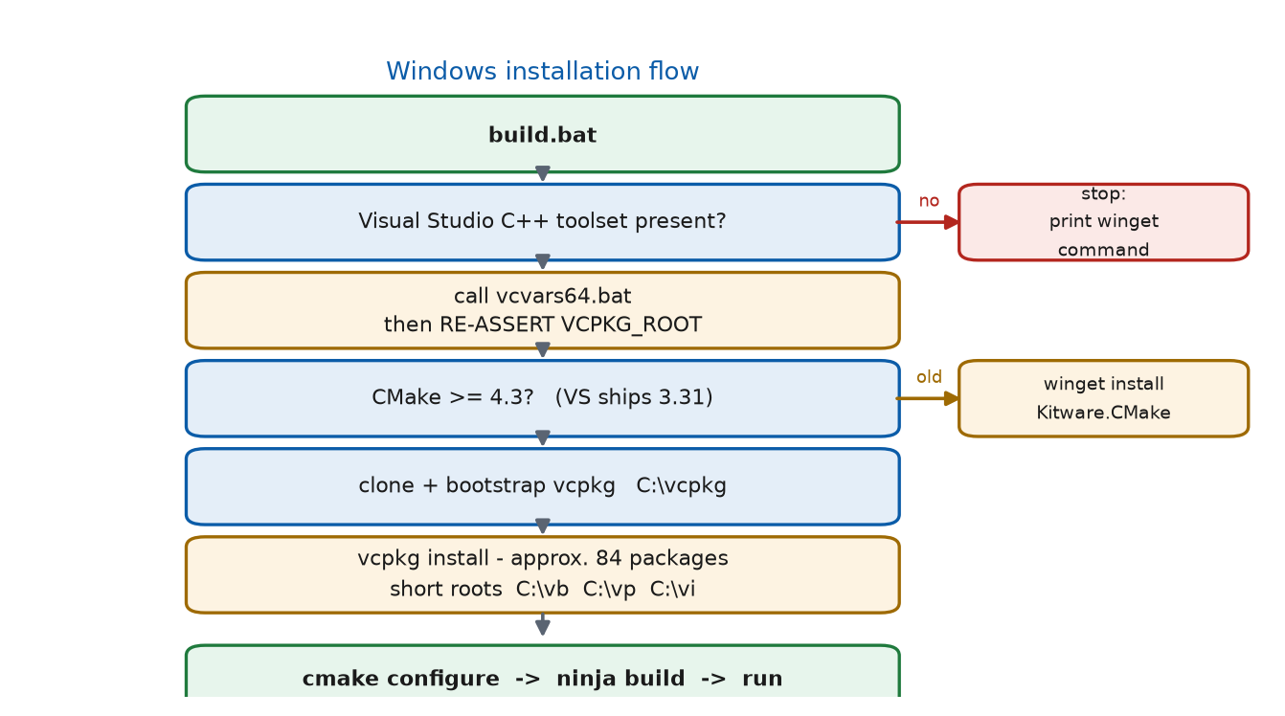
Figure 7 — Windows installation flow, with the two hazards marked

Step 4.5 What was installed and where
Path | Contents | Why here
C:\vcpkg | vcpkg clone | Short path — see 4.6
C:\vb | vcpkg build trees | Short path — see 4.6
C:\vp | vcpkg packages | Short path — see 4.6
C:\vi | installed headers, libs, DLLs | Short path — see 4.6
cmake-build-msvc-static-release\ | build output and the executable | In the repository

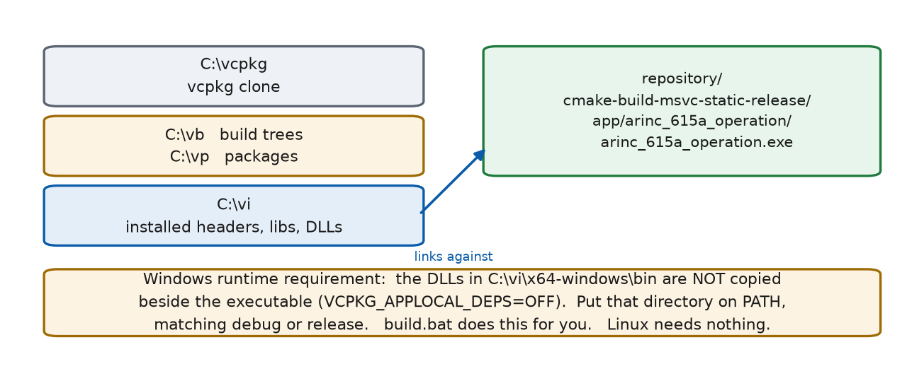
Figure 8 — Where the installation puts things, and the runtime DLL requirement

4.6 Why the short paths are mandatory
vcpkg builds libiconv with autotools. During make install it forms a path by concatenating the package directory with the full install prefix. Under a deep project path the result exceeds the Windows 260-character limit, libtool falls back to the long-path form, and cl.exe rejects it as an unknown option:
cl : Command line warning D9002 : ignoring unknown option '//?/C:/.../iconv.lib'
iconv.obj : error LNK2019: unresolved external symbol libiconv_open
.libs\iconv.exe : fatal error LNK1120: 7 unresolved externals

The import library is silently dropped and the port fails after roughly 40 minutes of work. Do not repoint these roots at longer paths.

5 Installation — Linux
Linux uses system libraries rather than vcpkg, because the GCC presets carry no vcpkg toolchain file. libiconv is therefore never built from source and the failure in 4.6 cannot occur.

Step 5.1 Obtain the source
git clone <repository-url> arinc-615a-tool-suite
cd arinc-615a-tool-suite

Step 5.2 Install, build and run — one command
./build.sh
./build.sh -c Find
./build.sh debug -c Find
./build.sh --no-run

sudo is invoked for package installation; you will be prompted for your password.
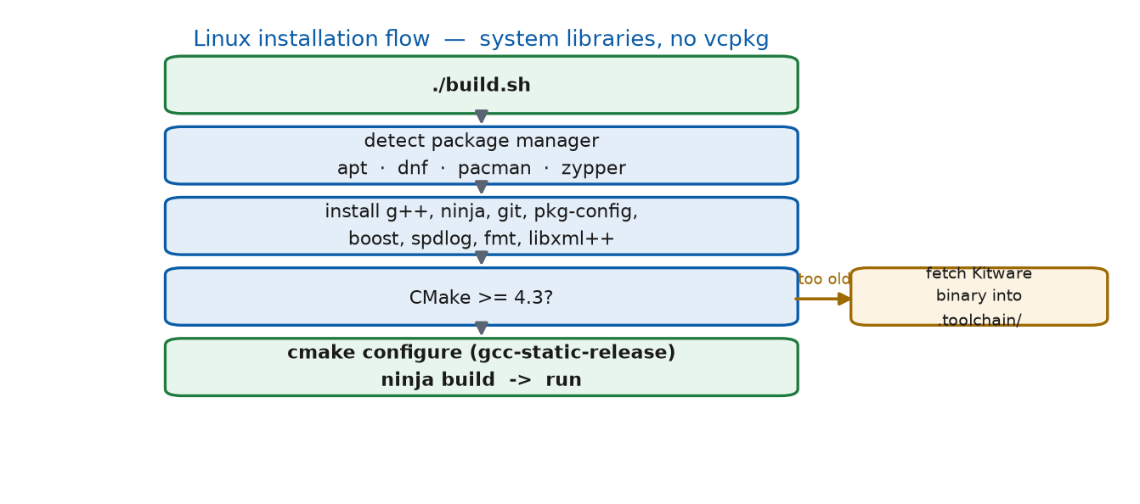
Figure 9 — Linux installation flow: distro packages, no vcpkg

Step 5.3 Packages installed per distribution
Need | apt | dnf | pacman | zypper
Compiler | build-essential g++ | gcc-c++ | base-devel | gcc-c++
Generator | ninja-build | ninja-build | ninja | ninja
Boost | libboost-all-dev | boost-devel | boost | boost-devel
spdlog | libspdlog-dev | spdlog-devel | spdlog | spdlog-devel
fmt | libfmt-dev | fmt-devel | fmt | fmt-devel
libxml++ | libxml++5.0-dev / 2.6 | libxml++-devel | libxml++ | libxml++-devel

If the distribution's CMake is older than 4.3 — most are — the installer downloads the official Kitware binary into a git-ignored .toolchain/ directory and uses that. Override the version with CMAKE_VERSION=4.4.2 scripts/install-deps.sh.

6 Post-installation verification
Three checks confirm a good installation before any operational use.

Check 6.1 The executable exists
REM Windows
dir cmake-build-msvc-static-release\app\arinc_615a_operation\arinc_615a_operation.exe

# Linux
ls -l cmake-build-gcc-static-release/app/arinc_615a_operation/arinc_615a_operation

Check 6.2 Windows only — put the DLLs on PATH
The Windows build links against the dynamic x64-windows triplet with VCPKG_APPLOCAL_DEPS=OFF, so dependency DLLs are not copied next to the executable. build.bat handles this; running the exe directly does not. Match the configuration — never mix release DLLs into a debug binary.
set "PATH=C:\vi\x64-windows\bin;%PATH%" REM release
set "PATH=C:\vi\x64-windows\debug\bin;%PATH%" REM debug

Linux needs nothing here — system libraries are already on the loader search path.

Check 6.3 The tool responds
arinc_615a_operation.exe --help

7 Operating procedures

7.1 Command syntax
arinc_615a_operation.exe -c <Command> [options]
arinc_615a_operation.exe -c <Command> --help
arinc_615a_operation.exe --help

7.2 MANDATORY — option syntax
Always use the long option form with '='. For example --timeout=5, not -t 5.
Space-separated values are mis-consumed, and short flags are reused for different meanings across option groups, so a short flag can silently bind to the wrong option:
Short flag | Means | But also means
-l | --log-level | --targets-list
-i | --target-id | --timeout-option (TFTP)
-t | --timeout (Find) | --tftp-timeout
-p | --dynamic-port (Find) | --server-port (TFTP)
-d | --media-set-manager-dir | --dally (TFTP)
-c | --command | --check-file-integrity, --no-check-validity

7.3 Addressing a target
REM directly by IP
--target-address=10.0.0.5 --target-id=THW-1

REM or resolve the ID through a list produced by Find
--targets-list=targets.json --target-id=THW-1

--target-id is required on every operation. BatchUpload accepts only --targets-list, because a batch spans multiple targets.

7.4 Options common to all ARINC 615A operations
Option | Default | Purpose
--dlp-timeout=<s> | 13 | Exception timer; fails a stalled operation
--dlp-retries=<n> | — | Protocol retry count
--port-option | off | Enable the ARINC 615A-3 Port Option
--local-tftp-address=<ip> | — | Interface the TFTP server binds to
--log-protocol-files | off | Log every protocol file sent and received
--log-level=<lvl> | warn | trace, debug, info, warn, err, critical, off
--server-port=<port> | — | Local TFTP server UDP port
--tftp-timeout=<s> | — | Packet timeout when none is negotiated
--dally | — | Wait after final ACK to survive a lost last ACK
--block-size-option[=n] | 1468 | Negotiate TFTP block size, 8 to 65464
--timeout-option[=s] | 2 | Negotiate TFTP timeout, 1 to 255
--handle-transfer-size-option | — | Negotiate the transfer size option

7.5 Typical operational session
REM 1. discover what is on the network
arinc_615a_operation.exe -c Find --timeout=5 --targets-list=targets.json

REM 2. read what is currently loaded on a target
arinc_615a_operation.exe -c Information --targets-list=targets.json --target-id=THW-1

REM 3. stage the software locally
arinc_615a_operation.exe -c Create --media-set-manager-dir=C:\msm
arinc_615a_operation.exe -c ImportMediaSet --media-set-manager-dir=C:\msm --source-directory=D:\medium1
arinc_615a_operation.exe -c ListLoads --media-set-manager-dir=C:\msm

REM 4. upload
arinc_615a_operation.exe -c Upload --targets-list=targets.json --target-id=THW-1 --media-set-manager-dir=C:\msm --media-set-pn=ABC12-3456-7890 --load-header=LOAD001.LUH

REM 5. confirm the change took effect
arinc_615a_operation.exe -c Information --targets-list=targets.json --target-id=THW-1

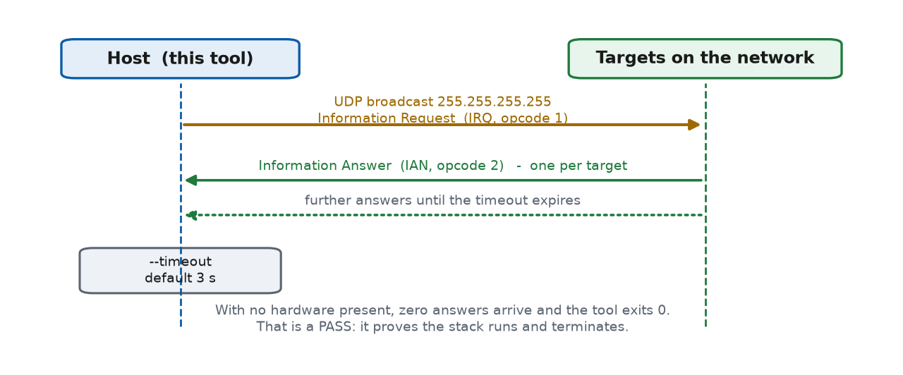
Figure 10 — FIND discovery: one broadcast, N answers, bounded by --timeout
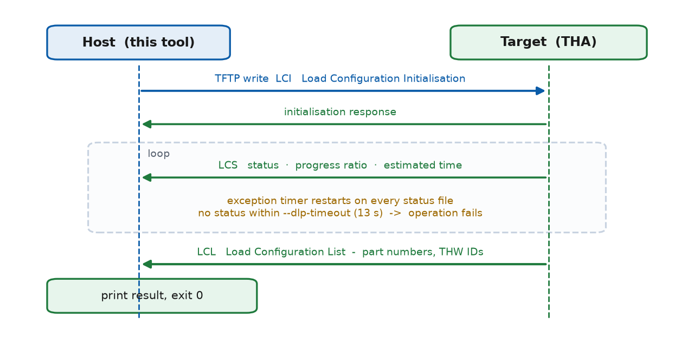
Figure 11 — Information operation: LCI out, LCS status loop, LCL result
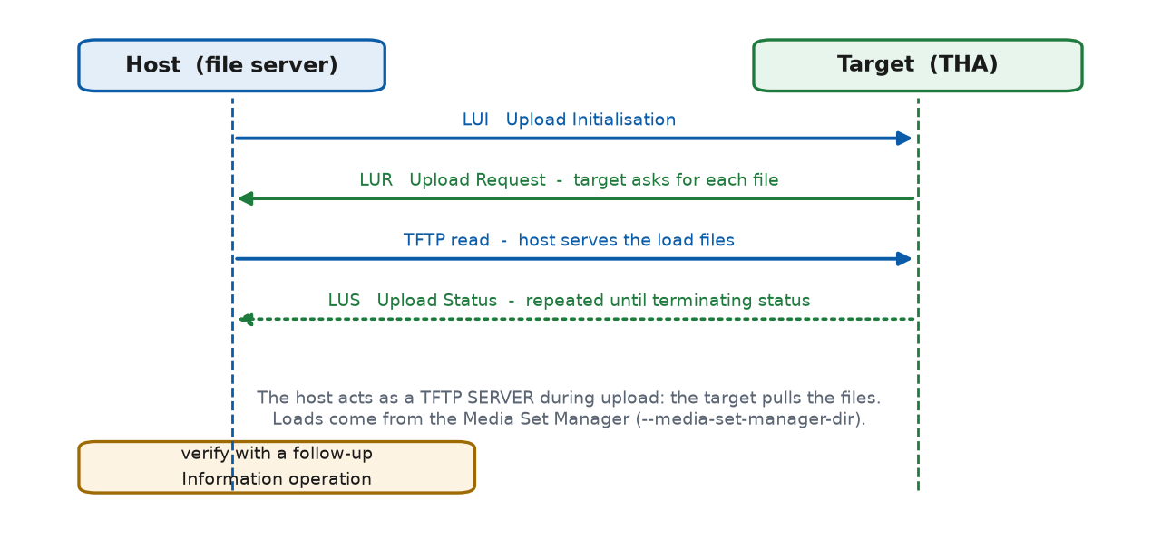
Figure 12 — Upload: the host becomes a TFTP server and the target pulls the files

7.6 Stopping an operation
Press Ctrl-C once for a graceful protocol abort — the tool tells the target to stop. Press Ctrl-C a second time only if the first does not return; that terminates hard and may leave the target in an undefined state. On real hardware, allow the first abort to complete.

8 Test procedure
Execute in order. Tests 1 to 12 need no target hardware and form the acceptance set for an installation. Tests 13 to 16 require hardware or a Linux host.
Legend | Meaning
VERIFIED | Executed on Windows x64; the expected output shown is the actual output
NOT EXECUTED | Specified from the tool's option definitions; not run

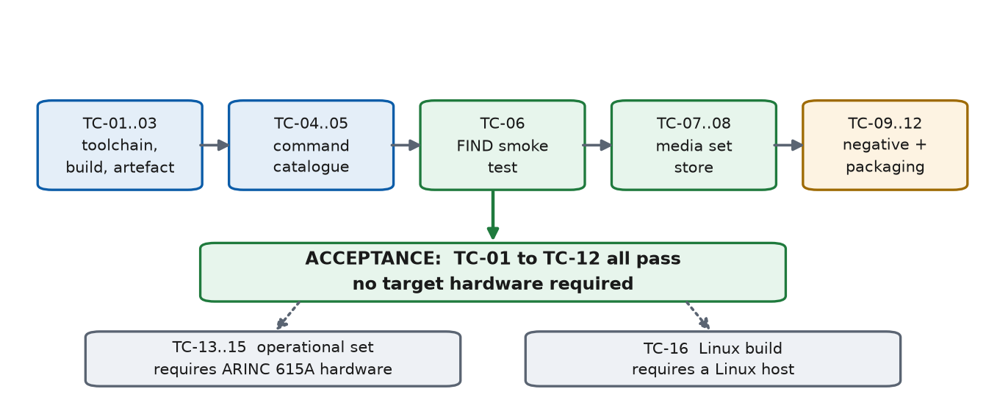
Figure 13 — Test sequence and the acceptance gate

8.1 Test environment used for verification
Item | Value
OS | Windows 11 x64
Compiler | MSVC 14.44 (Visual Studio 2022 Build Tools)
CMake / generator | 4.4.2 / Ninja
Configuration | msvc-static-release
Executable size | 2,091,520 bytes
Network | No ARINC 615A target hardware present

9 Test cases

TC-01 Toolchain prerequisites are detected
Field | Detail
Objective | Confirm the installer finds the compiler, CMake 4.3+ and Ninja.
Preconditions | Visual Studio 2022 C++ tools and CMake 4.3+ installed.
Verification status | VERIFIED

Procedure
scripts\install-deps.bat

Expected result
[1/3] Checking toolchain...
OK: Visual Studio C:\Program Files (x86)\Microsoft Visual Studio\2022\BuildTools
OK: CMake C:\Program Files\CMake\bin\cmake.exe
OK: Ninja

Exit code: 0

TC-02 One-command build from a clean tree
Field | Detail
Objective | Confirm dependencies install and all targets build.
Preconditions | TC-01 passed. Network access available.
Verification status | VERIFIED

Procedure
build.bat --no-run

Expected result
==== BUILD OK ====
Executable: ...\cmake-build-msvc-static-release\app\arinc_615a_operation\arinc_615a_operation.exe

Exit code: 0
Note: first run may take hours (libiconv). Later runs, seconds.

TC-03 Build artefact is produced
Field | Detail
Objective | Confirm the executable exists and is non-trivial in size.
Preconditions | TC-02 passed.
Verification status | VERIFIED

Procedure
dir cmake-build-msvc-static-release\app\arinc_615a_operation\arinc_615a_operation.exe

Expected result
One file listed, size approximately 2,091,520 bytes (Release).
Debug builds are larger, approximately 9 MB.

TC-04 Command catalogue is complete
Field | Detail
Objective | Confirm all 16 commands register.
Preconditions | TC-03 passed; DLLs on PATH per 6.2.
Verification status | VERIFIED

Procedure
arinc_615a_operation.exe --help

Expected result
ARINC 615A Operation - (<git-hash>)
Command Options:
-c [ --command ] command Command to execute
-h [ --help ] Help
Commands are:
* AdhocUpload * BatchUpload * Create * Find
* ImportMediaSet * ImportMediaSetXml * Information * ListBatches
* ListLoads * ListMediaSets * MedDownload * OpDownload
* RemoveMediaSet * Targets * Upload * UploadLoads

PASS if all 16 names appear. Exit code: 1 (help with no command)

TC-05 Per-command help dispatches
Field | Detail
Objective | Confirm a sub-command parses and reports its own options.
Preconditions | TC-04 passed.
Verification status | VERIFIED

Procedure
arinc_615a_operation.exe -c ListMediaSets --help

Expected result
List all Media Sets registered with the Media Set Manager.

List ARINC 665 Media Sets Options:
-d [ --media-set-manager-dir ] Directory
ARINC 665 Media Set Manager directory.
Required.

Exit code: 0

TC-06 FIND discovery executes and terminates
Field | Detail
Objective | Confirm the protocol stack opens a socket, broadcasts, honours its timeout and shuts down cleanly. This is the primary smoke test.
Preconditions | TC-04 passed. Any network interface up.
Verification status | VERIFIED

Procedure
arinc_615a_operation.exe -c Find

Expected result
ARINC 615A Operation - (<git-hash>)
ARINC 615A FIND Query
ARINC 615A FIND Query finished

Exit code: 0
With no target hardware present, zero targets are reported. That is a PASS —
the test proves the stack runs and terminates, not that hardware exists.

TC-07 Media Set Manager can be created
Field | Detail
Objective | Confirm the ARINC 665 local store initialises.
Preconditions | TC-04 passed.
Verification status | VERIFIED

Procedure
arinc_615a_operation.exe -c Create --media-set-manager-dir=%TEMP%\msm-test

Expected result
Create ARINC 665 Media Set Manager
Media Set Manager directory: C:\Users\<user>\AppData\Local\Temp\msm-test

Exit code: 0
A file MediaSetManager.json (6 bytes when empty) is created in that directory.

TC-08 Empty store reports empty
Field | Detail
Objective | Confirm the list commands read the store and report correctly when it is empty.
Preconditions | TC-07 passed.
Verification status | VERIFIED

Procedure
arinc_615a_operation.exe -c ListMediaSets --media-set-manager-dir=%TEMP%\msm-test
arinc_615a_operation.exe -c ListLoads --media-set-manager-dir=%TEMP%\msm-test
arinc_615a_operation.exe -c ListBatches --media-set-manager-dir=%TEMP%\msm-test

Expected result
List ARINC 665 Media Sets
*** No media sets within media set manger ***

List ARINC 665 Loads
*** No loads within media set manger ***

List ARINC 665 Batches
*** No batches within media set manger ***

Exit code: 0 for all three.
Note: 'manger' is the tool's own spelling; match it exactly when parsing output.

TC-09 Negative — no command supplied
Field | Detail
Objective | Confirm a missing command is rejected with guidance.
Preconditions | TC-04 passed.
Verification status | VERIFIED

Procedure
arinc_615a_operation.exe

Expected result
Error parsing command line: the option 'command' is required but missing
Enter <path>\arinc_615a_operation.exe --help for command line description.

Exit code: 1

TC-10 Negative — unknown command
Field | Detail
Objective | Confirm an invalid command name is rejected.
Preconditions | TC-04 passed.
Verification status | VERIFIED

Procedure
arinc_615a_operation.exe -c NoSuchCommand

Expected result
Error parsing command line: the argument ('NoSuchCommand') for option is invalid
Enter <path> --command NoSuchCommand --help for command line description.

Exit code: 1

TC-11 Negative — required option omitted
Field | Detail
Objective | Confirm required options are enforced per command.
Preconditions | TC-04 passed.
Verification status | VERIFIED

Procedure
arinc_615a_operation.exe -c Information --target-address=127.0.0.1
arinc_615a_operation.exe -c ListMediaSets

Expected result
ARINC 615A Information Operation
Error parsing command line: the option '--target-id' is required but missing

List ARINC 665 Media Sets
Error parsing command line: the option '--media-set-manager-dir' is required but missing

Exit code: 1 for both

TC-12 Release package is self-contained
Field | Detail
Objective | Confirm the published binary runs with no vcpkg directory on PATH.
Preconditions | Release zip downloaded and extracted.
Verification status | VERIFIED

Procedure
REM in a shell whose PATH contains only C:\Windows and C:\Windows\system32
arinc_615a_operation.exe -c Find

Expected result
ARINC 615A Operation - (<git-hash>)
ARINC 615A FIND Query
ARINC 615A FIND Query finished

Exit code: 0
PASS requires no missing-DLL dialog. The package bundles six DLLs:
boost_program_options, fmt, iconv-2, libxml2, xml++, z.

TC-13 Information operation against a target
Field | Detail
Objective | Read part numbers and versions from real target hardware.
Preconditions | An ARINC 615A target reachable on the network; its IP and target ID known.
Verification status | NOT EXECUTED — requires target hardware

Procedure
arinc_615a_operation.exe -c Information --target-address=<ip> --target-id=<id> --log-level=info

Expected result
The host writes an LCI, receives LCS status files while the target works, and
finally an LCL listing target hardware IDs and loaded part numbers.

PASS: part numbers are printed and the exit code is 0.
FAIL: operation aborted by DLP (no status within --dlp-timeout, default 13 s).

TC-14 Upload operation
Field | Detail
Objective | Upload a load from a registered media set to a target.
Preconditions | TC-13 passed. A media set imported and its P/N and load header known.
Verification status | NOT EXECUTED — requires target hardware

Procedure
arinc_615a_operation.exe -c Upload --target-address=<ip> --target-id=<id> --media-set-manager-dir=<dir> --media-set-pn=<pn> --load-header=<file>

Expected result
Progress is reported from LUS status files until a terminating status.

PASS: exit code 0, and a subsequent TC-13 reports the new part number.
Verify the change actually took effect; do not rely on exit code alone.

TC-15 Download operation
Field | Detail
Objective | Retrieve files from a target.
Preconditions | TC-13 passed.
Verification status | NOT EXECUTED — requires target hardware

Procedure
REM list what is offered without downloading — omit --file
arinc_615a_operation.exe -c MedDownload --target-address=<ip> --target-id=<id>

REM then fetch specific files
arinc_615a_operation.exe -c MedDownload --target-address=<ip> --target-id=<id> --file=<name> --download-base-directory=<dir>

Expected result
Without --file the operation cancels after the list transfer, showing what is
available. With --file, the named files are written to a sub-directory of
--download-base-directory (default: current directory).

PASS: requested files present on disk and validity check passes; exit code 0.

TC-16 Linux build and run
Field | Detail
Objective | Confirm the Linux path installs, builds and runs.
Preconditions | A supported Linux distribution with sudo and network access.
Verification status | NOT EXECUTED — no Linux environment was available

Procedure
./build.sh --no-run
cmake-build-gcc-static-release/app/arinc_615a_operation/arinc_615a_operation -c Find

Expected result
BUILD OK, then the same FIND output as TC-06, exit code 0.
No PATH configuration is needed on Linux.

The Linux scripts are syntax-checked only. Distro package names are the most
likely thing to need adjusting.

9.1 Acceptance criteria
An installation is acceptable when TC-01 through TC-12 all pass. TC-13 through TC-15 form the operational acceptance set and can only be executed against target hardware. TC-16 applies to Linux hosts.

10 Troubleshooting
Symptom | Cause | Action
LNK2019 / LNK1120 building libiconv; 'ignoring unknown option //?/C:/...' | Path length. vcpkg concatenates the install prefix onto the package directory, exceeding 260 characters; libtool emits the long-path form and cl.exe drops the .lib. | Ensure vcpkg roots are C:\vcpkg, C:\vb, C:\vp, C:\vi. Do not relocate to longer paths.
error C2220 with warning C4127 inside a Boost header | The presets combine /WX with /external:templates-, so a warning in a dependency's headers becomes an error. | Use scripts\build.bat, which passes -DCMAKE_COMPILE_WARNING_AS_ERROR=OFF.
CMake Error: No target "arinc_615a_download_request_file" | InstallPackage.cmake referenced a target that app/CMakeLists.txt no longer builds; fails at generate time, after configure succeeds. | Already fixed here with if( TARGET ... ). Re-apply if merging upstream changes.
Configure fails cloning dependencies | No network access to git.thomas-vogt.de. There is no offline fallback. | Restore access, or place checkouts beside the source tree so CMake picks them up.
Application fails to start with a missing-DLL error | Dynamic triplet with VCPKG_APPLOCAL_DEPS=OFF; DLLs are not beside the executable. | Set PATH per 6.2, matching debug/release, or use the Release zip which bundles them.
CMake reports a version below 4.3 | The CMake bundled with Visual Studio is 3.31 and appears first on PATH after vcvars. | Install CMake 4.3+; the script searches for a qualifying installation.
'the required argument for option --timeout is missing' | Space-separated short option. | Use --timeout=5, not -t 5.
'the argument (--timeout) for option --log-level is invalid' | -l is bound to both --log-level and --targets-list in Find. | Avoid -l on that sub-command; use long forms with '='.
Operation aborted by DLP | The target sent no status file within the exception timer. | Check connectivity and target state; raise --dlp-timeout; add --log-protocol-files.
Build appears frozen for a long time | libiconv's autotools configure. vcpkg buffers a port's output until it finishes. | Normal. Watch file timestamps under C:\vb\libiconv rather than the console.

11 Appendices

Appendix A Exit codes
Code | Meaning
0 | Success, including a sub-command --help
1 | Argument error, protocol failure, or top-level --help with no command

Appendix B Command index
Command | Group | Needs target hardware
Find | Discovery | No — safe smoke test
Targets | Discovery | No — reads a saved list
Information | 615A operation | Yes
Upload | 615A operation | Yes
AdhocUpload | 615A operation | Yes
BatchUpload | 615A operation | Yes
UploadLoads | 615A operation | Yes
MedDownload | 615A operation | Yes
OpDownload | 615A operation | Yes
Create | ARINC 665 store | No
ImportMediaSet | ARINC 665 store | No
ImportMediaSetXml | ARINC 665 store | No
ListMediaSets | ARINC 665 store | No
ListLoads | ARINC 665 store | No
ListBatches | ARINC 665 store | No
RemoveMediaSet | ARINC 665 store | No

Appendix C Related documents
Document | Contents
README.md | Overview, diagrams, quick start, command list
docs/BUILD.md | Build stages, dependencies, failure modes, linked resources
docs/ARCHITECTURE.md | Layer map, directory walkthrough, design conventions
docs/CODE-TRACE.md | Function-by-function trace from main() to the wire

Appendix D Standards
Reference | Title
ARINC 615A-4 | Software Data Loader Using Ethernet Interface
ARINC 665-5 | Loadable Software Standards
ARINC 649 | Common Terminology and Functions for Software Distribution and Loading
RFC 1350 | The TFTP Protocol (Revision 2)
RFC 2347/2348/2349 | TFTP Option Extension, Blocksize, Timeout and Transfer Size

ARINC standards are published by SAE ITC and are not redistributed with this software. ARINC is a trademark of its respective owner; this project implements the publicly documented protocol and is not affiliated with or endorsed by ARINC.

