

VISVESVARAYA TECHNOLOGICAL UNIVERSITY
“JnanaSangama”, Belgaum -590014, Karnataka.

LAB RECORD

Bio Inspired Systems (23CS5BSBIS)
Submitted by
Hitish Rao P USN: 1BM23CS116

in partial fulfilment for the award of the degree of

BACHELOR OF ENGINEERING
in
COMPUTER SCIENCE AND ENGINEERING

B.M.S. COLLEGE OF ENGINEERING
(Autonomous Institution under VTU)
BENGALURU-560019
Aug-2025 to Dec-2025

B.M.S. College of Engineering,
Bull Temple Road, Bangalore 560019
(Affiliated To Visvesvaraya Technological University, Belgaum)
Department of Computer Science and Engineering

CERTIFICATE

This is to certify that the Lab work entitled “Bio Inspired Systems (23CS5BSBIS)” carried out by Hitish Rao P (1BM23CS116), who is Bonafide student of B.M.S. College of Engineering. It is in partial fulfilment for the award of Bachelor of Engineering in Computer Science and Engineering of the Visvesvaraya Technological University, Belgaum. The Lab report has been approved as it satisfies the academic requirements of the above-mentioned subject and the work prescribed for the said degree.

Sowmya T  Assistant Professor  Department of CSE, BMSCE | Dr. Kavitha Sooda Professor & HOD  Department of CSE, BMSCE

Index

Sl.  No. | Date | Experiment Title | Page No.
1 | 18/08/2025 | Genetic Algorithm for Optimization Problems | 4 - 7
2 | 25/08/2025 | Optimization via Gene Expression Algorithms | 8 - 10
3 | 01/09/2025 | Particle Swarm Optimization for Function Optimization | 11 – 13
4 | 08/09/2025 | Ant Colony Optimization for the Traveling Salesman Problem | 14 – 16
5 | 15/09/2025 | Cuckoo Search (CS) | 17 – 20
6 | 29/09/2025 | Grey Wolf Optimizer (GWO) | 21 – 22
7 | 13/10/2025 | Parallel Cellular Algorithms and Programs | 23 – 24

GitHub Link:
https://github.com/Hitish-Rao-P/bis-lab

Program 1: Genetic Algorithm for Optimization Problems

Genetic Algorithms (GA) are inspired by the process of natural selection and genetics, where the fittest individuals are selected for reproduction to produce the next generation. GAs are widely used for solving optimization and search problems. Implement a Genetic Algorithm using Python to solve a basic optimization problem, such as finding the maximum value of a mathematical function.

Algorithm:
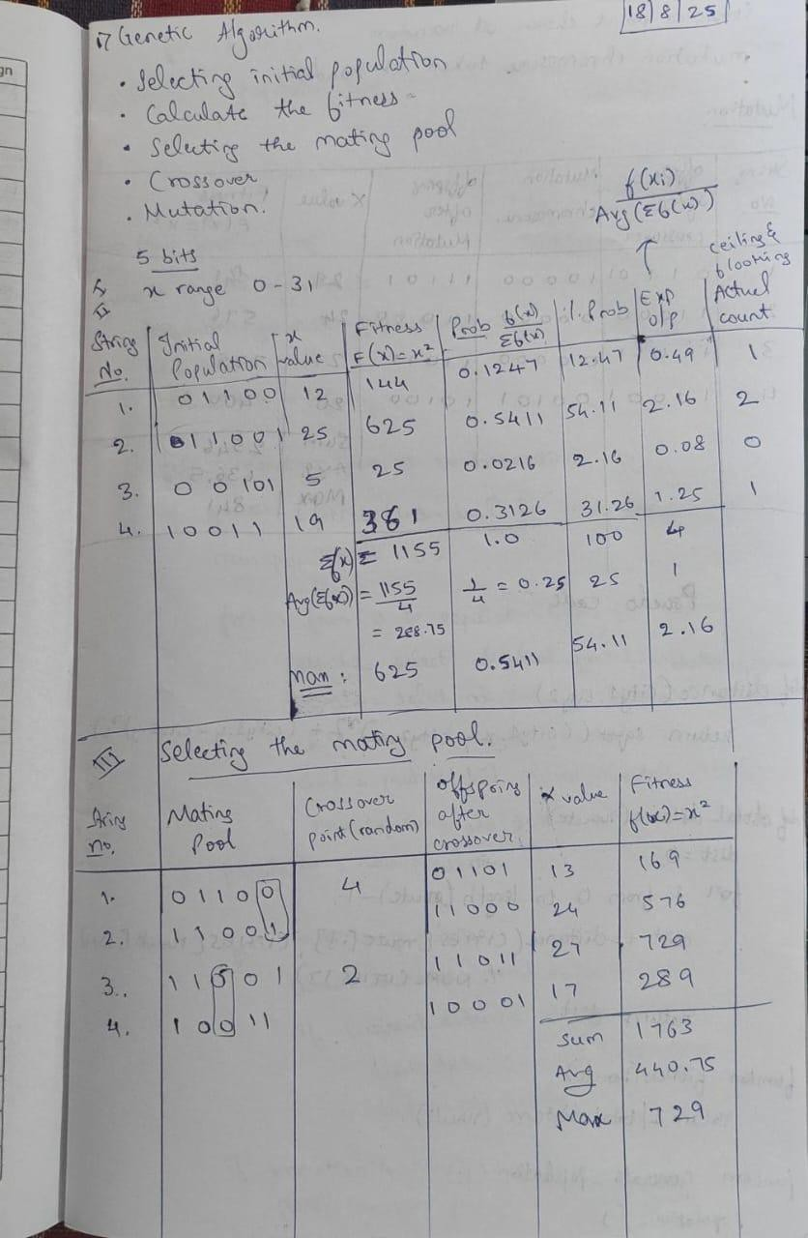

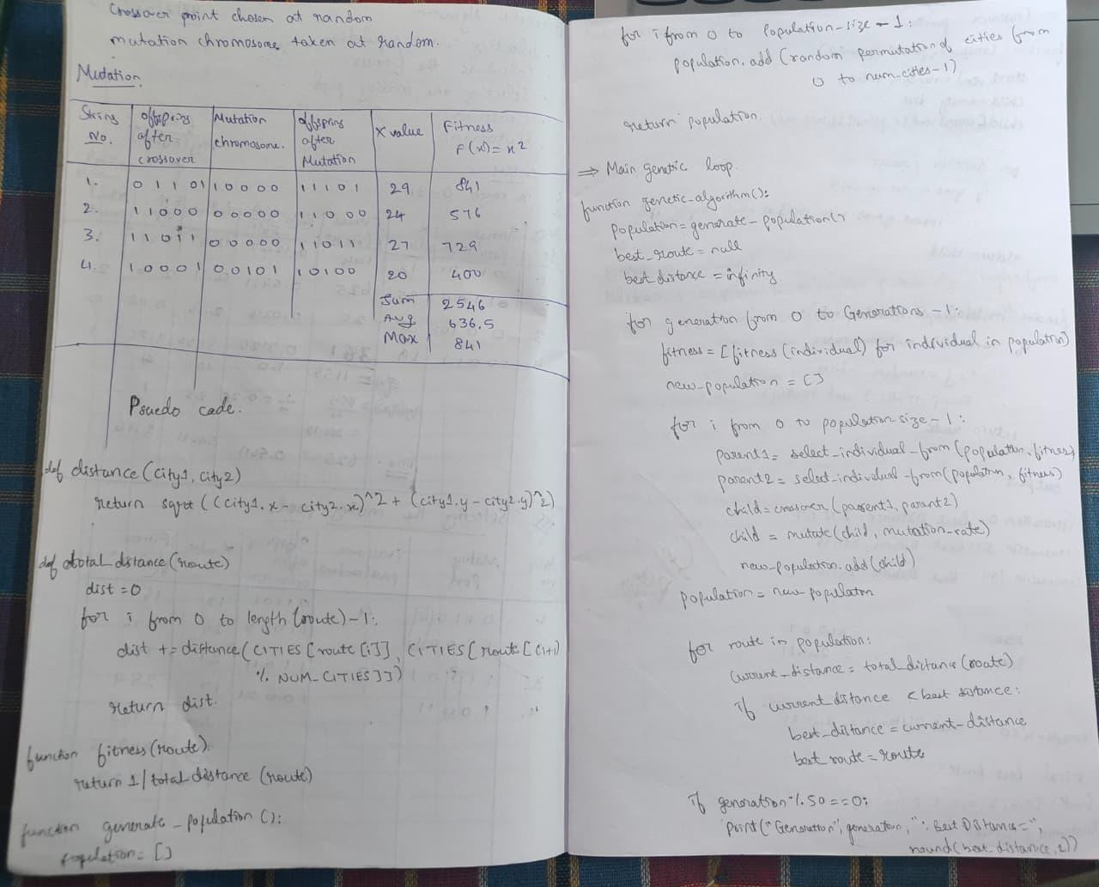
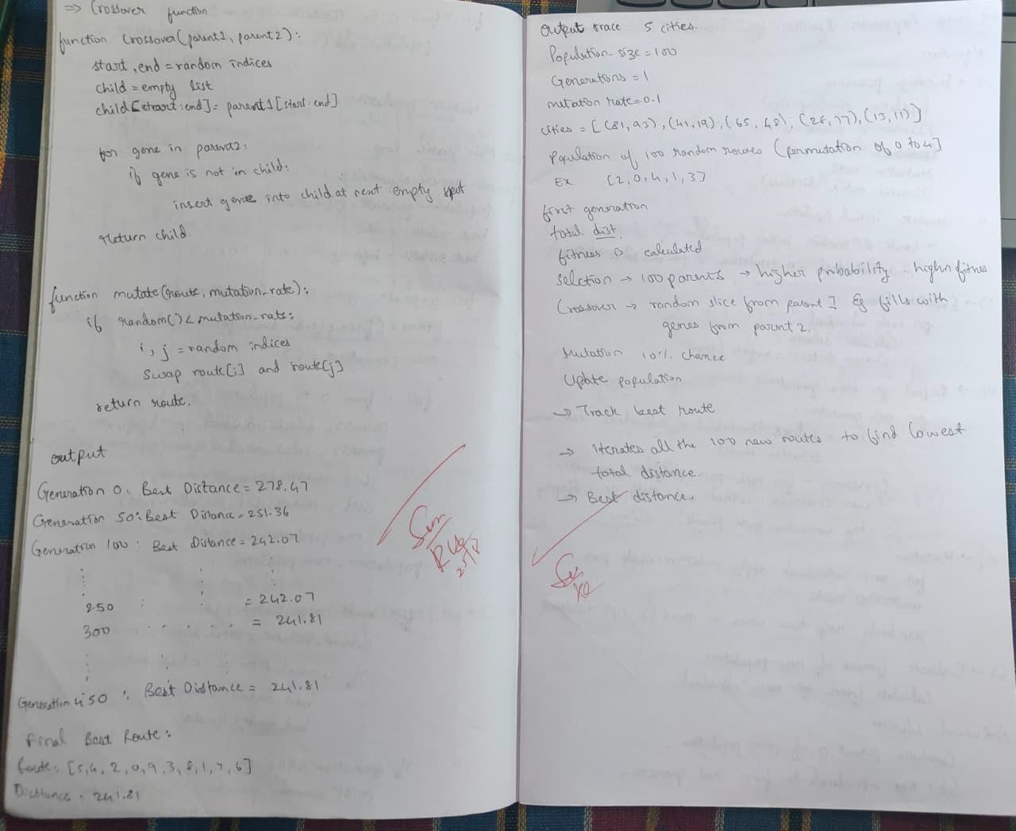

Code:

import random import math

NUM_CITIES = 10
POPULATION_SIZE = 100
GENERATIONS = 500
MUTATION_RATE = 0.1
cities = [(random.randint(0, 100), random.randint(0, 100)) for _ in range(NUM_CITIES)] def distance(city1, city2):
return math.sqrt((city1[0] - city2[0])**2 + (city1[1] - city2[1])**2)

def total_distance(route): dist = 0
for i in range(len(route)):
dist += distance(cities[route[i]], cities[route[(i + 1) % NUM_CITIES]]) return dist
def fitness(route):
return 1 / total_distance(route)
def generate_population():
return [random.sample(range(NUM_CITIES), NUM_CITIES) for _ in range(POPULATION_SIZE)]

def selection(population, fitnesses):
selected = random.choices(population, weights=fitnesses, k=POPULATION_SIZE) return selected
def crossover(parent1, parent2):
start, end = sorted(random.sample(range(NUM_CITIES), 2)) child = [None] * NUM_CITIES
child[start:end] = parent1[start:end] pointer = 0
for gene in parent2:
if gene not in child:
while child[pointer] is not None: pointer += 1
child[pointer] = gene return child

def mutate(route):
if random.random() < MUTATION_RATE:
i, j = random.sample(range(NUM_CITIES), 2) route[i], route[j] = route[j], route[i]
return route

def genetic_algorithm():
population = generate_population() best_route = None
best_distance = float('inf')

for generation in range(GENERATIONS): fitnesses = [fitness(ind) for ind in population] new_population = []

for _ in range(POPULATION_SIZE):
parent1, parent2 = selection(population, fitnesses)[:2] child = crossover(parent1, parent2)
child = mutate(child) new_population.append(child)
population = new_population for route in population:
dist = total_distance(route)
if dist < best_distance: best_distance = dist best_route = route
if generation % 50 == 0:
print(f"Generation {generation}: Best Distance = {round(best_distance, 2)}")

print("\n Final Best Route:") print("Route:", best_route) print("Distance:", round(best_distance, 2))
genetic_algorithm()

Program 2: Optimization via Gene Expression Algorithms:

Gene Expression Algorithms (GEA) are inspired by the biological process of gene expression in living organisms. This process involves the translation of genetic information encoded in DNA into functional proteins. In GEA, solutions to optimization problems are encoded in a manner similar to genetic sequences. The algorithm evolves these solutions through selection, crossover, mutation, and gene expression to find optimal or near-optimal solutions. GEA is effective for solving complex optimization problems in various domains, including engineering, data analysis, and machine learning.
Algorithm:
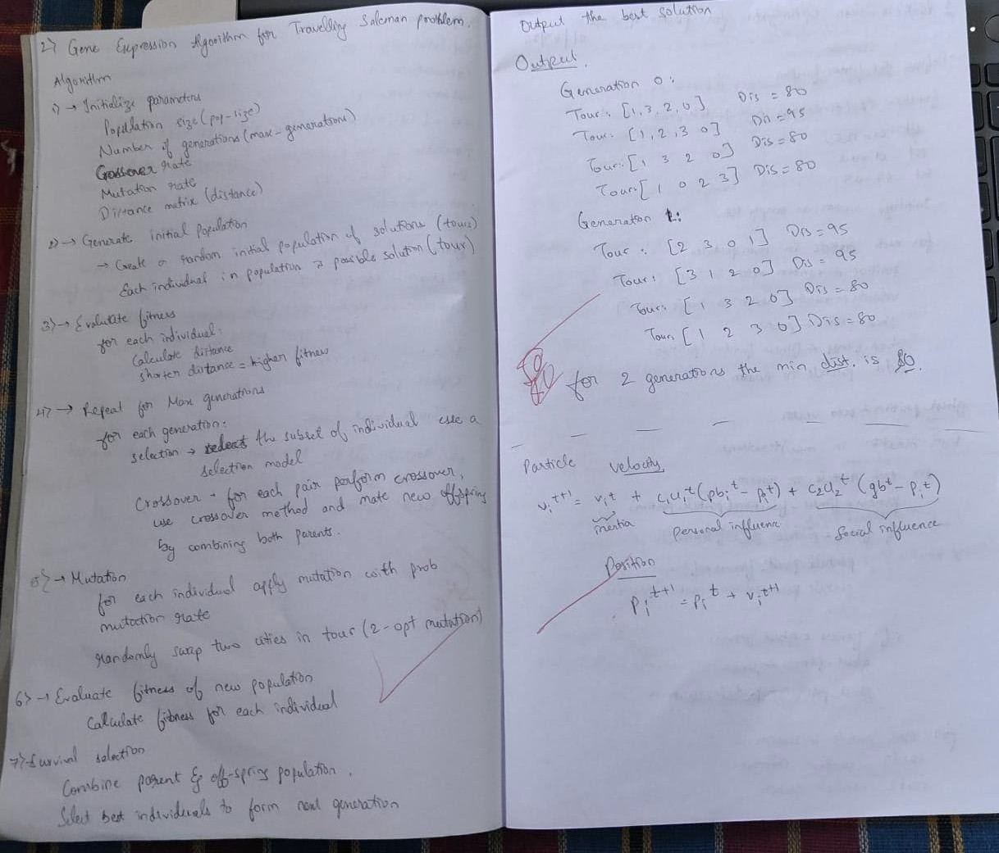

Code:

import random import math
# Parameters NUM_CITIES = 10
POPULATION_SIZE = 100
GENERATIONS = 500
MUTATION_RATE = 0.1

# Generate random cities
cities = [(random.randint(0, 100), random.randint(0, 100)) for _ in range(NUM_CITIES)]

def distance(city1, city2):
return math.sqrt((city1[0] - city2[0])**2 + (city1[1] - city2[1])**2)

def total_distance(route): dist = 0
for i in range(len(route)):
dist += distance(cities[route[i]], cities[route[(i + 1) % NUM_CITIES]]) return dist

def fitness(route):
return 1 / total_distance(route)

def generate_population():
return [random.sample(range(NUM_CITIES), NUM_CITIES) for _ in range(POPULATION_SIZE)]

def selection(population, fitnesses):
selected = random.choices(population, weights=fitnesses, k=POPULATION_SIZE) return selected

def crossover(parent1, parent2):
start, end = sorted(random.sample(range(NUM_CITIES), 2)) child = [None] * NUM_CITIES
child[start:end] = parent1[start:end] pointer = 0
for gene in parent2:
if gene not in child:
while child[pointer] is not None: pointer += 1
child[pointer] = gene return child

def mutate(route):
if random.random() < MUTATION_RATE:
i, j = random.sample(range(NUM_CITIES), 2) route[i], route[j] = route[j], route[i]
return route

def genetic_algorithm():
population = generate_population() best_route = None
best_distance = float('inf')

for generation in range(GENERATIONS): fitnesses = [fitness(ind) for ind in population] new_population = []

for _ in range(POPULATION_SIZE):
parent1, parent2 = selection(population, fitnesses)[:2] child = crossover(parent1, parent2)
child = mutate(child) new_population.append(child)
population = new_population # Track best
for route in population:
dist = total_distance(route) if dist < best_distance:
best_distance = dist best_route = route
if generation % 50 == 0:
print(f"Generation {generation}: Best Distance = {round(best_distance, 2)}")

print("\n Final Best Route:") print("Route:", best_route) print("Distance:", round(best_distance, 2))
genetic_algorithm()

Program 3: Particle Swarm Optimization for Function Optimization:

Particle Swarm Optimization (PSO) is inspired by the social behaviour of birds flocking or fish schooling. PSO is used to find optimal solutions by iteratively improving a candidate solution with regard to a given measure of quality. Implement the PSO algorithm using Python to optimize a mathematical function.

Algorithm:
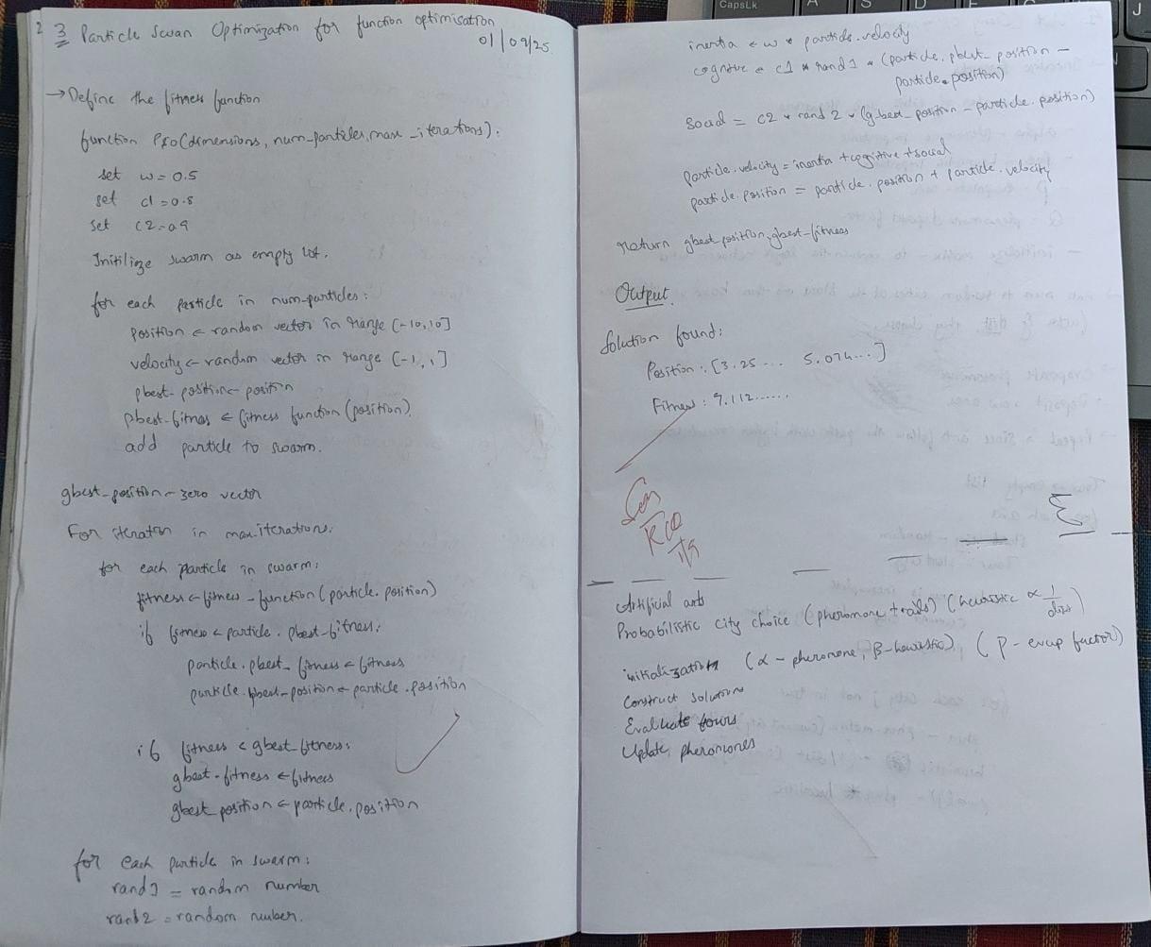

Code:

import random import numpy as np
def fitness_function(position): x, y = position
return -(x**2 + y**2 - 4*x - 6*y)

def particle_swarm_optimization(dimensions, num_particles, max_iterations, threshold): w = 0.5
c1 = 1.2
c2 = 1.4

swarm = []
for _ in range(num_particles):
position = np.random.uniform(-10, 10, size=dimensions) velocity = np.random.uniform(-1, 1, size=dimensions) pbest_position = position.copy()
pbest_fitness = fitness_function(position) swarm.append({'position': position, 'velocity': velocity,
'pbest_position': pbest_position, 'pbest_fitness': pbest_fitness})

gbest_position = np.zeros(dimensions) gbest_fitness = -float('inf')
for i in range(max_iterations): for p in swarm:
fitness = fitness_function(p['position'])
if fitness > p['pbest_fitness']: p['pbest_fitness'] = fitness p['pbest_position'] = p['position'].copy()

if fitness > gbest_fitness: gbest_fitness = fitness gbest_position = p['position'].copy()

if gbest_fitness >= threshold: print(f"Early stopping at iteration {i}") break
for p in swarm:
rand1 = random.random() rand2 = random.random()

inertia = w * p['velocity']
cognitive = c1 * rand1 * (p['pbest_position'] - p['position']) social = c2 * rand2 * (gbest_position - p['position'])

p['velocity'] = inertia + cognitive + social

p['position'] = p['position'] + p['velocity']

print("SOLUTION FOUND:")
print(f" Position: {gbest_position}") print(f" Fitness: {gbest_fitness}") return gbest_position, gbest_fitness

particle_swarm_optimization(dimensions=2, num_particles=20, max_iterations=5000, threshold=2)

Program4: Ant Colony Optimization for the Traveling Salesman Problem:

The foraging behaviour of ants has inspired the development of optimization algorithms that can solve complex problems such as the Traveling Salesman Problem (TSP). Ant Colony Optimization (ACO) simulates the way ants find the shortest path between food sources and their nest. Implement the ACO algorithm using Python to solve the TSP, where the objective is to find the shortest possible route that visits a list of cities and returns to the origin city.
Algorithm:
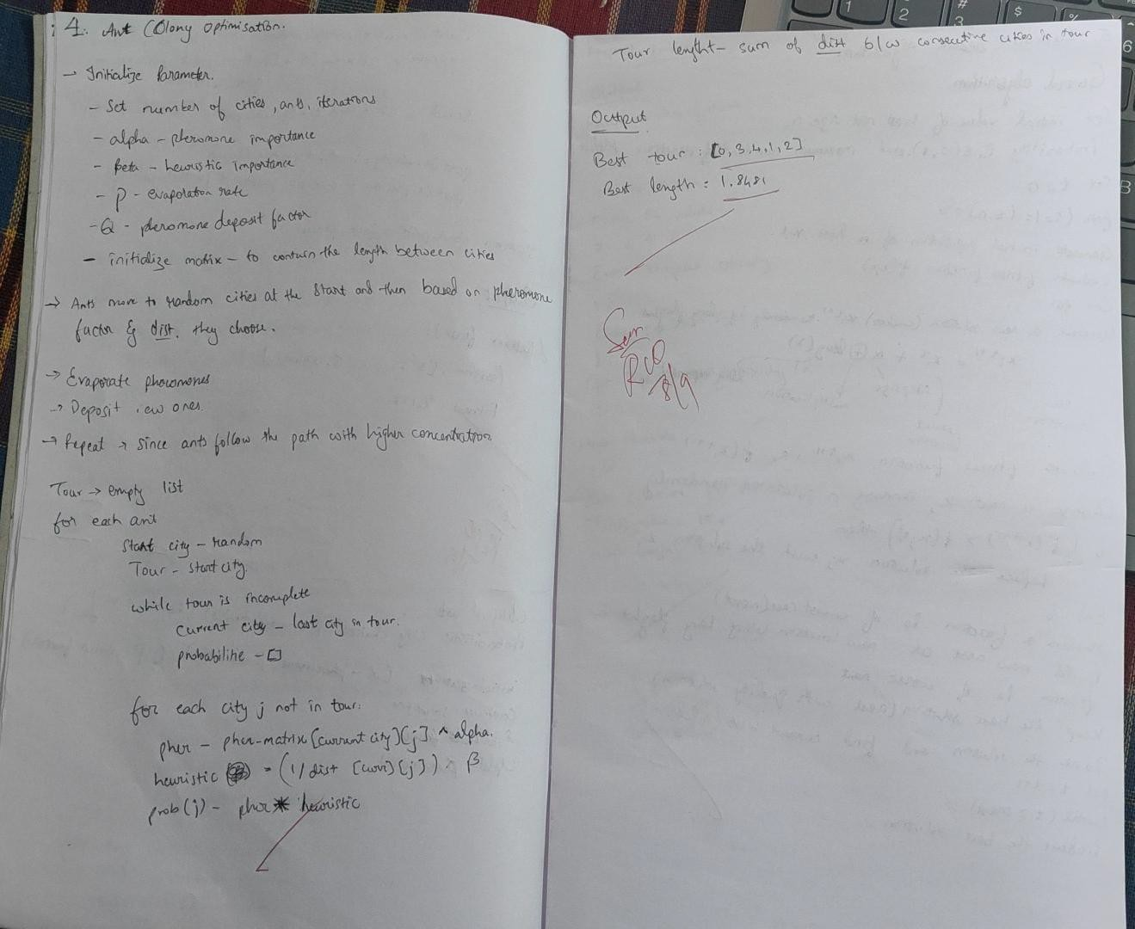

Code:

import numpy as np import random

NUM_CITIES = 5
NUM_ANTS = 20
NUM_ITERATIONS = 100
ALPHA = 1.0
BETA = 5.0
RHO = 0.5
Q = 100

cities = np.random.rand(NUM_CITIES, 2)
distance_matrix = np.linalg.norm(cities[:, None] - cities, axis=2) pheromone_matrix = np.ones((NUM_CITIES, NUM_CITIES))

def calculate_probabilities(current_city, visited): probabilities = []
for next_city in range(NUM_CITIES): if next_city in visited:
probabilities.append(0) else:
pheromone = pheromone_matrix[current_city][next_city] ** ALPHA heuristic = (1 / distance_matrix[current_city][next_city]) ** BETA probabilities.append(pheromone * heuristic)
total = sum(probabilities)
return [p / total if total > 0 else 0 for p in probabilities]

def construct_tour():
start_city = random.randint(0, NUM_CITIES - 1) tour = [start_city]
while len(tour) < NUM_CITIES:
probs = calculate_probabilities(tour[-1], tour)
next_city = np.random.choice(range(NUM_CITIES), p=probs) tour.append(next_city)
return tour

def compute_tour_length(tour):
return sum(distance_matrix[tour[i]][tour[(i + 1) % NUM_CITIES]] for i in range(NUM_CITIES))

best_tour = None best_length = float('inf')

for iteration in range(NUM_ITERATIONS): all_tours = []
for _ in range(NUM_ANTS):

tour = construct_tour()
length = compute_tour_length(tour) all_tours.append((tour, length))

if length < best_length: best_tour = tour best_length = length
pheromone_matrix *= (1 - RHO) for tour, length in all_tours:
for i in range(NUM_CITIES):
a, b = tour[i], tour[(i + 1) % NUM_CITIES] pheromone_matrix[a][b] += Q / length pheromone_matrix[b][a] += Q / length # symmetric TSP

clean_tour = [int(city) for city in best_tour] print("Best tour:", clean_tour)
print("Best length:", round(best_length, 4))

Program 5: Cuckoo Search (CS):

Cuckoo Search (CS) is a nature-inspired optimization algorithm based on the brood parasitism of some cuckoo species. This behavior involves laying eggs in the nests of other birds, leading to the optimization of survival strategies. CS uses Lévy flights to generate new solutions, promoting global search capabilities and avoiding local minima. The algorithm is widely used for solving continuous optimization problems and has applications in various domains, including engineering design, machine learning, and data mining.

Algorithm:
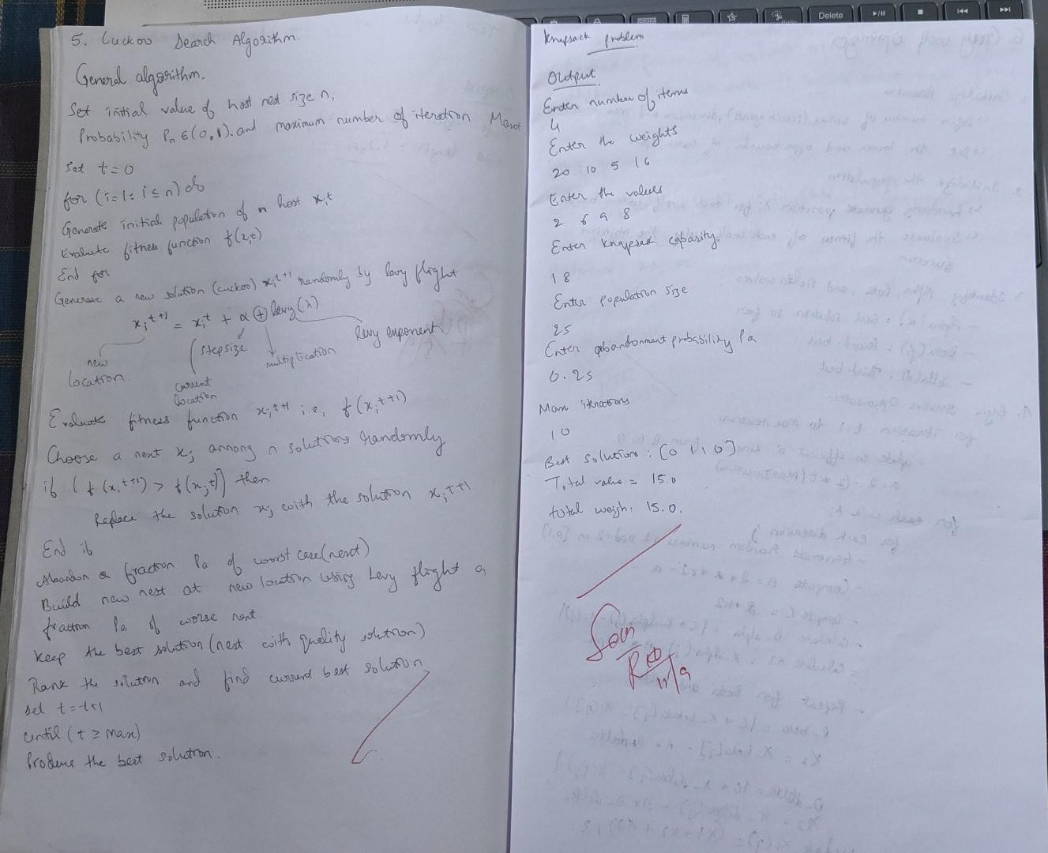

Code:

import numpy as np import math
# --- Levy flight ---
def levy_flight(Lambda, dim):
sigma = (math.gamma(1 + Lambda) * np.sin(np.pi * Lambda / 2) /
(math.gamma((1 + Lambda) / 2) * Lambda * 2**((Lambda - 1) / 2)))**(1 / Lambda) u = np.random.normal(0, sigma, size=dim)
v = np.random.normal(0, 1, size=dim) step = u / abs(v)**(1 / Lambda)
return step

# --- Sigmoid for binary conversion ---def sigmoid(x):
return 1 / (1 + np.exp(-x))
# --- Fitness function for knapsack ---
def fitness_function(x_bin, weights, values, capacity): total_weight = np.sum(x_bin * weights)
total_value = np.sum(x_bin * values) if total_weight > capacity:
return -1 # Penalize overweight solutions heavily else:
return total_value
# --- Cuckoo Search for Binary Knapsack ---
def cuckoo_search_knapsack(weights, values, capacity, n=25, Pa=0.25, Maxt=500): dim = len(weights)
# Initialize nests (continuous vectors)
nests = np.random.uniform(low=-1, high=1, size=(n, dim)) # Convert to binary solutions
nests_bin = np.array([sigmoid(nest) > np.random.rand(dim) for nest in nests]) fitness = np.array([fitness_function(x, weights, values, capacity) for x in nests_bin])

best_idx = np.argmax(fitness) best_nest = nests[best_idx].copy() best_bin = nests_bin[best_idx].copy() best_fitness = fitness[best_idx]

t = 0
while t < Maxt:
for i in range(n):
# Generate new solution by Levy flight step = levy_flight(1.5, dim)
new_nest = nests[i] + 0.01 * step # Convert new_nest to binary
new_bin = sigmoid(new_nest) > np.random.rand(dim)
new_fitness = fitness_function(new_bin, weights, values, capacity)

# If new solution is better, replace

if new_fitness > fitness[i]: nests[i] = new_nest nests_bin[i] = new_bin fitness[i] = new_fitness

if new_fitness > best_fitness: best_fitness = new_fitness best_nest = new_nest.copy() best_bin = new_bin.copy()

# Abandon fraction Pa of worst nests num_abandon = int(Pa * n)
worst_indices = np.argsort(fitness)[:num_abandon] for idx in worst_indices:
nests[idx] = np.random.uniform(-1, 1, dim)
nests_bin[idx] = sigmoid(nests[idx]) > np.random.rand(dim)
fitness[idx] = fitness_function(nests_bin[idx], weights, values, capacity)
if fitness[idx] > best_fitness: best_fitness = fitness[idx] best_nest = nests[idx].copy() best_bin = nests_bin[idx].copy()

t += 1
return best_bin, best_fitness if name == " main ":
print("Enter the number of items:")
n_items = int(input())

weights = [] values = []
print("Enter the weights of the items (space-separated):") weights = np.array(list(map(float, input().split())))
if len(weights) != n_items:
raise ValueError("Number of weights does not match number of items.")

print("Enter the values of the items (space-separated):") values = np.array(list(map(float, input().split())))
if len(values) != n_items:
raise ValueError("Number of values does not match number of items.")

print("Enter the knapsack capacity:") capacity = float(input())

print("Enter population size (default 25):") n = input()
n = int(n) if n.strip() else 25

print("Enter abandonment probability Pa (default 0.25):")

Pa = input()
Pa = float(Pa) if Pa.strip() else 0.25

print("Enter maximum iterations Maxt (default 500):") Maxt = input()
Maxt = int(Maxt) if Maxt.strip() else 500

best_solution, best_value = cuckoo_search_knapsack(weights, values, capacity, n=n, Pa=Pa, Maxt=Maxt)

print("\nBest solution (items selected):", best_solution.astype(int)) print("Total value:", best_value)
print("Total weight:", np.sum(best_solution * weights))

Program 6: Grey Wolf Optimizer (GWO):

The Grey Wolf Optimizer (GWO) algorithm is a swarm intelligence algorithm inspired by the social hierarchy and hunting behavior of grey wolves. It mimics the leadership structure of alpha, beta, delta, and omega wolves and their collaborative hunting strategies. The GWO algorithm uses these social hierarchies to model the optimization process, where the alpha wolves guide the search process while beta and delta wolves assist in refining the search direction. This algorithm is effective for continuous optimization problems and has applications in engineering, data analysis, and machine learning.
Algorithm:
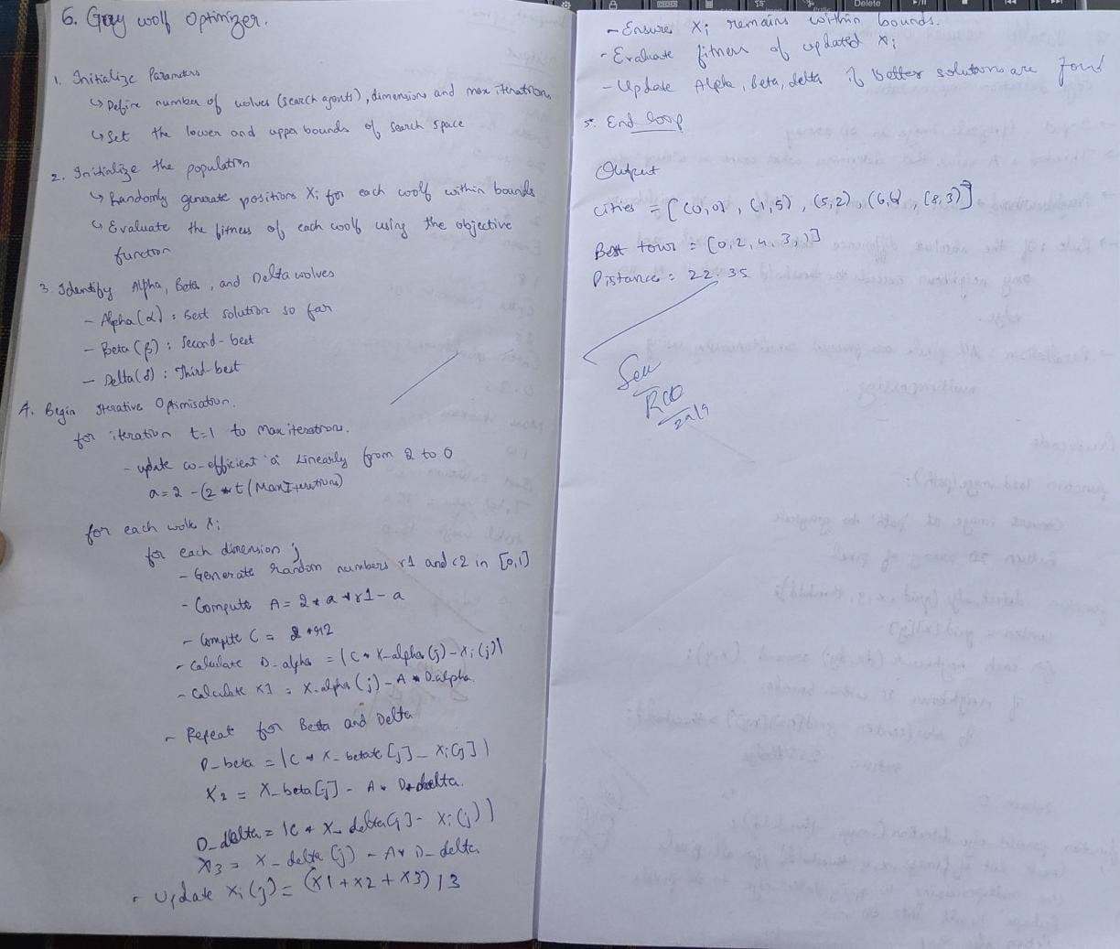

Code:

import numpy as np import random
def distance_matrix(cities): n = len(cities)
dist = np.zeros((n, n)) for i in range(n):

for j in range(n):
dist[i][j] = np.linalg.norm(np.array(cities[i]) - np.array(cities[j])) return dist

def tour_length(tour, dist):
return sum(dist[tour[i]][tour[(i+1)%len(tour)]] for i in range(len(tour)))

def initialize_population(num_wolves, num_cities):
return [random.sample(range(num_cities), num_cities) for _ in range(num_wolves)]

def gwo_tsp(cities, num_wolves=20, max_iter=100): dist = distance_matrix(cities)
population = initialize_population(num_wolves, len(cities)) fitness = [tour_length(tour, dist) for tour in population]
alpha, beta, delta = sorted(zip(population, fitness), key=lambda x: x[1])[:3] for iter in range(max_iter):
a = 2 - iter * (2 / max_iter)
new_population = []

for wolf in population: new_tour = []
for i in range(len(cities)):
r1, r2 = random.random(), random.random() A1 = 2 * a * r1 - a
C1 = 2 * r2
D_alpha = abs(C1 * alpha[0][i] - wolf[i])
X1 = alpha[0][i] - A1 * D_alpha

# Repeat for beta and delta
# Combine X1, X2, X3 and discretize new_tour.append(int(X1) % len(cities))
# Ensure it's a valid permutation new_tour = list(dict.fromkeys(new_tour)) while len(new_tour) < len(cities):
new_tour.append(random.choice([i for i in range(len(cities)) if i not in new_tour])) new_population.append(new_tour)
population = new_population
fitness = [tour_length(tour, dist) for tour in population]
alpha, beta, delta = sorted(zip(population, fitness), key=lambda x: x[1])[:3] return alpha[0], alpha[1]
# Example usage
cities = [(0,0), (1,5), (5,2), (6,6), (8,3)]
best_tour, best_distance = gwo_tsp(cities) print("Best tour:", best_tour) print("Distance:", best_distance)

Program 7: Particle Swarm Optimization for Function Optimization:

Particle Swarm Optimization (PSO) is inspired by the social behavior of birds flocking or fish schooling. PSO is used to find optimal solutions by iteratively improving a candidate solution with regard to a given measure of quality. Implement the PSO algorithm using Python to optimize a mathematical function.

Algorithm:
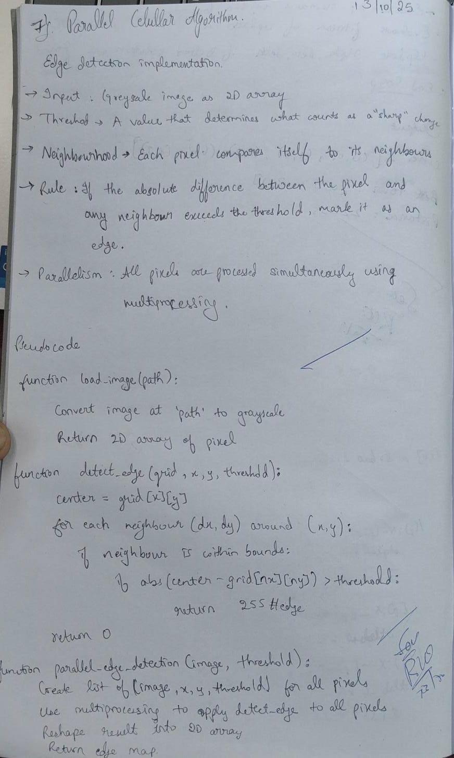

Code:

import numpy as np
from multiprocessing import Pool from PIL import Image
# Load image and convert to grayscale def load_image(path):
img = Image.open(path).convert('L') # 'L' mode = grayscale return np.array(img)
# Edge detection rule for a single pixel def detect_edge(args):
grid, x, y, threshold = args rows, cols = grid.shape center = grid[x][y]
for dx in [-1, 0, 1]:
for dy in [-1, 0, 1]:
if dx == 0 and dy == 0: continue
nx, ny = x + dx, y + dy
if 0 <= nx < rows and 0 <= ny < cols:
if abs(int(center) - int(grid[nx][ny])) > threshold: return 255 # Edge
return 0 # Non-edge

# Parallel cellular edge detection
def parallel_edge_detection(image, threshold=20): rows, cols = image.shape
args = [(image, x, y, threshold) for x in range(rows) for y in range(cols)] with Pool() as pool:
edges = pool.map(detect_edge, args) return np.array(edges).reshape((rows, cols))
# Save or display result
def save_edge_image(edge_array, output_path='edges.png'): edge_img = Image.fromarray(edge_array.astype(np.uint8)) edge_img.save(output_path)
edge_img.show()

# Example usage
if name == ' main ':
image = load_image('your_image.jpg') # Replace with actual image path edges = parallel_edge_detection(image, threshold=30) save_edge_image(edges)

