
Cardiovascular Disease Risk Factor Analysis using Clinical Parameters
Submitted In Partial Fulfillment of Requirements
For the Degree Of
Bachelor of Technology
(Computer and Electronic Engineering)
By
Ritika Mallah
Roll No: 16014025018
Hitisha Choudhary
Roll No: 16014025015

Guide
Ms. Pragya Gupta


Somaiya Vidyavihar University
Vidyavihar, Mumbai - 400 077
2026-27

Somaiya Vidyavihar University

K. J. Somaiya College of Engineering

Certificate

This is to certify that the capstone project report entitled Cardiovascular Disease Risk Factor Analysis using Clinical Parameters submitted by Ritika Mallah (Roll No. 16014025018) and Hitisha Choudhary (Roll No. 16014025015) is a bona fide record of the work carried out by them under my guidance, in partial fulfillment of the requirements for the degree Bachelor of Technology (Computer and Electronic Engineering) of Somaiya Vidyavihar University

_________________ _____________________
Guide Head of the Department

_________________
Principal

Date:
Place: Mumbai-77

Somaiya Vidyavihar University

K. J. Somaiya College of Engineering

DECLARATION
We declare that this written report submission represents the work done based on our and / or others’ ideas with adequately cited and referenced the original source. We also declare that we have adhered to all principles of intellectual property, academic honesty and integrity as we have not misinterpreted or fabricated or falsified any idea/data/fact/source/original work/ matter in my submission.
We understand that any violation of the above will be cause for disciplinary action by the college and may evoke the penal action from the sources which have not been properly cited or from whom proper permission is not sought.
______________________________  Signature of the Student  _______________________________  Roll No. 16014025018 | ______________________________  Signature of the Student  _______________________________  Roll No. 16014025015

Date:
Place: Mumbai-77

Abstract
Cardiovascular diseases are the leading cause of death worldwide, and a small set of clinical measurements is routinely recorded during cardiac assessment. This project applies Python-based exploratory data analysis to a heart-disease dataset (heart.csv) of 303 records and 14 attributes, to study how age, resting blood pressure, serum cholesterol, maximum heart rate achieved and ST depression (oldpeak) vary with the recorded heart-disease outcome.
The data were loaded with pandas and checked for missing values (none) and duplicates (one removed, leaving 302 records). Two derived features, age group and cholesterol category, were created. Four visualizations were produced with Matplotlib and seaborn: the target distribution, outcome counts across age groups, a box plot of maximum heart rate by outcome, and a correlation heatmap. The cleaned data contain 138 records labelled no disease and 164 labelled heart disease.
Among the selected variables, oldpeak (r = -0.43) and maximum heart rate (r = 0.42) have the strongest linear association with the target, followed by age (r = -0.22). The direction of these associations is opposite to what is clinically expected, so the target coding of the supplied file should be verified against its documentation. The results are descriptive associations within one dataset; they do not establish causation or provide a diagnosis.
Key words: Cardiovascular disease, heart disease, exploratory data analysis, Python, pandas, seaborn, correlation and data visualization.
Contents
List of Figures vii
List of Tables vii
Nomenclature viii
1 Introduction 1
1.1 Background 1
1.2 Motivation 1
1.3 Scope of the project 1
1.4 Brief description of project undertaken 1
1.5 Organization of the report 2
2 Literature Survey 3
2.1 Cardiovascular disease risk factors 3
2.2 Heart-disease datasets 3
2.3 Exploratory data analysis 3
2.4 Tools and techniques 3
3 Project design 5
3.1 Introduction 5
3.2 Problem statement 5
3.3 Objectives 6
3.4 Dataset attributes 6
3.5 Technology stack 7
4 Implementation and experimentation 8
4.1 Steps in implementing the analysis 8
4.2 Dataset used for the analysis 8
4.3 Data cleaning and feature engineering 8
4.4 Descriptive statistics 9
4.5 Implementation of the visualizations 9
4.6 Program output 10
4.7 Results and discussion 10
4.7.1 Target distribution 10
4.7.2 Outcome across age groups 11
4.7.3 Maximum heart rate by outcome 11
4.7.4 Correlation analysis 11
4.7.5 Direction of the associations and target coding 12

5 Conclusions and scope for further work 13
5.1 Conclusions 13
5.2 Limitations 13
5.3 Scope for further work 13
Bibliography 14
Appendix A 15
Acknowledgements 17

List of Figures
3.1 Workflow of the cardiovascular risk-factor analysis 5
4.1 Four-panel output of the visualization program 10

List of Tables
3.1 Attributes of the heart.csv dataset 6
4.1 Data-quality checks and actions 8
4.2 Descriptive statistics of the cleaned dataset (302 records) 9
4.3 Outcome counts across age groups 11
4.4 Correlation of each feature with the target 11

Nomenclature
age | Age of the patient in years
trestbps | Resting blood pressure
chol | Serum cholesterol
thalach | Maximum heart rate achieved during exercise testing (bpm)
oldpeak | ST depression induced by exercise relative to rest
target | Outcome label: 0 = no heart disease, 1 = heart disease (as assumed in the project code)
age_group | Derived category of age: <40, 40-55 and >55
chol_category | Derived category of cholesterol: desirable, borderline high and high
r | Pearson correlation coefficient, between -1 and +1
bpm | Beats per minute
CVD | Cardiovascular disease
EDA | Exploratory data analysis
CSV | Comma-separated values file
DataFrame | Two-dimensional table of data used by the pandas library
Std. dev. | Standard deviation

1 Introduction
1.1 Background
Cardiovascular diseases (CVDs) are a group of disorders of the heart and blood vessels. According to the World Health Organization, they are the leading cause of death worldwide: an estimated 17.9 million people died from CVDs in 2019, about 32% of all global deaths, and 85% of these deaths were due to heart attack and stroke [1]. Many of these conditions develop silently, so clinicians record a set of routine measurements during cardiac assessment, such as the age of the patient, resting blood pressure, serum cholesterol, the highest heart rate reached during an exercise test and the ST-segment depression produced by exercise.
Hospitals and research groups collect such measurements for many patients. The resulting tables can be explored with data-analysis tools to see how the recorded values are distributed and how they differ between patients with and without a recorded heart-disease outcome. This project carries out such an exploration in Python.
1.2 Motivation
The motivation of this project is to apply the data-science skills learned in the course, namely data loading, cleaning, transformation, visualization and correlation analysis, to a healthcare-related dataset. A small clinical dataset suits this purpose well: it is large enough to show meaningful patterns, yet small enough to be inspected completely. Exploratory analysis is also the foundation of any later predictive modelling, because the quality of a model depends on how well the data have been understood and cleaned beforehand [4].
1.3 Scope of the project
The project loads the supplied file heart.csv, checks its dimensions, missing values and duplicate rows, removes the duplicates, derives two categorical features (age group and cholesterol category) and produces four visualizations in a 2 x 2 layout. The analysis is descriptive. It does not diagnose any individual, does not train or validate a prediction model and does not perform formal hypothesis tests. The results describe this one dataset and should not be generalized to the wider population.
1.4 Brief description of project undertaken
The project is implemented in Python using the pandas, NumPy, Matplotlib and seaborn libraries. The program is organized as three functions. The function load_data() reads the CSV file into a DataFrame and prints its shape; clean_and_transform_data() checks for missing values, removes
duplicate rows and creates the derived columns; and plot_health_visualizations() draws four plots: the target distribution, outcome counts across age groups, a box plot of maximum heart rate by outcome and a correlation heatmap. After cleaning, the dataset contains 302 records, of which 138 are labelled as no heart disease and 164 as heart disease.
1.5 Organization of the report
Chapter 1 introduces the project. Chapter 2 gives the background on risk factors, heart-disease datasets, exploratory data analysis and the tools used. Chapter 3 defines the problem, the objectives, the workflow and the dataset attributes. Chapter 4 explains the implementation, the cleaning steps, the visualizations and the results. Chapter 5 presents the conclusions, the limitations and the scope for further work. The Python code is given in Appendix A.
2 Literature Survey
2.1 Cardiovascular Disease Risk Factors
Cardiovascular risk is influenced by several measurable factors. Increasing age, raised blood pressure and raised serum cholesterol are among the best-known risk factors, and the World Health Organization lists an unhealthy diet, physical inactivity, tobacco use and harmful use of alcohol as the main behavioural contributors [1]. During exercise testing, two further quantities are routinely recorded: the maximum heart rate achieved, which reflects exercise capacity, and the ST depression induced by exercise relative to rest (called oldpeak in the dataset), which is used as an indicator of reduced blood supply to the heart muscle.
This project studies these five numerical parameters descriptively. It does not make clinical decisions and does not estimate the probability of disease for any individual.
2.2 Heart-Disease Datasets
Heart-disease records collected at several medical centres are available through the UCI Machine Learning Repository [3]. The data were contributed by investigators including Janosi, Steinbrunn, Pfisterer and Detrano, and the work of Detrano et al. [2] used such records to evaluate a probability algorithm for the diagnosis of coronary artery disease. Many teaching and research projects use a 14-attribute subset of these records with a binary outcome column. The file supplied for this project has the same 14-attribute layout and 303 records. Its exact origin and licence were not documented with the file and should be confirmed before the report is circulated.
2.3 Exploratory data analysis
Exploratory data analysis (EDA), introduced by Tukey [4], stresses looking at the data before building models. Typical tools are counts and summary statistics, bar charts for categorical variables, box plots for comparing the spread of a numerical variable across groups, and correlation matrices for relationships among variables. These are the tools used in this project.
2.4 Tools and techniques
Python is the implementation language. NumPy [5] provides numerical arrays, pandas [6] provides the DataFrame structure used for loading, cleaning and transforming the data, Matplotlib [7] provides the plotting area and the subplot layout, and seaborn [8] provides the count plots, box plot and heatmap used here. The relationships between variables are measured with the Pearson correlation coefficient r, which takes values from -1 to +1. A positive value means that two variables tend to increase

together, a negative value means that one tends to fall as the other rises, and a value near zero indicates
a weak linear relationship. When one of the variables is a 0/1 label, as with the target here, r measures how strongly the numerical variable differs between the two label groups in a linear sense.
3 Project Design
3.1 Introduction
This chapter states the problem, shows the workflow as a block diagram, lists the objectives and describes the dataset attributes and the technology used.
3.2 Problem Statement
To analyze patient clinical parameters (age, resting blood pressure, serum cholesterol, maximum heart rate and ST depression) using Python data-science libraries, in order to identify risk-factor patterns, evaluate the correlation of each feature with the target outcome and perform an exploratory visual analysis of heart-disease presence in the supplied dataset.
3.3 Block Diagram
The analysis follows the six-stage workflow in Figure 3.1. The data are read from heart.csv, inspected, cleaned, enriched with two derived categorical columns, visualized and finally interpreted.

- Load data: heart.csv is read into a pandas DataFrame and its number of rows and columns is printed (303 x 14).
- Inspect data: the total number of missing values is computed; it is 0, so no rows are dropped.
- Remove duplicates: drop_duplicates() removes one repeated record, leaving 302 records.
- Derive features: pd.cut() creates age_group and chol_category from age and chol.
- Visualize: four plots are drawn in a 2 x 2 layout using seaborn and Matplotlib.
- Interpret: counts, spread and correlations are read from the plots and summarized with their limitations.
3.4 Objectives
- To load and inspect the heart.csv dataset and report its dimensions.
- To identify missing values and duplicate records and clean the data.
- To create age and cholesterol categories using pd.cut().
- To examine the distribution of the target outcome.
- To compare outcome counts across age groups and maximum heart rate across outcome groups.
- To visualize the correlations between the numerical features and the target.
- To interpret the results and state the limitations of the analysis.
3.5 Dataset Attributes
The dataset has 14 attributes, Categorical attributes are stored as integer codes.

Attribute | Description | Kind
age | Age in years | Numeric
sex | Encoded sex | Encoded
cp | Encoded chest-pain type | Encoded
trestbps | Resting blood pressure (usually in mm Hg) | Numeric
chol | Serum cholesterol (usually in mg/dl) | Numeric
fbs | Encoded fasting blood sugar indicator | Encoded
restecg | Encoded resting ECG result | Encoded
thalach | Maximum heart rate achieved (bpm) | Numeric
exang | Encoded exercise-induced angina indicator | Encoded
oldpeak | ST depression induced by exercise relative to rest | Numeric
slope | Encoded slope of the peak-exercise ST segment | Encoded
ca | Encoded number of major vessels | Encoded
thal | Encoded thalassemia-related category | Encoded
target | Outcome: 0 = no disease, 1 = heart disease (as assumed in the project code) | Encoded

The exact meaning of each encoded value should be confirmed from the documentation of the dataset provider. The analysis in this report uses only the numerical attributes age, trestbps, chol, thalach and oldpeak, together with target.
3.6 Technology Stack
The analysis was written in Python (Anaconda distribution) and run from Visual Studio Code on Windows. The libraries used are NumPy, pandas, Matplotlib and seaborn. The input is a single CSV file, heart.csv. Seaborn is configured with the whitegrid theme so that all plots share the same style.
4 Implementation and Experimentation
4.1 Steps in Implementing the Analysis
The program is divided into three functions, which are called in order at the end of the script:
1. load_data(file_path) reads the CSV file with pd.read_csv(), prints a dataset overview (number of rows and columns) and returns the DataFrame.
2. clean_and_transform_data(df) counts the missing values, drops rows only if any are found, removes duplicate rows, and adds the columns age_group and chol_category.
3. plot_health_visualizations(df) creates a 14 x 10 inch figure with four subplots and displays it.
Keeping loading, cleaning and plotting in separate functions makes each step easy to test and to reuse with a different file.
4.2 Dataset used for the Analysis
The supplied file heart.csv contains 303 rows and 14 columns before cleaning, as printed by the program. The column target holds the outcome. In the project code, target 0 is treated as no heart disease and target 1 as heart disease; this assumption is discussed further in Section 4.7.5. After cleaning, 302 records remain: 138 with target 0 and 164 with target 1.
4.3 Data Cleaning and Feature Engineering
Table 4.1 summarizes the data-quality checks. The call df.isnull().sum().sum() returned 0, so the conditional dropna() step removed nothing. The call df.drop_duplicates() removed one repeated row, reducing the data from 303 to 302 records. The result is copied with .copy() so that the new columns are added to an independent DataFrame.

Check | Finding | Action
Original data | 303 rows x 14 columns | Loaded with pandas
Missing values | 0 | No rows removed
Duplicate rows | 1 | Removed with drop_duplicates()
Cleaned data | 302 records | Used for all analysis

Two categorical features are derived with pd.cut(). Age is grouped with the bin edges [0, 40, 55, 100] and cholesterol with the edges [0, 200, 239, 1000]. By default pd.cut() uses intervals that are closed
on the right, so the age groups are (0, 40], (40, 55] and (55, 100]. A patient aged exactly 40 therefore falls in the group labelled "<40 (Young)", and a patient aged exactly 55 falls in "40-55 (Middle-aged)". The group labels are used as given in the code and should be read as approximate. The cholesterol column chol_category (desirable, borderline high and high) is created but is not used in the four plots of this report.
4.4 Descriptive Statistics
Table gives the descriptive statistics of the five numerical features in the cleaned dataset. The cholesterol maximum of 564 is far above the median of 240.5 and is the most extreme value in the table; it was kept because there is no evidence that it is an error.

Feature | Mean | Std. dev. | Min | Median | Max
Age (years) | 54.42 | 9.05 | 29 | 55.50 | 77
Resting BP (trestbps) | 131.60 | 17.56 | 94 | 130.00 | 200
Cholesterol (chol) | 246.50 | 51.75 | 126 | 240.50 | 564
Max heart rate (thalach) | 149.57 | 22.90 | 71 | 152.50 | 202
ST depression (oldpeak) | 1.04 | 1.16 | 0.00 | 0.80 | 6.20

4.5 Implementation of the Visualizations
The function plot_health_visualizations() creates one figure with four subplots using plt.subplot(2, 2, n):
1. Plot 1, target distribution: sns.countplot() with the Set2 palette shows the number of patients in each outcome class.
2. Plot 2, outcome across age groups: sns.countplot() with hue set to target and the Set1 palette shows the counts of each outcome within every age group.
3. Plot 3, maximum heart rate: sns.boxplot() with the Pastel1 palette compares the spread of thalach between the two outcome groups.
4. Plot 4, correlation matrix: sns.heatmap() with the coolwarm colour map and printed values shows the Pearson correlations among age, trestbps, chol, thalach, oldpeak and target.
In seaborn 0.13 and later, passing a palette without assigning hue produces a FutureWarning. The final code therefore sets hue to target with legend=False in plots 1 and 3, and suppresses the remaining FutureWarning messages with warnings.simplefilter(). The complete code is given in Appendix A.
4.6 Program Output
When the program is run, it prints the following overview and then displays the four-panel figure shown
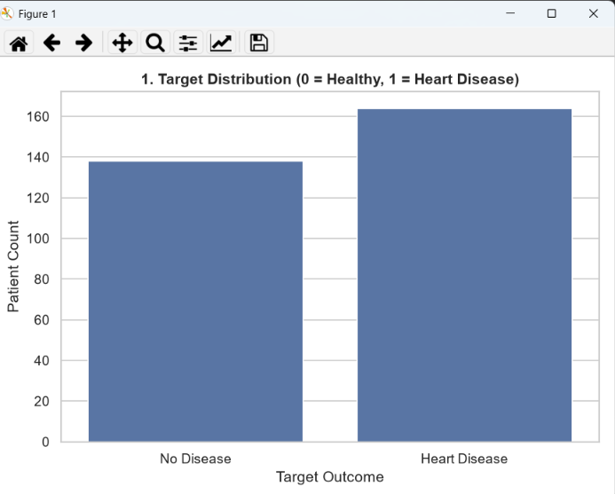
Target Distribution: Shows the number of patients with and without heart disease.
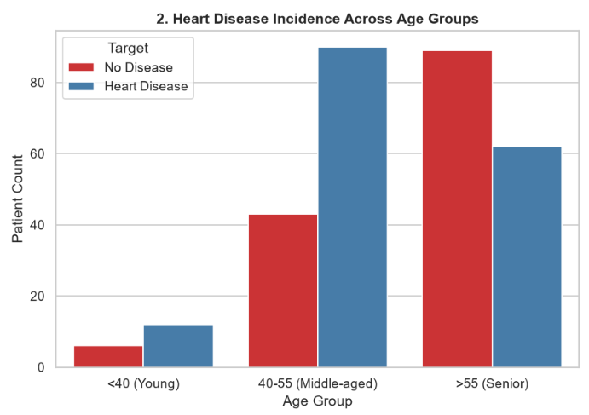
Heart Disease Across Age Groups: Compares heart disease cases across different age groups.
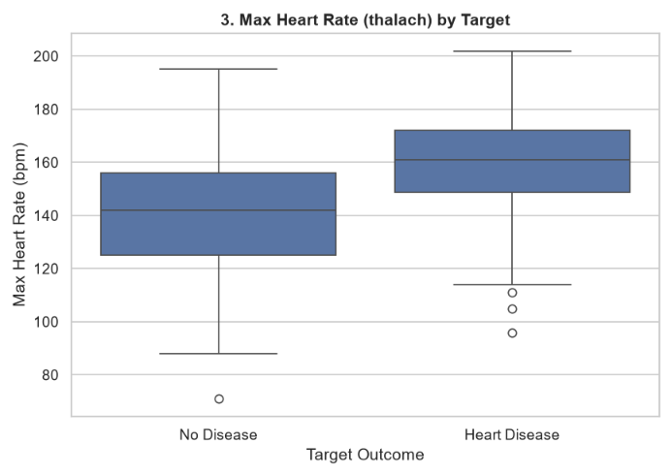
Maximum Heart Rate by Target: Compares maximum heart rates of patients with and without heart disease.
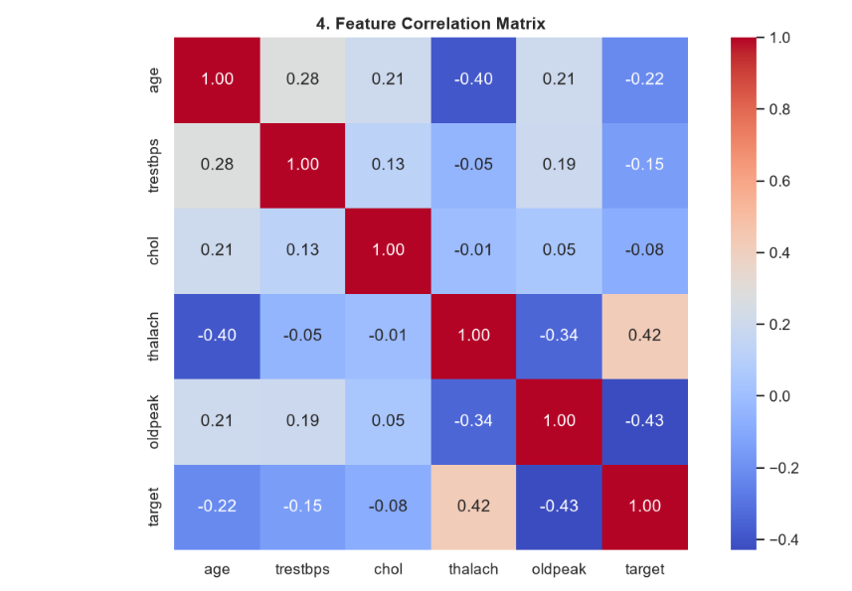
Feature Correlation Matrix: Shows the correlation between different numerical health features and heart disease

4.7 Results and Discussion
4.7.1 Target Distribution
Plot 1 shows 138 records with target 0 (45.7%) and 164 records with target 1 (54.3%). The two classes are fairly balanced, with a ratio of about 1.2 to 1, so the dataset does not suffer from a strong class imbalance.
4.7.2 Outcome across age groups
Table 4.3 gives the counts behind Plot 2, together with the share of each age group that carries the target-1 label. The shares are calculated from the counts.

Age group | Target 0 (no disease) | Target 1 (heart disease) | Total | Share with target 1
<40 (Young) | 6 | 12 | 18 | 66.7%
40-55 (Middle-aged) | 43 | 90 | 133 | 67.7%
>55 (Senior) | 89 | 62 | 151 | 41.1%
All patients | 138 | 164 | 302 | 54.3%

The 40-55 band contains the largest number of target-1 records (90). The group above 55 is the largest group overall (151 patients) but only 41.1% of it carries the target-1 label, whereas about two-thirds of the two younger groups do. This agrees with the negative correlation between age and target (r = -0.22) in Section 4.7.4. These are sample counts and shares, not population risk rates, and the group below 40 contains only 18 records, so its share is not reliable.
4.7.3 Maximum Heart Rate by Outcome
The mean maximum heart rate is 139.1 bpm for target 0 and 158.4 bpm for target 1, a difference of about 19 bpm. In Plot 3 the box for target 1 lies higher, with a median of roughly 160 bpm compared with roughly 142 bpm for target 0. The target-0 group has a wider spread and one low outlier near 71 bpm, which is the minimum of the whole dataset. The target-1 group has three low outliers between about 95 and 111 bpm. The two boxes overlap, so maximum heart rate alone does not separate the groups.
4.7.4 Correlation Analysis
Table lists the correlation of each numerical feature with the target, read from the heatmap (Plot 4). As a rule of thumb, |r| below 0.3 is called weak and 0.3 to 0.5 moderate.

Feature | Correlation (r) | Strength | Direction
age | -0.22 | Weak | Negative
trestbps | -0.15 | Weak | Negative
chol | -0.08 | Very weak | Negative
thalach | 0.42 | Moderate | Positive
oldpeak | -0.43 | Moderate | Negative

Among the selected features, oldpeak (r = -0.43) and thalach (r = 0.42) have the strongest linear association with the target, and resting blood pressure and cholesterol are almost unrelated to it in this sample. The heatmap also shows relationships between the features themselves: age and maximum heart rate are negatively correlated (r = -0.40), so older patients reach lower peak heart rates; thalach and oldpeak are negatively correlated (r = -0.34); and age has weak positive correlations with resting blood pressure (r = 0.28) and cholesterol (r = 0.21). Pearson correlation detects only linear association and does not establish causation.

4.7.5 Direction of the Associations and Target Coding
The signs of some associations deserve attention. In clinical practice, a larger ST depression (oldpeak) during exercise is usually regarded as a sign of greater cardiac stress, and a lower maximum heart rate is usually associated with poorer exercise capacity. In this file, however, the group labelled target 1 ("Heart Disease" in the code) has a higher mean maximum heart rate and a lower oldpeak than the group labelled target 0. This is the opposite of the clinically expected direction. It is consistent with the possibility that the target column is coded the other way round in this copy of the data (1 = absence and 0 = presence of disease), which has been reported for some publicly circulated copies of this dataset.
Because the documentation of the file was not available, this report keeps the labelling assumed in the project code and records the point as a limitation. The target coding must be verified against the source documentation before any clinical meaning is attached to the results. If the coding is reversed, the numerical results remain valid, but the labels "no disease" and "heart disease" in the figures and
tables would have to be swapped.
5 Conclusions and Scope for Further Work
5.1 Conclusions
The project demonstrates a complete exploratory analysis workflow in Python for a cardiovascular dataset. The supplied file contained 303 rows and 14 columns; after one duplicate was removed, 302 records were retained with no missing values. Four visualizations summarize the target distribution, the outcome counts across age groups, the maximum heart rate by outcome and the correlations among selected numerical features. Maximum heart rate and ST depression showed the strongest linear association with the target, while resting blood pressure and cholesterol showed almost none. The observed correlations are descriptive patterns of this dataset and must not be treated as medical conclusions.
5.2 Limitations
• The source and licence of the supplied CSV were not documented.
• The sample is small (302 records) and may not represent the general population.
• The direction of several associations is opposite to clinical expectation, so the target coding needs to be verified (Section 4.7.5).
• The encoded categorical variables need the original documentation for their exact labels.
• The age groups use right-closed intervals, so the boundary ages 40 and 55 belong to the lower group.
• The group below 40 has only 18 records, and the cholesterol category is created but not plotted.
• No model was trained, and no statistical test or confidence interval was computed.
5.3 Scope for Further Work
• Verify the dataset source, the target coding and the meaning of the encoded variables.
• Add visualizations of the cholesterol categories and resting blood pressure.
• Report statistical tests, confidence intervals and effect sizes for the group differences.
• Extend the analysis to the categorical attributes such as chest-pain type, exercise-induced angina and number of major vessels.
• If machine learning is added, use a train/test split and suitable evaluation metrics, and report them with the limitations of a small dataset.
Bibliography
[1] World Health Organization, "Cardiovascular diseases (CVDs)," fact sheet. [Online]. Available: https://www.who.int/news-room/fact-sheets/detail/cardiovascular-diseases-(cvds)
[2] R. Detrano et al., "International application of a new probability algorithm for the diagnosis of coronary artery disease," Am. J. Cardiol., vol. 64, no. 5, pp. 304-310, 1989.
[3] D. Dua and C. Graff, "UCI Machine Learning Repository," University of California, Irvine, School of Information and Computer Sciences, 2019. [Online]. Available: https://archive.ics.uci.edu
[4] J. W. Tukey, Exploratory Data Analysis. Reading, MA, USA: Addison-Wesley, 1977.
[5] C. R. Harris et al., "Array programming with NumPy," Nature, vol. 585, pp. 357-362, 2020.
[6] W. McKinney, "Data structures for statistical computing in Python," in Proc. 9th Python in Science Conf. (SciPy), 2010, pp. 56-61.
[7] J. D. Hunter, "Matplotlib: A 2D graphics environment," Comput. Sci. Eng., vol. 9, no. 3, pp. 90-95, 2007.
[8] M. L. Waskom, "seaborn: statistical data visualization," J. Open Source Softw., vol. 6, no. 60, p. 3021, 2021.
[9] Python Software Foundation, "Python documentation." [Online]. Available: https://docs.python.org/3/
Acknowledgements
We would like to express our sincere gratitude to our project guide, Ms. Pragya Gupta, for her guidance, encouragement and valuable suggestions throughout this project. We are thankful to the Head of the Department of Computer and Electronic Engineering and to the Principal of K. J. Somaiya College of Engineering for providing the facilities and the academic environment needed to complete this work. We also thank the developers of the open-source Python libraries used in this project, and our families and friends for their constant support.

Ritika Mallah (Roll No. 16014025018)
Hitisha Choudhary (Roll No. 16014025015)

