SYNOPSIS
on
KnapResume: Optimal Content Allocation
and Provenance Tracking for Job-Aligned Resumes

Co-Op project at Industry (Module-1) 22AI026

Submitted by

Hitkar Miglani (2310993837)
Batch : B2023
Semester : 7th


Bachelor of Engineering- Computer Science & Engineering
(Artificial Intelligence)

Guided by
Dr. Manu Midha
CHITKARA UNIVERSITY INSTITUTE OF ENGINEERING & TECHNOLOGY
CHITKARA UNIVERSITY, RAJPURA
December 2026

Table of Contents

S. No. | Title | Page.No.
1 | Introduction | 3
2 | Problem Formulation | 4
3 | Proposed Solution / Methodology | 6
4 | Flowchart | 7
5 | References | 9

Introduction

Job seekers spend hours and hours editing their resumes' professional summations each time they apply to a different job description (JD), re-selecting and rewording core experience to fit each specific JD. This is repetitive, prone to human error, difficult to scale across a dozen applications and studies of labor-economics in the callback rates indicate meaningfully increased rates of callbacks with customization and care in the deep, meaningful way rather than ‘one size fits all.' Meanwhile, most available AI resumes generators – from paid, market-leading platforms like Rezi, Teal, and Kickresume – execute a single pass through the resume, lack transparency on whether the claim came from the resume, and provide no guidance for the user to know what users section of their profile is blocking an application.
By allowing a user to input their professional data once and have their profile translated to a JD-specific resume with an ATS-friendly template all while taking care of generating full resumes, this project hopes to provide a platform to store an individual's professional data in a normalized, re-usable profile and then automatically translate it to a resume depending on the parameters specified in a job description and key words selected from a template.
The system is designed to be deliberately confined to a number of properties not found in the existing marketplace:
- Constantly remember to check for section-aware and constrained content allocation instead of single pass rewriting,
- A provenance and verification layer to trace any claim back to a source fact provided by the user, with an explicit provenance and verification layer,
- A weakest-section feedback signal operating on a JD which makes the tool an iterative profile improvement loop instead of creating a single document.
In the rest of this synopsis, the problem to be solved is formalised, and the proposed architecture and methodology is described, as well as visualised in a system flow chart and placed in the context of the nearest current academic work.

Problem Formulation

Applicant Tracking Systems (ATS) and the job description (JD) may differ and a job seeker often needs to adjust and customize their resume to make it relevant to the JD and compatible with the ATS. Looking up the relevant skills, experiences, projects and achievements in each application is time consuming. The other type of AI-powered resume makers that are currently available mostly leverage a single pass technique to regenerate resumes based on a JD in the language of their AI model. These are not specifically designed around the issue of effectively balancing and allocating a limited resume versus the competing pieces of candidate information.
One of the biggest problems is the credibility of the AI content. LLM can throw away unsupported achievement, metrics, or skills at the start of a candidate profiles improvement process. This poses the possibility of factual inaccuracy and affects user trust. The current methods are also, to a limited extent, not transparent about the origin of claims that are generated and most do not prioritize a section of a resume for a specific JD. The proposed system remedies these drawbacks by providing constraints-aware optimizations, a provenance tracker, verification controls and JD-specific feedback.
Resume generation is thus seen as an evidence based optimization problem, rather than just a text generation task, in the system. It draws data from an existing resume, GitHub projects, and/or any manual entry; processes and filters the JD; scores candidate information against the criteria for a career posted on the job description; optimally allocates resume space by implementing Knapsack based approach; generates grounded content and validates it and identifies the weakest area of a resume for enhancement.
The proposed system resolves following three problems in the tailoring of a resume for particular jobs:
- Limited Content Selection: The candidate may have a lot of information to include on a resume that may require more than 1 page, and may have some sections focus on one JD rather than opening them up to everyone. The system should choose the most relevant content and adhere to the space and section requirements.
- Risk of AI-Generated Resumes: AI Machines can add to unsupported claims or metrics. The system should be designed to make it evident that the generated content originated with information provided by a user.The system shall provide proof of provenance and verification of the source of information generated.
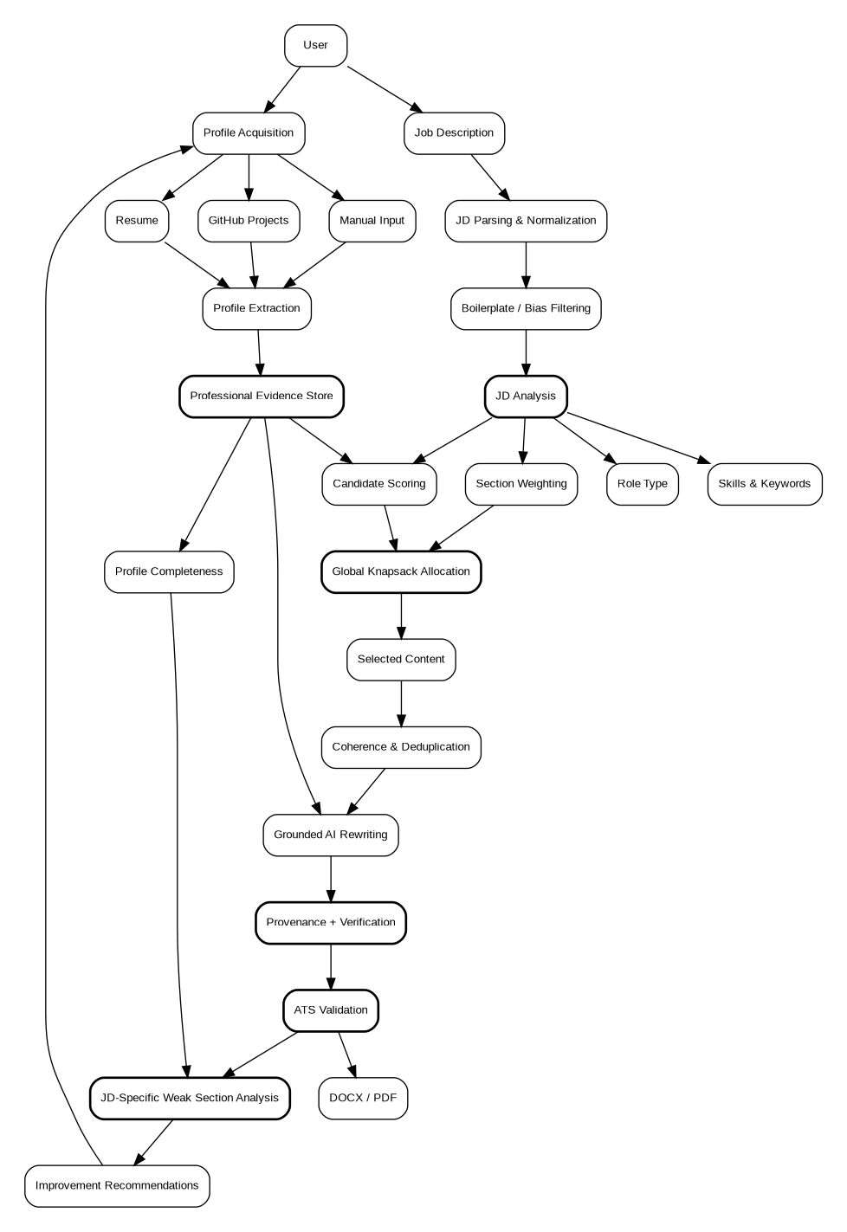
- Lack of Actionable Feedback: Current resume creation is done almost entirely one-shot, and doesn't indicate which section of a candidate's profile is deficient with a specific JD. The system should be able to do weakest section analysis specific to the JD which will allow iterative improvement of the JD profiles.
Image 1:High level diagram of the whole system

Proposed Solution / Methodology

The proposed system will have these phases:
- Generating AI-generated resumes and dividing them into sections relevant to the JD; Splitting the content into relevant segments to create JD-tailored resumes while preserving space constraints, factual relevance, and content relevance.
- Profile Acquisition: System is capable of gathering the professional information from the existing resume, projects selected on the GitHub platform, or manual entries and save it for future use as evidence of the candidate.
- JD Processing: Normally, a JD is uploaded and is then parsed and normalized, then undergoes boilerplate and bias filtering. Then, skills, keywords, and role type are extracted.
- Content Scoring & Allocation: Keywords & semantic similarity are used to score and allocate a candidate's information against the JD. Section weights are defined by roles and the most relevant content within given limits of resume-space is chosen by the knapsack allocation algorithm.
- Grounded Generation: Selected content is reCurated by an LLM and claims adjacent to evidence is displayed through a provenance track and/or verification flag.
- ATS & Feedback: The final resume is screened to meet ATS criteria and keywords. The weakest area of a JD is identified and improvement suggestions are made, which allows it to be refined iteratively.
AI reasoning, algorithmic optimization, and verification mechanisms all figured into the system. Allocation based on knapsack: limited resume space given to certain information, proportional to the capacity of the knapsack.Risk of fabricated claims is reduced with controls for provenance and verification which determine what information gets limited resume space depending on the capacity of the knapsack. The final paper is validated and the weakest-section analysis gives valuable feedback for an improvement in the profile of the paper.
This means that the sequence of the system is:
Find → Understand → Mark → Optimise → Create → Test → Enhance
This is quite unlike a regular AI-driven resume generator; it's actually an iterative, constraint-aware resume optimization system.

Flowchart

User Profile Intake  Resume upload / GitHub / Manual entry | Job Description Input  Pasted / uploaded JD text
↓ | ↓
Completeness Scoring  weighted score per profile section | JD Parsing  LLM structured extraction + regex fallback
↓ | ↓
Structured Profile Store  Postgres: atomic, tagged bullets | Extracted JD Signals  skills, keywords, seniority
 | ↓

Role-Type Classification

section weight profile
↘ | ↙

Per-Section Candidate Scoring

embedding similarity + keyword overlap (hybrid)

↓

Global Knapsack Allocation

fits selected bullets to a one-page budget optimally

↓

Coherence and Dedup Pass

removes redundant or conflicting bullets

↓

Grounded Rewriting

provenance-tracked; verified flag on every claim

↓

ATS-Safety Validation

parseability check + keyword coverage score
↙ | ↘
Weakest-Section Ranking  JD-specific; feeds back to profile intake | DOCX / PDF Export  template-driven rendering engine
 | ↓

Tailored, ATS-Friendly Resume

delivered to the user for review and download

Figure 2: End-to-end pipeline from parallel profile/JD intake through scoring, constrained allocation, grounded rewriting, ATS validation, and export, with a JD-specific weakest-section signal feeding back into profile intake.

References
- A. V. Zinjad, A. Bhattacharjee, A. Panzade, and H. Liu, "ResumeFlow: An LLM-facilitated Pipeline for Personalized Resume Generation and Refinement," in Proc. 47th Int. ACM SIGIR Conf. Research and Development in Information Retrieval (SIGIR '24), 2024. [Online]. Available: https://dl.acm.org/doi/10.1145/3626772.3657680
- "Resume Refactorer: A Modular LLM-Based System for Job-Aligned Resume Generation," in Lecture Notes, Springer Nature, 2026. [Online]. Available: https://link.springer.com/chapter/10.1007/978-3-032-19681-1_42
- "Human and LLM-based Resume Matching: An Observational Study," Findings of NAACL 2025.
- "AI Hiring with LLMs: A Context-Aware and Explainable Multi-Agent Framework for Resume Screening," IEEE/CVF Workshop Proceedings, 2025.
- "Gender Bias in LLM-Generated Reference Letters," arXiv:2310.09219, 2023.
- “Overview of TalentCLEF 2026: Skill and Job Title Intelligence for Human Capital Management." [Online]. Available: https://arxiv.org/pdf/2606.31692
- “State of Resume Tailoring 2026: Research Report and Data Analysis," TailorForge, 2026. [Online]. Available: https://tailorforge.com/blog/state-of-resume-tailoring-2026
- "LLM-Driven Resume Parsing and Job Description Matching: Evaluation on 998 Real Resumes," ResearchGate preprint, Jan. 2026.

