nbCcTalkCoinAcceptor

Nikola Brežnjak

Content
1. Introduction 2
2. ccTalk 3
3. Coin Acceptor 5
3.1. Using the application 5
3.2. Using the API 6
3.2.1. Add the reference to the ccTalk library 8
3.2.2. Connect to the coin acceptor 8
3.2.3. Modify inhibit status 10
3.2.4. Start/End polling for events 11
3.2.5. Start/Stop master inhibition 11
3.2.6. Accepting the coins 12

Introduction
This document contains usage instructions and code examples for communication with coin acceptor using the ccTalk protocol.

Revisions of this document along with their respective numbers, dates and notes (user and short explanation of the content change) are in the Table 1.1.
Table 1.1. Revision table
Revision | Date | Note
1 | 25.02.13 | [Nikola Brežnjak] – First version of the document

ccTalk
ccTalk is a serial protocol in widespread use throughout the money transaction industry. The protocol was developed at a company Crane Payment Solutions. The protocol uses an asynchronous transfer of character frames in a similar manner to RS232. The main difference is that it uses a single two-way communication data line for half-duplex communication rather than separate transmit and receives lines.

It operates at TTL voltages and is "multi-drop" i.e. peripherals can be connected to a common bus and are logically separated by a device address. Each peripheral on the ccTalk bus must have a unique address. The original protocol operated at 4800 baud with subsequent releases standardising on 9600 baud. Low cost bridge chips are now available from a number of manufacturers to allow ccTalk to run over USB at baud rates of at least 1 Mbit/s.

Advantages of ccTalk include low cost UART technology, a simple-to-understand packet structure, an easily expandable command interface and no licensing requirements. The latter affords the protocol a good deal of popularity in a crowded and highly competitive field similar to open-source software.

An Example ccTalk Message Packet looks like:
TX data = 002 000 001 245 008
- 002 = destination address
- 000 = zero data bytes
- 001 = source address
- 245 = command header ‘Request equipment category id’
- 008 = checksum ( 002 + 000 + 001 + 245 + 008 = 256 = 0 mod 256 )

This is a message from address 1 ( the host ) to peripheral address 2 to find out what it is:
RX data = 001 013 002 000 067 111 105 110 032 065 099 099 101 112 116 111 114 022
- 001 = destination address
- 013 = 13 data bytes
- 002 = source address
- 000 = reply header
- 067…114 = ASCII for ‘Coin Acceptor’
- 022 = checksum ( sum of all packet bytes is zero )
The reply from address 2 back to address 1 identifies it as a coin acceptor.

In ccTalk a coin has a 6 character identifier <2-letter country code><3-letter value><1-letter issue code>. The country code conforms to ISO 3166. The issue code is assigned to different issue dates or special mint variations of the same coin. Few examples follow:
- US025A United States 25c
- GB010B Great Britain 10p
- EU200A Euro 2€

Bank notes follow the same pattern but 4 characters are allocated to the value and there is an associated scaling factor, usually x100, with the country. Few examples follow:
- US0001A - United States $1
- GB0020A - Great Britain £20
- EU0005A - Euro 5€

Coin Acceptor
This project uses the aforementioned ccTalk protocol and it's based on other ccTalk project which has been discontinued. API is based on ccTalk generic specification issue 4.6 as specified on the official ccTalk website.

It is a basic C# .NET assembly, built for 4.0 framework. Although the project on which this one is based has support for bill validators they have not been tested and the example WinForms application demostrates only the usage for coin acceptor.

The main reason this project was made is because the aforementioned projects didn't work "out of the box" and didn't include enough documentation to make an easy start. Also, the coin acceptor didn't have full implementation for basic usage (for example, the initial coin inhibition setting was missing).

Using the application
The main and only form in the nbCcTalkCoinAcceptor project which demonstrates the usage of cctalklib API is shown on Illustration 1.
You can run the application either by running the nbCcTalkProject.exe file in bin folder or by compiling it with Visual Studio. First thing to do is make sure the port number is correctly set and then click Connect button. After that you have to tick the Poll Start/Stop checkbox in order to start polling for coins. The example of these actions and few inserted coins is shown on Illustration 2 where the last two icons were inhibited due to the Master Inhibit status flag set intentionally during testing.
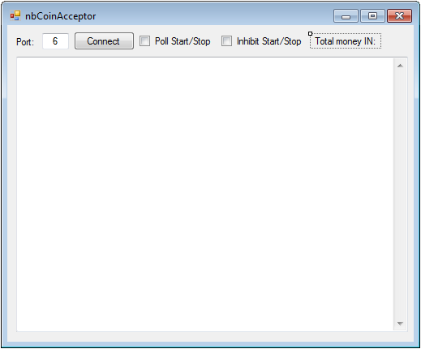Illustration 1. Main form to demonstrate the usage of cctalklib API
This example works with Euro currency, and if you wish to make it work with some other currency, please follow the chapter 3.2. Using the API.
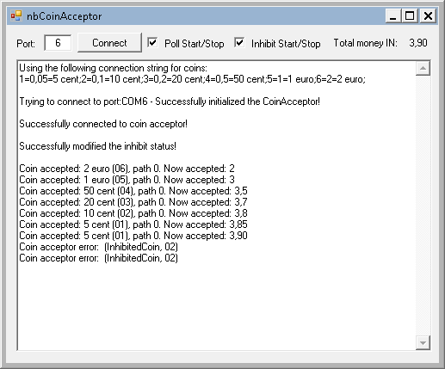Illustration 2. Example of few inserted coins and setting the master inhibit flag

Using the API
When you open up the project in Visual Studio you will see a solution explorer like the one shown on Illustration 3.
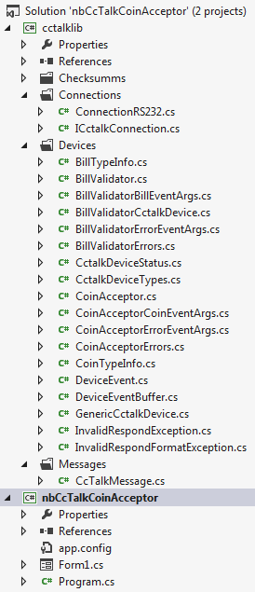Illustration 3. Solution explorer
As you can see, there are two projects, cctalklib and nbCcTalkCoinAcceptor, where the latter uses the ccTalk wrapper functions defined in project cctalklib.

The whole code for the nbCcTalkCoinAcceptor project is in the Form1.cs file, which by itself is not a favorable approach (don't mix the presentation with logic), but it will suffice in this case of a quick demonstration on how to use the cctalklib API.

The steps that follow should be done exactly in that order when implementing your own solution based on the CctalkLib.dll library. Here I'm referring to CctalkLib.dll because if you build the cctalklib project that's the file you will get as an output, since the project is set to output type of Class library as shown on Illustration 4.
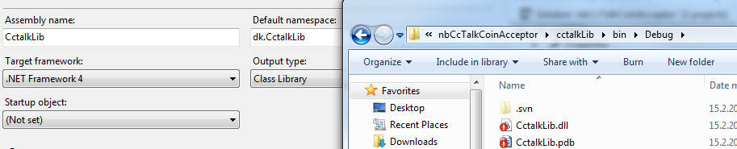Illustration 4. cctalklib's project output set to Class Library and the output is CctalkLib.dll

Add the reference to the ccTalk library
First thing to do is to add a reference to the CctalkLib.dll file by using the Add Reference menu, as shown on Illustration 5. You can choose to only reference the direct dll file which you can find in the bin folder of the cctalklib project named CctalkLib.dll, as shown on Illustration 4.
After this you have to reference the library in your code by typing the following two using commands:
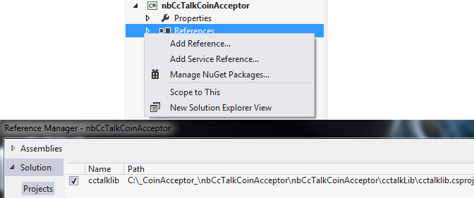Illustration 5. Adding reference to the cctalklib project
using dk.CctalkLib.Connections;
using dk.CctalkLib.Devices;

Connect to the coin acceptor
Connection to the coin acceptor will be made on the click event of the Connect button, as shown previously on Illustration 2. The function listing is shown below and the explanation follows after it:
private bool ConnectToCoinAcceptor()
{
Dictionary<byte, CoinTypeInfo> coins;
coins = CoinAcceptor.DefaultConfig;
byte deviceNumber = 2; //device number defaults to 2 - coin acceptor
//can be changed to ones liking by using SetCoins(coinsDefaultText, out coins)
//default from .dll is:
//1=0,05=5 cent; 2=0,1=10 cent; 3=0,2=20 cent; 4=0,5=50 cent; 5=1=1 euro;6=2=2 euro;
string coinsDefaultText = CoinAcceptor.ConfigWord(CoinAcceptor.DefaultConfig);
txtLog.Text += "Using the following connection string for coins:" + Environment.NewLine +
coinsDefaultText + newline;
try
{
string port = "COM" + txtPortNumber.Text;
var connection = new ConnectionRs232
{
PortName = port,
RemoveEcho = true
};

txtLog.Text += "Trying to connect to port:" + port + " - ";

_coinAcceptor = new CoinAcceptor(deviceNumber, connection, coins, null);

_coinAcceptor.CoinAccepted += _coinAcceptor_CoinAccepted;
_coinAcceptor.ErrorMessageAccepted += _coinAcceptor_ErrorMessageAccepted;

_coinAcceptor.Init(true);

if (_coinAcceptor.IsInitialized)
{
txtLog.Text += "Successfully initialized the CoinAcceptor!" + newline;
return true;
}

txtLog.Text += "Failed initializing the CoinAcceptor!" + newline;
DisposeCoinAcceptor();
connection.Close();
}
catch (Exception ex)
{
MessageBox.Show(ex.ToString());
}

return false;
}
First we need to set the coins definition, and if in your case the currency is different from Euro (€), you can change the coin definition accordingly by using the SetCoins()function by conforming to the format listed in the code:
1=0,05=5 cent; 2=0,1=10 cent; 3=0,2=20 cent; 4=0,5=50 cent; 5=1=1 euro;6=2=2 euro;

Next, we need to set up the connection by providing the port, and most importantly setting the RemoveEcho to true. Then we set the _coinAcceptor variable to an instance of the of the CoinAcceptor object by providing it's constructor with device number (nuber 2 by default – you may need to check this with your setting), connection variable and coin definition. After this you just need to subscribe to two events from CoinAcceptor, call the Init() function and eventually check for errors like this:
_coinAcceptor.CoinAccepted += _coinAcceptor_CoinAccepted;
_coinAcceptor.ErrorMessageAccepted += _coinAcceptor_ErrorMessageAccepted;
_coinAcceptor.Init(true);

if (_coinAcceptor.IsInitialized)
{
txtLog.Text += "Successfully initialized the CoinAcceptor!" + newline;
return true;
}

txtLog.Text += "Failed initializing the CoinAcceptor!" + newline;
DisposeCoinAcceptor();
connection.Close();

Modify inhibit status
After successfully connecting to the coin acceptor you have to set the inhibit status for coins, which basically means setting which coins will be accepted and which won't. To do that, you have to call the ModifyInhibitStatus() function which takes two parameters which are optional. As stated in Part 2 offical manual of the ccTalk protocol (can be obtained on the official web site: http://www.cctalk.org/ on the right hand side of the page named Download ccTalk Part 2 v4.6 as shown on Illustration 6 – and it's also included in the Documentation folder along with this document that you're reading) you have to send two bytes of data as follows:
Send: [Dir] [2] [2] [231] [Data 1] [Data 2] [Chk]
Reply: [1] [0] [Dir] [0] [Chk] -> ACK without data
[Data 1] = Inhibit byte 1 (LSB), coins 1 to 8
[Data 2] = Inhibit byte 2 (MSB), coins 9 to 16
bit 0 (in Data 1): coin 1
bit 15 (in Data 2, equivalent to bit 7 of Data 2): coin 16

So, Data1 byte sets the coins 1 to 8 and Data2 byte sets the coins 9 to 16. Basically, if you convert the byte to bits then each bit which is set to 1 means that this coin will be set to be able to accept the coins. So if we convert nuber 255 to bits it equals 11111111.
As mentioned, the parameters to the ModifyInhibitStatus function are optional, because by default they are set to numbers 255 (as Data1 parameter) and 0 (as Data2 parameter), which means that first 8 coins are set to be accepted.

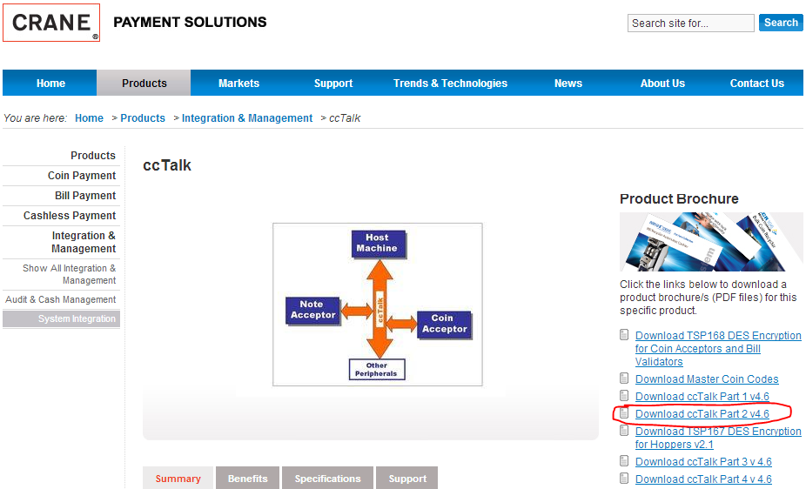Illustration 6: Part 2 of the official documentation where the ccTalk list of commands are explained

Start/End polling for events
To start polling for events you have to call the StartPoll() function of the CoinAcceptor class (on your object instance of course) and to end the polling you have to call the EndPoll() function. In my code example I'm doing this change on the checkbox's CheckedChanged event:
private void checkBox1_CheckedChanged(object sender, EventArgs e)
{
if (_coinAcceptor == null) return;
if (!_coinAcceptor.IsInitialized)
_coinAcceptor.Init(true);

if (cbPolling.Checked)
_coinAcceptor.StartPoll();
else
_coinAcceptor.EndPoll();
}

Start/Stop master inhibition
To start inhibiting all coins no matter of other settings per coin you have to set the IsInhibiting property of your CoinAcceptor object. In my code example I'm doing this change on the checkbox's CheckedChaned event:
private void cbInhibit_CheckedChanged(object sender, EventArgs e)
{
if (_coinAcceptor != null)
_coinAcceptor.IsInhibiting = cbInhibit.Checked;
}

Accepting the coins
As mentioned, in the chapter 3.2.2. Connect to the coin acceptor, we subscribed to the coin acceptor CoinAccepted event like this:
_coinAcceptor.CoinAccepted += _coinAcceptor_CoinAccepted;
where we defined that the function _coinAcceptor_CoinAccepted will be handling the event when a coin is accepted. The code listing for this function is below:
void _coinAcceptor_CoinAccepted(object sender, CoinAcceptorCoinEventArgs e)
{
if (InvokeRequired)
{
Invoke((EventHandler<CoinAcceptorCoinEventArgs>)_coinAcceptor_CoinAccepted, sender, e);
return;
}
_coinValue += e.CoinValue;
txtLog.Text += String.Format("Coin accepted: {0} ({1:X2}), path {3}. Now accepted: {2}",
e.CoinName, e.CoinCode, _coinValue, e.RoutePath) + Environment.NewLine;
labTotalMoneyIn.Text = _coinValue.ToString();

// There is simulator of long-working event handler
Thread.Sleep(1000);
}

The InvokeRequired checks whether the caller must call an invoke method when making method calls to the control because the caller is on a different thread than the one the control was created on. Value of the inserted coin is stored in the CoinValue attribute, name of the coin is stored in the CoinName attribute, code of the coin is stored in the CoinCode attribute and finally the route through which the coin was accepted is stored in the RoutePath attribute of the CoinAcceptorCoinEventArgs class.

