Software Architecture Designs

1. Structure Design –
1.1 Block Diagram –
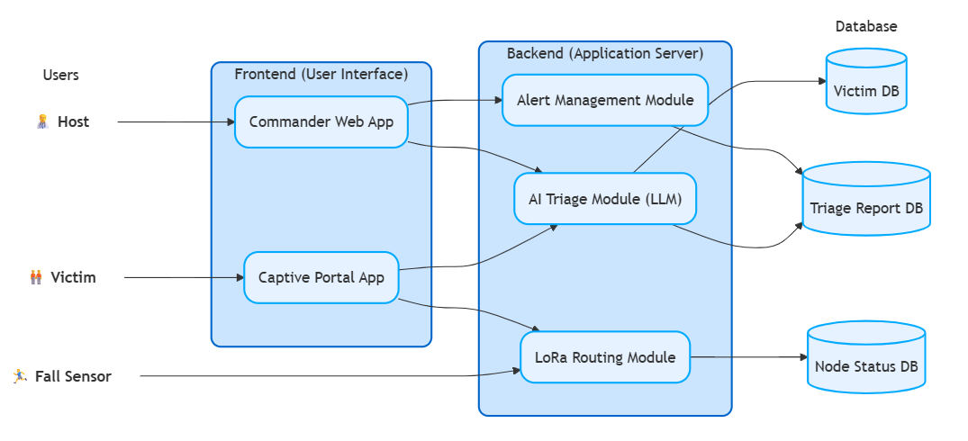

2. Structure Design –
2.1 Class Diagram –
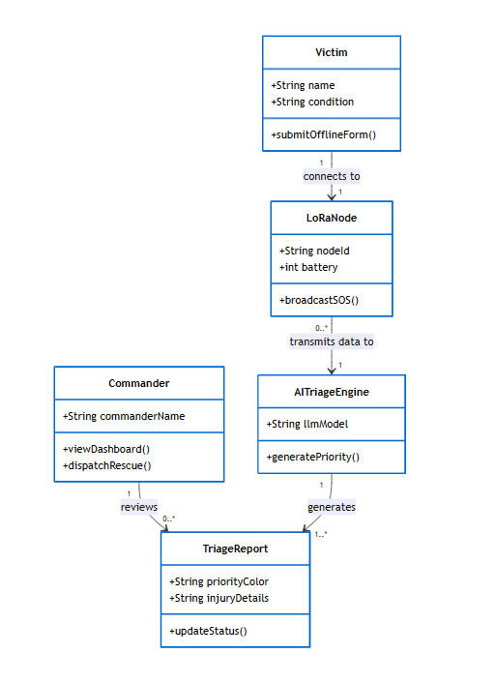

2.2 Data Flow Diagram –
DFD Level 0 –
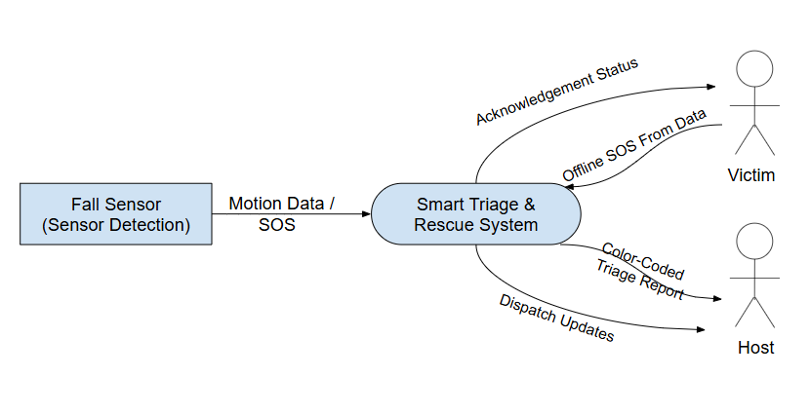
DFD Level 1 –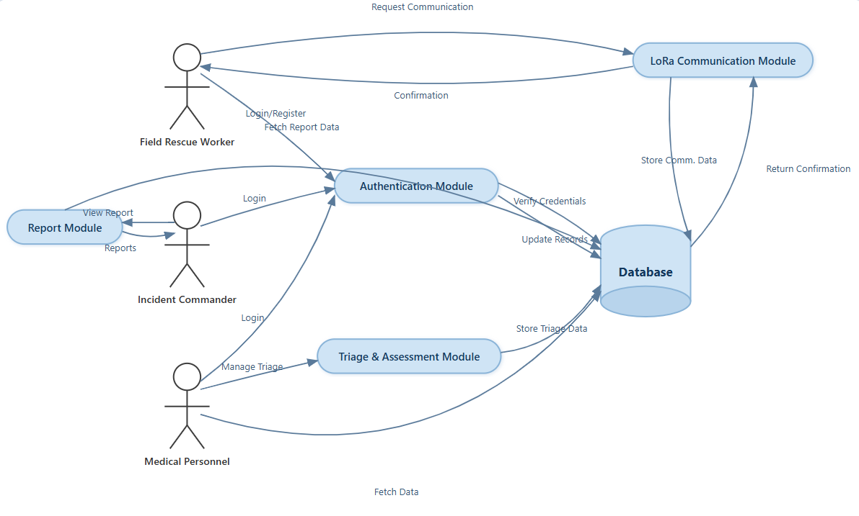

DFD Level 2 –
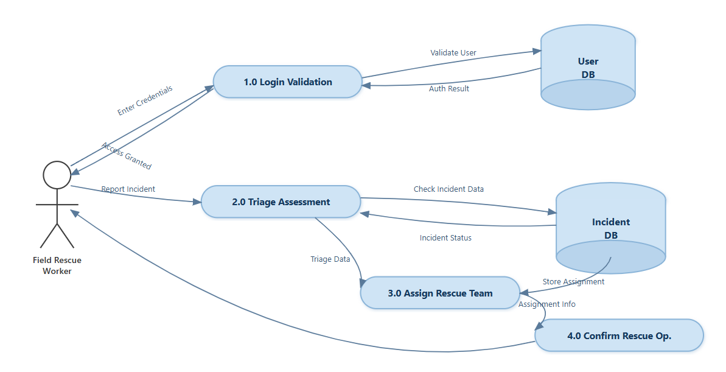

3. Behavioral Diagrams –
3.1 Sequence Diagram –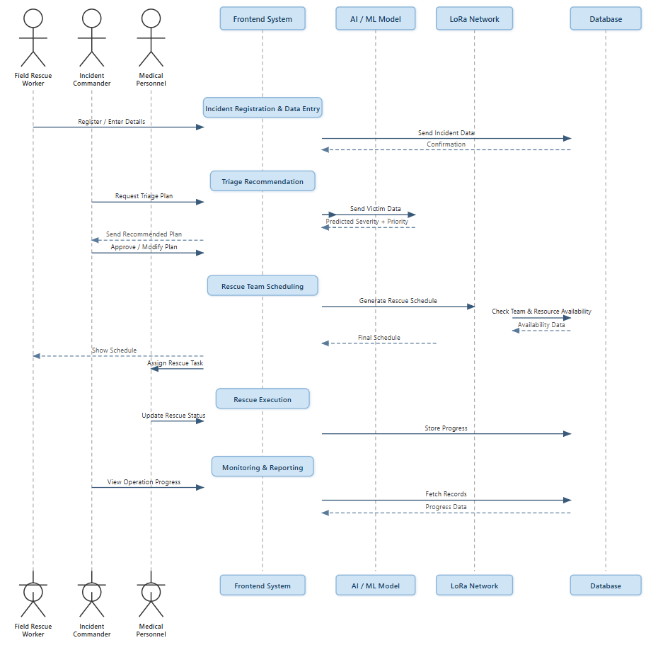

3.2 Collaboration Diagram –
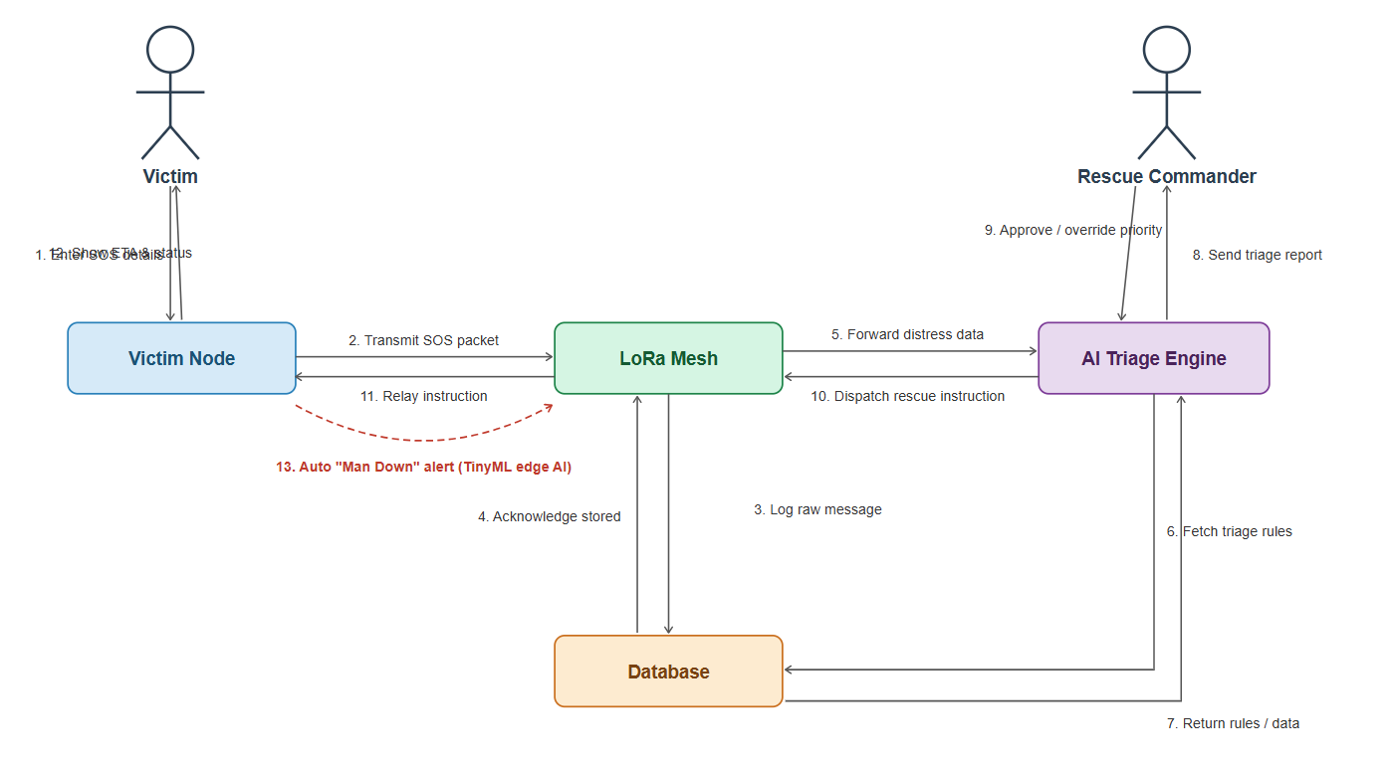

3.3 Activity Diagram –
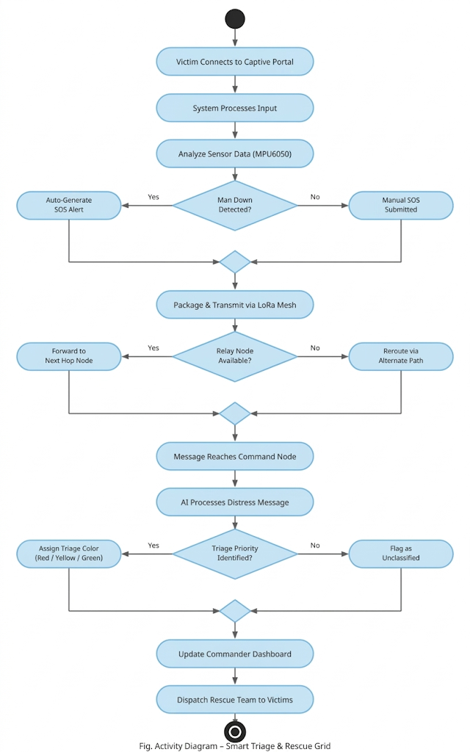

3.4 State-Chart Diagram –
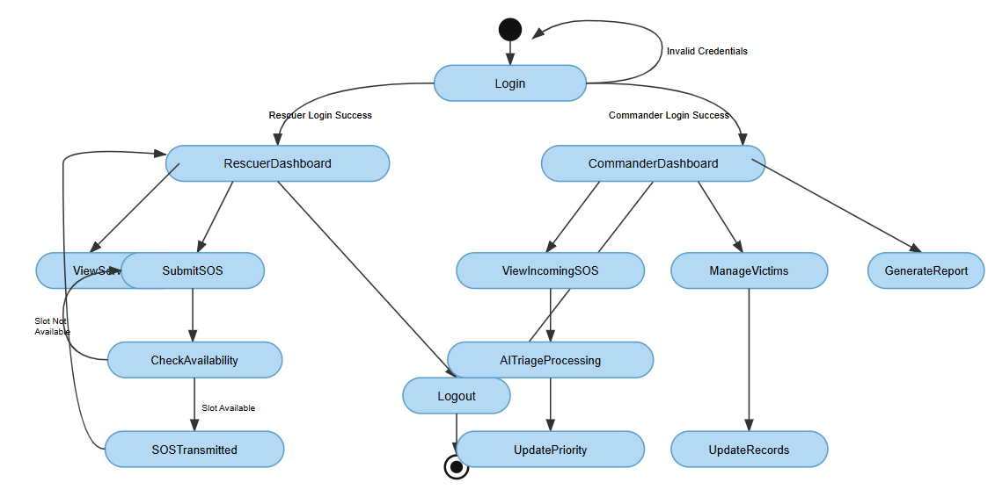

4. Implementation Design –
4.1 Component Diagram –
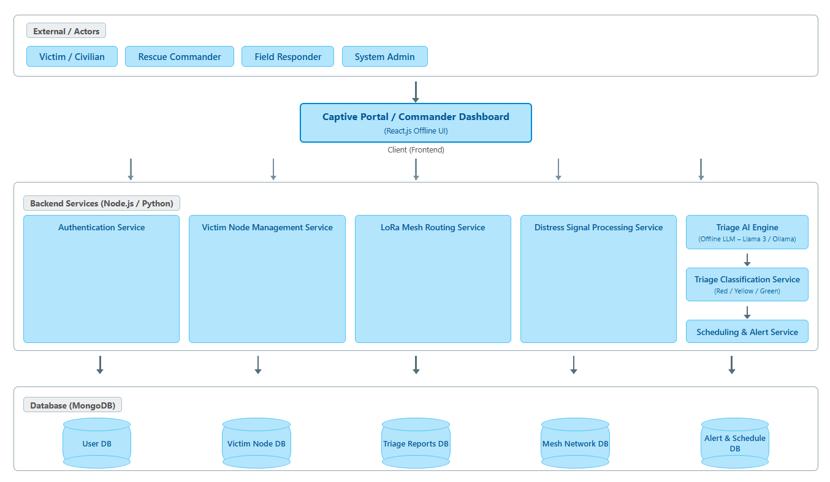

4.2 Deployment Diagram –
