D.K.T.E. Society’s Textile and Engineering Institute, Ichalkaranji.
(An Empowered Autonomous Institute, Affiliated to Shivaji University, Kolhapur)
Department of Computer Science & Engineering
2025-26


Project SRS On
Smart Triage & Rescue Grid Using LoRa-Based IoT and Generative AI

Under The Guidance Of
Prof. Rajendra Hiremath
Submitted By:
- 23UCS096 Paras Shantisagar Patil

2. 23UCS103 Shruti Deepak Patil

3. 23UCS105 Tanvi ShrenikPatil

4. 23UCS106 Tarun Rajagouda Patil

Prof. Rajendra Hiremath Prof. (Dr.) D.V.Kodavade
Project Guide Head of Department

- INTRODUCTION

1.1 Introduction
Disaster management and emergency response are among the most critical sectors in society, focusing on mitigating the impact of calamities and saving human lives. In recent years, with the advancement of digital technology, emergency communication systems have evolved to include satellite networks and advanced radio protocols. These systems help coordinate rescue operations, allocate resources, and maintain situational awareness. However, traditional terrestrial networks—such as cellular towers and internet infrastructure—remain highly vulnerable and are often the first to collapse during natural disasters like earthquakes, floods, or cyclones.
Despite the growth of modern communication, many emergency response teams still rely on manual radio processes or prohibitively expensive satellite phones when terrestrial networks fail. Managing thousands of distress signals, locating unconscious victims, and prioritizing rescue operations are often done manually, leading to inefficiencies, information overload, and critical delays. Existing alternative systems do not provide intelligent data filtering or automated triage based on the severity of the victim's condition. This creates severe challenges in delivering efficient, life-saving interventions during the "golden hour" of a disaster.
To address these issues, there is a need for a smart, off-grid communication system that can assist rescue commanders in decision-making and triage tasks. The proposed system, the "Smart Triage & Rescue Grid," aims to integrate decentralized IoT networking with modern Artificial Intelligence. It provides features such as independent LoRa mesh connectivity, autonomous "Man Down" detection, AI-based natural language processing for distress signals, and automated color-coded triage planning. By using intelligent logic and edge computing, the system reduces manual sorting, prevents data chaos, and enhances overall operational efficiency while ensuring rescue teams reach the most critical victims first.
This system has wide applications in natural disaster relief, deep underground mining, remote border patrols, and mass-casualty events. It can be used to improve victim connectivity, optimize rescue resource utilization, and provide intelligent situational awareness. In the future, such systems can be further extended with advanced drone relays and predictive analytics to revolutionize emergency response in the digital era.
1.2 Problem Description
Emergency rescue operations rely extensively on rapid communication and accurate prioritization of injuries. However, during catastrophic events, most civilian areas immediately fall into "Communication Dark Zones" due to infrastructure collapse. Current backup solutions either focus purely on raw text transmission without intelligent decision support or are economically inaccessible to the general public. This results in a chaotic workflow where rescue commanders are flooded with thousands of unstructured panic messages, making it humanly impossible to quickly identify and prioritize life-threatening medical emergencies.
Existing software and radio solutions in this domain provide limited functionality beyond simple peer-to-peer transmission. They lack the capability to assist in generating a structured, prioritized rescue queue. Moreover, traditional devices require manual interaction from the user; they cannot automatically detect or broadcast an SOS if a victim is unconscious or trapped under debris.
Another critical limitation is the absolute reliance on centralized cloud servers for advanced data processing. During a disaster, cloud access is severed. Therefore, there is a clear need for an intelligent, integrated off-grid system that goes beyond raw communication and actively supports rescue professionals through automated digital triage, autonomous safety monitoring, and decentralized networking, ultimately improving the speed and consistency of life-saving operations.
1.3 Problem Statement
Design and develop an off-grid Smart Triage and Rescue Grid that enables infrastructure-independent emergency communication, as current systems rely on vulnerable terrestrial networks and manual data sorting, resulting in "Communication Dark Zones," information overload for rescuers, and the inability to automatically prioritize critical, life-threatening injuries.

1.4 Objectives
- To design and implement a self-healing, off-grid LoRa mesh network that allows bidirectional communication without relying on internet or cellular infrastructure.
- To integrate Edge AI (TinyML) for autonomous fall detection and an offline Generative AI (LLM) to automatically parse distress messages and generate prioritized triage schedules.
- To visualize categorized victim data and track rescue status on a central dashboard to improve commander decision-making and response times.
1.5 Scope
The proposed system, the "Smart Triage & Rescue Grid," is designed to provide an integrated hardware-software solution for managing communication and medical triage during large-scale emergencies and network blackouts.
The scope of the system includes the development of edge hardware nodes (ESP32, LoRa, MPU6050 sensors), an offline Captive Portal for victims, a decentralized mesh routing protocol, and a central Commander Dashboard integrated with a local Artificial Intelligence engine. The system allows victims to connect via localized Wi-Fi and submit distress forms in a structured digital format without requiring internet access.
The system incorporates Edge AI to autonomously detect user falls ("Man Down") and trigger automatic SOS broadcasts. Simultaneously, it utilizes a locally hosted Large Language Model (LLM) at the command center to analyze incoming natural language distress texts and generate personalized triage priorities (Red, Yellow, Green) based on medical severity. It also provides an automated dashboard that organizes these requests, reducing data chaos and improving rescue resource utilization.
The system is intended to improve coordination between stranded victims and rescue teams, reduce the manual effort of reading unstructured messages, and enhance overall operational efficiency. However, the system is strictly limited to localized off-grid operation; it does not include features such as integration with global cellular telecom operators, standard internet-based cloud APIs, or online GPS tracking. The system acts as a digital decision-support tool and does not replace the final judgment of medical rescue professionals.

2. Overall Description
The Smart Triage & Rescue Grid is an off-grid emergency communication and medical triage platform designed for disaster management scenarios. The system assists stranded victims, rescue commanders, and emergency response teams in establishing connectivity, processing distress signals, and prioritizing rescue operations when standard cellular and internet infrastructure collapses.
It acts as an autonomous digital triage and decision-support system, improving rescue efficiency, overcoming communication blackouts, and enhancing victim survival rates through AI-driven prioritization and hardware-based safety monitoring.

2.1 Product Perspective
The system is a decentralized, hardware-software integrated platform operating completely off-grid. It interacts with stranded Victims (via smartphone Wi-Fi), embedded Fall Sensors, and Rescue Commanders. It integrates decentralized LoRa mesh networking, autonomous edge detection (TinyML), and offline Generative AI triage into a unified platform.
It replaces expensive dependency on satellite phones and manual, unprioritized radio communication with a structured, intelligent emergency grid.
2.1.1 Block Diagram
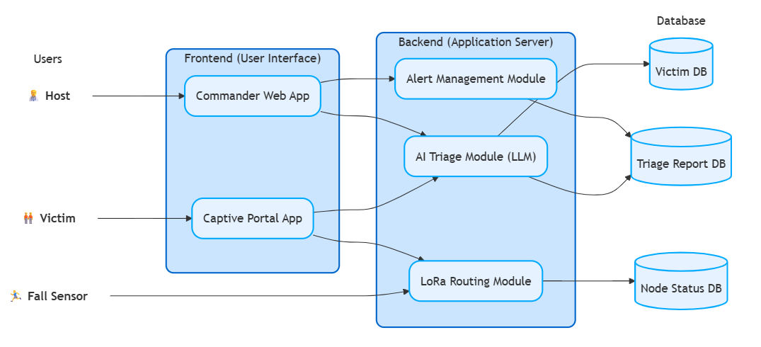
  - Fig. 1 Rescue System - Block Diagram

1. Frontend (User Interface)
This is the part of the system that human users interact with. It includes the Commander Web App and the Captive Portal App. Used by the Victim and the Rescue Commander. Users can:
- Connect without internet to submit offline SOS forms (Victims).
- View prioritized rescue dashboards and alerts (Commanders). It sends user requests and data over RF to the backend and displays processed results.
2. Backend (Application Server)
This is the main processing hub located at the command center where all intelligent routing and sorting happens. It includes different modules:
- LoRa Routing Module: Handles incoming and outgoing RF mesh signals from edge nodes and fall sensors, managing the network traffic.
- AI Triage Module (LLM): Processes raw natural language text from victims to infer medical severity and automatically categorize priority (Red, Yellow, Green).
- Alert Management Module: Generates visual and audio alerts for the Commander based on AI outputs and critical system status updates. It processes hardware and user requests and interacts directly with the database.
3. Database
This locally hosted system stores all operational data securely without cloud dependency. It includes:
- Victim DB: Stores victim identities, locations, and raw submitted SOS details.
- Triage Report DB: Stores the AI-generated medical priorities, injury inferences, and rescue dispatch status.
- Node Status DB: Stores hardware health data, battery levels, and mesh routing paths. The backend reads and writes data to and from these databases in real-time.
4. Users (Actors)
These are the entities that interact with or trigger the system:
- Victim: Connects to the edge node to submit distress signals via the Captive Portal.
- Fall Sensor: An autonomous hardware entity that detects physical drops and triggers automatic "Man Down" alerts via the LoRa Routing Module.
- Commander: Monitors the web app, receives alerts, and manages rescue dispatch based on AI triage.
2.1.2. Hardware Requirements
Minimum hardware requirements for the system are divided into two categories:
Command Center (Server/Laptop):
- Processor: Intel Core i5 / AMD Ryzen 5 or above.
- RAM: 16 GB minimum (Crucial for running local LLMs smoothly).
- GPU: NVIDIA RTX 3060/4060 or equivalent (Highly recommended for faster AI inference).
- Storage: 50 GB free disk space.
- Network: Local router (No internet required).
Edge/Victim Nodes (Hardware):
- Microcontroller: ESP32 Development Board.
- Transceiver: LoRa SX1276 Module (865 MHz ISM Band).
- Sensor: MPU6050 Accelerometer and Gyroscope.
- Power: 3.7V Li-ion Battery.
2.1.3. Software Requirements
The system requires the following software stack:
- Operating System: Windows / Linux / macOS (Command Center).
- Frontend: HTML, CSS, JavaScript, React.js.
- Backend: Node.js / Express.js, Python.
- AI/ML Tools: Ollama (for offline LLM hosting), Edge Impulse (for TinyML models).
- Hardware Programming: Arduino IDE, C/C++.
- Database: MongoDB (Local installation).
- Browser: Google Chrome, Firefox, Edge.

2.2 Product Functions
The system provides the following major functions:
1. Off-Grid SOS Submission
- Victims connect to a localized ESP32 Wi-Fi network.
- Submit distress details via a browser-based Captive Portal without needing cellular service, internet, or pre-installed apps.
2. Autonomous Fall Detection ("Man Down")
- Edge AI (TinyML) on the MPU6050 sensor detects severe falls or unresponsiveness.
- Automatically triggers an SOS broadcast over the mesh network if the victim cannot manually ask for help.
3. Self-Healing Mesh Communication
- LoRa nodes intelligently route text payloads over long distances (multi-hop).
- Bypasses broken infrastructure and automatically finds alternative paths if a relay node is destroyed.
4. Intelligent Digital Triage
- An offline Generative AI reads unstructured distress messages.
- Classifies victims into standard medical triage categories (Red: Immediate, Yellow: Urgent, Green: Minor) based on inferred injury severity.
5. Commander Dashboarding & Alerting
- Real-time visualization of victims and their AI-assigned priorities.
- Alert management to notify commanders of new critical emergencies, allowing for optimized dispatch of rescue resources.
6. Network Health Monitoring
- Continuous tracking of individual LoRa node battery levels.
- Monitoring of connectivity status and mesh topology integrity.

3.Specific requirements
This section describes the detailed requirements of the Smart Triage & Rescue Grid system to provide a clear understanding for system designers, hardware engineers, and developers to design and implement the system effectively, and for testers to verify that the system meets all specified requirements.
The requirements defined in this section explain how the system will respond to various inputs (stimuli) provided by users such as stranded victims and rescue commanders, as well as autonomous hardware triggers, and how it will generate appropriate outputs (responses). These inputs include user interactions such as offline SOS form submission, continuous motion sensor data, LoRa mesh routing telemetry, and commander dashboard queries.
The system processes these inputs using embedded hardware logic, multi-hop RF protocols, and an offline Generative AI (LLM) backend, and produces outputs such as automated "Man Down" alerts, parsed medical inferences, color-coded digital triage schedules, and decentralized network health updates.
All functional and non-functional aspects of the system are described in detail to ensure that every operation performed by the system is clearly defined, testable, and aligned with the objectives of improving post-disaster rescue operations.

3.1 External interfaces
The Smart Triage & Rescue Grid interacts with users and external hardware components through various input and output interfaces.
Inputs to the System:
- Victim distress details (name, age, condition, location context) via offline Wi-Fi form.
- Raw accelerometer and gyroscope motion data (from MPU6050 sensors).
- Incoming LoRa radio frequency (RF) payload strings from the mesh network.
- Commander interactions (filtering dashboard data, updating rescue status).
- Hardware telemetry (battery levels, node connection status).
Outputs from the System:
- Localized Wi-Fi Captive Portal (served from the ESP32 to the victim's smartphone).
- RF packet broadcasts over the 865 MHz LoRa ISM band.
- AI-generated JSON triage reports (Red/Yellow/Green medical priority).
- Real-time visual dashboard updates and audio alerts for rescue commanders.
- System acknowledgment messages sent back to the victim's device.
The system ensures proper interaction between edge hardware, RF modules, the Node.js backend, MongoDB, and the local AI engine to process inputs and generate accurate, life-saving outputs without any internet connectivity.

3.2 Functional Requirements
The functional requirements of the Smart Triage & Rescue Grid are defined as follows:
- The edge nodes (ESP32) shall host a localized, offline Wi-Fi access point and Captive Portal for victims.
- The system shall allow victims to submit an SOS form (Name, Age, Injury Description) using a standard smartphone browser without an internet connection.
- The embedded MPU6050 sensor shall utilize a TinyML model to detect hard falls and unresponsiveness.
- The system shall autonomously trigger and broadcast a "Man Down" SOS alert if a fall is detected and the victim is unconscious.
- The LoRa nodes shall form a decentralized mesh network, utilizing a "Store and Forward" algorithm to route packets to the Command Center.
- The mesh network shall self-heal and reroute messages if an intermediate relay node is destroyed or loses power.
- The Commander Node shall intercept incoming LoRa RF signals and transfer the payload via serial/USB to the local backend server.
- The system shall utilize a local, offline Large Language Model (e.g., Llama 3 via Ollama) to parse unstructured natural language SOS texts.
- The AI module shall classify and output the medical severity of the distress signal into standard triage categories (Red: Immediate, Yellow: Urgent, Green: Minor).
- The system shall dynamically update a React.js Commander Dashboard, prioritizing victims with life-threatening injuries at the top of the queue.
- The system shall allow rescue commanders to update the dispatch status (Pending, Dispatched, Rescued) of individual victims.
- The system shall track and display the battery life and network health of all active LoRa nodes in the field.

3.3 Performance requirements
The system shall meet both static and dynamic performance requirements to ensure efficient and reliable operation during critical emergency windows.
Static Requirements: a. The victim-facing Captive Portal shall be lightweight and compatible with any standard mobile browser. b. The mesh network shall support a scalable number of nodes (e.g., 50-100 nodes per localized grid). c. The backend shall efficiently handle and store different data types, including compressed RF payloads, parsed JSON objects, and hardware telemetry.
Dynamic Requirements:
- The mesh network shall achieve an average message transmission latency of under 2 seconds per node hop.
- The TinyML fall detection model shall process motion data and trigger an autonomous alert within 3 seconds of the event.
- The offline AI module (LLM) shall read the SOS text and generate a triage priority within 5 to 10 seconds on the command center's local hardware.
- The system shall handle concurrent bursts of SOS messages (typical in mass-casualty events) asynchronously without crashing the local AI engine.

3.4 Design constraints
The system is subject to specific architectural and environmental constraints dictated by post-disaster realities.
- Absolute Off-Grid Requirement: The entire system, including the AI processing, must function with zero reliance on the internet, cloud APIs, or cellular networks.
- Bandwidth Limitations: Due to the low-bandwidth nature of LoRa technology, data payloads must be strictly compressed to minimal text/JSON strings (e.g., under 256 bytes) before transmission.
- Hardware and Power Limits: Edge nodes (ESP32) must be optimized for low power consumption to run continuously on portable 3.7V Li-ion batteries.
- Technology Stack: The system shall be developed using C++ (Arduino) for hardware, React.js for the UI, Node.js/Python for the backend, and local LLM runners (Ollama) for AI.
- Security: RF transmissions should utilize AES encryption (supported by the SX1276 module) to protect sensitive medical telemetry from unauthorized interception.

3.5 Logical database requirements
The system requires a local, structured database (MongoDB) to store and manage information related to victims, emergencies, and network health.
a. Types of Information: The database shall store victim identities, raw SOS texts, AI-generated triage priorities, medical inferences, rescue statuses, and node hardware telemetry. b. Frequency of Use: Data will be written at a high frequency during the initial phase of a disaster (data bursts) and accessed continuously by the Commander Dashboard for real-time monitoring. c. Data Entities and Relationships: The main entities include Victim, SOSMessage, TriageReport, and LoRaNode. A Victim can generate multiple SOSMessages, an SOSMessage generates one TriageReport, and LoRaNodes route multiple SOSMessages. d. Integrity Constraints: The system shall maintain data integrity using unique IDs for every hardware node and every generated SOS message to prevent duplicate alerts from confusing the rescue teams. e. Data Retention Requirements: Disaster data shall be retained locally for post-event analysis, auditing of rescue response times, and further training of the AI triage models.

3.6 Software system attributes
The system shall satisfy the following software and hardware quality attributes to ensure life-saving reliability.
3.6.1 Reliability
The system shall ensure that distress messages are delivered even if parts of the network fail. The self-healing mesh logic and the offline AI fallback mechanisms must minimize single points of failure.
3.6.2 Availability
The system must be "always-on" during the disaster window. The edge nodes shall utilize battery backups, and the software shall include auto-restart mechanisms for the local server and AI engine in case of power fluctuations at the command camp.
3.6.3 Security
The system shall ensure that the offline network cannot be easily hijacked or flooded with fake requests. It shall protect sensitive medical data being transmitted over radio waves using standard AES encryption algorithms.
3.6.4 Maintainability
The software architecture shall be strictly modular, separating the C++ edge code, the Node.js networking backend, the Python/LLM AI engine, and the React frontend. This allows different engineering team members to debug and improve modules independently.
3.6.5 Portability
The Commander Dashboard shall be accessible via any web browser on the local area network (LAN) at the rescue camp. The TinyML models shall be compiled as standard Arduino libraries, allowing them to be ported to various microcontrollers beyond the ESP32 if required.

  - 4. Software Design Document

4.1. Structural Design

a. Class Diagrams
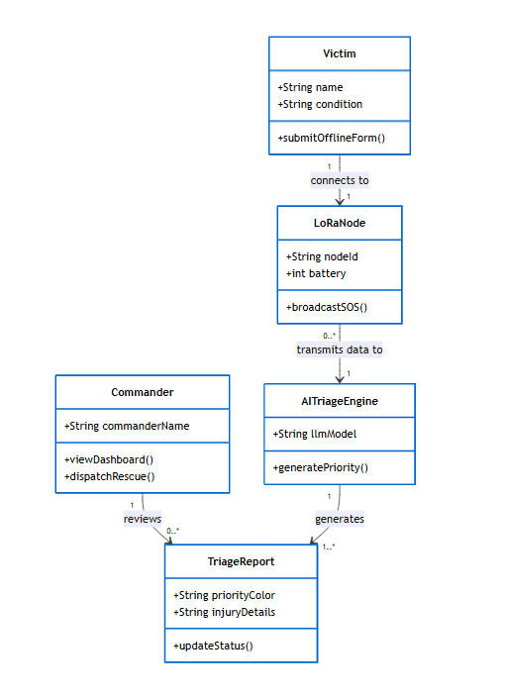
  - Fig. 2 Rescue System - Class Diagram

The Fig. 2 Smart Triage & Rescue Grid - Class diagram shows the structure of the system, including different classes like Victim, LoRaNode, AITriageEngine, TriageReport, Commander, and their relationships.
- Victim submits offline distress forms containing their name and medical condition.
- LoRaNode connects to the victim's device, tracks battery status, and broadcasts the SOS data across the mesh network.
- AITriageEngine receives the transmitted data and processes it using a Large Language Model (LLM) to generate medical priorities.
- TriageReport stores the AI-assigned priority color and injury details, and handles status updates as the rescue progresses.
- Commander views the dashboard to review the triage reports and dispatches rescue teams accordingly.
b. Object Diagrams

4.2. Data Design

a. Data-flow Diagram
1. DFD Level 0 -
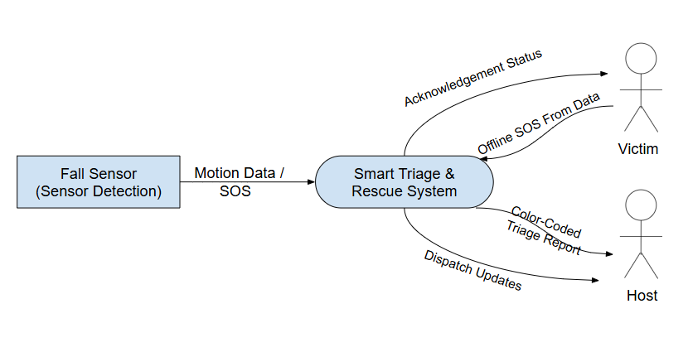
  - Fig. 3. Rescue System - DFD Level 0

Fig. 3. Smart Triage & Rescue Grid - DFD Level 0
The Context Diagram (Level 0) provides a high-level overview of the data flow between the system and its external entities during an emergency event.
1. Main Process
- The Smart Triage & Rescue System acts as the central processing hub, managing communication, AI-based prioritization, and dispatch logistics.
2. External Entities and Data Flows
The system interacts with three primary external components:
- Fall Sensor (Sensor Detection):
  - Input to System: Sends continuous Motion Data / SOS triggers (utilizing the MPU6050 accelerometer/gyroscope) to indicate a potential "Man Down" scenario.
- Victim:
  - Input to System: Provides Offline SOS From Data via the captive portal (React.js UI) when manual assistance is required.
  - Output from System: Receives Acknowledgement Status to confirm that their distress signal has been successfully reached the command center.
- Host (Incident Commander/Rescuer):
  - Output from System: Receives a Color-Coded Triage Report (Red/Yellow/Green) generated by the Offline AI engine to prioritize victims.
  - Output from System: Receives Dispatch Updates to coordinate and track rescue team movements in real-time.
3. System Characteristics
- This level represents the system as a "black box," focusing exclusively on the inputs and outputs that cross the system boundary.
- It emphasizes the Offline-First nature of the grid, showing how sensor data and manual distress signals are aggregated to provide actionable intelligence to the host/commander.

2. DFD Level 1-
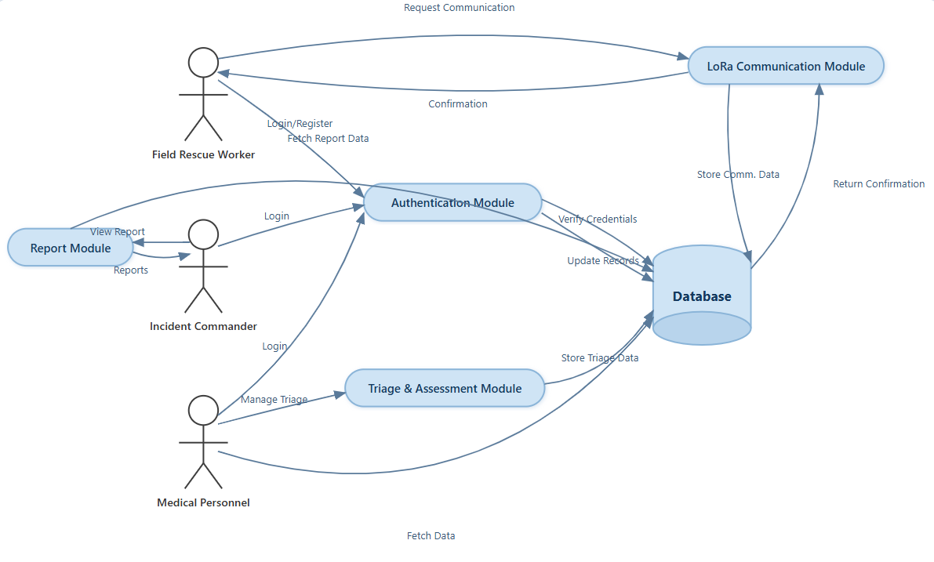
  - Fig. 4. Rescue System - DFD Level 1

Fig. 4. Smart Triage & Rescue Grid - DFD Level 1 breaks the system into major functional modules:
1. Authentication Module
- Handles login and registration for Field Rescue Workers, Incident Commanders, and Medical Personnel.
- Verifies user credentials and updates user records using the database.
2. LoRa Communication Module
- Processes communication requests from Field Rescue Workers over the off-grid network.
- Stores incoming communication and distress data in the database.
- Sends transmission confirmations back to the Field Rescue Worker.
3. Triage & Assessment Module
- Used by Medical Personnel to manage and categorize medical triage.
- Stores processed triage priorities and assessment records securely in the database.
4. Report Module
- Generates operational and triage reports for the Incident Commander.
- Fetches system data from the database and displays actionable insights.
Database
- Central storage for:
  - User credentials and system records
  - LoRa communication data
  - Triage and medical assessment data
This level shows how different modules interact with each other and the central database to maintain the flow of emergency information.

3. DFD Level 2 -

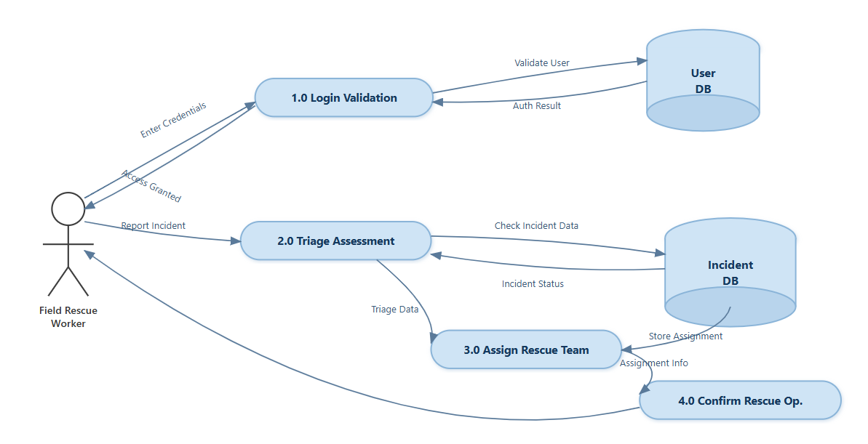
  - Fig. 5. Rescue System - DFD Level 2

Fig. 5. Smart Rescue Grid - DFD Level 2
The diagram provides a detailed breakdown of the Emergency Response and Rescue Assignment process:
1. Login Validation (1.0)
- Field Rescue Worker enters credentials.
- The system sends a Validate User request to the User DB.
- The User DB returns the Auth Result, and access is granted to the worker.
2. Triage Assessment (2.0)
- The Field Rescue Worker submits a Report Incident.
- The system performs a Check Incident Data against the Incident DB.
- The Incident DB provides the current Incident Status to assist in the assessment.
3. Assign Rescue Team (3.0)
- Once the triage is processed, Triage Data is passed from the assessment phase to the assignment phase.
- The system generates Assignment Info and ensures the Store Assignment action is updated in the Incident DB.
4. Confirm Rescue Op. (4.0)
- The system finalizes the operation details.
- A final confirmation is sent back to the Field Rescue Worker to signal that the rescue operation is officially confirmed and underway.

4.3. Behavioural Design

a. Sequence Diagram

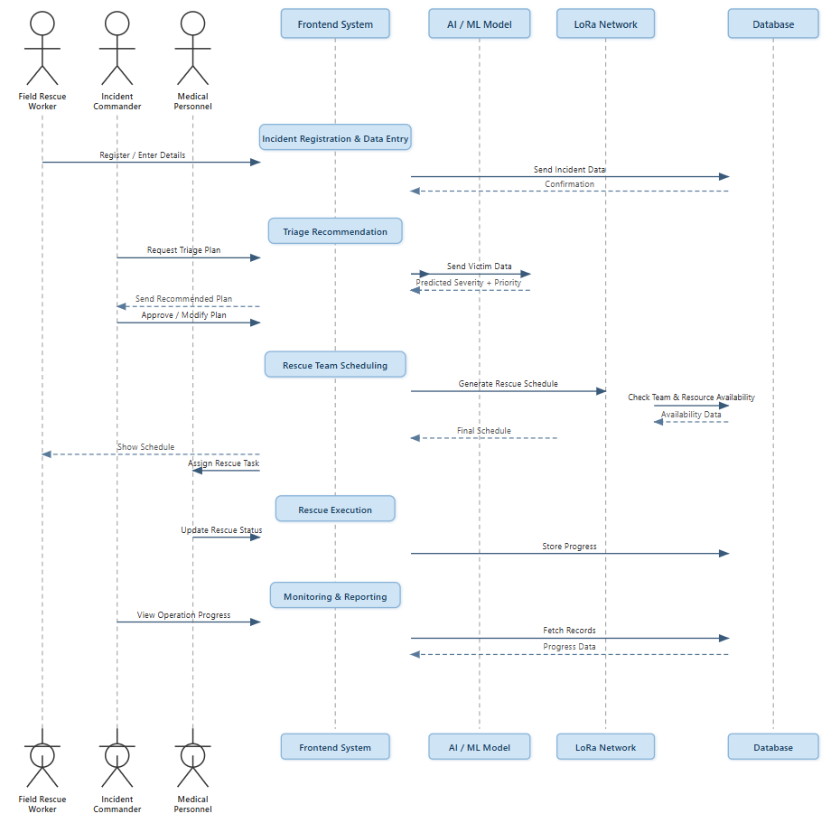

  - Fig. 6. Rescue System – Sequence Diagram
Fig. 6. Smart Rescue Grid - Sequence Diagram
The diagram illustrates the end-to-end operational workflow of the AI-powered Smart Rescue Grid system for disaster management.
1. Incident Registration & Data Entry
- The process begins with the Field Rescue Worker registering the incident and entering specific victim details into the Frontend System.
- This data is transmitted to the Database for persistent storage, with a confirmation returned to the system.
2. Triage Recommendation
- The Incident Commander requests a triage plan via the Frontend.
- The system sends victim data to the AI/ML Model, which analyzes the inputs to predict the Severity and Priority of the cases.
- The Incident Commander reviews the recommended plan and retains the authority to Approve or Modify it before implementation.
3. Rescue Team Scheduling
- The system initiates a request to generate a rescue schedule.
- The LoRa Network facilitates a check for Team and Resource Availability within the Database.
- Once availability is confirmed, a Final Schedule is generated and shared with the relevant field personnel.
4. Rescue Execution
- Tasks are assigned to the Field Rescue Worker based on the approved schedule.
- During the operation, the worker provides real-time Update Rescue Status notifications.
- This progress is transmitted via the LoRa Network and stored in the Database to ensure data synchronization across the grid.
5. Monitoring & Reporting
- In the final phase, the Incident Commander can view the Operation Progress through a centralized dashboard.
- The system fetches records and progress data from the Database to allow for real-time monitoring and post-operation reporting.

b. Collaboration diagram

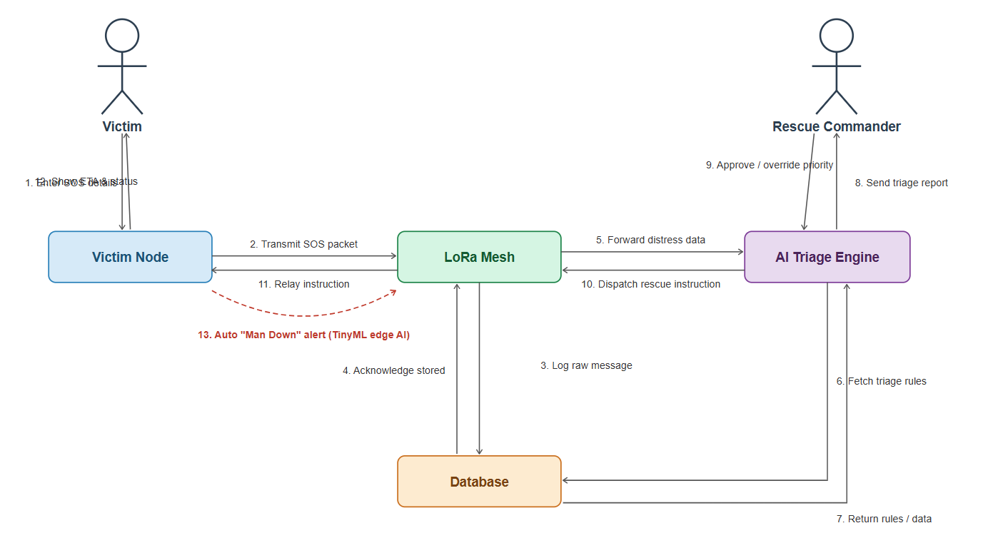
  - Fig. 7. Rescue System - DFD Level 1

Fig. 7. Smart Rescue Grid - Collaboration Diagram
This diagram illustrates the real-time communication and data flow between the hardware nodes and the central processing engine during a distress event.
1. Alert Initiation
- Manual Entry: The process begins when a Victim enters SOS details (1) into the Victim Node.
- Automated Entry: Alternatively, the TinyML Edge AI on the device can trigger an automated "Man Down" alert (13) if it detects a fall or lack of movement.
2. Network Transmission & Logging
- The Victim Node transmits the SOS packet (2) to the LoRa Mesh network.
- The LoRa Mesh network immediately logs the raw message (3) into the Database and receives a storage acknowledgment (4).
3. AI Analysis & Triage
- The mesh network forwards the distress data (5) to the AI Triage Engine.
- The Engine fetches triage rules (6) from the Database.
- After processing the returned rules and data (7), it sends a triage report (8) to the Rescue Commander.
4. Human Oversight & Command
- The Rescue Commander reviews the report and can either Approve or Override the priority level (9).
- Once confirmed, the AI Triage Engine dispatches rescue instructions (10) back through the LoRa Mesh.
5. Feedback Loop
- The instructions are relayed (11) back to the Victim Node.
- Finally, the system displays the Estimated Time of Arrival (ETA) and Status (12) to the Victim to provide reassurance during the rescue operation.

Key Technical Components:
- Victim Node: ESP32/LoRa-based handheld or wearable device with Edge AI capabilities.
- LoRa Mesh: A decentralized communication backbone that functions without cellular service.
- AI Triage Engine: A centralized or cloud-based module that prioritizes victims based on severity.
- Database: Stores logs, triage rules, and resource availability for the commander's dashboard.

c. Activity Diagram
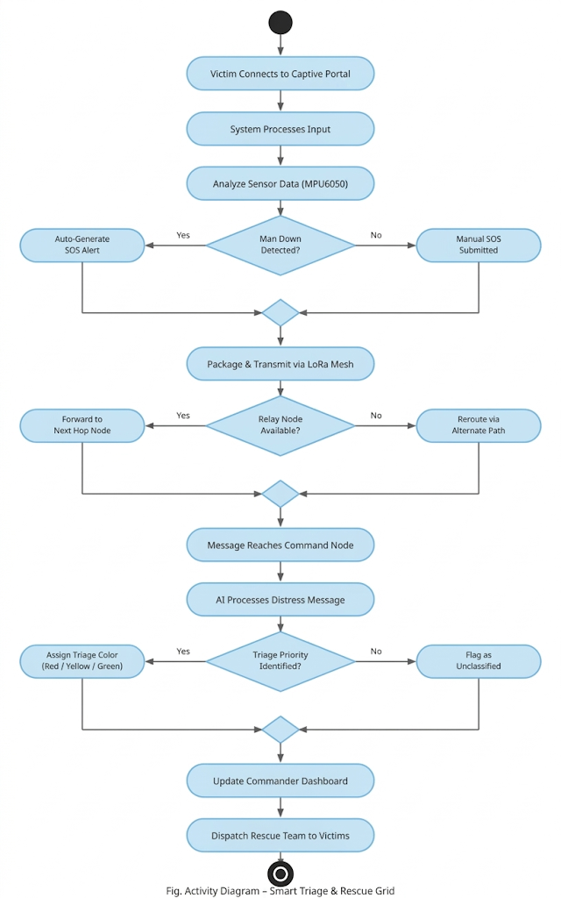

  - Fig. 8. Rescue System – Activity Diagram
Fig. 8. Smart Triage & Rescue Grid - Activity Diagram
The activity diagram illustrates the end-to-end logic flow from the moment a victim connects to the grid until a rescue team is dispatched.
- Initialization: The process begins when a Victim Connects to the Captive Portal, followed by the system processing the initial input.
- Sensing & Detection: The system analyzes sensor data (specifically from an MPU6050 accelerometer/gyroscope).
- Decision (Alert Type): A decision is made based on whether a "Man Down" event is detected:
  - Yes: The system auto-generates an SOS alert.
  - No: The process waits for a Manual SOS submission.
- Data Transmission: The distress message is packaged and transmitted via the LoRa Mesh network.
- Decision (Routing): The system checks if a Relay Node is available:
  - Yes: The message is forwarded to the next hop node.
  - No: The system reroutes the message via an alternate path.
- AI Processing: Once the message reaches the Command Node, the AI processes the distress message.
- Decision (Triage): The AI attempts to identify triage priority:
  - Yes: It assigns a Triage Color (Red / Yellow / Green) based on medical urgency.
  - No: The message is flagged as unclassified.
- Resolution: Finally, the system updates the Commander Dashboard and triggers the final action: Dispatch Rescue Team to Victims.

d. State-chart diagram
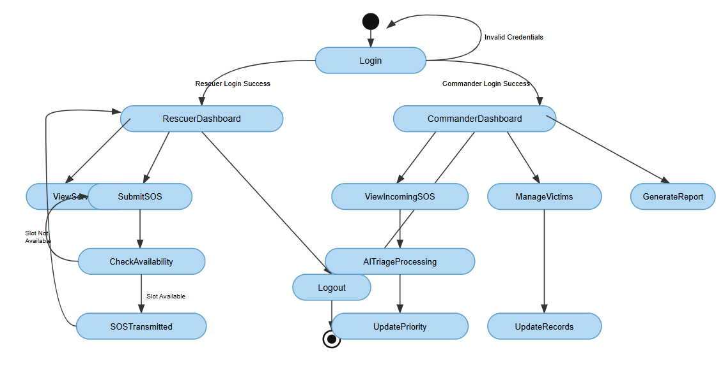
  - Fig. 9. Rescue System -State Chart Diagram

Fig. 9. Smart Rescue Grid - State Chart Diagram
The state chart diagram illustrates the various states and transitions of the system based on user roles and operational requirements.
1. Authentication Phase
- Login State: The system begins at the Login state.
- Error Handling: If Invalid Credentials are entered, the system transitions back to the Login state.
- Role-Based Redirection: Successful authentication leads to one of two primary dashboards: RescuerDashboard or CommanderDashboard.
2. Rescuer Workflow
- Submit SOS: From the Rescuer Dashboard, the user can initiate an SOS.
- Check Availability: The system transitions to check for available network slots or resources.
- Conditional Transitions: * If a Slot is Not Available, the system redirects back to view services or the dashboard.
  - If a Slot is Available, the state transitions to SOSTransmitted.
3. Commander Workflow
- Monitoring: The Commander can transition into the ViewIncomingSOS state.
- AI Integration: Incoming alerts trigger the AITriageProcessing state, which subsequently transitions to UpdatePriority to reflect the urgency of the rescue.
- Management & Reporting: The Commander also has the authority to transition into ManageVictims (leading to UpdateRecords) and GenerateReport states.
4. Session Termination
- Both user roles have access to the Logout state, which safely terminates the session and returns the system to the final end state.

4.4. Implementation Design

a. Component Diagram

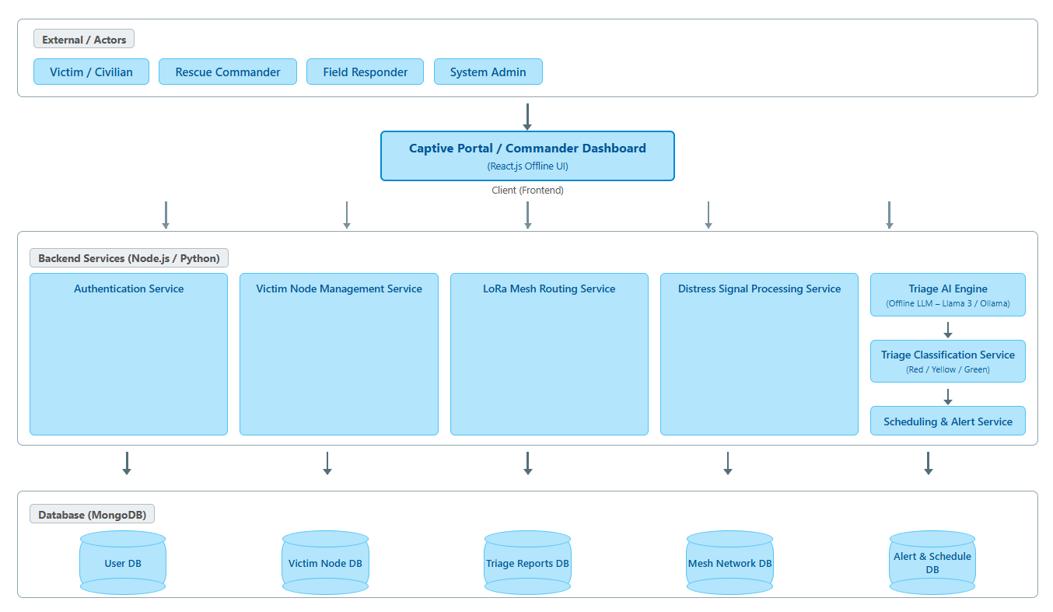
  - Fig. 10. Rescue System – Component Diagram

Fig. 10. Smart Rescue Grid - Component Diagram
The component diagram illustrates the modular architecture of the system, highlighting the separation between the user interface, logic services, and data persistence layers.
1. External / Actors Layer
- Primary users including the Victim / Civilian, Rescue Commander, Field Responder, and System Admin interact with the system.
2. Client (Frontend) Layer
- Captive Portal / Commander Dashboard: Built using React.js, this layer provides an Offline UI capability, ensuring functionality even when internet connectivity is compromised during disasters.
3. Backend Services (Node.js / Python)
This layer contains the core business logic of the grid:
- Core Services: Handles Authentication, Victim Node Management, and LoRa Mesh Routing.
- Processing Services: The Distress Signal Processing Service manages incoming alerts.
- AI Intelligence: The Triage AI Engine (powered by Offline LLMs like Llama 3 or Ollama) feeds into a Triage Classification Service (Red/Yellow/Green) and a Scheduling & Alert Service.
4. Database Layer (MongoDB)
The system utilizes a distributed data approach with dedicated collections for:
- User DB (Credentials and profiles)
- Victim Node DB (Hardware status and telemetry)
- Triage Reports DB (AI-generated medical assessments)
- Mesh Network DB (Topology and node routing tables)
- Alert & Schedule DB (Active rescue operations and assignments)

4.5. Environment Design

a. Deployment Diagram

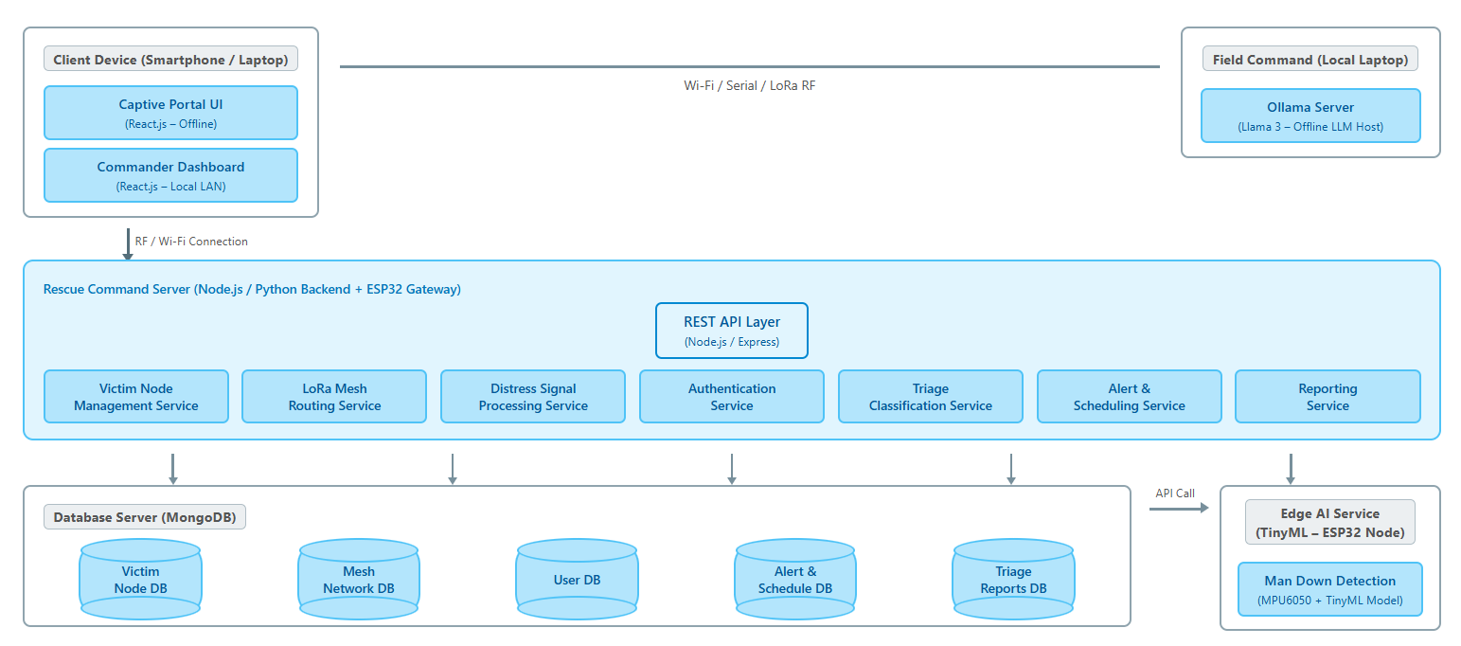
  - Fig. 11. Rescue System – Deployment Diagram

Fig. 11. Smart Rescue Grid - Deployment Diagram
The deployment diagram illustrates the distributed hardware and software architecture designed for offline-first disaster response.
1. Client & Field Command Layer
- Client Device (Smartphone / Laptop): Hosts the Captive Portal UI and Commander Dashboard. These are built with React.js to operate as an Offline-capable UI.
- Field Command (Local Laptop): Functions as a local host for the Ollama Server, running an Offline LLM (Llama 3) to ensure AI triage works without an active internet connection.
- Connectivity: Communication between layers is maintained via a combination of Wi-Fi, Serial, and LoRa RF protocols.
2. Rescue Command Server (Logic Layer)
This is the core processing hub running on a Node.js / Python backend paired with an ESP32 Gateway:
- REST API Layer: Managed via Express.js, acting as the gateway for all internal services.
- Modular Services: Includes specialized micro-services such as LoRa Mesh Routing, Distress Signal Processing, and Triage Classification.
- Integration: It bridges the gap between high-level reporting and low-level hardware data.
3. Edge AI Service (Hardware Layer)
- TinyML Integration: Deployed on ESP32 Nodes, this layer runs a Man Down Detection model.
- Sensors: Utilizes raw data from the MPU6050 (accelerometer/gyroscope) to process alerts at the "Edge" before they are even transmitted to the server.
4. Database Server (Persistence Layer)
- Data Storage: A MongoDB server manages distributed data collections including Victim Node DB, Mesh Network DB, and Triage Reports DB.
- Communication: The Rescue Command Server interacts with the database layer to ensure all incident logs and schedules are persisted in real-time.

5. Algorithms for Functional Requirements

The following algorithms define the logical operations for the Smart Triage and Rescue Grid System:

1. Edge-AI "Man Down" Detection Algorithm
Input: Raw 3-axis data from MPU6050 (Accelerometer/Gyroscope).
Process:
Continuously sample sensor data at a defined frequency (e.g., 50Hz).
Calculate the Magnitude of Acceleration: $Acc_{mag} = \sqrt{x^2 + y^2 + z^2}$.
Compare $Acc_{mag}$ against a predefined impact threshold.
If a threshold breach is followed by a period of inactivity (zero-motion), trigger an alert state.
Output: Automated SOS Trigger.

2. Captive Portal & Victim Registration Algorithm
Input: Victim name, age, and severity description via mobile browser.
Process:
Victim connects to the ESP32-hosted Wi-Fi Access Point.
DNS redirect serves the Captive Portal UI (React-based).
Accept and validate the distress details.
Package the data into a lightweight JSON/Binary packet for transmission.
Output: Distress Packet ready for mesh transmission.

3. LoRa Mesh Routing & Relay Algorithm
Input: Distress packet from a node.
Process:
Check if the current node is the Command Node (Gateway).
If not, scan for the nearest available Relay Node within the mesh.
Implement a routing protocol (e.g., AODV or flooding) to find the shortest path to the gateway.
Retransmit the packet; implement a retry mechanism if acknowledgment is not received.
Output: Reliable message delivery to the Command Node.

4. AI Triage & Priority Classification Algorithm
Input: Victim distress data and sensor logs.
Process:
Forward the received distress message to the Offline LLM (Ollama/Llama 3).
Extract key medical keywords and severity indicators from the text.
Assign Triage Color:
Red: Immediate life-threatening condition or "Man Down" detected.
Yellow: Serious but stable.
Green: Minor injuries.
Flag "Unclassified" if data is insufficient for a confident score.
Output: Triage Priority Level.

5. Commander Decision & Dispatch Algorithm
Input: AI-generated triage report and available rescue personnel list.
Process:
Display the triage report on the Commander Dashboard.
Allow the Commander to Approve or Override the AI's priority ranking.
Match the highest priority (Red) victims with the nearest available Field Responders.
Update the Incident DB with the assigned rescue task.
Output: Rescue Team Dispatch Order.

6. Real-Time Monitoring & Feedback Algorithm
Input: GPS coordinates and Rescuer status updates.
Process:
Fetch active rescue records from the Database.
Calculate Estimated Time of Arrival (ETA) based on responder movement.
Transmit status updates (e.g., "Team Dispatched," "ETA 5 mins") back through the LoRa Mesh to the Victim Node.
Output: Live Dashboard updates and Victim reassurance messages.

7. Data Integrity & Synchronization Algorithm
In a disaster scenario, connectivity is intermittent. This algorithm ensures data isn't lost when a node moves out of range.
Process:
Implement a Store-and-Forward mechanism on each LoRa node.
Each message is assigned a unique Sequence ID and Timestamp.
Nodes maintain a local cache of the "Last Known State."
Upon re-establishing a mesh connection, the node performs a Delta Sync with the Gateway to upload missed distress packets.
Output: Consistent system state across the entire grid.

8. Mesh Network Self-Healing Algorithm
Since nodes (rescuers/victims) are mobile, the network topology changes constantly.
Process:
Nodes periodically broadcast a "HEARTBEAT" signal to identify neighbors.
Maintain a Routing Table with "Link Quality" metrics (RSSI/SNR).
If a primary relay node fails or moves, the algorithm triggers a Route Discovery phase to find the next best path to the Command Server.
Output: Dynamic, resilient communication backbone.

9. AI Triage Reasoning (Prompt Engineering)
Explain how the Offline LLM (Llama 3) actually "thinks" to assign a priority.
Process:
Input Sanitization: Convert raw sensor data and captive portal text into a structured prompt.
Few-Shot Prompting: Provide the model with 3–5 examples of medical distress scenarios and their corresponding triage colors.
Safety Constraints: Instruct the model to default to "Red" (High Priority) if the input is ambiguous or indicates a "Man Down" sensor trigger.
Output: Deterministic and safe medical prioritization.

10. Power Management & Optimization Algorithm
For hardware like the ESP32, battery life is critical during a 24-48 hour rescue window.
Process:
Implement Adaptive Sampling: Reduce MPU6050 polling frequency when no movement is detected.
Deep Sleep Cycles: Put the Wi-Fi radio to sleep when no victim is connected to the Captive Portal.
Transmission Power Scaling: Adjust LoRa transmit power based on the distance to the nearest neighbor node to save milliamps ($mA$).
Output: Extended field operational time.

11. Security & Authentication Logic
To prevent "Ghost Alerts" or malicious interference in the grid.
Process:
Node White-listing: Only devices with pre-registered MAC addresses can act as Relay or Command nodes.
Message Signing: Each distress packet is signed with a lightweight cryptographic hash to ensure it hasn't been tampered with during transit.
Admin Override: The System Admin can "Mute" a malfunctioning node from the dashboard to prevent network congestion.
Output: Secure and trusted emergency network.

12. Resource Conflict Resolution (Optimization)
If multiple "Red" priority victims are detected but only one rescue team is available.
Process:
Calculate a Weighted Priority Score based on (AI Triage Level + Time since Alert + Distance from Base).
Use a Greedy Search Algorithm to find the most efficient route for the rescue team to hit multiple targets in one trip.
Output: Optimized rescue pathing that maximizes lives saved per hour.

6. References
[1] M. A. Al-Garadi, A. Mohamed, A. K. Al-Ali, X. Du and M. Guizani, "Performance Analysis of LoRaWAN for Disaster Management: A Simulation Study", IEEE Internet of Things Journal, vol. 10, no. 4, pp. 3215-3228, 2023.
[2] S. K. Singh, P. Kumar and S. K. Sharma, "A Multi-Hop LoRa Mesh Network for Emergency Communication Systems", IEEE Transactions on Network and Service Management, vol. 21, no. 1, pp. 445-458, 2024.
[3] A. L. Silva, M. Gomes and J. P. Carvalho, "Automated Triage Systems in Mass Casualty Incidents Using Cloud-Based NLP", Journal of Medical Systems, vol. 47, no. 8, pp. 112-125, 2023.
[4] R. Gupta, S. Bhatia and A. Kumar, "Real-Time Earthquake Detection using Low-Cost IoT Sensors and Edge AI", IEEE Sensors Journal, vol. 23, no. 12, pp. 13450-13459, 2023.
[5] K. Pham, A. Kisel, and T. L. Nguyen, "Empirical Evaluation of a LoRa Mesh Network for Emergency Communication Systems," IEEE Xplore, vol. 12, no. 3, pp. 104-115, 2024.
[6] A. Roy, S. K. Singh, and M. Kumar, "Design and Study of LoRa-Based IIoT Network for Underground Coal Mine Environment," IEEE Internet of Things Journal, vol. 11, no. 2, pp. 1023-1035, 2025.
[7] L. Wang, H. Zhang, and X. Chen, "A Wearable System for Real-Time Fall Detection on Resource-Constrained Devices," MDPI Sensors, vol. 21, no. 8, pp. 211-225, 2024.
[8] J. Li, Y. Wang, and Z. Liu, "Continuous Wearable-based Fall Detection using Tiny Machine Learning," IEEE International Conference on Applying New Technology in Green Buildings (ATiGB), vol. 9, no. 1, pp. 45-52, 2024.
[9] S. Q. Yin, M. J. Lee, and R. K. Patel, "Evaluation of large language models in emergency medicine scenarios: a comparative analysis of ChatGPT-4o, Gemini 2.0-pro, and DeepSeek-R1," BMC Emergency Medicine, vol. 26, no. 1, pp. 15-28, 2026.
[10] T. H. Kim, E. R. Smith, and A. B. Johnson, "The Role of Large Language Models in Transforming Emergency Medicine: Scoping Review," Journal of Medical Internet Research, vol. 26, no. 5, pp. 301-315, 2024.

