**CONFIGURATION PLAN**



**Author: Quang Nguyen**

**Date: 24/10/2016**

**Revision history**

|  |  |  |  |
| --- | --- | --- | --- |
| **Version** | **Date** | **Author** | **Notes** |
| **1.0** | 24/10/2016 | Quang Nguyen | Created |
| 1.1 | 2/11/2016 | Viet Dang | Updated |
|  |  |  |  |

Contents

I. INTRODUCTION 4

1. Purpose 4

2. Audience 4

II. CONFIGURATION MANAGEMENT 4

1. Organization 4

2. Training 4

III. CONFIGURATION MANAGEMENT ACTIVITIES 4

1. Configuration Identification 4

1.1 Document name 4

1.2 Prescribe for Word Document 4

1.3 Prescribe for Excel Document 6

1.4 Tools 6

# INTRODUCTION

## Purpose

This document is describe how configuration management will be conducted throughout the project lifecycle. The plan describes in simple, straight forward term the processes required to ensure that the changes occur within an identifiable and controlled environment.

## Audience

This document is created for develop team to comply the format have given.

# CONFIGURATION MANAGEMENT

## Organization

Roles that influence the software configuration management function:

* Project manager

The user organization will connect to Google Drive.All of documents will be stored on Google Drive.

|  |  |  |  |  |
| --- | --- | --- | --- | --- |
| **Folder Organization** | | | | |
| **Level 1** | **Level 2** | **Level 3** | **Level 4** | **Describe** |
| CAPSTONE | Warm up | Team logo  PrepareForPlanning  PrepareForKick-Off |  | Prepare , research information, document before meeting |
| Template | Recycle Bin  Process template  Document |  | Store templates, documents of project. |
| Task log | Week# |  | Assign tasks to members weekly |
| Planning | Recycle Bin  Research  Process model  Planning documents |  | All information, documents related to Planning phase. |
| Meeting minutes | Recycle Bin  Team  Mentor  Customer |  | Meeting reports |
| Kick-Off | Team Policy  Customer commnunication |  | Prepare for kick-off project. |
| Implement |  |  |  |
| EOMP | #(1,2,3..) |  | Save necessary documents to submit EOMP. |

## Training

To be defined.

# CONFIGURATION MANAGEMENT ACTIVITIES

## Configuration Identification

### Document name

TeamName-DocumentName-vX.Y

X: Revision : it will change when the changes occur in documents which have been baselined.

Y: Sub-revision : it will change when the changes occur in documents which have not been baselined.

### Prescribe for Word Document

Header and Footer:

* Font: Calibri (Body)
* Size: 11
* Color: Light Gray

Example:

Header:

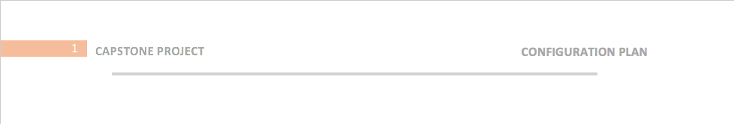

Footer:



Document Name:

* Font: Arial
* Size: 48
* Color: Dark Gray

Author and Date:

* Font: Arial
* Size: 20
* Color: Dark Gray

Heading 1:

* Font: Arial
* Size: 18
* Color: Dark Gray

Heading 2:

* Font: Arial
* Size: 14
* Color: Light Gray

Heading 3:

* Font: Arial
* Size: 12
* Color: Light Gray

Content:

* Font: Calibri (Body)
* Size: 11

Headline:

* Font: Times New Roman
* Size: 12

Revision History:

* Font: Arial
* Size: 14

Table:

* Font: Arial
* Size: 11
* Title Color: Orange

### Tools

Microsoft Word 2013

Microsoft Excel 2013