**CONFIGURATION PLAN**



**Author: Quang Nguyen**

**Date: 24/10/2016**

**Revision history**

|  |  |  |  |
| --- | --- | --- | --- |
| **Version** | **Date** | **Author** | **Notes** |
| **1.0** | 24/10/2016 | Quang Nguyen | Created |
| 1.1 | 2/11/2016 | Viet Dang | Updated |
| 1.2 | 18/11/2016 | Viet Dang | Update |

Contents

I. INTRODUCTION 4

1. Purpose 4

2. Audience 4

II. CONFIGURATION MANAGEMENT 4

1. Organization 4

2. Training 5

III. CONFIGURATION MANAGEMENT ACTIVITIES 5

1. Configuration Identification 5

1.1 Document name 5

1.2 Prescribe for Word Document 5

1.3 Tools 7

1.4 Activities 7

# INTRODUCTION

## Purpose

This document is describe how configuration management will be conducted throughout the project lifecycle. The plan describes in simple, straight forward term the processes required to ensure that the changes occur within an identifiable and controlled environment.

## Audience

This document is created for develop team to comply the format have given.

# CONFIGURATION MANAGEMENT

## Organization

The user organization will connect to Google Drive.All of documents will be stored on Google Drive.

|  |  |  |  |  |
| --- | --- | --- | --- | --- |
| **Folder Organization** | | | | |
| **Level 1** | **Level 2** | **Level 3** | **Level 4** | **Describe** |
| CAPSTONE | Initiate | Finalized  Research |  | Do tasks, do researching related to Initiate phase .  Put it into Research.  Documentation in clearly word or excel and put it into Finalized |
| Meeting minutes  Template | Team  Mentor  Customer |  | Meeting reports. |
| Recycle Bin |  |  | Failure documents or something wrong will be get into Recycle Bin |
| Sprint 0 | Finalized  Research |  | Do tasks, do researching related to Sprint 0 phase .  Put it into Research.  Documentation in clearly word or excel and put it into Finalized |
| Sprint Implementation |  |  | Research design , how to analyze, manage of sprints.Put all of research into Sprint Implementation |
| Task log | Week #  # : number of week |  | Tasks assignment |
| Template |  |  | All of document templates about the project will be put in Template folder. |
| Warm-up | Finalized  Research |  | Documents, Researching , Preparation for Kick off .Do tasks before define process.  Put researching into Research and documentation it into Finalized |

## Training

To be defined.

# CONFIGURATION MANAGEMENT ACTIVITIES

## Configuration Identification

### Document name

TeamName-DocumentName-vX.Y

X: Revision : it will change when the changes occur in documents which have been baselined.

Y: Sub-revision : it will change when the changes occur in documents which have not been baselined.

### Prescribe for Word Document

Header and Footer:

* Font: Calibri (Body)
* Size: 11
* Color: Light Gray

Example:

Header:

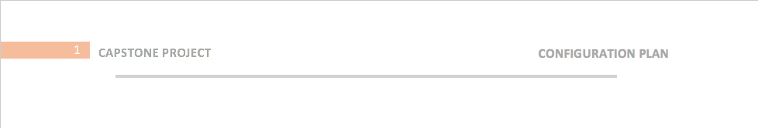

Footer:



Document Name:

* Font: Arial
* Size: 48
* Color: Dark Gray

Author and Date:

* Font: Arial
* Size: 20
* Color: Dark Gray

Heading 1:

* Font: Arial
* Size: 18
* Color: Dark Gray

Heading 2:

* Font: Arial
* Size: 14
* Color: Light Gray

Heading 3:

* Font: Arial
* Size: 12
* Color: Light Gray

Content:

* Font: Calibri (Body)
* Size: 11

Headline:

* Font: Times New Roman
* Size: 12

Revision History:

* Font: Arial
* Size: 14

Table:

* Font: Arial
* Size: 11
* Title Color: Orange

### Tools

Microsoft Word 2013

Microsoft Excel 2013

### Activities

|  |  |
| --- | --- |
| **Step** | **Describe** |
| Identify Configuration Items | The configuration Items (CI) can belong to a kind of CI:   * + Hardware   + Software   + Communications/Networks   + Documentation   The item must be uniquely identified so that it can be distinguished from all other configuration items.  The CI is subject to acceptance verification based on established criteria. |
| Retrieve and Update Configuration Items | After identify CI and it’s not a new CI you need to update it. |
| Add new configuration items to Repository | This just happen when you have a new CI and it to be add to repository |
| Monitor and Track Configuration Items | After new CI or CI updated you need to monitor and track it. |