**PROJECT CHARTER**



**Author: Viet Dang**

**Date: 25/10/2016**

**Revision history**

|  |  |  |  |
| --- | --- | --- | --- |
| **Version** | **Date** | **Author** | **Notes** |
| **1.0** | 25/10/2016 | Viet Dang | Created |
|  |  |  |  |
|  |  |  |  |

Contents

I. PROJECT DESCRIPTION 4

II. PROJECT STAKEHOLDERS 4

1. Roles and Responsibilies 4

III. HIGH-LEVEL REQUIREMENTS 6

IV. PROJECT MILESTONES (HIGH-LEVEL) 6

V. CONSTRAINTS 7

VI. PROJECT RISKS 7

VII. APPROVAL 8

# PROJECT DESCRIPTION

The purpose of Vinaswap project is build a community website to help registered users (Vinaswap members) swap and barter skills, services and goods directly and without paying any fees.

The project starts in 01/10/2016 and runs for 30 weeks.

# PROJECT STAKEHOLDERS

## Roles and Responsibilies

|  |  |  |  |
| --- | --- | --- | --- |
| **Roles** | **Name** | **Responsibility** | **Email** |
| Customer | To Thi Thu Thao | - Represent for organization or business.  -Require the product that team will develop for her business  -Communicate and Collaborate with development team to give requirements for the product.  -Feedback on product increment and progress to help improving them | [yenthaoxhnv@gmail.com](mailto:yenthaoxhnv@gmail.com) |
| Mentor | To Dinh Hieu | -Communicate with development team to give advices about project and progress.  -Assess team by project work. | [todinhhieu@gmail.com](mailto:todinhhieu@gmail.com)  [todinhhieu@vanlanguni.edu.vn](mailto:todinhhieu@vanlanguni.edu.vn) |
| Scrum master | Nguyen Bao Thach (Leader) | -Facilitate Scrum events  -Help team remove impediments in development progress  -Find techniques for effective Product backlog management | [b.thach511@gmail.com](mailto:b.thach511@gmail.com) |
| Product owner | Nguyen Hoang Nam Phuong | -Describe, Prioritize and Optimize Product backlog  -Ensure Product backlog is visible, transparent  -Define goals for team to focus on | [Nguyenhoangnamphuong2110@gmail.com](mailto:Nguyenhoangnamphuong2110@gmail.com) |
| Scrum team  (Development team) | Nguyen Dang Quang(developer)  Tran Phan Trung Chanh(developer)  Nguyen Huu Tai(tester)  Dang Quoc Viet(tester) | -Define what are customer's needs.  -Contact and collaborate regularly with stakeholders.  -Apply development process and techniques to deliver value to customer  -Confirm and propose for customer after a term or a sprint/release | [Ndq.quang511@gmail.com](mailto:Ndq.quang511@gmail.com)  [hunteratthenight@gmail.com](mailto:hunteratthenight@gmail.com)  [nguyenhuutai1995k19t01@gmail.com](mailto:nguyenhuutai1995k19t01@gmail.com)  [vietdang.2509@gmail.com](mailto:vietdang.2509@gmail.com) |

# HIGH-LEVEL REQUIREMENTS

|  |  |
| --- | --- |
| **Req.#** | **Requirements description** |
| 1 | Manage profile(user) |
| 2 | Search profile with offers and needs |
| 3 | Request swap |
| 4 | Exchange swap detail |
| 5 | Review user |
| 6 | Auto-match |
| 7 | Manage account(staff) |
| 8 | View report of site activities(staff) |

# PROJECT MILESTONES (HIGH-LEVEL)

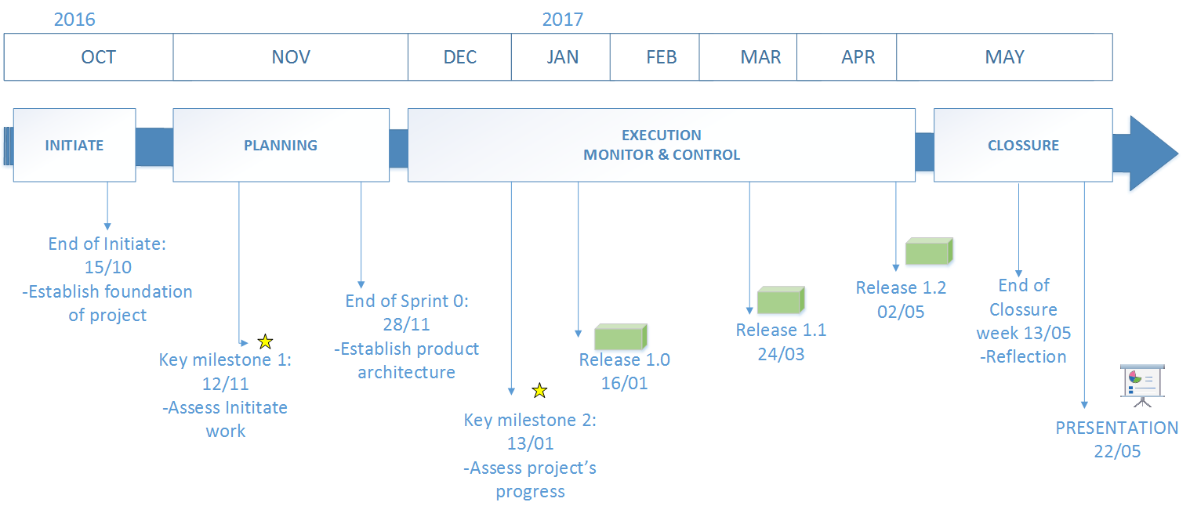

|  |  |
| --- | --- |
| **Milestone** | **Description** |
| INITIATE | Timeframe: 01/10-15/10 |
| KEY MILESTONE 1 | Time: 12/11 |
| PLANNING | Timeframe: High-level Planning: 17/10-11/11  Sprint 0: 13/11-28/11 |
| KEY MILESTONE 2 | Time: 13/01 |
| EXECUTION MONITOR & CONTROL | Timeframe: RELEASE 1.0: 01/12-16/01  RELEASE 1.1: 06/02-24/03  RELEASE 1.2: 30/03-29-04 |
| CLOSSURE | Timeframe: 04/05-13/05  PRESENTATION 22/05 |

# CONSTRAINTS

|  |  |
| --- | --- |
| **Constraint** | **Description** |
| Technical | The system must be developed in both Web application and Mobile application (Android & iOS) |
| Business | The User Interface must be in multiple languages (Vietnamese, English) & default language is Vietnamese.The project must be developed in 30 weeks |
| Development process | Scrum framework |

# PROJECT RISKS

|  |  |
| --- | --- |
| **ID** | **Risk** |
| R-002 | Conflict between customer and team members (requirement misunderstanding) |
| R-019 | Customer can not attend meeting with team |
| R-010 | Wrong identification about Scope of project |
| R-004 | Members lack of skills (technical, presentation, management,.) |

More info:

<Imagineer-RiskManagementLogTemplate-v1.0.xls>

# APPROVAL

|  |  |  |
| --- | --- | --- |
| **Role** | **Signature** | **Date** |
| Customer |  |  |
| Scrum team leader |  |  |