**PROCESS DECISION**



**Author: Thach Nguyen**

**Date: 25/10/2016**

**Revision history**

|  |  |  |  |
| --- | --- | --- | --- |
| **Version** | **Date** | **Author** | **Notes** |
| **1.0** | 25/10/2016 | Thach Nguyen | Created |
| **1.1** | 14/11/2016 | Thach Nguyen | Modified |
|  |  |  |  |

Contents

I. INTRODUCTION 4

1. Purpose 4

2. Scope 4

3. References 4

4. Definition, Acronyms and Abbreviations 4

II. PROJECT OVERVIEW 4

1. Project goals and objectivities 4

2. Scope definition 4

3. Constraints 4

4. Project process 4

III. PROJECT RESOURCES 4

1. Human resource 4

2. Non-Human resource 4

IV. PROJECT SCHEDULE 4

# INTRODUCTION

## Purpose

-This document describes decision of chosing agile method over traditional one.

-Evaluate Process chosen with Homeground analysis.

## Scope

-Audience of this document will be Stakeholders of the VinaSwap project

## References

## Definition, Acronyms and Abbreviations

# TRADITIONAL(PLAN-DRIVEN) VS AGILE

## Comparison between Traditional & Agile

-Traditional Methodology(Plan-Driven Methodology): assert the need for strong process discipline and rigorous practices.

-Some characteristics:

* Assuming requirements are known at start.
* Stage of Planning is very detailed
* BDF( big design upfront) is required
* Spend more effort to rework
* For big team not always geographically collocated
* Documentation is very large and describes all features of system
* WATERFALL, V-MODEL are some typical Traditional models.

-Agile Methodology: use lighter, more adaptive paradigms.

-Some characteristics:

* Requirements is to collect by time
* Just enough planning
* Just enough Architecture decision
* Time-boxed interations
* Continously delivering business value
* Handling with unexpected events
* Motivating team
* Repeatable, Sustainable iterations
* Small team that are self-organized
* Documentation is not detail but critical
* SCRUM, XP are some typical Agile model.

# HOMEGROUND ANALYSIS

## Purpose

-This approach is used for conducting Qualitative assessment between Traditional and Agile methodologies

-Also, using Home ground analysis method can help with balancing between Agility and Planning in our project

## Introduction

-The complex nature of software development and the wide variety of methods make comparison of Agile and Plan-driven approaches difficult and imprecise

-There are some different characteristics between two methods: Application, Management, Technical, Personnel

-Homegrounds analysis basically focus on characteristics differences to tell which suit intended project most.

## Activities

Identify the differences in characteristics of two methods:

|  |  |  |
| --- | --- | --- |
| Project characteristics | Agile home ground | Plan-driven Home ground |
| Application | | |
| Primary goals | Rapid value,responding to change | Predictability, stability, high assurance |
| Size | Smaller teams and projects | Larger teams and projects |
| Environment | Turbulent, high change, project focused | Stable, low change, project and organization focused |
| Management |  |  |
| Customer relations | Dedicated onsite customers, focused on prioritized increments | As-needed customer interactions, focused on contract provisions |
| Planning and Control | Internalized plans, quanlitative control | Documented plans, quantitative control |
| Communications | Tacit interpersonal knowledge | Explicit documented knowledge |
| Technical |  |  |
| Requirements | Prioritized informal stories and test cases, undergoing unforeseeable change | Formalized project, capability, interface, quality, foreseeable evolution requirements |
| Development | Simple design, short increments, refactoring assumed inexpensive | Extensive design, longer increments, refactoring, assumed expensive |
| Test | Executable test cases define requirements, testing | Documented test plan and procedures |
| Personnel |  |  |
| Customers | Dedicated, collocated Crack* performers | Crack* performers, not always collocated |
| Developers | 30% full time Cockburn Level 2 and 3 experts; no Level -1 personnel** | 50% Cockburn Level 3s early; 10% throughout; 30% Level 1B’s workable; no Level -1s** |
| Culture | Comfort and empowerment via many degrees of freedom (thriving on chaos) | Comfort and empowerment via framework of policies and procedures (thriving on order) |

|  |  |
| --- | --- |
| Level | Criteria |
| Level -1 | Unable or Unwilling to collaborate or follow shared methods |
| Level 1B | Hard Working, less experienced, needs structure(training) |
| Level 1A | Hard Working, less experienced but feels comfortable working in a structured way |
| Level 2 | Functions well in managing small teams in precedent projects |
| Level 3 | Functions well in managing large and small scale teams in unprecedented projects |

Each characteristic is presented into score:

|  |  |  |
| --- | --- | --- |
| Factor(s) | Agile home ground | Plan-driven Home ground |
| Criticality | 1-Very Unsatisfied  2-Unsatisfied  3-Neutral  4-Satisfied  5-Very satisfied | 1-Very Unsatisfied  2-Unsatisfied  3-Neutral  4-Satisfied  5-Very satisfied |
| Size | 1-Very Unsatisfied  2-Unsatisfied  3-Neutral  4-Satisfied  5-Very satisfied | 1-Very Unsatisfied  2-Unsatisfied  3-Neutral  4-Satisfied  5-Very satisfied |
|  | 1-Very Unsatisfied  2-Unsatisfied  3-Neutral  4-Satisfied  5-Very satisfied | 1-Very Unsatisfied  2-Unsatisfied  3-Neutral  4-Satisfied  5-Very satisfied |
| Personnel (Team expertise) | 1-Very Unsatisfied  2-Unsatisfied  3-Neutral  4-Satisfied  5-Very satisfied | 1-Very Unsatisfied  2-Unsatisfied  3-Neutral  4-Satisfied  5-Very satisfied |
| Dynamism | 1-Very Unsatisfied  2-Unsatisfied  3-Neutral  4-Satisfied  5-Very satisfied | 1-Very Unsatisfied  2-Unsatisfied  3-Neutral  4-Satisfied  5-Very satisfied |
| Culture | 1-Very Unsatisfied  2-Unsatisfied  3-Neutral  4-Satisfied  5-Very satisfied | 1-Very Unsatisfied  2-Unsatisfied  3-Neutral  4-Satisfied  5-Very satisfied |

Team do survey and the score is collected in table:

Five factors to determine the relative suitability of Agile or Plan-driven methods in a particular project situation:

* Criticality (elements affect product)
* Size(number of personnel)
* Personnel( %Level of 1B)(%Level 2 and 3)
* Dynamism(%Requirement-change/ month)
* Culture(%Thriving on chaos vs in order)

For each factor, identify the questions and conduct survey for final chart:

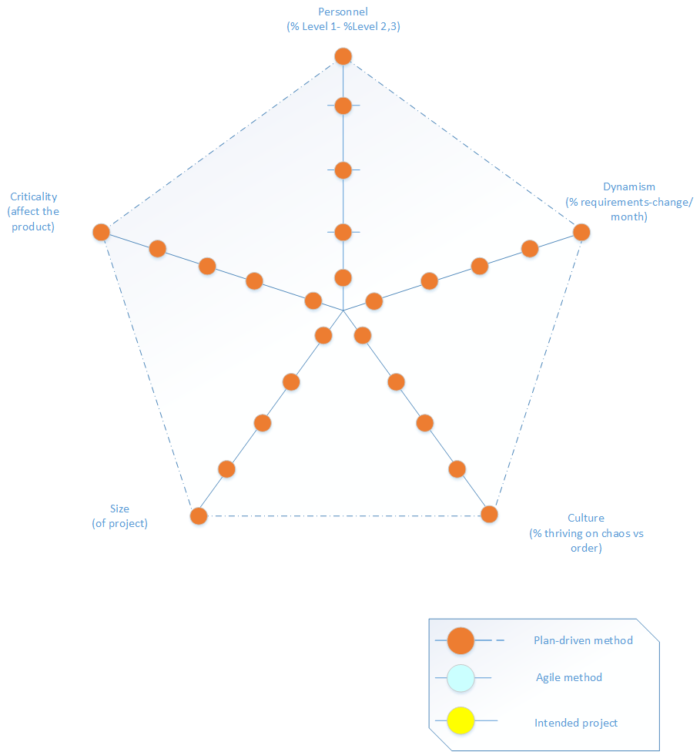

# AGILE METHOD COMPARISON:

## Comparison between Scrum, Kanban and FDD

To be defined