**PROCESS DECISION**



**Author: Thach Nguyen**

**Date: 25/10/2016**

**Revision history**

|  |  |  |  |
| --- | --- | --- | --- |
| **Version** | **Date** | **Author** | **Notes** |
| **1.0** | 25/10/2016 | Thach Nguyen | Created |
| **1.1** | 14/11/2016 | Thach Nguyen | Modified |
| **1.2** |  | TN | Modified. Add criteria, point, survey |

Contents

I. INTRODUCTION 4

1. Purpose 4

2. Scope 4

3. References 4

4. Definition, Acronyms and Abbreviations 4

II. PROJECT OVERVIEW 4

1. Project goals and objectivities 4

2. Scope definition 4

3. Constraints 4

4. Project process 4

III. PROJECT RESOURCES 4

1. Human resource 4

2. Non-Human resource 4

IV. PROJECT SCHEDULE 4

# INTRODUCTION

## Purpose

-This document describes decision of chosing agile method over traditional one.

-Evaluate Process chosen with Homeground analysis.

## Scope

-Audience of this document will be Stakeholders of the VinaSwap project

## References

## Definition, Acronyms and Abbreviations

# TRADITIONAL(PLAN-DRIVEN) VS AGILE

## Comparison between Traditional & Agile

-Traditional Methodology(Plan-Driven Methodology): assert the need for strong process discipline and rigorous practices.

-Some characteristics:

* Assuming requirements are known at start.
* Stage of Planning is very detailed
* BDF( big design upfront) is required
* Spend more effort to rework
* For big team not always geographically collocated
* Documentation is very large and describes all features of system
* WATERFALL, V-MODEL are some typical Traditional models.

-Agile Methodology: use lighter, more adaptive paradigms.

-Some characteristics:

* Requirements is to collect by time
* Just enough planning
* Just enough Architecture decision
* Time-boxed interations
* Continously delivering business value
* Handling with unexpected events
* Motivating team
* Repeatable, Sustainable iterations
* Small team that are self-organized
* Documentation is not detail but critical
* SCRUM, XP are some typical Agile model.

# HOMEGROUND ANALYSIS

## Purpose

-This approach is used for conducting Qualitative assessment between Traditional and Agile methodologies

-Also, using Home ground analysis method can help with balancing between Agility and Planning in our project

## Introduction

-The complex nature of software development and the wide variety of methods make comparison of Agile and Plan-driven approaches difficult and imprecise

-There are some different characteristics between two methods: Application, Management, Technical, Personnel

-Homegrounds analysis basically focus on characteristics differences to tell which suit intended project most.

## Activities

Identify the differences in characteristics of two methods:

|  |  |  |  |
| --- | --- | --- | --- |
| Factor | Description | Point | Note |
| Size | Traditional is more suitable for medium to large project  Agile: small t medium project | Traditional: 3.5-5 point  Agile: 1-3.4 point | 1: Very small  2: Small  3: Medium  4: Large  5:Very large |
| Dynamism(Change rate) | Traditional: change is not welcome  Agile: work well with high change rate | Traditional: 3.5-5 point  Agile: 1-3.4 point | 1: change rate very high  2: high  3: medium  4: low  5: very low |
| Culture | Traditional: Have procedure, follow rule to finish work  Agile: empowered, have degree of freedom to finish work | Traditional: 1-3.4  Agile:3.5-5 point | 1: Follow very strictly to rule  2: Follow rule right way  3: Flexible in following rule  4: Have some degree of freedom  5: Empowered |
| Personel | Traditional: have mix of (high& low) skilled personel; leader of each phase is recommended  Agile: suitable for high skilled personel | Traditional: 1-3.4  Agile: 3.5-5 | 1: Overall very weak  2: weak at something  3: Average: balance some skills, perform basic work learned from skills  4: Good at some skills  5: Master at some skills |
| Criticality | Traditional: complex and well-planned project  Agile: simplier project | Traditional: 3.5-5  Agile: 1-3.4 | 1: Simple  2: Somewhat complex  3: Medium complex  4: High Complex  5:Very high complex |
|  |  |  |  |

Team do survey and the score is collected in table:

Five factors to determine the relative suitability of Agile or Plan-driven methods in a particular project situation:

* Criticality
* Size
* Personnel
* Dynamism
* Culture

For each factor, identify the questions and conduct survey for final chart:

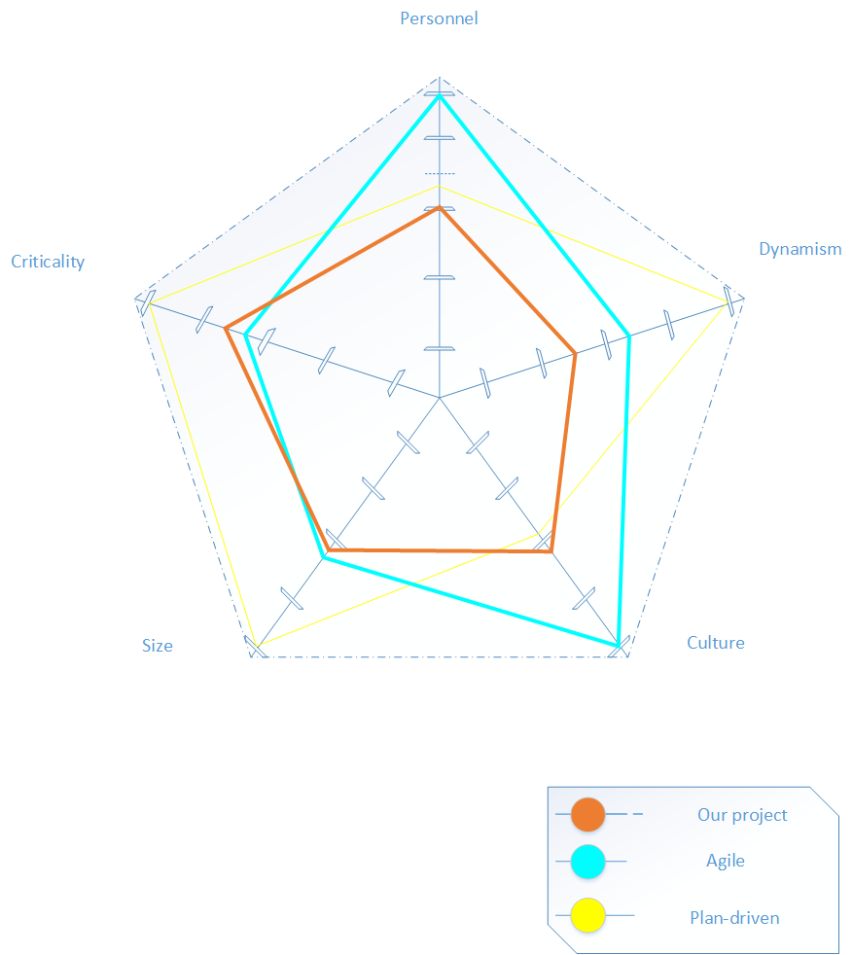

# AGILE METHOD COMPARISON:

## Comparison between Scrum, Kanban and FDD

To be defined