**PROCESS MODEL**



**Author: Thach Nguyen**

**Date: 25/10/2016**

**Revision history**

|  |  |  |  |
| --- | --- | --- | --- |
| **Version** | **Date** | **Author** | **Notes** |
| **1.0** | 25/10/16 | Thach Nguyen | Created |
| **1.1** | 14/11/16 | Thach Nguyen | Modified |
|  |  |  |  |

Contents

I. INTRODUCTION 4

1. Purpose 4

2. Scope 4

3. References 4

4. Definition, Acronyms and Abbreviations 4

II. PROJECT OVERVIEW 4

1. Project goals and objectivities 4

2. Scope definition 4

3. Constraints 4

4. Project process 4

III. PROJECT RESOURCES 4

1. Human resource 4

2. Non-Human resource 4

IV. PROJECT SCHEDULE 4

# INTRODUCTION

## Purpose

## Scope

## References

## Definition, Acronyms and Abbreviations

# PROCESS

## Process model:

### Model:

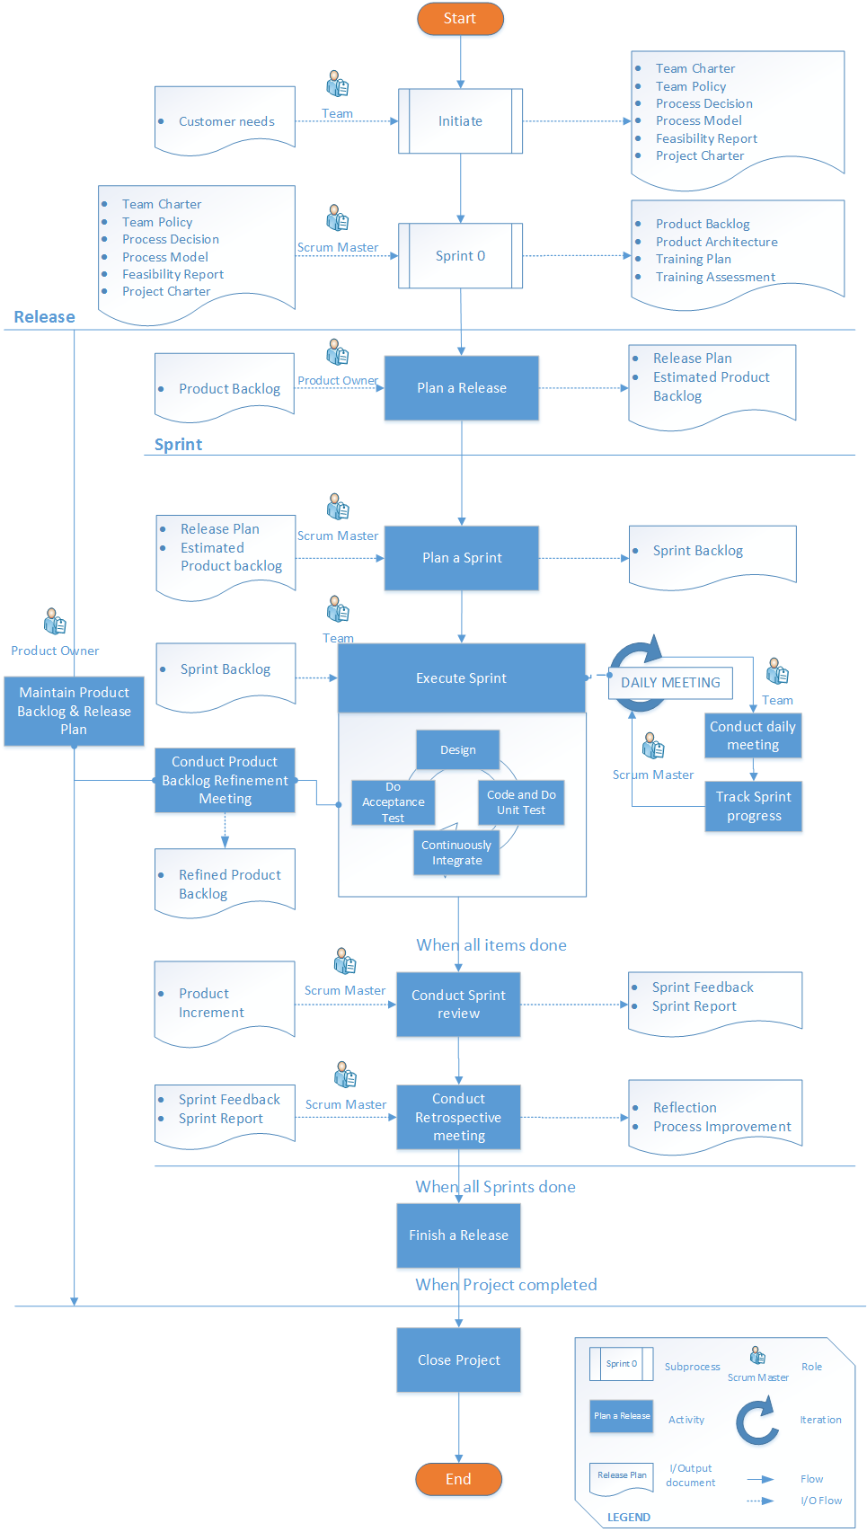

### Description:

|  |  |  |  |  |
| --- | --- | --- | --- | --- |
| Name | Activity(ies) | Input/Outcome(s) | Technique(s)/Tool(s) | Template(s) |
| Initiate  -Establish project team and decide on development process as well as create project plan and analyze the product feasibility-  Kick-off meeting to get approval from stakeholders- | 1. Establish team: Introduce to team about the project and team policy as discover member expectations. 2. Establish Dev. Process: Research and evaluate the development process. 3. Analyze Product Feasibility: Analyze SWOT and Business model of product/system. | Input(s):   * Customer needs   Outcome(s):   * Team Charter * Team Policy * Process Decision * Process Model * Feasibility Report * Project Charter | Technique(s):   * Brainstorm * Evaluation * SWOT analysis * Business model analysis   Tool(s):   * Documentation(Word) * Process drawing(Visio) * Business model canvas * SWOT table | Imagineers-TeamCharter-v1.0  Imagineers-TeamPolicy-v1.0  Imagineers-ProcessModel-v1.0  Imagineers-ProcessDecision-v1.0  Imagineers-FeasibilityReport-v1.0  Imagineers-ProjectCharter-v1.0 |
| Sprint 0  -Prepare the Product backlog, Architecture and Infrastructure; Train team- | 1. Analyze High level Requirement(s): Use technique(s) to analyze and Write down as User stories. 2. Develop Product Architecture: Provide architecture decision(s), suggested pattern(s) cocerned with Quality Att(s), Constraint(s). 3. Buid Product Backlog: Categorize Epics and User Stories in PB 4. Establish infrastructure: Network, Logistic requirements; Environment for Work, Project development; Tool(s), licensing Software(s). | Input(s):   * HLRequirements from Project Charter * Initiate artifacts   Outcome(s):   * Product Backlog * Product Architecture * Training Plan | Technique(s):  Analyze Requirement(s)   * Brainstorm * Interview * Questionaire * 4H+1W questions * Priortize & Catagorize   Est. Architecture:   * Architecture decision * Prototyping   Tool(s):   * Word * Visio * Excel | Imagineers-ArchitectureDecision-v1.0  Imagineers-ProductBacklog-v1.0  Imagineers-TrainingPlan-v1.0  Imagineers-TrainingAssessment-v1.0 |
| Plan a Release  (Event)  -An approach to creating the wider view that make a Release to market successfully-  In essence the meeting answers how we can turn the agreed vision into a wining product, meeting or even exceeding stakeholder expectations.  With three level models:   * Vision * Roadmap * Release   Time-box: 2-4 hours | 1. Conduct meeting to declare:  * Goals of Release (PO) * Background, business competitive climate (PO)🡪Product vision, Product Roadmap * Technical Issues( Team): Design, Code,Test, CI. * Resources * Tentative schedule(PO)🡪Release date  1. Priortize Product Backlog 2. Roughly estimate team velocity( after some Sprints get real number)🡪No. of Sprints | Input(s):   * Product backlog   Outcome(s):   * Release Plan * Estimated product backlog |  | Imagineers-ReleasePlan-v1.0  Imagineers-ProductBacklog-v1.0 |
| Plan a Sprint  (Event)  -During the first half, the team decides “what” to complete during the sprint from the product backlog and defines a sprint goal.  -During the second half of the meeting the team decides “how” to complete the selected backlog items  Time-box: 5% of Sprint duration | 1. Set Sprint Goals 2. Take items from PB to Sprint backlog 3. Define the definition of “Done” item | Input(s):   * Release plan   Outcome(s):   * Sprint Backlog(with DoD)   DoD: definition of done |  |  |
| Execute Sprint  - Sprint is a time-boxed iteration, during which the scrum master protects the team from vision or scope creep that could affect the sprint goal. If a goal cannot be met, the sprint is aborted abnormally and restarted from the planning point.  -Daily Scrum meeting-Time: 15mins- stand up meeting  Sprint Time-box: ~1-4 weeks | 1. Design, Code,Test is done by individual 2. Continously intergrate previous increment with the latest |  |  |  |
| Backlog refinement meeting  -During 1st half, Team review and revise PB items  PO discuss and reprioritize backlog, give explanation  -During 2nd half, Team estimate the PBI  Time-box: 2nd week of Sprint, 2hrs | 1. PO goes through the PB with team to revise the items 2. PO reprioritizes the PB and give explanation 3. Team estimate the PBI | Input(s):   * Product backlog(PB)   Outcome(s):   * Refined Product backlog(PB) |  |  |
| Sprint review  -At Sprint end  During 1st half, Team report on Sprint  During 2nd half, demonstration of Sprint Increment; get feedback from stakeholders  Time-box: 1-2hrs | 1. Meet with stakeholders 2. Report the Sprint 3. Demo the Sprint increment 4. Get feedback from customer | Input(s):   * Sprint increment   Outcome(s):   * Sprint feedback |  | Imagineers-MeetingMinutesdd/mm/yy-SprintReview |
| Sprint retrospective  - Team inspects the last sprint in terms of people, process, collaboration, tools, etc.  - Identify actions that can be implemented in the next sprint to improve. | 1. Meet with stakeholders 2. Report the progress 3. Report the reflection from Sprint 4. Get feedback for improvement |  |  | Imagineers-ProcessImprovement-v1.0  Imagineers-Reflection-v1.0 |
| Finish a Release  -Deploy release and continue to plan other release(if there any) |  |  |  |  |
| Close Project  -All releases finishes- |  |  |  |  |