D:\CMU_Nam_4\Capton Project\TaiNguyen_UpdateTest.png

**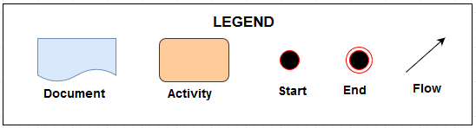**

**Decription :**

* Step 1 : Start test, input user stories, write testcase and output list testcase.
* Step 2 : Input code (software) and add an acceptance test, run acceptance test (test code follow list testcase). Acceptance test pass (testcase pass) then running back next testcase.
* Step 3: If Acceptance test fail (testcase fail), change code (softvare). Developer use unit test and run unit test (add a developer test, run developer test).
  + Developer test pass then running back next unit test continues.
  + If developer test fail, developer will change code (software).
  + After change, developer run continues developer test. Deceloper test fail then come back step change (change code) and continues run the developer test.
  + Step run the developer test pass, functionality complete.
* Step 4 : Run the acceptance test (run list testcase) with functionality complete of developer. If fail then come back step change. If pass then development continues. If all testcase of list pass, development stop. Finish phase test.