Name: Gemver Harry Santos Course&Section: BSIS-2A

- Problem Solving Cryptography (5pts each)

Caesar Cipher Cryptography (shift 6)
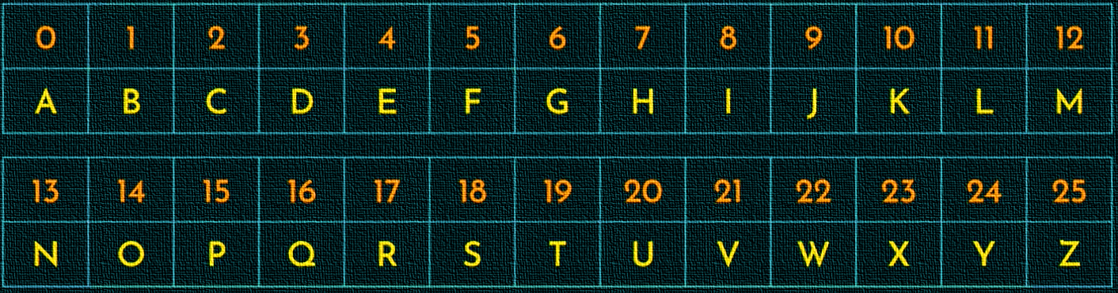

Instructions: Take the following plain text message
- Decrypt the message using Caesar Cipher with shift 6:

Cipher Text:
- NGRG HKYNE UE - HALA BESHY OY
- OEG OEG YG ZG QGXA TNAN - IYA IYA SA TA KARU NHUH
- YO SOYY SGT MAJG HG - SI MISS MAN GUDA BA
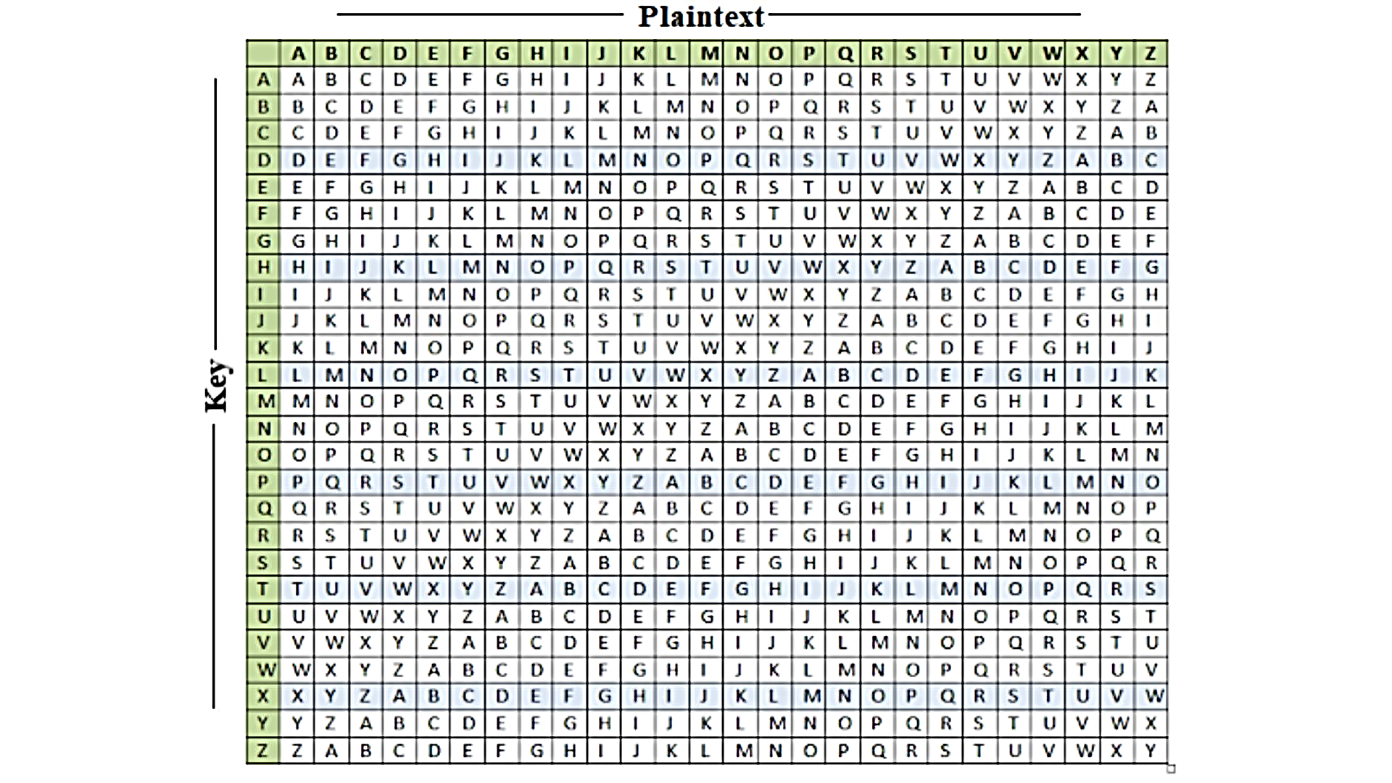

Vigenère Cipher Cryptography

Encryption Process:
- Use the Vigenère square to encrypt each letter.
- Use the keyword: EXAM for encryption.
PLAINTEXT:
KEY:
CIPHER ENCRYPTION:

- “Always remember” =
PLAINTEXT: | A | L | W | A | Y | S |  | R | E | M | E | M | B | E | R
KEY: | E | X | A | M | E | X |  | A | M | E | X | A | M | E | X
CIPHER ENCRYPTION: | E | I | W | M | C | P |  | R | Q | Q | B | M | N | I | O

- “The more you fail in college” =
PLAINTEXT: | T | H | E |  | M | O | R | E |  | Y | O | U |  | F | A | I | L |  | I | N |  | C | O | L | L | E | G | E
KEY: | E | X | A |  | M | E | X | A |  | M | E | X |  | A | M | E | X |  | A | M |  | E | X | A | M | E | X | A
CIPHER ENCRYPTION: | X | E | E |  | Y | S | O | E |  | K | S | R |  | F | M | M | I |  | I | Z |  | G | L | L | X | I | D | E

- “The more you gain knowledge” =
PLAINTEXT: | T | H | E |  | M | O | R | E |  | Y | O | U |  | G | A | I | N |  | K | N | O | W | L | E | D | G | E
KEY: | E | X | A |  | M | E | X | A |  | M | E | X |  | A | M | E | X |  | A | M | E | X | A | M | E | X | A
CIPHER ENCRYPTION: | X | E | E |  | Y | S | O | E |  | K | S | R |  | G | M | M | K |  | K | Z | S | T | L | Q | H | D | E

