|  |  |
| --- | --- |
| **Name:** | Hatim Sawai |
| **UID:** | 2021300108 |
|  | **Experiment 3 (Application)** |

**PROBLEM**

**DEFINITION:**

Analyze the Audio Signal in frequency domain.

**ALGORITHM:**

1.

Record Audio Password and filter the noise ==> x[n].

2.

Plot x[n].

3.

Transform Audio Signal x[n] from Time Domain to Frequency

Domain using DFT ==> X[k].

4.

Plot Magnitude Spectrum of X[k].

**EXPE**

**RIMENTATION AND RESULT ANALYSIS:**

**RESULT:**

**Graphs:**

1

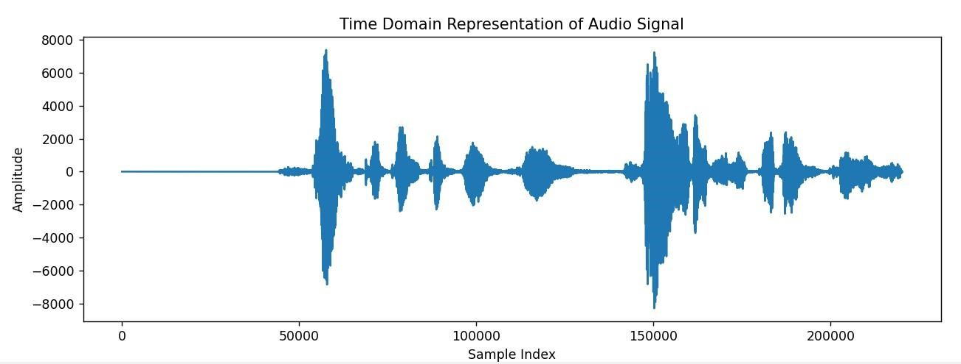

|  |  |
| --- | --- |
|  |  |

2