Setting up Local Development Environment/ Container for Volvo People

Prerequisite 1: Github account
Preferred option especially for SW developers and AI contributor roles is to have a Volvo Github account. Follow process given below to get a Volvo Github account and Volvo Github Copilot license:
How-to-get-access-to-GitHub-Copilot.aspx
Note: If you have not gotten a Github account via Volvo Backstage, and instead directly went to Github website and created a profile using your Volvo Email manually then that will not be a Github Enterprise account:
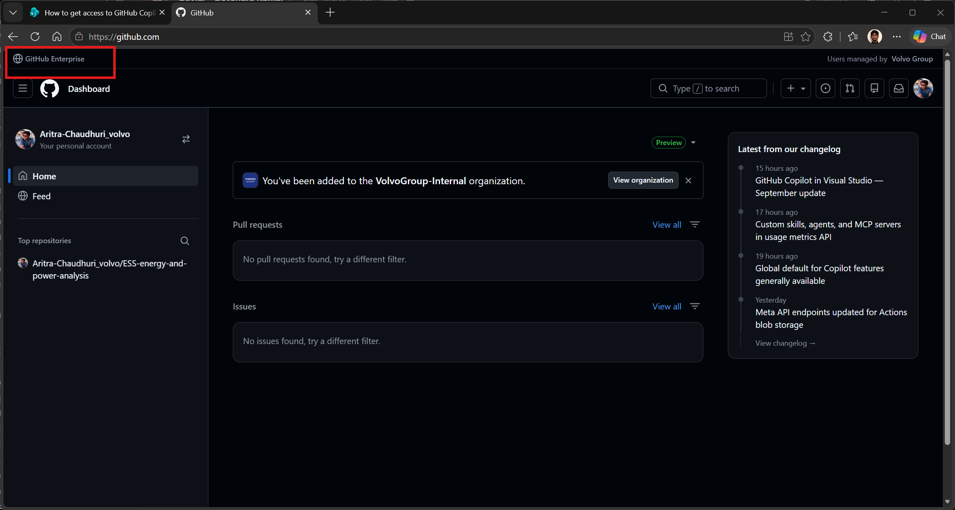
If your Github account is not the Enterprise/ business account then you can delete your profile and create a new one using above process via Volvo Backstage.

Prerequisite 2: Docker
Docker can be requested via Service-now.
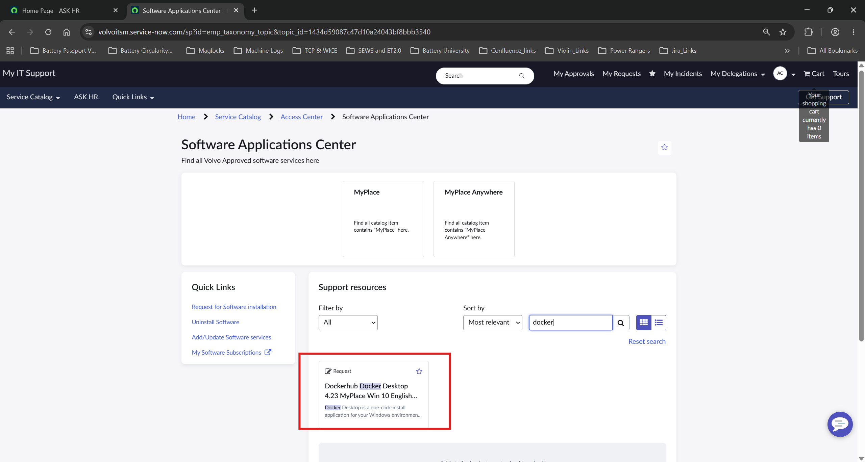
Use Docker “Containerize your walkthrough” which gives clear instructions to follow to create your project docker.
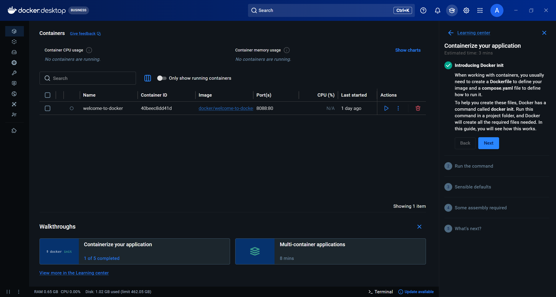

Docker init:
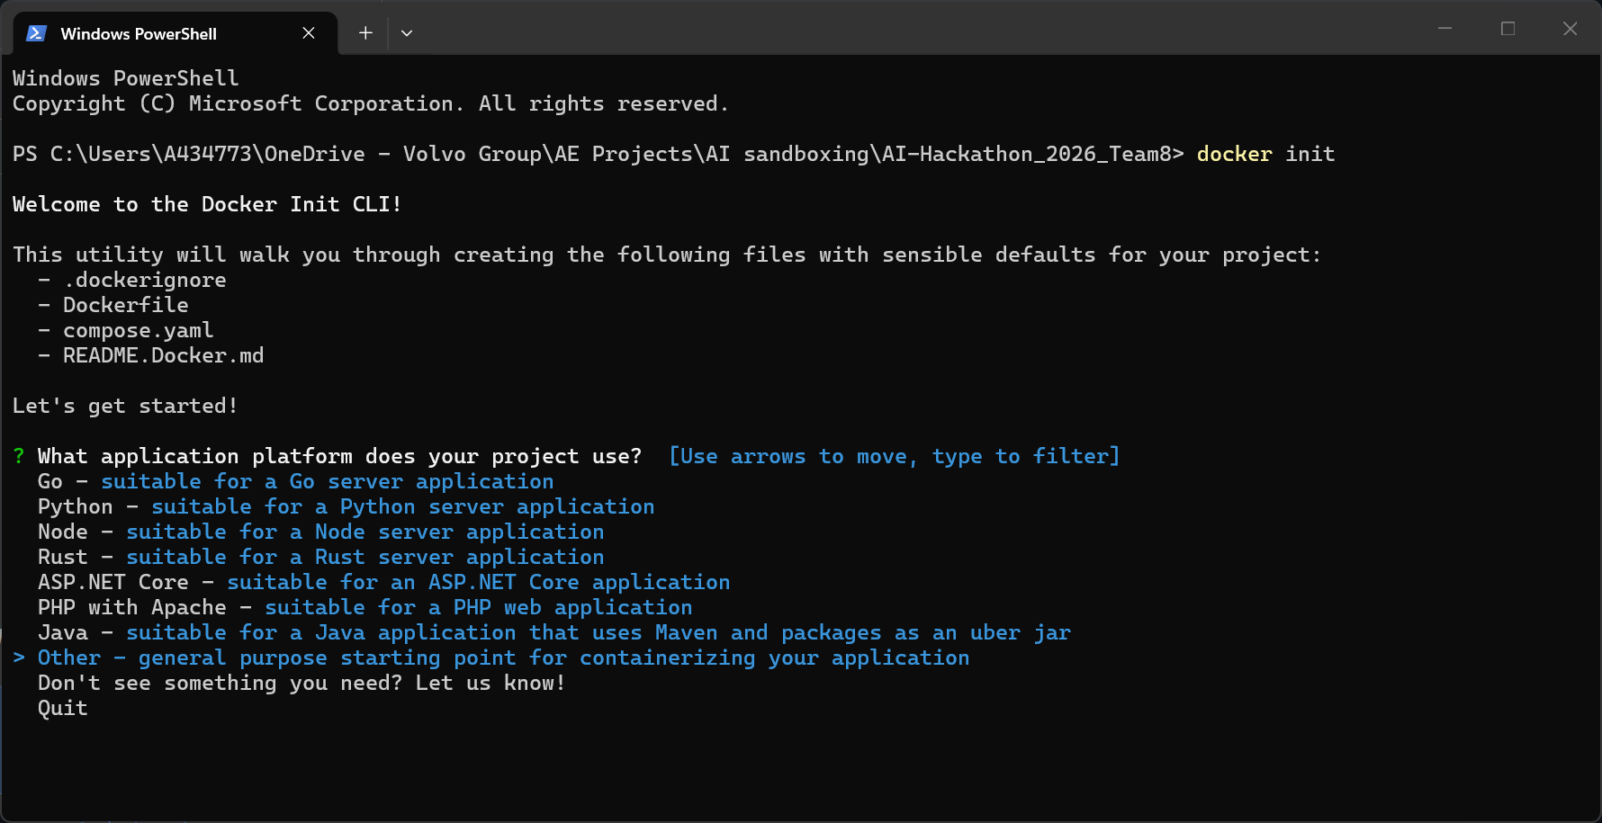
Docker example:
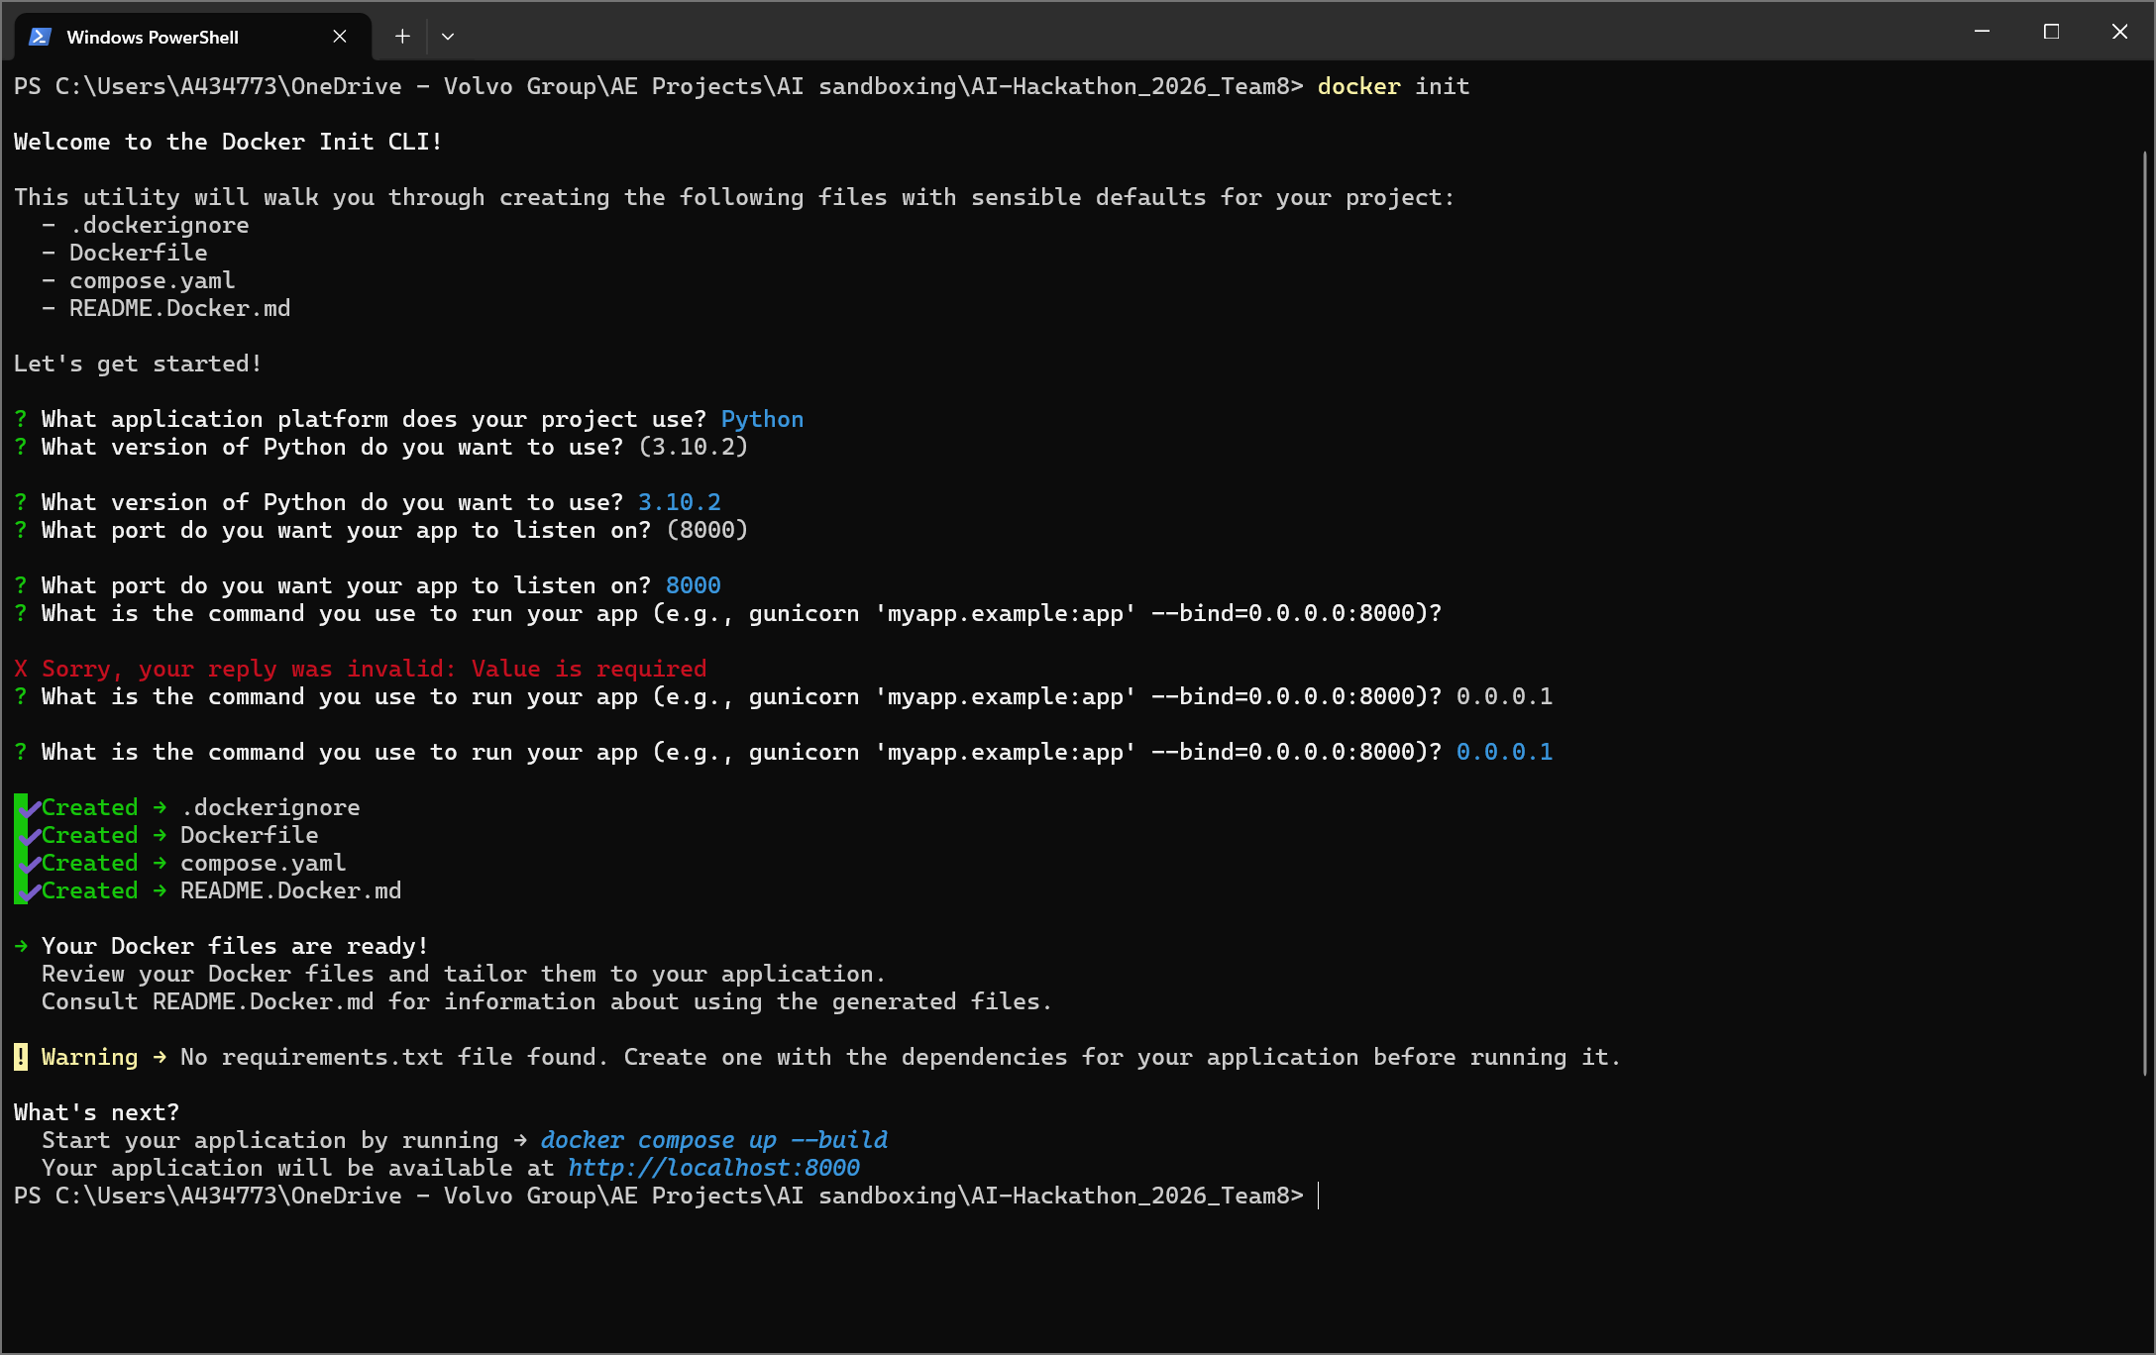

Prerequisite 3: VS Code
VS Code can be requested via Service-now.
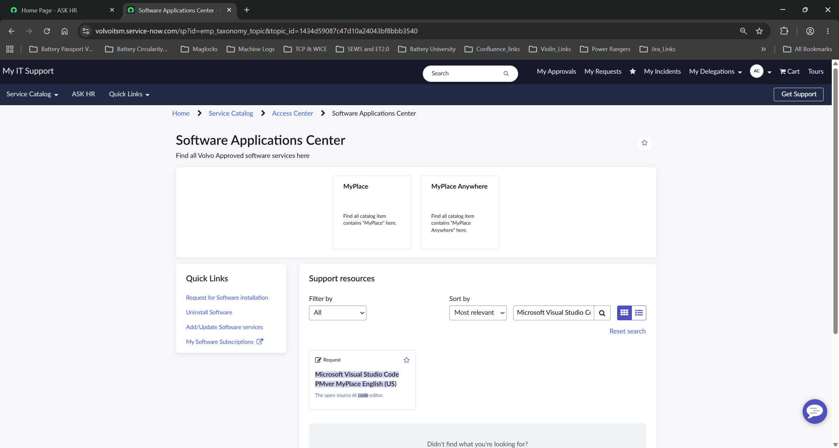
Once VS code is installed by IT in your system, you can open the project folder:
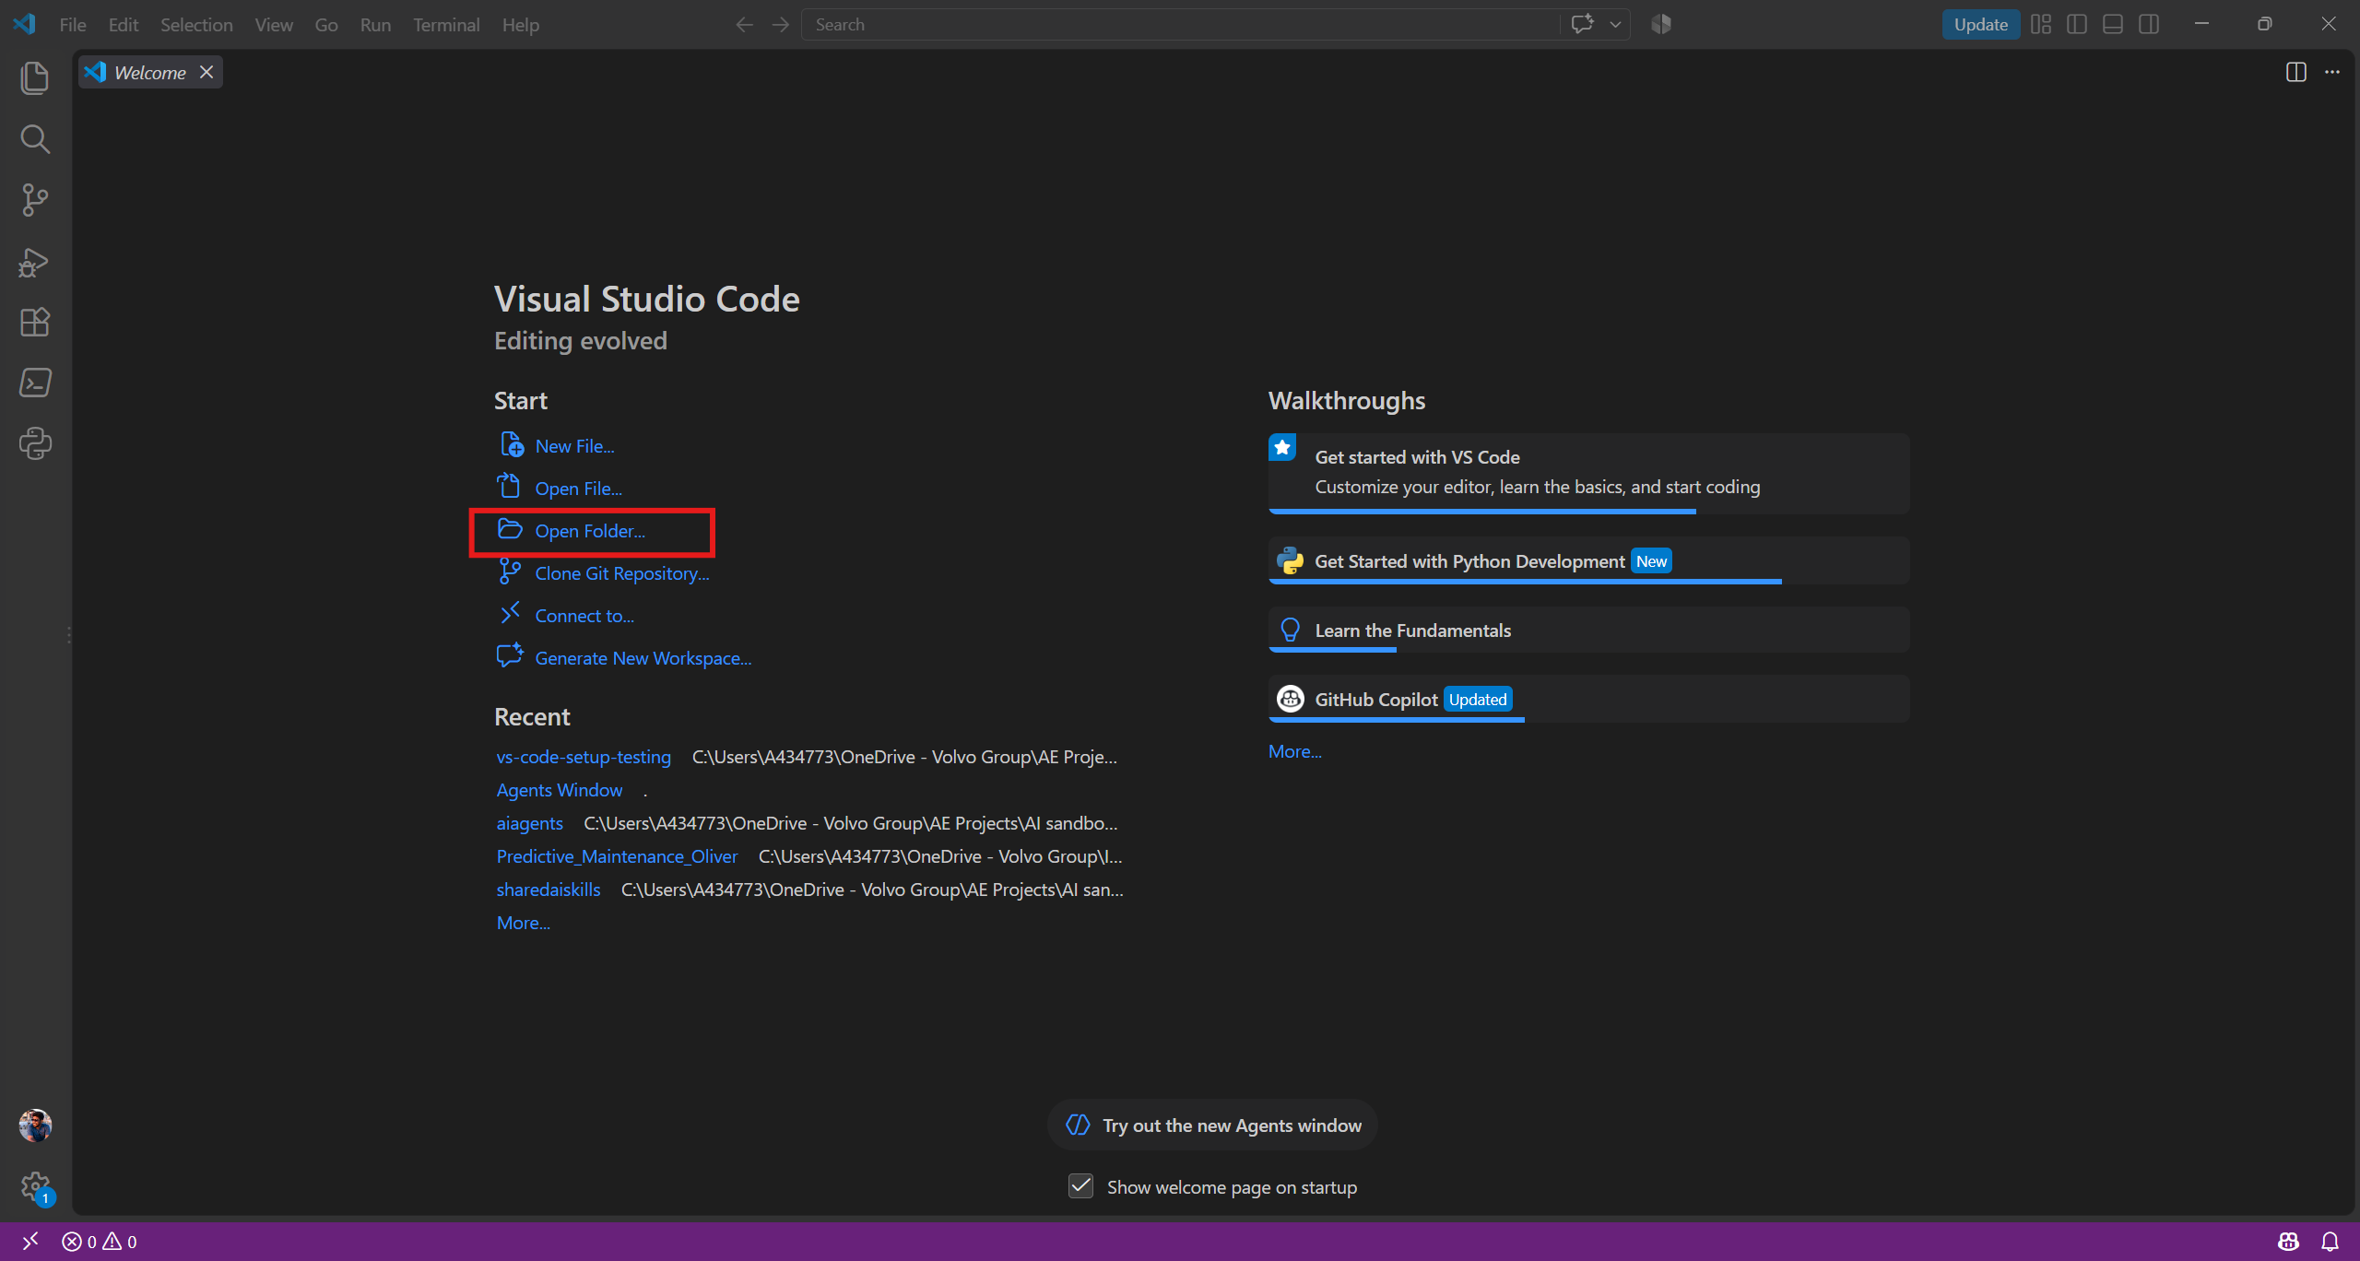

Example folder with docker files: 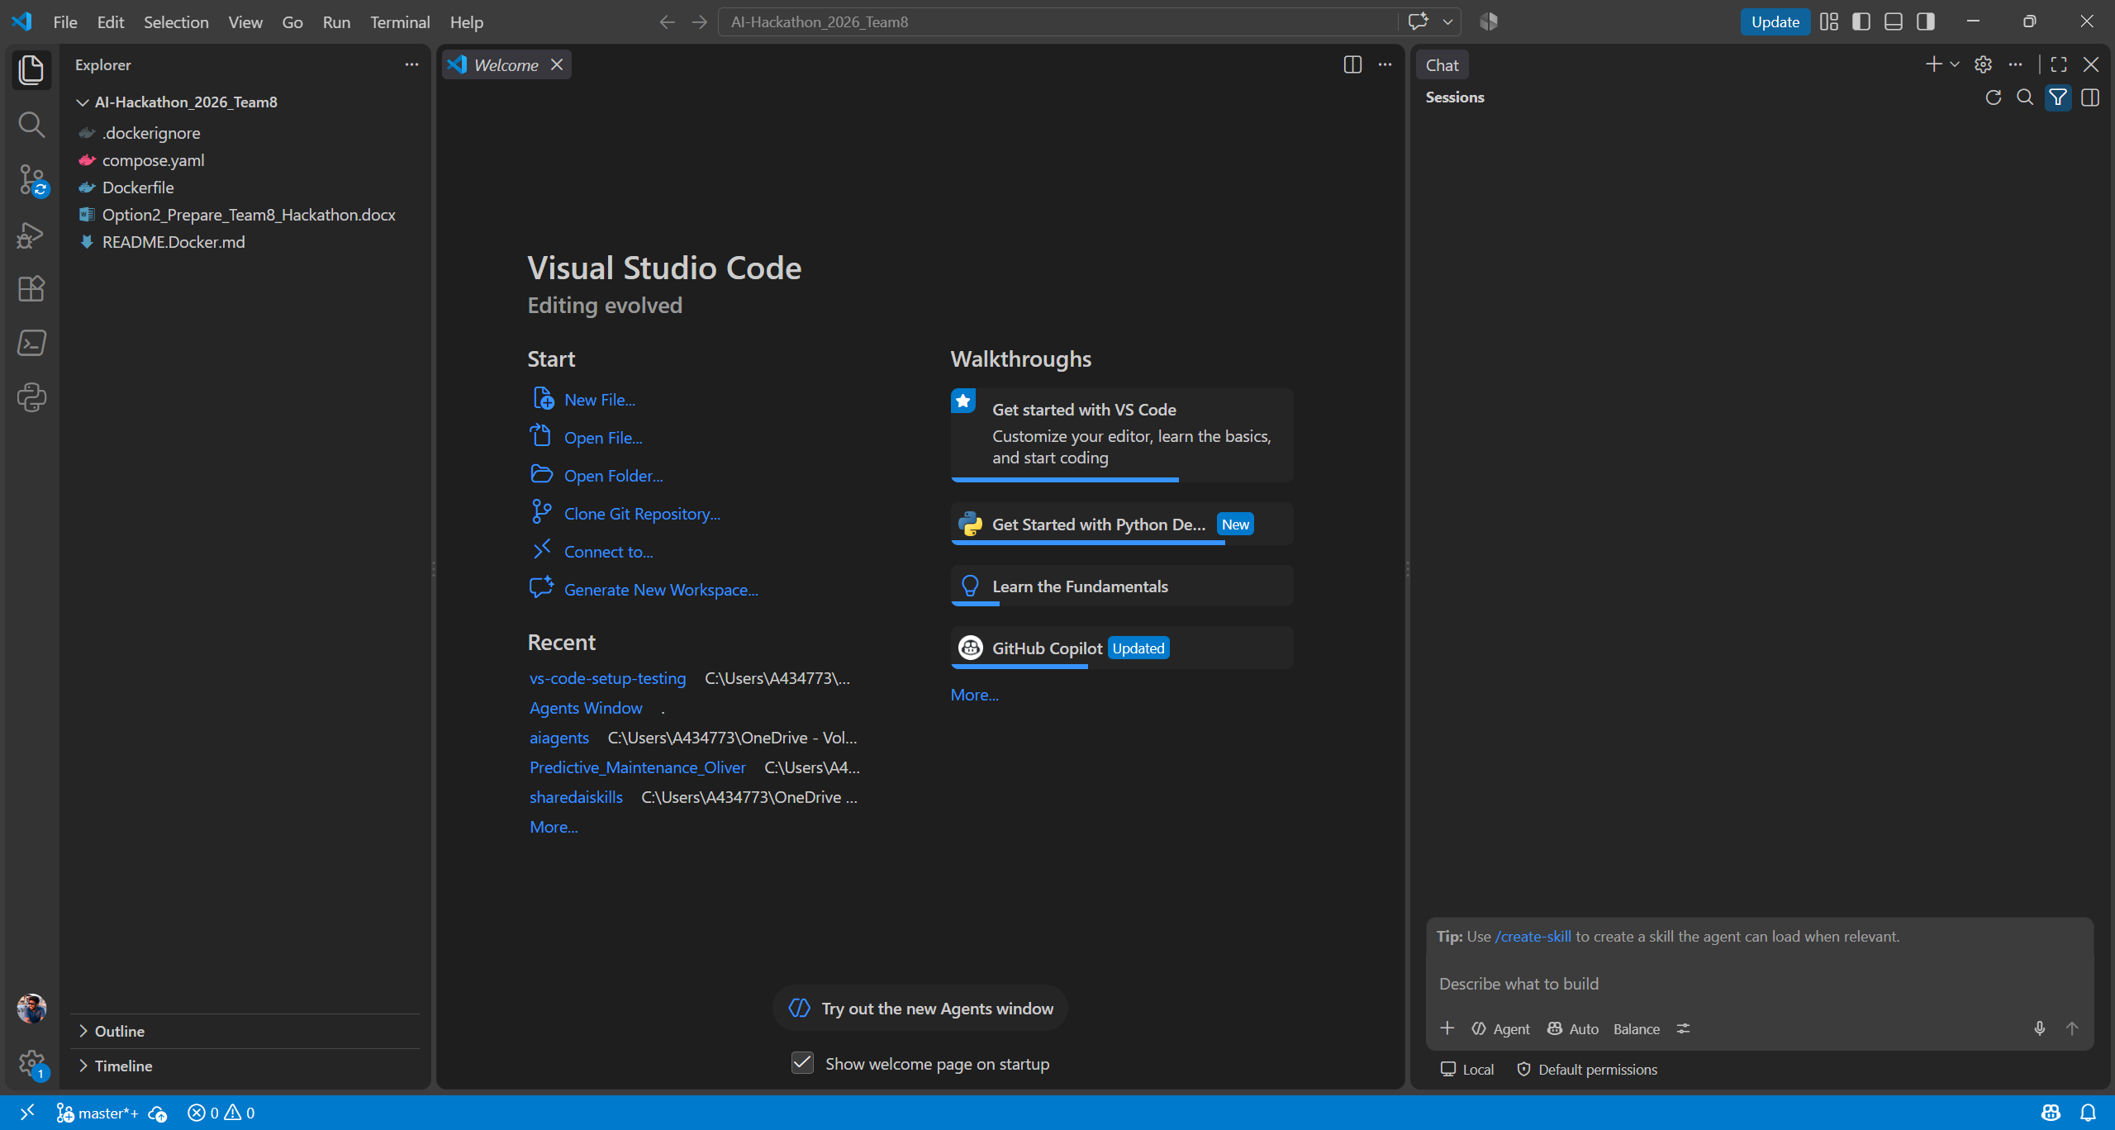
If you have set up Volvo Github Copilot and selected VS code as your IDE, then we should already start with Github Copilot agent in your VS code IDE
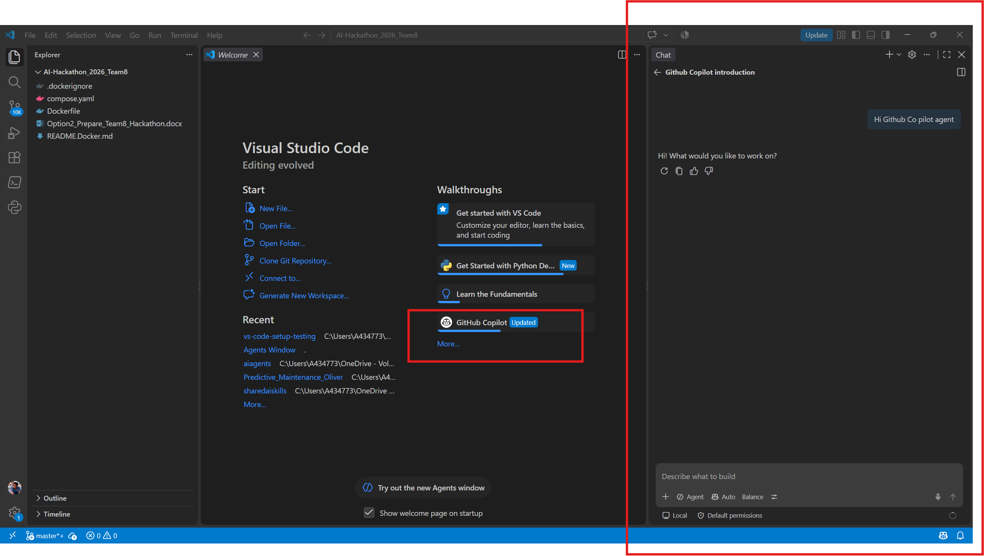

Congrats you have become an Volvo Github AI developer !!

Prerequisite 4: Python
Can be requested via service now: choose 3.13 (my own version is still old, need to update )
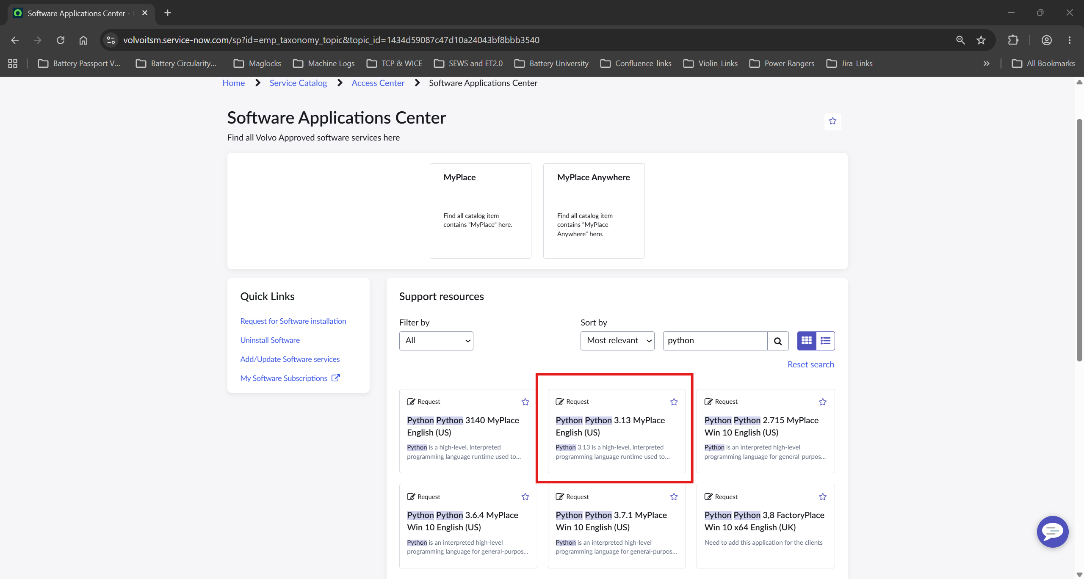

Prerequisite 5: Git
Follow instructions from this page: https://confluence.srv.volvo.com/spaces/CALMS/pages/520327399/Git+installation+and+setup+on+Windows
Feel free to skip step 1: Bitbucket if only for hackathon, for the hackathon I don’t think we need bitbucket.
If bitbucket is there, then Cool
- https://confluence.srv.volvo.com/spaces/CALMS/pages/520327440/Prepare+for+Git+installation
- https://confluence.srv.volvo.com/spaces/CALMS/pages/520327464/Git+installation
literally any GUI is good – take your own choice from: https://confluence.srv.volvo.com/spaces/CALMS/pages/545793523/Git+GUIs

Fancy Stuff 1: Jupyter extension in your VS code
Find Extension tab inside VS code IDE and add the extension for Jupyter
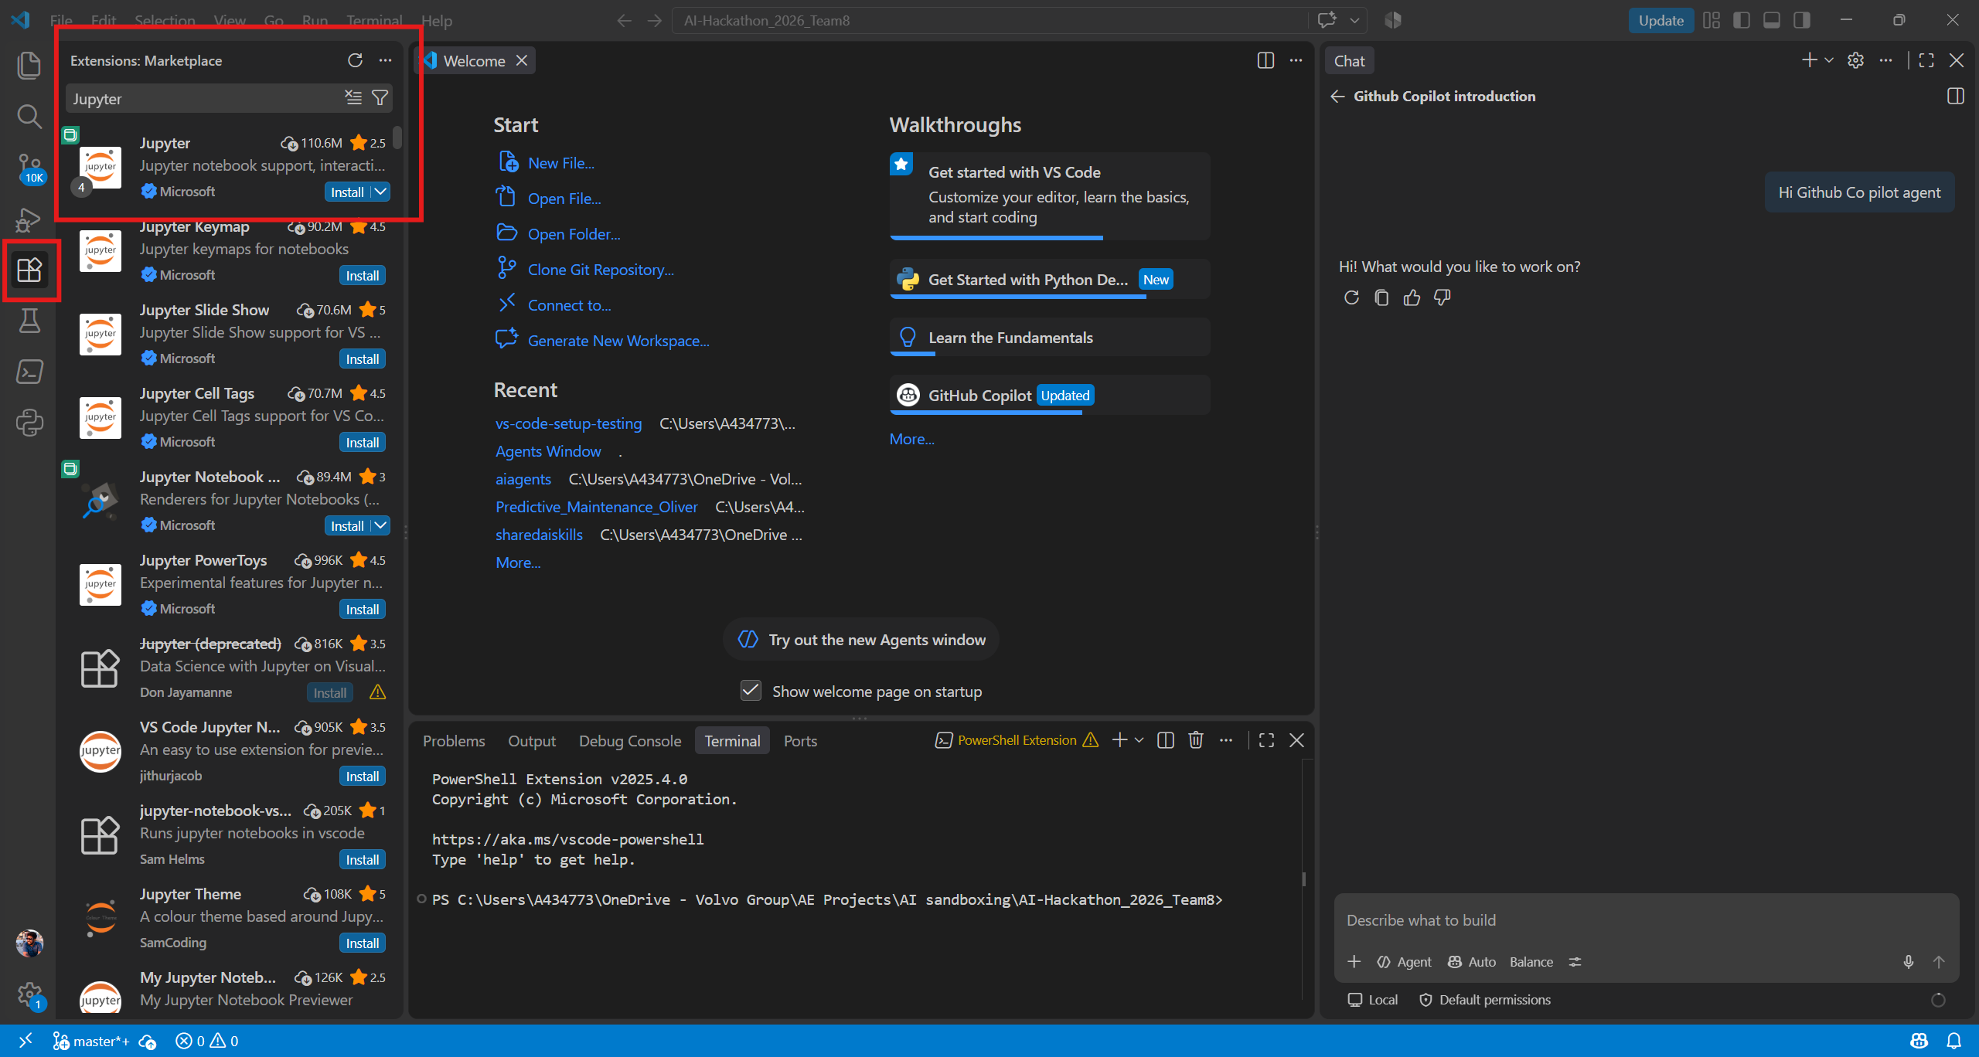
Once extension installed, walkthrough will start and give you prompts, follow and set up in your chosen folder.
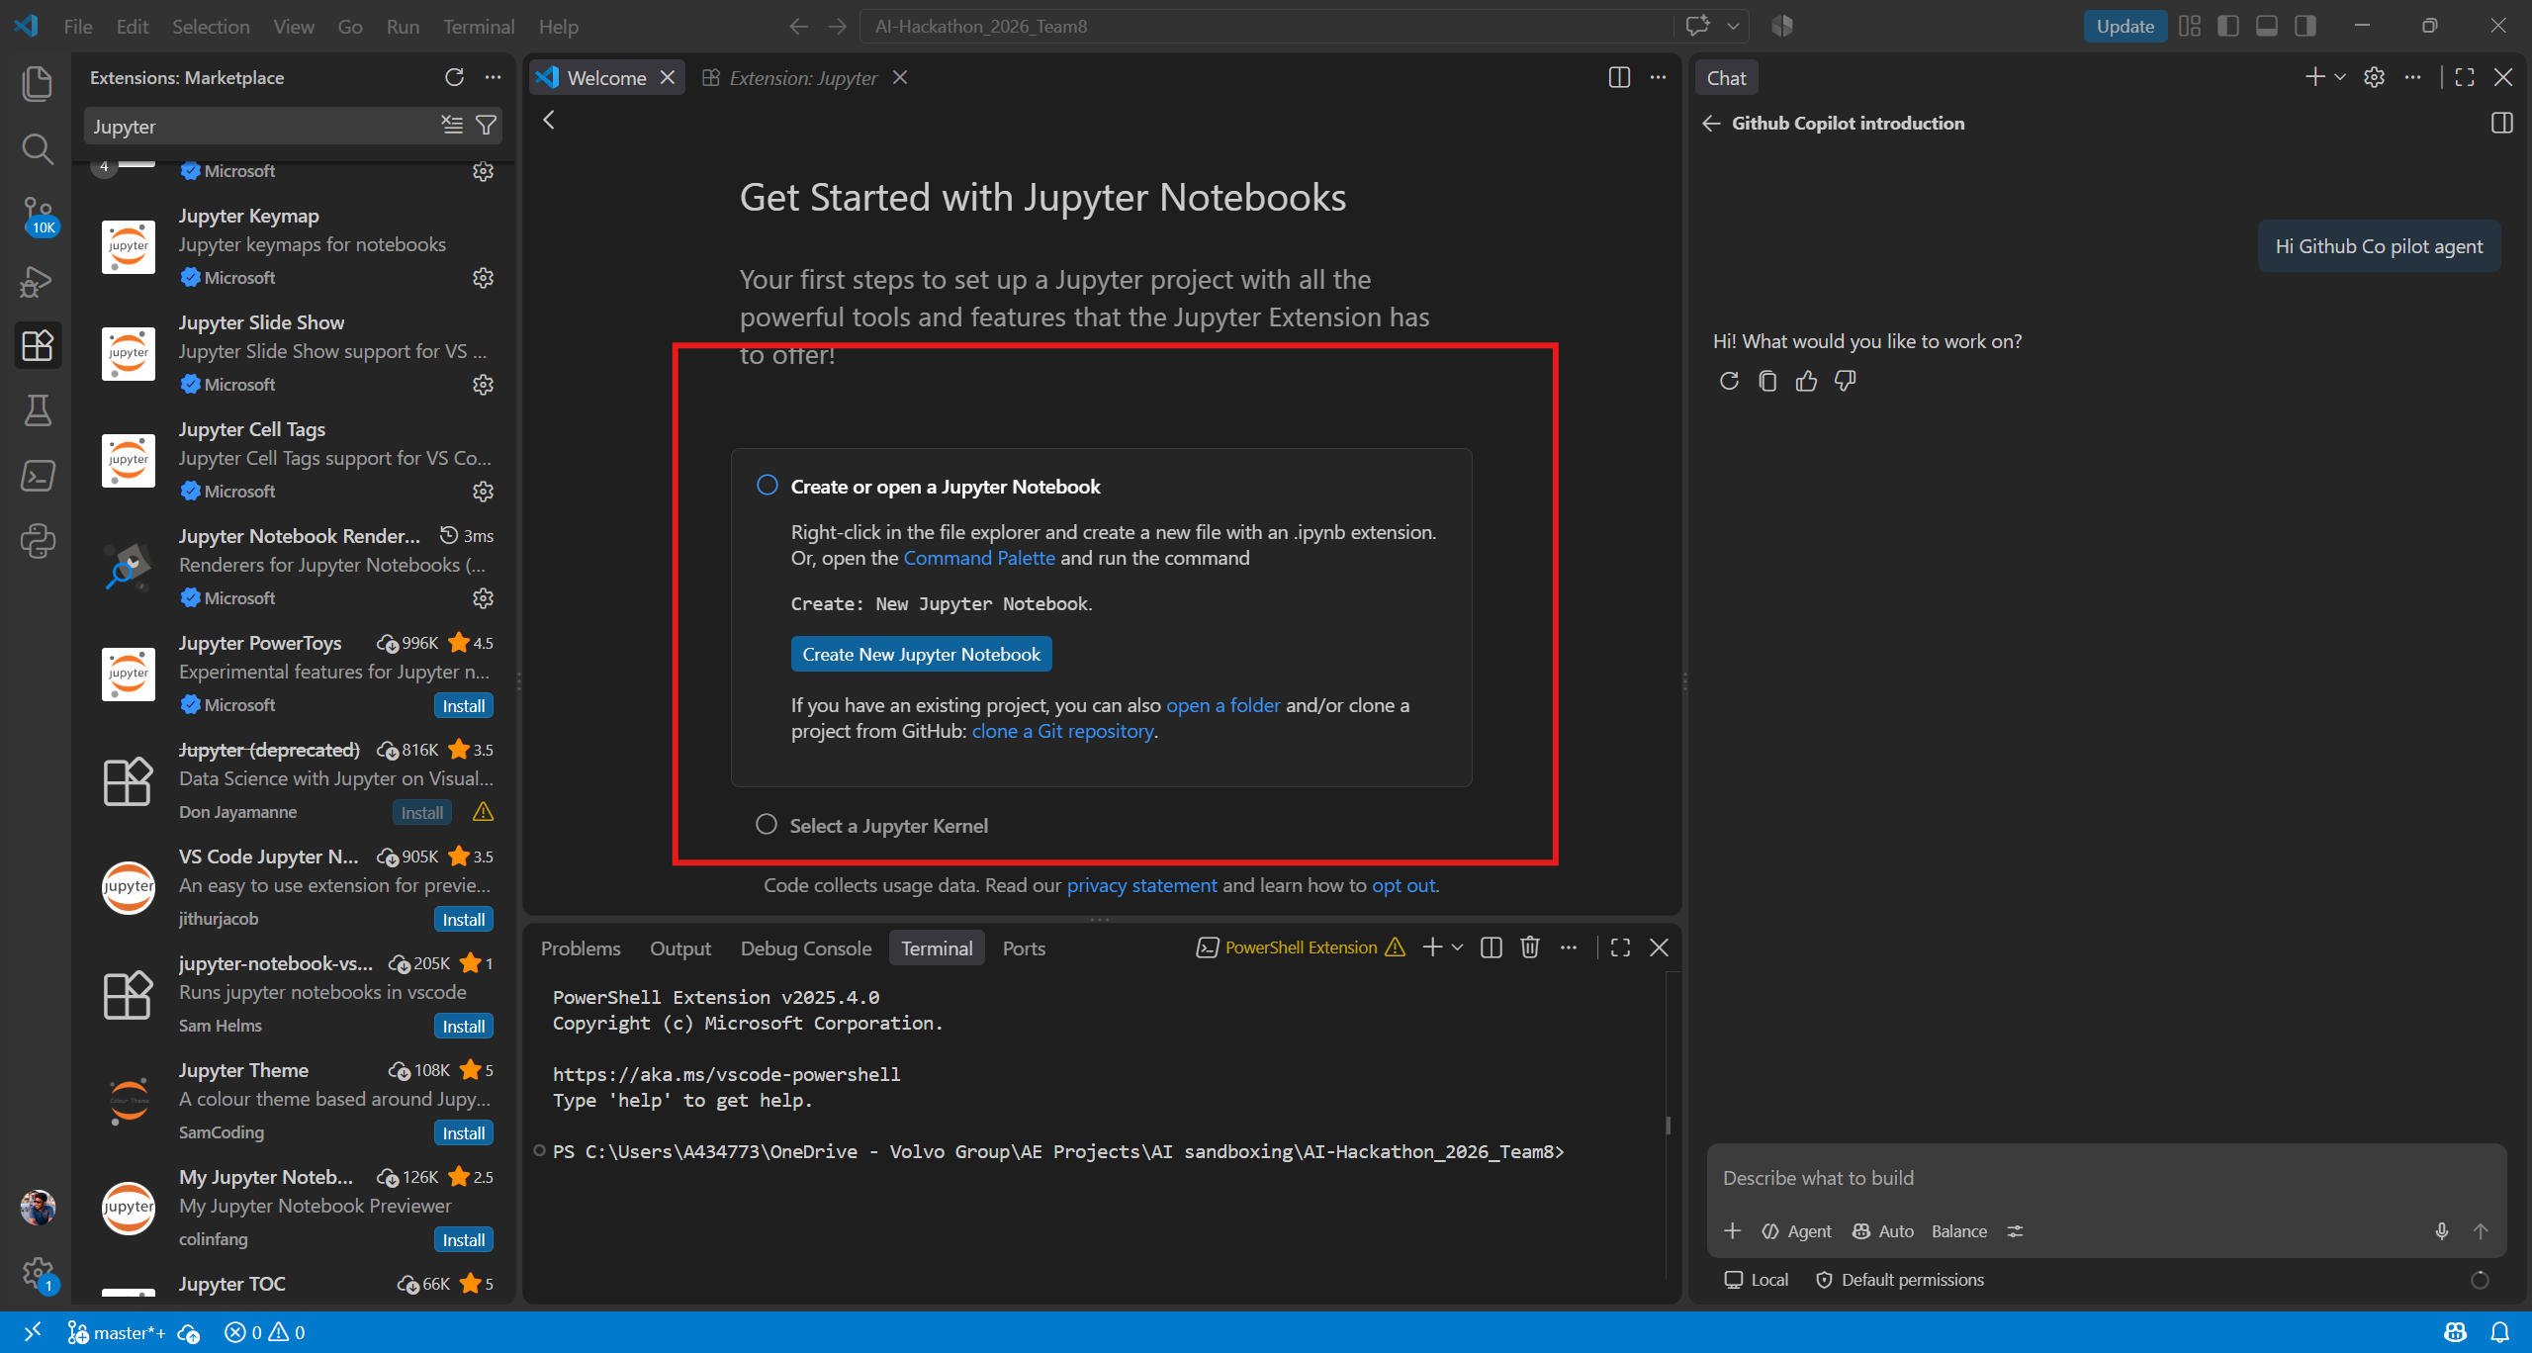
Pop up may ask for python kernel, install relevant python kernel. Mark Done when ready

Fancy Stuff 2: Python/ pylance extension in your VS code
Use extension marketplace and install python and pylance
Python
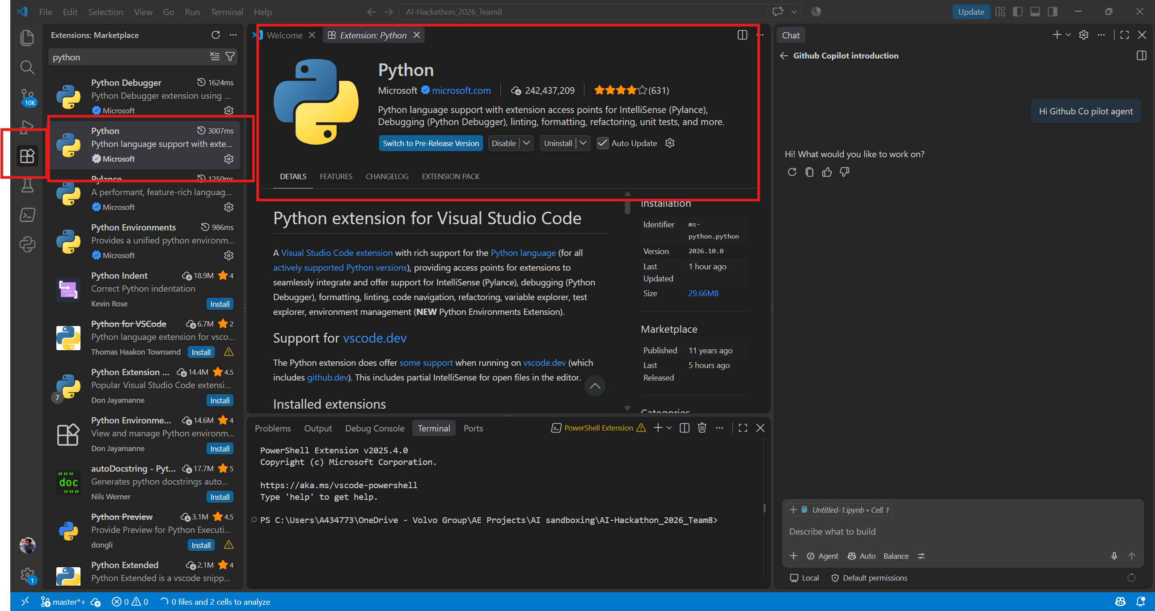
Pylance
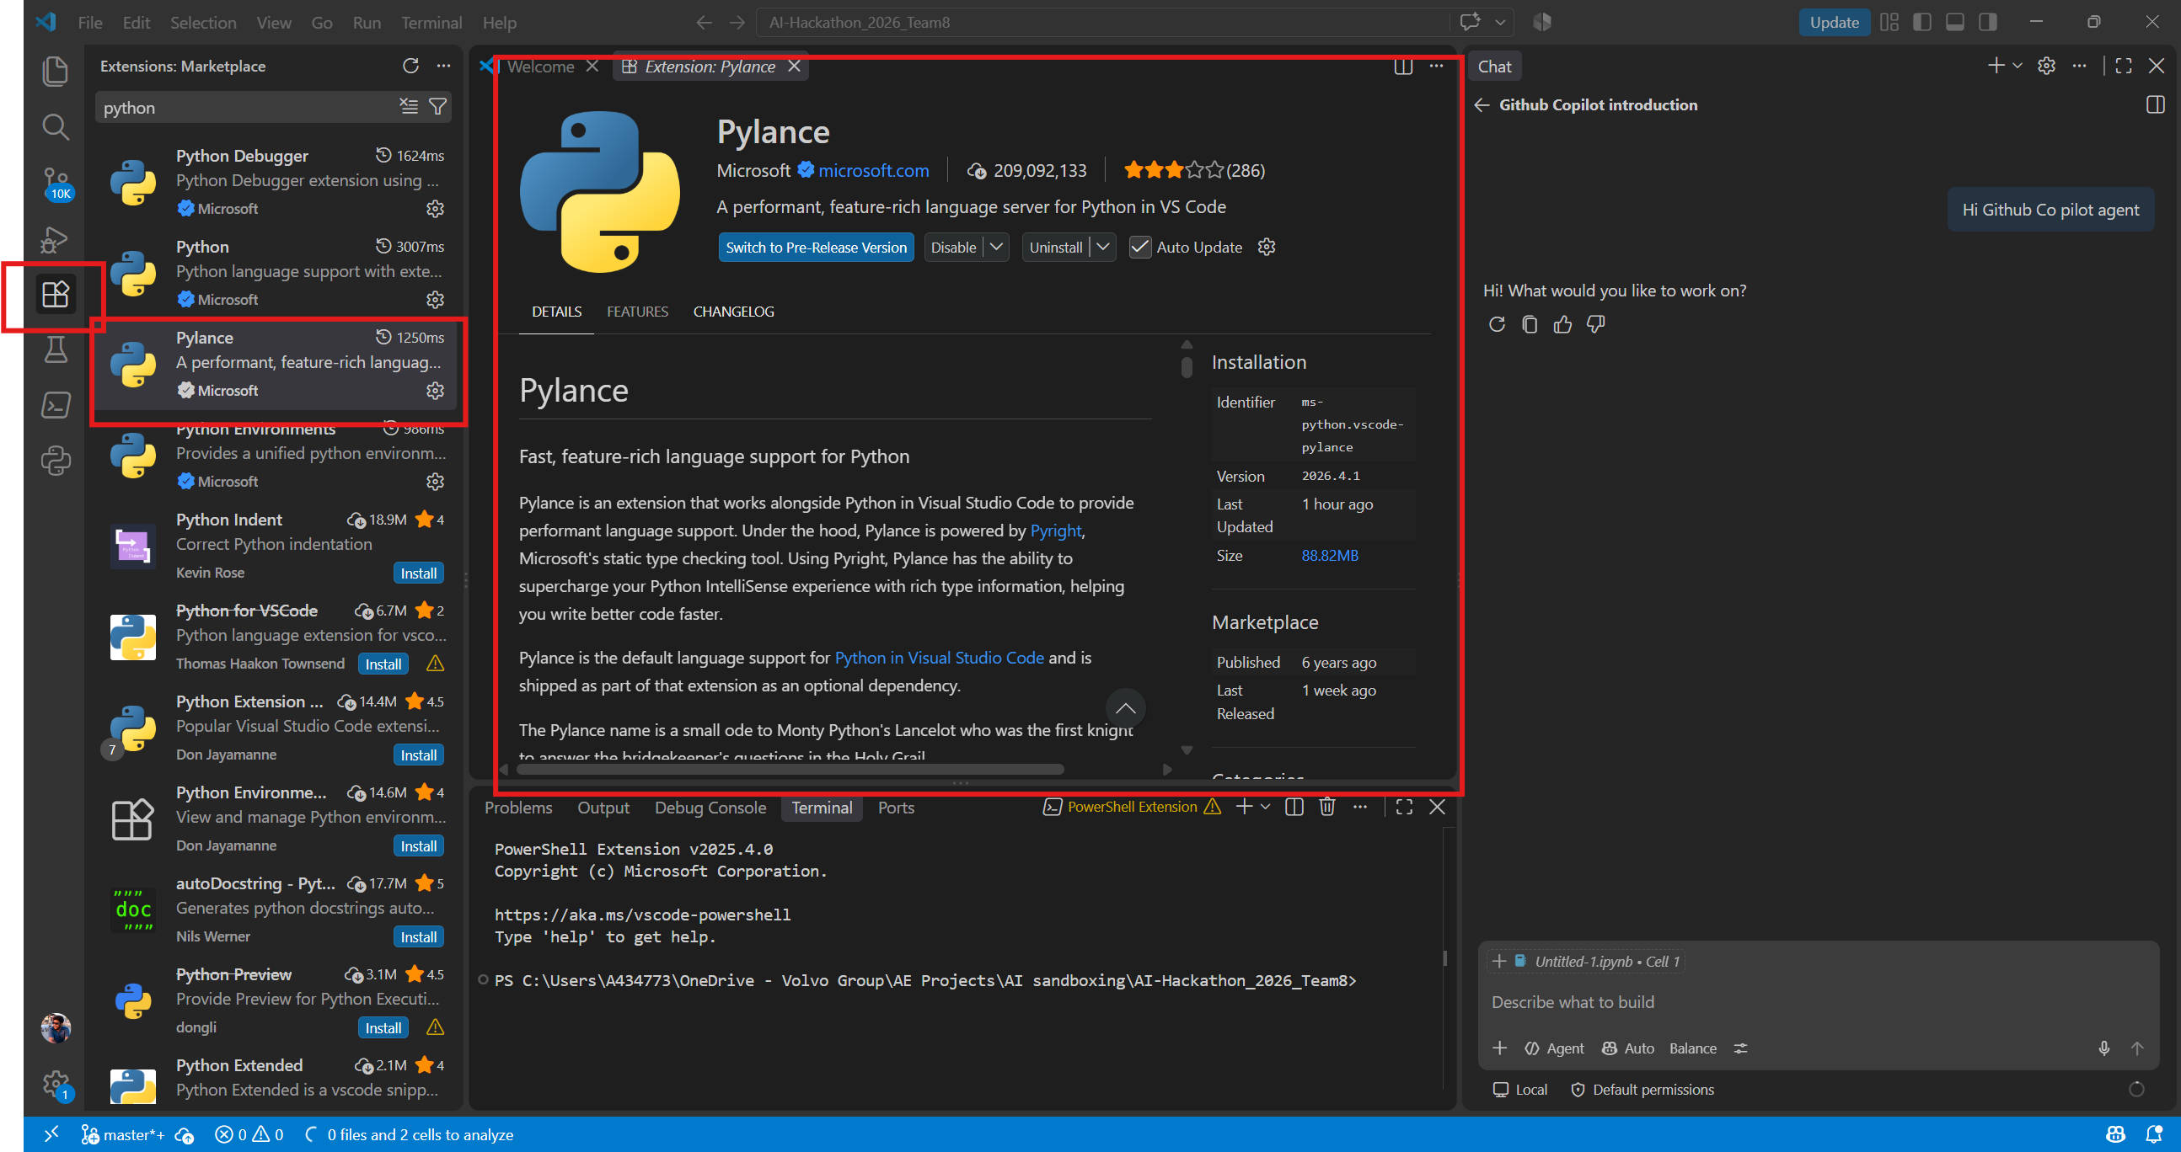

Fancy Stuff 3: Foundry Toolkit extension in your VS code

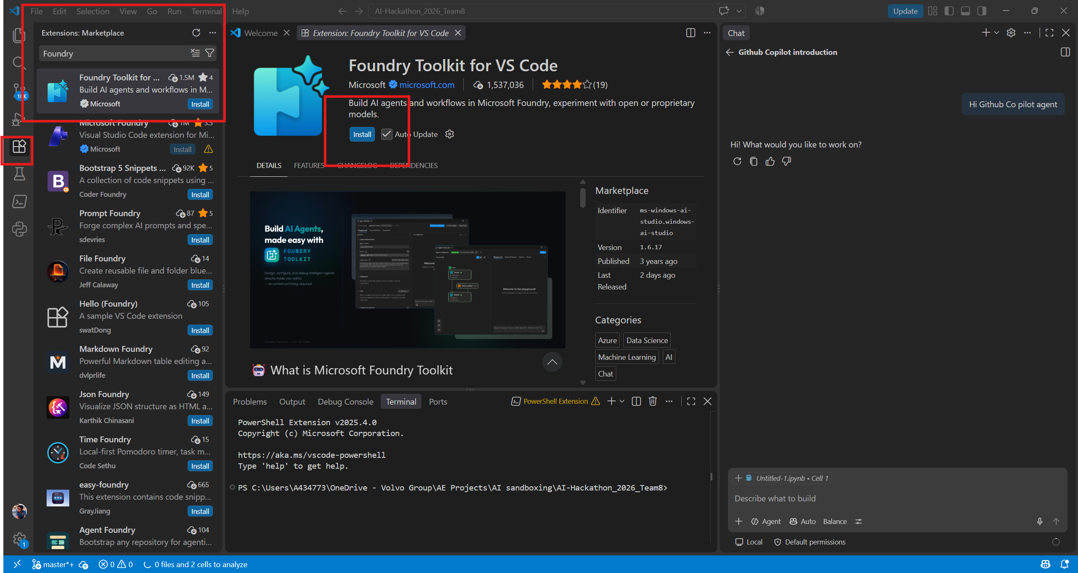

You will get an walkthrough, can just skip for now by checking in, I guess we will go through agent creation in hackathon days.
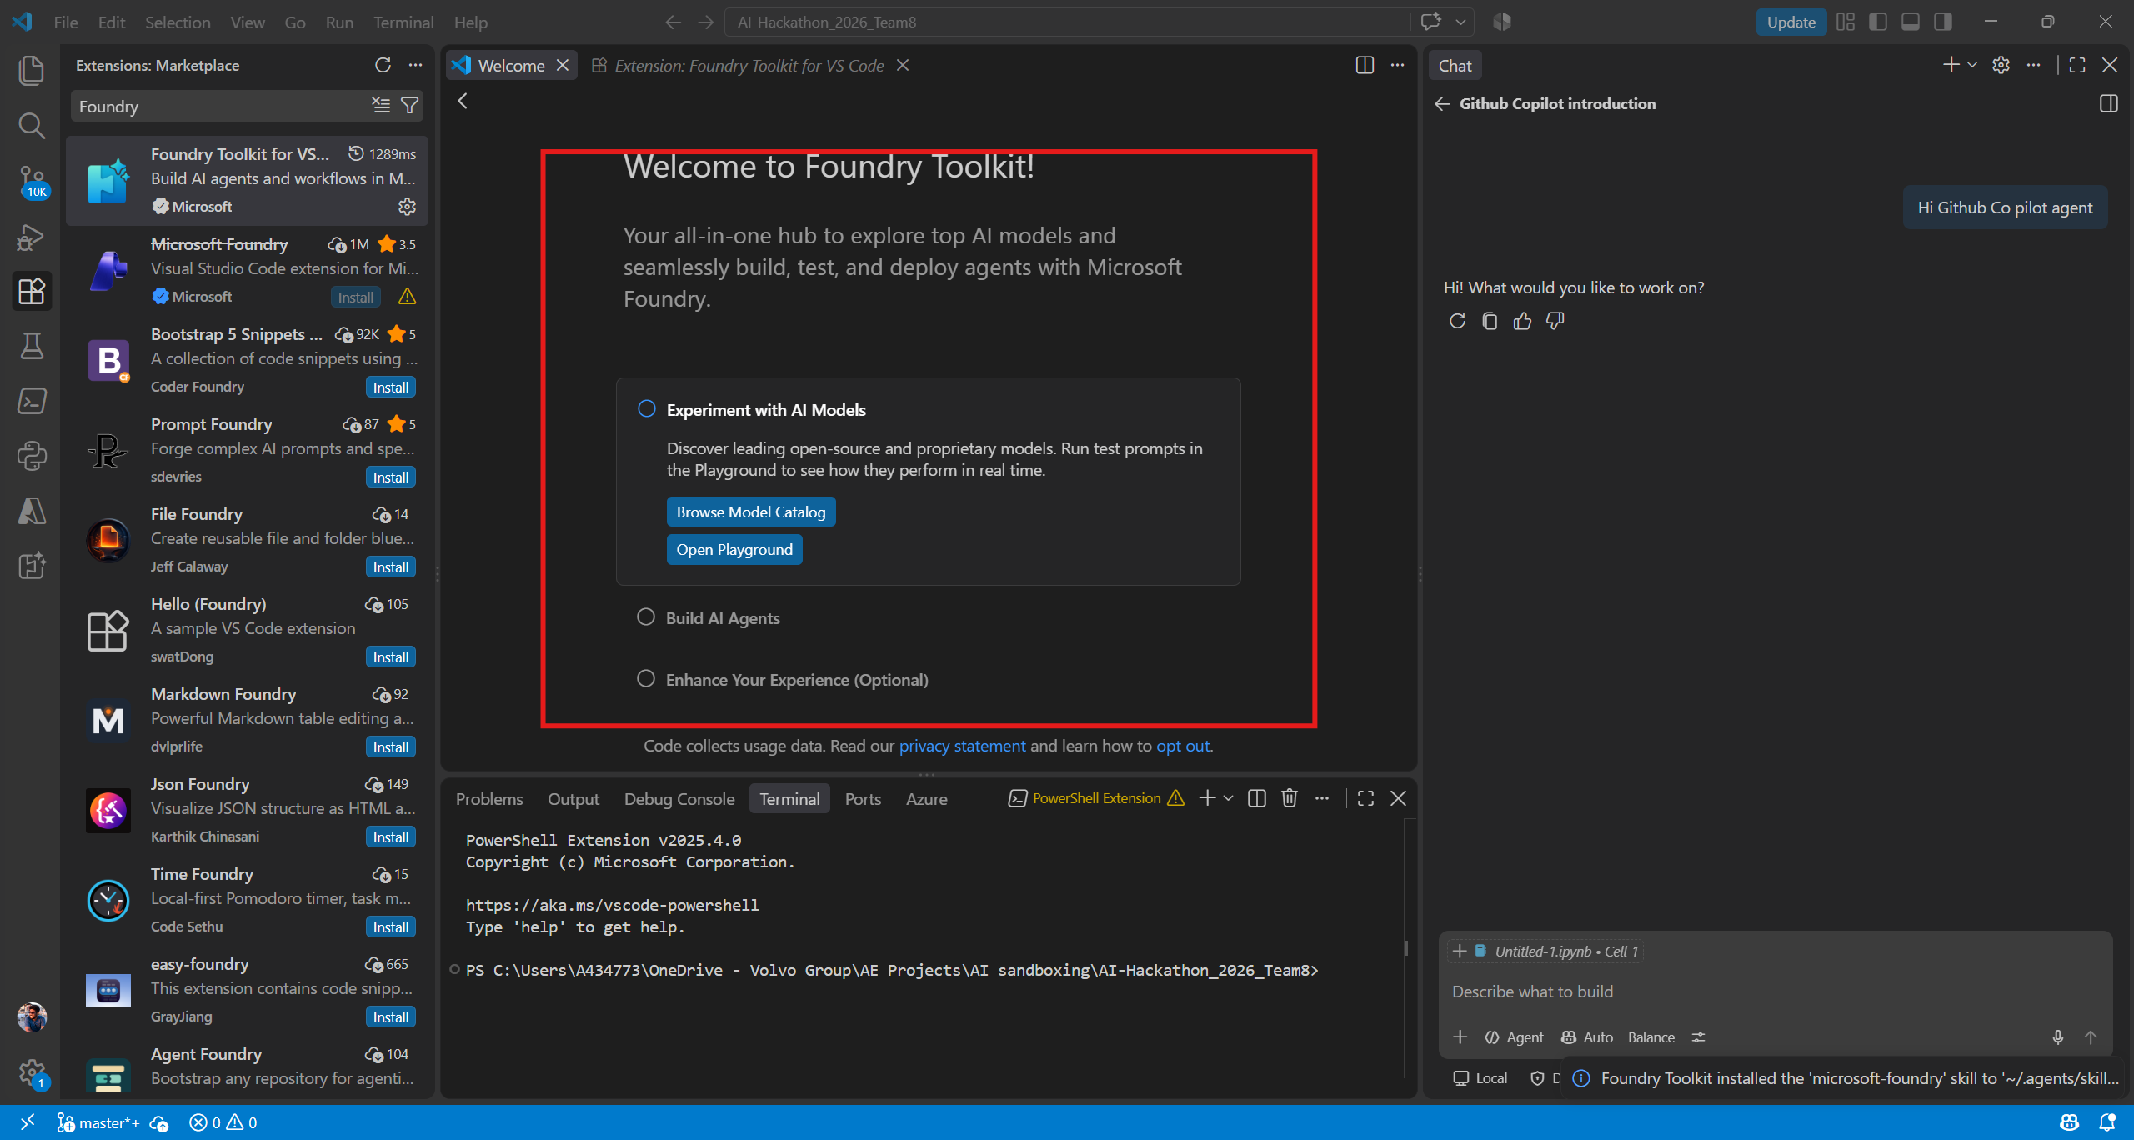

Now you have new agents window:
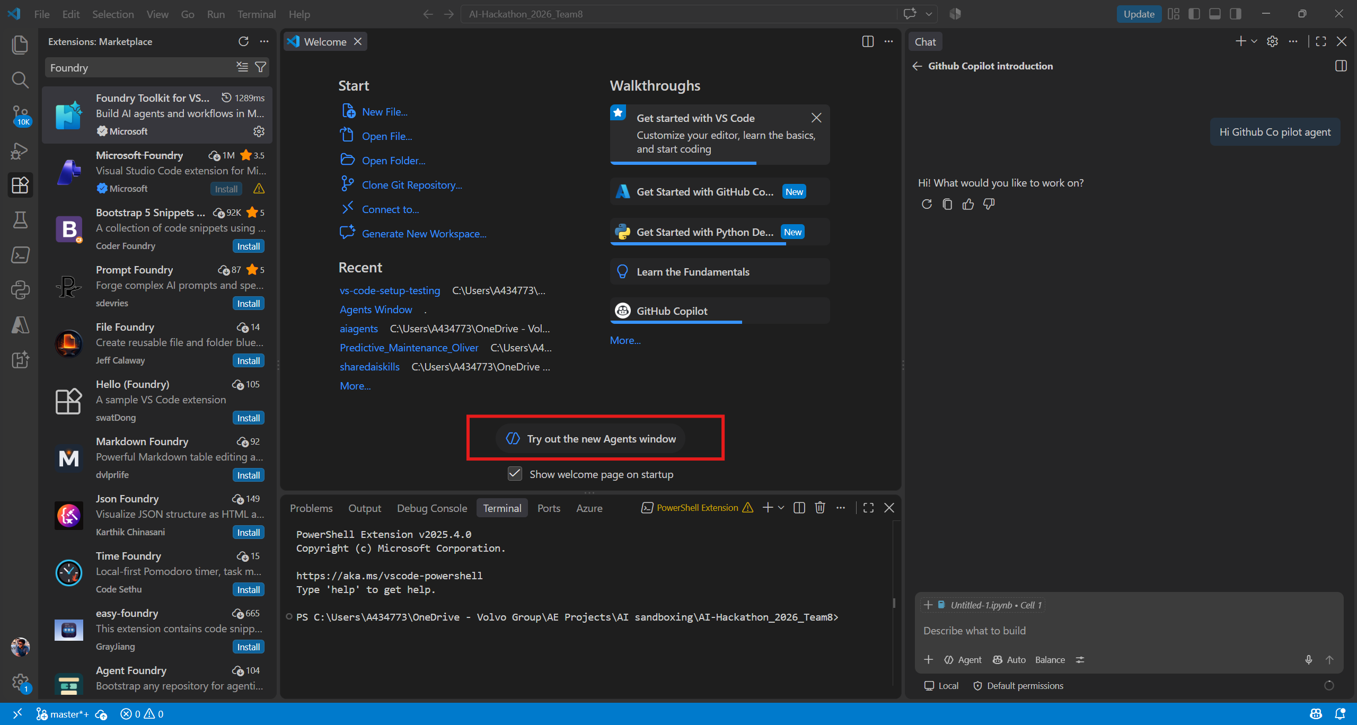

Feel free to explore Github Copilot agent that comes with your Volvo Enterprise account
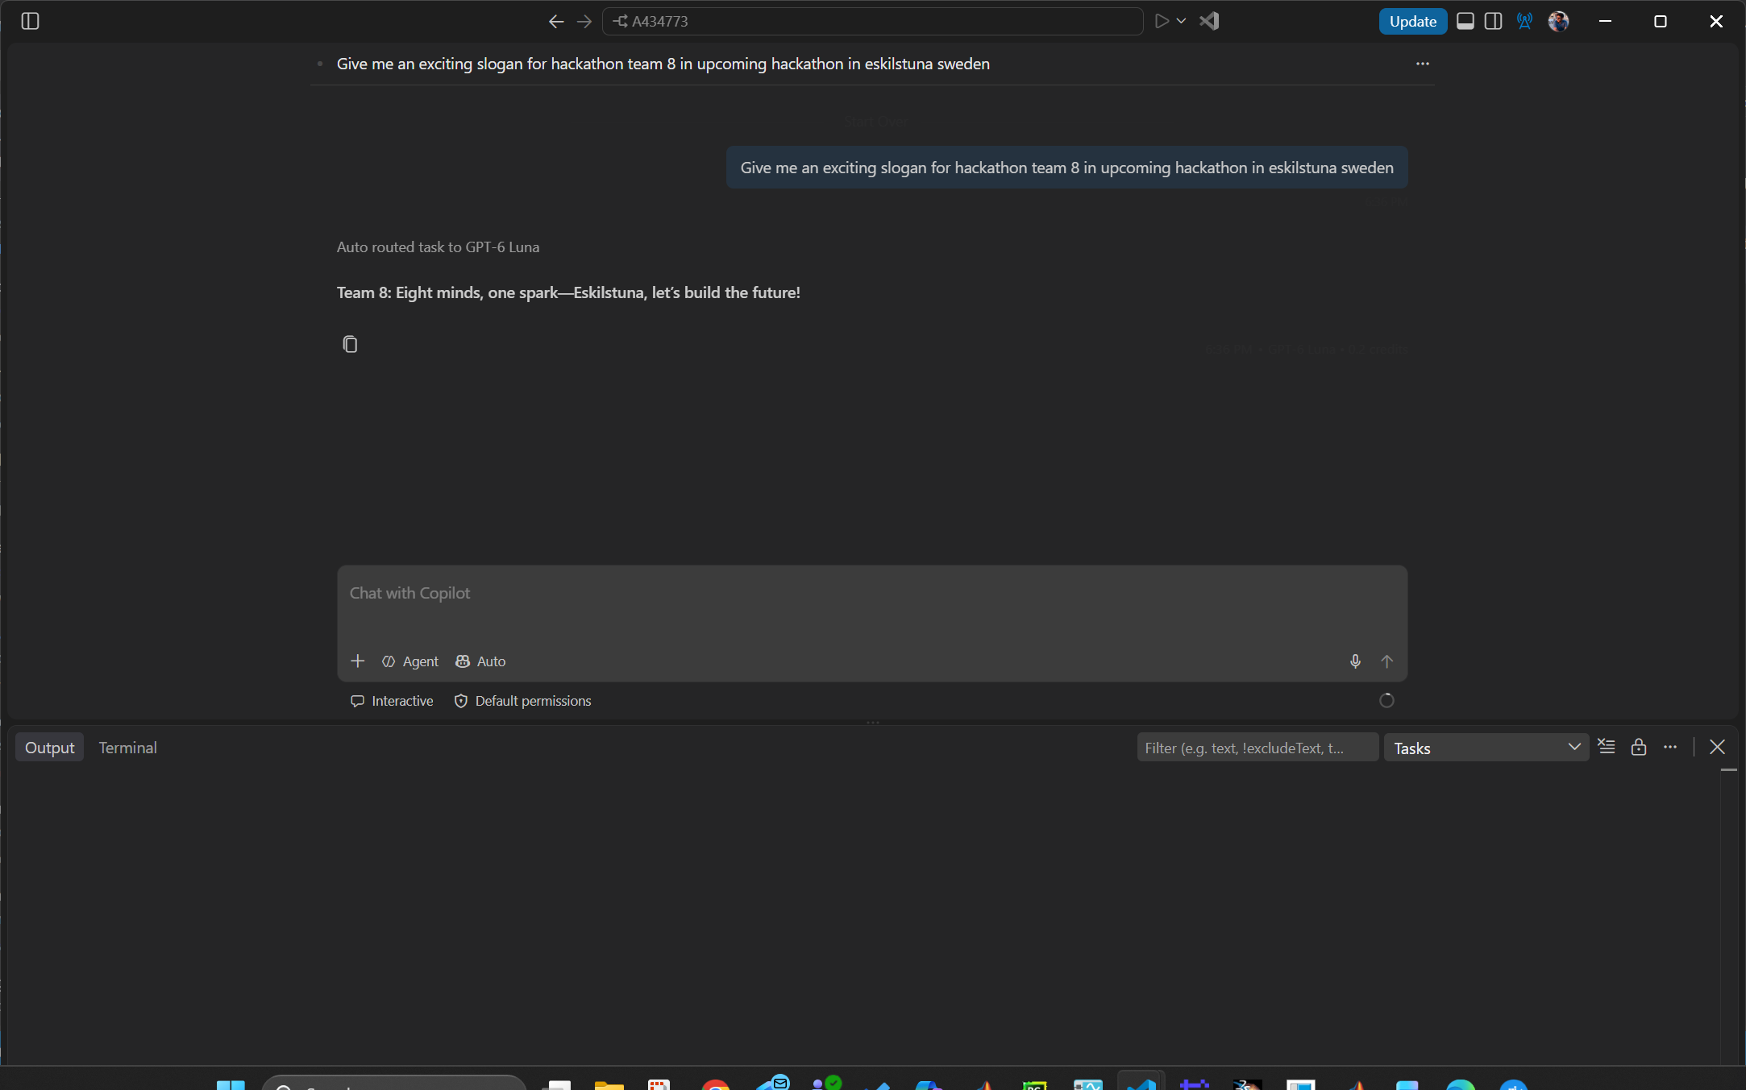

Fancy Stuff 4: install and login to Azure CLI
Install from Install the Azure CLI on Windows | Microsoft Learn
I used Windows Powershell, administrator mode:
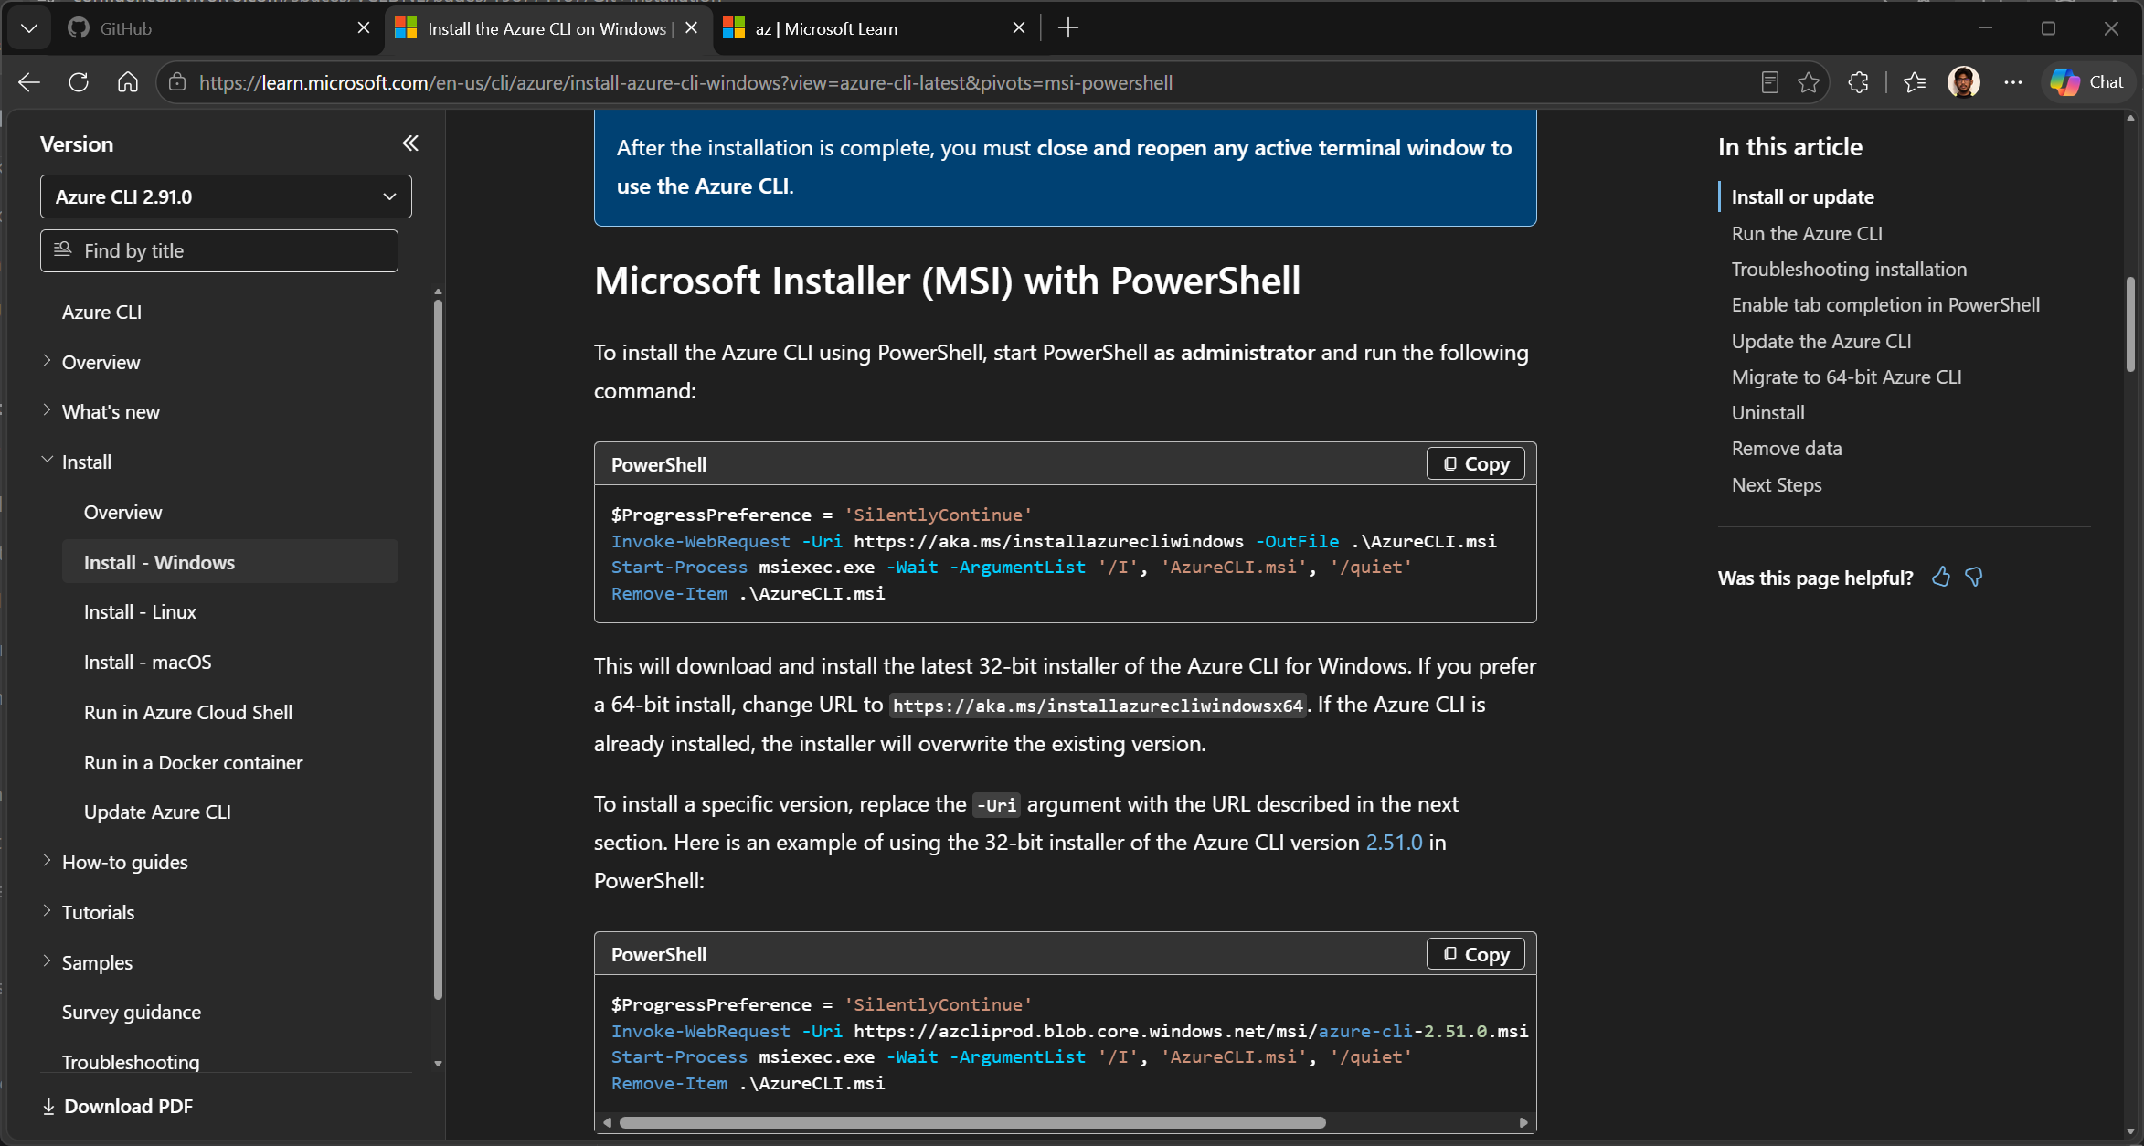
But zip or MSI should work fine.
Once installed, then you can run a bash or powershell, and check with “az version” as follows –
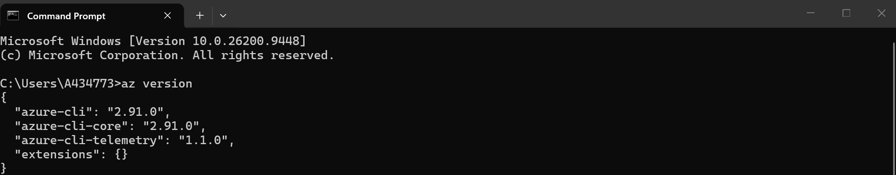
You can login to azure using default volvo group workgroup as follows:
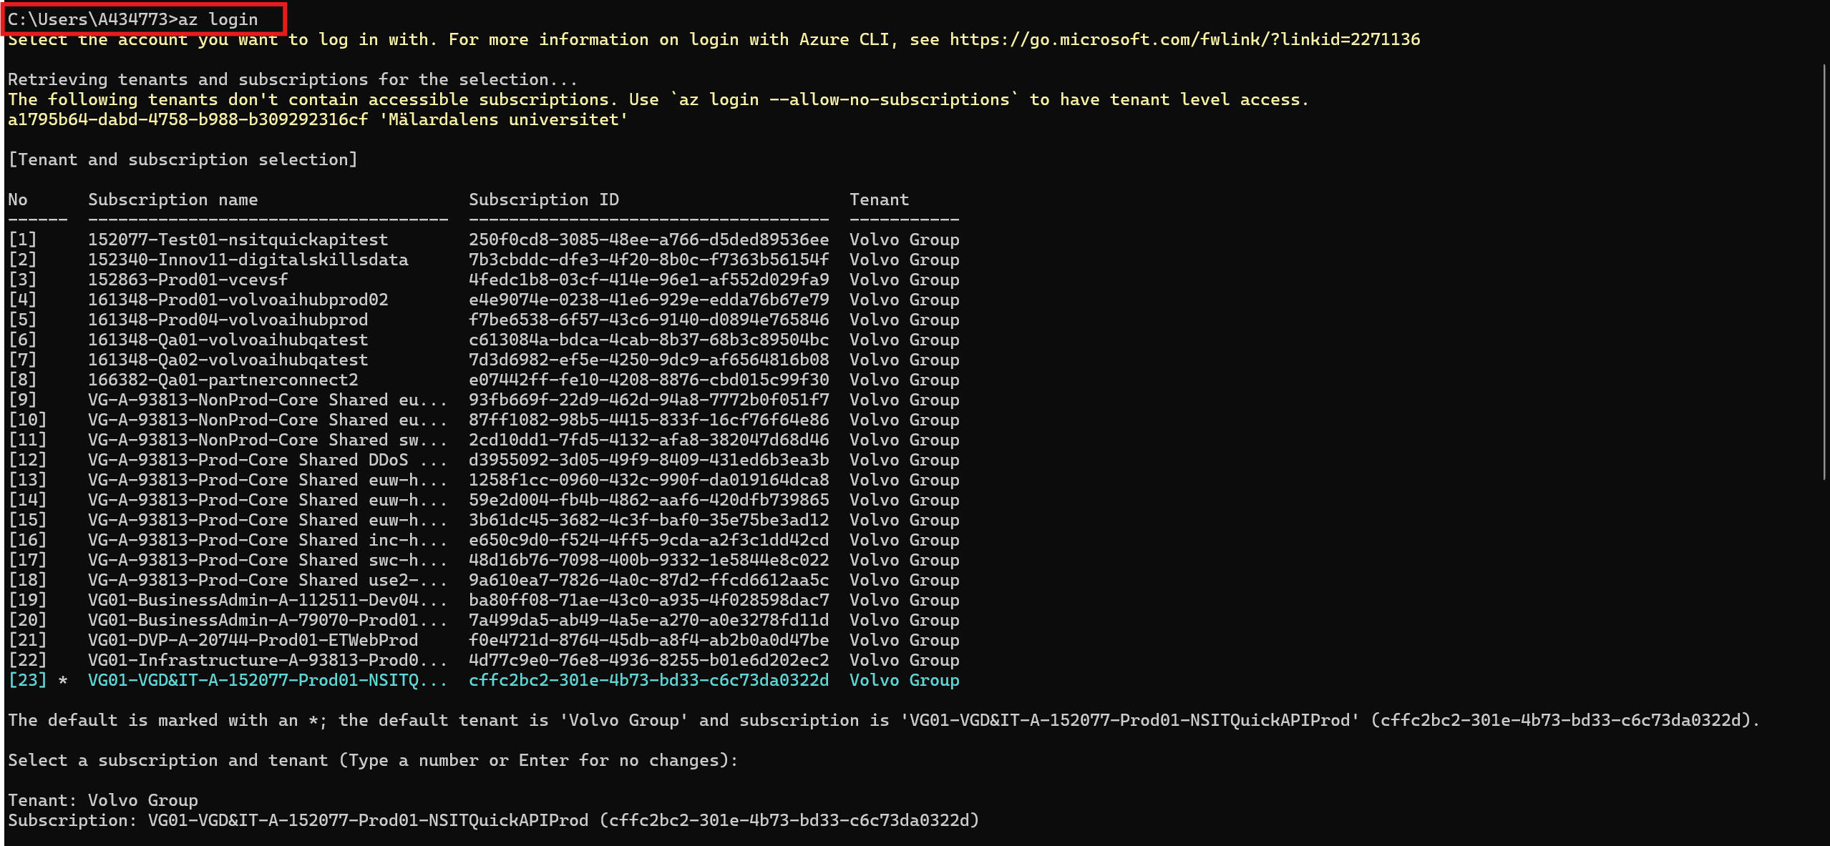

Easy Stuff: install .NET SDK 10.0
Get SDK 10.0402 x64 or X86 as applicable from: Download .NET 10.0 (Linux, macOS, and Windows) | .NET

