**Your report should be prepared as presentation slides** (using power point / Beamer etc.). The presentation slides must be converted to a pdf file and submitted.

The report should consist of slides in following sequence:

First slide stating your name, roll number. The subsequent slides would be pertaining to each of the assignments and shall be arranged sequentially

1. Assignment 01: Waypoint generation and trajectory tracking with turtlebot Assignment
   * Plot the trajectory generated and the tracking performance of the robot as an x-y graph
   * Deviation from the Lissajous curve for tracking problem: Tabulate the Root Mean Square Error (RMSE). Report your control law and its tuning parameters. (The error is defined as the different between the setpoint and the actual position of the robot)
   * Your key observations/conclusions, if any as bullet points
2. Assignment 02: Obstacle Avoidance with Range Sensing

* X- Y Plot
* Tuning Paramaters
* Your key observations/conclusions, if any as bullet points

1. Assignment 03: Trilateration with ground mobile robot
   * Calculate Root Mean Squared Error (*RMSE*)*i* for each state variable, where (*RMSE*)*i* is computed as:

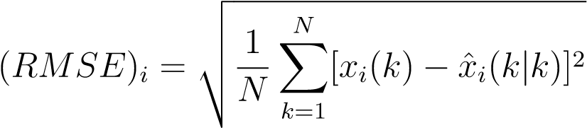

* Report Tuning Parameters
* Your key observations/conclusions, if any as bullet points

1. Assignment 04: Kalman Filter
   * In a tabular form, summarize the mean and variance of each innovation (y-y_precidted) (mean, variance computed across time).
   * Calculate Root Mean Squared Error (*RMSE*)*i* for each state variable, where (*RMSE*)*i* is computed as:



for the Kalman

* Tuning parameters and Key observations/conclusions