Evaluating and Enhancing Adversarial Robustness of ML Models for NIDS
IIT Kanpur B.Cyber Programme — Project Report
Hitvika Pathak | June 2026

Evidence of Work / Portfolio Summary
Local repository: C:\Users\HP\adversarial-nids-cicids2017
GitHub: Publish this folder as adversarial-nids-cicids2017 (README included)
Reproduce: python run.py
Dataset: CIC-IDS2017 — Thursday-WorkingHours-Morning-WebAttacks.pcap_ISCX.csv
Models: Random Forest, XGBoost, MLP
Attacks: FGSM + PGD (white-box MLP, transfer to tree models)
Defenses: Adversarial training, feature squeezing, ensemble
Key result: RF clean 97.5% → PGD transfer detection 0.0%
Demo video script: docs/demo_video_script.md

Abstract
This project investigates whether machine-learning-based Network Intrusion Detection Systems remain reliable under adversarial manipulation. Using CIC-IDS2017 (Thursday Web Attacks subset, 170,366 raw flows), I trained Random Forest, XGBoost, and MLP classifiers and evaluated them with FGSM and PGD under a STRIDE threat model. High clean accuracy did not guarantee security: Random Forest dropped from 97.5% clean accuracy to 0.0% attack-detection rate under transferred PGD (ε=0.05). Adversarial training improved MLP PGD detection to 97.0%. The work shows why NIDS models must be tested under attacker-aware conditions before deployment.

Problem Statement
ML-NIDS classify network flows from statistical features. If an attacker can perturb those features within realistic bounds, malicious traffic may be labeled benign. This project measures that risk on CIC-IDS2017 and compares mitigation strategies.

Why This Matters for Cybersecurity
- Evasion attacks can bypass automated alerts in SOC pipelines.
- Clean-test accuracy hides failure modes that appear only under adversarial input.
- Robustness checks should be integrated into secure SDLC for detection systems.
- Layered defense (ML + constraints + logging + analyst review) is required in production.
- For national infrastructure, robust detection is a security control, not a leaderboard metric.

Dataset and Preprocessing
Source: CIC-IDS2017 (Thursday-WorkingHours-Morning-WebAttacks.pcap_ISCX.csv). Raw records: 170,366; features used: 78; missing values handled: 20; duplicates removed in analysis: 6,066. Labels collapsed to binary Benign vs Attack. Class distribution (raw): {'BENIGN': 168186, 'Web Attack � Brute Force': 1507, 'Web Attack � XSS': 652, 'Web Attack � Sql Injection': 21}. Preprocessing: drop identifiers, numeric coercion, top-30 variance features, StandardScaler, balanced sampling (4680 flows), split 72% train / 8% val / 20% test (stratified).

Threat Model using STRIDE
STRIDE | NIDS Example | Feature-Level Attack | Defense
Tampering | Alter timing behavior | Flow Duration / IAT perturbation | Constraint validation
Spoofing | Mimic benign traffic | Reduce packet-rate features | Behavioral baselines
Repudiation | Hide malicious footprint | Suppress volume features | Immutable flow logs
Information Disclosure | Model probing | Boundary search via queries | Access control
Denial of Service | Flood crafted flows | High-volume adversarial samples | Rate limits + robust model
Elevation of Privilege | Bypass policy action | Force benign classification | Defense-in-depth rules

Realistic Perturbation Constraints
- Packet counts and durations remain non-negative.
- Protocol identifiers are not arbitrarily changed.
- Derived statistics stay internally consistent.
- Perturbations preserve attack intent (evasion, not benign conversion).
- Categorical network fields are not treated as free continuous pixels.
- All perturbations clipped to L∞ bounds after scaling.

Models Implemented
Random Forest (200 trees, depth 20, balanced class weights) for strong tabular baseline and interpretability. XGBoost (200 estimators) for boosted nonlinear boundaries. MLP (64-32 ReLU, Adam) as differentiable surrogate for gradient attacks.

Adversarial Attack Design
FGSM and PGD require gradients, so white-box attacks were executed on MLP using finite-difference gradients over attack-class loss. Random Forest and XGBoost were evaluated with transfer attacks from MLP-generated adversarial examples.
Attack | Epsilon | Steps | Step Size | Targeted? | Model
FGSM | 0.01, 0.05, 0.1 | 1 | — | No | MLP (white-box)
PGD | 0.01, 0.05, 0.1 | 20 | 0.01 | No | MLP (white-box)
Transfer | 0.05 primary | — | — | No | RF, XGBoost

Defense Mechanisms
1) Adversarial training: MLP retrained on clean + PGD examples (ε=0.05). 2) Feature squeezing: 4-bit precision reduction before inference. 3) Ensemble: majority vote of Random Forest and robust MLP.

Experimental Setup and Reproducibility
Seed: 42. Environment: Python 3.12, Windows 10, CPU execution. Attack evaluation set: 200 attack flows. Command: python run.py. Artifacts: results/metrics.json, results/*.png, models/all_models.joblib.

Results and Graphs
PGD/FGSM columns report attack-detection rate on adversarial attack flows.
Model | Clean Acc | Clean Recall | F1 | FGSM Det. | PGD Det. | Post-Defense PGD
Random Forest | 97.5% | 97.9% | 97.4% | 0.0% | 0.0% | —
XGBoost | 97.8% | 97.7% | 97.6% | 0.0% | 0.0% | —
MLP | 94.6% | 91.1% | 94.0% | 92.5% | 92.5% | 97.0%

Defense | Clean Acc | PGD Det. | Compute Cost
Baseline MLP | 94.6% | 92.5% | Low
Adversarial Training (MLP) | 94.4% | 97.0% | High (retraining)
Feature Squeezing (MLP) | 94.6% | 92.5% | Low
Ensemble (RF + Robust MLP) | 95.9% | 97.0% | Medium

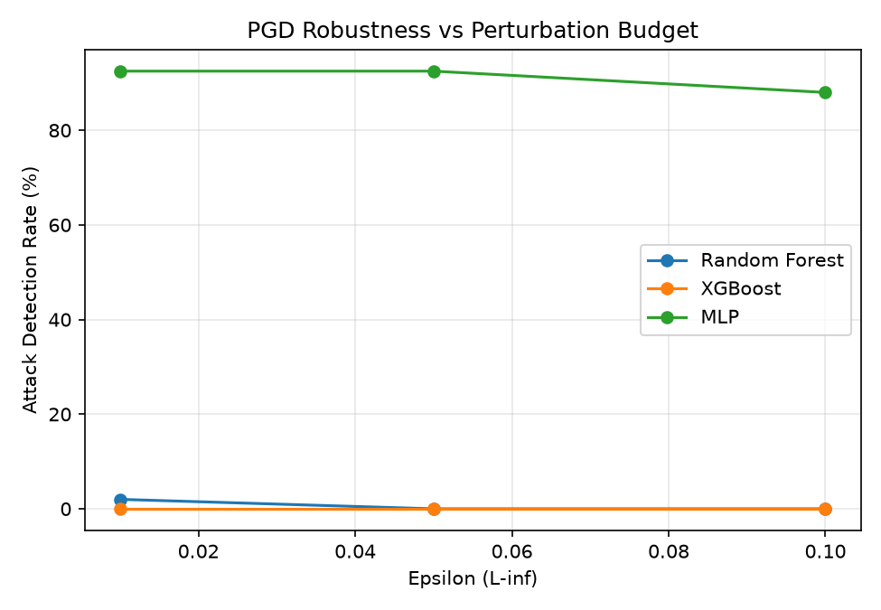
Figure 1: Attack-detection rate vs epsilon.
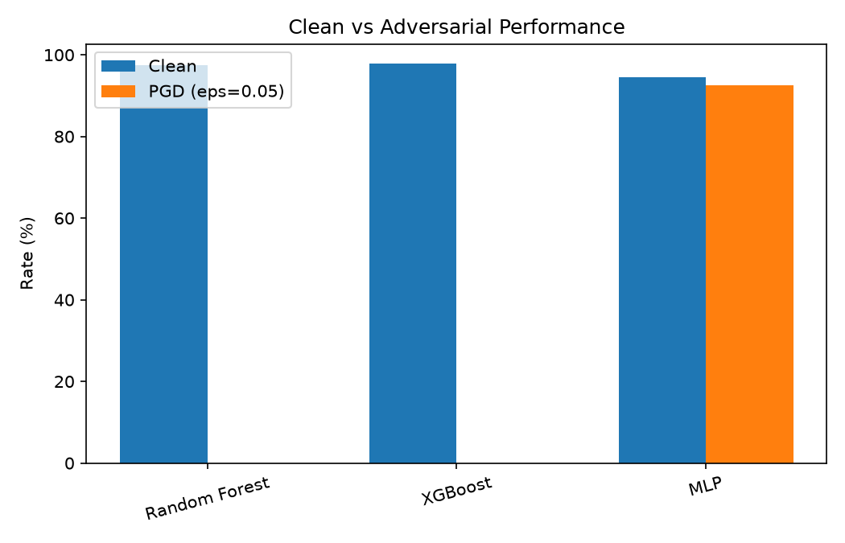
Figure 2: Clean vs PGD performance by model.
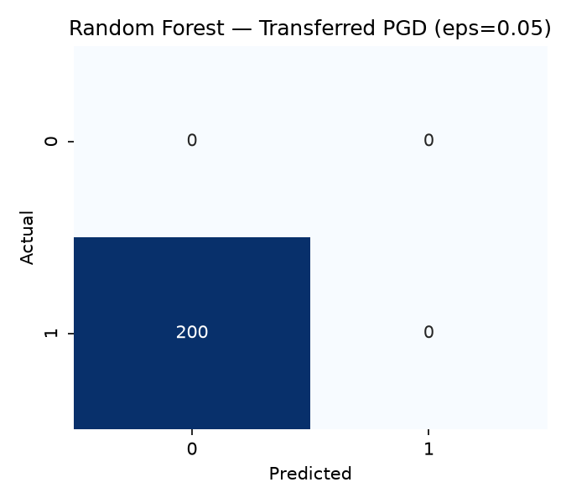
Figure 3: Random Forest under transferred PGD.
At ε=0.1, MLP detection fell to 88.0%, showing sensitivity to larger perturbation budgets.

Failure Analysis
- Transferred PGD was most damaging to tree models (0.0% RF detection).
- MLP white-box PGD at ε=0.05 retained 92.5% detection but degraded at higher epsilon.
- Feature squeezing did not improve PGD detection in this run.
- Class imbalance mitigation helped clean recall, but attack-only adversarial recall remained the critical metric.
- Adversarial training improved MLP PGD detection to 97.0% with minor clean-accuracy trade-off.

Deployment Considerations
Deploy with feature constraint checks, dual-model ensemble scoring, centralized logging, periodic red-team adversarial tests, and human analyst escalation for low-confidence alerts.

Limitations
Single-day CIC-IDS2017 file, sampled flows for compute limits, feature-level attacks (not packet-level), and finite-difference gradients instead of native autograd.

Future Work

Extension: From Model Robustness to Operational Security
- FastAPI dashboard for live flow classification.
- API security middleware for inference endpoint protection.
- Cloud deployment demo with monitored endpoints.
- Threat-analysis pipeline from traffic logs.
- CTF-style adversarial evasion challenge.

References
[1] Goodfellow, I. J., Shlens, J., & Szegedy, C. (2015). Explaining and Harnessing Adversarial Examples.
[2] Madry, A., et al. (2018). Towards Deep Learning Models Resistant to Adversarial Attacks.
[3] Carlini, N., & Wagner, D. (2017). Towards Evaluating the Robustness of Neural Networks.
[4] Xu, W., Evans, D., & Qi, Y. (2018). Feature Squeezing.
[5] Sharafaldin, I., Lashkari, A. H., & Ghorbani, A. A. (2018). CIC-IDS2017 dataset paper.
[6] Nicolae, I., et al. (2018). Adversarial Robustness Toolbox.

Appendix: GitHub, Screenshots, Code Snippets
Repository root: C:\Users\HP\adversarial-nids-cicids2017
Reproduce: python run.py
Screenshot artifact: results/screenshots/terminal_output.png
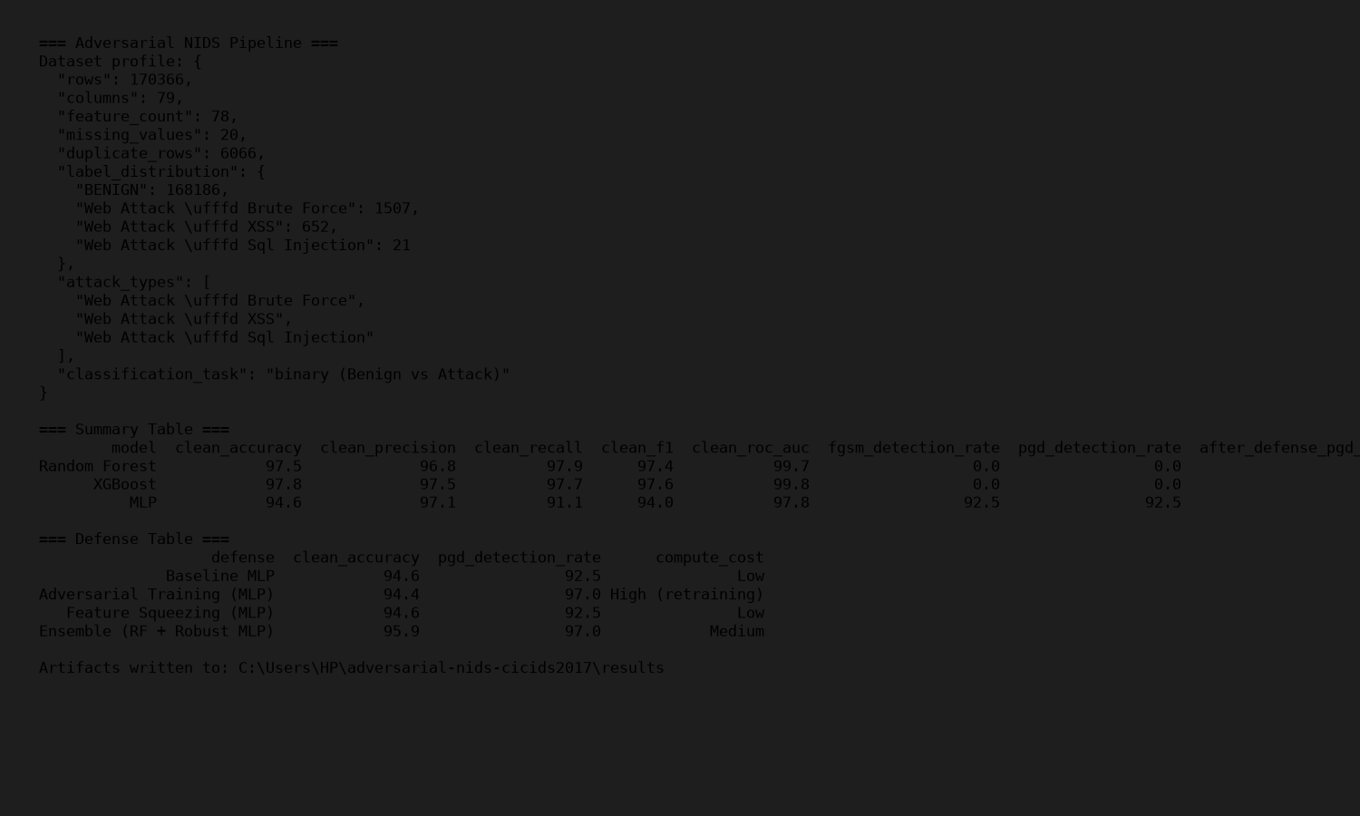
Appendix Figure: Pipeline terminal output.
Code snippet (attack call): pgd_adv = pgd_attack(mlp, attack_x, attack_y, epsilon=0.05)

Personal Reflection
I chose adversarial robustness in network intrusion detection because clean accuracy alone can create a false sense of security. During this project, I saw Random Forest reach 97.5% clean accuracy on CIC-IDS2017, then fall to 0.0% attack-detection rate under transferred PGD examples. That gap changed how I think about ML in cybersecurity: model training is only one step, and attacker-aware evaluation must be part of deployment.
At IIT Kanpur B.Cyber, I want to build operational security systems, not only offline models. My next steps are a FastAPI inference dashboard, API abuse detection around model endpoints, and a CTF-style challenge where participants craft traffic features to test detector robustness. I am especially interested in combining threat modeling (STRIDE), red-team style testing, and practical defenses for national digital infrastructure.

