

**HỌC VIỆN CÔNG NGHỆ BƯU CHÍNH VIỄN THÔNG**

**KHOA: CÔNG NGHỆ THÔNG TIN 1**

-----🙞🙜🕮🙞🙜-----

**BÁO CÁO BÀI TẬP LỚN**

**MÔN HỌC: CƠ SỞ DỮ LIỆU**

**Giảng viên:** Phan Thị Hà

**Nhóm: 1**

**Các thành viên:** Bùi Trung Dũng

Tạ Tương Việt Anh

Đỗ Quang Tuấn

Nguyễn Trường An

Đoàn Nguyễn Thanh Tùng

Nguyễn Đình Hiếu

**Hà Nội, 2023**

**Members**

|  |  |
| --- | --- |
| Bùi Trung Dũng  Tạ Tương Việt Anh  Đỗ Quang Tuấn  Nguyễn Trường An  Đoàn Nguyễn Thành Tùng  Nguyễn Đình Hiếu | B21DCVT139  B21DCCN159  B21DCVT443  B21DCVT051  B21DCAT216  B21DCDT093 |
|  |  |

**Table of contents**

**I. Real-world scenario** 3

**1. Database application** 3

**2. Data requirements to be stored** 3

**II. Entity-Relationship Diagram** 4

**III. Set of relational schemas** 5

**IV. Normalizing the relational schemas to 3NF (Third Normal Form).** 6

**V. System installation** 9

❖ **11 data tables** 9

❖ **Query statements** 16

**OVERVIEW REPORT**

**DEVELOPMENT OF AIRPORT SYSTEM DATABASE MANAGEMENT**

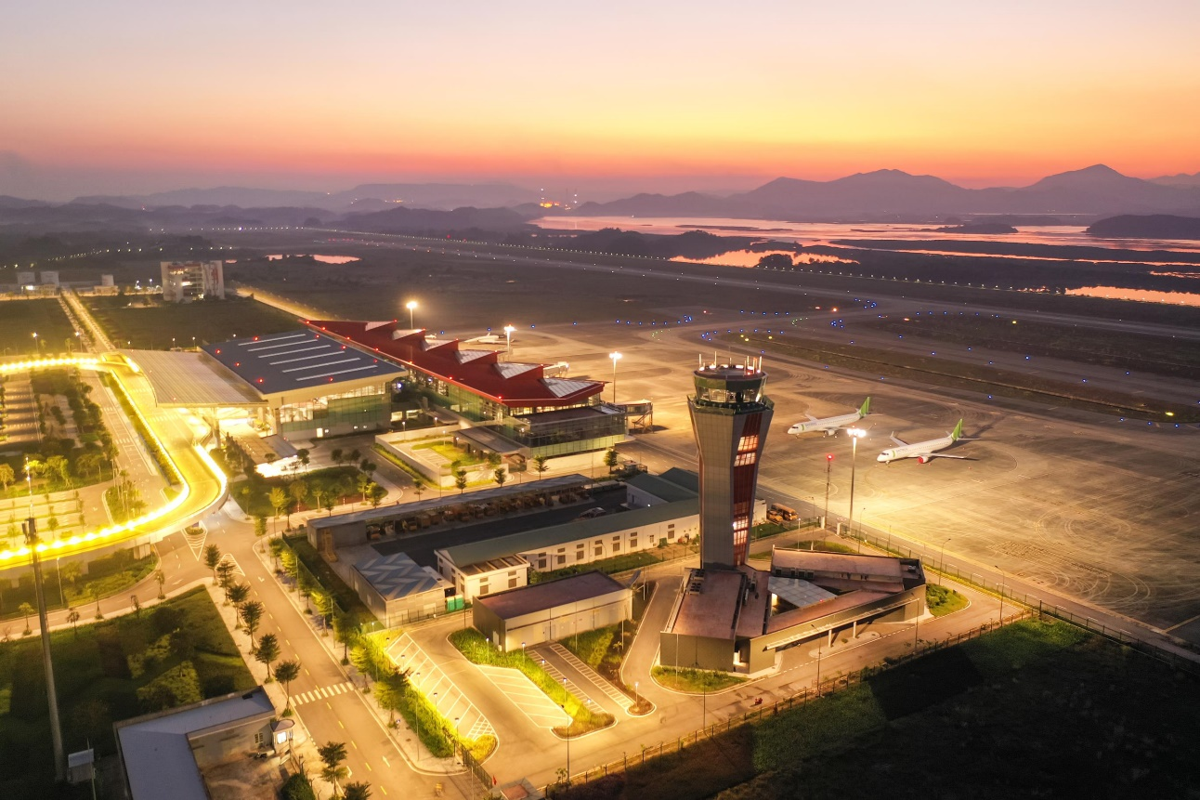

# **I. Real-world scenario**

## **1. Database application**

- Managing lists of departing/arriving flights.

- Managing lists of passengers.

- Managing lists of airport staff.

- Managing different ticket classes.

## **2. Data requirements to be stored**

- Data about employee information, including: full name, date of birth, employee ID, salary, gender, position: ground or pilot.

- Data about passenger information, including: full name, date of birth, employee ID, salary, gender.

- Data about tickets, ticket status: booked, canceled, destination, airline, ticket number, price, seat number, seat class, departure time, arrival time, flight duration.

- Data about flights, whether the flight requires a connection, departure time, arrival time, flight status, flight number, destination.

- Data about airports, city, airport name.

- Data about airlines, airline name.

# **II. Entity-Relationship Diagram**

The E-R diagram consists of 7 entity sets, including 1 weak entity set, 2 subtype entity sets, and 1 ternary relationships.

# **III. Set of relational schemas**

The E-R diagram including 7 entity sets and 3 multivalued attributes, which is transformed into 14 relational schemas:

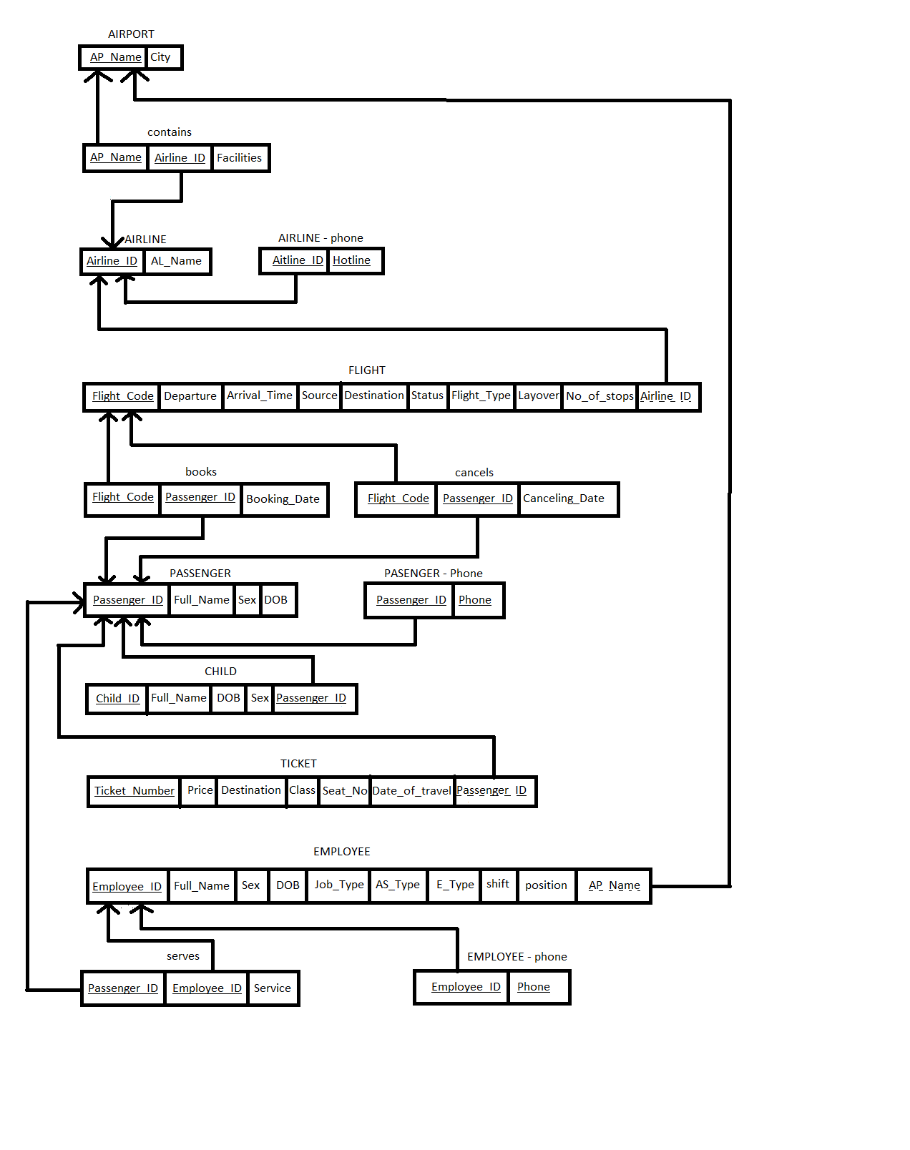

# **IV. Normalizing the relational schemas to 3NF (Third Normal Form).**

* Airport (AP_name, city)

F1 = {AP_name → city}

* Every attribute is atomic → The relation is in 1NF
* *AP_name* is a single-attribute key, *city* is fully functional dependent on the key → The relation is in 2NF
* *AP_name* is a super key → The relation is in 3NF
* Airline (Airline_ID, AL_Name)

F2 = {Airline_ID →AL_Name}

* Every attribute is atomic → The relation is in 1NF
* *Airline_ID* is a single-attribute key, *AL_Name* is fully functional dependent on the key → The relation is in 2NF
* *Airline_ID* is a super key → The relation is in 3NF
* Airline - Hotline (Airline_ID, Hotline)

F3 = {Hotline → Airline_ID}

* Every attribute is atomic → The relation is in 1NF
* Airline_ID is fully functional dependent on *Hotline* → The relation is in 2NF
* *Hotline* is a super key → The relation is in 3NF
* contains (AP_name, Airline_ID, facilities)

F4 = {AP_name, Airline_ID→ facilities}

* Every attribute is atomic → The relation is in 1NF
* *facilities* is fully functional dependant on *AP_Name* and *Airline_ID* → The relation is in 2NF
* *AP_Name* and *Airline_ID* are super keys → The relation is in 3NF
* Flight (Flight_Code, Departure_Time, Arrival_Time, Source, Destination, Status, Flight_Type, Layover_time, No_of_stops, Airline_ID)

F5 = {Flight_Code → Departure_Time, Arrival_Time, Source, Destination, Status, Flight_Type, Layover_time, No_of_stops, Airline_ID}

* Every attribute is atomic → The relation is in 1NF
* *Flight_Code* is a single-attribute key, all non-prime attributes are fully functional dependant on the key→ The relation is in 2NF
* *Flight_Code* is a super key → The relation is in 3NF
* Passenger (Passenger_ID, Full_Name, DOB, Sex)

F6 {Passenger_ID → Full_Name, DOB, Sex}

* Every attribute is atomic → The relation is in 1NF
* *Passenger_ID* is a single-attribute key, all non-prime attributes are fully functional dependant on the key → The relation is in 2NF
* *Passenger_ID* is a super key → The relation is in 3NF
* Passenger - Phone (Passenger_ID, Phone)

F7 = {Phone → Passenger_ID}

* Every attribute is atomic → The relation is in 1NF
* *Passenger_ID* is fully functional dependent on the *Phone* → The relation is in 2NF
* *Phone* is a super key → The relation is in 3NF
* Child (Child_ID, Passenger_ID, Full_Name, DOB, Sex)

F8 = {Child_ID, Passenger_ID → Full_Name, DOB, Sex}

* Every attribute is atomic → The relation is in 1NF
* All non-prime attributes are fully functional dependent on the keys → The relation is in 2NF
* *Child_ID, Passenger_ID* are super keys → The relation is in 3NF
* books (Passenger_ID, Flight_Code, Booking_Date)

F9 = {Passenger_ID, Flight_Code → Booking_Date}

* Every attribute is atomic → The relation is in 1NF
* All non-prime attributes are fully functional dependent on the keys → The relation is in 2NF
* *Passenger_ID, Flight_Code* are super keys → The relation is in 3NF
* cancels (Passenger_ID, Flight_Code, Canceling_Date)

F10 = {Passenger_ID, Flight_Code → Canceling_Date}

* Every attribute is atomic → The relation is in 1NF
* all non-prime attributes are fully functional dependent on the keys → The relation is in 2NF
* *Passenger_ID, Flight_Code* are super keys → The relation is in 3NF
* Ticket (Tiket_Number, Price, Destination, Class, Date_Of_Travel, Seat_No, Passenger_ID)

F11 = {Tiket_Number → Price, Destination, Class, Date_Of_Travel, Seat_No, Passenger_ID}

* Every attribute is atomic → The relation is in 1NF
* *Ticket_Number* is a single-attribute key, all non-prime attributes are fully functional dependent on the key → The relation is in 2NF
* *Ticket_Number* is a super key → The relation is in 3NF
* Employee (Employee_ID, Full_Name, DOB, Sex, Job_Type, AP_Name)

F12 = {Employee_ID → Full_Name, DOB, Sex, Job_Type, AP_Name}

* Every attribute is atomic → The relation is in 1NF
* *Employee_ID* is a single-attribute key, all non-prime attributes are fully functional dependent on the key→ The relation is in 2NF
* *Employee_ID* is a super key → The relation is in 3NF
* Employee - Phone (Employee_ID, Phone)

F13 = {Phone → Employee_ID}

* Every attribute is atomic → The relation is in 1NF
* *Employee_ID* is fully functional dependent on the *Phone* → The relation is in 2NF
* *Phone* is a super key → The relation is in 3NF
* serves (Passenger_ID, Employee_ID, service)

F14 = {Passenger_ID, Employee_ID → service}

* Every attribute is atomic → The relation is in 1NF
* *service* is fully functional dependant on *Passenger_ID* and *Employee_ID* → The relation is in 2NF
* *Passenger_ID* and *Employee_ID* are super keys → The relation is in 3NF

# **V. System installation**

From ? schemas in 3NF, we can build 20 data tables as follows:

* **11 data tables**

1. Airline name: information of operating airlines

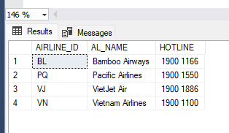

1. Airport name: information of airports in the country

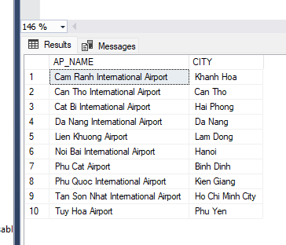

1. Books: Information of tickets booked by passengers

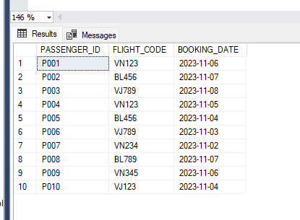

1. Cancels: Information of tickets cancelled by passengers

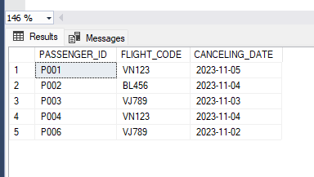

1. Child: Information of accompanying children

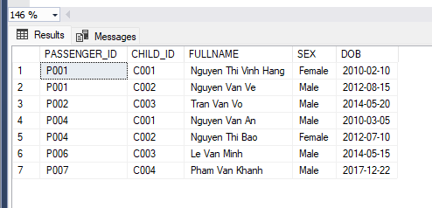

1. Contain: Information about facilities of airlines at each airport

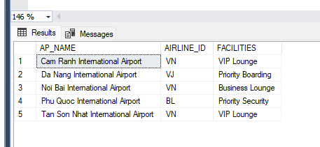

1. Employee: Information about employees working in all airports

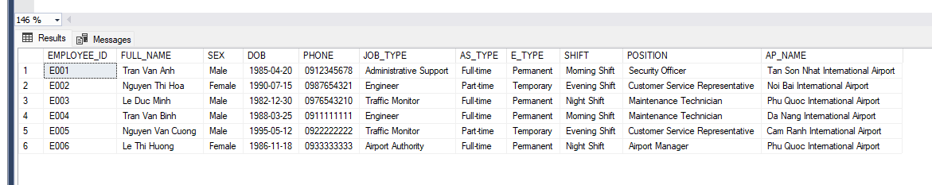

1. Flights: Information about all flights taking place during the specified timeframe

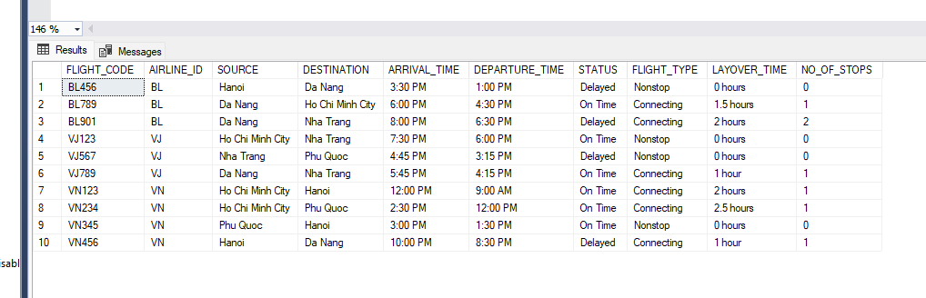

1. Passenger: Information about all passengers boarding flights during the specified timeframe

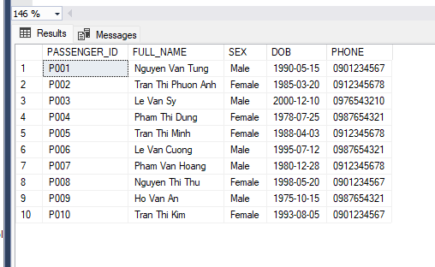

1. Serve: Information about roles and responsibilities of each employee

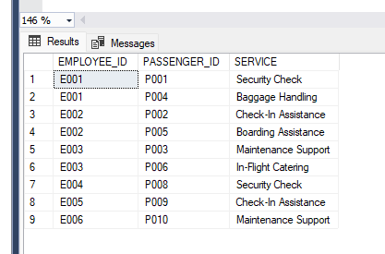

1. Ticket: Information about tickets of each flight taking place

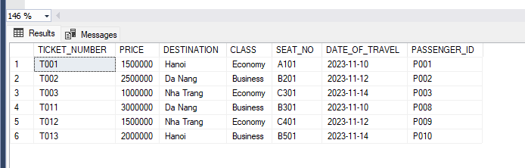

* **Query statements**

1. Find passengers (PASSENGER) who have booked tickets (BOOKS) for flight (FLIGHT) with "FLIGHT_CODE" as 'VN123' and display their names and phone numbers

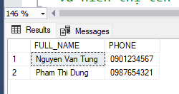

1. Calculates the total number of children (CHILD) traveling with each passenger (PASSENGER) and displays the passenger's name and the total number of children

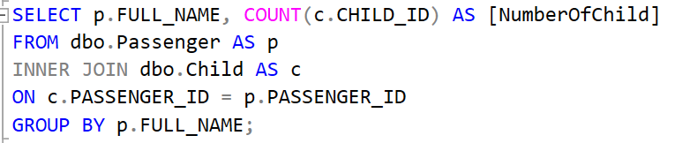

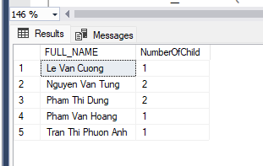

1. List all flights (FLIGHT) that the airline (AIRLINE) with hotline "1900 1100" completed (STATUS is 'On Time') and had at least one stopover (NO_OF_STOPS greater than 0).

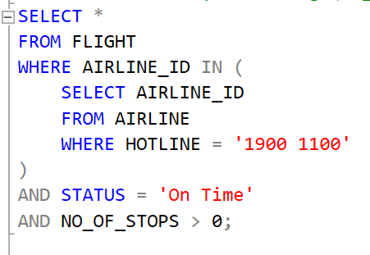



1. Calculate the total booking value (PRICE) for each passenger (PASSENGER) and display their name and total booking value.

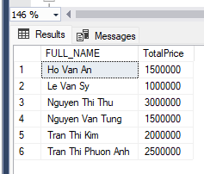

1. Find the name of the airline (AL_NAME) with the most flights in the FLIGHT table.

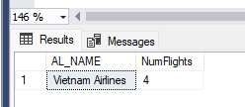

1. List all flights (FLIGHT) in ascending order of departure time for Vietnam Airline and displays information about departure airport and destination airport.

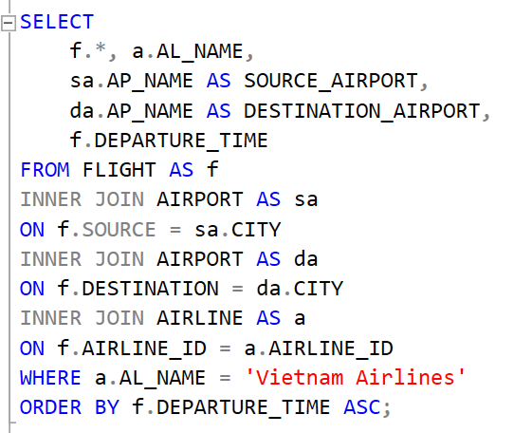



1. Find flights (FLIGHT) with a passenger count (from the BOOKS table) greater than the average number of passengers across all trips.

1. List all passengers (PASSENGER) who have booked tickets (BOOKS) for "Vietnam Airlines" flights that have had at least one cancellation (CANCELS).

