PROJECT REPORT OF CO-OP Project at Industry (Module-2)
ON
FROM MINDFUL LIVING TO ALGORITHMIC DEPENDENCE: Psychological Consequences of AI-Driven Health and Wellness Applications
submitted in partial fulfilment of the requirements for the award of degree of

BACHELOR OF ENGINEERING
In
COMPUTER SCIENCE AND ENGINEERING


Submitted by: Supervised By:
Shivi Dr. Rajat Takkar
2210992333
Hiya Kashyap
2210990415

DEPARTMENT OF COMPUTER SCIENCE AND ENGINEERING

CHITKARA UNIVERSITY INSTITUTE OF ENGINEERING AND TECHNOLOGY
CHITKARA UNIVERSITY, PUNJAB, INDIA

CONTENTS

S.No. | Title | Page No.
 | Acknowledgement | 4
 | List of Figures and Tables | 5
 | Abstract | 6
1 | Introduction | 7
2 | Methodology | 12
3 | Tools and Technologies | 16
4 | Implementation | 18
5 | Major Findings/Outcomes/Output/Results | 25
6 | Conclusion and Future Scope | 31
 | References | 34

DECLARATION

I hereby certify that the work which is being presented in the project report entitled “Mindful Living to Algorithmic Dependence: Psychological Consequences of AI-Driven Health and Wellness Applications” in partial fulfilment of requirement for the award of the degree of Bachelor of Engineering (Computer Science and Engineering) submitted in the department of Computer Science and Engineering at Chitkara University Institute of Engineering and Technology, Chitkara University, Punjab, India, is an authentic record of my own work carried out under the supervision of Dr. Rajat Takkar. The matter presented in this project report has not been submitted in any other university/institute for the award of any degree.

Place: Rajpura Hiya Kashyap - 2210990415
Date: 28th April, 2026 Shivi - 2210992333

This is to certify that the above statement made by the candidate is correct to the best of my knowledge and belief.

Dr. Rajat Takkar
Assistant Professor
Department of Computer Science and Engineering
Chitkara University Institute of Engineering and Technology,
Chitkara University, Punjab, India

ACKNOWLEDGEMENT

We would like to extend our sincere and heartfelt gratitude to all those who have directly or indirectly contributed to the successful completion of this project report titled "From Mindful Living to Algorithmic Dependence: Psychological Consequences of AI-Driven Health and Wellness Applications." This project would not have been possible without the constant guidance, support, and encouragement we received throughout the journey.
We owe our deepest gratitude to our esteemed mentor and guide, Dr. Rajat Takkar, Department of Computer Science and Engineering, Chitkara University, for his invaluable guidance, constructive criticism, and continuous motivation. His insightful suggestions, scholarly input, and unwavering support have been instrumental in shaping this research paper and giving it its final form.

We are profoundly thankful to Chitkara University, Patiala, for providing us with the academic environment, resources, and opportunity to undertake this research as part of our CO-OP (Cooperative Education) Module-2 program. The university's emphasis on industry-aligned research has enriched our academic experience and given us a deeper appreciation for the human dimensions of technology.
Our sincere thanks also go to the faculty members of the Department of Computer Science and Engineering for fostering a stimulating academic environment that encouraged interdisciplinary inquiry. The exposure we received to research methodology, academic writing, and analytical thinking proved invaluable during the preparation of this report.
We are deeply indebted to the researchers, scholars, and authors whose published works form the empirical backbone of this study. Their rigorous investigations into wearable technologies, AI chatbots, parasocial relationships, digital amnesia, and cognitive offloading have given us the foundation upon which our analysis is built.
Finally, we wish to express our heartfelt thanks to our families and friends whose unconditional love, patience, and moral support sustained us throughout this academic journey. Their belief in us has been our greatest source of strength.
LIST OF FIGURES AND TABLES

List of Figures
Figure No. | Title | Page No.
Figure 4.1 | Wearable Device Market Growth (2020 - 2028) | 14
Figure 4.2 | Digital Amnesia Research Publication Growth (4× Increase) | 16
Figure 5.1 | Clinical Harm and Negative Effects Prevalence | 21
Figure 5.2 | Learning Retention: Handwriting vs Typing | 24

List of Tables
Table No. | Title | Page No.
Table 1.1 | AI Adoption Rates (2025) | 3
Table 4.1 | Healthy vs. Harmful Tracking Behaviour | 15
Table 4.2 | AI Companionship and Support Statistics (2025-2026) | 16
Table 4.3 | Human vs. AI Emotional Support | 16
Table 4.4 | Cognitive Losses Attributed to Technology | 17
Table 5.1 | Thresholds of Harm in Self-Tracking | 20
Table 5.2 | Empathy Development Requirements | 22
Table 5.3 | Digital Amnesia Statistics | 23
Table 5.4 | Vulnerable Populations and Risk Factors | 25

ABSTRACT

The transition from a tool that supports human capability to one that humans depend upon often goes unnoticed. Nowhere is this transition more visible than in the domain of artificial-intelligence-driven health and wellness applications, where wearable trackers, calorie-counting apps, sleep monitors, and conversational chatbots have woven themselves into the fabric of daily life. While these technologies were originally designed to support mindful living and improve health outcomes, an increasing body of evidence indicates that excessive reliance on them produces measurable psychological, emotional, and cognitive costs.

This research project, undertakes a systematic literature review of fifteen empirical studies published between 2020 and 2025, with a combined sample size exceeding 80,000 participants. The review investigates three interconnected questions: where the boundary lies between healthy self-monitoring and pathological self-tracking; how artificial-intelligence companions affect the development of empathy, non-verbal intelligence, and conflict resolution; and which cognitive skills users surrender to algorithms over time.

The findings reveal that nearly seventy-five per cent of individuals diagnosed with eating disorders use calorie-tracking applications, of whom seventy-three per cent report that the application worsens their condition. Approximately two per cent of fitness-tracker users develop orthosomnia, a clinical anxiety induced by sleep tracking. Ninety-one per cent of smartphone users treat the internet as a "second brain," while seventy-one per cent of adults can no longer recall the phone numbers of their own children. Studies of more than 5,600 chatbot users across six European nations demonstrate that prolonged emotional dependence on AI companions paradoxically increases loneliness rather than alleviating it.

Keywords: Algorithmic Dependence, Self-Tracking Pathology, AI Emotional Support, Cognitive Offloading, Interoceptive Awareness, Digital Amnesia, Orthosomnia, Parasocial Relationships, Mindful Living.
CHAPTER 1: INTRODUCTION

1.1 Background

The twenty-first century has witnessed an unprecedented integration of artificial intelligence into the most personal corners of human life. Technologies that once existed in the periphery of human activity, such as fitness trackers and smartphone applications, have moved to the centre of daily routines. A typical morning in 2026 begins not with a stretch or a glance out of the window, but with the soft buzz of a wearable device announcing that the user's sleep cycle has ended. Before shoes are tied or breakfast is prepared, the smartwatch has already issued instructions concerning step targets, hydration goals, calorie budgets, and stress scores.

This shift represents far more than a change in lifestyle: it represents a redefinition of how human beings perceive their own bodies, regulate their own emotions, and exercise their own cognition. What was once a tool for health support has, for many users, become a source of psychological dependence. The very devices that promise wellbeing now generate anxiety; the very applications that promise connection now produce isolation; the very algorithms that promise to extend cognition now appear to atrophy it.

The phenomenon under investigation in this report sits at the intersection of computer science, behavioral psychology, neuroscience, and public-health policy. It demands an interdisciplinary approach that examines not only the technical architecture of artificial-intelligence systems, but also the human consequences of using them habitually.

1.2 Problem Statement

Millions of users today determine when to wake, when to sleep, what to eat, where to walk, and even what to feel based on the readouts of their devices. Sleep is no longer judged by how rested the body feels, but by a numerical sleep score. Hunger is no longer felt internally, but read from a calorie-tracking dashboard. Routes to familiar destinations are no longer remembered, but consulted from a navigation application. Emotional distress, once shared with friends or family, is increasingly disclosed to chatbots.

None of these substitutions is, in itself, harmful. Difficulties arise when the tool ceases to serve the user and the user begins to serve the tool. The boundary between supportive technology and dependence-inducing technology is poorly defined, both in academic literature and in public discourse. This research report seeks to characterise that boundary and to identify the psychological consequences of crossing it.

1.3 Scale of the Issue

The scale of dependence on artificial intelligence in 2025 is striking. Wearable health-tracking devices are used by approximately 35.8 per cent of the adult population, and the global wearable market is projected to reach 114 billion United States dollars by 2028, up from 36.34 billion in 2020. Adoption is highest among teenagers and young adults: approximately 72 per cent of individuals aged 13 to 17 use AI chatbots for emotional support. Among adults, 28 per cent report having used AI in the context of romantic or intimate relationships. Within the population of individuals already living with mental-health conditions, 48.7 per cent use mental-health-focused AI tools, and 91 per cent of internet users now describe their phone or the internet as a substitute brain.

Table 1.1 summarises adoption statistics across the most prominent categories of AI-driven health and wellness technologies in 2025.

Table 1.1: AI Adoption Rates (2025)
Technology / Users | Adoption Rate | Key Finding
Wearable devices | 35.8 % of population | Market projected at $114 B by 2028
AI chatbots (teens 13–17) | 72 % | Used for emotional support
AI relationships (adults) | 28 % | Romantic / intimate interactions
Mental-health AI | 48.7 % | Among those with mental-health conditions
Digital amnesia (smartphone-as-brain) | 91 % | Use internet as substitute memory

1.4 The Hidden Cost

The most striking aspect of algorithmic dependence is that its costs are largely hidden from the user. Few people who download a calorie-tracking application anticipate that they may develop or worsen an eating disorder. Few who buy a fitness tracker anticipate that they may experience clinical sleep anxiety. Few teenagers who turn to a chatbot for emotional support anticipate that they may emerge from the conversation feeling lonelier than before. And yet the empirical record demonstrates that all of these outcomes are common.

Approximately two per cent of fitness-tracker users develop orthosomnia, a recognised clinical condition involving anxiety induced by sleep-tracking technology. Around seventy-five per cent of individuals diagnosed with eating disorders use the calorie-tracker MyFitnessPal, and seventy-three per cent of those users report that the application makes their condition worse. Forty-four per cent of users describe their smartphone as their personal memory bank. In a particularly tragic case widely reported in 2024, a teenager committed suicide after extended interactions with a conversational AI to which he had disclosed thoughts of self-harm.

These outcomes are not anomalies; they are systematic patterns. They indicate a structural mismatch between the design intentions of AI-driven wellness technologies and the psychological mechanisms that govern human use of them.

1.5 Research Questions

This research report is organised around three core questions:
- Where does the boundary lie between constructive health management and destructive psychological dependence in self-tracking behaviour?
- How does the use of artificial-intelligence companions affect the human capacity for empathy, non-verbal intelligence, conflict resolution, and the formation of genuine social relationships?
- What cognitive abilities, including memory, attention, spatial cognition, and interoceptive awareness, are being progressively transferred from human cognition to algorithmic systems?

1.6 Objectives of the Study

The study pursues four primary objectives that together address the research questions above:
- To compile a comprehensive evidence base on the psychological consequences of AI-driven health and wellness applications, drawing on peer-reviewed empirical literature published between 2020 and 2025.
- To develop diagnostic criteria that distinguish helpful self-tracking behaviour from pathological self-tracking behaviour.
- To assess the impact of human-machine emotional interaction on the development and maintenance of empathy, non-verbal communication, and conflict-resolution skills.
- To identify cognitive skills that are being outsourced to algorithmic systems and to evaluate the long-term implications of that outsourcing, particularly for children whose neural architectures are still developing.

1.7 Significance and Scope

This study is significant for three reasons. First, it provides one of the few interdisciplinary syntheses that examines wearable technologies, AI chatbots, and smartphone-based cognitive offloading as a single, integrated phenomenon rather than as three separate research silos. Second, it grounds its findings in empirical data drawn from over 80,000 participants, lending the analysis a degree of statistical robustness that single-study analyses cannot provide. Third, the study formulates concrete, actionable recommendations directed not only at individual users but also at application designers and policymakers.

The scope of the study is deliberately bounded. It focuses on the psychological, emotional, and cognitive consequences of AI-driven health and wellness applications. It does not, except in passing, examine economic effects, employment effects, or industry-level competitive dynamics. It also concentrates on consumer-facing technologies rather than enterprise or clinical-decision-support systems.

CHAPTER 2: METHODOLOGY

2.1 Research Approach

The research approach adopted in this study is a systematic literature review supported by thematic analysis. A systematic literature review is appropriate here because the research questions are descriptive and integrative in nature: they require the collation and synthesis of findings reported across many independent studies. Conducting fresh primary empirical research on populations of comparable size would be infeasible within the time and resource constraints of an undergraduate CO-OP project.

The review is supplemented by thematic analysis, in which the literature is organised around three substantive themes: wearables and mental health; AI chatbots, social support, and parasocial relationships; and cognitive offloading and digital amnesia. These themes were derived inductively from a preliminary scan of the literature and are presented in detail in Chapter 4.

2.2 Data Sources and Search Strategy

Database searches were conducted across PubMed, Web of Science, IEEE Xplore, ACM Digital Library, ScienceDirect, JMIR, Google Scholar, arXiv, and the preprint repositories Preprints.org and bioRxiv. Searches targeted four thematic areas: (1) health-tracking devices and psychology; (2) AI chatbots and human relationships; (3) digital amnesia and memory; and (4) eating disorders and tracking applications. Search terms included "wearable health tracker," "orthosomnia," "AI companion," "parasocial relationship AI," "digital amnesia," "cognitive offloading," "calorie counting eating disorder," "smartphone memory," and corresponding Boolean combinations.

The temporal range was restricted to publications from January 2020 to October 2025 in order to capture the post-pandemic surge in digital wellness adoption. After deduplication and screening, fifteen empirical studies were retained for full-text analysis. Their combined sample size exceeded 80,000 participants drawn from North America, Europe, and parts of Asia.

2.3 Inclusion and Exclusion Criteria

Studies were included if they satisfied all of the following criteria: they reported empirical data based on human subjects; they directly addressed at least one of the three research questions; they were published in reputable peer-reviewed journals or in established preprint repositories; and they reported sufficient methodological detail to allow critical appraisal of their findings. Studies were excluded if they were purely theoretical or speculative; if they focused exclusively on technical performance benchmarks without psychological outcomes; or if they relied solely on industry-funded promotional surveys without independent verification.

2.4 Theoretical Framework

Four complementary theoretical lenses were applied to interpret the findings. Each lens illuminates a different aspect of the relationship between users and AI-driven wellness technologies.

2.4.1 Self-Determination Theory

Self-Determination Theory, formulated by Deci and Ryan, posits that human flourishing depends on the satisfaction of three basic psychological needs: autonomy, the need to feel in charge of one's own life; competence, the need to feel capable; and relatedness, the need to feel connected to others. AI-driven wellness applications systematically affect all three. Algorithms that recommend dietary, exercise, or sleep behaviour can erode autonomy. Tools that perform cognitive functions on the user's behalf can erode the development of competence. AI companions that simulate friendship can substitute for, rather than complement, genuine human relatedness.

2.4.2 Enhancement versus Replacement

A second framework distinguishes between two modes of technology use. In enhancement mode, a tool amplifies the user's existing capabilities without diminishing them: the calculator user who already understands arithmetic, or the spell-checker user who already knows the language. In replacement mode, the tool gradually substitutes for the user's capability, which subsequently atrophies through disuse. The classic example is the GPS navigation user who, after years of reliance, can no longer find familiar destinations without device assistance. The distinction matters because it predicts long-term outcomes: enhancement-mode use produces more capable users, whereas replacement-mode use produces more dependent users.

2.4.3 Brain Plasticity: Use It or Lose It

Neuroscientific research has established that brain regions adapt structurally and functionally in response to use patterns. London taxi drivers, who memorise extensive street networks, exhibit enlarged posterior hippocampi. Conversely, habitual GPS users show reduced hippocampal grey-matter density and weaker spatial memory. This neural plasticity underpins the central concern of the present study: cognitive abilities that are not exercised are not merely under-developed at a given moment, but may be permanently reduced, particularly in children whose neural architectures are still forming.

2.4.4 Motivation Theory

The distinction between intrinsic and extrinsic motivation provides a fourth interpretive lens. Mindful living traditionally depends on intrinsic motivation, that is, behaviour pursued for its own sake. Wellness applications, however, often substitute extrinsic motivators such as streaks, badges, points, and notifications. Empirical work in motivation psychology demonstrates that when extrinsic incentives are introduced into intrinsically motivated activity, they can crowd out the original motivation, leaving the user dependent on the external incentive structure for behavioural maintenance.

2.5 Analytical Process

The analytical process proceeded in five stages. First, full-text articles were read and coded against the three research questions. Second, statistics, effect sizes, and qualitative findings were extracted into a structured matrix. Third, findings were grouped thematically. Fourth, points of convergence and divergence among studies were identified, with attention to methodological factors that might explain disagreement. Fifth, gaps in the existing literature were articulated to motivate Chapter 6's recommendations for future research.

CHAPTER 3: TOOLS AND TECHNOLOGIES
This chapter describes both the technological resources used to conduct the research and the technologies that constitute the object of study.

3.1 Visualization Tools

Charts presented later in this report (Figures 4.1, 4.2, 5.1, and 5.2) were prepared in Python using the Matplotlib and Seaborn libraries, with stylistic post-processing performed in standard graphics editors. Tables were prepared in Microsoft Word and validated for cross-referencing with the underlying source data.

3.2 Documented Technologies under Study

The following categories of consumer technologies form the empirical object of the present study:

3.2.1 Wearable Health and Fitness Trackers

Wearable devices include wrist-worn fitness bands, smartwatches, smart rings, and sleep-tracking mats. Modern devices integrate accelerometers, photoplethysmographic heart-rate sensors, electrodermal-activity sensors, oximetric sensors, and increasingly, electrocardiographic and continuous-glucose sensors. The proprietary algorithms that translate raw sensor data into sleep scores, recovery scores, and stress scores form the immediate point of contact between the user and the wider artificial-intelligence stack.

3.2.2 Calorie-Tracking and Nutrition Applications

Applications such as MyFitnessPal, Noom, Lose It!, and Cronometer transform the user's food intake into numerical values: calories, macronutrients, and micronutrients. These applications use barcode scanners, image recognition, and large food databases to reduce the friction of logging. Their statistical models predict caloric trajectories, weight outcomes, and adherence patterns.

3.2.3 Sleep-Monitoring Applications

Sleep monitors range from sub-features within general fitness trackers to dedicated devices such as Oura, Whoop, and the Apple Watch sleep stages. They infer sleep stages from movement, heart-rate variability, respiratory rate, and skin temperature, and present users with a single composite "sleep score" each morning.

3.2.4 AI Chatbots and Companions

This category includes general-purpose conversational AI such as ChatGPT, dedicated emotional-support chatbots such as Woebot and Wysa, and AI companion applications such as Replika and Character.ai. Underlying technologies include transformer-based large language models, retrieval-augmented generation, reinforcement learning from human feedback, and persona-conditioning techniques.

3.2.5 Navigation and Mapping Applications

GPS-based navigation applications, including Google Maps, Apple Maps, and Waze, provide turn-by-turn directions even for routes the user has traversed many times. They are notable not because they are inherently harmful, but because their habitual use has been linked in neuroimaging research to measurable changes in hippocampal grey-matter volume.

CHAPTER 4: IMPLEMENTATION
This chapter implements the research methodology by reviewing the empirical evidence on each of the technologies described in Chapter 3. Each section begins with the conceptual framing, then presents the relevant empirical findings, and finally identifies the points of tension that the chapter on findings (Chapter 5) will resolve.

4.1 The Concept of Mindful Living

Mindful living can be defined as a way of life characterized by self-awareness, deliberate decision-making, and emotional stability. Mindfulness practices give individuals the opportunity to observe their thoughts and behaviors without bias and to bring intentionality to actions that would otherwise be performed on autopilot. Substantial empirical evidence has accumulated to indicate that mindful living reduces stress, enhances concentration, and supports psychological wellbeing.

Crucially, mindfulness is traditionally understood to be intrinsically motivated. Healthful habits develop through internal motivation and self-discipline, sustained over time without dependence on external prompts. Self-motivation has been associated with durable behavioural change and stable psychological wellbeing. The questions raised by AI-driven wellness applications are therefore framed by a baseline expectation of internal regulation, against which externalised regulation must be evaluated.

4.2 Health Tracking: From Tool to Tyrant

Wearable health and fitness technologies have undergone explosive growth in recent years. The wearable technology market was valued at approximately 36.34 billion United States dollars in 2020 and is projected to reach 114.36 billion United States dollars by 2028. Figure 4.1 illustrates this trajectory.

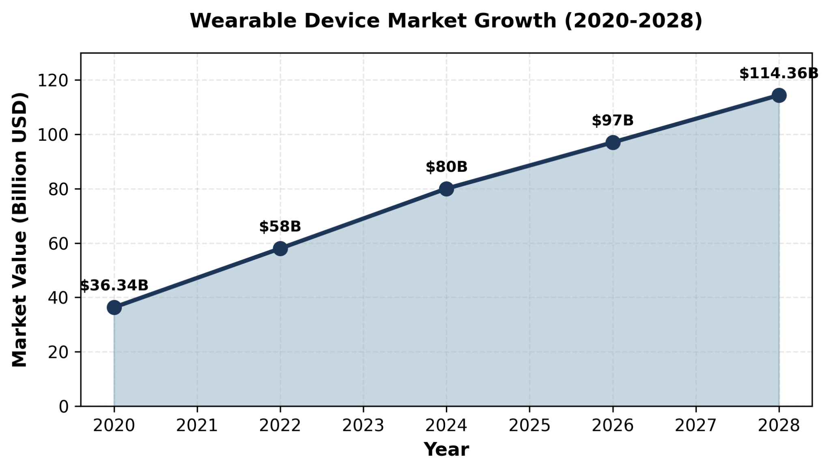

Figure 4.1: Wearable Device Market Growth (2020 - 2028)

These devices have unquestionable benefits. They give users access to objective data on their own physiology, support behaviour change in conditions such as hypertension and diabetes, and extend health-relevant feedback to people who would otherwise lack access to traditional clinical services.

However, the same data streams that empower informed users can disempower vulnerable users. A widely cited case study published in the Journal of Clinical Sleep Medicine described a 27-year-old woman who insisted that the results of a clinical sleep study were incorrect because her Fitbit had registered poor sleep on the same nights. This case introduced the concept of orthosomnia, that is, clinical sleep anxiety induced by sleep-tracking technology. Approximately two per cent of Fitbit users are estimated to develop the condition. Table 4.1 summarises the behavioural and emotional markers that distinguish healthy tracking from harmful tracking.

Table 4.1: Healthy vs. Harmful Tracking Behaviour
Healthy Use | Harmful Use
Check occasionally | Check 10+ times daily
Data informs decisions | Data controls all choices
Can function without device | Panic if device unavailable
Trust body and data together | Trust only the data
Improves overall wellbeing | Causes anxiety and guilt

4.3 AI Companions and the Loneliness Paradox

The rise of AI companions has been one of the most consequential developments in consumer technology over the past three years. Approximately one-third of the population now reports a preference for AI-mediated therapy over conventional psychotherapy, and 24 per cent of Americans report that they would consider using an AI therapist. Among college students, 42 per cent see AI as a companion, compared to only 11 per cent of non-college young people. With respect to romantic relationships, 16 per cent of single adults report having interacted with an AI companion, a proportion that rises to 33 per cent among single members of Generation Z.

Table 4.2: AI Companionship and Support Statistics (2025-2026)
AI Role | Usage Percentage
Therapist | 25 % – 32 %
Friend | 11 % – 42 %
Romantic partner | 16 % – 33 %

The structural limits of AI as a substitute for human relationship are documented in Table 4.3. The table juxtaposes capacities that human interlocutors provide naturally with capacities that current AI systems cannot provide at all.

Table 4.3: Human vs. AI Emotional Support
Humans Provide | AI Cannot Provide
Real empathy | Programmed responses
Facial expressions | Text-based only
Genuine disagreement | Always agrees
Reciprocal vulnerability | No genuine self
Unpredictable growth | Predetermined patterns
Accountability | No consequences

A study of approximately 5,663 chatbot users across six European countries found that, contrary to the marketing claims of many AI-companion products, prolonged users reported greater loneliness after using the application than before. Researchers have characterised this paradox as "curing loneliness through isolation." An additional study of mental-health AI tools found that 9 per cent of users reported actively negative responses from the tool, including responses that worsened their distress. In one tragic case widely reported in 2024 to 2025, a 16-year-old boy died by suicide after extended interactions with ChatGPT in which he had disclosed thoughts of self-harm.

4.4 Digital Amnesia and Cognitive Offloading

The third domain reviewed here concerns the externalisation of memory and cognition. A Kaspersky Lab survey of internet users found that 91 per cent treat the internet as a "second brain," 47 per cent prefer to consult their smartphone before making any cognitive effort, 44 per cent describe their smartphone as a substitute for their own memory, and 71 per cent cannot recall the phone numbers of their own children. Academic interest in digital amnesia has grown rapidly in parallel with the phenomenon: the number of indexed publications on the topic increased from 195 in 2019 to 837 in 2023, a fourfold rise in four years (Figure 4.2)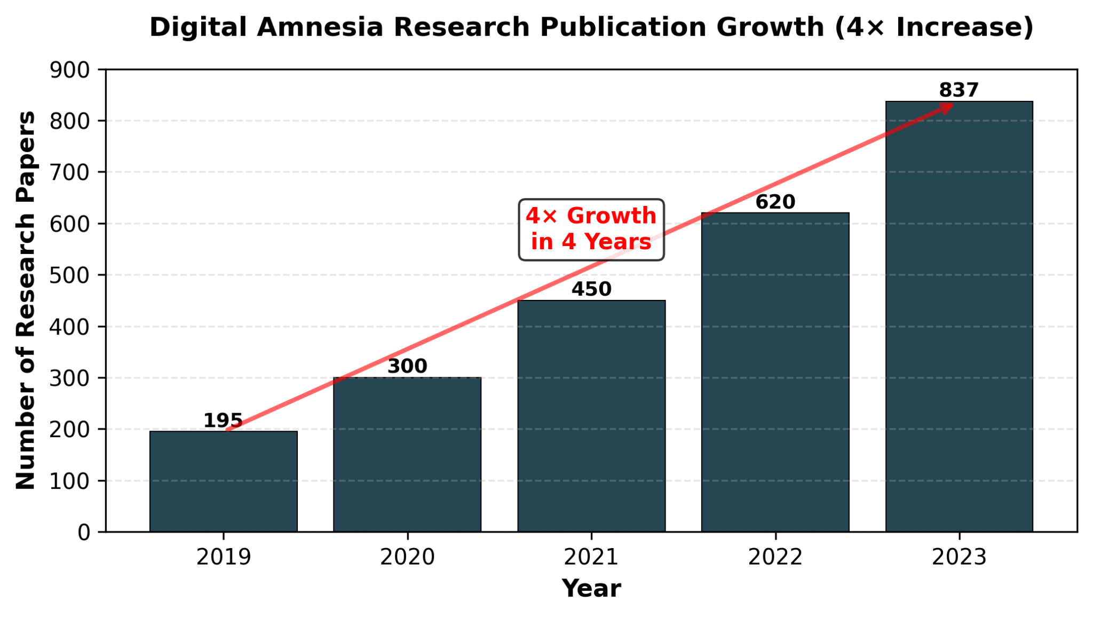

Figure 4.2: Digital Amnesia Research Publication Growth (4× Increase)

Neuroimaging studies have identified structural brain correlates of these behavioural changes. Habitual GPS users show reductions in hippocampal grey matter, a region central to spatial and episodic memory. London taxi drivers, who must memorise an enormous mental map of the city as part of professional certification, show enlarged hippocampi. Handwritten note-taking has been associated with retention rates approximately 34 per cent higher than those associated with typing the same content, suggesting that the motor-cognitive coupling involved in handwriting supports deeper encoding.

Table 4.4: Cognitive Losses Attributed to Technology
Function | Loss Documented | Evidence
Phone numbers | Cannot recall family numbers | 71 % affected (Kaspersky)
Navigation | Cannot find way home unaided | Hippocampal shrinkage in GPS users
Learning | Shallow processing | Typing vs handwriting studies
Calculation | Loss of mental arithmetic | Calculator dependency
Attention | Cannot focus deeply | Smartphone-presence studies

4.5 Eating Disorders and Body Tracking

A particularly serious concern in the literature is the association between body-tracking applications and clinical eating disorders. Approximately 75 per cent of individuals with diagnosed eating disorders use the calorie-counter MyFitnessPal, and 73 per cent of those users report that the application worsens their condition. More broadly, around 71 per cent of adults use some form of calorie-tracking application. Such applications can train users to ignore the body's natural hunger and satiety signals in favour of numerical inputs, a process that erodes interoceptive awareness, that is, the ability to perceive internal bodily states.

Crucially, individuals who notice signals from their bodies but choose to dismiss them are at higher risk of developing an eating disorder than individuals who simply ignore such sensations. In other words, actively distrusting one's own body is more damaging than failing to notice it. The implication is that calorie-tracking applications, which encourage users to override bodily signals in favour of algorithmic recommendations, may be particularly harmful for users with pre-existing vulnerability.

4.6 Identification of Research Gap

Across the three thematic domains reviewed in this chapter, three classes of research gap emerge.

4.6.1 Wearables and Mental Wellbeing

Findings on the mental-wellbeing effects of wearable devices are mixed. Some studies emphasise increased self-awareness and motivation; others document increased anxiety and burnout. Two limitations recur. First, samples are dominated by white adults from high-income countries, leaving cross-cultural variation under-investigated. Second, study durations are typically short, leaving long-term trajectories undocumented. The identified gap is therefore the absence of long-term, cross-cultural research on wearables and mental health.

4.6.2 AI Chatbots and Parasocial Relationships

Research on AI chatbots presents a similarly mixed picture. While these systems can deliver emotional support and reduce short-term loneliness, prolonged reliance correlates with weakened human social skills and the formation of parasocial bonds with the AI itself. The methodological gap is the small sample sizes characteristic of this literature, the over-representation of student participants, and the case-study (rather than systematic) nature of the most striking findings, including the link between AI companionship and severe psychological harm.

4.6.3 Cognitive Offloading and Digital Amnesia

Research on cognitive offloading consistently shows a direct relationship between digital-tool use and reduced memory retention. Most studies, however, are short-term laboratory experiments or focus narrowly on student samples. The identified gap is the absence of long-term, real-world studies on how continuous cognitive offloading shapes memory, attention, and learning across the lifespan.

4.6.4 The Overarching Gap

Taken together, the three domains share a deeper structural problem. Wearables affect behaviour; AI chatbots affect emotion; smartphones affect cognition. Yet the academic literature treats these technologies in isolation, even though human users encounter them simultaneously throughout the day. The same person who tracks sleep with a wearable also seeks emotional support from a chatbot and offloads memory to a phone. There is currently no interdisciplinary framework capable of investigating the combined psychological, emotional, and cognitive effects of this triad of technologies.

CHAPTER 5: MAJOR FINDINGS, OUTCOMES, AND RESULTS
This chapter presents the principal findings of the study, organised around the three research questions stated in Chapter 1.

5.1 When Tracking Becomes Harmful

Self-tracking transitions from beneficial to harmful when one or more of the following warning signs appear. Table 5.1 sets out a diagnostic checklist.

Table 5.1: Thresholds of Harm in Self-Tracking
Warning Sign | What It Looks Like
Checking frequency | Ten or more times per day
Emotional response | Panic or guilt over numbers
Body disconnect | Cannot sense hunger without app
Device dependence | Cannot function if device fails
Health impact | Tracking causes more stress than it relieves

Quantitative thresholds reinforce this checklist. Orthosomnia affects approximately 2 per cent of fitness-tracker users. Among individuals with diagnosed eating disorders, 75 per cent use a calorie-tracking application, and 73 per cent of those users report that the application worsens their condition. Tracking has crossed into harm whenever one or more of the following four conditions hold: (i) the data produces more harm than benefit on net; (ii) the user requires the device in order to perceive their own bodily state; (iii) the user cannot function without the device; or (iv) a clinical condition such as orthosomnia or eating-disorder relapse has developed.

Figure 5.1 visualises the prevalence of clinical harm and negative effects across the categories considered in this study.

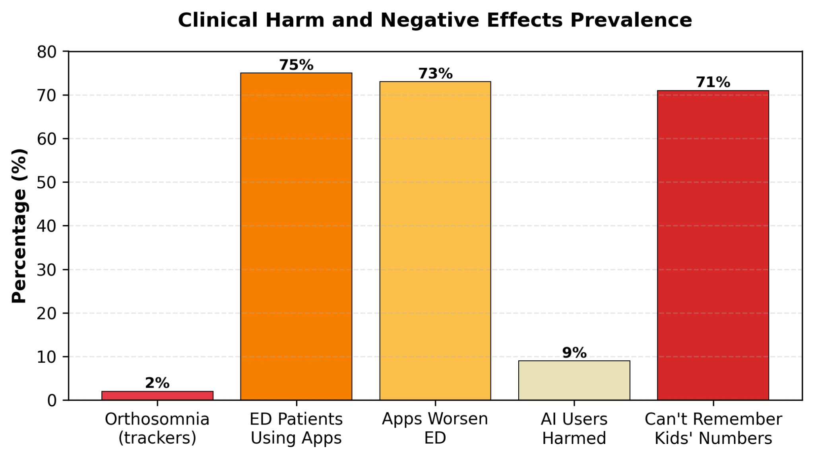

Figure 5.1: Clinical Harm and Negative Effects Prevalence

5.2 How AI Affects Human Relationships

AI companionship, by its structural nature, eliminates the experiences from which human social skills are built. Table 5.2 summarises the requirements of empathy development against what AI can actually provide.

Table 5.2: Empathy Development Requirements
Skill Needed | Requires | AI Provides?
Reading emotions | Facial expressions, tone of voice | No - text-only interaction
Handling conflict | Real disagreement | No - AI agrees by default
Reciprocal care | Both parties vulnerable | No - the relationship is one-way
Non-verbal communication | Body language | No - the AI has no body

In the study of 5,663 individuals across six countries cited earlier, chatbot users reported greater loneliness after sustained use than before, rather than less. Among university students specifically, depression appears to drive higher AI use, but higher AI use does not in turn reduce depressive symptoms. The paradox is striking: AI companions can make users feel less lonely in the moment, but they do not resolve the underlying loneliness, and they may reduce the user's motivation to seek the human interactions that would resolve it.

5.3 Cognitive Skills Lost to Algorithms

Table 5.3 summarises the principal statistics on cognitive offloading and digital amnesia.

Table 5.3: Digital Amnesia Statistics
Measure | Percentage | Source
Use internet as second brain | 91 % | Kaspersky Lab
Phone IS my memory | 44 % | Kaspersky Lab
Cannot remember children's phone numbers | 71 % | Kaspersky Lab
Research-publication growth (4 years) | 4× (195 → 837) | Web of Science

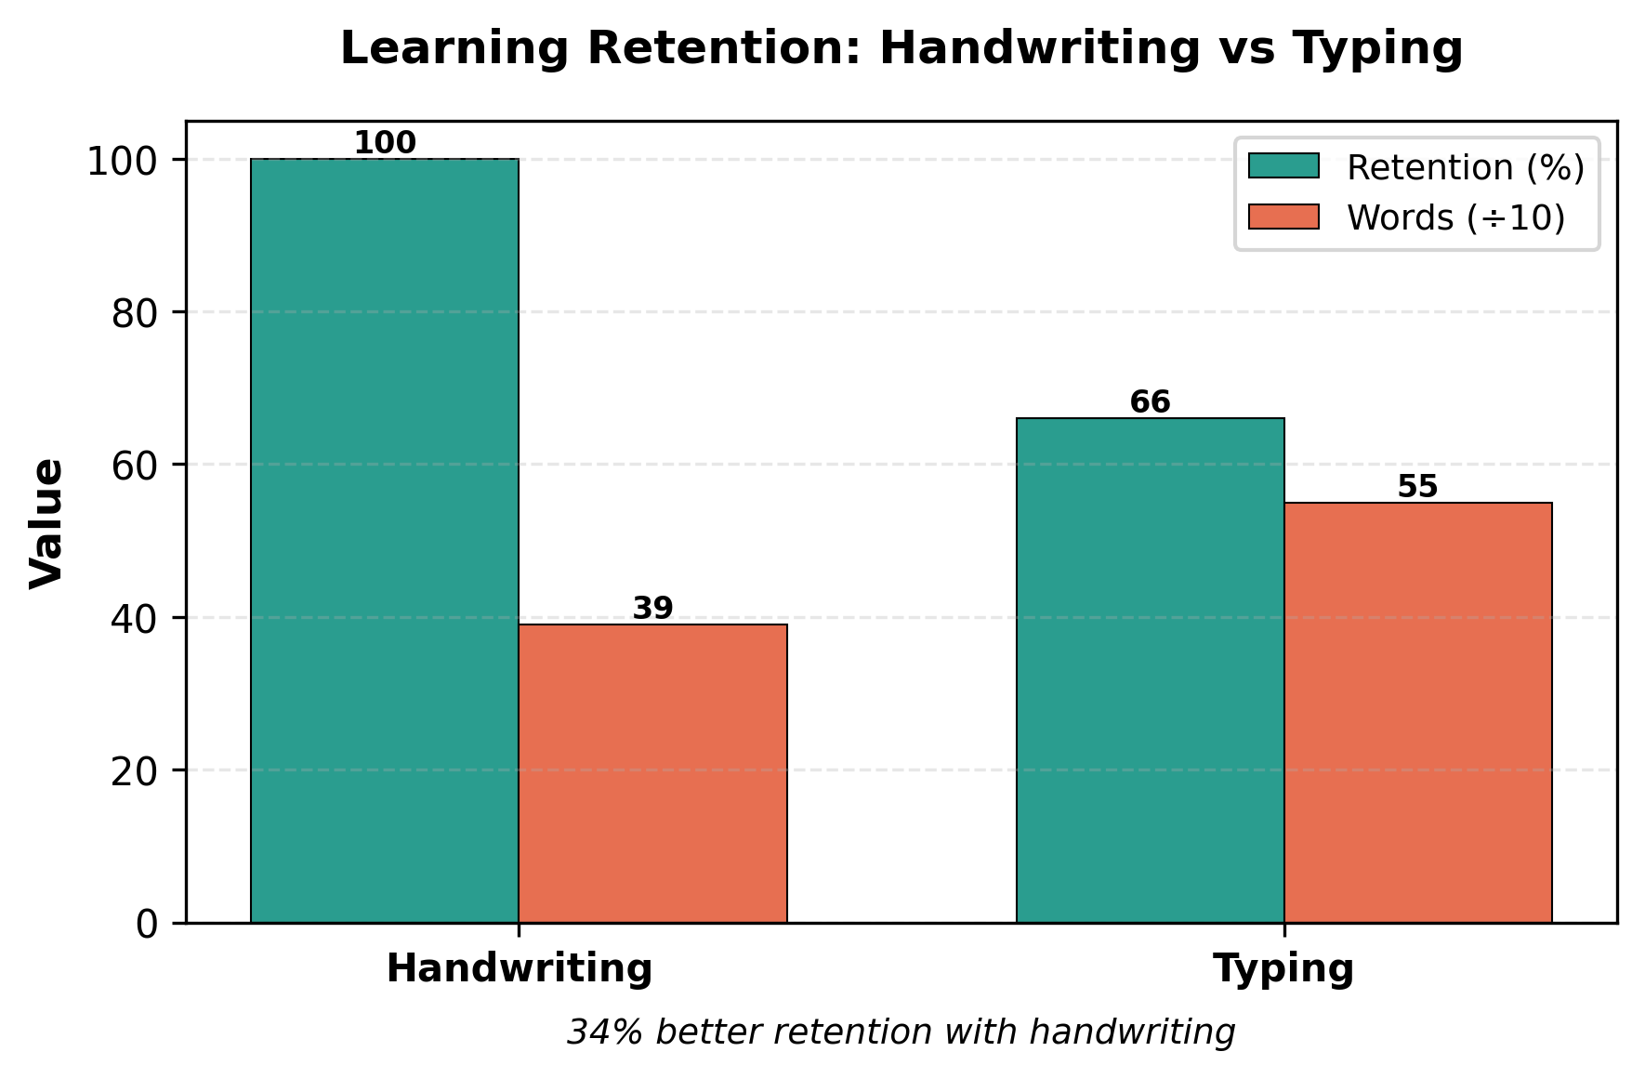
Documented brain changes accompany these behavioural shifts. Habitual GPS users show hippocampal volume reduction and weaker spatial memory, whereas London taxi drivers, who memorise complex street networks, show enlarged hippocampi. Handwriting produces approximately 34 per cent better retention of learned material than typing.

Figure 5.2: Learning Retention - Handwriting vs Typing

The implications for the next generation are particularly concerning. Children growing up today may never develop certain skills at all: navigation skills (because GPS is always on), phone-number memorisation (because contacts are always stored), emotional self-regulation in unstructured situations (because an AI chatbot is always reachable), and handwriting (because tablets have replaced paper in many primary-school curricula). Developmental research indicates that abilities that fail to develop during sensitive childhood windows may never develop fully thereafter.

5.4 The Common Pattern

All three research questions reveal the same underlying pattern: short-term gain leads to long-term loss. Tracking feels helpful in the short run but produces anxiety and bodily disconnection over time. AI feels supportive in the short run but prevents the development of real relationship skills over time. Devices feel convenient in the short run but lead to atrophy of capabilities over time. The pattern is so consistent across domains that it strongly suggests a single underlying mechanism, namely, the gradual replacement (rather than enhancement) of human capacity by algorithmic substitute.

5.5 Vulnerable Populations

Not all users are at equal risk. Table 5.4 identifies the populations most vulnerable to algorithmic dependence.

Table 5.4: Vulnerable Populations and Risk Factors
Group | Why Vulnerable
Teenagers | Brain still developing; 72 % use AI chatbots
People with mental-health conditions | 48.7 % use mental-health AI; 9 % report harm
People with eating-disorder history | 75 % use tracking apps; 73 % report worsening
Low-income users | Cannot afford human professional services

5.6 Practical Recommendations

5.6.1 For the Individual User
- Self-test: ask whether you can manage without your device for 24 consecutive hours. If the answer is no, you have crossed from use into dependence.
- Exercise the cognitive abilities that the device replaces: navigate without GPS occasionally, memorise the phone numbers of close family members, take notes by hand, and reflect on emotions before turning to a chatbot.
- Set explicit boundaries: reduce the frequency with which you check tracking data, prioritise face-to-face human interaction, and reserve technology for tasks where it genuinely augments rather than replaces capability.
5.6.2 For Application Designers
- Reduce the frequency of recommended check-ins, rather than maximising them in pursuit of engagement metrics.
- Avoid addictive design patterns such as streaks, badges, and intermittent-reinforcement notifications when applied to health behaviour.
- Programme AI companions to challenge users where appropriate, rather than always agreeing with them.
- Disclose the limitations of automated systems clearly, especially in mental-health contexts.
- Provide warnings against overuse, modelled on warnings already in use for gambling and alcohol products.
5.6.3 For Governments and Policymakers
- Establish consumer-protection requirements for health applications equivalent to those that already apply to medical devices.
- Set minimum-age requirements for AI-companion applications, particularly those marketed for romantic or therapeutic purposes.
- Mandate crisis-response protocols for any conversational AI in which a user discloses self-harm ideation.
- Fund digital-literacy education in schools, alongside continued investment in human mental-health professionals.
Moreover, users may evaluate their dependency on AI through a specially-designed questionnaire for this research paper. It is accessible at the following link:
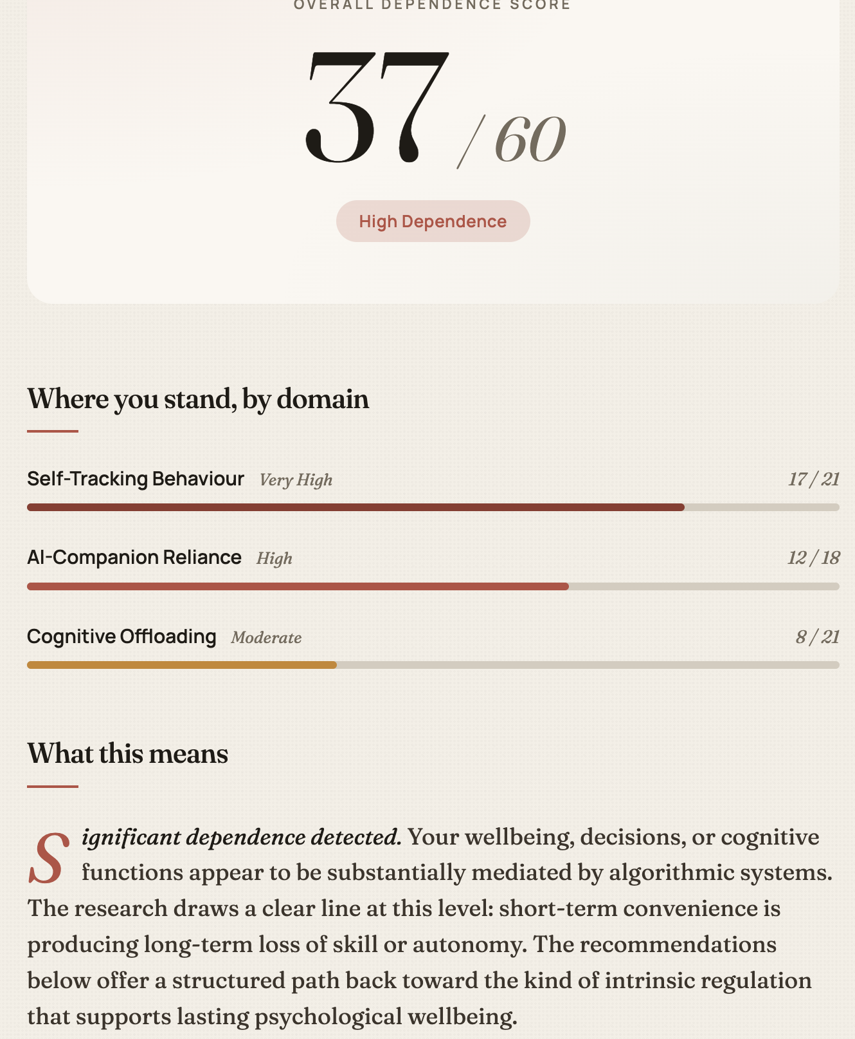
https://assesment-researchpaper.netlify.app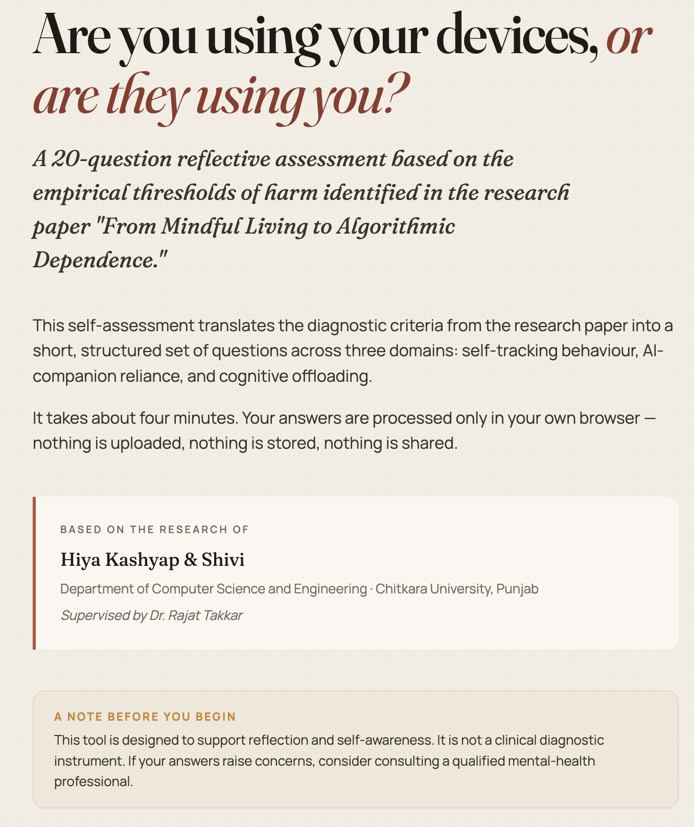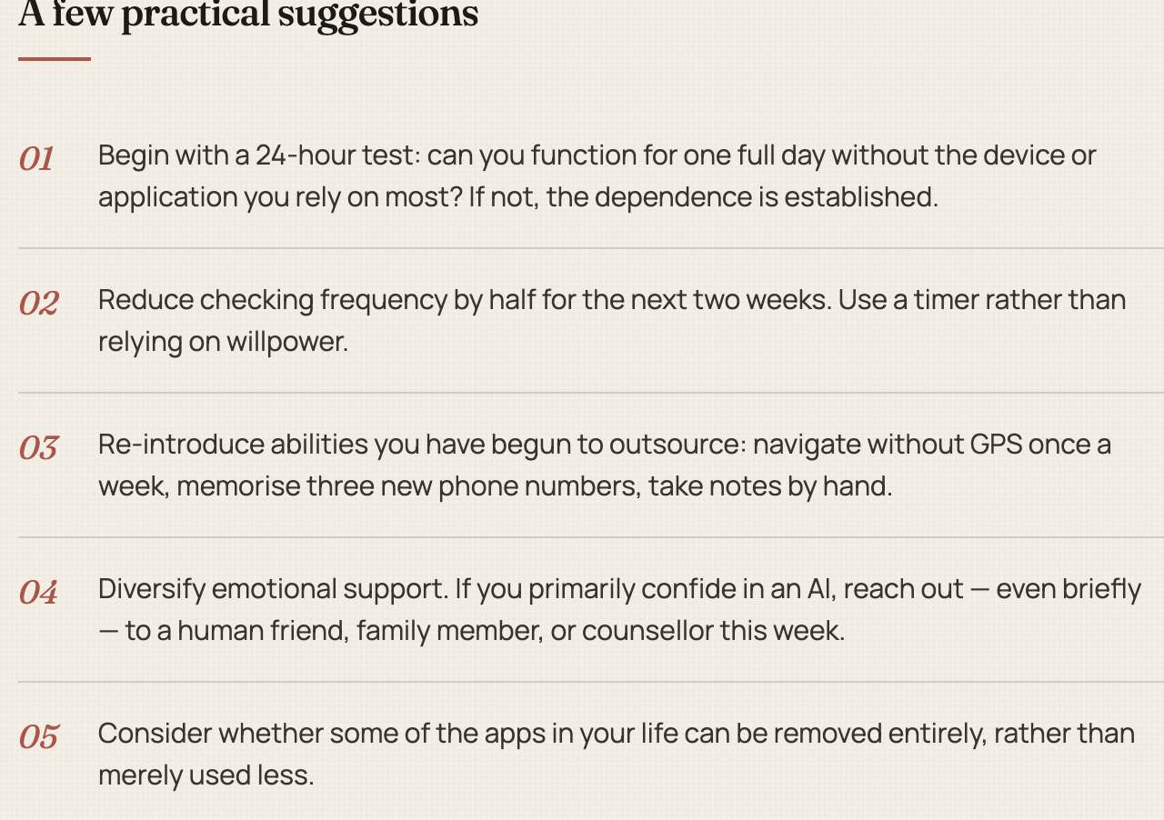

CHAPTER 6: CONCLUSION AND FUTURE SCOPE

6.1 Summary of Findings

This research project was conceived around a deceptively simple observation: technologies designed to support human wellbeing are in many cases producing the opposite effect. Through a systematic review of fifteen empirical studies and more than 80,000 participants, this study has documented the boundary between beneficial and harmful self-tracking, the impact of AI companions on the development of human relational skills, and the cognitive abilities that are being progressively transferred from humans to algorithms.

The evidence supports a clear conclusion. Wellness applications are dual-natured. They genuinely help many users adhere to healthy behaviours, expand access to mental-health support, and provide objective feedback on physiological states. At the same time, they can erode self-motivation, undermine self-regulation, and reduce autonomous behavioural capacity, particularly among users who interact with them goal-orientedly and continuously. Future generations of these applications must be designed to support, rather than substitute for, technology-mediated guidance and self-motivation.

6.2 Implications

Before letting an artificial-intelligence system make the next decision, every user should pause to ask four reflective questions. First, am I genuinely unable to do this myself, or am I merely avoiding the discomfort of trying? Second, what skill am I failing to develop by deferring this task? Third, what will I lose if that skill never develops? Fourth, is the convenience worth the loss?

The most serious implication of the present findings concerns children. Children whose navigation, memorisation, empathic, and emotional-regulation skills are not exercised during the developmental window may suffer permanent reductions in capacity. Empirical work in developmental neuroscience supports this concern. The question is not whether AI should be used, but whether human users have retained the introspective capacity to decide responsibly when to use it and when not to.

6.3 Limitations of the Study

Four limitations of the present study warrant explicit acknowledgement.
- Most of the literature reviewed reports short-term outcomes. The long-term consequences of being raised from childhood under the constant influence of AI companions and tracking devices remain largely unexplored.
- The direction of causation between AI use and mental-health symptoms is not always clear. AI use may worsen pre-existing conditions; alternatively, individuals with mental-health conditions may self-select into heavier AI use. In all probability, both directions of causation operate simultaneously.
- Most studies have been conducted in Westernised societies, which limits generalisability to populations whose cultural relationship with technology may be quite different.
- Individual differences in vulnerability are inadequately characterised. The reasons that some users develop pathological patterns and others do not remain incompletely understood.

6.4 Future Research Directions

Several research priorities emerge directly from the limitations above:
- Longitudinal studies extending over ten to twenty years are required to evaluate long-term exposure effects on self-regulatory development, intrinsic motivation, and addictive behaviour.
- Neuroimaging studies are required to determine how, and how quickly, the brain recovers when reliance on cognitive-offloading technologies is reduced.
- Intervention trials are required to test whether mindful-use protocols, digital sabbaticals, and design changes within applications can reverse documented harms.
- Cross-cultural studies are required to identify global versus local patterns of digital dependence.
- Comparative effectiveness research is required to distinguish the relative impacts of physical-activity apps, meditation apps, nutrition apps, and AI-companion apps on psychological wellbeing.
- Above all, an interdisciplinary framework is required that examines wearables, AI chatbots, and smartphones not as separate research subjects, but as components of a single technological ecosystem within which contemporary humans live their lives.
Technology should serve humanity, not replace it. The findings of this study suggest that the line between service and replacement has, in many domains, already been crossed. The task of the coming decade is to redraw that line consciously and to give human users the tools, the language, and the policy structures with which to defend it.

REFERENCES
[1] Lasikiewicz N. and Scudds R., "WAT's up? Investigating the effects of wearable activity trackers," Journal of Technology in Behavioral Science, October 2024.
[2] Cambridge Dictionary, "Parasocial chosen Word of the Year 2025," Common Sense Media poll (n = 1,060), Vantage Point poll (n = 1,000+), November 2025.
[3] "Digital Mental Health Post-COVID-19: The Age of AI Chatbots," Preprints.org, December 2025.
[4] Baron K. G. et al., "Orthosomnia: Are some patients over-quantifying themselves to excess?" Journal of Clinical Sleep Medicine, vol. 13, no. 2, pp. 351-354, 2017.
[5] Levinson C. A. et al., "My Fitness Pal calorie counter use among eating-disorder patients," Eating Behaviors, vol. 27, pp. 14-16, 2017.
[6] Kaspersky Lab, "Digital Amnesia: The Disappearance of Memory," 2015.
[7] "Parasocial Relationships With AI: Dangers, Threats, and Possible Solutions," FasPsych, October 2025.
[8] "Influences of attractions on chatbot usage and media addiction," BMC Psychology, vol. 13, art. 986, August 2025.
[9] Maguire E. A. et al., "London taxi drivers: an MRI analysis of brain structure," Hippocampus, vol. 16, 2006.
[10] Macrynikola N. et al., "The impact of mindfulness apps on psychological processes of change: a systematic review," npj Mental Health Research, vol. 3, no. 1, art. 14, 2024.
[11] Valentine L. et al., "A meta-analysis of persuasive design, engagement, and efficacy in 92 RCTs of mental-health apps," npj Digital Medicine, vol. 8, art. 229, 2025.
[12] Uslu U., "Understanding digital wellbeing: impacts, strategies, and the path to healthier technology practices," Digital Wellbeing, vol. 5, art. 145, 2025.
[13] Almoallim S. and Sas C., "Toward research-informed design implications for interventions limiting smartphone use: functionalities review of digital wellbeing apps," JMIR Formative Research, vol. 6, no. 4, e31730, 2022.
[14] Ahmad F. et al., "Examining the impact of web-based mindfulness on undergraduate students' quality of life: a randomized controlled trial," BMC Digital Health, vol. 1, p. 22, 2023.
[15] Perakslis R. and Quintana Y., "Social media is addictive and influences behavior: should it be regulated as a digital therapeutic?" Journal of Medical Internet Research, vol. 25, e43174, 2023.
[16] Kolhe D. and Naik A. R., "Digital detox as a means to enhance eudaimonic wellbeing," Frontiers in Human Dynamics, vol. 7, art. 1572587, 2025.
[17] "Digital Wellbeing Apps: Adoption, Usage and Perceived Impact," Computers in Human Behavior, 2022.
[18] "Effects of Digital Interventions on Mental Health and Psychological Wellbeing," PMC, 2025.
[19] Adanyin A., "AI Feedback Loops in Digital Technologies: Psychological Impacts on User Behavior and Wellbeing," arXiv, 2024.
[20] "Virtual Mindfulness Interventions for Enhancing Adult Wellbeing: Mixed-Methods Systematic Review," Journal of Affective Disorders, 2022.
[21] Zhao Z. et al., "Relationships between Self-Control, Psychological Resilience, and Digital Addiction among College Students," Frontiers in Psychology, vol. 17, 2025.
[22] "Wellness in the Digital Age: Interrelationships between Digital Health Literacy, Anxiety, and Self-Efficacy," BMC Public Health, 2025.
[23] "Digital Technologies and Student Mental Health: Risks of Social Media Platforms and Promise of Virtual Reality and ASMR Interventions," Psycho-Behavioural Research, 2025.
[24] "From Sleep Tracking Apps to Chatbots: How the New Generation of Health Tech Widens Access to Treatment," 2024.

