Experiment no : 11
Aim
Use JavaScript timers (setTimeout(), setInterval()) and ES6 modules (import/export) to build a dynamic countdown or class scheduler with real-time updates and responsive layout.

Theory
JavaScript provides timer functions such as setTimeout() and setInterval() to execute code after a specified delay or repeatedly at regular intervals. These functions are useful for developing dynamic and interactive web applications.
In this experiment, a Class Scheduler is developed using HTML, CSS, and JavaScript. HTML creates the structure of the webpage, CSS provides styling and a responsive layout, and JavaScript handles the application’s functionality.
The setInterval() function updates the digital clock and countdown every second, while setTimeout() displays reminders before a scheduled class begins. JavaScript DOM manipulation allows users to add and remove class details dynamically without reloading the webpage. Event handling is used to process form submissions and update the schedule.
The application displays the subject name, room number, class time, next upcoming class, and countdown timer. This experiment demonstrates the practical use of JavaScript timers, events, and DOM manipulation in creating a real-time scheduling application.

Software/Tools Required
- HTML5: To create the webpage structure.
- CSS3: To style the interface and make it responsive.
- JavaScript: To implement timers, countdowns, and class management.
- Visual Studio Code: For writing and editing code.
- Web Browser: For running and testing the application.

Path - Class Scheduler

Name – Hiya Kriplani , PRN - 24070521277
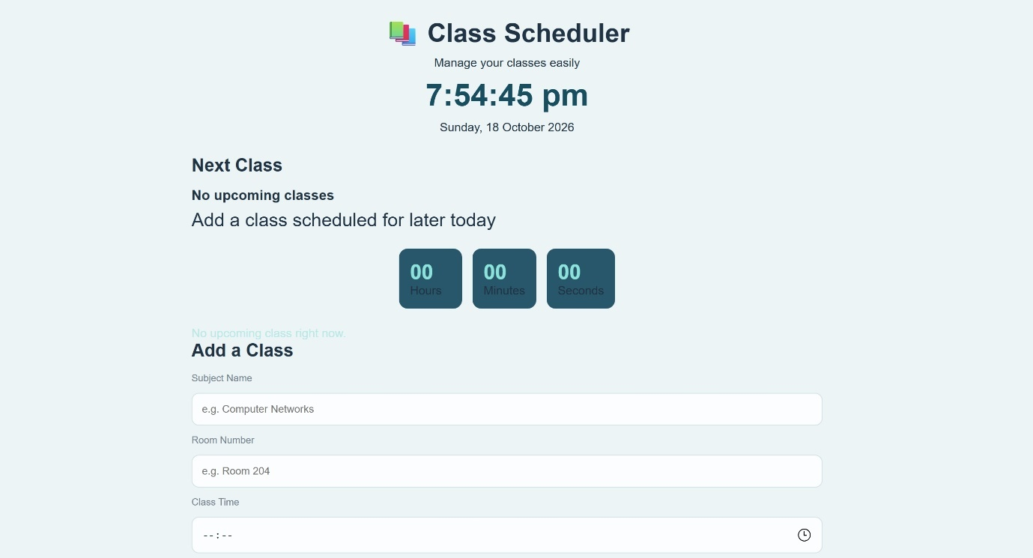
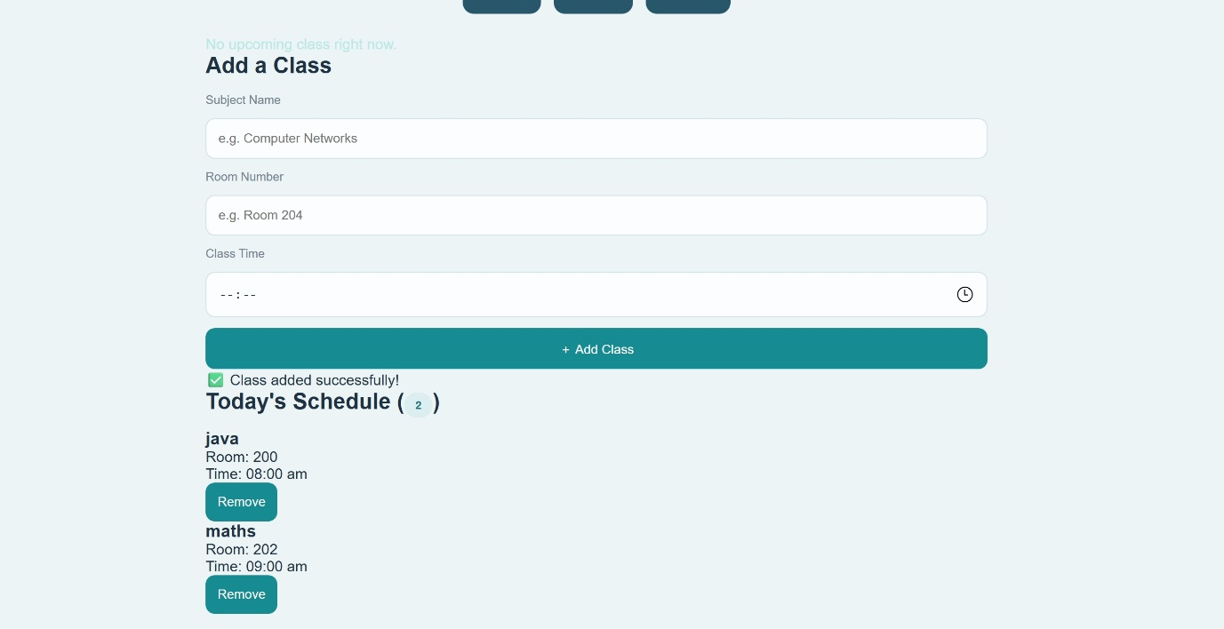

Conclusion
Thus, a dynamic Class Scheduler was developed using HTML, CSS, and JavaScript. The application allows users to add and remove classes, view a live clock, track countdowns, and receive class reminders using JavaScript timers.

