Experiment No: 2
Aim: Use var, let const and demonstrate basic features like template literals and destructuring; build a billing calculator with user input.
Software Required: VS Code (HTML, JS), Google Chrome
Experiment Program Code:
1.
<!DOCTYPE html>
<html lang="en">
<head>
<meta charset="UTF-8">
<meta name="viewport" content="width=device-width, initial-scale=1.0">
<title>Document</title>
</head>
<body>
<script>
const colors = ["Red","Green","Blue"];
const [first, second] = colors;
console.log(first);
console.log(second);
const student = {id: 1, name: "Riya", branch: "CSE" };
const {name, branch} = student;
console.log(name);
console.log(branch);
</script>
</body>
</html>

2.
<!DOCTYPE html>
<html lang="en">
<head>
<meta charset="UTF-8">
<meta name="viewport" content="width=device-width, initial-scale=1.0">
<title>Document</title>
</head>
<body>
<h2> Enter values </h2>
x: <input type = "number" id = "num1"><br><br>
y: <input type = "number" id = "num2"><br><br>
z: <input type = "number" id = "num3"><br><br>
<button onclick = "showValues()">Show</button>
<p id = "result"></p>
<script>
function showValues(){
var x = Number(document.getElementById("num1").value);
let y = Number(document.getElementById("num2").value);
const z = Number(document.getElementById("num3").value);
x = x + 10;
y = y + 10;
document.getElementById("result").innerHTML = "Updated x: " + x + "<br>"
+ "updated y: " + y + "<br>" + "z(const): " + z;
}
</script>
</body>
</html>

3.
<!DOCTYPE html>
<html lang="en">
<head>
<meta charset="UTF-8">
<meta name="viewport" content="width=device-width, initial-scale=1.0">
<title>Document</title>
</head>
<body>
<script>
let str = "Hello";
let num = 42;
let isReady = true;
let empty = null;
let notDefined;
console.log(typeof str);
document.write(str);
console.log(typeof num);
console.log(typeof isReady);
console.log(typeof empty);
console.log(typeof notDefined);
</script>
</body>
</html>

4.
<!DOCTYPE html>
<html lang="en">
<head>
<meta charset="UTF-8">
<meta name="viewport" content="width=device-width, initial-scale=1.0">
<title>Variables</title>
</head>
<body>
<script>
var x = 5;
let y = 10;
const z = 15;
console.log("var x: ",x);
console.log("let y: ",y);
console.log("const z: ",z);
x = 20;
y = 25;
z = 30;
console.log("updated x: ",x);
console.log("updated y: ",y);
// updated values are not seen as these are immutable
</script>
</body> </html>
Code Outputs:
HiyaKriplani_1277
2.
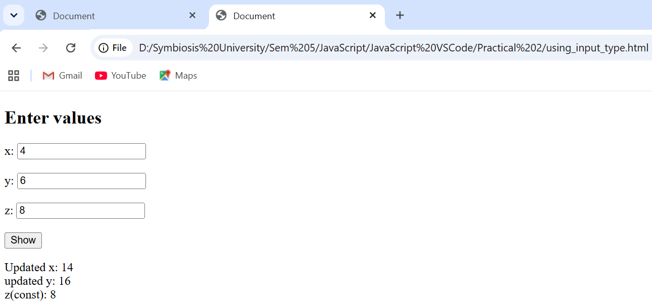
HiyaKriplani_1277
3.
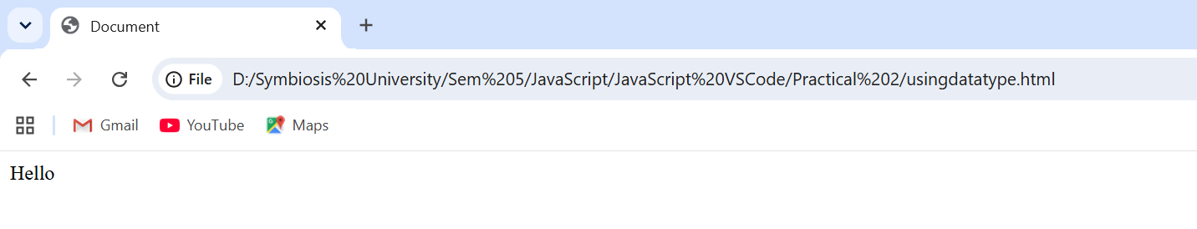
4.
HiyaKriplani_1277

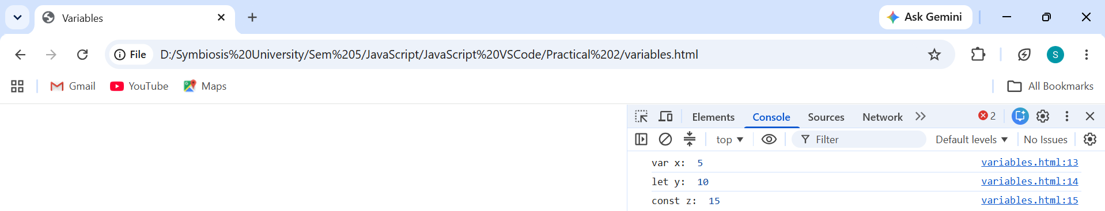

Case Study Title – Online Book store
Case Study Program Output –

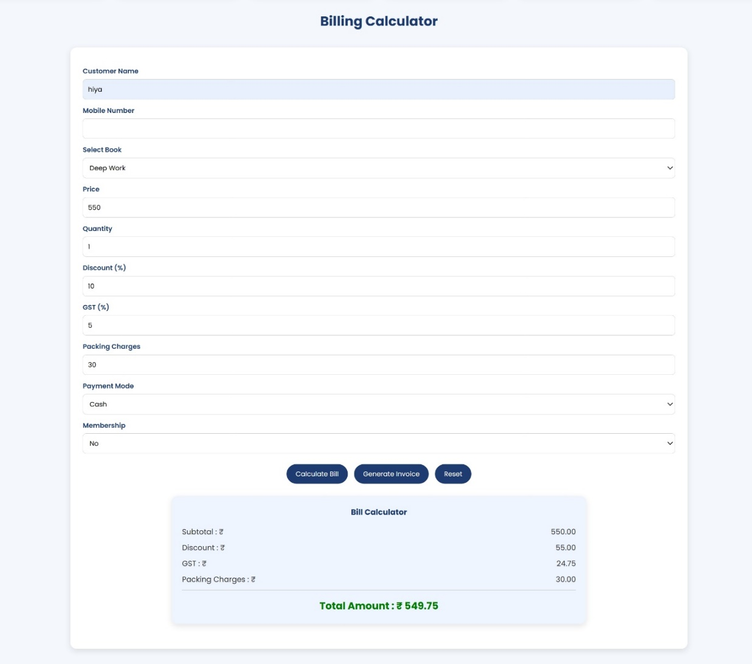
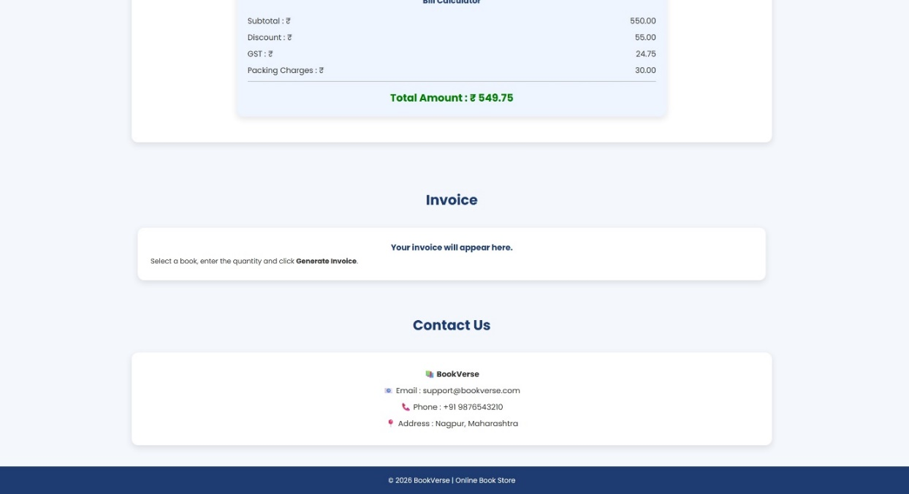

Path: BookVerse - Online Book Store
Name: Hiya Kriplani PRN: 24070521277

