JavaScript Lab Experiment: 3

AIM: Implement control structures and form validation; create a grading system based on user-entered marks.
Software/Tools required: Text editor (VS code, Notepad), Web Browser (Chrome, Edge)
Experiment Program Code
1.While
<!DOCTYPE html>
<html lang="en">
<head>
<meta charset="UTF-8">
<meta name="viewport" content="width=device-width, initial-scale=1.0">
<title>Document</title>
</head>
<body>
<h2> While Loop Example</h2>
<script>
let i=1;
while(i<=10){
document.write(i + "<br>");
i++;
}
</script>
</body>
</html>

2.Do_while
<!DOCTYPE html>
<html lang="en">
<head>
<meta charset="UTF-8">
<meta name="viewport" content="width=device-width, initial-scale=1.0">
<title>Document</title>
</head>
<body>
<h2> While Loop Example</h2>
<script>
let i=1;
do{
document.write(i + "<br>");
i++;
}while(i <=10);
</script>
</body>
</html>

3.If Code
<!DOCTYPE html>
<html lang="en">
<head>
<meta charset="UTF-8">
<meta name="viewport" content="width=device-width, initial-scale=1.0">
<title>If Satement</title>
</head>
<body>
<h2> If Statement Example</h2>
<script>
let age = 20;
if (age >= 18){
document.write("You are eligible to vote.");
}
</script>
</body>
</html>

4.Prompt
<!DOCTYPE html>
<html lang="en">
<head>
<meta charset="UTF-8">
<meta name="viewport" content="width=device-width, initial-scale=1.0">
<title>Document</title>
</head>
<body>
<h2>JavaScript Prompt and Alert Example</h2>
<script>
let name = prompt("Enter your name:");
alert("Hello, "+ name + "! Welcome to JavaScript.");
document.write("<h3>Welcome, "+ name + "!</h3>");
</script>
</body>
</html>

5.Add Element Listener
<!DOCTYPE html>
<html lang="en">
<head>
<meta charset="UTF-8">
<meta name="viewport" content="width=device-width, initial-scale=1.0">
<title>Document</title>
</head>
<body>
<button id = "myButton">Click Me</button>
<p id="message"></p>
<script>
const button = document.getElementById("myButton");

button.addEventListener("click", function(){
document.getElementById("message").innerHTML = "Button clicked successfully";
});
</script>
</body>
</html>

6.For Element
<!DOCTYPE html>
<html lang="en">
<head>
<meta charset="UTF-8">
<meta name="viewport" content="width=device-width, initial-scale=1.0">
<title>Document</title>
</head>
<body>
<input type ="text" id="name"/>
<button onclick = "getname()">Submit</button>
<script>
function getname(){
let name = document.getElementById("name").value;
alert("Hello, "+ name);
}
</script>
</body>
</html>

7.Key Up
<!DOCTYPE html>
<html lang="en">
<head>
<meta charset="UTF-8">
<meta name="viewport" content="width=device-width, initial-scale=1.0">
<title>Document</title>
</head>
<body>
Enter Name:
<input type="text" id ="name">
<p id = "output"></p>

<script>
const textbox = document.getElementById("name");
textbox.addEventListener("keyup", function(){
document.getElementById("output").innerHTML = "You entered: " + textbox.value;
});
</script>
</body>
</html>

8.Mouse Up
<!DOCTYPE html>
<html lang="en">
<head>
<meta charset="UTF-8">
<meta name="viewport" content="width=device-width, initial-scale=1.0">
<title>Document</title>
</head>
<body>
<h2>Mouse Down and Mouse Up</h2>
<div id="box" style="width:200px;height:100px;background:skyblue;text-align:centre;line-height:100px;">
Press Mouse
</div>
<script>
const box = document.getElementById("box");
box.addEventListener("mousedown", function() {
box.innerHTML = "Mouse Button Pressed";
});
box.addEventListener("mouseup", function(){
box.innerHTML = "Mouse Button Released";
});
</script>
</body>
</html>

9.Mouse Over
<!DOCTYPE html>
<html lang="en">
<head>
<meta charset="UTF-8">
<meta name="viewport" content="width=device-width, initial-scale=1.0">
<title>Document</title>
</head>
<body>
<div id = "box" style="width:200px;height:100px;background:lightgray;text-align:centre;line-height:100px;">
Move Mouse Here
</div>
<script>
document.getElementById("box").addEventListener("mouseover", function(){
this.style.backgroundColor = "yellow";
this.innerHTML = "Mouse is Over!";
});
</script>
</body>
</html>

Output:
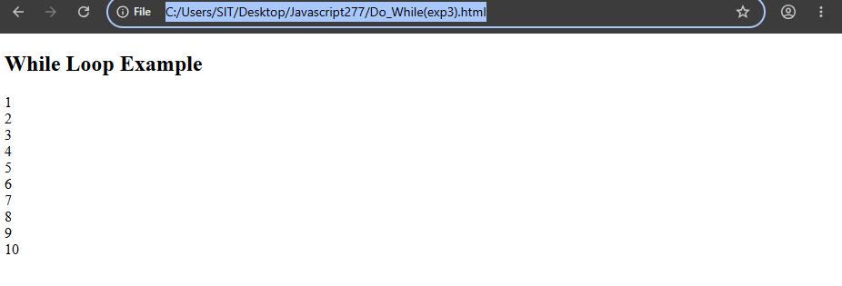
Name: Hiya Kriplani , PRN: 24070521277 -DoWhile
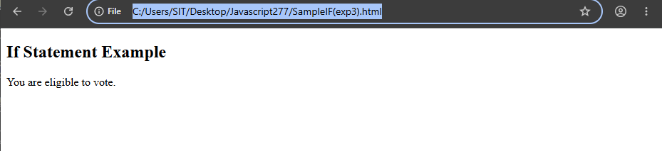
Name: Hiya Kriplani , PRN: 24070521277 -SampleIF

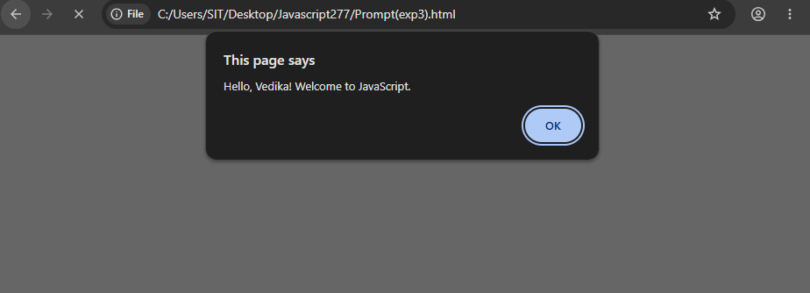
Name: Hiya Kriplani , PRN: 24070521277 -Prompt

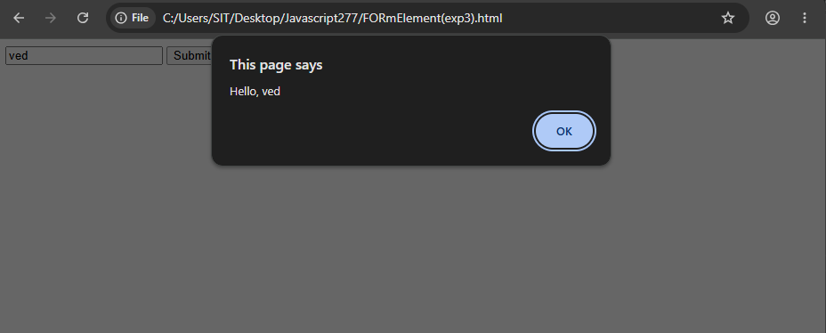
Name: Hiya Kriplani , PRN: 24070521277 -For Element

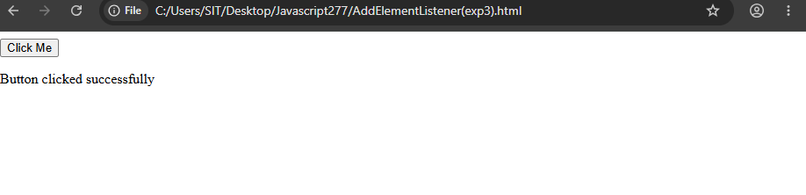
Name: Hiya Kriplani , PRN: 24070521277 -Add element

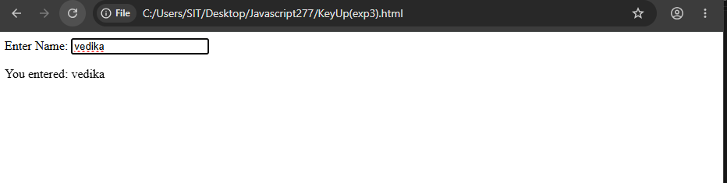
Name: Hiya Kriplani , PRN: 24070521277 -Key UP

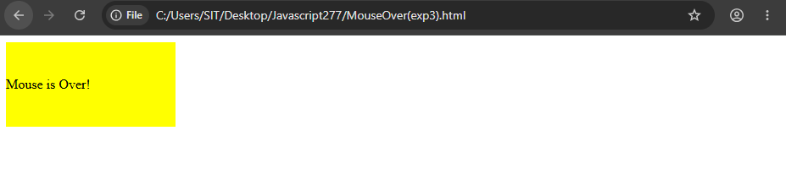
Name: Hiya Kriplani , PRN: 24070521277 -Mouse Over

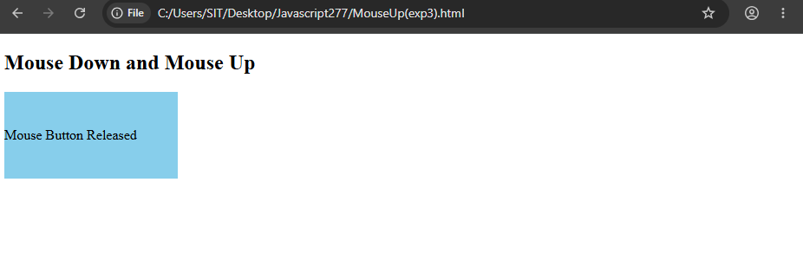
Name: Hiya Kriplani , PRN: 24070521277 -Mouse Over

Case Study: create a grading system based on user-entered marks.
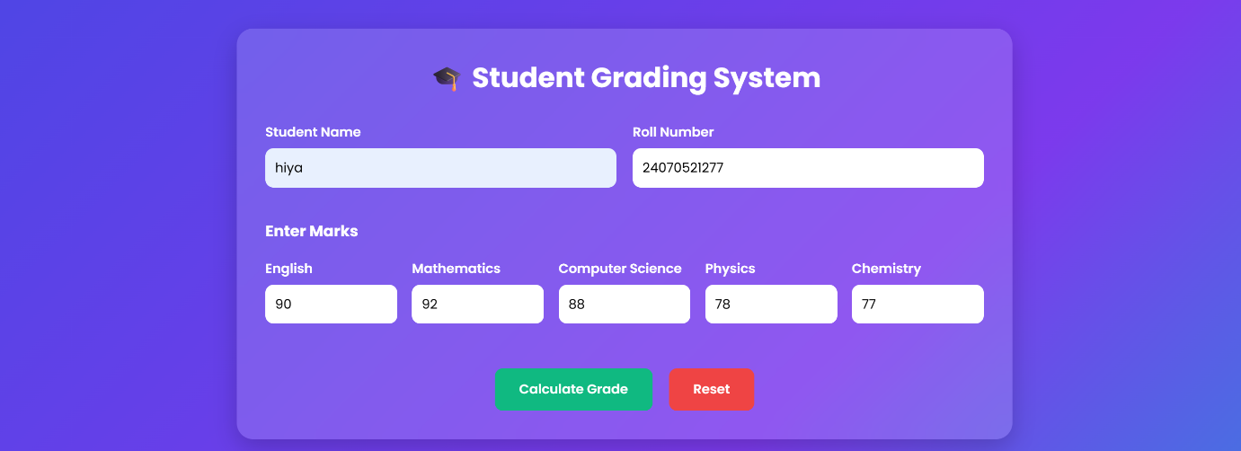

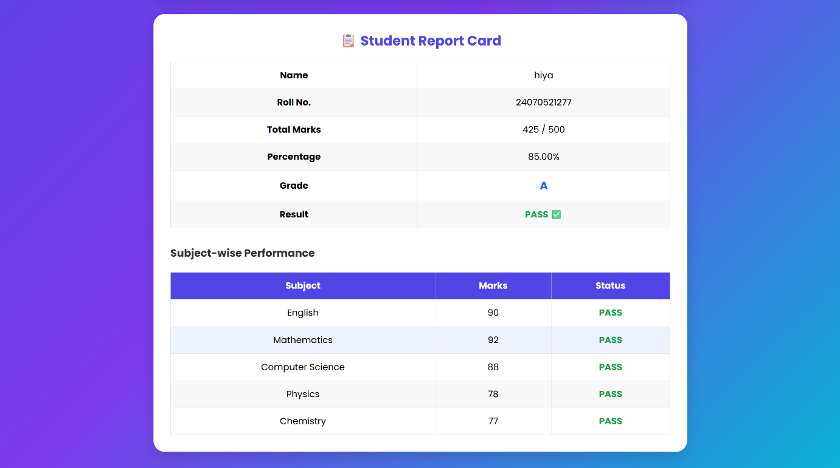

Result: The Student Grading System was successfully developed using HTML, CSS, and JavaScript. The application validates student details and marks, calculates the total, percentage, grade, and pass/fail status, and dynamically displays a well-formatted result summary with the option to print the result.

NAME: Hiya Kriplani PRN: 24070521277
PATH: Student Grading System

