JavaScript Lab Experiment: 4
AIM: Use function types, scope, and closures; apply try-catch; build a palindrome checker.
Software/Tools required: Text editor (VS code, Notepad), Web Browser (Chrome, Edge)
Experiment Program Code
1.Function New
<!DOCTYPE html>
<html lang="en">
<head>
<meta charset="UTF-8">
<meta name="viewport" content="width=device-width, initial-scale=1.0">
<title>Document</title>
</head>
<body>
<h2>JavaScript setTimeout()</h2>
<p>Wait for 2 seconds...</p>

<script>
setTimeout(function(){
alert("Executed after 2 seconds");
},2000);

</script>
</body>
</html>

2.Function Parameter
<!DOCTYPE html>
<html lang="en">
<head>
<meta charset="UTF-8">
<meta name="viewport" content="width=device-width, initial-scale=1.0">
<title>Function example</title>
</head>
<body>
<h2>Addition Using Javascript Function</h2>
<script>
function add(a, b){
return a + b;
}
let result = add(5, 3);
alert("The sum is: " + result);
</script>
</body>
</html>

3.Function Passing
<!DOCTYPE html>
<html lang="en">
<head>
<meta charset="UTF-8">
<meta name="viewport" content="width=device-width, initial-scale=1.0">
<title>Function Expression</title>
</head>
<body>
<h2>JavaScript Function Expression</h2>
<script>
const greet = function () {
return "Hello from Function Expression";
};
alert(greet());
</script>
</body>
</html>

4.Try-Catch
<!DOCTYPE html>
<html lang="en">
<head>
<meta charset="UTF-8">
<meta name="viewport" content="width=device-width, initial-scale=1.0">
<title>Document</title>
</head>
<body>
<h2>Try-Catch Example</h2>
<p id ="result"></p>

<script>
try{
document.getElementById("result").innerHTML = x;
}
catch (error){
document.getElementById("result").innerHTML = "Error: " + error.message;
}
</script>
</body>
</html>

5.Try-Catch2
<!DOCTYPE html>
<html lang="en">
<head>
<meta charset="UTF-8">
<meta name="viewport" content="width=device-width, initial-scale=1.0">
<title>Document</title>
</head>
<body>
<h2>Age Validation</h2>
<input type="Text" id="age" placeholder="Enter your age">
<button onclick="checkAge()">check</button>

<p id="result"></p>
<script>
function checkAge(){
try{
let age = document.getElementById("age").value;

if (age === ""){
throw new Error("Age cannot be empty.");
}
age = Number(age);

if (isNaN(age)){
throw new Error("Please enter a valid number.");
}
if (age<18){
throw new Error("You are not eligible.");
}
document.getElementById("result").innerHTML = "You are eligible";
}
catch(error){
document.getElementById("result").innerHTML = "Error: " + error.message;
}
}
</script>
</body>
</html>

6.Try-Catch String
<!DOCTYPE html>
<html lang="en">
<head>
<meta charset="UTF-8">
<meta name="viewport" content="width=device-width, initial-scale=1.0">
<title>Document</title>
</head>
<body>
<p id="result"></p>
<script>
try{
let num = 10;
let result = num.toUpperCase();
document.getElementById("result").innerHTML = result;
}
catch(error){
document.getElementById("result").innerHTML = "An error occurrent: " + error.message;
}
</script>
</body>
</html>

Output:

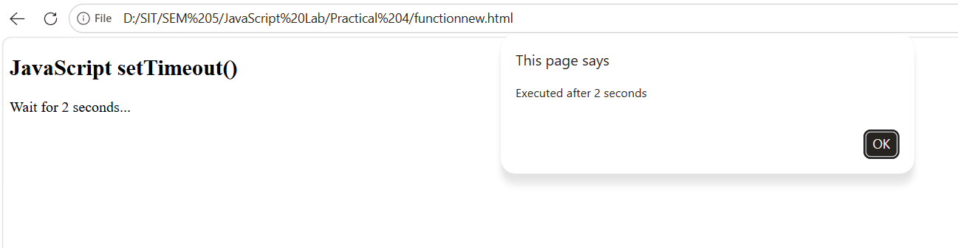

Name: Hiya Kriplani , PRN: 24070521277 -FunctionNew
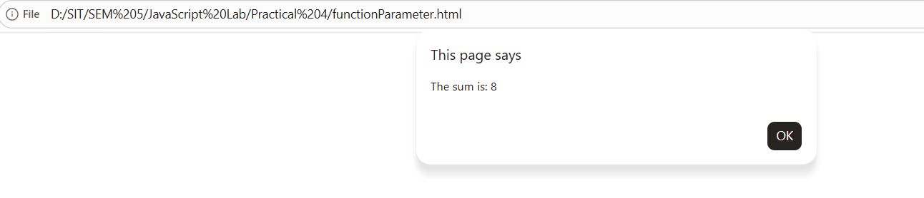
Name: Hiya Kriplani , PRN: 24070521277 -FunctionParameter
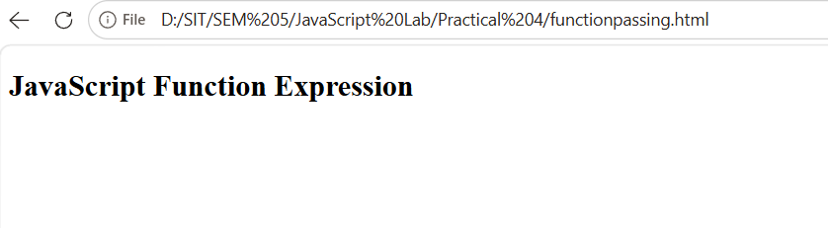
Name: Hiya Kriplani , PRN: 24070521277 -FunctionPassing
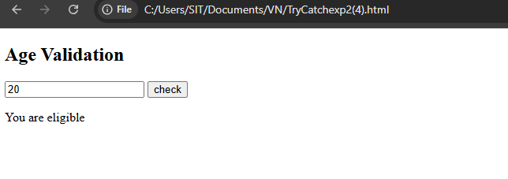
Name: Hiya Kriplani , PRN: 24070521277 -TryCatch2
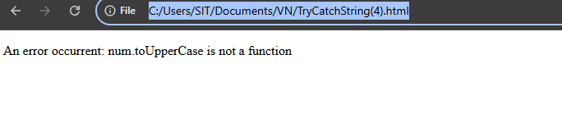

Name: Hiya Kriplani , PRN: 24070521277 -TryCatch String
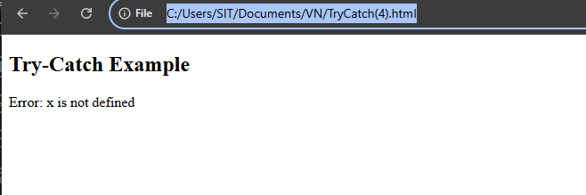
Name: Hiya Kriplani , PRN: 24070521277 -TryCatch

Case Study: create a palindrome checker
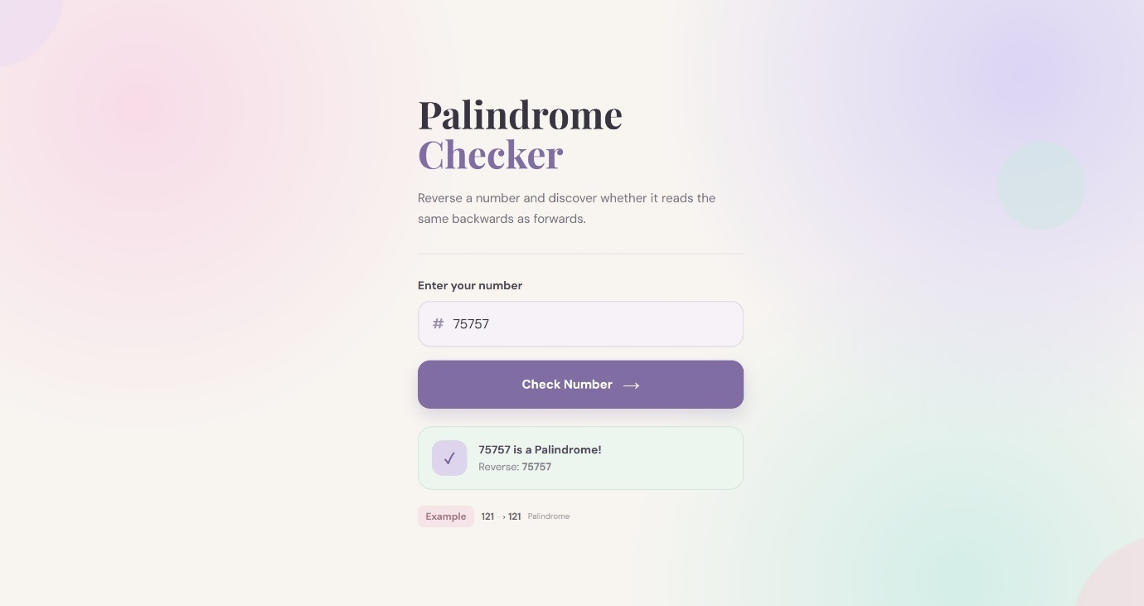
Additional Assignment:
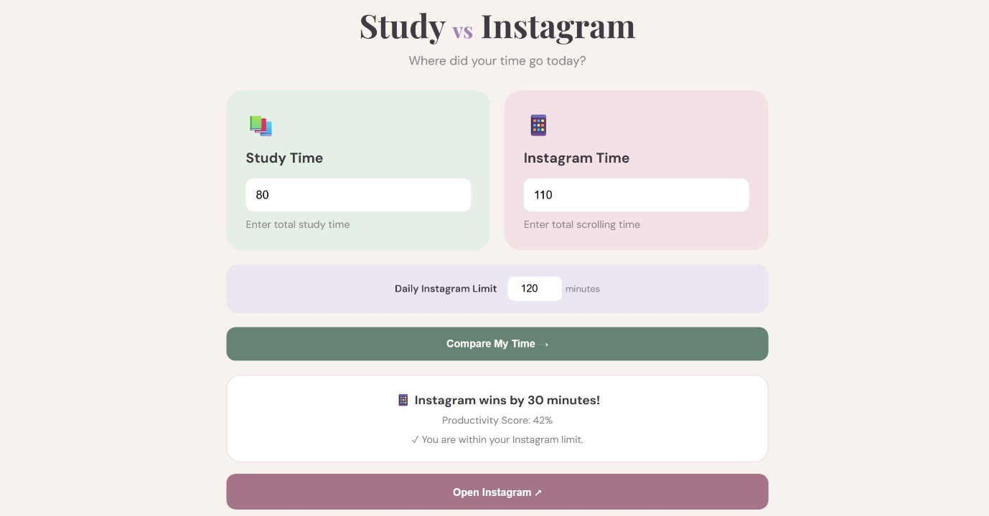
Result: The program successfully reverses the given number and checks whether it is a palindrome using JavaScript functions and exception handling.

NAME: Hiya Kriplani , PRN: 24070521277
PATH: Palindrome Checker

