Experiment no : 10
Aim
Load and display JSON data using fetch() and jQuery $.getJSON(); render results dynamically in a table.

Theory
JSON (JavaScript Object Notation) is a lightweight format used to store and exchange data. The fetch() API and jQuery $.getJSON() method are used to retrieve JSON data from a server. JavaScript DOM manipulation is used to display the retrieved records dynamically in an HTML table. Search, filtering, and sorting features help users manage and view student information efficiently.

Software/Tools Required
- HTML5
- CSS3
- JavaScript
- jQuery library
- Visual Studio Code
- Web browser and Live Server extension
- Internet connection

Path - Student Record Management System

Name – Hiya Kriplani , PRN - 24070521277
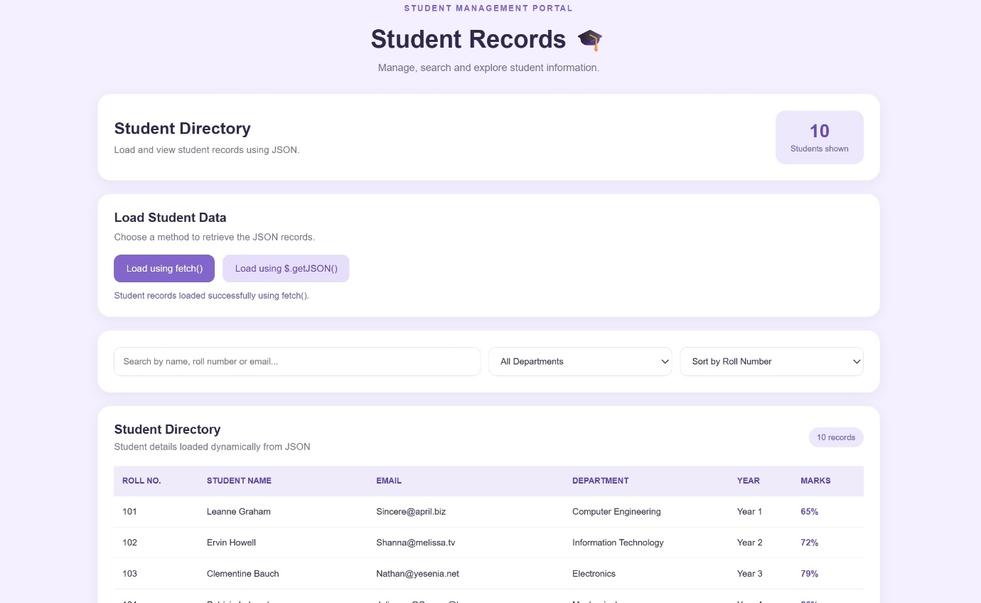
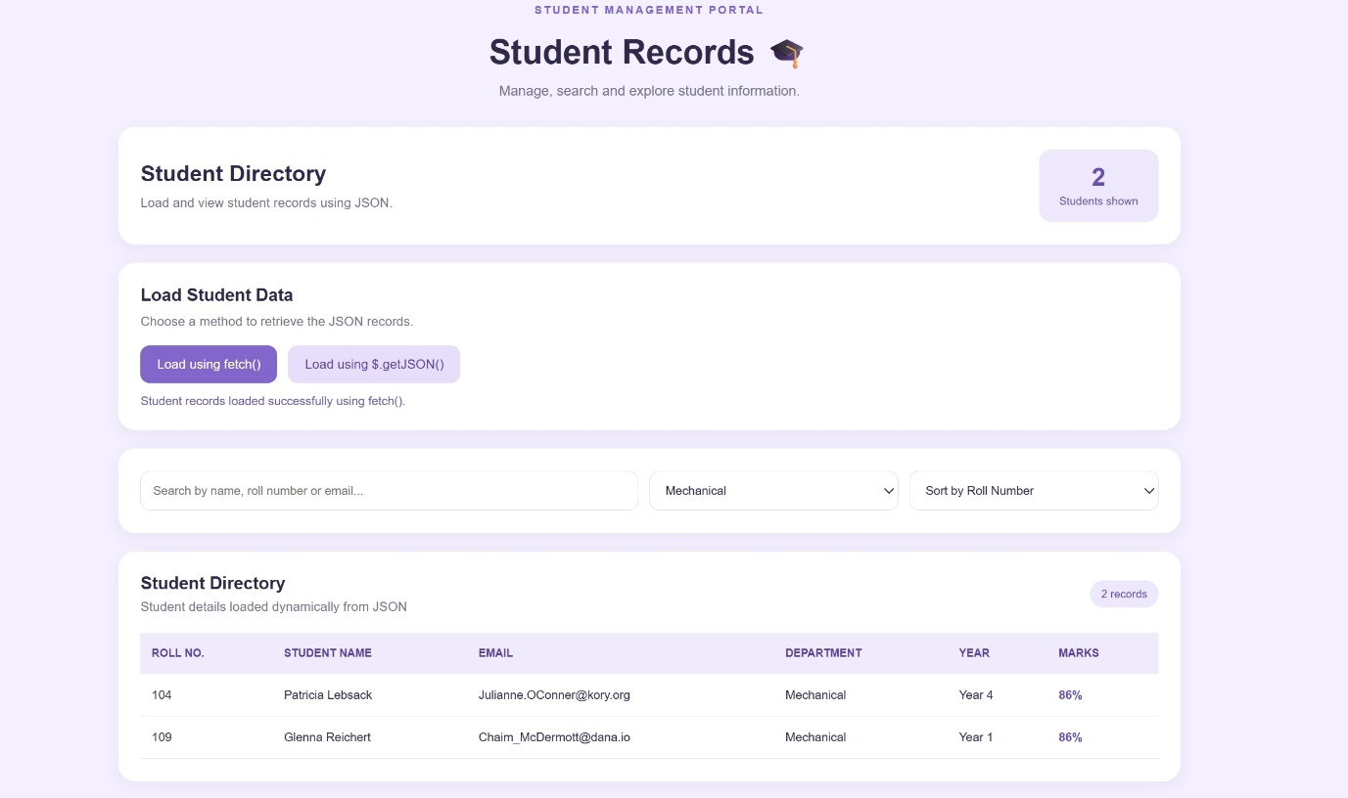

Conclusion
The Student Record Management System webpage was successfully developed to retrieve JSON data using fetch() and jQuery $.getJSON(). The retrieved data is displayed dynamically in a table with search, filtering, and sorting functionality.

